ERD Diagram for eBay Relational Database Design
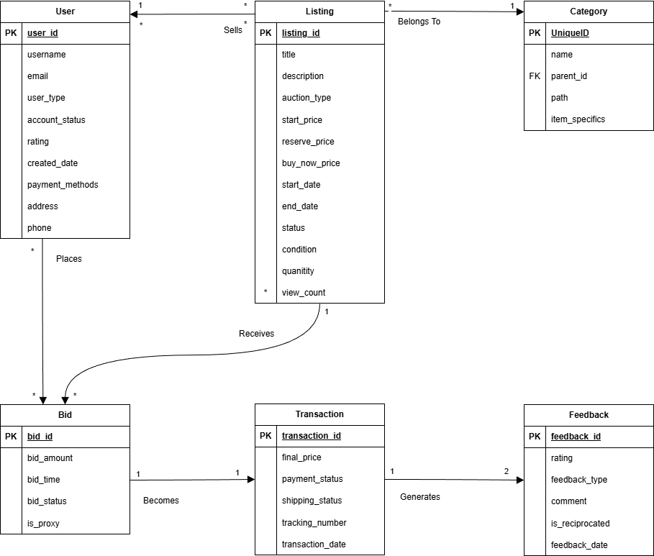
Taylor Heffington - theffington@hawk.illinoistech.edu
Cardinalities
User | 1 → * | Listing | One User sells many Listings
User | * → * | Listing | Many Users watch many Listings
User | * → * | Bid | One User places many Bids
Listing | 1 → * | Bid | One Listing receives many Bids
Bid | 1 → 1 | Transaction | One winning bid becomes one Transaction
Transaction | 1 → 2 | Feedback | One transaction generates two Feedback entries
Category | 1 → * | Listing | One contains many Listings

Relational Schema
User(user_id, username, email, user_type, account_status, rating, created_date, payment_methods, address, phone)
Listing(listing_id, title, description, auction_type, start_price, reserve_price, buy_now_price, start_date, end_date, status, condition, quantity, view_count)
Category(category_id, name, parent_id(FK), path, item_specifics)
Bid(bid_id, bid_amount, bid_time, bid_status, is_proxy)
Transaction(transaction_id, final_price, payment_status, shipping_status, tracking_number, transaction_date)
Feedback(feedback_id, rating, feedback_type, comment, is_reciprocated, feedback_date)

