Networks and Systems Administration

UPGRADING THE LOCAL AREA NETWORK OF A BANK



MD Monajir Hussain

B1393756@live.tees.ac.uk

Teesside University

Contents

|  |  |  |
| --- | --- | --- |
| SN | Title | Page |
|  | Introduction | 2 |
|  | Network Analysis | 2 |
|  | Network Design   * Description | 3 - 4 |
|  | Network Implementation   * Screenshot of ping * Subnet * Protocol and design justification * Topology used * Protocols used * Network security | 5 - 10 |
|  | Cost plan | 11 |
|  | Conclusion | 11 |
|  | Bibliography | 12 |
|  | References | 12 - 13 |

# Introduction

In London, Barclays Bank has a single office building with four levels. There is an immediate need to replace the networks as it no longer satisfies the high standards for performance and availability demanded by today's institutions. Along with the design, all hardware and wiring need to be updated. We are searching for a solution that would not only satisfy our immediate needs but also sustain that service level into the near future.

The networking plan will follow three distinct steps, which are network analysis to identify the network requirements, followed by characterizing the existing network, and Designing the network topology and solutions.

# Network Analysis

The nature of banking is evolving due to changes in consumer expectations, competition, and new technology requirements. While keeping key components of the conventional person-to-person business model, the banking industry is moving toward a digital and technology-based one. Banks must improve their networking systems if they want to stay competitive (Jiby Jacob, 2021).

As is well known, Barclays is currently among the top financial firms in the UK. For a large variety of British companies and industries, they offer financial services. Since so many people depend on the system on a daily basis, it is obvious how crucial it is to maintain it so that it can support daily services. Even a day of system downtime would result in serious loss and disruption. It has been observed that the network administration and system in the bank are outdated. It is acknowledged that such a large business requires advanced networking systems and protocols.

Proper switches are still crucial in today's modern business since they can support the Internet of Things, smart buildings, and additional wireless connectivity, all of which contribute to more sustainable operations (Keith Shaw, 2022 ). Updates to the quickest and newest routers should be made to all of them. Better coverage is where a modern router's real advantages lie. If the bank has any dead spots, a new router might be able to send out a stronger signal that can extend Wi-Fi to more areas of the establishment. Even with the same broadband package, this also offers a faster, more reliable connection (David Nield, 2021). On the routers with extra bandwidth lanes, the most recent settings should be applied. It will be effective to use wireless repeaters to improve reception and broadband accelerators to improve signal speeds. Utilizing VPNs will improve traffic flow (Cohen, 2021) . Processor with more cores and a faster clock speed should be used to interact with more programmes more quickly. The computers will run more quickly if high marks is ticked in these areas (Dwight Pavlovic, 2019). A backup server should also be installed since the bank uses five different servers for email, the web, file storage, databases, and domain servers. Although it is optional, it is ultimately highly important. It is advised to instal it remotely so that it will be safe in the event of a fire or other damage to the bank's networking infrastructure or to the actual bank.

# Network Design

BT_Internet

Virgin_Media

Backup_server (Offsite)

**

Server for email, web, file storage, database and domain server

Server Room

**Floor_4**

**Floor_3**

**Floor_2**

**Floor_1**

FIG.1: Network design

5 x PC

25 x PC

25 x PC

10 x PC

Access layer

1*Printer

3*Printer

3*Printer

3*Printer

InternetBT

InternetvM

Firewall

Firewall

Core layer

Distribution layer

**Description**

This is the design that I believe will be much efficient to be followed in the networking system installation for the bank in order to obtain the sustainable advancement and keeping up with the customers need. I have tried to keep the design neat by not keeping too many wire but used gigabit ethernet cable from firewall to 24 port switch and fast ethernet cable from 24 port switch to pcs. There are total of four floors in the building, where each building will be divided with respect to the staffs working there. The first floor will be for 10 support staffs, the second and third floor will be occupied by 50 junior level staffs whereas the top floor will be for senior managers. The design is so planned that the connection for installation of new devices for the increasing staffs wont be an issue.

All of the servers will be set up in one location within the facility. The server room will be an enclosed area that will act as the bank's central management hub for all network server resources. It will be simpler to maintain and safeguard them if they are kept together in a different room. The network will be supported by 7 servers. Servers for email, web, file storage, database, domain server and also for authentication, to keep the network secure will be retained on site. Backup servers will also be included in the package because they are essential to a long-lasting network. However, it will be kept off-site so that, in the event of a disaster, the backup server would be safe and secure and the bank won't lose any of its data. As a result, the information kept there can always be retrieved.

All of them are connected to a switch, which is then connected to another switch that I'll refer to as the main switch. The main switch is then connected to the router, which is then connected to the firewall, modem, and cloud backup. Extra ports from the main switch are accessible to connect different devices, making it future-proof. The design's primary goal is to maintain it cost-effectively futureproof.

# Network Implementation

The network implementation in Cisco Packet Tracer is as follows. To ensure that the implementation checks practically all of the requirements, great care has been taken to maintain the design's completeness.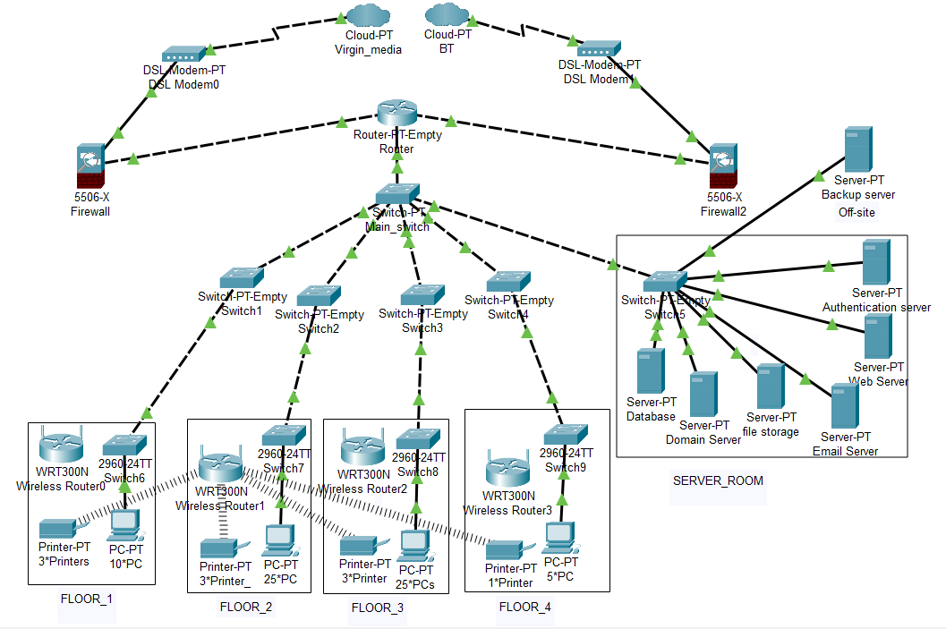

FIG.2: Network Implementation

Fig.2 is the implementation overview of the network. Since fig. 1 is only a Word design of the bank's suggested strategy, certain improvements have been made to the implementation. Each floor's network distribution is carefully planned.

# Screenshot of Ping

As proof of the networking plan's success, several screenshots of pinging will be presented in this section.

1. Screenshot 1:

Here, floor 1 PC and floor 3 PC have been ping-ed. As a result, the pinging was successful.

1. Screenshot 2:

Here, the database server and floor 1 have been ping-ed. As a result, the pinging was successful.

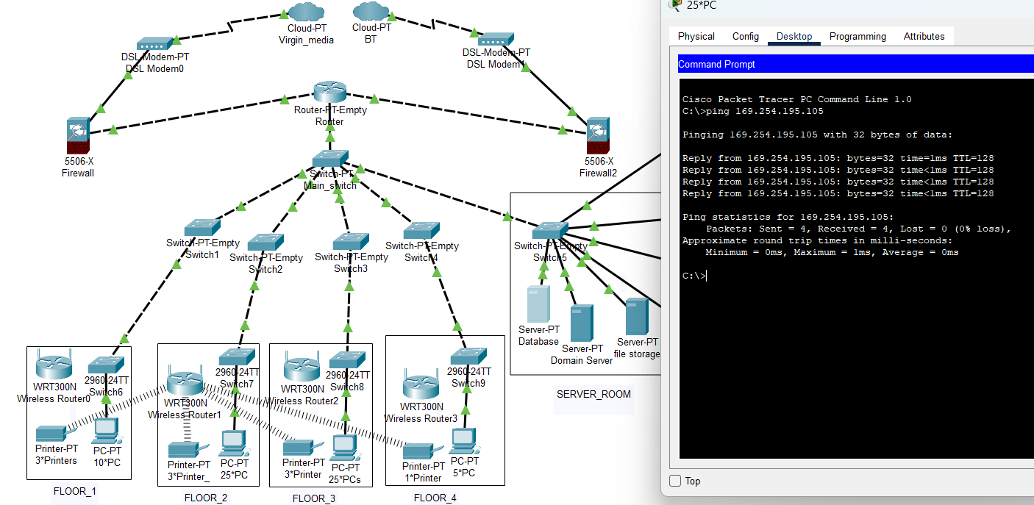

1. Screenshot 3:

Here we have pinged Database server and file storage server. As a result, the pinging was successful.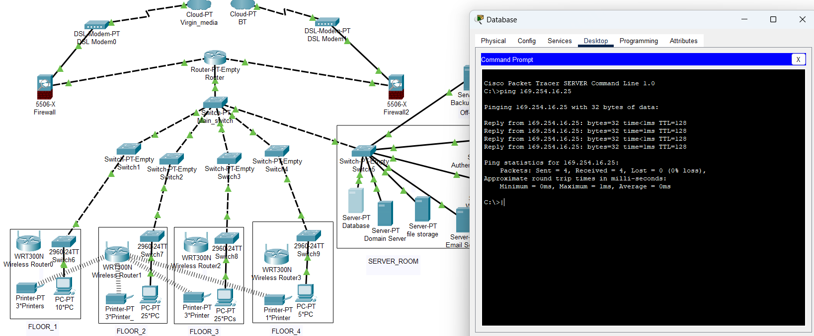

1. Screenshot 4:

Here we have pinged floor_4 pc with backup server. As a result, the pinging was successful.

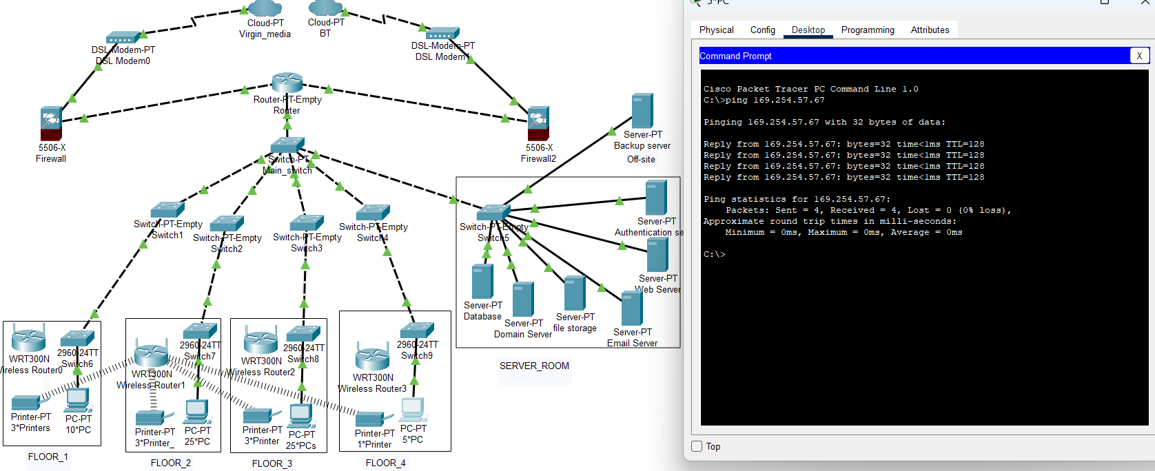

1. Screenshot 5:

Here we have pinged Domain server with floor 3. As a result, the pinging was successful.

**Subnet:**

Subnetting is the process of dividing a network into two or more networks. Routing effectiveness, network management control, and network security are commonly enhanced by subnetting (TeamA, 2018). Our network's use of subnet can significantly lower network traffic and speed up internet access. In our network, we have three subnets into which we will split it, with Network ID being the first unusable IP address, Broadcast ID being the last unusable IP address, and First and Last Host being the range of useable IP addresses within each subnet. Subnet mask is also there which is used to determine the size of subnet which looks like this: 255.255.255.255. The size of the network and its potential future use have both been taken into account in our network. So that there won't be any issues in the future, we made the subnet range extremely large. Here is how our network is segmented.

Division of our network:

We have divided this network into three subnets. First is junior officers subnet (S1) which consists of 50 pcs. Next one is supporting staff (S2) subnet which consists of 10 pcs and lastly, manager subnet (S3) which consists of 5 pcs. Here is how we divide it;

|  |  |  |  |  |  |
| --- | --- | --- | --- | --- | --- |
| **Subnet** | **Network ID** | **Broadcast ID** | **First host** | **Last host** | **Subnet mask** |
| S1 | 192.168.0.0 | 192.168.7.255 | 192.168.0.1 | 192.168.0.254 | 255.255.248.0 |
| S2 | 192.168.8.0 | 192.168.8.255 | 189.168.8.1 | 192.168.8.254 | 255.255.255.0 |
| S3 | 192.168.9.0 | 192.168.9.255 | 189.168.9.1 | 192.168.9.254 | 255.255.255.0 |

**Protocol and design justification**

The network is already discussed earlier but we are going more in depth here. This network is based in partial mesh topology so there should be fast connection. The network has Class C IPv4 address and uses cat 7 cable in most of place and cat 6 from 24 port switch to pc. Ethernet (IEEE 802.3) is installed and STP(spanning tree protocol) is put into practise. There is no packet loss in the network. And there is hardware firewall, software firewall and other security measures taken into account. From 9 am until 6 pm, the network is accessible. Considering hardware failure with these reasons, the network will be accessible 99.99% of the time. However, there could be a technical problem with the hardware or the end user could setup the settings incorrectly. For other devices like a printer, laptop, etc., there is a Wi-Fi in this network that is connected to the switch. Even with all of these factors in place, there are still plenty of ports available for new work pcs in all three work rooms, making the network efficient for more than five years. The traffic is minimised using protocols and subnet, and there is no packet loss, so the internet in this network is quite fast.

**Topology Used:**

Due to the fact that not every device are connected to each other the network's topology is partial mesh rather than mesh or bus since no computers or network devices are connected to the network's main cable, which is dangerous and could result in data loss. In partial mesh topology it is not fully mesh and it is also not bus. With the devices connected to each other, we have a fast connection and little traffic, so there is always room for additional data to flow. Partial mesh is also good for subnetting.

**Protocols Used:**

Some protocols used in this network is as follow:

1. Transmission Control Protocol (TCP):

A network communication between applications is established and maintained according to the Transmission Control Protocol (TCP) standard. TCP often breaks up messages into little data packets and sends them to another machine for assembly (Ben Lutkevich, 2021).

2. Internet Protocol (IP):

Data packets can move across networks and be addressed and routed using the IP protocol to get to their intended location. As a result of data being split up into smaller units known as packets, the network traffic on the internet is considerably reduced (Sean Kerner).

3. Internet Control Message Protocol:

ICMP messages relay information about problems with network connectivity to the origin of the corrupted transmission. It transmits control messages such source route failure, source quench, and destination network inaccessible. (ExtraHop, no date).

4. Post Office Protocol:

It is a protocol for message requests that is used to send messages from an email server to an email client (Michael Sampson, 2003).

5. File transfer protocol (FTP):

On a computer network, the transfer of files from a server to a client is done via the FTP standard communication protocol (Forouzan, 2000).

6. Link Control protocol (LCP):

This protocol enables the delivery of HDLC-style services over LAN. It is a kind of PPP protocol that is used to set up, test, configure, keep up with, end, or terminate links for data transmission.

7. Hypertext transfer Protocol (HTTP):

Hypertext texts contain hyperlinks to other resources that the user may access easily, for example by a mouse click or by tapping the screen in a web browser. HTTP is the basis of data transfer for the World Wide Web (Fielding, 2022).

8. Ethernet Protocol:

Ethernet is the traditional technology for connecting devices in a wired local area network (LAN) or wide area network (WAN). It allows for the use of a protocol, which is a set of guidelines or common network language, to allow devices to communicate with one another (Wesley Chai, 2021).

9. Point-to-Point Protocol (PPP):

PPP is a protocol that computers use to connect online or via telephone networks. When two systems are physically connected by a phone line, they have a PPP connection. To connect one system to another, we'll use PPP (IBM I, 2021).

10. Telnet protocol:

It is a popular client server-program that provides connection to a remote computer where local terminal appears. It is very useful for company and for that reason it is also called terminal network (JavaTpoint, no date).

12. Domain Network System(DNS) protocol:

(DNS) protocol will assist Internet users and network devices to discover websites by using human-readable hostnames, instead of numeric IP addresses.

**Network Security**

The protection of customer assets is the clear justification for the significance of cyber security in banking sector transactions. While planning the network, a workable solution to a number of security issues was considered.

Desktop machines are running a Windows Vista as an Operating System with the decade-old version of the OS. Microsoft has retired Windows Vista on 2017, which indicates that since that time the devices have not received any maintenance, including security and performance updates. Because of the upgrade's importance, we must instal Windows 10 Professional on every computer. Since servers are typically running both Windows and Linux, We can use Samba to have Linux systems map discs to Windows systems and Windows systems map drives to Linux systems because servers typically run both Windows and Linux (Ken Hess, 2020). Fibre optic cables will be utilised for the internet connection because they are superior to other types of internet in terms of quality, speed, and dependability.

Ethernet (IEEE 802.3) is installed to be used in all forms of data networking from connecting to a variety of devices in the bank. STP (Spanning Tree Protocol) with switches are implemented as it prevents looping within a network topology. It will prevent the issues that occur when computers exchange data on a LAN that has redundant paths (Robert Sheldon, 2021). Because Mozilla Firefox is one of the best and most reliable open source browsers for employees to use when accessing corporate systems, we have installed it on every computer.

Six servers, including the authentication server, are housed in the building. They are all kept together for easier maintenance and security because each one will be kept together , preferably not too far up in the structure because that will require more wiring. Backups, both full and incremental, are kept on a server off-site. The system is secured by employing the authentication server and two factor authentication.

# Cost Plan

The cost plan is merely an estimate of what the network replacement will cost.

(Note: Only the price of new items will be considered because some older products are still in use)

The below pricing is based on the amazon.co.uk website.

|  |  |  |  |  |
| --- | --- | --- | --- | --- |
| **SN.** | **Product name** | **Quantity** | **Unit price** | **cost** |
|  | Servers | 2 | £457.9 | £915.8 |
|  | 24 port Switch | 11 | £85 | £935 |
|  | modem | 2 | £89.99 | £179.98 |
|  | Firewall | 2 | £646.6 | £1293.2 |
|  | Router | 1 | £104.99 | £104.99 |
|  | Wifi Router | 4 | £79.99 | £319.96 |
|  | 30mm ethernet cable | 10 | £52 | £520 |
|  | 50m fibre optic cable | 2 | £109.99 | £219.98 |
|  | Miscellaneous expenses | N/A | N/A | £500 |

|  |  |
| --- | --- |
| **Total Cost:** | £4988.91 |

# Conclusion

Therefore, the bank's network is high performing and accessible 99.99% of the time without having to worry about security according to the design and evidences supplied. It satisfies the exacting performance and availability standards demanded by today's banks. The design has been upgraded along with all of the hardware and cabling. A solution is offered that not only addresses the needs of the present but also ensures that those needs will continue to be satisfied in the near future.

# Bibliography

|  |  |  |
| --- | --- | --- |
| SN. | IEEE Reference | Image/icon |
| 1. | [Global Enterprise Network Topology Icon - Bing images](https://www.bing.com/images/search?view=detailV2&ccid=jCBX1SKS&id=BD6EBB8B0742608E1F5971565E604B2559AA1E62&thid=OIP.jCBX1SKSJqinHXHXD4VcFgHaHa&mediaurl=https%3A%2F%2Fcdn2.iconfinder.com%2Fdata%2Ficons%2Fdigital-and-internet-marketing-4-1%2F50%2F166-512.png&cdnurl=https%3A%2F%2Fth.bing.com%2Fth%2Fid%2FR.8c2057d5229226a8a71d71d70f855c16%3Frik%3DYh6qWSVLYF5WcQ%26pid%3DImgRaw%26r%3D0&exph=512&expw=512&q=Global+Enterprise+Network+Topology+Icon&simid=608005818756660791&form=IRPRST&ck=2521A1A16B330F7D687FB589C0C7DBA4&selectedindex=1&ajaxhist=0&ajaxserp=0&vt=0&sim=11) |  |
| 2. | https://vecta.io/symbols/240/cisco-network-topology-icons-3015 | Icon  Description automatically generated    Icon  Description automatically generated  A picture containing company name  Description automatically generated  Icon  Description automatically generated  A blue rectangle with white lines  Description automatically generated with medium confidence  Icon  Description automatically generated |

# References

1. Jiby Jacob (28/07/2021). Strategies for Improving Banks’ Operating Efficiency**.** Available at: <https://www.gieom.com/blog/strategies-for-improving-banks-operating-efficiency/> (Accessed on: 11/01/2023)
2. Keith Shaw(05/10/2022). What is a network switch, and how does it work?. Available at: <https://www.networkworld.com/article/3584876/what-is-a-network-switch-and-how-does-itwork.html#:~:text=Switches%20remain%20important%20in%20today's,create%20a%20more%20sustainable%20operation>. (Accessed on:11/01/2023)
3. David Neild(08/11/2021). Better internet could be a simple router upgrade away. Available at: <https://www.popsci.com/story/diy/router-upgrade-guide/>. (Accessed on:11/01/2023)
4. Share How to Build a Really Fast Desktop Computer on FacebookShare How to Build a Really Fast Desktop Computer on LinkedInShare How to Build a Really Fast Desktop Computer on TwitterShare How to Build a Really Fast Desktop Computer on RedditShare How to Build a Really Fast Desktop Computer via EmailCopy the link to share How to Build a Really Fast Desktop Computer
5. Dwight Pavlovic(31/05/2019). How to Build a Really Fast Desktop Computer Available at: <https://www.hp.com/us-en/shop/tech-takes/how-to-build-fast-desktop-computer#:~:text=Processor,Your%20processor%20or&text=Having%20a%20processor%20with%20more,what%20makes%20your%20computer%20faster>. (Accessed on:11/01/2023 )
6. Doron Ben Cohen (18/09/2021). How to Prevent and Reduce Network Congestion. Available at: <https://www.atera.com/blog/how-to-prevent-and-reduce-network-congestion/> (Accessed on: 11/01/2023)
7. Blog Team A(16/11/2018). The benefits of subnetting. Available at: <https://www.accessagility.com/blog/benefits-of-subnetting#:~:text=Subnetting%20is%20the%20practice%20of,control%2C%20and%20improving%20network%20security>. (Accessed on: 12/01/2023)
8. Ben Lutkevich (10/2021). Transmission Control Protocol (TCP). Available at: <https://www.techtarget.com/searchnetworking/definition/TCP#:~:text=Transmission%20Control%20Protocol%20(TCP)%20is,of%20data%20to%20each%20other>. (Accessed on: 12/01/2023)
9. Sean Kerner(no date). Available at: <https://www.techtarget.com/searchunifiedcommunications/definition/Internet-Protocol#:~:text=Internet%20Protocol%20(IP)%20is%20the,other%20computers%20on%20the%20internet>. (Accessed on: 12/01/2023)
10. ExtraHop(no date). Internet Control Message Protocol. Available at: <https://www.extrahop.com/resources/protocols/icmp/#:~:text=Internet%20Control%20Message%20Protocol%20(ICMP),-What%20is%20ICMP&text=ICMP%20is%20a%20network%20level,route%20failed%2C%20and%20source%20quench>. (Accessed on:12/01/2023)
11. Michael Sampson(2003). Post Office Protocol. Available at: <https://www.sciencedirect.com/topics/computer-science/post-office-protocol#:~:text=The%20post%20office%20protocol%20(POP)%20is%20the%20most%20commonly%20used,messages%20out%20to%20the%20client>. (Accessed on: 12/01/2023)
12. Forouzan (2000). *TCP/IP: Protocol Suite* (1st ed.). New Delhi, India: Tata McGraw-Hill Publishing Company Limited. (Accessed on: 12/01/2023)
13. Fielding, R.; Nottingham, M.; Reschke, J. (June 2022). HTTP Semantics. Available at: <https://datatracker.ietf.org/doc/html/rfc9110> (Accessed on: 12/01/2023)
14. Wesley Chai (10/2021). Ethernet. Available at: <https://www.techtarget.com/searchnetworking/definition/Ethernet#:~:text=Ethernet%20is%20the%20traditional%20technology,rules%20or%20common%20network%20language>. Accessed on: (12/01/2023)
15. IBM I (14/04/2021). What is PPP. Available at: <https://www.ibm.com/docs/en/i/7.2?topic=concepts-what-is-ppp> . (Accessed on: 12/01/2023)
16. Java T Point (no date). Telnet. Available at: <https://www.javatpoint.com/computer-network-telnet#:~:text=A%20popular%20client%2Dserver%20program,be%20at%20the%20remote%20side>. (Accessed on: 12/01/2023)
17. Ken Hess (07/02/2020). Windows and Linux interoperability: A look at Samba. Available at: <https://www.redhat.com/sysadmin/windows-linux-interoperability#:~:text=Samba%20uses%20the%20Server%20Message,latter%20is%20far%20more%20likely>. (Accessed on: 12/01/2023)
18. Robert Sheldon (08/2021). Spanning Tree Protocol (STP). Available at: <https://www.techtarget.com/searchnetworking/definition/spanning-tree-protocol#:~:text=Spanning%20Tree%20Protocol%20(STP)%20is,LAN)%20that%20contains%20redundant%20paths>. (Accessed on: 12/01/2023)