TableAbstain: A Benchmark for Evidence-Sensitive Abstention in Tabular Question Answering
S. Varun Vaibhav  Sri Ramachandra Faculty of Engineering  Sri Ramachandra Institute of Higher Education  Porur, Chennai, India  Umasubramanian81@gmail.com | Pradeep Kumar M  Sri Ramachandra Faculty of Engineering  Sri Ramachandra Institute of Higher Education  Porur, Chennai, India  prxdeep27727@gmail.com

Abstract—A language model answering questions over tables should decline when the table cannot support an answer, yet table question-answering benchmarks contain only answerable questions. We present TableAbstain, a benchmark of 10,485 items derived from 4,727 de-duplicated, table-only FinQA instances. Besides the unmodified answerable item, each source can yield four abstention-required variants: missing evidence (gold rows deleted), contradiction (an operand the question uses is altered so that an existing total or change column no longer agrees), absent metric (the question asks for a quantity the table does not report), and underspecified (a year is removed from the question, and re-executing the gold program shows that other years give answers differing by at least 5%). Each variant passes computational validity checks and is re-checked by an independently implemented verifier with no failures; generation is deterministic. We evaluate Qwen2.5-7B-Instruct on a stratified test sample (135 items valid in the released version) with decision-level confidence. The model abstained on 22/23 missing-evidence and 30/30 absent-metric items but on 22/29 contradiction and 13/24 underspecified items, declined 12/29 answerable questions, and answered 10/29 correctly. Self-consistency over the answer-or-abstain decision ordered outputs better than chance (AURC 0.208 vs. 0.281), whereas prompted verbalized confidence and P(True) ordered them worse than chance, because the model assigned zero confidence to 96 of its 99 abstentions despite being asked for confidence in its decision. A leakage audit shows residual shallow cues for two variants. Results are from one model, one serialization and a small sample; human validation of the labels is pending.
Index Terms—Tabular question answering, abstention, selective prediction, evidence sufficiency, benchmark construction, dataset artifacts, large language models, FinQA.

1 Introduction
A model that answers a question about a financial table should also recognize when the table cannot support an answer: the rows the question needs are missing, the figures it would use contradict each other, it asks for a metric the table never reports, or it has more than one reading. In each case a fluent numeric answer is an error that looks like a correct one.
Table question-answering benchmarks measure answer correctness. FinQA [1] provides 8,281 expert-written questions over S&P 500 filings with executable reasoning programs, and TableBench [7] reports that GPT-4-Turbo reaches 51.32% against a human score of 86.3% on complex table reasoning; both contain answerable questions only. Studies of abstention show that models often answer from insufficient context [4] and that reasoning fine-tuning can reduce abstention [3], but they use text passages. A 2026 study of confidence for tabular QA [8] compares confidence methods across models and serializations but does not construct tables that are deliberately insufficient or inconsistent.
We contribute a benchmark, a verification procedure, an evaluation protocol and a first evaluation. Items are abstention-required because of a specific, recorded change to an answerable FinQA item, checked computationally, including by executing the gold program. We ask: RQ1, does a model abstain when the evidence a question needs has been removed? RQ2, does abstention differ between missing evidence, contradictory evidence, an absent metric and an underspecified question? RQ3, which confidence signals best predict whether a model’s final answer-or-abstain decision is correct? We answer these for one open model on a small sample and state throughout what that does and does not establish.
2 Related Work
2.1 Table question answering.
WikiTableQuestions [2] (22,033 questions over 2,108 tables) and TabFact [11] (117,854 statements over 16,573 tables) established question answering and fact verification over Wikipedia tables. FinQA [1] targets multi-step arithmetic over financial filings and annotates the rows that support each answer. TableBench [7] extends the range of reasoning. None contains questions designed to require abstention.
2.2 Evidence sufficiency and abstention.
Sufficient Context [4] separates the sufficiency of retrieved context from answer correctness and finds that models frequently answer from insufficient context. AbstentionBench [3] collects 20 datasets of questions that should be declined and reports that two reasoning models (DeepSeek R1 Distill Llama 70B and s1) abstained on average 24% less than their non-reasoning counterparts. Both use text passages; in a table, the cells an answer depends on are known from the gold program, so sufficiency can be manipulated precisely.
2.3 Cell-level grounding.
SciTabAlign [5] annotates the cells that justify scientific claims and finds that models often predict the correct label while selecting the wrong cells (best cell-selection F1 50.8). TraceBack [6] performs cell-level attribution for table QA. These works measure grounding but do not use it to decide whether to answer.
2.4 Confidence for tabular QA and selective prediction.
Voss [8] compares five confidence methods on two tabular QA benchmarks and reports that self-evaluation methods (verbalized confidence, P(True)) reach AUROC 0.42 to 0.76, while perturbation methods (semantic entropy, self-consistency, multi-format agreement) reach 0.78 to 0.86. P(True) follows Kadavath et al. [13]; self-consistency follows Wang et al. [14]. Selective prediction supplies the evaluation frame: the risk-coverage trade-off [9], its use with deep networks [10], and AURC and E-AURC [12].
3 Methodology
3.1 Overview and terminology.
Fig. 1 summarizes the pipeline. Items produced by variants B to E are called abstention-required: by construction a careful analyst should decline to give a single answer. We reserve unanswerable for items confirmed by human annotators, which has not yet been done (Section 3.8).
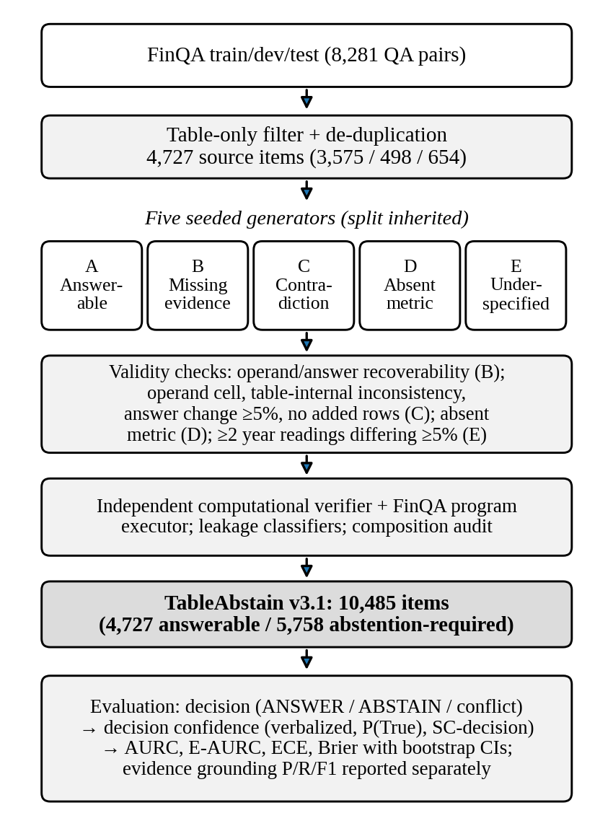
Fig. 1. TableAbstain v3.1 construction, verification and evaluation. Counts are those of the released benchmark.
3.2 Source data.
FinQA [1] annotates, for each question, the supporting table rows and text sentences, and gives an executable program. We keep items with at least one supporting table row and no supporting text sentence, so every manipulation acts on evidence the model sees. FinQA contains 29 items whose question and table duplicate another item, and 4 dev or test items whose table also occurs in an earlier split; we drop these, leaving 4,727 source items (3,575 train, 498 dev, 654 test). Every variant inherits its source’s split. Our executor for FinQA’s arithmetic operations runs 8,009 of the 8,281 programs (the rest use table-aggregation operations) and reproduces the gold answer for all 8,009. FinQA writes some numbers twice, as in “-8349 ( 8349 )” or “12.5% ( 12.5 % )”; our parser accepts such cells when both values agree and reads 98.6% of the 72,406 digit-bearing cells.
3.3 Variant generators.
Answerable (A). The item is unchanged. Its gold evidence is the set of non-label cells in the annotated rows.
Missing evidence (B). All annotated rows are deleted. Because a deleted value can sometimes be rebuilt from what remains (for example owned = total − leased, or a subtotal as the sum of three adjustments), we apply a recoverability filter. Let O be the literal operands of the gold program and a its executed answer. A value v is recoverable if |v|, 100|v| or |v|/100 is within 0.5% of (i) a surviving cell, (ii) the sum, difference, product or ratio of any two surviving cells, or (iii) a signed sum of three surviving cells in one row or column. The item is discarded if a is recoverable, if every operand in O is recoverable, or if the program cannot be executed. The filter is partial: it rules out common reconstruction routes but does not prove that no answer exists. It discarded 2,876 of 4,727 candidates.
Contradiction (C). Changing a gold value does not by itself require abstention: the model never sees the original and the altered table may remain consistent. We require (a) the altered cell to be a literal operand of the gold program, located as the closest annotated cell within 0.1%; (b) re-executing the program with the new value to change the answer by at least 5%; (c) the new value to break an arithmetic relation that already holds in the source table, so the inconsistency is detectable from the modified table alone; and (d) no added row, column or label. Factors come from {0.55, 0.60, 0.70, 1.30, 1.40, 1.50}; the new value copies the original cell’s decimal places, separators and signs.
C1, change column. A row has values L (later year) and E (earlier year), with year order read from the header, and a change column p satisfying |100(L − E)/|E| − p| ≤ max(1, 0.05|p|). After the operand is altered we require
| 100(L′ − E′) / |E′| − p | ≥ 5. (1)
Among the 316 FinQA rows with two year columns and a parseable change column, 115 satisfy (later − earlier)/|earlier| within this tolerance and none satisfy (earlier − later)/|later|; the other 201 refer to other comparisons and are never used.
C2, column total. Rows between the previous total row (or the header) and a total row T sum to T within 1% in the operand’s column; after alteration
| Σ_{i} x′_{i} − T | ≥ 0.05 |T|. (2)
C3, row total. The same condition along a row whose column headed total equals the sum of its other component columns. An earlier version appended a synthetic “stated ratio” row; that mechanism has been removed.
Absent metric (D). The gold row label that appears verbatim, exactly once, in the question is replaced by a row label that another FinQA question in the same split asks about, chosen so that none of its content words (under two crude stemmers) occurs in the table. The rest of the question is unchanged.
Underspecified (E). If the question names exactly one year, the header has at least two year columns, and every located operand lies in that year’s column, we re-execute the program with each other year’s values from the same rows. If at least one alternative answer differs by at least 5%, the year phrase is deleted and the rest of the question is left character-for-character unchanged.
TABLE I. BENCHMARK COMPOSITION (V3.1)
Variant | Train | Dev | Test | Total | Yield
A Answerable | 3,575 | 498 | 654 | 4,727 | 100.0%
B Missing ev. | 1,412 | 198 | 241 | 1,851 | 39.2%
C Contradiction | 752 | 106 | 146 | 1,004 | 21.2%
D Absent metric | 1,788 | 291 | 324 | 2,403 | 50.8%
E Underspec. | 379 | 61 | 60 | 500 | 10.6%
Total | 7,906 | 1,154 | 1,425 | 10,485
Yield = generated items / 4,727 source items. 5,758 items are abstention-required.
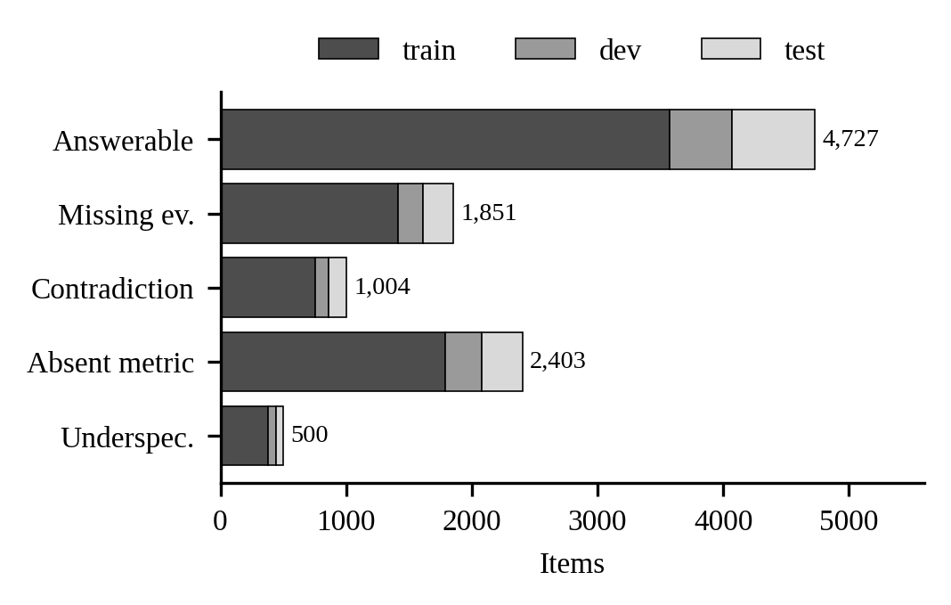
Fig. 2. Items per variant, stacked by FinQA split.
TABLE II. CONTRADICTION MECHANISMS
 | Relation broken | Items | Tr/Dev/Test | Median incons. | Median ans. change
C1 | stated change ≠ change of year values | 87 | 78/8/1 | 42.9 pp | 40.0%
C2 | component rows ≠ total row | 840 | 609/90/141 | 15.9% | 40.0%
C3 | component columns ≠ total column | 77 | 65/8/4 | 13.4% | 40.0%
Inconsistency: |implied − stated| in percentage points for C1; |sum − total| as % of total for C2 and C3.
3.4 Worked example.
Table III shows the variants of test item GS/2013/page_85.pdf-1, which reports U.S.-dollar and non-U.S.-dollar deposits and their total for two years. The question asks what share of the 2013 total was non-U.S.-dollar, 45826 / 182650 = 0.2509.
TABLE III. VARIANTS OF ONE SOURCE ITEM
 | Question (abridged) | Change and effect
A | ...during 2013 were non-u.s . dollar-denominated? | none; answer 0.2509
B | same as A | rows 2, 3 deleted; only the U.S.-dollar row remains
C | same as A | C2: 2013 non-U.S. 45826 → 64156; components sum to 200,980, total row states 182,650; answer 0.2509 → 0.3513
D | ...during 2013 were statutory net income? | metric absent from the table
E | ...included in gce were non-u.s . dollar-denominated? | “during 2013” removed; 2012 reading gives 0.2730

3.5 Computational verification and reproducibility.
An independently implemented verifier re-derives each property from the stored tables, taking the answerable variant’s table as the original. For contradictions it checks that exactly one cell differs and the shape is unchanged, that the cell was a program operand, that the relation held before and fails after by the stated margin, that the executed answer changes by at least 5%, and that formatting matches. For missing evidence it checks that the table equals the original minus the deleted rows and that the executed answer is not visible in a surviving cell. For absent metrics it checks, with a second stemmer, that the inserted label’s words are absent from the table and the original label is gone from the question. For underspecified items it checks that the year was removed and an alternative answer exists. It also checks split leakage. On the released benchmark it reports no failures, and two independent generation runs produce byte-identical files. This is computational verification; semantic validity requires human judgment.
Building the benchmark exposed defects that are fixed in this version: the number parser initially read 53.5% of digit-bearing cells, then 83.7%, and only after handling FinQA’s doubled notation 98.6%, so earlier recoverability and contradiction checks silently ignored many cells; the missing-evidence filter initially missed subtraction and three-cell reconstructions; operand matching with a 1% tolerance could alter an adjacent year’s cell; an earlier contradiction mechanism added a synthetic row; absent-metric and underspecified questions were templated (182 and 10 distinct strings); morphological variants defeated the absence check; and string hashing made generation non-deterministic. The first three were found only when the model evaluation in Section 5 was inspected (Section 6.5).
3.6 Evaluation protocol.
Serialization and prompting. Tables are serialized as Markdown, CSV, JSON or HTML. The system prompt asks the model to answer only from the table, to abstain when evidence is missing, the needed values are inconsistent, the requested quantity is absent, or the question has more than one reasonable reading, to cite the cells used, and to end with CONFIDENCE: <0-100, your probability that your response (answer or abstention) is correct> and FINAL: <number> or FINAL: ABSTAIN.
Decision and correctness. All FINAL lines are read. If they mix ABSTAIN and a value, the output is a conflict: neither an answer nor an abstention, and incorrect. Otherwise the last FINAL line gives ABSTAIN, yes/no, or a number; without FINAL, the number after the last answer cue (“the answer is”, “i.e.”, “=” and similar) is used, and failing that the output is unparsed and incorrect. A numeric answer v is correct if, for some h in {g, 100g, g/100} with g the gold answer, |v − h| < 10^(−d) and |v − h| ≤ 0.05|h|, where d is the number of decimal places the model wrote (plus two if it wrote a percent sign): the answer must agree with gold to the precision the model reported. The decision is correct, dᵢ = 1, if the model answers an answerable item correctly or abstains on an abstention-required item. On 25 hand-constructed responses the scorer returns the intended judgment in all 25; it has not been validated against human judgments of real outputs.
Decision confidence. Each signal estimates P(dᵢ = 1). Verbalized: the CONFIDENCE value (missing values set to 0.5). P(True): a second turn asks, for answers and abstentions alike, whether the response is correct and supported; YES scores 1, NO 0. SC-decision: N further samples at temperature 0.7 are reduced to decisions, and the score is the fraction agreeing with the first response’s decision. Answer-level agreement is recorded separately and not used.
Evidence grounding. Cells whose values the response mentions are compared with the gold evidence cells, giving precision, recall and F1 on answerable items. Grounding needs gold evidence and is unavailable at inference time, so we report it separately from the confidence signals.
Selective prediction. For confidences cᵢ and errors ℓᵢ = 1 − dᵢ, coverage and selective risk at threshold τ are
φ(τ) = 1⁄n Σ_{i} 1[c_{i} ≥ τ], (3)
r(τ) = Σ_{i} ℓ_{i} 1[c_{i} ≥ τ] / Σ_{i} 1[c_{i} ≥ τ]. (4)
We use the rank-based AURC [12]: outputs are sorted by descending confidence and the risk of the k most confident outputs is averaged over every k,
AURC = 1⁄n Σ_{k=1}^{n} (1/k) Σ_{j≤k} ℓ_{(j)}, (5)
with ties resolved by the exact expectation over a random order within each tied group. A random ordering gives AURC = E/n, where E is the number of incorrect decisions, and the best ordering gives
AURC* = 1⁄n Σ_{k=1}^{n} max(0, k − (n − E)) / k; E-AURC = AURC − AURC*. (6)
Integrating r(τ) only over the coverage a signal reaches is not comparable across signals, because a signal with few distinct values reaches only high coverage. We also report ECE over ten equal-width bins and the Brier score (1/n)Σ(cᵢ − dᵢ)².
3.7 Statistical reporting.
Proportions are reported with 95% Wilson intervals [15]. AURC, ECE and Brier have 95% percentile bootstrap intervals over 1,000 item resamples; differences between signals, and between a signal and the random-order baseline, are tested with paired bootstrap intervals over 2,000 resamples.
3.8 Human validation protocol (pending).
The release includes an annotation sheet of 230 v3.1 items (50 each of variants B to E and 30 answerable controls from dev and test, with variant labels hidden), guidelines, and a script computing Fleiss’ κ [16] and per-variant validity. Three annotators judge, from the table alone, whether the question can be answered, whether the table is inconsistent and whether that affects the question, whether the requested quantity is present, and whether the question has several reasonable readings. The study has not yet been carried out.
4 Benchmark Audit
4.1 Can the variant be predicted without reasoning?
We trained classifiers on the train split to predict the variant and tested them on the test split (1,425 items): logistic regression on TF-IDF word and character n-grams of the question, the serialized table, or both, and gradient-boosted trees on 15 shallow features (table size, numeric-cell count, % and $ counts, decimal places, header years, question length, years in the question and similar).
TABLE IV. VARIANT PREDICTION FROM SHALLOW INPUTS (TEST SPLIT)
Input | v2.1 acc. | v2.1 macro-F1 | v3.1 acc. | v3.1 macro-F1
Majority class | 0.314 | 0.096 | 0.459 | 0.126
Question only | 0.703 | 0.665 | 0.462 | 0.442
Table only | 0.404 | 0.419 | 0.463 | 0.403
Question + table | 0.810 | 0.802 | 0.505 | 0.460
Surface features | 0.862 | 0.866 | 0.547 | 0.552

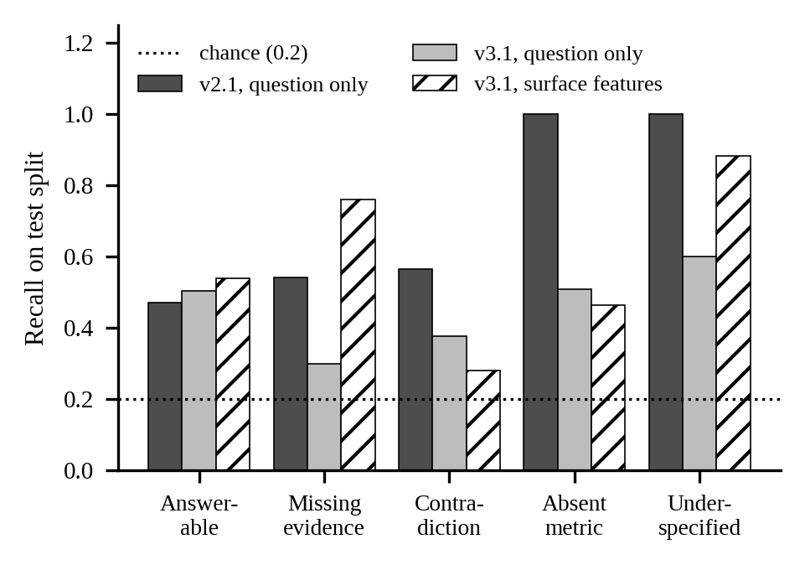
Fig. 3. Per-variant recall of variant classifiers on the test split. v2.1 is an earlier, templated version.
Source-specific edits removed the most direct cue: question-only recall on absent-metric and underspecified items fell from 1.000 on the templated version to 0.509 and 0.600. The variants are still not indistinguishable. The surface-feature model recovers 0.883 of underspecified items and 0.759 of missing-evidence items: the first follows from the construction (a question without a year over a table with several year columns), the second from deletion shortening the table. A model can obtain part of the abstention signal from these cues, and results on B and E should be read with that in mind.
4.2 Composition of the source items.
Generators B to E require specific structures, so their sources differ from the answerable pool (Table V). Contradiction and underspecified sources are dominated by single-division programs and contain more numeric cells; missing-evidence sources contain fewer. Differences across variants can therefore reflect question type as well as evidence condition.
TABLE V. SOURCE-ITEM STATISTICS BY VARIANT
Variant | Q words | Rows | Numeric cells | Program steps | Divide share | Distinct Q
Answerable | 16.0 | 5.6 | 15.0 | 1.50 | 0.39 | 4,661
Missing ev. | 16.3 | 5.0 | 10.4 | 1.48 | 0.51 | 1,834
Contradiction | 15.7 | 5.5 | 17.9 | 1.18 | 0.76 | 992
Absent metric | 16.1 | 5.5 | 15.5 | 1.45 | 0.43 | 2,403
Underspec. | 15.5 | 5.5 | 17.6 | 1.30 | 0.69 | 381

5 Experimental Setup
We evaluated Qwen2.5-7B-Instruct [17] served locally through Ollama (tag qwen2.5:7b-instruct) with Markdown serialization and N = 3 self-consistency samples. The sample is 30 test items per variant drawn with seed 42 from the benchmark as it stood before the final revision (v3). After inspecting the outputs (Section 6.5) we released v3.1, which adds the doubled-notation parser, de-duplication and the 5% underspecified threshold. 135 of the 150 evaluated items are also valid in v3.1; the other 15 (7 missing-evidence, 6 underspecified, 1 contradiction, 1 answerable) are excluded from the primary results. The scorer was also revised after inspecting the outputs, to handle conflicting FINAL lines, yes/no answers and exact integers; the stored responses were re-scored without new model calls, which changed 5 decisions and 6 correctness labels among the 150 items. Section 6.6 reports all 150 items and the results as originally logged. All per-item responses are retained.
6 Results
6.1 Decisions by variant (RQ1, RQ2).
TABLE VI. DECISIONS BY VARIANT, QWEN2.5-7B-INSTRUCT (N = 135)
Variant | n | Decision correct | Wilson 95% CI
A Answerable | 29 | 10/29 | [0.199, 0.527]
B Missing ev. | 23 | 22/23 | [0.790, 0.992]
C Contradiction | 29 | 22/29 | [0.579, 0.878]
D Absent metric | 30 | 30/30 | [0.886, 1.000]
E Underspec. | 24 | 13/24 | [0.351, 0.721]
All items | 135 | 97/135 | [0.637, 0.787]
For A, decision correct = answered correctly; for B to E, decision correct = abstained.
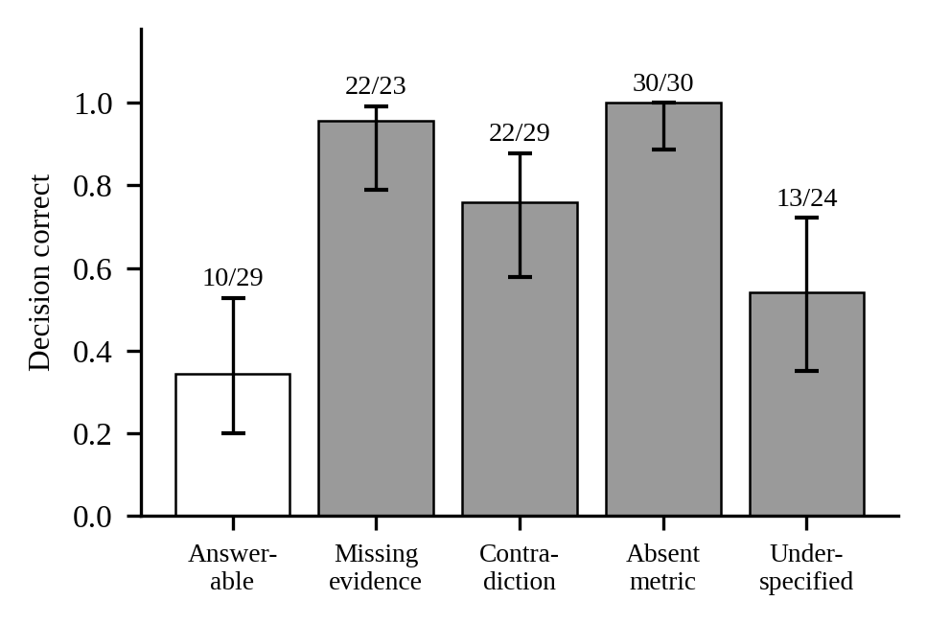
Fig. 4. Proportion of correct decisions by variant with Wilson 95% intervals.
The model abstained on 22/23 missing-evidence and 30/30 absent-metric items, on 22/29 contradiction items and on 13/24 underspecified items (interval [0.351, 0.721]). The underspecified interval lies below the absent-metric interval; the contradiction interval overlaps the others. On answerable items it declined 12/29 questions and answered 10/29 correctly. Overall abstention recall was 0.821 [0.737, 0.882] and precision 0.879 [0.800, 0.929]. For this model and sample, recognizing that evidence is absent was more reliable than recognizing an ambiguous question, and abstention came at a substantial cost on answerable questions. Because the surface cues in Section 4.1 affect the missing-evidence and underspecified variants, part of this behaviour may reflect those cues.
6.2 Decision confidence (RQ3).
TABLE VII. DECISION-CONFIDENCE SIGNALS (N = 135, E = 38)
Signal | AURC (95% CI) | E-AURC | ECE (95% CI) | Brier
Verbalized | 0.469 [0.342, 0.588] | 0.424 | 0.801 [0.737, 0.870] | 0.801
P(True) | 0.448 [0.331, 0.557] | 0.403 | 0.793 [0.726, 0.859] | 0.793
SC-decision | 0.208 [0.140, 0.281] | 0.163 | 0.203 [0.141, 0.274] | 0.204
Random order | 0.281 | 0.236 | n/a | n/a
Oracle | 0.045 | 0.000 | n/a | n/a
Paired bootstrap (2,000 resamples) differences are given in the text.
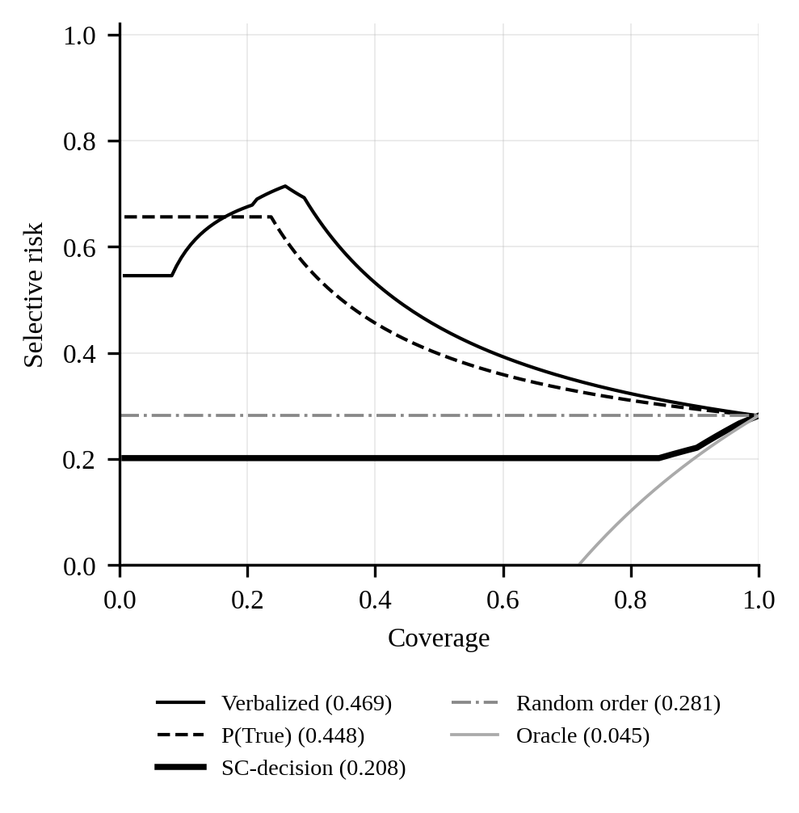
Fig. 5. Rank-based risk-coverage curves of the decision-confidence signals. Legend values are AURC.
Only SC-decision ordered outputs better than a random ordering: its AURC minus the random-order value is -0.074 (paired 95% CI -0.113 to -0.036). Verbalized confidence and P(True) were worse than random (differences +0.187 and +0.166, both intervals above zero), and SC-decision beat each of them (paired differences -0.261 and -0.240, intervals excluding zero). SC-decision was also far better calibrated (ECE 0.203 vs. 0.801 and 0.793). The direction agrees with Voss [8], who found self-evaluation signals weaker than perturbation signals for tabular QA.
6.3 Why the prompted signals failed.
The prompt asked for confidence in the response, answer or abstention, and P(True) was asked for abstentions too. The model did not use them that way. It gave CONFIDENCE 0 on 96 of its 99 abstentions and answered NO to P(True) on 98, although 87 of those abstentions were correct. It treated both as confidence that an answer exists. We tried one post hoc diagnostic, which we do not propose as a method: reading abstentions’ scores as 1 − c gives AURC 0.166 for verbalized confidence and 0.251 for P(True): so the verbalized score does carry information about the decision, but we chose this reading after seeing the data and it would need confirmation on held-out items.
6.4 Evidence grounding.
On answerable items, the cells mentioned in the model’s response had mean evidence precision 0.625, recall 0.462 and F1 0.493 against the gold cells: the model usually cited some correct cells but omitted others.
6.5 Error analysis and benchmark defects found.
Contradiction: of the 7 contradiction items not abstained on, 4 were answered with exactly the value computed from the altered cell, 2 with other values and 1 with conflicting FINAL lines; the model used a corrupted figure without checking it against the total that no longer agreed. Underspecified: of 11 not abstained on, 5 used the latest year, 2 another single year, 1 matched several readings and 3 were conflicts. Answerable: of 29, 10 correct, 12 false abstentions (7 of them asking for the change between two values and 2 for a sum), 3 arithmetic or multi-step errors (e.g., 713 × 42 given as 30046), 2 wrong cells, 1 sign error and 1 conflict.
Inspecting the outputs also exposed benchmark defects. A missing-evidence item answered with exactly its original answer (85929) turned out to be recoverable as 91640 + 2638 − 8349 from surviving cells; the filter missed it because the parser did not read “-8349 ( 8349 )”. Three underspecified questions appeared twice because FinQA contains duplicated items. One underspecified item’s alternative readings differed by under 2%. Five responses contained both a numeric FINAL and FINAL: ABSTAIN, apparently copying the output format, and one answer was accepted by the 1% tolerance although it was wrong. Each defect led to a change in v3.1 or the scorer, and the affected evaluated items are excluded from the primary results.
TABLE VIII. REPRESENTATIVE FAILURES (REAL OUTPUTS)
Case | Question | Model output | Why wrong
Contradiction not detected | what percentage of total freight revenues was the intermodal commodity group in 2015? | FINAL: 28.0%, CONFIDENCE: 100 | answer equals the value computed from the altered cell (0.2796); expected ABSTAIN
Ambiguity resolved silently | what percent of the total increase or decrease would the euro be? | CITE: euro 2017 value: 35, total 2017 increase: 130; FINAL: 26.92% | chose 2017 without noting the other year; expected ABSTAIN
Missing evidence answered | as of december 31 , 2017 what was the value of the granted share awards | Value = 428328 x 52.35 = 22,369,954.80; FINAL: 22369954.80; CONFIDENCE: 100 | computed from unrelated surviving cells; expected ABSTAIN
False abstention | what was 2017 gross margin percent? | ABSTAIN; CONFIDENCE: 0; FINAL: ABSTAIN | gold 0.16127; expected ANSWER
Conflicting output | what is the net change in the gross liability for unrecognized tax benefits during 2008? | FINAL: -87618 ... CONFIDENCE: 85, FINAL: ABSTAIN | two contradictory FINAL lines; gold -62259.0; scored incorrect

6.6 Sensitivity.
On all 150 evaluated items with the revised scorer, abstention recall was 0.833 [0.756, 0.889], answer accuracy 10/30, and the AURC of SC-decision, verbalized confidence and P(True) was 0.200, 0.456 and 0.436 (random 0.267); SC-decision again beat random (paired difference -0.067, CI -0.103 to -0.033). As originally logged, before the scorer revision, abstention recall was 0.867 and the three AURCs were 0.198, 0.393 and 0.408. The conclusions of Sections 6.1 and 6.2 hold in all three versions.
7 Threats to Validity
Construct validity: the recoverability filter does not search longer arithmetic chains; the underspecified construction leaves a detectable cue; some substituted metrics give odd questions; and all labels are rule-derived until human validation is complete. Internal validity: the benchmark and scorer were revised after inspecting this evaluation. We report the pre-revision results, exclude items invalidated by the revision, and re-scored stored responses without new model calls, but the primary numbers are nevertheless post hoc with respect to those revisions. Statistical validity: 23 to 30 items per variant give wide intervals, and C1 and C3 have almost no test items (1 and 4). External validity: one 7B model, one serialization, one prompt, one English financial corpus.
8 Experiment Status and Limitations
TABLE IX. STATUS OF EVALUATIONS
Evaluation | Status
Benchmark generation, verifier, determinism | done
Leakage and composition audit | done
Qwen2.5-7B, Markdown, 30 per variant | done (135 valid items)
Error analysis on real outputs | done
Human validation of labels (230 items) | pending; kit released
Scorer validation against human judgment | pending
CSV / JSON serialization | pending
Larger or different models | pending
Fresh sample on v3.1 test split | pending

The results come from one small model, one serialization and a sample drawn before the final revision; they illustrate what the benchmark measures and should not be read as general properties of language models. Label validity rests on computational checks until the human study is done, and residual shallow cues remain for two variants.
9 Future Work
In order: complete the 230-item annotation study and report κ and per-variant validity; draw a fresh sample from the v3.1 test split, which avoids the post hoc exclusions of this study, and evaluate it in Markdown, CSV and JSON with at least one larger model; validate the scorer against human judgments; test the decision-aligned reading of verbalized confidence (Section 6.3) as a pre-registered hypothesis on held-out items; reduce the residual cues with answerable controls that share the underspecified and missing-evidence surface features; and extend the recoverability search to longer arithmetic chains.
10 Conclusion
TableAbstain v3.1 provides 10,485 items whose abstention requirement comes from recorded transformations of de-duplicated FinQA items, checked computationally, re-checked by an independent verifier and generated deterministically. On a small evaluation of Qwen2.5-7B-Instruct, the model declined when evidence was absent far more reliably than when a question was ambiguous, frequently used corrupted figures without noticing that totals no longer agreed, and declined many answerable questions. Only self-consistency over the answer-or-abstain decision predicted which decisions were correct; the model reported prompted confidence as confidence in an answer, even when asked about its decision. Evaluating the model also uncovered benchmark defects that computational checks alone had missed. Human validation, more models and serializations, and a fresh sample on the released version are needed before these observations can be generalized.
References
[1] Z. Chen, W. Chen, C. Smiley, S. Shah, I. Borova, D. Langdon, R. Moussa, M. Beane, T.-H. Huang, B. Routledge, and W. Y. Wang, "FinQA: A Dataset of Numerical Reasoning over Financial Data," in Proc. EMNLP, 2021, pp. 3697–3711.
[2] P. Pasupat and P. Liang, "Compositional Semantic Parsing on Semi-Structured Tables," in Proc. ACL, 2015.
[3] P. Kirichenko, M. Ibrahim, K. Chaudhuri, and S. J. Bell, "AbstentionBench: Reasoning LLMs Fail on Unanswerable Questions," in Proc. NeurIPS, 2025.
[4] H. Joren, J. Zhang, C.-S. Ferng, D.-C. Juan, A. Taly, and C. Rashtchian, "Sufficient Context: A New Lens on Retrieval Augmented Generation Systems," in Proc. ICLR, 2025.
[5] X. Ho, S. Kumar, Y.-A. Wu, F. Boudin, A. Takasu, and A. Aizawa, "Table-Text Alignment: Explaining Claim Verification Against Tables in Scientific Papers," in Findings of EMNLP, 2025.
[6] T. Anvekar, J. Park, R. Jha, D. Gupta, P. Ganesan, P. Mathur, and V. Gupta, "TraceBack: Multi-Agent Decomposition for Fine-Grained Table Attribution," arXiv:2602.13059, 2026.
[7] X. Wu, J. Yang, L. Chai, G. Zhang, J. Liu, X. Du, D. Liang, D. Shu, X. Cheng, T. Sun, G. Niu, T. Li, and Z. Li, "TableBench: A Comprehensive and Complex Benchmark for Table Question Answering," in Proc. AAAI, vol. 39, 2025, pp. 25497–25506.
[8] L. Voss, "Calibrated Confidence Estimation for Tabular Question Answering," arXiv:2604.12491, 2026.
[9] R. El-Yaniv and Y. Wiener, "On the Foundations of Noise-Free Selective Classification," J. Mach. Learn. Res., vol. 11, pp. 1605–1641, 2010.
[10] Y. Geifman and R. El-Yaniv, "Selective Classification for Deep Neural Networks," in Proc. NeurIPS, 2017, pp. 4885–4894.
[11] W. Chen, H. Wang, J. Chen, Y. Zhang, H. Wang, S. Li, X. Zhou, and W. Y. Wang, "TabFact: A Large-scale Dataset for Table-based Fact Verification," in Proc. ICLR, 2020.
[12] Y. Geifman, G. Uziel, and R. El-Yaniv, "Bias-Reduced Uncertainty Estimation for Deep Neural Classifiers," in Proc. ICLR, 2019.
[13] S. Kadavath et al., "Language Models (Mostly) Know What They Know," arXiv:2207.05221, 2022.
[14] X. Wang, J. Wei, D. Schuurmans, Q. Le, E. Chi, S. Narang, A. Chowdhery, and D. Zhou, "Self-Consistency Improves Chain of Thought Reasoning in Language Models," in Proc. ICLR, 2023.
[15] E. B. Wilson, "Probable Inference, the Law of Succession, and Statistical Inference," J. Amer. Statist. Assoc., vol. 22, no. 158, pp. 209–212, 1927.
[16] J. L. Fleiss, "Measuring Nominal Scale Agreement Among Many Raters," Psychol. Bull., vol. 76, no. 5, pp. 378–382, 1971.
[17] A. Yang et al., "Qwen2.5 Technical Report," arXiv:2412.15115, 2024.

