# COMP 3218: Coursework 2 Storytelling in Games

|  |  |
| --- | --- |
| Wicked Conflict  (inspired by the Wolf and the Crane) | Syed Muhamamd Baqar Zaidi, smbz1g16 |
| Will, wljd1g18 |

In Wicked Conflict, you have a gun at your disposal and a predicament placed in your hands. In a post-apocalyptic setting, two rival factions, the Skeletons and the Imps, are at each other’s throats. You are free to talk to anyone you want to, to provide narrative context to their power struggle. Or if you so wish, you may shoot anyone you wish to. Consequence is only a gunshot away!

Characters may compel you to help them out and it is your choice whether to take them up on their offer. Depending on the faction you gain reputation with as well as the choices you make, you may achieve one of several game endings.

How does your Story Engine work?

The narrative is drawn by interacting with the members of the Skeleton and Imp factions. Each of them has something to say that will add to the story. As such, the narrative element of the game is completely optional, at the whim of the player themselves.

The key to changing the narrative lies in gaining reputation with the respective factions. Which faction you choose to side with will determine the outcome of this story. How you approach one of the side quests may also result in other alternate endings. My favourite ending is naturally achieved by killing both *-redacted-* and *-redacted-*.

# Feedback and Response

* Portray the Core Dynamic clearly

The core dynamic for this game is destruction. This is highlighted by the requirement to destroy some physical barriers that are blocking progression and the first NPC threatening the player not to shoot them. The player has the freedom to kill any NPC at any point, which will naturally have consequences on the story.

* Make sure decisions impact the story clearly

Each NPC killed tips the scale that is the player’s reputation with each faction. As does the player’s decided outcome of the side quests. The player will achieve one of several story endings depending on these factors.

* Clearly reflect the moral of the story

The fable that has inspired us for this game narrative is The Wolf and the Crane. The moral is reflected in the ending the player experiences.

# Narrative Structure

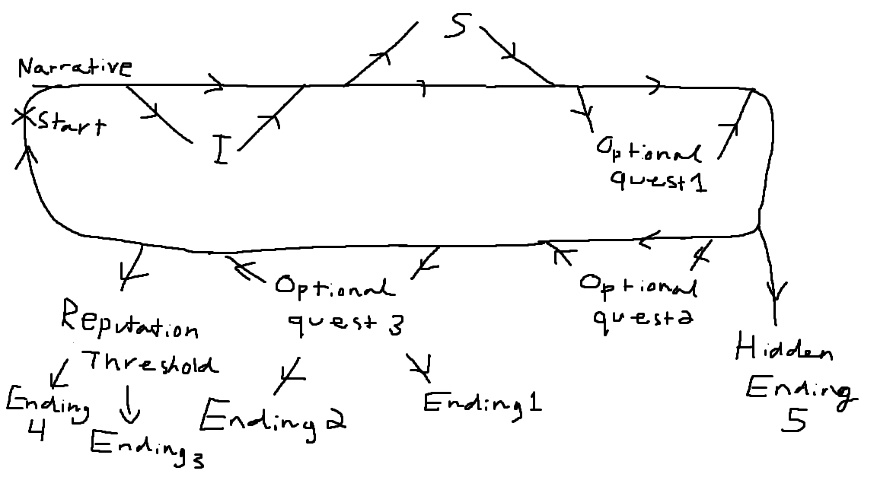

The narrative structure is based entirely on optional interactions between the player and NPCs. The player may talk to any Imp or Skeleton they wish to and hear what they have to say, or not at all. This can be done in any order whatsoever.

Completing quests or killing NPCs will earn reputation with either the Imps or the Skeletons. When enough reputation has been gained with one faction, you will gain their leader’s trust and unlock an ending. There is a secret ending to be unlocked as well as 2 different endings as a result of an optional side quest.