WEDDING WEBSITE
& MANAGEMENT PLATFORM
Detailed implementation specification
NEXT.JS • SUPABASE • NO-CODE ADMIN CMS
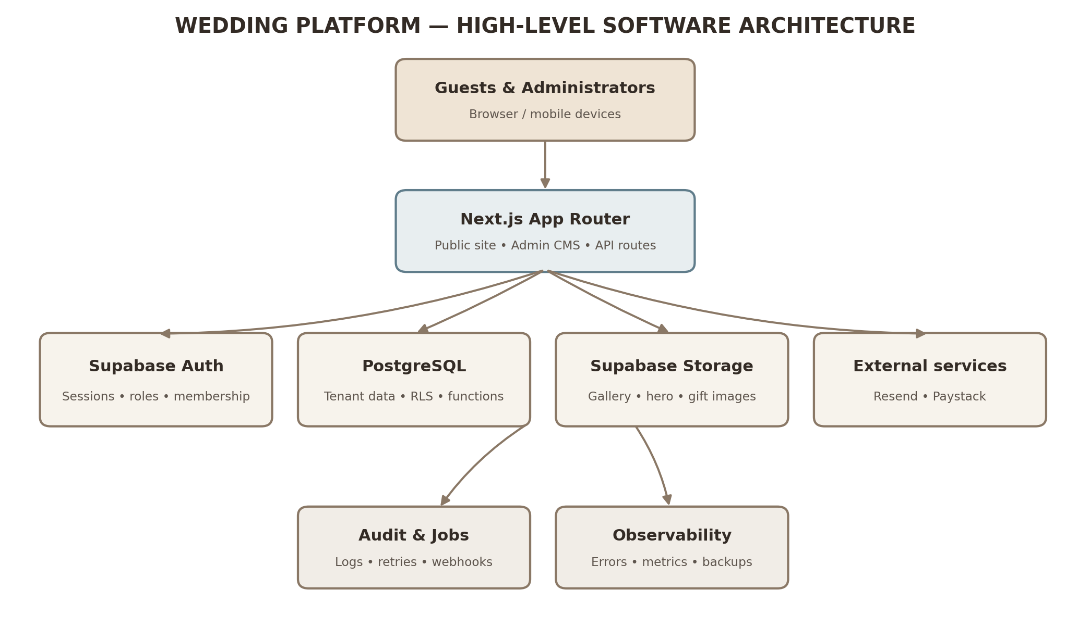
High-level system architecture
Design inspiration: https://www.daraandore.online/

Document guide
- 1. Product vision and scope
- 2. Recommended technology stack
- 3. System architecture
- 4. Database design and relationships
- 5. SQL migration plan and implementation notes
- 6. Development phases and AI coding prompts
- 7. Public website specification
- 8. Invitations, RSVP and guest management
- 9. Wishlist, gifts and payments
- 10. No-code administration dashboard
- 11. Advanced features
- 12. Testing, security and deployment
- 13. Release roadmap and project schedule
- 14. Master orchestration prompt
- Appendix A. Additional SQL migrations
This document is designed as an editable implementation blueprint. It combines product requirements, architecture diagrams, database guidance, development phases, acceptance criteria, and copy-ready prompts for an AI coding agent.

1. Product vision and scope
Build an elegant, responsive wedding website and guest-management platform inspired by the editorial presentation of Dara & Ore. The public experience should feel like a premium digital invitation. The private administration experience should let a non-technical couple or coordinator manage content, guests, RSVPs, gifts, media, and event-day operations without editing code.

Core product areas
- Public wedding website: homepage, story, events, RSVP, wishlist, gallery, FAQ, travel, guestbook, personalized invitation.
- Guest management: invitation groups, individual guests, guest allowances, invitation delivery, RSVP tracking, CSV import/export.
- Gift registry: categories, gift items, quantity reservations, fulfilment, optional monetary contributions.
- No-code administration: content editor, theme editor, event management, guest management, analytics, team permissions.
- Wedding-day operations: QR check-in, seating tables, attendance reports, announcements.
- Future SaaS expansion: multiple wedding workspaces, custom domains, subscription billing, reusable templates.

2. Recommended technology stack
Layer | Technology | Purpose
Web application | Next.js App Router + TypeScript | Public pages, admin dashboard, server routes and rendering
UI system | Tailwind CSS + Shadcn/UI + Lucide | Responsive components and accessible interactions
Animation | Framer Motion | Subtle transitions and page/section motion
Database | Supabase PostgreSQL | Wedding data, relationships, transactions and reporting
Authentication | Supabase Auth + Supabase SSR | Secure sessions and role-aware access
File storage | Supabase Storage | Hero images, gallery albums, gift images
Email | Resend | Invitations, confirmations, reminders and notifications
Payments | Paystack | Optional monetary contributions, initially NGN-focused
Hosting | Vercel | Next.js deployment and preview environments
Testing | Vitest + React Testing Library + Playwright | Unit, component, integration and end-to-end tests

Use Server Components by default and Client Components only for interactive controls. Keep service-role credentials, payment secrets, and email API keys on the server. Supabase must remain the source of truth for wedding-specific content.

3. System architecture
Figure 1. High-level platform architecture
Architecture notes:
- Guests and administrators access the platform from browser or mobile devices.
- Next.js serves public wedding pages, the private admin CMS, and trusted server-side workflows.
- Supabase Auth handles identity and sessions; PostgreSQL stores tenant-owned records and enforces RLS.
- Supabase Storage holds approved media assets. Resend handles email delivery; Paystack handles payment processing.
- Audit logs, retryable jobs, webhook records, monitoring, and backups support reliable operations.

4. Database design and relationships
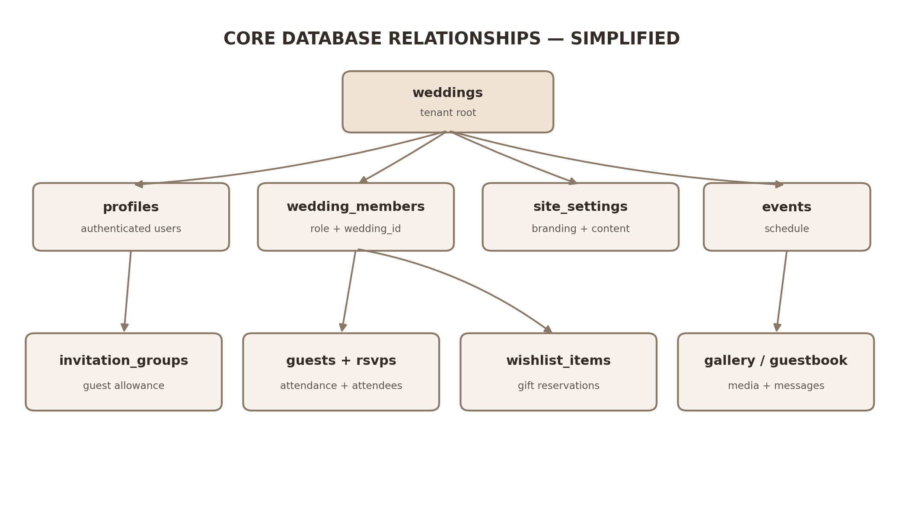
Figure 2. Simplified core database relationships
The database should be multi-tenant from the beginning. Each wedding is a tenant root. Every wedding-owned record must carry a wedding_id and use foreign keys or composite foreign keys that prevent records from being associated with another wedding.

Core tables
Domain | Tables | Key relationships
Tenant and identity | weddings, profiles, wedding_members | A profile can belong to many weddings through wedding_members; each membership has a role.
Website content | site_settings, story_sections, events, FAQs, announcements, travel_information | Each record belongs to one wedding.
Invitations and guests | invitation_groups, guests, rsvps, rsvp_attendees, event_attendance | Groups contain guests; RSVP records are scoped to a wedding and invitation group.
Gift registry | wishlist_categories, wishlist_items, gift_reservations, contributions | Categories contain items; reservations reference items; contributions are separate payment records.
Media and messages | gallery_albums, gallery_images, guestbook_messages | Albums contain images; guestbook messages require moderation before public display.
Operations | seating_tables, seat_assignments, check_ins, notifications, audit_logs | Attendance and seating are wedding-scoped; audit records capture privileged actions.
Payment integrity | payment_webhook_events | Unique provider event IDs prevent duplicate webhook processing.

Relationship and integrity rules
- Use UUID primary keys and TIMESTAMPTZ timestamps.
- Add composite uniqueness such as UNIQUE (wedding_id, id) where needed to support tenant-safe composite foreign keys.
- Use composite foreign keys for relationships between wedding-owned tables.
- Use explicit deletion behavior: CASCADE only where child records should truly disappear; RESTRICT where historical or financial records must be retained.
- Allow nullable guest email addresses and do not assume one email per guest.
- Enforce guest allowances and gift quantities in trusted database transactions, not only in client-side validation.
- Keep payment contributions distinct from physical gift reservations.
- Use append-only audit logs for sensitive administrative actions.

5. SQL migration plan and implementation notes
Migration | Scope
001_initial_schema.sql | Core tables, types, primary keys, foreign keys and base constraints.
002_security_and_rls.sql | RLS, tenant membership checks, role permissions and policies.
003_database_functions.sql | Transactional RSVP, gift reservation, check-in and privileged operations.
004_storage_policies.sql | Storage buckets and upload/read/delete policies.
005_indexes_and_optimizations.sql | Indexes, query support and performance improvements.
006_extended_functionality.sql | Story sections, RSVP attendees, payment webhook idempotency and audit logs.

Supabase environment variables
NEXT_PUBLIC_APP_URL=http://localhost:3000
NEXT_PUBLIC_SUPABASE_URL=
NEXT_PUBLIC_SUPABASE_ANON_KEY=
SUPABASE_SERVICE_ROLE_KEY=
RESEND_API_KEY=
PAYSTACK_SECRET_KEY=
NEXT_PUBLIC_PAYSTACK_PUBLIC_KEY=
NEXT_PUBLIC_DEFAULT_TIMEZONE=Africa/Lagos
Never commit .env.local. The service-role key, Resend API key, and Paystack secret key must only be accessed from trusted server-side code.

Critical SQL integrity example
The following illustrates the tenant-safe invitation-group relationship. Adapt constraint names to the actual initial migration before applying it.
ALTER TABLE invitation_groups
ADD CONSTRAINT invitation_groups_wedding_id_id_key
UNIQUE (wedding_id, id);

ALTER TABLE guests
ADD CONSTRAINT guests_invitation_group_tenant_fk
FOREIGN KEY (wedding_id, invitation_group_id)
REFERENCES invitation_groups(wedding_id, id)
ON DELETE CASCADE;
If an equivalent single-column foreign key already exists, remove or replace it deliberately after inspecting the actual schema. Do not blindly apply ALTER statements against unknown constraint names.

Transactional gift reservation pattern
-- Simplified transaction pattern; implement as a restricted
-- SECURITY DEFINER function or trusted server-side transaction.
SELECT quantity_required
INTO v_required
FROM public.wishlist_items
WHERE id = p_item_id
AND wedding_id = p_wedding_id
AND is_active = TRUE
FOR UPDATE;

IF NOT FOUND THEN
RAISE EXCEPTION 'Gift unavailable';
END IF;

SELECT COALESCE(SUM(quantity), 0)::INTEGER
INTO v_reserved
FROM public.gift_reservations
WHERE wishlist_item_id = p_item_id
AND status IN ('reserved', 'fulfilled');

IF v_reserved + p_quantity > v_required THEN
RAISE EXCEPTION 'Insufficient quantity';
END IF;

-- Insert reservation within the same transaction.
Lock the wishlist item row before calculating active reservations. Do not combine an aggregate query with FOR UPDATE. Validate quantity, ownership, status, and caller permissions; restrict function execution and use a fixed safe search_path for privileged functions.

Additional migration 006 — SQL
CREATE TABLE story_sections (
id UUID PRIMARY KEY DEFAULT gen_random_uuid(),
wedding_id UUID NOT NULL REFERENCES weddings(id) ON DELETE CASCADE,
title TEXT NOT NULL,
content TEXT,
image_url TEXT,
section_type TEXT DEFAULT 'story',
sort_order INTEGER DEFAULT 0,
is_published BOOLEAN DEFAULT TRUE,
created_at TIMESTAMPTZ DEFAULT NOW()
);

CREATE TABLE rsvp_attendees (
id UUID PRIMARY KEY DEFAULT gen_random_uuid(),
wedding_id UUID NOT NULL REFERENCES weddings(id) ON DELETE CASCADE,
rsvp_id UUID NOT NULL,
guest_name TEXT NOT NULL,
is_primary BOOLEAN DEFAULT FALSE,
attendee_type TEXT DEFAULT 'guest',
created_at TIMESTAMPTZ DEFAULT NOW(),
FOREIGN KEY (wedding_id, rsvp_id)
REFERENCES rsvps(wedding_id, id) ON DELETE CASCADE
);

CREATE TABLE payment_webhook_events (
id UUID PRIMARY KEY DEFAULT gen_random_uuid(),
provider TEXT NOT NULL,
provider_event_id TEXT NOT NULL,
payment_reference TEXT,
processing_status TEXT DEFAULT 'pending',
processed_at TIMESTAMPTZ,
created_at TIMESTAMPTZ DEFAULT NOW(),
UNIQUE(provider, provider_event_id)
);

CREATE TABLE audit_logs (
id UUID PRIMARY KEY DEFAULT gen_random_uuid(),
wedding_id UUID NOT NULL REFERENCES weddings(id) ON DELETE CASCADE,
actor_id UUID REFERENCES profiles(id),
action TEXT NOT NULL,
entity_type TEXT NOT NULL,
entity_id UUID,
metadata JSONB DEFAULT '{}'::JSONB,
created_at TIMESTAMPTZ DEFAULT NOW()
);
Important: add RLS and explicit policies for every new table. Ensure audit logs are append-only for ordinary users and payment webhook records can only be written by trusted server-side code.

6. Development phases and AI coding prompts
Build in controlled phases. Do not move to the next phase until the current phase passes its acceptance criteria. The coding agent must inspect the existing codebase before making changes and must not regenerate working files unnecessarily.

Phase 1 — Project foundation and infrastructure
Implementation scope: Initialize Next.js App Router, TypeScript, Tailwind, Shadcn/UI, Lucide, Framer Motion, Supabase SSR, environment variables, shared layouts, design tokens, error/loading states, Supabase CLI and migrations workflow.
Acceptance criteria:
- Next.js app runs; Supabase connection works; strict TypeScript passes; public and admin layouts exist; environment setup is documented.

Copy-ready AI coding prompt
You are a senior full-stack engineer specializing in Next.js, TypeScript, Supabase and scalable architecture. Implement Phase 1 only.
Set up Next.js App Router, strict TypeScript, Tailwind CSS, Shadcn/UI, Lucide React, Framer Motion, Supabase SSR clients for browser/server, cookie-aware authentication utilities, shared public and admin layouts, global design tokens, reusable controls, loading/error/not-found states, environment documentation, Supabase CLI and migration workflow.
Design direction: premium editorial wedding aesthetic inspired by https://www.daraandore.online/ — elegant serif headings, warm ivory, muted earthy colors, generous spacing, beautiful photography and subtle motion. The admin should be clean and functional.
Use Server Components by default. Do not expose secrets or hardcode wedding content. Configure the project to support multiple weddings. Run the app, linting and type checks. Report files created and configuration completed. Do not build the full website yet.

Phase 2 — Database and backend foundation
Implementation scope: Implement migrations 001–006, tenant-safe relationships, indexes, RLS, membership authorization, storage policies, triggers, transactional functions, TypeScript types and development seed data.
Acceptance criteria:
- Migrations apply; RLS and tenant isolation are tested; storage policies work; gift concurrency and RSVP uniqueness are tested; database types are generated.

Copy-ready AI coding prompt
Act as a senior PostgreSQL and Supabase engineer. Implement the complete wedding platform database using the migration plan in this specification.
Create migrations 001_initial_schema.sql through 006_extended_functionality.sql. Include weddings, profiles, wedding_members, site_settings, invitation_groups, guests, rsvps, rsvp_attendees, events, event_attendance, wishlist_categories, wishlist_items, gift_reservations, contributions, gallery_albums, gallery_images, faqs, guestbook_messages, travel_information, announcements, seating_tables, seat_assignments, check_ins, notifications, story_sections, payment_webhook_events and audit_logs.
Implement primary/foreign keys, tenant-safe composite foreign keys, unique constraints, indexes, updated_at triggers, auth profile creation, membership authorization, RLS, storage buckets/policies, secure invitation token support, transactional RSVP and gift reservation, check-in uniqueness and payment idempotency.
Every exposed table must have explicit RLS policies. Public users must only access published content. Guest and invitation records must remain private. Payment status must only be changed through a verified server-side process. Restrict SECURITY DEFINER functions, use a fixed safe search_path, and grant execute only to intended roles.
Seed development data, generate TypeScript database types, and test cross-tenant access, role permissions, gift concurrency, duplicate RSVP, payment webhook replay and check-in uniqueness. Do not call the backend complete merely because migrations execute.

Phase 3 — Public wedding website
Implementation scope: Build homepage, story, events, RSVP entry point, wishlist, gallery, FAQ, travel, guestbook and personalized invitation pages, all resolved by wedding slug.
Acceptance criteria:
- All routes render; content is loaded from Supabase; mobile layouts work; published-content filtering and dynamic SEO metadata work.

Copy-ready AI coding prompt
Act as a senior frontend engineer and UI/UX designer. Implement the public wedding website using the existing Next.js and Supabase architecture.
Use https://www.daraandore.online/ as visual inspiration, not as a source to copy. Create an original premium editorial wedding experience with sophisticated serif typography, warm ivory/champagne surfaces, muted earthy accents, large photographs, generous whitespace and subtle motion.
Build homepage, Our Story, Events, RSVP entry, Wishlist, Gallery, FAQ, Travel and Accommodation, Guestbook, and personalized Invitation pages. Resolve the wedding by slug. Fetch content from Supabase and show published records only. Do not hardcode couple names, dates, photos or events.
Homepage sections: full-bleed hero, couple names/date, welcome, live countdown, venue, story preview, event schedule, gallery preview, RSVP CTA, gift registry preview and footer.
Use optimized Next.js Image, Supabase Storage URLs, accessible semantic HTML, keyboard controls, alt text, reduced-motion support, loading and error states. Test all routes, mobile breakpoints and dynamic data fetching.

Phase 4 — Invitations, RSVP and guest management
Implementation scope: Implement secure invitations, hashed tokens, QR codes, invitation groups, guest allowance, RSVP transactions, email delivery, guest search and CSV import/export.
Acceptance criteria:
- Tokens are unguessable and hashed; guest allowances are enforced server-side; guests cannot read other groups; RSVP and CSV workflows work.

Copy-ready AI coding prompt
Act as a senior backend and full-stack engineer. Build a secure invitation, RSVP and guest-management system.
Admin features: create guests and family invitation groups, set allowances, generate cryptographically secure random invitation tokens, store only token hashes, generate QR codes, send personalized invitations, track delivery, import/export CSV, filter guests and view RSVP analytics.
Guest flow: open secure invitation URL, validate token and expiry on the server, view only their invitation details and eligible events, accept/decline, provide attendee names, dietary/accessibility needs and optional message, then submit.
Enforce wedding ownership, invitation expiry, guest limits, event eligibility, rate limits, input sanitization and duplicate protection server-side. Use Zod. Save RSVP and attendee records transactionally. Email failure must not roll back a saved RSVP; log and retry notifications. Do not expose guest records or token hashes through public queries. Write integration tests for valid, invalid, expired and over-limit invitations.

Phase 5 — Wishlist, gift registry and contributions
Implementation scope: Implement gift categories/items, images, availability, transactional reservations, fulfilment, optional monetary contributions, Paystack initialization and verified idempotent webhooks.
Acceptance criteria:
- Gift CRUD works; concurrent over-reservation is prevented; payment signatures and provider transactions are verified; duplicate webhooks are harmless.

Copy-ready AI coding prompt
Act as a senior full-stack engineer. Implement the wedding wishlist and gift registry.
Admin: manage categories, gifts, images, quantities, prices/currencies, external purchase links, active status, reservations and fulfilment.
Public: browse categories, view gift details and remaining quantity, reserve gifts, provide optional name/message and receive confirmation. Keep guest identities private unless the couple explicitly opts to reveal them.
Use an atomic database reservation function: lock the item row, calculate active reservations, validate quantity, and insert within one transaction. Handle cancellation and administrative release of abandoned reservations.
Integrate Paystack for optional monetary contributions. Initialize payments server-side with unique references. Verify webhook signatures and independently verify transactions with Paystack. Match amount, currency and reference. Store webhook event IDs with a unique constraint. Only mark a contribution successful after verification. Prevent duplicate webhook processing. Keep physical gift reservations separate from cash contributions. Test concurrent reservations, failed payments, repeated webhooks and successful payments.

Phase 6 — No-code administration dashboard
Implementation scope: Build visual CMS and operational dashboard for content, guests, RSVP, events, wishlist, gallery, FAQ, guestbook, seating, check-in, payments, settings and roles.
Acceptance criteria:
- All CRUD persists; role checks work server-side and in RLS; content preview/publish works; analytics use real records.

Copy-ready AI coding prompt
Act as a senior full-stack developer and product designer. Build a complete no-code wedding administration dashboard at /admin/[weddingId].
Modules: overview, website content, guest management, invitations, RSVP, events, wishlist, gallery, FAQ, guestbook moderation, seating, check-in, contributions/payment reports, travel information, announcements, theme settings and team permissions.
Every module must support appropriate create/read/update/delete, search, filtering, sorting, pagination and bulk actions. Build visual forms for couple names, hero content, images, story, date, venue, footer, social links, fonts, colors, buttons and section visibility. Provide preview-before-publish.
Roles: owner, admin, coordinator, viewer. Enforce permissions in server-side authorization and Supabase RLS, not only by hiding controls. Analytics must query real database records. Build accessible responsive navigation, data tables, dialogs, toasts, loading and empty states. Test each module individually.

Phase 7 — Communication and advanced features
Implementation scope: Implement Resend email templates, notification logs/retries, albums and gallery, guestbook moderation, QR check-in, seating and announcements.
Acceptance criteria:
- Emails are logged and retryable; gallery permissions work; unapproved messages remain private; QR check-in is secure and unique; seating capacity is enforced.

Copy-ready AI coding prompt
Act as a senior full-stack engineer. Implement advanced wedding operations.
Integrate Resend with reusable responsive templates for invitations, RSVP confirmation/updates, reminders, gift reservations and announcements. Track delivery, log failures and support retries.
Gallery: create albums, upload multiple images, captions, ordering, deletion and publication controls. Guestbook: accept messages, moderate, approve/reject and show approved messages only. Add rate limiting and spam protection.
QR check-in: generate secure revocable invitation QR codes that contain no private guest data. Build mobile scanning and manual search, validate invitation, display permitted guest details, confirm check-in and prevent duplicates. Record timestamp and coordinator.
Seating: create tables, set capacities, assign/reassign guests, enforce capacity transactionally and generate reports. Add tests for all features and permissions.

Phase 8 — Testing, deployment and production readiness
Implementation scope: Complete unit, integration and E2E tests, security review, performance, SEO, Vercel/Supabase deployment and runbooks.
Acceptance criteria:
- Critical tests pass; tenant isolation is verified; production secrets are configured; migrations and backup/recovery instructions are documented.

Copy-ready AI coding prompt
Act as a senior QA and DevOps engineer. Review the complete wedding platform and prepare production deployment.
Use Vitest, React Testing Library, Supabase local integration tests and Playwright. Test authentication, authorization, tenant isolation, public navigation, invitation validation, RSVP limits, gift concurrency, payment verification, webhook replay, emails, uploads, guestbook moderation, seating and check-in.
Review RLS, server-side authorization, secret handling, rate limiting, input validation, upload restrictions, payment webhook verification, invitation tokens, cross-tenant access and public API exposure.
Review image optimization, database indexes, rendering, caching, pagination, loading states, bundle size and mobile performance. Implement dynamic metadata, Open Graph, sitemap, robots.txt, canonical URLs and appropriate structured data.
Prepare GitHub, Supabase production, Vercel, custom domain and HTTPS. Document environment variables, migration deployment, backups and recovery. Do not claim readiness until tests have run and critical issues are resolved. Report results, known limitations and outstanding risks.

7. Public website specification
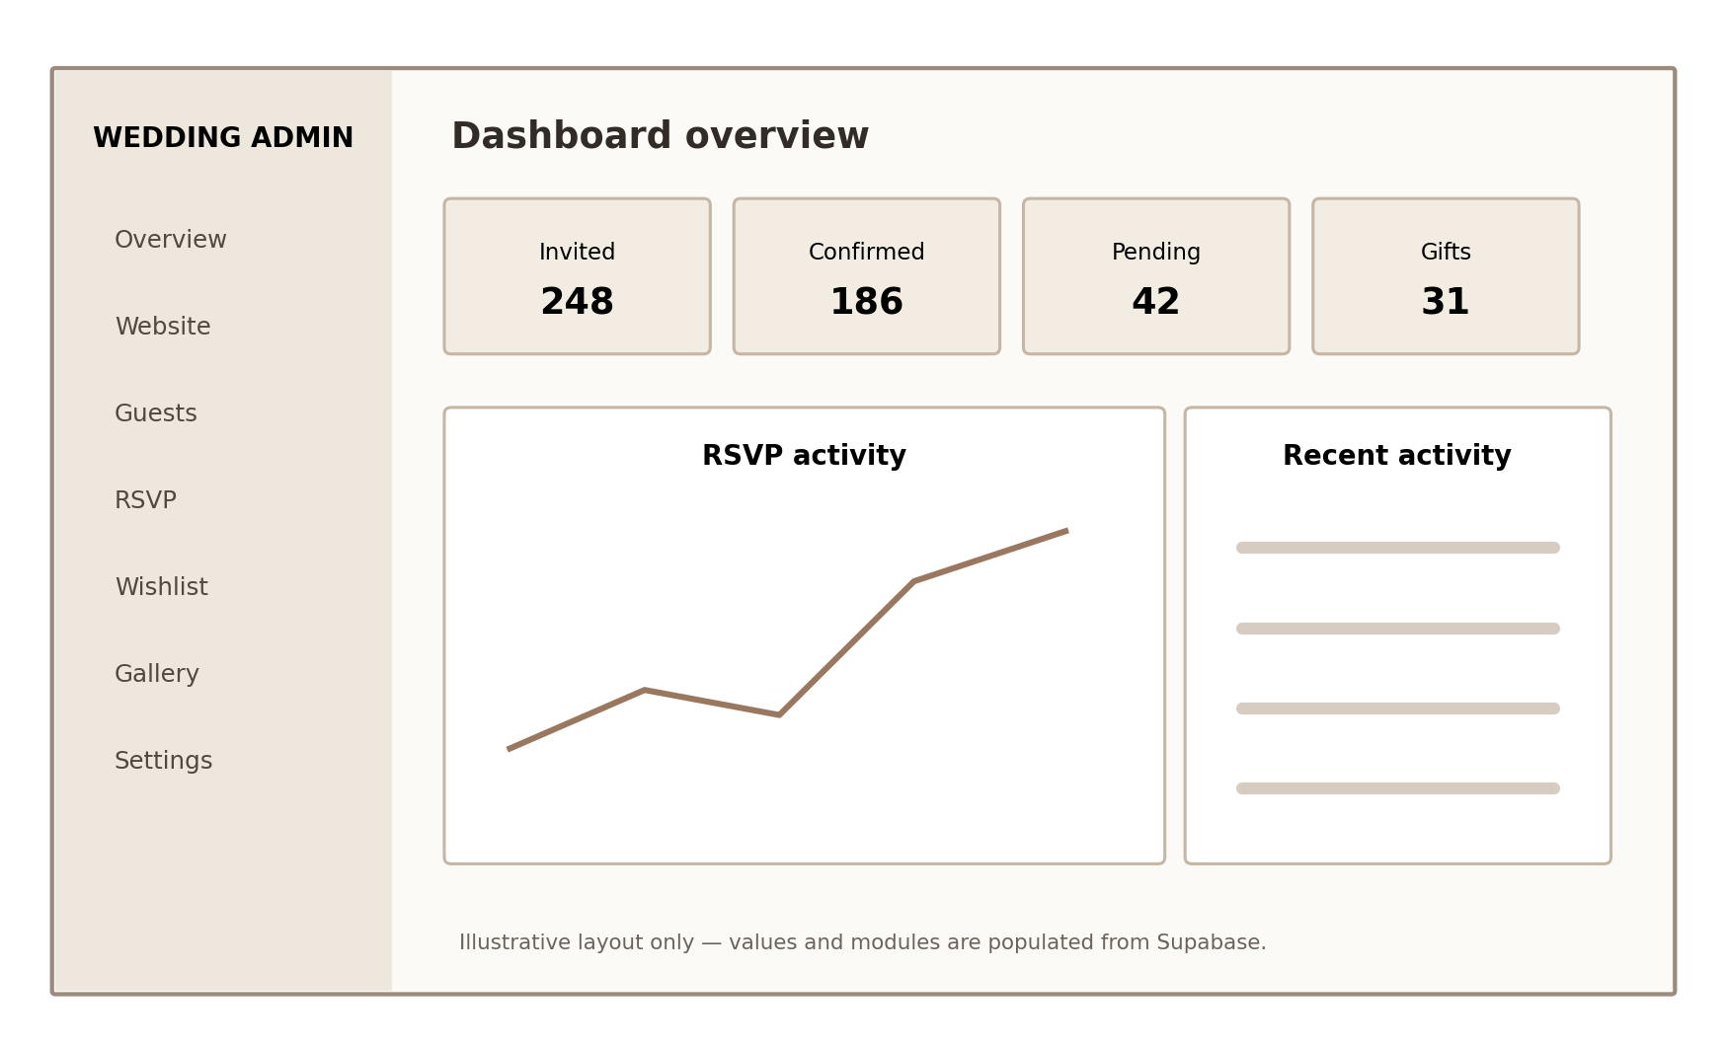
Figure 3. Illustrative admin dashboard layout; production values must come from Supabase.

Recommended public page structure
Page | Primary components
Homepage | Hero, couple names, wedding date, countdown, introduction, story preview, events, gallery, RSVP CTA, wishlist preview and footer.
Our Story | Relationship timeline, story sections, photographs and captions.
Events | Ceremony/reception details, dates, times, venues, dress code and map links.
RSVP | Secure invitation validation, attendance response, attendee details and confirmation.
Wishlist | Gift categories, cards, availability, reservations and contribution option.
Gallery | Albums, responsive image grid and lightbox.
FAQ | Accessible accordion questions and answers.
Travel | Venue details, directions, accommodation and transport information.
Guestbook | Message submission and approved public messages.
Invitation | Personalized invitation with secure token-based access.

Use a wedding slug to resolve all public content, for example /[weddingSlug], /[weddingSlug]/story, /[weddingSlug]/events, /[weddingSlug]/rsvp and /[weddingSlug]/wishlist. Do not create hardcoded pages for individual couples.

8. Invitations, RSVP and guest management
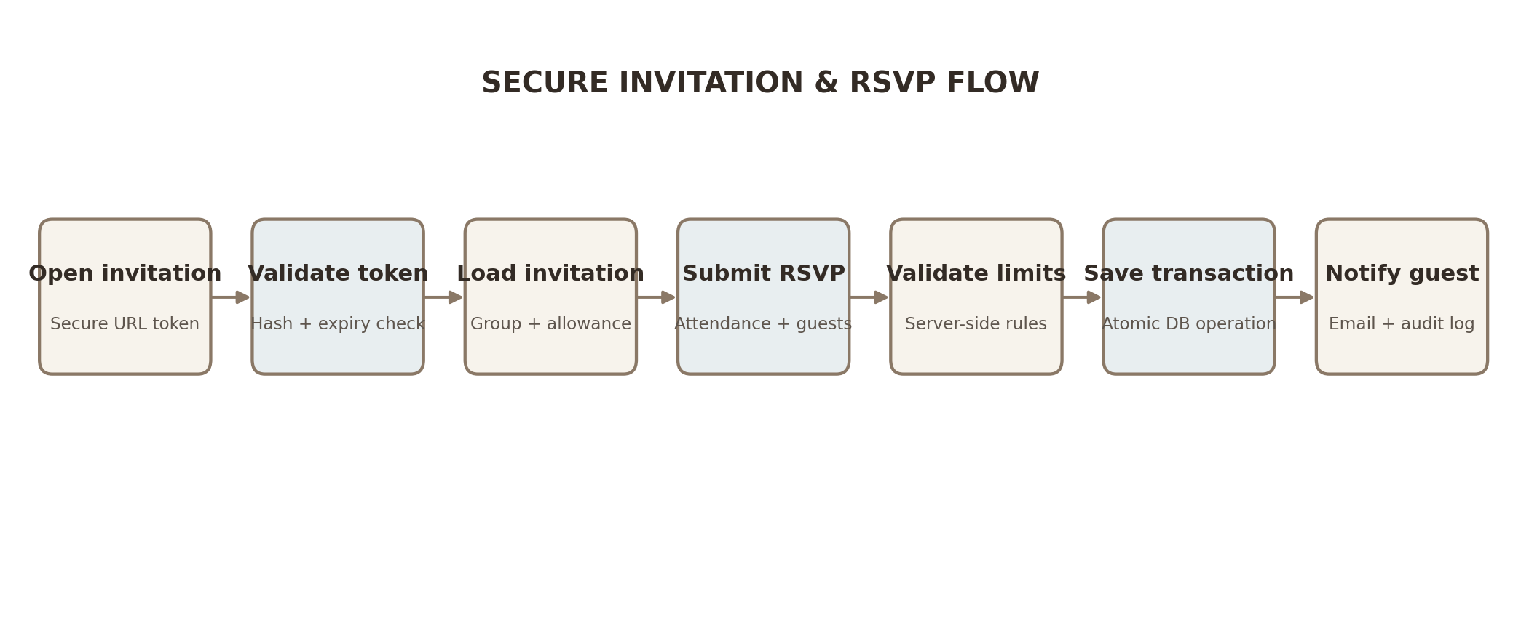
Figure 4. Secure invitation and RSVP flow
Invitation URL example: https://example.com/invitation/SECURE_RANDOM_TOKEN
- Generate a cryptographically secure token and store only its hash.
- Validate the token and expiry on the server before returning invitation details.
- Never use a predictable guest UUID as an invitation credential.
- Enforce the invitation group's guest allowance on the server.
- Save RSVP and attendee details transactionally.
- Send confirmation email asynchronously; email failure must not undo a valid RSVP.
- Provide guest search, filters, CSV import/export, status tracking and event-level attendance.

Guest management metrics
Metric | Meaning
Invitations sent | Invitation groups or recipients with successful/attempted delivery, clearly distinguished.
Invited guests | Total allocated invited attendees.
Confirmed attendance | Number of individual attendees confirmed, not just RSVP groups.
Declined | Guests or groups who declined; define the counting unit consistently.
Pending | Invitations without a final response.
RSVP rate | Responses received divided by invitations issued, with the denominator defined.

9. Wishlist, gifts and payments
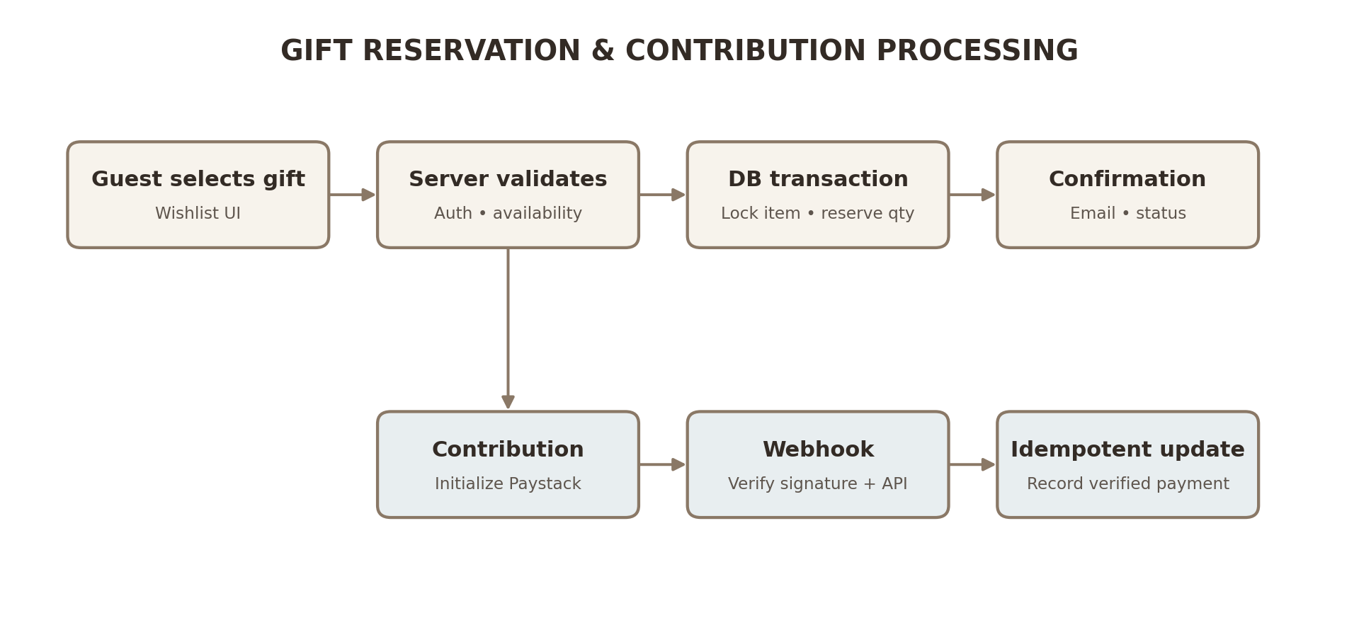
Figure 5. Gift reservation and payment processing
A gift reservation is not a payment. Guests may reserve a physical gift to purchase elsewhere. Monetary contributions are a separate workflow processed through Paystack.

Gift card fields
- Image, title and description.
- Category, price and currency.
- Quantity required, reserved and remaining.
- Optional external purchase link.
- Reservation status and fulfilment status.
- Privacy preference for contributor visibility.

Payment safety
- Initialize transactions on the server and use unique references.
- Verify webhook signatures and independently verify transactions with the provider.
- Match amount, currency and reference before updating contribution status.
- Store webhook event IDs with a unique constraint to make processing idempotent.
- Never collect or store raw card details.
- Keep payment secrets server-side and log payment state transitions.

10. No-code administration dashboard
The dashboard should act as the operational CMS. Non-technical administrators should manage all wedding-specific content through forms, tables, upload controls and preview/publish workflows.
Module | Capabilities
Overview | Guest and RSVP metrics, gift reservations, contributions, upcoming events and recent activity.
Website editor | Edit names, hero, welcome text, story, date, venue, footer and social links.
Theme editor | Colors, fonts, logo, button styles, section visibility and live preview.
Guests and invitations | Guest CRUD, groups, allowances, tokens, delivery status, CSV import/export.
Attendance | RSVP review, event attendance, seating, check-in and reports.
Registry | Categories, gifts, images, quantities, reservations, fulfilment and contributions.
Media | Albums, multi-image upload, captions, ordering and publication.
Communication | Announcements, email templates, notification history and retries.
Guestbook | Moderate, approve, reject and publish messages.
Settings and team | Wedding settings, membership, roles, permissions and domain configuration.

Role permission matrix
Permission | Owner | Admin | Coordinator | Viewer
Edit branding | Yes | Yes | No | No
Manage guests | Yes | Yes | Yes | View
Manage RSVPs | Yes | Yes | Yes | View
Manage events | Yes | Yes | Yes | View
Manage wishlist | Yes | Yes | Yes | View
Manage payments | Yes | Yes | No | View
Manage members | Yes | Limited | No | No
Delete wedding | Yes | No | No | No

This is a starting permission matrix. Enforce permissions in server-side authorization and database policies, not merely by hiding UI controls.

11. Advanced features

Email notifications
- Invitation emails.
- RSVP confirmations and updates.
- Event reminders.
- Gift reservation confirmations.
- Wedding announcements.
- Administrative alerts.
- Delivery logs, retries and suppression handling.

Gallery and guestbook
- Multiple albums and image uploads.
- Captions, ordering, visibility and deletion.
- Guestbook submission with moderation.
- Only approved messages are publicly visible.
- Rate limiting and spam protection.

QR check-in and seating
- Secure QR tokens should not expose private guest details.
- Support scanning and manual guest lookup.
- Record check-in time and coordinator identity.
- Prevent duplicate check-ins.
- Create tables with capacities and enforce capacity on assignment.
- Support reassignment and exportable seating reports.

12. Testing, security and deployment
Test area | Expected result
Admin login | Authorized user accesses the correct wedding workspace.
Invalid login | Access rejected; protected routes remain private.
Tenant isolation | Wedding A cannot access Wedding B's private records.
Guest invitation | Valid token returns only the correct invitation.
Expired invitation | Expired token is rejected.
RSVP | Response and attendee details save correctly.
Guest allowance | Excess attendee count is rejected server-side.
Gift reservation | Available quantity is updated atomically.
Concurrent reservation | No over-reservation occurs.
Payment verification | Only independently verified payments succeed.
Duplicate webhook | No duplicate contribution is created.
Gallery upload | File is stored and access follows policy.
Guestbook | Unapproved message remains hidden.
Check-in | Guest can be checked in only once.
Seating | Table capacity is respected.

Deployment sequence
- GitHub: source control, branches, pull requests and CI checks.
- Supabase: production project, migrations, Auth configuration, Storage and RLS.
- Vercel: connect repository, set environment variables and deploy preview/production.
- Custom domain: configure DNS, HTTPS and canonical URL.
- Production verification: test invitations, RSVP, email, payments, media uploads and mobile layouts.

Production security checklist
- RLS enabled and explicitly tested on every exposed table.
- No service-role or provider secret exposed to the browser.
- Server-side authorization on all sensitive operations.
- Invitation tokens are random, hashed, revocable and rate-limited.
- Payment webhook signatures and provider transaction details are verified.
- File upload MIME types, sizes and access policies are restricted.
- Audit logs capture privileged changes.
- Backups and recovery procedures are documented.
- Production error monitoring and alerting are configured.

13. Release roadmap and project schedule
Release | Included capabilities
Release 1 — Wedding MVP | Homepage, wedding information, story, events, invitations, RSVP, guest administration, wishlist, gift reservations, admin content editor and responsive design.
Release 2 — Complete platform | Email automation, gallery, guestbook, Paystack contributions, QR check-in, seating, analytics and theme editor.
Release 3 — SaaS expansion | Multiple wedding workspaces, custom domains, subscriptions, reusable templates, platform administration, onboarding and usage analytics.

Phase | Estimated effort
Foundation | 1–2 working days
Database/backend | 2–4 working days
Public website | 3–5 working days
Invitations and RSVP | 2–4 working days
Wishlist and payments | 2–3 working days
Admin dashboard | 4–6 working days
Advanced features | 2–4 working days
Testing and deployment | 2–3 working days
Total | 18–31 working days

These are planning estimates for one developer using an AI coding assistant. Actual delivery depends on design refinement, integration issues, testing depth and deployment requirements.

14. Master orchestration prompt

Copy-ready master prompt
You are the lead software architect, senior full-stack developer, database engineer, UI/UX designer and QA engineer responsible for delivering a complete wedding website and management platform.
TECHNOLOGY: Next.js App Router, TypeScript, Tailwind CSS, Supabase PostgreSQL, Supabase Auth, Supabase Storage, Supabase RLS, Shadcn/UI, Framer Motion, Resend, Paystack and Vercel.
DESIGN REFERENCE: https://www.daraandore.online/ . Use it as inspiration for an original premium editorial wedding experience.
PRODUCT OBJECTIVE: Build an elegant public wedding website and private guest-management platform. The public site is an emotionally engaging digital invitation. The admin is a no-code CMS for non-technical users.
ARCHITECTURAL PRINCIPLES:
1. Use multi-tenant architecture.
2. Supabase is the source of truth.
3. Keep components modular and reusable.
4. Implement secure authentication and authorization.
5. Validate sensitive operations server-side.
6. Use transactions for critical operations.
7. Make wedding content editable through the dashboard.
8. Avoid hardcoded wedding-specific information.
9. Support multiple weddings and independent administrators.
10. Prioritize performance, security, accessibility and maintainability.
ROADMAP:
Phase 1 foundation; Phase 2 database; Phase 3 public website; Phase 4 invitations and RSVP; Phase 5 wishlist and payments; Phase 6 no-code dashboard; Phase 7 communication and advanced features; Phase 8 testing and production.
EXECUTION RULES:
- Work incrementally; do not implement all phases simultaneously.
- Inspect the codebase before changes.
- Do not overwrite working functionality unnecessarily.
- Do not replace real integrations with fake implementations.
- Do not use mock data in production.
- Run tests after significant implementation.
- Resolve TypeScript and lint errors.
- Validate migrations and RLS.
- Keep secrets server-side.
- Maintain an implementation checklist.
- Document architectural decisions.
- Report blockers rather than inventing solutions.
For each phase: explain the plan, identify files, implement, connect to Supabase, test, resolve errors, update documentation and report completion status. Do not proceed until the current phase passes acceptance criteria.
Begin with Phase 1 only. The final product must be a beautiful, responsive, secure wedding platform whose public content and administrative functions are fully connected to Supabase.

Appendix A — Important implementation decisions
- Build a single-wedding first release while preserving multi-tenant database architecture.
- Do not begin with visual pages before the core data model and RLS are validated.
- Keep the public website and admin dashboard as separate layouts within one Next.js application.
- Use a secure server-side workflow for invitation validation, RSVP, reservations and payments.
- Use a preview/publish workflow so edits do not unexpectedly appear on the live website.
- Treat email delivery as an asynchronous side effect; persist the business transaction first.
- Use database-level idempotency and locking for payment webhooks and gift reservations.
- Do not assume the reference website's exact implementation, content or assets are available; reproduce the design direction with original assets and components.

Appendix B — Recommended initial build order
- Create the Next.js project and shared design system.
- Create the Supabase development project and configure CLI.
- Implement migrations, relationships, RLS and storage policies.
- Test tenant isolation and critical database transactions.
- Build the admin shell and content editor.
- Build public pages from real Supabase content.
- Implement secure invitation and RSVP flows.
- Implement gift registry and payment contributions.
- Complete email, gallery, guestbook, check-in and seating.
- Run end-to-end tests and deploy.

