Report on Document Categorization
Survi Makharia (15CS60R01), Kalyani Roy(15CS60R20), Gowtham Nayak(15CS60R22), Dimpi Saikia(15CS60R08)
Masters of Technology, Computer Science & Engineering
IIT Kharagpur
12th April, 2016

- Problem Statement

This project explores the problem of categorizing documents into predetermined groups based on their content. The categories and texts should be such that a human reader who understands the subject matter can easily do the categorization. The categorization is based on rules determined by keyword recognition by associating the presence of particular keywords with a specific category. Sentence Segmentation is also applied to determine the category. It focuses on developing a statistical model that represent the information found in the training set and provide a framework for applying information found in the unknown document.

B. System Overview

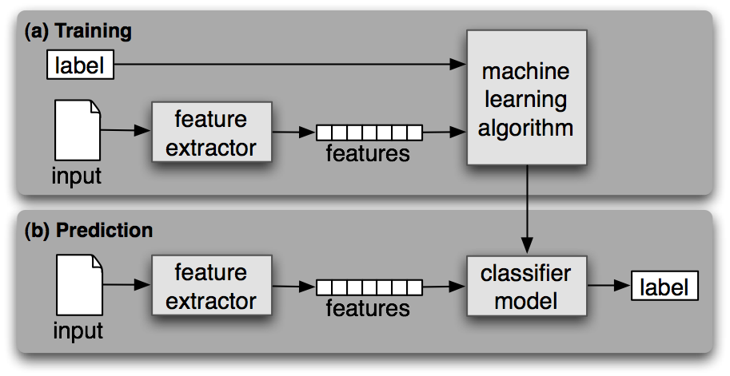

In our experiment we are considering a supervised training corpora containing the correct label for each input. We then identify features of data that are salient for classifying. The features that we have considered are as follows :
- Unigram Prbability of terms
- Average word length
- Average sentence length
- Count of Subordinate Clauses
- Language Model Score
We calculate the Language Model score using a multinomial classifiaction model, one for each grade.
We then perform probabilistic classification of a document into various grade labels based on logistic regression.
C. Experiments
Our corpora consists of NCERT textbooks of different grades. We gathered 550 English documents across 12 grade levels. The pages were drawn from a wide variety of subject areas: english, maths, science,social studies etc. Before defining a classification model, we examined the corpus for trends in word frequency. We observed that more difficult words were introduced at later grade levels. Similarly, higher grade levels use more abstract words with increased frequency. We observed both types of behavior in our Web corpus. Figure 1 shows Data from each of the 12 grades in the corpus are shown, ordered by ascending grade level. The solid line is a smoothed version of the word frequency data.
The Unigram Model
In text classification terms, each class is described by a language model corresponding to a predefined level of difficulty. We trained 12 language models corresponding to the 12 grade levels. The language models we use are based on unigrams and assume that the probability of a token is independent of the surrounding tokens, given the grade language model. A unigram language model is defined by a list of types (words) and their individual probabilities. We then do the Prediction with Multinomial Naïve Bayes method.
Feature Selection
For feature selection we perform lemmatization on the words. We also remove low-frequency
terms – those that occur less than 2 to 5 times in a model’s training data.

C. Results

