***Introduction to HTML***

# Topics to be covered

* Types of website
* Front End and Back End Concepts
* HTML Introduction

# Introduction to Webpage

* A web page is single document or page available on world wide web.
* The web pages are created using HTML (Hyper Text Mark-up Language) and are interpreted, displayed by web browsers.
* Each web page has unique address called URL (Uniform Resource Locator) which distinguishes one page to another on [WWW.](http://WWW/) For example, the URL of a web page of Futura Labs like :

https://thefuturalabs.com



Website

* A website is a collection of related web pages.
* It may contain text and other multimedia elements like images, graphics, videos etc.
* The website loads with its default web page called Home page of the website.
* The related web pages are linked together using concept of hyper linking and hyper text.
* A **hyperlink** is link or reference that points to another webpage or another location of same web page.
* A **Hypertext** is that text on webpage that contains hyperlink. When user move mouse over the hypertext, the shape of the mouse gets changed, and by clicking on hypertext, the user can move to another location.
* Actually the term hypertext has been now replaced with **hypermedia** because not only text but also images, video etc can be hyperlinked in the webpage.

## A website can be accessed by typing website’s name (known as domain name) in the address bar of the web browser (like Google chrome, Mozilla firefox etc).

* Examples of some websites are [www.thefuturalabs.com](http://www.nielit.gov.in/) (Futura Labs Website), [www.facebook.com](http://www.facebook.com/) (Social networking site), [www.google.com](http://www.google.com/) (search engine site).



# Types of website

## There are two types of websites:

* 1. Static Websites
  2. Dynamic Websites

## Static Websites:

* Static websites, as its name suggests, are those which has predefined and fixed contents and remain same every time when user accesses the website. Static websites are informative website.
* The user can not interact with static website. Static websites do not require any information to be stored in the database.
* Static websites are designed using only front end tools (HTML, CSS, and JavaScript).
* The contents of static websites can be changed manually at server side. The user can not modify it.

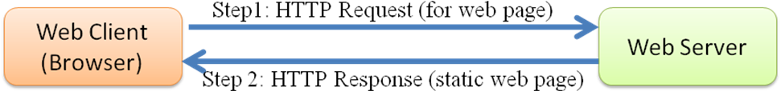

Figure: Working of Static website

## Dynamic Websites:

* Dynamic websites are created using front end and back end tools. Dynamic website is something whose contents changes dynamically on the basis of user request.
* The examples of dynamic website include facebook, twitter etc.
* The contents of these website changes as per the user input. The contents of the facebook’s website like posts, comments, photos etc are stored in the database. The facebook page differs from one user to another user.
* In dynamic website, when user makes request for web page, it is processed at server side and dynamically the web page is created in real time, then transferred to client side and displayed on the browser.

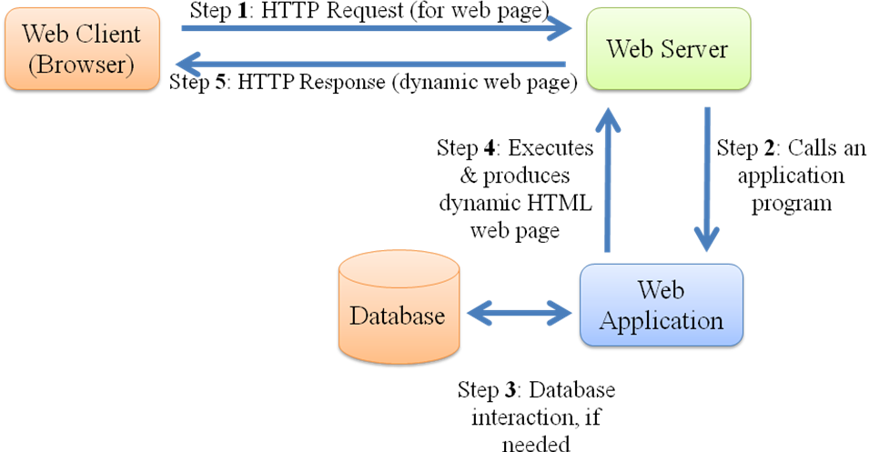

Figure: Working of Dynamic website

# Front End

* **Front end** refers to client side design of website. Front end is involved with what the users see and interact with the website i.e. the User Interface (UI) which includes the design, layout, navigation menu, text, images, videos, image gallery etc.
* The languages used for front end designing and development of the website include

**HTML** – It is fundamental language for creating and organizing web contents.

**CSS** – It defines the style and layout of the website contents.

**JavaScript** – It is used for more interactive elements, handling events and to set the behavior of the webpage.

* Apart from above, here are some most popular front end framework and libraries:

**W3.CSS** (CSS Framework) - It is used for creating responsive website. It contains standard CSS only.

**Bootstrap** (CSS and JavaScript Framework) - It is also used for creating responsive website. It contains CSS and JavaScript.

# Back End

* Back end refers design and development of website at server side.
* It is involved with what the user cannot see in the browser like database and server information etc.
* It concerns with security aspects, data storage and manipulation, content management, user authentication etc.
* The languages used for back end development of the website include: Python, PHP, Java, Ruby etc.
* Popular framework for back end: Node.js, Django, etc

# HTML Introduction

* HTML stands for Hyper Text Markup Language.
* It is standard and fundamental markup language for creating web pages and websites.
* It specifies the structure of the web page.
* The building blocks of HTML are the elements of the HTML.
* HTML elements are represented by tags and their attributes.
* Web browsers do not display the HTML tags, but use them to render the contents of the web page.
* Web browsers receive HTML documents from web server or from local storage and render the document into web pages.

## History & Version of HTML

In 1991, Tim Berners Lee invented HTML and wrote browser and server software There are many versions of HTML till now:

|  |  |
| --- | --- |
| **Version** | **Published Year** |
| HTML | 1991 |
| HTML 2.0 | 1995 |
| HTML 3.2 | 1997 |
| HTML 4.01 | 1999 |
| XHTML (Extensible) | 2000 |
| HTML 5 | 2014 |
| HTML 5.1 | 2016 |
| HTML 5.2 | 2017 |

# HTML5 Introduction

* HTML 5 is the latest version of HTML. It is maintained by W3C (World Wide Web Consortium).
* HTML5 has new and latest feature that makes it more powerful and dynamic while designing websites.
* New tags and attributes are introduced in HTML5, some elements are removed, some elements are redefined.
* Some new elements of HTML 5 are <audio>, <video>, <section> , <header>, <footer>,

<nav>, <mark> etc.

* <frame>, <frameset>, <strike>, <font>, <center> etc. elements are dropped in HTML5.
* New form input types are introduced in HTML – date, time, email, url etc.
* 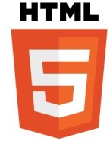W3C has presented logo of HTML5 in 2011.

Logo of HTML5

# Basic Structure of HTML

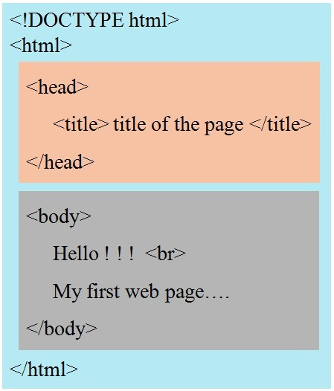

## Explanation:

* The first line <!DOCTYPE html> defines the type of the document. It tells the web browser about the language in which the web page is written.
* Next, the whole html code is enclosed within <html> …. </html> tag.
* Then, the html code is comprised of two sections i.e. Head section and Body section.
* The head section is defined within <head> ….. </head> tag. This section contains the meta information (data about data) like document title, character set, style, script and other meta information.
* The body section is defined within <body> …. </body> tag. This section contains main contents/ information that is visible on the web page.

# Creating and running of HTML

* **Step 1:** Open any text/code editor like notepad/ notepad++ or sublime or IDE like VS code etc.
* **Step 2:** Write the HTML code.
* **Step 3:** Save the document by giving the desired primary name of the document with extension .html or .htm
* **Step 4:** Open the document with using any of the web browser installed on the system like Chrome, Firefox, Internet Explorer etc. to see the output of the html code.

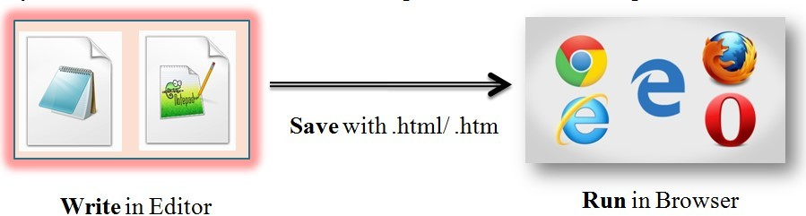

# HTML Tags/Elements

* Tags are the mark up and coded instructions referred to as source code. It is enclosed in a pair of angle bracket. Usually there are opening (start) and closing (end) tags with containing some text or objects in between.
* The opening tag begins with left angle bracket (<), followed by tagname and then right angle bracket (>). For example:

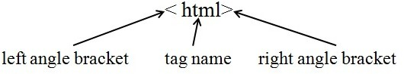

* The closing tags are identical to opening tag except a forward slash (/) before the tag name. For example:

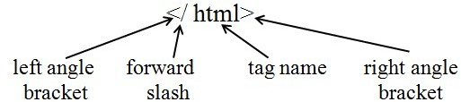

# Types of Tags

* HTML tags are two types: 1. Container tag 2. Empty tag
* **Container tags** are those tags that have both opening (on) tag and closing (off) tag. These tags have some objects being affected between opening and closing tag.

Syntax:

Examples:

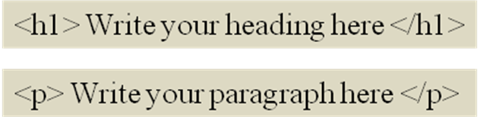

* **Empty tags** are those that have only opening tag and don’t have end tag associated. The reason behind this is that they don’t act on block of objects. <br> and <hr> are examples of empty tag.

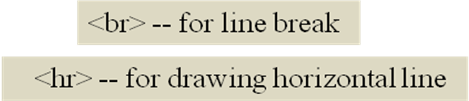

# HTML Attributes

* Attributes are associated with tags. It allows to modify or change the appearance or behaviour of the tag. The value of attribute is specified by percentage, pixels, unit value, names, directional etc.
* Syntax:



* For example: <body> tag has basically three attributes :

1. **bgcolor** : It is used to specify the background color of the web page.
2. **text**: It is used to specify the text color of the web page.
3. **background**: It is used to set the picture on the background of the page.



-- This will change the page’s background color as yellow and text color as red.



-- This will set the nature.jpg picture on the background of the page and text color as white.

**Note:** If users don’t mention the attributes. These have some default value, like <body> tag has the background color as white, text color as black and background picture as none by default.

# Head Section and Elements of head section

* The head section is defined within <head> ... </head> tag. It consists of Meta information (data about data) of the web page.
* The metadata is not displayed on the web page.
* It contains document title, character encoding, styles, scripts, links to the style sheet/ scripts files, and other Meta information which is helpful for search engines.
* The elements of head section are:

# <title>

* 1. **<style>**
  2. **<meta>**
  3. **<link>**
  4. **<script>**

1. **<title> tag:** It is used to define the title of the web page. The title is displayed on browser’s tab, and also displays in search engine’s result.
2. **<style> tag:** It is used to define internal CSS (Cascading Style Sheet). Internal CSS means style information is applicable for single html page.

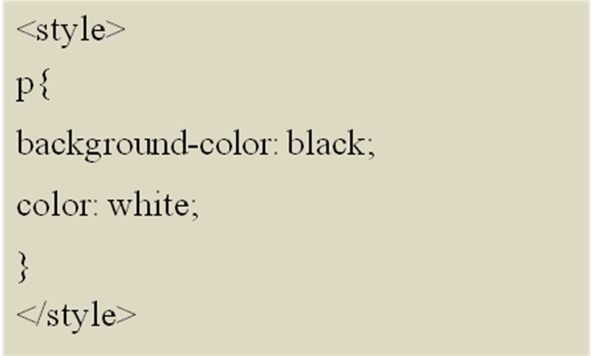

--The <p> elements of body section will be styled i.e. background color of the paragraph will be black and text color will be white.

1. **<meta> tag:** It is used to define the meta information about the web page. Meta information is helpful for web browsers and search engines. The meta information includes character encoding, descriptions of web page, keywords for search engine, author information etc.

-- The text in webpage is encoded using Unicode.

- It is used to give the descriptions about page which helps to search engine for finding the page.

- It is used to give the author name in web page.

-- It is used to specify the keywords in the web page which helps to search engine for indexing and searching based on the keywords.

**<meta> tag** is also used to set the viewport of the web page i.e. visible area of the page for user. The visible area depends on the device’ screen width where the web page is loaded and the screen size differs from one device to another. Mobile phones have smaller screen rather than computer screen. This viewport controls the scaling of screen.

-- width=device-width means the width of the page is set to follow the width of the device’ screen and i nitial-scale=1.0 means the initial zoo m level is 1.0 when the page is loaded on the browser for first time.

1. **<link> tag:** It is used to link the external style sheet to the html document. External CSS is applicable for multiple web pages.

-- This will provide the link of external CSS file (styleA.css) to the HTML document.

1. 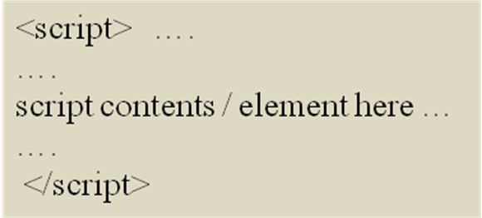**<script> tag:** It is used to define the client side scripting usually JavaScript to the HTML document. The <script> tag can contain script elements/contents or it can also be used to point/link the external script file.

-- This will provide the link of external JavaScript file (fileA.js) to the HTML document.

# Formatting Elements

* **Headings** in HTML are defined by using <h1>, <h2>, <h3>, <h4>, <h5>,<h6> tags. These are level of headings where <h1> is the largest level of heading and <h6> is the smallest level of heading.

## Example: Heading

<!doctype html>

<html>

<head>

<title> HTML Heading </title>

</head>

<body bgcolor="green" text="white">

<h1> I am Heading Level 1 </h1>

<h2> I am Heading Level 2 </h2>

<h3> I am Heading Level 3 </h3>

<h4> I am Heading Level 4 </h4>

<h5> I am Heading Level 5 </h5>

<h6> I am Heading Level 6 </h6>

</body>

</html>

**Output: Heading**

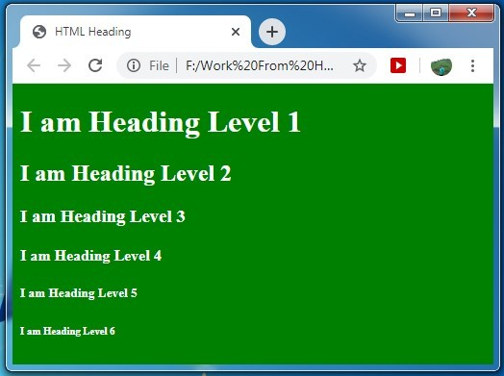

**Paragraph** in HTML is defined by <p> tag.

## Example: Paragraph

<!doctype html>

<html>

<head>

<title> HTML Paragraph </title>

</head>

<body bgcolor="lightgreen" text="darkwhite">

<p> I am Paragraph 1. kdirek djfepdf erede dkneir vbprnv bknvhrand vjperisvn erdvk eineh nfei kneron jbeo jb enejoefn fenc fkdd.</p>

<p> I am Paragraph 2. irpwnv derip mveroj ndfpn eirpe qwrie zcnp mpeej eurbdjb euhclsjfb eocbjdb ueobdb euhdbk eln. </p>

</body>

</html>

**Output: Paragraph**

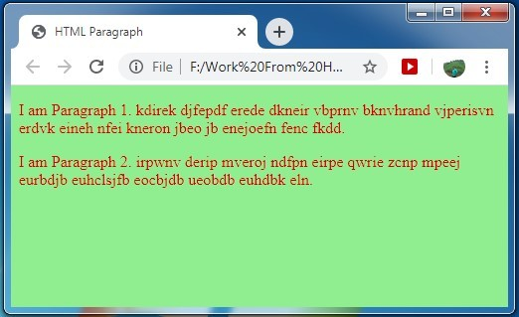

* HTML defines various elements for text formatting and styling. These tag are container tags because they act on block of text. These elements are:

|  |  |
| --- | --- |
| **Element (Tag)** | **Description** |
| <b> | To bold/ dark the text |
| <i> | To italic the text |
| <u> | To underline the text |
| <strong> | It defines strong text, same as <b> tag, but with extra importance on text. |
| <em> | It defines emphasized text, same as <i>, but with extra importance on text. |
| <small> | It defines the smaller text than other text ( in size) |
| <big> | It defines the bigger text than other text (in size) |
| <strike> or <s> | It defines the strikethrough effects on text. |
| <sup> | It defines superscript text i.e. above the base line ( e.g. 10th) |
| <sub> | It defines subscript text i.e. below the base line ( e.g. H2O) |
| <mark> | It defines the marked/highlighted text. |
| <del> | It defines the deleted/removed text. |
| <ins> | It defines the inserted/edited text. |
| <tt> | It defines teletype (monospace) text which means each letter is displayed with equal fixed size width. |

<!doctype html>

<html>

<head>

<title> HTML Formattng </title>

</head>

<body bgcolor="lightgreen" text="darkgreen">

<h1> Bold, Italic, Underlined Formattng </h1> I am <b>Bold/dark</b> text. <br>

I am <i>Italic </i>text. <br>

I am <u> Underlined</u> text. <br>

I am <b> <i> <u>bold, italic and underlined </b></i></u> text.

<h1> Strong, Emphasized Formattng</h1>

I am <strong>strong </strong> text. I have extra importance.<br> I am <em>emphasized </em>text. I have extra importance.

<h1> Big, Small Formattng</h1>

I am <big>big </big> text. I am little bigger than other text. <br>

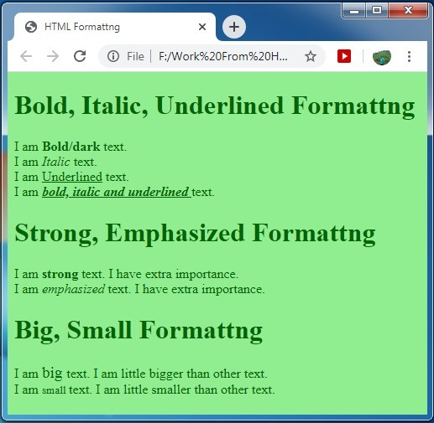**Output1: Formatting Elements**

**Example2: Formatting Elements**

<!doctype html>

<html>

<head><title> HTML Formattng </title></head>

<body bgcolor="lightgreen" text="darkgreen">

<h1> Superscript</h1>

(A+B)<sup>2</sup> = A<sup>2</sup> + B<sup>2</sup> + 2AB <br> (A-B)<sup>3</sup> = A<sup>3</sup> - B<sup>3</sup> - 3AB (A-B)

<h1> Subscript</h1>

Water - H<sub>2</sub>O <br>

Baking Soda - NaHCO<sub>3</sub> <br>

Vinegar - C<sub>2</sub>H<sub>4</sub>O<sub>2</sub>

<h1> Highlighted Text </h1>

<mark> This is highlighted text. </mark>

<h1> Deleted, Inserted Text </h1>

Price: <del>3000/- </del> <ins>2500/- </ins>(special discount)

<h1> Strikethrough text </h1>

<strike> I am strikethrough text. </strike> Same as deleted text.</body></html>

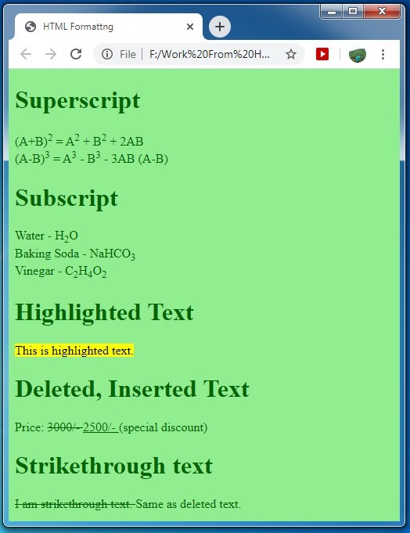**Output2: Formatting Elements**

* **<pre> tag:** It is used to define pre - formatted text.

Suppose user wants to present tabular data on the web page. Then, <pre> tag can be used to display tabular data without using any additional tag. It preserves the spaces and line break as in the code.

## Example2: Pre

<!doctype html>

<html>

<head><title> Pre tag </title></head>

|  |  |  |  |
| --- | --- | --- | --- |
| Sr.No. | Name | Course |  |
| 01 | Rakesh |  | PHP |
| 02 | Shyam | JAVA |  |
| 03 | Lakshmi |  | PYTHON |

**HTML Tables**

* **Tables** are the combinations of rows and columns. Rows are arranged horizontally and columns are arranged vertically.
* In HTML, **<table>** tag is used to define table. Each **row** of the table is defined by **<tr>** tag. Each **cell/data** is defined by **<td>.** The **header cell** is defined by **<th>** tag.

## Attributes of <table> tag:

* **width:** To specify the width of table.
* **height**: To specify the height of table.
* **border:** To specify the border of table.
* **bgcolor**: To specify background color of table.

## Example: Table

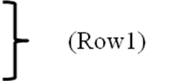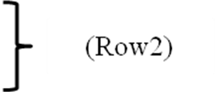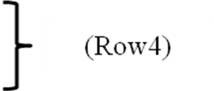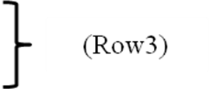

<!doctype html>

<html>

<head><title> Table in HTML </title></head>

<body bgcolor="silver">

<h1> List of Products </h1>

<table width="80%" border="1">

<tr>

<th> Product Name</th>

<th> Make</th>

<th> Cost</th>

</tr>

<tr>

<td>Mouse</td>

<td>Dell </td>

<td>300</td>

</tr>

<tr>

<td>Keyboard</td>

<td>HP</td>

<td>400</td>

</tr>

<tr>

<td>Pen drive</td>

<td>Sony</td>

<td>800</td>

</tr>

</table></body></html>

**Output: Table**

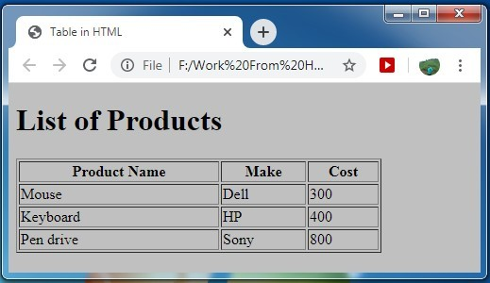

In above table, there are **04 rows**, and **03 columns.** Therefore, In the code, there are 04 set of <tr> ….. </tr>.

The first <tr> set has 03 set of <th> … </th>. The next three <tr> has 03 set of <td> … </td>.

# cellspacing and cellpadding – attribute of <table> tag:

* **cellspacing:** This attribute is used to add space between adjacent cells.
* **cellpadding:** This attribute is used to add space between the edge of the cell and contents of the cell.

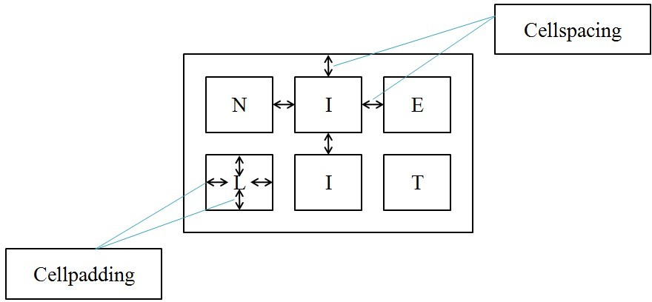

**Example2: Table (cellspacing, cellpadding):**

<!doctype html>

<html>

<head><title> Cellspacing and Cellpadding </title>

</head>

<body bgcolor="khaki" text="chocolate">

<h1> Cellspacing and Cellpadding in table </h1>

<table width="80%" border="1" cellspacing=30px cellpadding=50px>

<tr> <td> N </td> <td> I </td> <td> E </td> </tr>

<tr> <td> L </td> <td> I </td> <td> T </td> </tr>

</table>

</body>

</html>

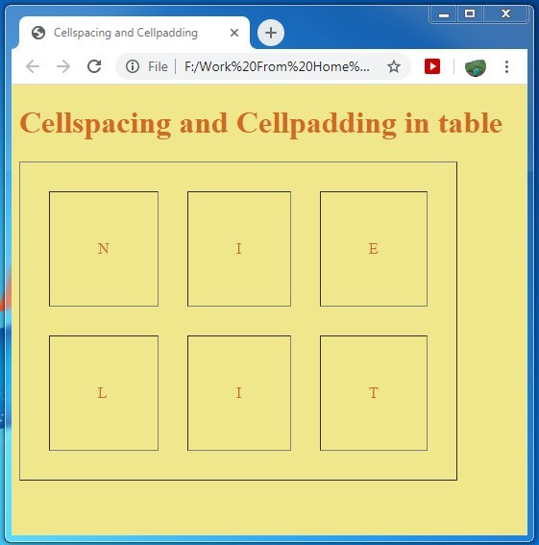**Output2: Table (cellspacing, cellpadding):**

# Adding caption in table:

* The <caption> tag is used to title or name of the table. It gives the short descriptions about table.

## Example2: Table Caption

<!doctype html>

<html>

<head><title> Caption in table</title>

</head>

<body bgcolor="linen" text="chocolate">

<h1> Caption in table </h1>

<table width="60%" border="1" align="center">

<caption align="bottom">Table 1 : Courses offered by Futura Labs

<tr> <th> Course <th> Duration <th> Eligibility</th></tr>

<tr> <td> PHP <td> 3 months <td> Graduation or diploma</td></tr>

<tr> <td> python-Django <td> 6 months <td> Graduation or diploma</td

></tr>

<tr> <td>Ui/UX</td> <td>6 months <td> No minimum qualification</td></tr

></table>

**Output2: Table Caption**

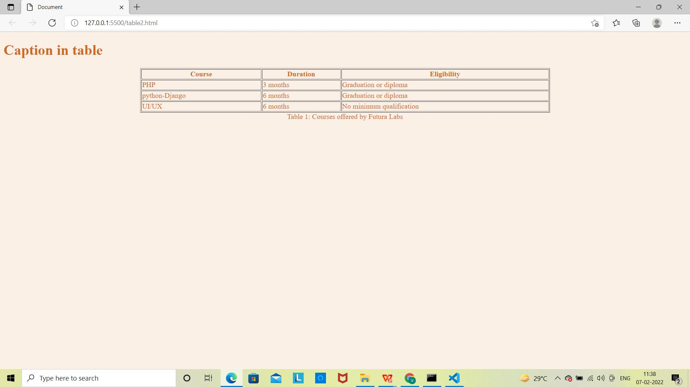

**Images in HTML:**

* Images can be inserted in web pages using **<img>** tag. Images are used to enhance the design and appearance of web page. **<img>** tag is empty tag which means that it does not have closing tag.

## Attributes of <img> tag:

* **src**: It specifies the address or path of the image.
* **height**: It specifies the height of the image.
* **width**: It specifies the width of the image.
* **alt:** This attribute provides alternate text for image. If for any reason the browser is not able to display the image (because of slow internet connection, error in path, image corruption etc.), then the alternate text will be displayed in place of image.

## Syntax:



**Example: Images**

<!doctype html>

<html>

<head>

<title> Inserting Images </title>

</head>

<body bgcolor="lightgreen" text="darkgreen">

<h1> Image 1 </h1>

<img src="quote.jpg" height="200px" width="300px" alt="Inspirational Quote 1" >

<h1> Image 2 </h1>

<img src="inspirational-bird-quote-freedom.jpg" height="200px" width="300px" alt="Inspirational Quote 2">

</body>

</html>

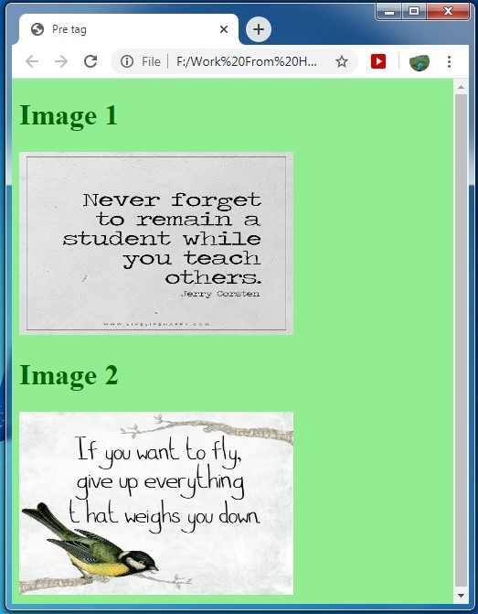**Output: Images**

Exercise

1)Write a program to create HTML table with the following output

