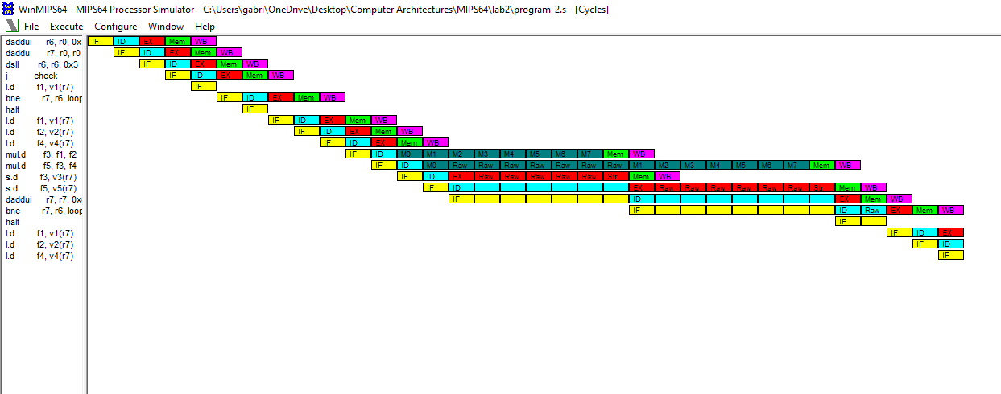

5  
 1   
 1  
 1  
  
 2   
  
 2  
 1  
 1  
 8  
 8

0  
 1  
 1  
 2

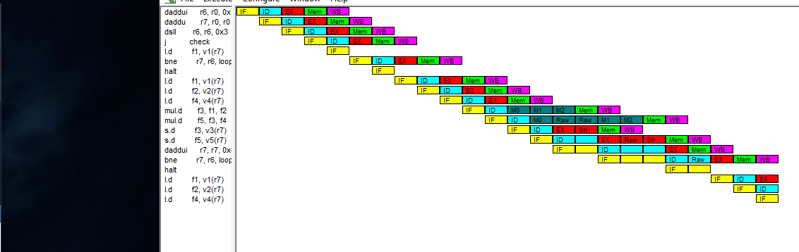 total = 5+5+25\*(2+1+1+8+8+0+1+1+2)+1=11+25\*24=611 (like the simulated)

5  
1  
1  
1  
  
2

2  
1  
1   
 3  
 3  
 0  
 1  
 1  
 2

Total = 10+25\*(2+1+1+3+3+0+1+1+2)+1 = 11+25\*14=361 (like the original one)

Base config:

* Simul: 611/361 = 1.83
* Hand: speed = 10\*25 = 250 frac = 250/661 = 0.378  
   hamd = 1/((1-0.378) + 0.378/250) = 1/(0.622+0.001512) = 1.61

IT SHOULD BE 4 CYCLES instead of 3 FOR MULTIPLICATION STAGES SO

Total = 10+25\*(2+1+1+4+4+0+1+1+2)+1 = 11+25\*16=411 (like the original one)

Config 2

* Simul: 611/411 = 1.48
* Hand: speed = 8\*25 = 200 frac = 250/611 = 0.409  
   hamd = 1/((1-0.378) + 0.378/250) = 1/(0.622+0.001512) = 1.69

Everything wrong:

Speedup = 8/4 = 2

Fraction = (2\*8\*25)/611 = 0.655