|  |  |
| --- | --- |
| **Architetture dei Sistemi**  **di Elaborazione 02GOLOV** | Delivery date:  Tuesday 22/12 |
| **Laboratory**  **9** | Expected delivery of lab_09.zip must include:   * zipped project folder of the exercise 1 * this lab track completed and converted to pdf format. |

Solve the following problems by starting from the *sample_BUTTON_LED* project (open the file project from the uVision menu). Test the problems using the *LandTiger* emulator.

Remember to check if the emulator is enabled in the menu “Options for Target” after installing the emulator.

|  |  |
| --- | --- |
| Tab “Debug”: load the emulator’s library   | Tab “C/C++”: define SIMULATOR   |

Once you run the debug, if the emulator is correctly installed and added to the debug option, you shall find *LandTiger* under the Peripherals menu.

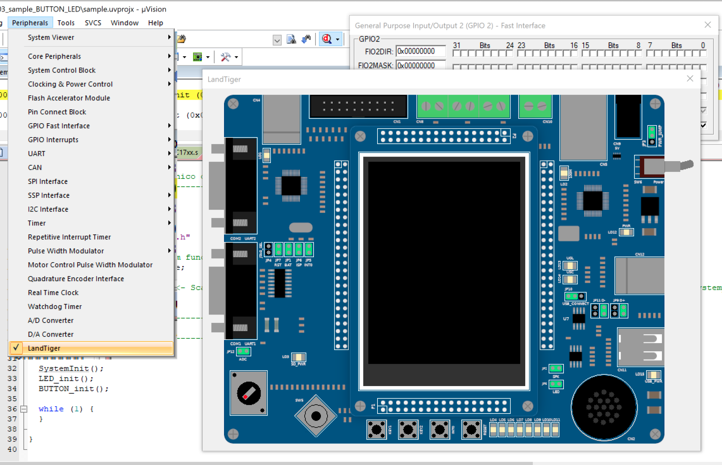

If you right-click on the board, you can access the configuration menu, where you can eventually change some default parameters (tab “Settings”)

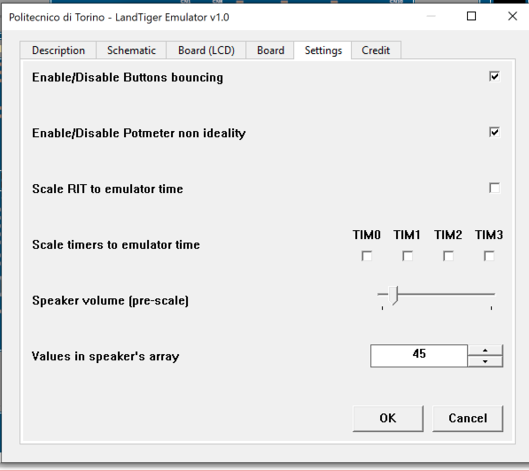

**Exercise 1)** Implement an 8-bit “signed counter” by usingLANDTIGER board; the software permits to use buttons to update a counting value which could be either positive or negative, and the LEDs to show the current value. By first using emulation capabilities, please implement the following functionalities:

* increment a variable every time the button Key1 is pressed,
* decrement when Key2 is pressed (in case, go to negative number)
* reset the count when INT0 is pressed

LEDs are showing the current count in a binary, 2’s complement representation.



**HINT**: It could be useful to use a global variable in order to keep the information about turned ON LEDs. For example, using a variable called “char led_value”, already available in the project.

**Q1:** By adjusting the emulator settings, you can activate a non-ideal behavior of the buttons called "bouncing". Do you notice any different behaviour on the emulator if you enable such a bouncing setting? Please comment.

The bouncing effect is caused by the physical structure of the switches that causes some “bounces” when pressed for an undefined time. These bounces can be seen as 0/1 by the logic of the chip different times and this can cause strange behaviour like in this case a multiple up or down counting.

**Q2:** What happens if you act on jumpers JP5 and JP8 with respect to the default configuration?

The JP8 jumper is near the LEDs circuitry. The inputs of the LEDs are connected to an IC (74LV244PW) that acts as a tri-state buffer for each output. The eight outputs are divided into 2 groups. Those buffers have an active-low “Output Enable” pin connected to 1G and 2G input port of the IC. When the jumper is connected, these 2 inputs are connected to GND, activating the output of the buffers (that can be in this way 0 or 1 according to the state of P1.0…P1.7). When the jumper is removed, 1G and 2G are brought up to Vcc by a pull up resistor (R31), that disables the output of the buffers: in this way they will show high impedance as output.

JP5 instead simply connects or disconnects the output of INT0 (that can be 0V is pressed, 3V3 if not pressed thanks to the pull up resistor) from P2.10.

Using the emulator, check the schematic and fill the following table.

|  |  |  |
| --- | --- | --- |
| Component | Pull-up resistor name | Pull-up resistor size |
| LEDs | RN3/RN2 | - |
| INT0 | R22 | 10K |
| KEY1 | R25 | 10K |
| KEY2 | R23 | 10K |