Gajan Nagaraj

Aditi Mithal

CS35L Lab 7

13 November 2018

Neural networks capable of finding medication complaints in social networks.

In the rapidly evolving field of artificial intelligence, researchers are constantly looking for ways to increase the intellectual capabilities of computers. The goal is to reach a point where computers are intelligent enough to recognize patterns and make informed decisions on their own, and thus better assist humans in everyday tasks. To achieve this, researches have been focusing on applying the principals of artificial intelligence to different fields, such as health and wellness, that can benefit humans. In such instances, we often see scientist developing machine learning models to help predict/diagnose if a patient has contracted a certain disease. Researchers at the Kazan Federal University and Moscow Institute of Physics and Technology looked to pursue a similar goal through a unique method. Instead of diagnosing the patient using biological data, the researchers aimed train a computer model to make informed decisions about a patient’s wellbeing by analyzing “complaints” from social media posts.

Essentially, the researches created a bot to scan patients social media posts, identify any “complaints,” translate these complaints into real symptoms, and then diagnose the patient. The main challenge in this is finding a way to compare syndromes mentioned by patients and specific medical terms. The process of doing so is called the normalization of medical concepts. To find a solution for normalization of medical concepts, researchers employed a recurrent neural network. A recurrent neural network is a type of neural network where the connections between units form a directed graph along a sequence. Essentially what this means is that RNNs store an internal state and update it as they learn on some input.[1] They use this internal state to influence decisions on later inputs. Figure 1 shows a simple RNN and what it looks like unraveled.

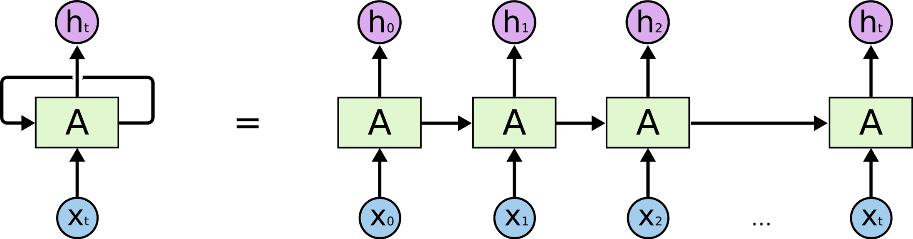

Figure 1

Researchers trained the RNN on a dictionary of social media language and their medical language translations. This would allow the model to take an input string from social media and create meaning for each word in the sentence based of the context of the sentence (words around it). From this, researchers can find the meaning of different words in social media posts and link them to diagnosis in the medical language dictionary.

Figure 2 shows the entire data pipeline from the social media input to the diagnosis. We can see that the input sentence is taken and pushed into the RNN and a sematic similarity database.

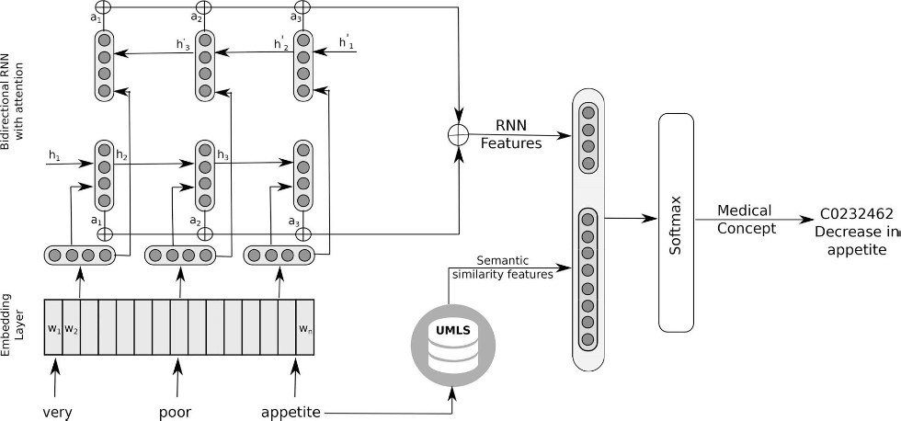

Figure 2

This way we can find meaning of the sentence using the RNN as well as consider synonyms of words to help us better understand the sentence. After this we get the diagnosis.

Although the field of machine learning is still growing, this is a step in the right direction towards using computers to better society. In this specific use, I think that it would be better for this machine model to be used separately, rather than through social media. This would be a better approach because then users can input their diagnosis in words and have the model translate that into an actual medial diagnosis. Additionally, I believe that we can extend this application further so to use what we infer more about the user. Lastly, I think this study shows us that we can potentially train computers to understand and interpret other human behaviors in even more detail.

1. Shekhar, Amit. “Understanding The Recurrent Neural Network – MindOrks – Medium.” *Medium*, Medium, 14 Apr. 2018, [medium.com/mindorks/understanding-the-recurrent-neural-network-44d593f112a2](https://medium.com/mindorks/understanding-the-recurrent-neural-network-44d593f112a2).