**International Institute of Information Technology, Hyderabad**

**Camera Calibration**

**DLT, Zhang’s method**

**Mohit Sharma**

**201505508**

**DLT (Direct Linear Transformation) based Calibration**

**Implementation steps:**

1. Noted 6 world points and corresponding image points.
2. Created matrix A using these points and ran SVD on the same to find out projection matrix. Code for the same is attached at the end.

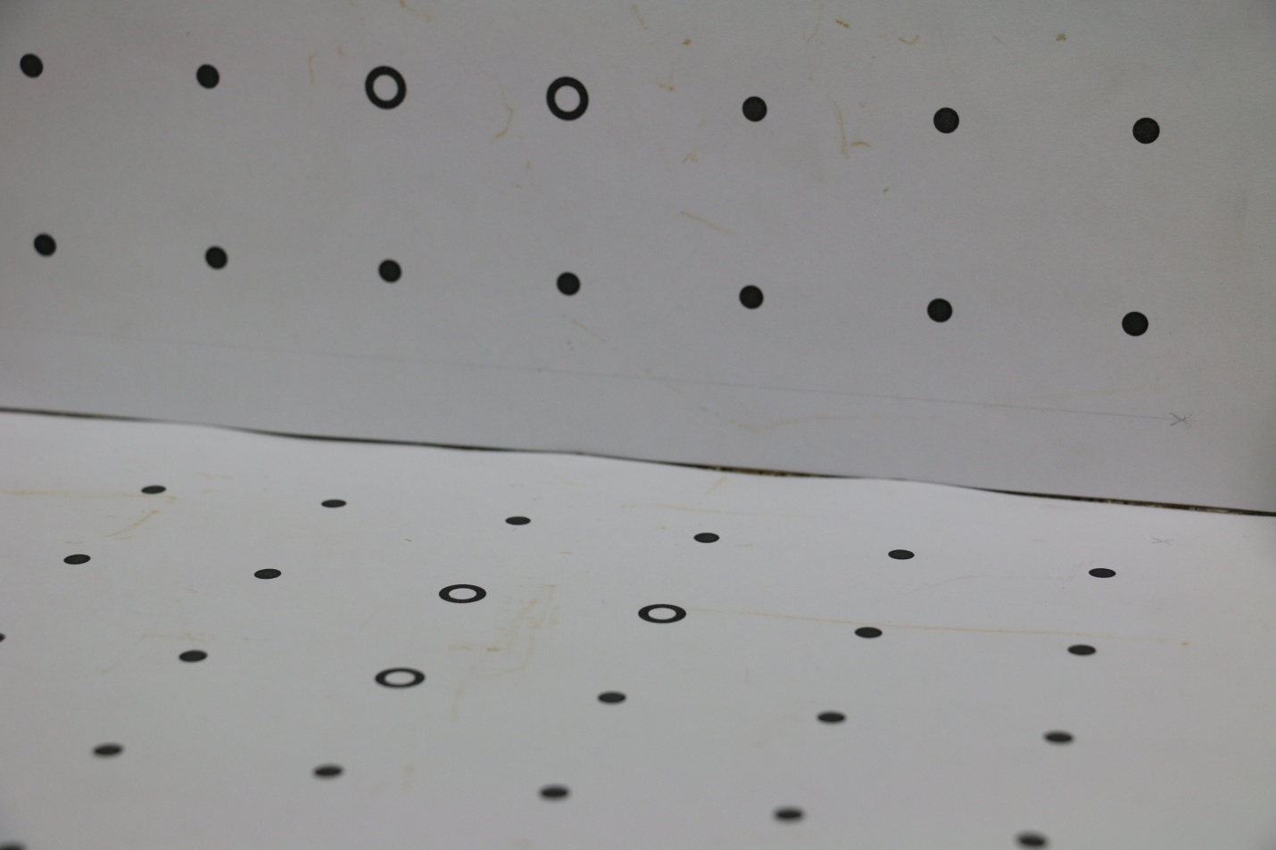

Image used for DLT

**Results:**

**Projection matrix:**

[[ -3.74192548e-03 -7.09352321e-04 -2.08639185e-03 9.11534249e-01]

[ -1.19471698e-04 -4.38859509e-03 6.67848748e-04 4.11177210e-01]

[ 1.03536464e-07 -2.21616919e-07 -3.72293950e-07 1.90809706e-04]]

**Camera’s intrinsic parameters:**

[[ 4.16539126e-03 4.99336916e-05 1.22688234e-03]

[ 0.00000000e+00 4.14347407e-03 1.59739944e-03]

[ -0.00000000e+00 0.00000000e+00 4.45462281e-07]]

**Camera’s extrinsic parameters:**

[[ 0.96537612 0.01336473 0.26051935]

[-0.11843851 -0.86736175 0.48337969]

[ 0.23242476 -0.49749873 -0.83574742]]

**Observation for the 6 points:**

|  |  |  |  |
| --- | --- | --- | --- |
| **S. No.** | **World Point** | **Image Point** | **Calculated point** |
| 1 | 144, 0, 144 | 475, 3222 | 475.03, 3222.32 |
| 2 | 36, 0, 36 | 3874, 2379 | 3874, 2378.99 |
| 3 | 36, 72, 0 | 4064, 509 | 4064, 508.99 |
| 4 | 72, 72, 0 | 3242, 475 | 3241.99, 475 |
| 5 | 72, 0, 108 | 2637, 3004 | 2636.93, 3003.37 |
| 6 | 0, 0, 72 | 4642, 2800 | 4642.03, 2800.30 |

**Wireframe image for the DLT:**

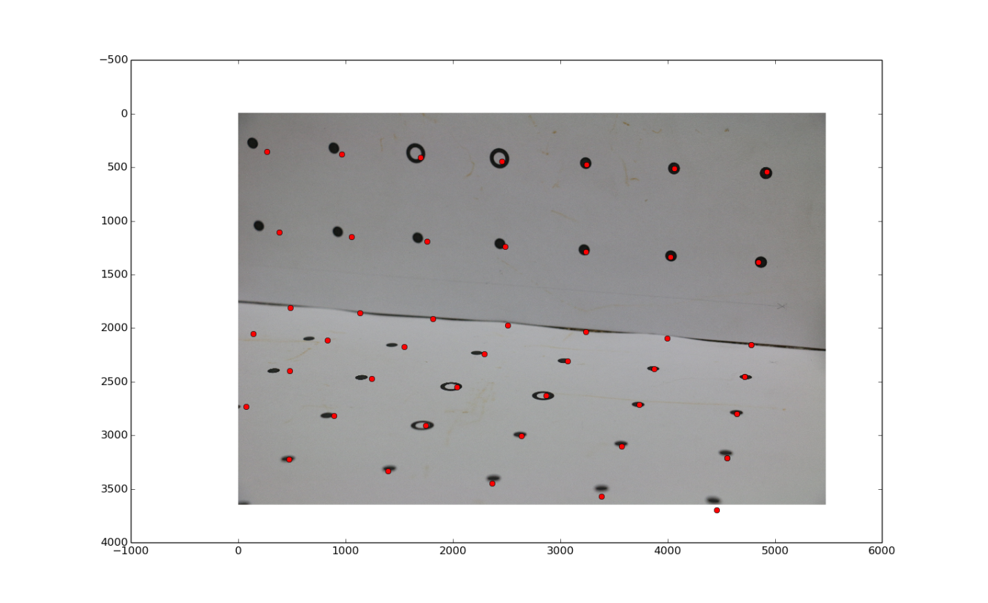

**Please note that only points have been plotted for clarity**

**Ransac based calibration:**

**Implementation steps:**

Image coordinates for 18 points are taken and followed these steps to calibrate:

1. Randomly select 6 points out of 18.
2. Find P matrix for above selected points using DLT.
3. Using this P matrix, Find out image coordinates (xi, yi) for all the 18 points.
4. Calculate the error in terms of Euclidean distance from calculated values (xi, yi) to actual values.
5. If this error is lesser than the threshold (taken as 1) then return P matrix as the final result.
6. Repeat above 5 steps until we reach threshold.



**Image used for Ransac**

**Results:**

**Projection matrix:**

[[ 3.96173182e-03 3.11538970e-04 1.86238666e-03 -9.13153168e-01]

[ 1.87708116e-04 4.24084506e-03 -8.65777998e-04 -4.07569902e-01]

[ -7.63671423e-08 1.19359844e-07 3.05929301e-07 -1.89856060e-04]]

**Camera intrinsic parameters:**

[[ 4.29469467e-03 3.63134684e-05 -9.02850295e-04]

[ 0.00000000e+00 4.27975669e-03 -6.73242439e-04]

[ -0.00000000e+00 0.00000000e+00 -3.37151969e-07]]

**Camera extrinsic parameters:**

[[ 0.9707605 0.00602357 0.23997451]

[-0.07949096 -0.93521699 0.34503677]

[ 0.22650659 -0.35402387 -0.9073929 ]]

**Observation for the 6 points:**

|  |  |  |  |
| --- | --- | --- | --- |
| **S. No.** | **World Point** | **Image Point** | **Calculated point** |
| 1 | 0, 0, 36 | 4731, 2453 | 4731.01, 2453.20 |
| 2 | 0, 36, 0 | 4873, 1407 | 4860.64, 1373.68 |
| 3 | 0, 72, 0 | 4914, 564 | 4914, 563.98 |
| 4 | 36, 0, 0 | 4010, 2073 | 4000.56, 2081.00 |
| 5 | 0, 0, 0 | 4826, 2141 | 4809.71, 2146.73 |
| 6 | 0, 0, 72 | 4642, 2800 | 4641.99, 2799.90 |

**Wireframe image for the Ransac:**

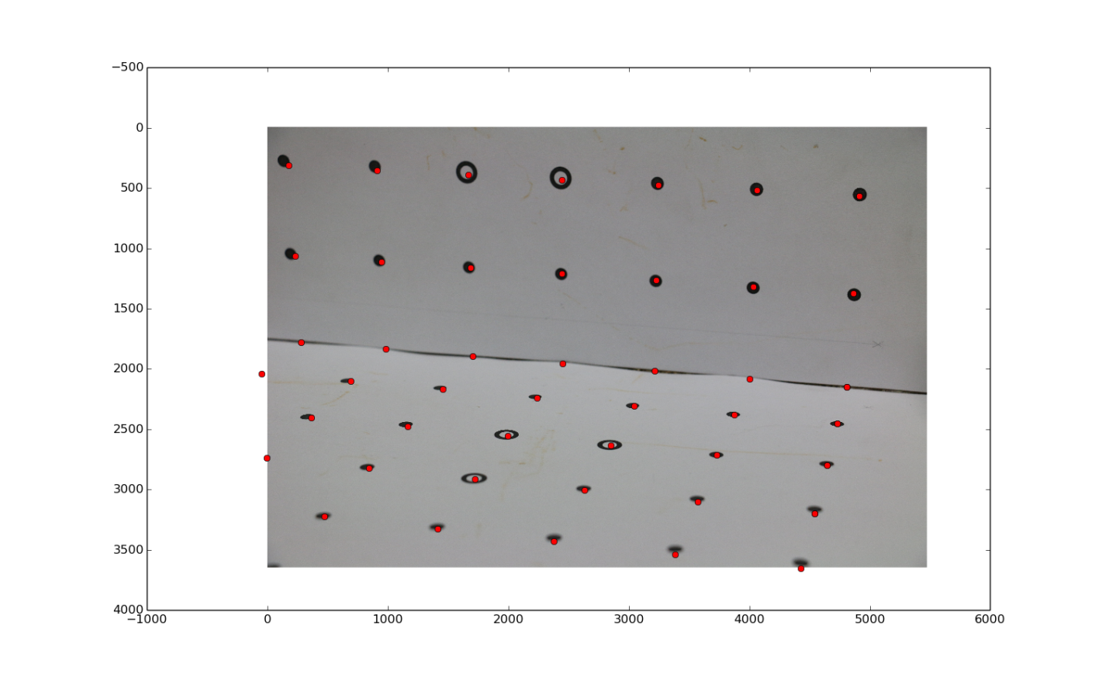

**Please note that only points have been plotted for clarity**

As we can see in the wireframe that error in calculating the image points is very low as compared to DLT. So projection matrix calculated using Ransac is better than that of DLT

**Zhang's to calibrate mobile phone camera:**

Captured following planar images of checker board and gave as input to opencv implementation of zhang’s calibration method:

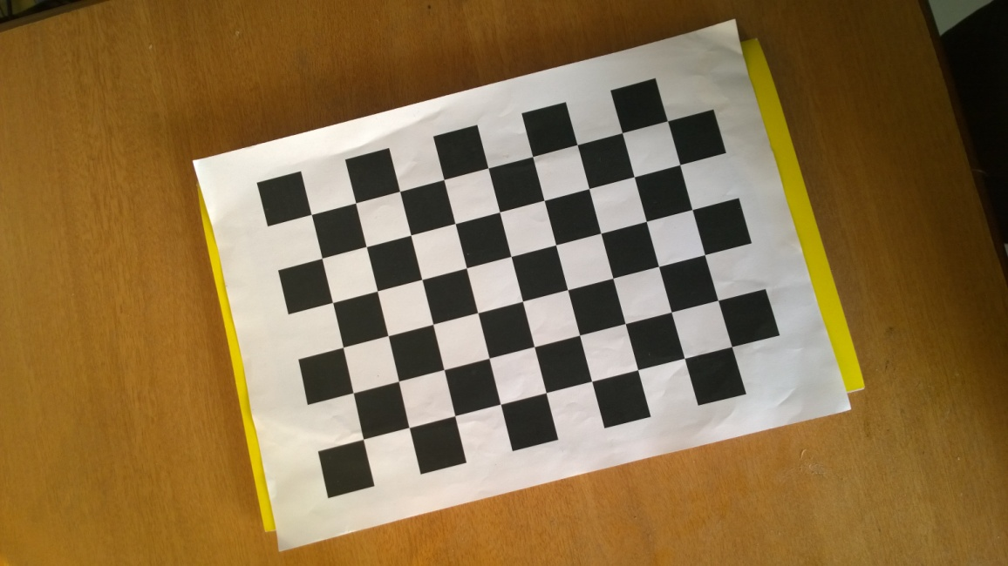

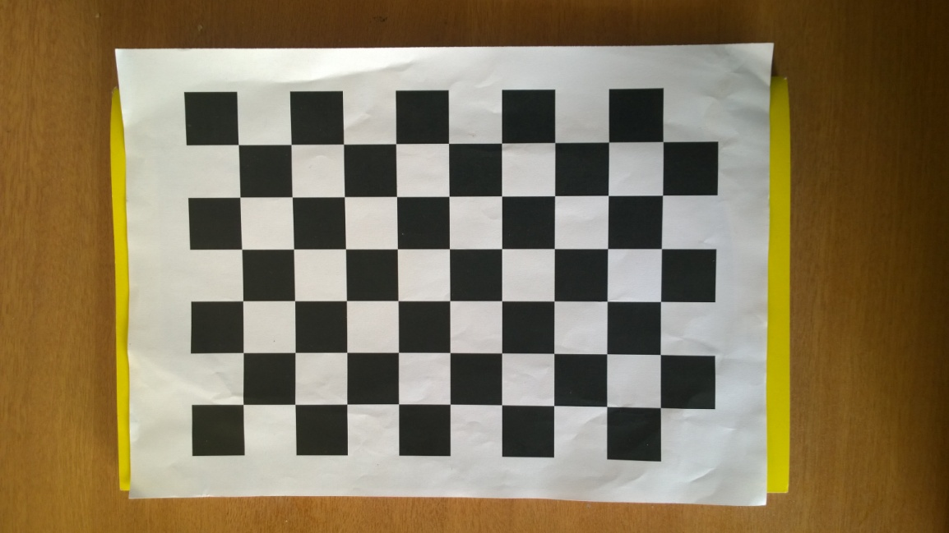

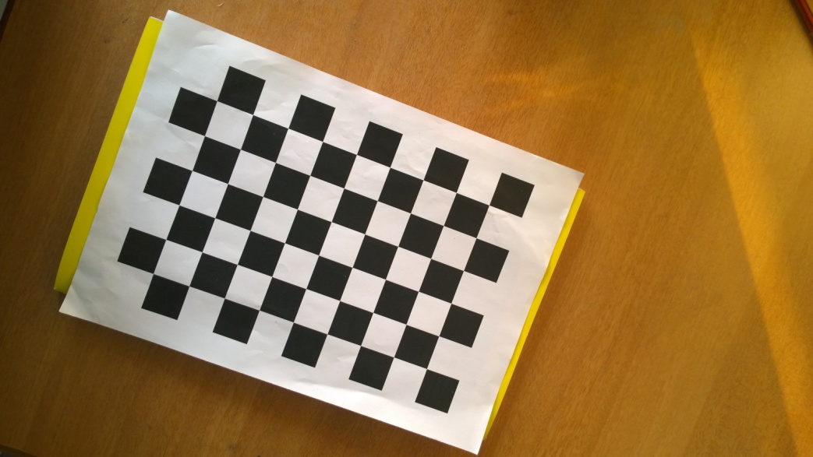

**Camera’s intrinsic parameters reported by zhang’s method:**

2.3429210562070466e+03 0. 1.5355000000000000e+03

0. 2.3429210562070466e+03 8.6350000000000000e+02

0. 0. 1.

**DLT to calibrate mobile phone camera:**

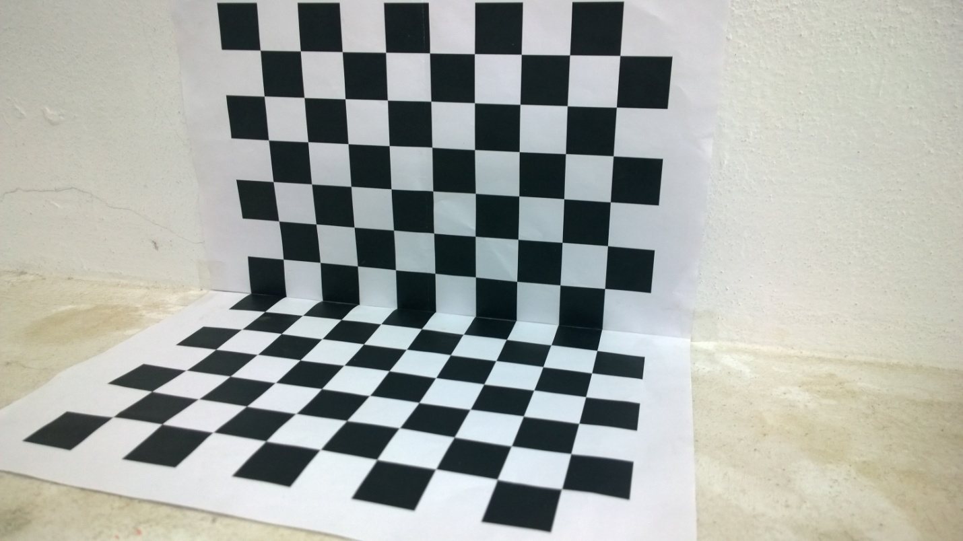

X

Z

Y

Image used for DLT

Same implementation of DLT as mentioned in 1st part is used

**Camera’s intrinsic parameters reported by DLT method:**

[[ 3.53671254e+03 0.0000012e-00 1.86234251e+03 ]

[ 0.00000000e+00 2.61537820e+03 8.47719485e+02]

[ 0.00000000e+00 0.00000000e+00 1]]

Please note above matrix is scaled to have a 1 in bottom right cell.

**Codes**

**# program to implement DLT method to calibrate the camera**

from numpy import *

import numpy as np

from scipy import linalg

A =[]

x = [[733, 989], [792,821], [775, 698], [912, 950], [803, 939], [651, 1045]] # checkerboard

X = [[0, 0, 25], [0,25,0], [0,50,0], [25,0,0], [0,0,0], [0,0,50]]

x = [[475, 3222], [3874, 2379], [4064, 509], [3242, 475], [2637, 3004], [4642, 2800]] # provided image

X = [[144, 0, 144], [36, 0, 36], [36, 72, 0], [72, 72, 0], [72, 0, 108], [0, 0, 72]]

def addPointToA(x,X): # Add image point x and world point X to A

l = [X[0],X[1],X[2],1,0,0,0,0,-1*x[0]*X[0], -1 * x[0]*X[1], -1*x[0]*X[2], -1*x[0]]

A.append(l)

l = [0,0,0,0,X[0],X[1],X[2],1,-1*x[1]*X[0], -1 * x[1]*X[1], -1*x[1]*X[2], -1*x[1]]

A.append(l)

def prepareA(): #prepare matrix A for selected points

for i in range(len(x)):

addPointToA(x[i], X[i])

prepareA()

print A

U,s,V = linalg.svd(A)

P = V[-1].reshape((3,4))

M =[]

for i in P:

M.append(i[0:3])

r, q = linalg.rq(M)

print 'Projection matrix is:'

print P

print 'camera intrinsic parameters are:'

print r

print

print 'camera extrinsic parameters are:'

print q

print 'Image points calculated using this camera matrix:'

for i in range(len(X)):

y = np.dot(P, X[i] + [1])

print 'World point: %s' % X[i]

print 'Actual Image point: %s' % x[i]

l = [y[0]/y[2], y[1]/y[2]]

print 'Calculated point: %s' % l

print

**# Program to implement ransac to calibrate camera**

from random import randint

from numpy import *

import numpy as np

from scipy import linalg

import math

A =[]

# 18 image points and world points

x = [[4731, 2453], [4873,1407], [4914, 564], [4010, 2073], [4826, 2141], [4642, 2800], [3874, 2379], [3038,2304], [4037, 1325], [4064,509], [3242, 475], [2440,1216], [3731,2712],[1155,2460], [2637,3004], [836,2807], [475,3222], [897,333]]

X = [[0, 0, 36], [0,36,0], [0,72,0], [36,0,0], [0,0,0], [0,0,72], [36,0, 36], [72,0,36], [36,36,0], [36,72,0], [72,72,0],[108,36,0], [36,0,72], [140,0,72],[72,0,108],[144,0,108], [144,0,144], [180,72,0]]

def addPointToA(x,X):

l = [X[0],X[1],X[2],1,0,0,0,0,-1*x[0]*X[0], -1 * x[0]*X[1], -1*x[0]*X[2], -1*x[0]]

A.append(l)

l = [0,0,0,0,X[0],X[1],X[2],1,-1*x[1]*X[0], -1 * x[1]*X[1], -1*x[1]*X[2], -1*x[1]]

A.append(l)

def prepareA():

d ={}

for i in range(6):

t = randint(0,17)

while t in d:

t = randint(0,17)

d[t] = 1

addPointToA(x[t], X[t])

P = []

threshold = 1

def getTotalError(): # return error in calculated points using current projection matrix

dist = 0

for i in range(0,12,2):

WP = [A[i][0], A[i][1], A[i][2]]

y = np.dot(P, WP + [1])

dist += (-1 * A[i][11] - y[0]/y[2]) * (-1 * A[i][11] - y[0]/y[2]) + (-1 * A[i+1][11] - y[1]/y[2]) * (-1 * A[i+1][11] - y[1]/y[2])

return math.sqrt(dist)

while 1:

A = []

prepareA()

U,s,V = linalg.svd(A)

P = V[-1].reshape((3,4))

if(getTotalError() <= threshold):

break;

M =[]

for i in P:

M.append(i[0:3])

r, q = linalg.rq(M)

print 'Projection matrix is:'

print P

print 'camera intrinsic parameters are:'

print r

print

print 'camera extrinsic parameters are:'

print q

print 'Image points calculated using this camera matrix:'

for i in range(6):

y = np.dot(P, X[i] + [1])

print 'World point: %s' % X[i]

print 'Actual Image point: %s' % x[i]

l = [y[0]/y[2], y[1]/y[2]]

print 'Calculated point: %s' % l

print

**#program to plot wireframe points for DLT and ransac, please note only points are plotted for clarity, lines joining them aren't drawn**

import matplotlib.pyplot as plt

import matplotlib.image as mpimg

import numpy as np

img=mpimg.imread('IMG_5455.JPG')

imgplot = plt.imshow(img)

P = [[ -3.74192548e-03, -7.09352321e-04, -2.08639185e-03, 9.11534249e-01], #DLT

[ -1.19471698e-04, -4.38859509e-03, 6.67848748e-04, 4.11177210e-01],

[ 1.03536464e-07, -2.21616919e-07, -3.72293950e-07, 1.90809706e-04]]

P = [[ 3.96173182e-03, 3.11538970e-04, 1.86238666e-03, -9.13153168e-01], #Ransac

[ 1.87708116e-04, 4.24084506e-03, -8.65777998e-04, -4.07569902e-01],

[ -7.63671423e-08, 1.19359844e-07, 3.05929301e-07, -1.89856060e-04]]

#all world points for provided image

X = [[[0, 72, 0], [36, 72, 0], [72, 72, 0], [108, 72, 0], [144, 72, 0], [180, 72, 0], [216, 72, 0]],

[[0, 36, 0], [36, 36, 0], [72, 36, 0], [108, 36, 0], [144, 36, 0], [180, 36, 0], [216, 36, 0]],

[[0, 0, 0], [36, 0, 0], [72, 0, 0], [108, 0, 0], [144, 0, 0], [180, 0, 0], [216, 0, 0]],

[[0, 0, 36], [36, 0, 36], [72, 0, 36], [108, 0, 36], [144, 0, 36], [180, 0, 36], [216, 0, 36]],

[[0, 0, 72], [36, 0, 72], [72, 0, 72], [108, 0, 72], [144, 0, 72], [180, 0, 72]],

[[0, 0, 108], [36, 0, 108], [72, 0, 108], [108, 0, 108], [144, 0, 108], [180, 0, 108]],

[[0, 0, 144], [36, 0, 144], [72, 0, 144], [108, 0, 144], [144, 0, 144]],

[[0, 72, 0], [0, 36, 0], [0 ,0 ,0], [0 ,0, 36], [0 ,0, 72], [0 ,0, 108]]]

for i in X:

for j in i:

y = np.dot(P, j + [1])

plt.plot(y[0]/y[2], y[1]/y[2], 'ro');

plt.show()