Attention Mask Benchmark
Dense vs. Sliding Window vs. BigBird-style Attention
Test System
Component | Specification
Processor | AMD Ryzen 7 7435HS (3.10 GHz)
Installed RAM | 24.0 GB (23.7 GB usable)
Graphics | NVIDIA GeForce RTX 3050 A Laptop GPU (4 GB)
Storage | 248 GB of 477 GB used
System type | 64-bit operating system, x64-based processor

Benchmark Results
Attention Type | Sequence Length | Time | Memory
Dense | 512 | 0.55 ms | 28.3 MB
Dense | 1024 | 0.41 ms | 36.9 MB
Dense | 2048 | 2.05 ms | 69.1 MB
Dense | 4096 | 8.18 ms | 193.6 MB
Dense | 8192 | 30.90 ms | 683.6 MB
Sliding Window | 512 | 0.42 ms | 28.3 MB
Sliding Window | 1024 | 0.54 ms | 36.9 MB
Sliding Window | 2048 | 1.86 ms | 69.1 MB
Sliding Window | 4096 | 7.10 ms | 193.6 MB
Sliding Window | 8192 | 27.74 ms | 683.6 MB
BigBird | 512 | 0.44 ms | 28.3 MB
BigBird | 1024 | 0.49 ms | 36.9 MB
BigBird | 2048 | 1.94 ms | 69.1 MB
BigBird | 4096 | 7.10 ms | 193.6 MB
BigBird | 8192 | 27.74 ms | 683.6 MB

System Screenshot
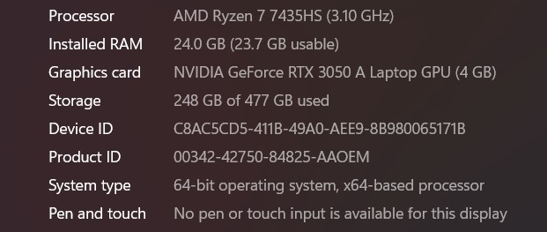
Hardware information used for the benchmark

