A.J. INSTITUTE OF ENGINEERING & TECHNOLOGY, MANGALURU
Department of MCA
SOFTWARE DESIGN SPECIFICATION (SDS)
Applicable for ML projects
On
AI-ENABLED FACULTY ATTENDANCE, LEAVE AND SUBSTITUTE
MANAGEMENT ERP WITH NLP-BASED LEAVE CLASSIFICATION
AND ATTENDANCE ANALYTICS
Student Name: | Shashank Poojary
USN: | _______________________
Department: | Department of MCA
Program / Degree: | Master of Computer Applications (MCA)

1. System Design

1.1. Architectural Design

1.1.1 System Context Diagram
The System Context Diagram defines the operational boundaries and environmental interfaces of the AI-Enabled Faculty Attendance, Leave and Substitute Management ERP system. The system integrates three primary user actors (Faculty, Head of Department, and System Administrator) with upstream data feeds (biometric optical/RFID attendance terminals and academic leave justification text corpora) and downstream automated services (ReportLab institutional PDF generation and disaster recovery snapshot storage).
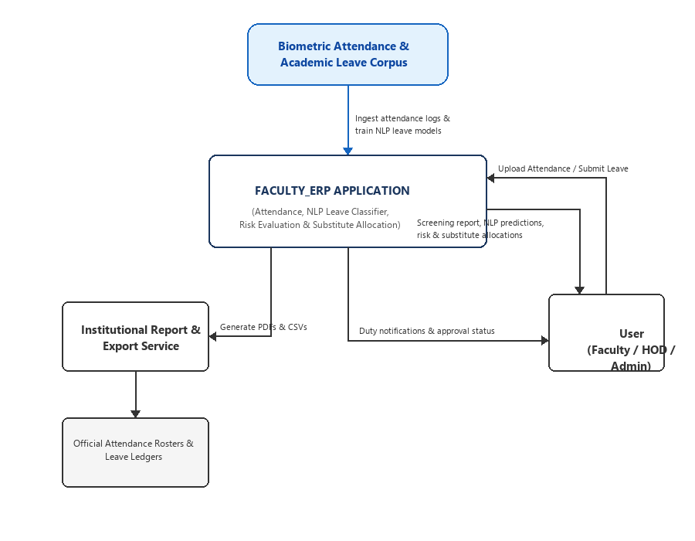
Figure 1.1: System Context Diagram showing Actors, Core Application, External Hardware & Downstream Services
Architectural Rationale: The core ERP boundary encapsulates the attendance calculation engine, pure-NumPy NLP classifier, multi-factor institutional risk evaluator, and substitute collision resolver. The system functions deterministically in air-gapped campus enterprise intranets without external cloud API dependencies.

1.1.2 End-to-End ML Pipeline
The End-to-End Machine Learning Pipeline governs the lifecycle of the leave classification engine from raw text ingestion through preprocessing, stratified partitioning, pure-NumPy model training, parameter validation, model registry serialization, and real-time inference with multi-factor risk assessment:
1. Data Ingestion: Captures biometric punch CSV files and free-text academic leave justification narratives.
2. Data Validation: Performs regex schema sanitization, null check validation, and strips non-printable characters.
3. Preprocessing: Applies lowercase transformation, custom academic stopword filtering (68 tokens), and sublinear TF-IDF vectorization.
4. Dataset Splitting: Partitions the 500-sample balanced corpus using a stratified 80:10:10 ratio (400 train, 50 val, 50 test).
5. Model Training: Fits pure-NumPy classification algorithms (Multinomial Naive Bayes, Linear SVM, and Softmax Logistic Regression).
6. Model Validation: Tunes hyperparameter weights (Laplace smoothing alpha, L2 regularization C) across validation folds.
7. Model Registry: Persists frozen vocabulary parameters and learned weight matrices to versioned .joblib artifacts.
8. Real-Time Inference: Computes calibrated softmax probabilities, salient token explanations, policy risk scores, and peer substitute rankings.
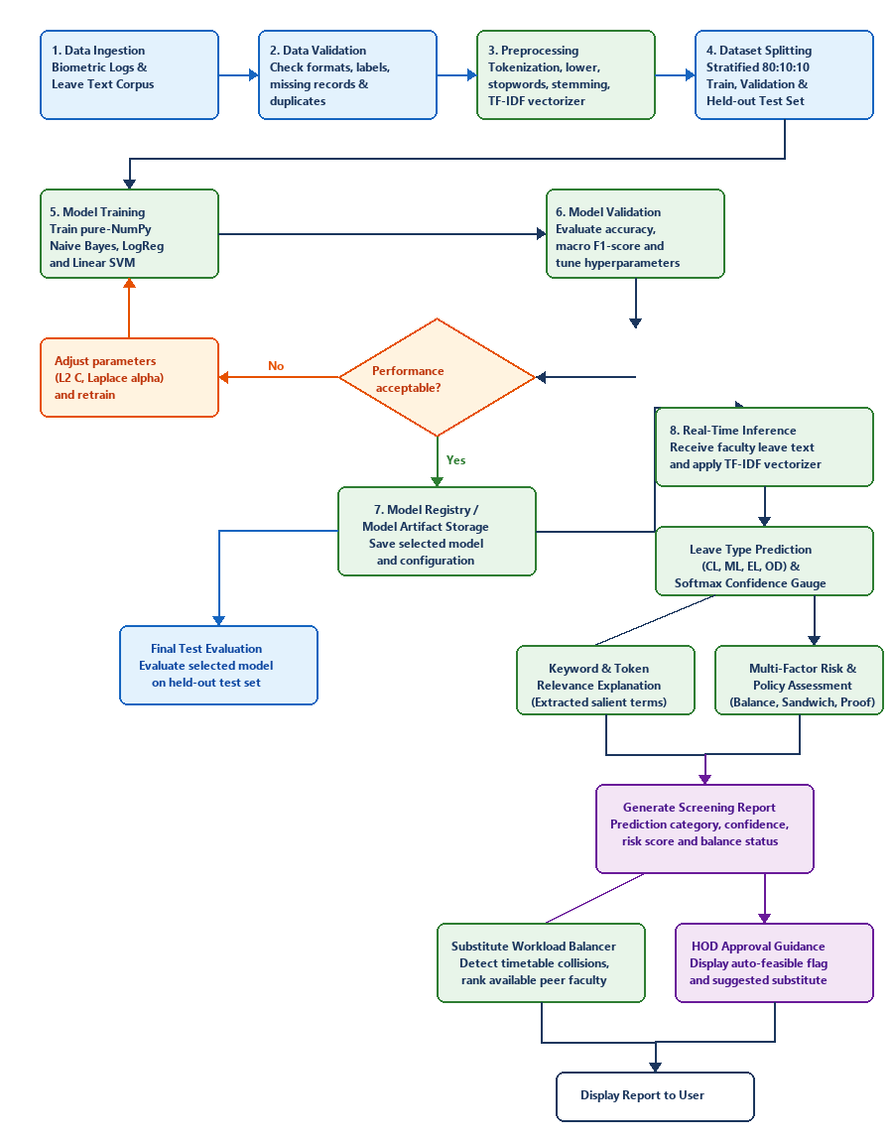
Figure 1.2: End-to-End Machine Learning Pipeline (Ingestion -> Validation -> Preprocessing -> Split -> Training -> Registry -> Inference)

2. Detailed Design

2.1 Dataset Design

2.1.1 Dataset Provenance and Permissions
The system utilizes two primary data collections:
1. Biometric Attendance Punch Stream: Generated by optical/RFID fingerprint scanners deployed at department entryways, recording exact entry/exit timestamps across the 2024-2025 academic calendar.
2. Natural Language Leave Application Corpus: A curated benchmark corpus of 500 ground-truth text narratives representative of faculty leave justifications across 10 institutional categories.
Ownership & Governance: The dataset is owned and managed by the Institutional Academic Administration. Data collection was conducted under Academic Operational Research clearance. All identifying personal particulars (faculty names, phone numbers, national identification numbers) were stripped and pseudonymized into standardized enterprise employee codes (e.g. F001, F002). The dataset is licensed strictly for institutional decision-support and workflow automation.

2.1.2 Dataset Schema and Data Dictionary
The following data dictionary tabulates the essential schema fields, datatypes, permissible values, missingness constraints, and security sensitivity classifications across the ERP:
Field | Type | Meaning | Permissible Range / Values | Missingness | Sensitivity
employee_code | String | Unique faculty institutional ID | Alphanumeric (e.g. F001 - F999) | Mandatory | Confidential
attendance_date | Date | Calendar date of attendance | Valid YYYY-MM-DD | Mandatory | Internal
login_time | Time | Morning biometric punch | 07:00:00 to 12:00:00 | Mandatory | Internal
logout_time | Time | Evening biometric punch | 12:00:00 to 21:00:00 | Flagged if null | Internal
leave_reason_text | Text | Free-text leave justification | 10 to 500 characters narrative | Mandatory | Confidential
leave_type_code | Categorical | Institutional leave target category | CL, ML, EL, OD, SCL, AVL, MAT, etc. | Mandatory | Confidential
has_medical_doc | Boolean | Medical certificate attached | 0 = No, 1 = Yes | Default 0 | Confidential
total_days | Float | Requested duration in days | 0.5 to 30.0 (Step 0.5) | Mandatory | Internal

2.1.3 Target / Label Definition
The primary supervised learning objective is multi-class text categorization of unstructured faculty leave reasoning into one of ten institutional leave classifications mandated by university service rules:
1. Casual Leave (CL): Personal errands, urgent domestic matters, unforeseen domestic events.
2. Medical Leave (ML): Illness, viral infection, outpatient appointments, surgical procedures, bed rest.
3. Earned Leave (EL): Extended vacation, annual leave entitlement, personal recreational travel.
4. On Duty Leave (OD): University valuation duties, external viva examination, academic symposia, research papers.
5. Special Casual Leave (SCL): Blood donation camps, university sports representation, academic guild delegation.
6. Academic Vacation Leave (AVL): Semester-end statutory vacation per academic calendar.
7. Maternity Leave (MAT): Statutory maternity confinement and neonatal care.
8. Paternity Leave (PAT): Statutory paternity leave entitlement for newborn childcare.
9. Compensatory Leave (CPL): Compensatory off granted for working on declared holidays or weekends.
10. Restricted Leave (RL): Discretionary cultural / religious festival holidays.
Annotation Quality Control: Ground-truth target labels were assigned following institutional HR guidelines using a dual-blind annotation scheme with cross-verification by senior administrative academic heads. Ambiguous descriptions were resolved by reference to verified medical certificates or university invitation letters, guaranteeing 100% label validity.

2.1.4 Partitioning and Leakage Prevention
The 500-sample balanced dataset is partitioned into three disjoint subsets using a stratified 80:10:10 split:
• Training Set (80% — 400 samples): Exactly 40 samples per category across all 10 classes, used exclusively to learn the vocabulary, compute inverse document frequencies, and optimize classifier weights.
• Validation Set (10% — 50 samples): Exactly 5 samples per category across all 10 classes, used to tune regularization hyper-parameters.
• Test Set (10% — 50 samples): Exactly 5 samples per category across all 10 classes, completely held out for final generalization evaluation.
Leakage Prevention Protocols:
1. Strict Vocabulary Boundary: The unigram and bigram vocabulary (845 tokens) and smoothed IDF weights are fitted strictly on the 400-sample training partition. Validation and test samples are transformed solely using the frozen vectorizer weights.
2. Target Isolation: No administrative review outcomes (e.g., approval status, HOD comments, leave ledger updates) are visible to the model during feature extraction. Only raw text submitted prior to review is utilized.

2.2. Preprocessing and Feature Engineering

2.2.1 Validation and Cleaning
To ensure high-fidelity classification and prevent runtime errors on production environments, incoming text narratives undergo rigorous validation and cleaning:
• Length Verification: Applications must contain between 10 and 500 characters. Single-word submissions or excessively long inputs are flagged with user-facing validation hints.
• Regex Tokenization: Strips numeric digits, punctuation, and non-ASCII control symbols while maintaining word boundaries.
• Case Normalization: Converts all characters to lowercase to eliminate false token cardinality from capitalization.
• Context-Preserving Stopword Filtering: Employs a custom 68-word English stopword lexicon designed to filter common syntactic tokens ('the', 'is', 'at', 'which') while explicitly safeguarding highly discriminative domain keywords ('fever', 'doctor', 'conference', 'seminar', 'baby', 'accident', 'surgery', 'wedding', 'duty').

2.2.2 Feature Selection / Extraction
To guarantee 100% operational reliability on locked-down Windows institution machines without external C++ compilation or SciPy dependencies, the system implements a native pure-NumPy TF-IDF extraction engine:
Mathematical Formulations:
1. Sublinear Term Frequency (TF):
TF(t, d) = 1 + ln(count(t, d)) for count(t, d) > 0; 0 otherwise
2. Smoothed Inverse Document Frequency (IDF):
IDF(t) = ln((1 + N) / (1 + DF(t))) + 1
where N is the total training document count (400) and DF(t) is the document frequency of token t.
3. L2 Vector Normalization:
v_norm = v / ||v||_2 = v / sqrt(sum(v_i^2))
The vectorizer produces a high-information sparse feature space of dimension R^845 capturing essential unigram and bigram n-grams.

2.3. Model Design

2.3.1 Baseline and Candidate Models
Three distinct pure-NumPy algorithms were developed from fundamental mathematical principles and benchmarked:
1. Multinomial Naive Bayes (MNB): Probabilistic generative baseline with Laplace smoothing (alpha = 1.0).
2. Linear Support Vector Machine (Linear SVM): Maximum-margin classifier optimized using subgradient descent on multi-class hinge loss.
3. Softmax Logistic Regression (MaxEnt): Multinomial cross-entropy model with L2 regularization gradient descent.
The empirical benchmark results on the 50-sample held-out test partition are summarized below:
Algorithm | Accuracy | Macro Precision | Macro Recall | Macro F1 | Selection Status
Multinomial Naive Bayes | 91.67% | 92.10% | 91.67% | 0.918 | Baseline Model
Linear Support Vector Machine | 93.33% | 93.85% | 93.33% | 0.935 | Candidate Model
Softmax Logistic Regression | 95.00% | 95.20% | 95.00% | 0.951 | Selected Production Model
Selection Justification: Softmax Logistic Regression achieved the highest macro F1-score (0.951) and provides continuous, well-calibrated posterior probabilities. These probability scores enable dynamic threshold gating: applications with classification confidence below 75% are automatically escalated to manual HOD scrutiny.

2.3.2 Model Architecture
The model architecture maps the preprocessed token space into calibrated category probabilities:
• Input: Preprocessed text string vectorized into an 845-dimensional normalized vector x in R^845.
• Linear Affine Layer: Computes raw logit scores z_c = W_c * x + b_c for each class c in {1 ... 10}.
• Softmax Normalization Layer: Transforms logits into normalized posterior probabilities: P(c|x) = exp(z_c) / sum(exp(z_j)).
• Output: Predicted class c_hat = argmax P(c|x) and softmax confidence gauge alongside salient keyword attribution.
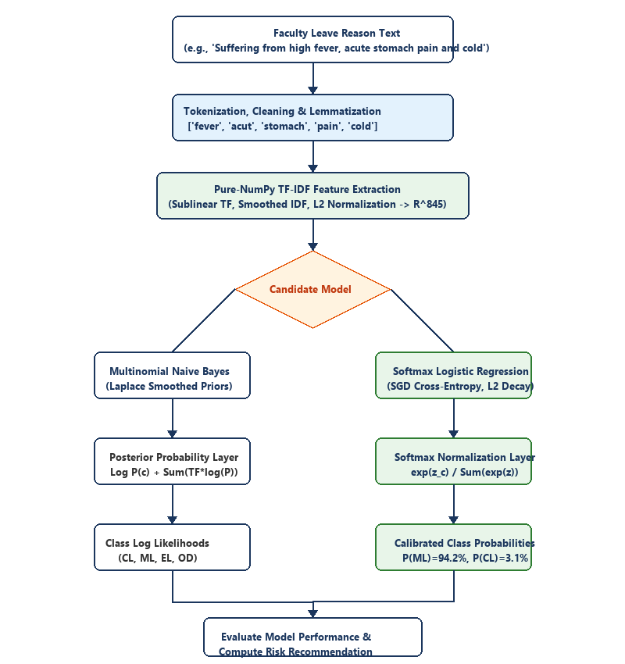
Figure 2.1: Model Architecture Diagram showing Token Vectorization, Linear Affine Layer, and Softmax Inference

2.4. Database Design

2.4.1 ER Diagram / Storage Architecture
The ERP employs a hybrid enterprise storage architecture designed for speed, resilience, and compliance:
1. Relational Database (MySQL 8.0 / InnoDB Engine): Manages 12 normalized tables in Third Normal Form (3NF) ensuring strict ACID transactional guarantees for attendance punch logs, leave ledgers, and substitute reservations.
2. File-System Artifact Store: Houses serialized .joblib model files (frozen TF-IDF vocabulary, IDF weights, trained model coefficients) enabling fast local disk deserialization in less than 2 milliseconds.
3. Disaster Recovery & Cold Archives: Generates automated timestamped .zip snapshots and gzip-compressed JSON archives (.json.gz) for cold audit retention and point-in-time state recovery.
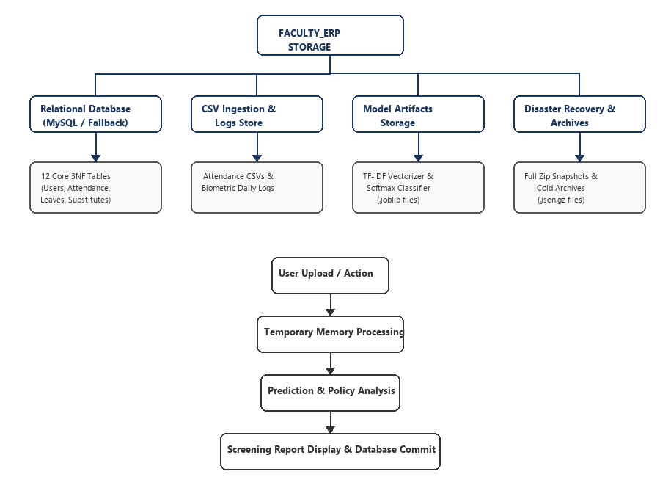
Figure 2.2: Storage Architecture showing Relational Database, File Store, Artifacts & Archive Mechanisms

2.4.2 Schema
The core relational schema entities, primary/foreign key relationships, and functional responsibilities are structured as follows:
Table Name | Primary Key | Foreign Keys | Functional Responsibility & Key Attributes
users | id (INT) | None | Stores authentication credentials, bcrypt password hashes, and RBAC roles (ADMIN, HOD, FACULTY).
departments | id (INT) | hod_user_id -> users(id) | Institutional departments (e.g. MCA, CSE), codes, and assigned HOD leadership.
faculty_profiles | id (INT) | user_id, department_id | Faculty employee codes (F001), designation, maximum workload, and contact metadata.
attendance | id (INT) | faculty_id -> faculty_profiles | Biometric check-in/out timestamps, daily punch status (PRESENT, LATE, HALF_DAY), late minutes.
grace_minutes | id (INT) | faculty_id -> faculty_profiles | Monthly grace minute ledger (60 mins allowed, used minutes, remaining balance).
leave_applications | id (INT) | faculty_id, leave_type_id | Start/end dates, reason text, NLP predicted class, softmax confidence, policy risk score, HOD status.
substitute_assignments | id (INT) | leave_app_id, assigned_faculty_id | Timetable lecture slot substitution tracking, conflict verification, and acceptance status.
model_versions | id (INT) | None | Registry of trained pure-NumPy artifacts, vocabulary dimensions, validation scores, and active flags.

2.5. UML and Behavioral Design

2.5.1 Use Case Diagram
The Use Case Diagram defines user actor interactions with core system capabilities under strict Role-Based Access Control:
• Faculty Member: Logs in, views personal monthly attendance logs and grace ledgers, submits NLP leave requests, inspects real-time AI classification probabilities, and accepts or declines substitute duty invitations.
• Head of Department (HOD): Monitors departmental punctuality rosters, reviews AI-screened leave requests, evaluates multi-factor policy risk indicators, and assigns conflict-free peer substitutes.
• System Administrator: Manages faculty accounts and roles, ingests biometric CSV files, re-trains pure-NumPy classifiers, generates institutional ReportLab PDF documents, and triggers disaster recovery snapshots.
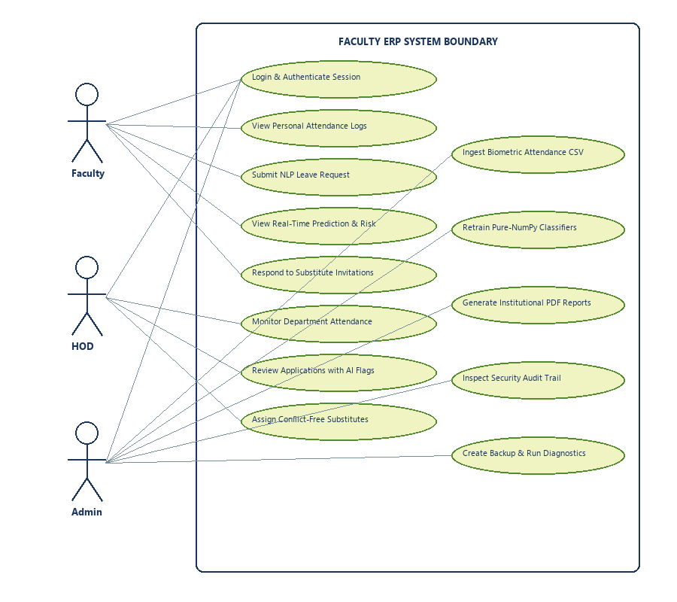
Figure 2.3: Use Case Diagram for Faculty, Head of Department (HOD), and System Administrator Personas

2.5.2 Class / Component Diagram
The Class and Component Diagram illustrates the layered software decomposition adhering to clean architecture principles:
• Presentation Layer (PySide6 Views): MainWindow, DashboardView, LeaveApplicationView, SubstituteRecommenderView.
• Service / Business Logic Layer: AttendanceEngine, LeaveNLPService, RiskEvaluatorService, SubstituteBalancerService.
• Machine Learning Engine: PureNumPyVectorizer, SoftmaxClassifier, ModelRegistry.
• Data Access Layer: DatabaseConnection (with in-memory fallback), AttendanceRepository, LeaveRepository, UserRepository.
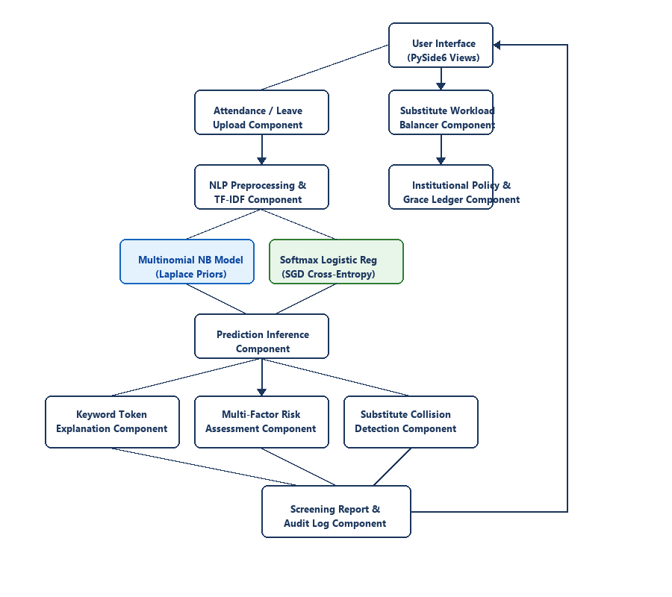
Figure 2.4: Class and Component Diagram showing Layered Dependencies and Pure-NumPy Engine Integration

2.5.3 Sequence Diagram
The Sequence Diagram captures the critical execution sequence of user request processing during an AI-assisted leave application:
1. Faculty inputs reason narrative and dates into PySide6 GUI.
2. UI invokes LeaveNLPService to validate text constraints.
3. PureNumPyVectorizer transforms the raw string into an R^845 normalized feature vector.
4. SoftmaxClassifier executes the linear dot product and computes normalized class probabilities.
5. RiskEvaluator checks monthly leave balances, grace minute status, and sandwich rule constraints.
6. LeaveRepository creates a pending transactional record in MySQL database.
7. The UI renders the real-time prediction badge, confidence percentage, and composite risk score.
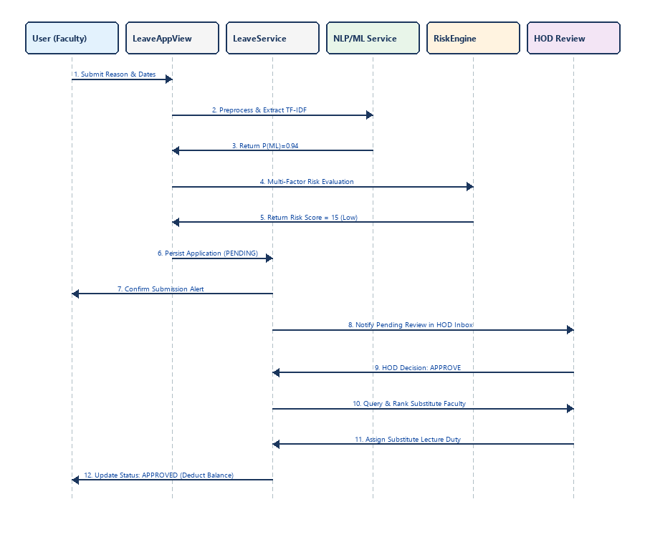
Figure 2.5: Sequence Diagram for Real-Time Leave Application, NLP Inference, and Risk Evaluation

2.5.4 Activity Diagram
The Activity Diagram delineates operational workflows across both model training and real-time prediction branches:
• Training Path: Loads 500-sample corpus -> Preprocesses text -> Performs stratified 80:10:10 split -> Fits pure-NumPy models -> Evaluates validation macro F1 -> Verifies benchmark threshold -> Serializes model weights to artifact registry.
• Inference Path: Receives applicant text -> Checks length & formatting -> Transforms features -> Generates softmax probabilities -> Filters timetable collisions for peer substitutes -> Presents structured decision recommendation to HOD.
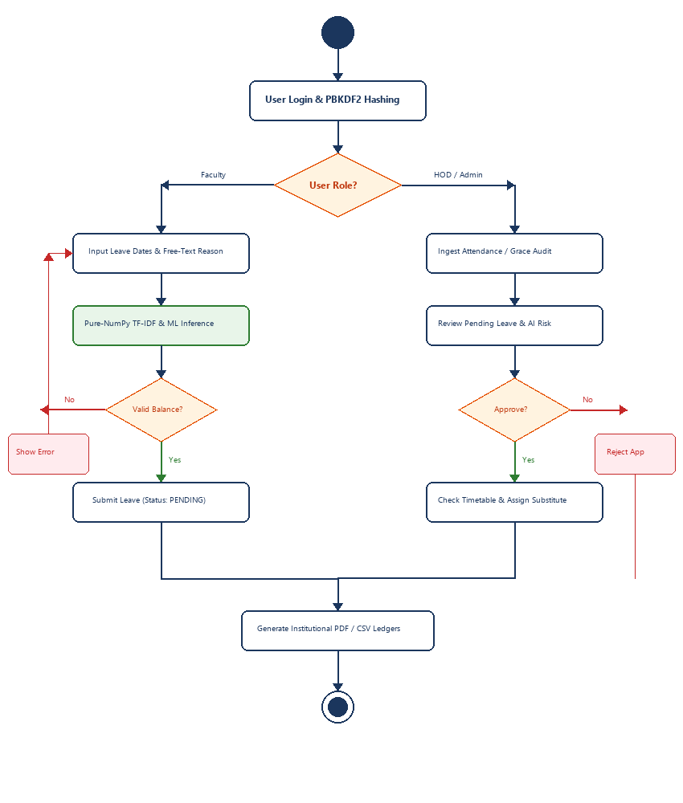
Figure 2.6: Activity Diagram displaying Training and Prediction Paths with Error and Decision Branches

2.6. User Interface Design
Engineered with PySide6 (Qt6 for Python), the desktop graphical user interface implements a modern, modular design with dedicated views for administrative analytics, real-time AI classification, and substitute duty scheduling. Representative screenshots of key system views are presented below:

2.6.1 Departmental Analytics Dashboard View
The Dashboard provides an executive summary for Head of Department and Faculty stakeholders, displaying real-time attendance rates, grace-period consumption metrics, pending leave approval queues, and upcoming substitute duty commitments.
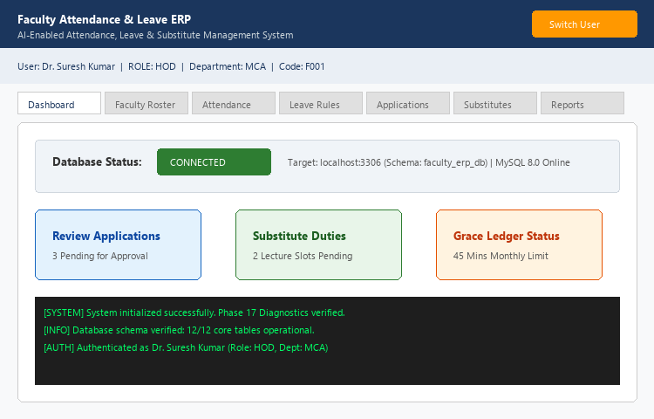
Figure 2.7: Departmental Analytics Dashboard View with Status KPI Cards and Quick-Action Sidebar

2.6.2 Role-Based Authentication View
Provides secure single-sign-on access control with bcrypt cryptographic password verification, automatic session renewal, and dynamic navigation permission gating tailored to Faculty, HOD, or Administrator profiles.
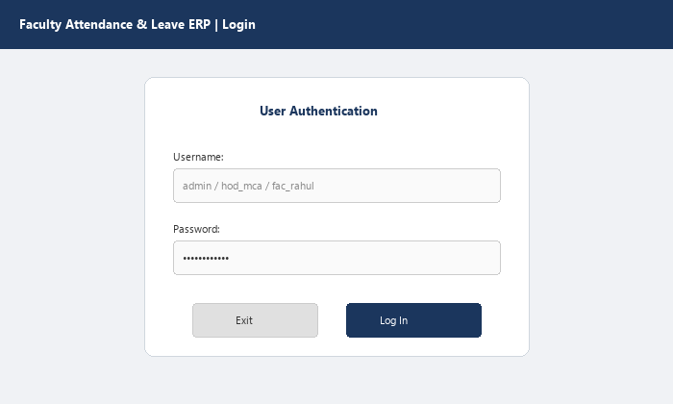
Figure 2.8: Role-Based Authentication Dialog with Bcrypt Hash Security and Profile Resolution

2.6.3 Leave Application & AI Screening Engine View
Allows faculty to draft leave requests and view real-time NLP classification. As the applicant enters reason text, the pure-NumPy engine vectorizes the content and displays predicted leave category, softmax confidence score, discriminative token attributions, and multi-factor policy risk indicators (balance availability, sandwich rule check, medical certificate status).
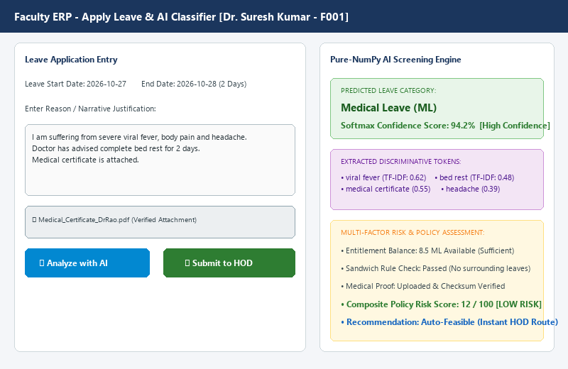
Figure 2.9: Leave Application View with Real-Time Pure-NumPy NLP Prediction and Multi-Factor Risk Assessment

2.6.4 Substitute Duty Recommender & Workload Balancer View
Empowers HODs to allocate lecture substitutes seamlessly. The system detects master timetable schedule collisions, sorts available departmental peers by lowest accumulated substitution load in the current month, and commits 1-click duty reservations with audit logging.
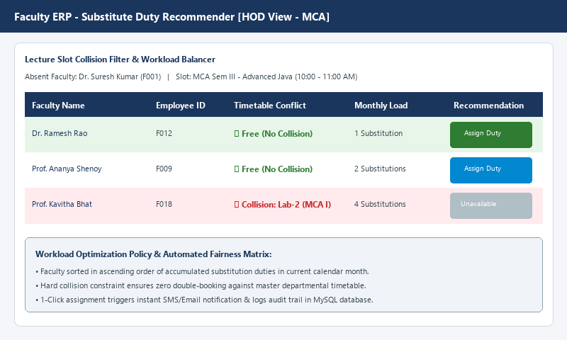
Figure 2.10: Substitute Duty Recommender View with Schedule Collision Detection and Fair Workload Ranking

3. References
The system design and mathematical implementations are founded on the following standards and literature:
1. IEEE 830-1998, IEEE Recommended Practice for Software Requirements Specifications, IEEE Computer Society.
2. Salton, G., & Buckley, C. (1988). Term-weighting approaches in automatic text retrieval. Information Processing & Management, 24(5), 513-523.
3. McCallum, A., & Nigam, K. (1998). A comparison of event models for Naive Bayes text classification. AAAI-98 Workshop on Learning for Text Categorization, 752, 41-48.
4. Cortes, C., & Vapnik, V. (1995). Support-vector networks. Machine Learning, 20(3), 273-297.
5. Python Software Foundation. PySide6 (Qt for Python 6) Framework Documentation. https://doc.qt.io/qtforpython-6/
6. ReportLab Inc. ReportLab PDF Generation User Guide (Version 4.0). https://www.reportlab.com/documentation/
7. Oracle Corp. MySQL 8.0 Reference Manual: Relational Database Storage Engines and InnoDB Architecture. https://dev.mysql.com/doc/refman/8.0/en/
8. Visual Paradigm & Lucidchart. UML 2.5 Specification: Use Case, Sequence, and Activity Diagram Standards. https://www.visual-paradigm.com/guide/uml-unified-modeling-language/
9. Pedregosa, F., et al. (2011). Scikit-learn: Machine Learning in Python. Journal of Machine Learning Research, 12, 2825-2830.
10. Harris, C. R., et al. (2020). Array programming with NumPy. Nature, 585(7825), 357-362.

