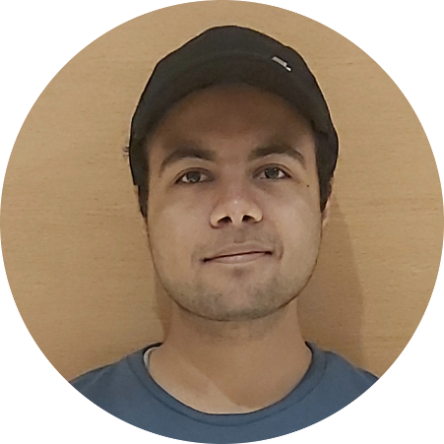

**Student Mentor:**

I was nominated as a student mentor by the college authority to guide my juniors on their academic and personal issues.

**Content Team Head:**

I was chosen as the content team head of a college-based club.

**Discord Chat Bot:**

I designed a basic prototype of a discord-based chat bot in python.

**Responsive Portfolio Website:**

I designed a responsive portfolio website using HTML, CSS and JavaScript

**School Discipline Minister:**

I was elected as the School Discipline Minister by the school authority.

**Voice controlled bot:**

I designed a voice-controlled bot using Arduino in a workshop.

**Management team:**

Organized several events both online and offline while in college.

I perform better when I work in a team. I am proficient in communication skills as I can efficiently communicate in both English and Hindi. Also, I learn things at a faster pace. I try to accomplish the task I’ve been assigned. I like to meet new people and am always enthusiastic about working with them. I do have the quality of leadership. I’m acquiring a lot of new skills and working on myself to present the best version of myself. I’m always ready for new opportunities.

Education

**2024:** Bachelor of Technology in Electronics Engineering *from* Madhav Institute of Technology and Science, Gwalior (M.P.)

**2019:** Graduated Pre-University (12th standard) in PCM *from* St. Joseph’s Convent Sr. Sec. School, Sagar (M.P.)

Experience

Summary

Basics of Python

Basics of MySQL

Basics of LTSpice

Basics of Java

Basics of WebDev

Content Writing

Skills

Languages

English

Hindi

Reading

Travelling

Drawing and sketching

Sports

Hobbies

Sagar- India

**6264713299**

[**thegarvitpandey@gmail.com**](mailto:thegarvitpandey@gmail.com)

**Garvit Pandey**