EXT: Multiple Content
Extension Key: jfmulticontent
Language: en
Keywords: multiple content tabulator accordion slider jquery ui
Copyright 2000-2019, Franz Holzinger, Juergen Furrer, <franz@ttproducts.de>

jQuery UI © 2009 Paul Bakaus, http://jqueryui.com/
jQuery © 2009 John Resig http://ejohn.org/ and the jQuery Team http://docs.jquery.com/Contributors
anythingSlider By Chris Coyier http://css-tricks.com
SlideDeck © 2010 digital-telepathy http://www.dtelepathy.com
easyAccordion © 2010 Andrea Cima Serniotti http://www.madeincima.eu
booklet © 2010 W. Grauvogel http://builtbywill.com/

easyAccordion and booklet sponsored by http://www.made-in-nature.de/typo3-agentur.html

This document is published under the Open Content License
available from http://www.opencontent.org/opl.shtml

The content of this document is related to TYPO3
- a GNU/GPL CMS/Framework available from www.typo3.org

Table of Contents
EXT: Multiple Content 1
Introduction 3
What does it do? 3
Screenshots 4
Users manual 5
Multiple Columns 7
Attributes 8
Overwrite Title 8
Options 9
Tab 10
Accordion 11
Slider 12
SlideDeck 13
easyAccordion 14
Booklet 15
Typoscript 16
Administration 17
Page configuration 18
Updater 19
Configuration 20
Reference 20
FAQ 26
Additional tt_news codes 29
Known problems 30
To-Do list 31
ChangeLog 32

Introduction

What does it do?
With this extension you're able to show multiple content elements in one content.
There are seven possibility's:
- Multiple contents, like the sub columns in yaml
- Tabulator
- Accordion
- Sider
- SlideDeck
- easyAccordion
- Booklet

Screenshots
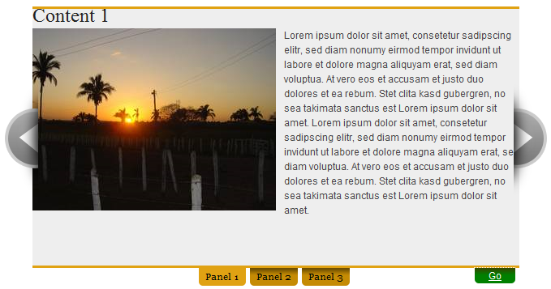
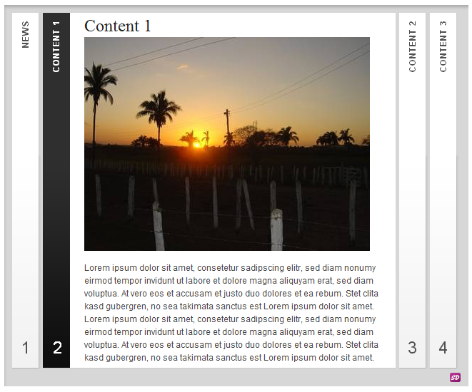
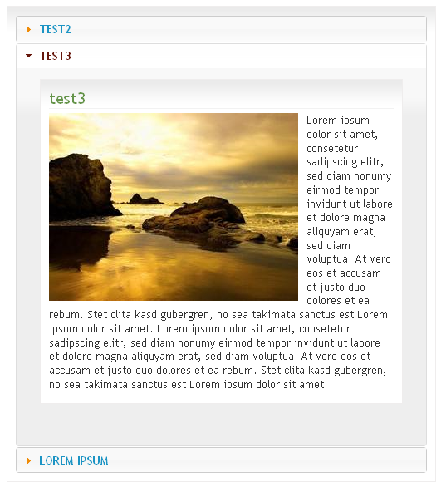
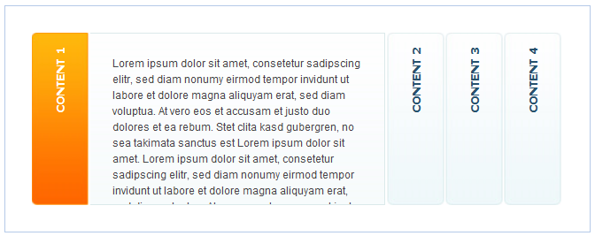
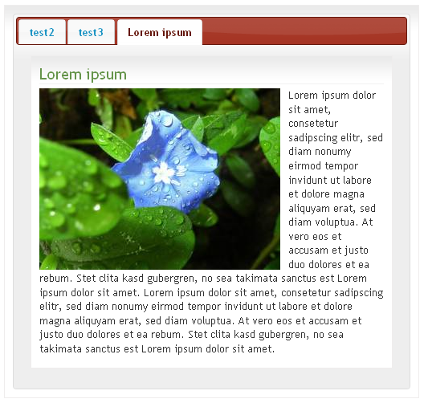
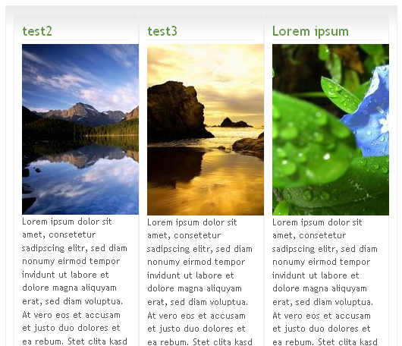
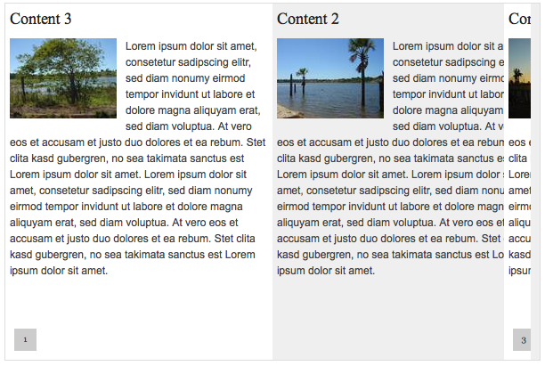

Users manual
Here you can find a video-tutorial in german:
http://jweiland.net/typo3-hosting/service/video-anleitungen/typo3-extensions/jfmulticontent.html

There are two different methods to choose multiple content:
- Choose content from one “General Record Storage page”
- Choose contents from any site
Your administrator can define this in the configuration of the extension. If this feature is activated, the select box of the content will change. More of this later.
To add a multiple content to a site, you have to define a “General Record Storage page” for your current page. You can define only one “General Record Storage page” per page.
To do this, you have to:
- Go to Web → Page
- Choose the page you want to add the “General Record Storage page”
- “Edit page property”
- Go to tab “Option”
- Set the TS Config entry to a Sysfolder e.g. with id=17:
TCEFORM.tt_content.tx_jfmulticontent_contents.PAGE_TSCONFIG_ID = 17
You should use a SysFolder for the related content records, formerly (before TYPO3 7) “General Record Storage page”.
Your Page could look like this:
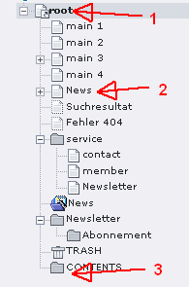
Define the related sysfolder on root (1) and set it to the SysFolder (3)
Go to the page (2) and create a new content:
- Go to Web → Page
- Choose the page where the new content should be displayed (2)
- Create new content
- Choose the plugin “Multiple Content”
- Go to tab “Plugin”

First you should define the contents to display before TYPO3 7.
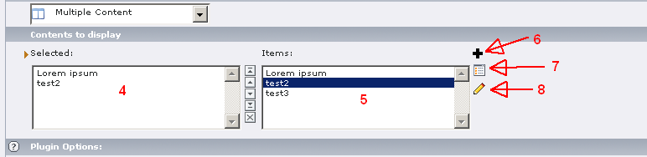
The “Selected” (4) are the contents witch will be displayed in the “Multi Content”
“Items” (5) show all available contents in “General Record Storage page”
You can add (6) new contents directly to the “General Record Storage page”
You can show (7) the list of all contents in “General Record Storage page”
You can edit (8) existing contents (choose them first in “Selected”)

In case of “Use General Record Storage page only”-configuration is turned off, the “Content to display” looks like this:
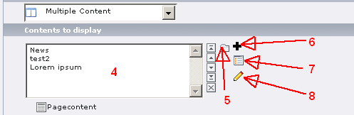
The only difference here is the file browser (5). You are able to choose content from every site and every SysFolder.
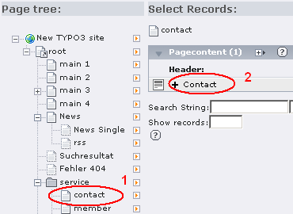
After click the icon (5) you get a popup, where you can choose a page on the left (1) and choose on the right the content to include in your multiple content element.
Be warned by changing content (8) you selected from another page, if you change it in multiple content, you will change it everywhere else too, because it is the same content!

Multiple Columns
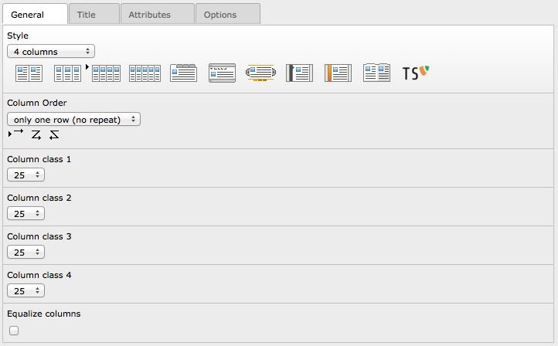
If you choose “2 columns” you have to select the “Column class 1” and the “Column class 2”. The sum of these values should be 100%. This applies to 3 and 4 columns also.
For 3 columns the following combinations are possible:
33 | 33 | 33
25 | 25 | 50
25 | 50 | 25
20 | 20 | 60
and so on...
This will generate, in normal configuration, classes to the content like in YAML:
class=”c33l” | class=”c33l” | class=”c33r”

The class name can be defined in constant editor by the integrator and will be wrapped with the number you choose.

Attributes
You can define additional attributes to the contents. Go to the “Attributes”-tab and write one attribute per line.
It's possible to define multiple attributes per line:
style=”width: 20em;” class=”myclass”
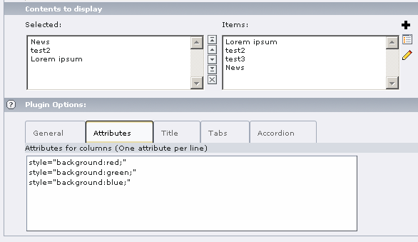
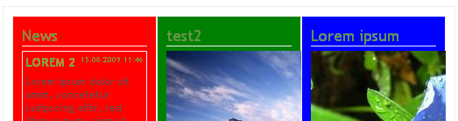

Overwrite Title
For “Tabs”, “Accordion”, “Slider”, “SlideDeck“, “easyAccordion”, “booklet”-style you can overwrite the titles by defining theme in “Overwrite titles”.
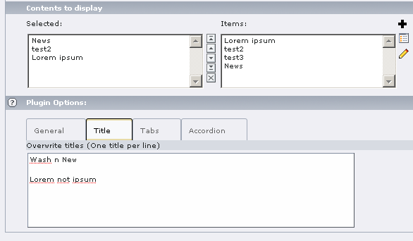
This example would produce an output like this:
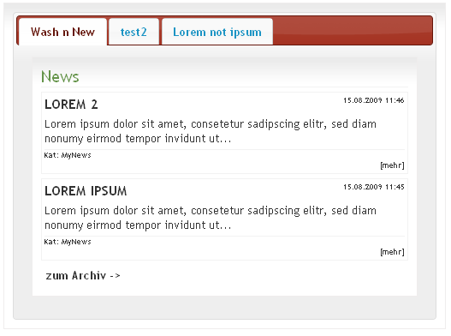
The second tab shows the title of the content, because only filled lines will be taken to overwrite the title of the content.

Options
Here you can define your own Javascript options.
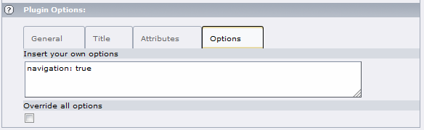
Be aware, that you have to know what you are doing!
See the following pages for possible options:
For “Tab”-style: http://jqueryui.com/demos/tabs/
For “Accordion”-style: http://jqueryui.com/demos/accordion/
For “Slider”-style: http://css-tricks.com/anythingslider-jquery-plugin/
For “SlideDeck”-style: http://www.slidedeck.com/usage-documentation/usage_available_options/
For “easyAccordion”: http://www.madeincima.eu/blog/jquery-plugin-easy-accordion/
For “booklet”: http://builtbywill.com/code/booklet/options
If you select the “override all options”, all defines options in the “General”-tab will be overridden by your options, elsewhere it will be appended to the other options defined in “General”-tab.

Tab
After you select “Tab”-style, the system ask you to reload the content.
After reload you can change the following options:
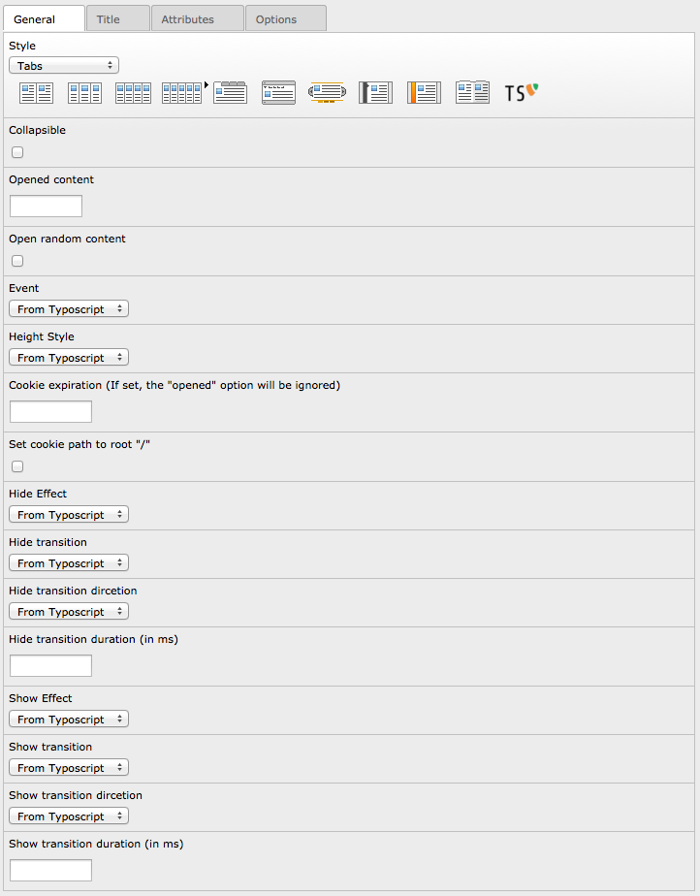
- “Collapsible”: You can “close” all tabs, if you click the active tab again
- “Opened content”: Defines the content witch is opened at startup. If define “0” no tab is active (closed at startup)
- “Open random content”: Check if you like to show the content randomly
- “Event”: Defines the event on witch the accordion will be opened (click or mouseover)
- “Height Style”: Defines how the contents height will be rendered (auto, fill or content)
- “Cookie expiration”: Defines the days to Keep the cookie
- “Set cookie path to root”: Set the domain for the cookie to “/”
- “Hide Effect”: Defines the effect to use for hide (none, fade, slide)
- “Hide Transition”: Configure your own animation (3 options: type, direction, duration)
- “Show Effect”: Defines the effect to use for show (none, fade, slide)
- “Show Transition”: Configure your own animation (3 options: type, direction, duration)

Accordion
After you select “Accordion”-style, the system ask you to reload the content.
After reload you can change the following options:
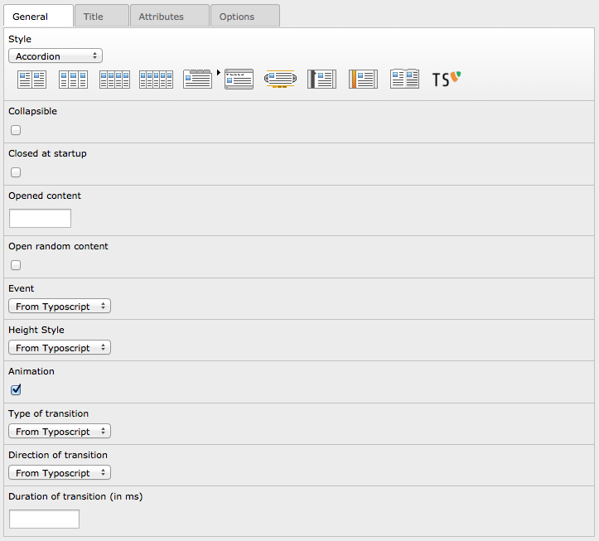
- “Collapsible”: If set, accordion will be collapsible
- “Closed at startup”: The accordion will be closed by default
- “Opened content”: Defines the content witch is opened at startup (will not work, if “Closed at startup” is active)
- “Open random content”: Check if you like to show the content randomly
- “Event”: Defines the event on witch the accordion will be opened (click or mouseover)
- “Height Style”: Defines how the contents height will be rendered (auto, fill or content)
- “Animation”: Activate the animation, settings can be done in “Transition”
- “Transition”: Configure your own animation (3 options: type, direction, duration)

Slider
After you select “Slider”-style, the system ask you to reload the content.
After reload you can change the following options:
- “Width”: Defines the width of the slider
- “Height”: Defines the height of the slider
- “Resize contents”: If true, solitary images/objects in the panel will expand to fit the viewport
- “Theme”: Used theme for slider
- “Opened content”: Defines the content witch is opened at startup
- “Open random content”: Check if you like to show the content randomly
- “Change URL (hash tag)”: If set, the URL will change if you choose a panel
- “Build Arrows”: If true, builds the forwards and backwards buttons
- “Toggle Arrows”: If true, side navigation arrows will slide out on hovering & hide at other times
- “Show navigation”: If set, the panels will be displayed
- “Paneltext from title”: Override the paneltext with the title from content
- “Toggle Controls”: If true, slide in controls (navigation + play/stop button) on hover and slide change, hide at other times
- “Start autoplay”: If set, the autoplay button will be on
- “Pause on mouseover”: If set, the autoplay will pause when mouse over
- “Resume on video end”: If true & the slideshow is active & a youtube video is playing, it will pause the autoplay until the video is complete
- “Stop at end”: If true & the slideshow is active, the slideshow will stop on the last page
- “Play rtl”: If true, the slideshow will move right-to-left
- “Transition”: Configure your own animation (3 options: type, direction, duration)
- “Delay for autoplay (in ms)”: Delay in milliseconds before the the next content is shown

SlideDeck
After you select “SlideDeck”-style, the system ask you to reload the content.
After reload you can change the following options:
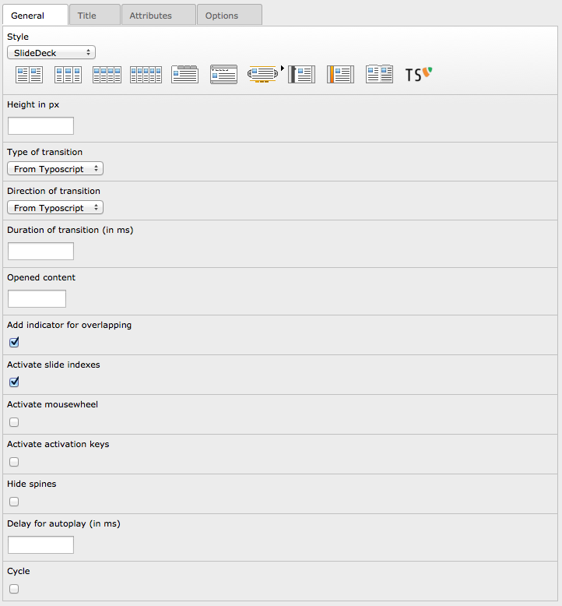
- “Height in px”: Sets the height of the SlideDeck
- “Transition”: Configure your own animation (3 options: type, direction, duration)
- “Opened content“: Defines the content witch is opened at startup
- “Add indicator for overlapping“: If set, there will be a overlaped indicator for active slide
- “Active slide indexes“: If set, every slide gets a number
- “Activate mousewheel“: If set, the slides can be moved with the mousewheel
- “Activate activation keys“: If set, every slide can be activated by a shortcut
- “Hide spine“: If set, the spines will not be displayed
- “Delay for autoplay (in ms)”: Delay in milliseconds before the the next content is shown
- “Cycle”: If set, the autoplay will start over after last slide

easyAccordion
After you select “easyAccordion”-style, the system ask you to reload the content.
After reload you can change the following options:
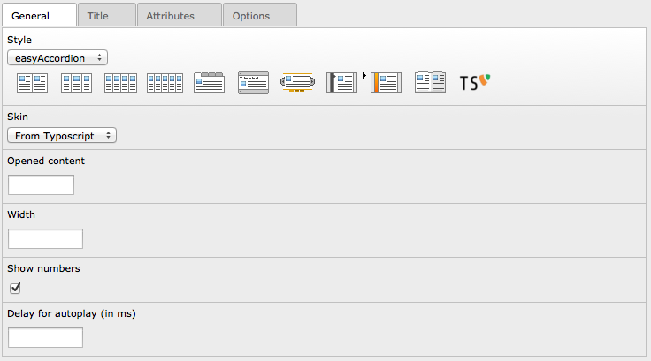
- “Skin”: Defines the used skin for this accordion
- “Opened content”: Defines the content witch is opened at startup
- “Width”: Sets the width of the accordion (the height is defined in css!)
- “Show numbers”: If set, the slide numbers will be displayed
- “Delay for autoplay (in ms)”: Delay in milliseconds before the the next content is shown

Booklet
After you select “booklet”-style, the system ask you to reload the content.
After reload you can change the following options:
- “Width”: Container width
- “Height”: Container height
- “Speed (in ms)”: Speed of the transition between pages
- “Starting page”: Index of the first page to be displayed
- “Direction right to left”: If set, the direction of the overall content organization will be right to left
- “Type of transition”: Type of transition ('swing', 'linear', 'Quad', 'Cubic', 'Quart', 'Quint', 'Sine', 'Expo', 'Circ', 'Back', 'Bounce' or 'Elastic')
- “Direction of transition”: Direction of transition ('In', 'Out' or 'InOut')
- “Page padding”: Padding for each page wrapper
- “Show page numbers”: Display page numbers on each page
- “Manual page turning”: Enables manual page turning, requires jQuery UI to function
- “Show shadows”: Display shadows on page animations
- “Booklet closed”: Start with the book "closed", will add empty pages to beginning and end of book
- “Show covers”: Used with "closed", makes first and last pages into covers, without page numbers (if enabled)
- “Center closed booklet”: Used with “closed”, makes book position in centre of container when closed
- “Use hash”: Enables navigation using a hash string, ex: #/page/1 for page 1, will affect all booklets with 'hash' enabled
- “Use keyboard”: Enables navigation with arrow keys (left: previous, right: next)
- “Autoplay”: Enables automatic navigation, requires “Delay for autoplay”
- “Delay for autoplay”: Amount of time between automatic page flipping
- “Activate overlay”: Enables navigation using a page sized overlay, when enabled links inside the content will not be clickable
- “Show arrows”: Adds arrows overlayed over the book edges
- “Hide arrows if mouseout”: Auto hides arrows when controls are not hovered
- “Hover effect”: Enables preview pageturn hover animation, shows a small preview of previous or next page on hover

Typoscript
After you select “typoscript”-style, the system ask you to reload the content.
All settings in the general-tab will be taken from typoscript, you cant change any settings in FlexForm

Administration
For administration, you can allow / disallow the following exclude fields for user:
- Pagecontent: Contents to display
You are able to change the following options in configuration:
Property: | Data type: | Description: | Default:
useStoragePidOnly | boolean | If set, only content can be choosen from the defined General Record Storage page | 1
ttNewsCodes | boolean | Enables the additional codes in tt_news | 0
frontendErrorMsg | boolean | If set, messages in case of missing templates are displayed in FE (Turn of in production) | 1
useSelectInsteadCheckbox | boolean | If set, most of checkboxes will turn into selectboxes, so you can choose "from TS" | 0
useOwnUserFuncForPages | boolean | If set, you have to do the page rendering with a own userFunc | 0
openExternalLink | boolean | If set, the external link in page-view will be opened | 0
showEmptyContent | boolean | If set, an empty content will be shown as well | 0
addBrowseLinks | boolean | If set, there will be an additional tab in the link-browser | 0
tabSelectByHash | boolean | If set, the tabs can be selected by hash-value in URL | 0
colPosOfIrreContent | integer | Select the colPos where the tt_content will be saved in IRRE-view | 93
style.2column | boolean | Enables the 2column-Style for the backend | 1
style.3column | boolean | Enables the 3column-Style for the backend | 1
style.4column | boolean | Enables the 4column-Style for the backend | 1
style.5column | boolean | Enables the 5column-Style for the backend | 1
style.tab | boolean | Enables the tab-Style for the backend | 1
style.accordion | boolean | Enables the accordion-Style for the backend | 1
style.slider | boolean | Enables the slider-Style for the backend | 1
style.slidedeck | boolean | Enables the slidedeck-Style for the backend | 1
style.easyaccordion | boolean | Enables the easyaccordion-Style for the backend | 1
style.booklet | boolean | Enables the booklet-Style for the backend | 1
style.typoscript | boolean | Enable the typoscrip-Style for the backend | 0
classInner | string | Possible values to wrap in column classes | ,16,20,25,33,38,40, 50,60,62,66,75,80
anythingSliderThemeFolder | string | Location of the themes folder of anythingSlider | EXT:jfmulticontent/res/anythingslider/themes/
easyAccordionSkinFolder | string | Location of the skin folder for easyAccordion | EXT:jfmulticontent/res/easyaccordion/skins/
anythingSliderModes | string | Possible values to use for AnythingSlider "mode" | horizontal,vertical,fade

Page configuration
Your able to configure the available styles by pageTS.
mod.jfmulticontent {
availableStyles = 2column,3column,tab
classInner = 16,33,50
anythingSliderModes = horizontal,vertical
}
In this case in the backend are only these three styles available:
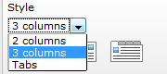

Be aware:
All values defined in plugin-configuration will be available, you can only choose theme in pageTS.

For example:
you define this value in plugin-configuration “16,33,50” and you choose this value in pageTS “16,25,33,75” the option show only the values “16,33”

Updater
If you update from prior versions, you should go to the updater of this plugin to prevent problems.
After installing the extension, choose “UPDATE!” from the dropdown or use the link in the updater message box.
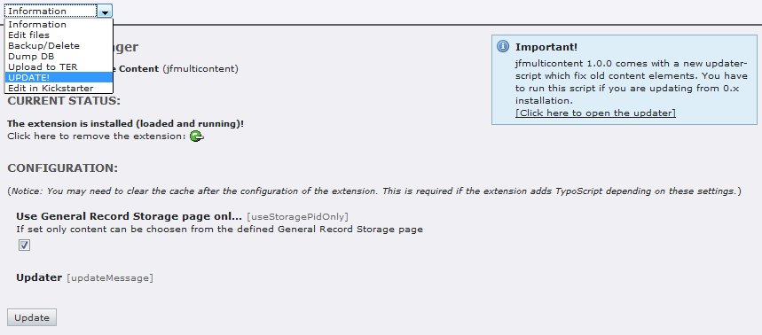
You will get a list of jobs to be done.
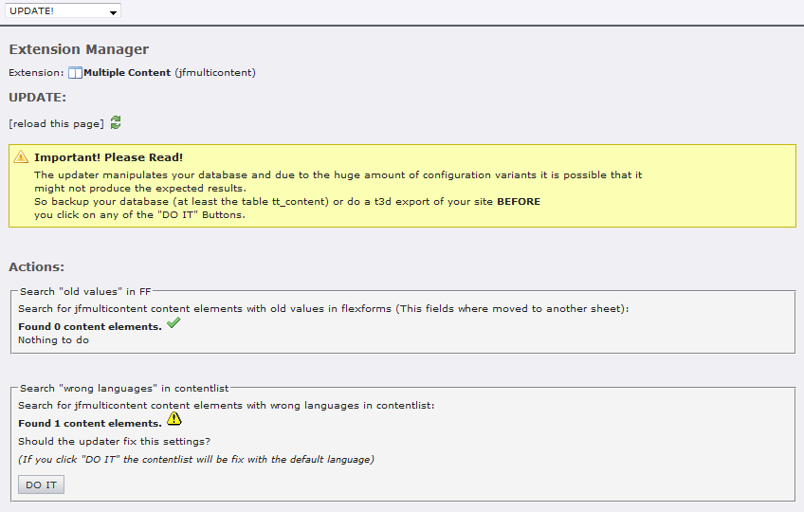
Please read the warning carefully!
To do the update of a job, you have to click the “DO IT” button.
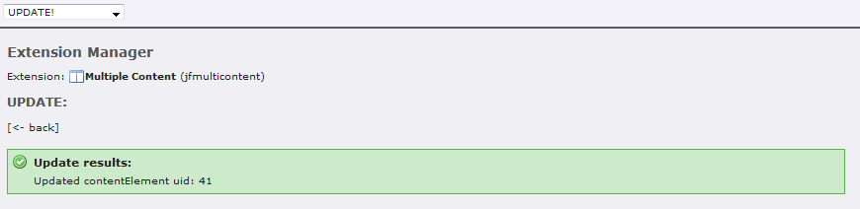

Configuration
After installing the extension, you have to add the static “Multi content (jfmulticontent)” to your template.
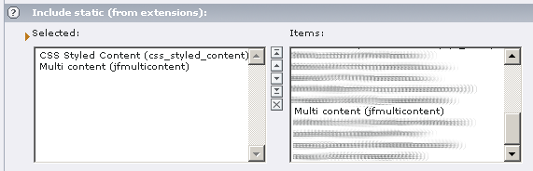
You can define the used JS-Library and the used template and CSS-file in the constant editor.

Reference
plugin.tx_jfmulticontent_pi1
Property: | Data type: | Description: | Default:
jQueryNoConflict | boolean | Use jQuery in noConflict mode | 1
jsInFooter | boolean | If set, the Javascript will be rendered in Footer | 0
jsMinify | boolean | If set, the Javascript will be minified | 0
jsInline | boolean | If set, the Javascript will be inserted into the inlineJS, after this, its possible to put it into externel files (config.removeDefaultJS = external) | 0
cssMinify | boolean | If set, the CSS will be minified | 0
templateFile | file | Location of the used template | EXT:jfmulticontent/res/tx_jfmulticontent_pi1.tmpl
templateFileJS | file | Location of the used template for JS | EXT:jfmulticontent/res/tx_jfmulticontent_pi1.js
cssFile | file | CSS-File to include, if empty or file does not exist, the script will not be included | EXT:jfmulticontent/res/tx_jfmulticontent_pi1.css
jQueryLibrary | file | Location of the jQuery Lib, if empty or file does not exist, the script will not be included | EXT:jfmulticontent/res/jquery/js/jquery-1.8.2.min.js
jQueryCookies | file | Location of jQuery Cookies, if empty or file does not exist, the script will not be included | EXT:jfmulticontent/res/jquery/js/jquery.cookies.js
jQueryEasing | file | Location of the jQuery Easing, if empty or file does not exist, the script will not be included | EXT:jfmulticontent/res/jquery/js/jquery.easing-1.3.js
jQueryMouseWheel | file | Location of the Mousewheel | EXT:jfmulticontent/res/jquery/js/jquery.mousewheel-3.0.6.min.js
jQueryUI | file | Location of the jQuery UI, if empty or file does not exist, the script will not be included | EXT:jfmulticontent/res/jquery/js/jquery-ui-1.9.1.custom.min.js
jQueryUIstyle | file | Location of the jQuery UI CSS, if empty or file does not exist, the script will not be included | EXT:jfmulticontent/res/jquery/css/theme-1.9.1/jquery-ui-1.9.1.custom.css
sliderJS | file | Location of the anythingSlider JS-file, if empty or file does not exist, the script will not be included | EXT:jfmulticontent/res/anythingslider/jquery.anythingslider-1.8.6.min.js
sliderJSvideo | file | Location of the anythingSlider Video JS-file | EXT:jfmulticontent/res/anythingslider/jquery.anythingslider-1.8.6.video.min.js
sliderJSfx | file | Location of the anythingSlider FX JS-file | EXT:jfmulticontent/res/anythingslider/jquery.anythingslider-1.8.6.fx.min.js
sliderCSS | file | Location of the default anythingSlider CSS-File, if empty or file does not exist, the script will not be included | EXT:jfmulticontent/res/anythingslider/style.css
sliderCSSie7 | file | Location of the anythingSlider CSS-File for IE7 and lower, if empty or file does not exist, the script will not be included | EXT:jfmulticontent/res/anythingslider/style-ie.css
sliderCSSanimate | file | Location of the anythingSlider CSS-File for CSS3-Animation | EXT:jfmulticontent/res/anythingslider/animate.css
slidedeckJS | file | Location of the SlideDeck JS-file | EXT:jfmulticontent/res/slidedeck/jquery.slidedeck-1.3.2.min.js
slidedeckCSS | file | Location of the SlideDeck CSS-File.  There are some skins available in “res/slidedeck/skins”, try theme to see the possibility’s of the SlideDeck | EXT:jfmulticontent/res/slidedeck/skins/default/skin.css
easyaccordionJS | file | Location of the Easy-Accordion JS-file | EXT:jfmulticontent/res/easyaccordion/jquery.easyAccordion-0.1.js
easyaccordionCSS | file | Location of the Easy-Accordion CSS-File | EXT:jfmulticontent/res/easyaccordion/skins/orange/style.css
bookletJS | file | Location of the Booklet JS-file | EXT:jfmulticontent/res/booklet/jquery.booklet.1.4.0.min.js
bookletCSS | file | Location of the Booklet CSS-file | EXT:jfmulticontent/res/booklet/jquery.booklet.1.4.0.css
2columnClasses | string | Wrap of the classname for 2 Column  This string will be used to wrap the selected classInner.  It is separated by the |*| and define in every part the wrap that is used in the column ([first column] |*| [second column] etc.) | c|l |*| c|r
3columnClasses | string | Wrap of the classname for 3 Column  This string will be used to wrap the selected classInner.  It is separated by the |*| and define in every part the wrap that is used in the column ([first column] |*| [second column] etc.) | c|l |*| c|l |*| c|r
4columnClasses | string | Wrap of the classname for 4 Column  This string will be used to wrap the selected classInner.  It is separated by the |*| and define in every part the wrap that is used in the column ([first column] |*| [second column] etc.) | c|l |*| c|l |*| c|l |*| c|r
5columnClasses | string | Wrap of the classname for 5 Column  This string will be used to wrap the selected classInner.  It is separated by the |*| and define in every part the wrap that is used in the column ([first column] |*| [second column] etc.) | c|l |*| c|l |*| c|l |*| c|l |*| c|r
equalizeClass | -> stdWrap | Defines the class to use when config.equalize is set, if you use the famous YAML framework, the subcolumns will have the same height, elsewhere you have to define the style by your own:  .equalize{  overflow: visible;  display: table;  table-layout: fixed;  } | equalize
columnWrap | -> stdWrap | Wrap for column based display.  You can define it like in TMENU with three states:  firstWrap |*| middleWrap |*| lastWrap  If you define just one stat, this state will be used for all contents.  If you define two states, it will use the first state for middle too.  Example:  plugin.tx_jfmulticontent_pi1.columnWrap {  wrap = <div class="subcl">|</div> |*| <div class="subcl">|</div> |*| <div class="subcr">|</div>  }
tabWrap | -> stdWrap | Wrap for tab based display (see above)
tabKey | cObject | Defines the key to use for tabs-style. The result will be stored in the marker ###TAB_KEY###  You're able to use some registered variables:  register:key – The key of the multicontent  register:content_id – The uid of the tt_content  register:id – The id of the actual tab (0,1,2,3 etc.)  register:title – The title of the tab  Example:  plugin.tx_jfmulticontent_pi1 {  tabKey = TEXT  tabKey {  value = {register:key}-{register:id}  insertData = 1  }  }
accordionWrap | -> stdWrap | Wrap for accordion based display (see above)
sliderWrap | -> stdWrap | Wrap for slider based display (see above)
slidedeckWrap | -> stdWrap | Wrap for slidedeck based display (see above)
easyaccordionWrap | -> stdWrap | Wrap for easyAccordion based display (see above)
bookletWrap | -> stdWrap | Wrap for booklet based display (see above)
disableJs | boolean | Disable the Javascript (for print) | 0
additionalMarkers / additionalContentMarkers |  | Here you can define your marks comma seperated, every mark will be replaced with the definition in additionalMarkerConf.  The used string have to be in upper case in your template.  ####CONTENTTITLE##  Example:  plugin.tx_jfmulticontent_pi1 {  additionalMarkers = contentmarker  additionalContentMarkers = itemmarker  }
additionalMarkerConf |  | The configuration of the used Marks, here you can define the TS to use for every mark defined in additionalMarkers or additionalContentMarkers  Example:  plugin.tx_jfmulticontent_pi1 {  additionalMarkerConf {  contentmarker = TEXT  contentmarker {  field = header  fieldRequired = header  if.equals.field = header_layout  if.value = 100  if.negate = 1  wrap = <span> | </span>  }  itemmarker = RECORDS  itemmarker {  source.data = register:content_id  tables = tt_content  dontCheckPid = 1  conf.tt_content = TEXT  conf.tt_content {  field = header  wrap = <p>Header: |</p>  }  }  }  }
config.* |  | Here you can optionally define the multicontent in TS to add it to the template
config.contentKey | string | Define the id of the element | jfmulticontent_ts1
config.style | string | Define the used style when you define the plugin threw TS  '2column', '3column', '4column', '5column', 'tab', 'accordion', 'slider', 'typoscript' | 2column
config.columnOrder | string | Define the order of the column:  0 = no repeat  1 = left to right, top to down  2 = right to left, top to down
config.column1 | string | Class value to use for column 1 will result in class=”c33l” | 50
config.column2 | string | Class value to use for column 2 will result in class=”c33l” | 50
config.column3 | string | Class value to use for column 3 will result in class=”c33l”
config.column4 | string | Class value to use for column 4 will result in class=”c33l”
config.equalize | string | If set, the equalizeClass will be inserted | 0
config.tabCollapsible | boolean | If set, tab will be collapsible | 0
config.tabOpen | integer | Defines the content witch is opened at startup. If 0 the tabs will be closed at startup (only if tabCookieExpires not set) | 1
config.tabRandomContent | string | Check if you like to show the content randomly | 0
config.tabEvent | string | Defines the event on witch the accordion will be opened ('click' or 'mouseover')
config.tabHeightStyle | string | Defines how the contents height will be rendered (auto, fill or content) | auto
config.tabCookieExpires | integer | Count of days, the cookie will be stored for selected tab.  If set, the tabOpen and tabRandomContent will be disabled
config.tabCookieRoot | boolean | If set, the cookie path will be set to “/” otherwise it will be set from URI | 0
config.tabHideEffect | string | Defines the effect to use for hide (none, fadeOut, slideUp) | fadeOut
config.tabHideTransition | string | Type of transition ('swing', 'linear', 'Quad', 'Cubic', 'Quart', 'Quint', 'Sine', 'Expo', 'Circ', 'Back', 'Bounce' or 'Elastic')
config.tabHideTransitiondir | string | Direction of transition ('In', 'Out' or 'InOut') | In
config.tabHideTransitionduration | integer | Duration of transition in ms
config.tabShowEffect | string | Defines the effect to use for show (none, fadeIn, slideDown) | fadeIn
config.tabShowTransition | string | Type of transition ('swing', 'linear', 'Quad', 'Cubic', 'Quart', 'Quint', 'Sine', 'Expo', 'Circ', 'Back', 'Bounce' or 'Elastic')
config.tabShowTransitiondir | string | Direction of transition ('In', 'Out' or 'InOut') | In
config.tabShowTransitionduration | integer | Duration of transition in ms
config.tabOptions | string | Define own options for tabs
config.tabOptionsOverride | boolean | Define if the options defined above will override all other options or append to theme | 0
config.accordionCollapsible | boolean | If set, accordion will be collapsible | 0
config.accordionClosed | boolean | The accordion will be closed by default | 0
config.accordionOpen | integer | Defines the content witch is opened at startup (will not work, if “Closed at startup” is active) | 1
config.accordionRandomContent | boolean | Check if you like to show the content randomly | 0
config.accordionEvent | string | Defines the event on witch the accordion will be opened ('click' or 'mouseover')
config.accordionHeightStyle | string | Defines how the contents height will be rendered (auto, fill or content) | auto
config.accordionAnimate | boolean | If set, the accordion will be animated | 1
config.accordionTransition | string | Type of transition ('swing', 'linear', 'Quad', 'Cubic', 'Quart', 'Quint', 'Sine', 'Expo', 'Circ', 'Back', 'Bounce' or 'Elastic')
config.accordionTransitiondir | string | Direction of transition ('In', 'Out' or 'InOut') | In
config.accordionTransitionduration | integer | Duration of transition in ms | 1000
config.accordionOptions | string | Define own options for accordion
config.accordionOptionsOverride | boolean | Define if the options defined above will override all other options or append to theme | 0
config.sliderWidth | string | Defines the width of the slider
config.sliderHeight | string | Defines the height of the slider
config.sliderResizeContents | boolean | If true, solitary images/objects in the panel will expand to fit the viewport | 0
config.sliderTheme | string | Used theme for slider
config.sliderOpen | integer | Defines the content witch is opened at startup | 1
config.sliderRandomContent | boolean | Check if you like to show the content randomly | 0
config.sliderHashTags | boolean | If set, the URL will change if you choose a panel | 0
config.sliderBuildArrows | boolean | If true, builds the forwards and backwards buttons | 1
config.sliderToggleArrows | boolean | If true, side navigation arrows will slide out on hovering & hide at other times | 0
config.sliderNavigation | boolean | If set, the panels will be displayed | 1
config.sliderStartStop | boolean | If set, the start/stop panel will be displayed | 1
config.sliderPanelFromHeader | boolean | Override the paneltext with the title from content | 0
config.sliderToggleControls | boolean | If true, slide in controls (navigation + play/stop button) on hover and slide change, hide at other times | 0
config.sliderAutoStart | boolean | If set, the autoplay button will be on | 0
config.sliderPauseOnHover | boolean | If set, the autoplay will pause when mouse over | 0
config.sliderResumeOnVideoEnd | boolean | If true & the slideshow is active & a youtube video is playing, it will pause the autoplay until the video is complete | 0
config.sliderAllowRapidChange | boolean | If true, allow rapid changing of the active pane, instead of ignoring activity during animation | 0
config.sliderStopAtEnd | boolean | If true & the slideshow is active, the slideshow will stop on the last page | 0
config.sliderPlayRtl | boolean | If true, the slideshow will move right-to-left | 0
config.sliderTransition | string | Type of transition ('swing', 'linear', 'Quad', 'Cubic', 'Quart', 'Quint', 'Sine', 'Expo', 'Circ', 'Back', 'Bounce' or 'Elastic') | swing
config.sliderTransitiondir | string | Direction of transition ('In', 'Out' or 'InOut') | In
config.sliderTransitionduration | integer | Duration of transition in ms | 1000
config.sliderAutoplay | boolean | Autoplay at start | 0
config.sliderOptions | string | Define own options for slider
config.sliderOptionsOverride | boolean | Define if the options defined above will override all other options or append to theme | 0
config.slidedeckHeight | integer | Sets the height of the SlideDeck | 300
config.slidedeckTransition | string | Type of transition ('swing', 'linear', 'Quad', 'Cubic', 'Quart', 'Quint', 'Sine', 'Expo', 'Circ', 'Back', 'Bounce' or 'Elastic') | swing
config.slidedeckTransitiondir | string | Direction of transition ('In', 'Out' or 'InOut')
config.slidedeckTransitionduration | integer | Duration of transition in ms | 500
config.slidedeckStart | integer | Defines the content witch is opened at startup | 1
config.slidedeckActivecorner | boolean | If set, there will be a overlaped indicator for active slide | 1
config.slidedeckIndex | boolean | If set, every slide gets a number | 1
config.slidedeckScroll | boolean | If set, the slides can be moved with the mousewheel | 0
config.slidedeckKeys | boolean | If set, every slide can be activated by a shortcut | 0
config.slidedeckHidespines | boolean | If set, the spines will not be displayed | 0
config.slidedeckOptions | string | Define own options for slidedeck
config.slidedeckOptionsOverride | boolean | Define if the options defined above will override all other options or append to theme | 0
config.easyaccordionSkin | string | Define the used skin | orange
config.easyaccordionOpen | integer | Defines the content witch is opened at startup | 1
config.easyaccordionWidth | integer | The width of the accordion in pixel | 600
config.easyaccordionSlideNum | boolean | If set, the slide numbers will be displayed | 1
config.easyaccordionOptions | string | Define own options for easyaccordion
config.easyaccordionOptionsOverride | boolean | Define if the options defined above will override all other options or append to theme | 0
config.bookletWidth | integer | Container width | 600
config.bookletHeight | integer | Container height | 400
config.bookletSpeed | integer | Speed of the transition between pages | 1000
config.bookletStartingPage | integer | Index of the first page to be displayed | 0
config.bookletRTL | boolean | If set, the direction of the overall content organization will be right to left | 0
config.bookletTransition | string | Type of transition ('swing', 'linear', 'Quad', 'Cubic', 'Quart', 'Quint', 'Sine', 'Expo', 'Circ', 'Back', 'Bounce' or 'Elastic')
config.bookletTransitiondir | string | Direction of transition ('In', 'Out' or 'InOut')
config.bookletPagePadding | integer | Padding for each page wrapper | 10
config.bookletPageNumbers | boolean | Display page numbers on each page | 1
config.bookletManual | boolean | Enables manual page turning, requires jQuery UI to function | 0
config.bookletShadows | boolean | Display shadows on page animations | 1
config.bookletClosed | boolean | Start with the book "closed", will add empty pages to beginning and end of book | 0
config.bookletCovers | boolean | Used with "closed", makes first and last pages into covers, without page numbers (if enabled) | 0
config.bookletAutoCenter | boolean | Used with “closed”, makes book position in centre of container when closed
config.bookletHash | boolean | Enables navigation using a hash string, ex: #/page/1 for page 1, will affect all booklets with 'hash' enabled | 0
config.bookletKeyboard | boolean | enables navigation with arrow keys  (left: previous, right: next) | 0
config.bookletAuto | boolean | Enables automatic navigation, requires “Delay for autoplay” | 0
config.bookletDelay | integer | Amount of time between automatic page flipping | 5000
config.bookletOverlays | boolean | Enables navigation using a page sized overlay, when enabled links inside the content will not be clickable | 1
config.bookletArrows | boolean | Adds arrows overlayed over the book edges | 0
config.bookletArrowsHide | boolean | Auto hides arrows when controls are not hovered | 0
config.bookletHovers | boolean | Enables preview pageturn hover animation, shows a small preview of previous or next page on hover | 1
config.bookletOptions | string | Define own options for booklet
config.bookletOptionsOverride | boolean | Define if the options defined above will override all other options or append to theme | 0
config.delayDuration | integer | Delay in milliseconds before the the next content is shown | 0
config.autoplayContinuing | boolean | If this option is enabled, the autoplay will continue after interaction from the user | 0
config.autoplayCycle | boolean | If set, the autoplay will start over after last slide | 0
views.[view].title | cObj | cObj to render title for specified view | TEXT
views.[view].content | cObj | cObj to render content for specified view | RECORDS
views.[view].rel | cObj | cObj to render rel for specified view | COA
contents.*.title | cObj | cObj for the title | COA
contents.*.content | cObj | cObj for the content | COA
contents.*.id | stdWrap | ID to use in the mark CONTENT_ID
[tsref:(cObject).plugin.tx_jfmulticontent_pi1]

FAQ

I like to add some scripts / css -files globally, is this possible?
If you like to add the library globally you can set an empty string to the values. Only existing files will be included!
This will work for cssFile, jQueryLibrary, jQueryCookies, jQueryEasing, jQueryUI, jQueryUIstyle, sliderJS and sliderCSS.

I have additional slides in SlideDeck-Style / easyAccordion, why?
Slidedeck and easyAccordion uses dt/dd elements as markup. If there are dt/dd elements in you content, Slidedeck will interpret it as an additional slider. It appears, if you are using one image with caption in image/text. To solve this, you have to use this configuration:
tt_content.image.20.renderMethod = ul

How can I add my own views for my records?
There is a demo extension in TER where you can see, how to use the HOOK to add your own views:
http://typo3.org/extensions/repository/view/jfmulticontent_viewdemo/current/

How can I change the quoted title to my needs?
You can override the language variable by using this TS:
plugin.tx_jfmulticontent_pi1._LOCAL_LANG.en {
default_quote_title_template = Welcome to “###TITLE###” on ###ID###
tab_quote_title_template = Welcome to “###TITLE###” on tab ###ID###
accordion_quote_title_template = Welcome to “###TITLE###” on accordion ###ID###
}

How can I use the view “page” with TemplaVoila?
Because TemplaVoila stores the used contents in XML, its not possible to use normal TS. You have to know the Filed-Name of your column you want to display in jfmulticontent, heres an example for “field_feature” and “field_content_block_1”:
includeLibs.jfmulticontent = EXT:jfmulticontent/class.tx_jfmulticontent.php
plugin.tx_jfmulticontent_pi1 {
views.page >
views {
page {
content = COA
content {
10 = USER
10 {
userFunc = tx_jfmulticontent->getContentFromTemplavoilaField
field = field_feature
pageID.data = register:pid
contentRender = RECORDS
contentRender {
tables = tt_content
source.data = register:uid
dontCheckPid = 1
}
}
20 < .10
20 {
field = field_content_block_1
}
}
title = TEXT
title.data = register:page_title
}
}
}
This will render the featured field on top, followed by the content_block_1
register:pid is the page selected in the plugin, the register:uid is the content.uid on the selected page (the contentRender will be passed multiple).
There are all values from the page available in the registry, they are stored with the prefix “page_” (page_title, page_hidden)
To use this feature, you have to activate the option “useOwnUserFuncForPages” in configuration.

How can I use the title as a alternative to the generic key?
Normally the id of the tabs looks something like “jfmulticontent_c115-1”. If you like to use the title you have to add the following typoscript:
plugin.tx_jfmulticontent_pi1 {
tabKey = TEXT
tabKey {
data = register:title
stdWrap {
case = lower
split {
token.char = 32
cObjNum = 1
1.current = 1
1.wrap = |_
}
substring = 0,-1
wrap = |
}
}
}

How can I remove all headers of the contents?
The headers are generated equally CSC, if you like to remove them, you can use the follow TS:
plugin.tx_jfmulticontent_pi1.views.content.content.conf.tt_content < tt_content
plugin.tx_jfmulticontent_pi1.views.content.content.conf.tt_content {
header.10 >
text.10 >
image.10 >
textpic.10 >
bullets.10 >
table.10 >
uploads.10 >
multimedia.10 >
swfobject.10 >
qtobject.10 >
media.10 >
mailform.10 >
search.10 >
menu.10 >
list.10 >
}

Additional tt_news codes
To add the tt_news codes, its very important, that you copy the templatecode from EXT:jfmulticontent/pi1/tt_news.tmpl into your tt_news template. You can change the three new template sections as you do normally in tt_news (Marker and subsets).
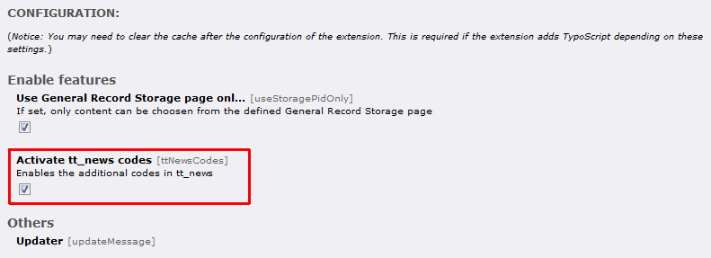
Enable the feature „Activate tt_news codes“ in the configuration of this extension.
After the configuration is done, you are able to choose three new codes in the backend.

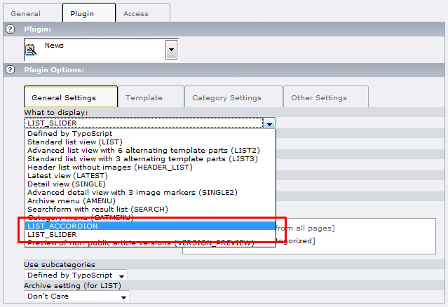
I'd like to translate these items, but there is a small bug in tt_news (http://bugs.typo3.org/view.php?id=14417) so it is called „LIST_ACCORDION”, „LIST_SLIDER”, „LIST_SLIDEDECK” and “LIST_EASYACCORDION”, perhaps in a later version of tt_news it will be possible to translate...

Known problems
- Report bugs at http://forge.typo3.org/projects/show/extension-jfmulticontent
- In “Tab” and “Accordion”-style, the title will be displayed twice (once in tab and once in content). You can turn off this by using the type “hidden” in the “secondary options”

To-Do list
- Report features at http://forge.typo3.org/projects/show/extension-jfmulticontent
- Add continuing to accordion autoplay

ChangeLog
Version | Changes:
0.0.1 | Initial development
0.1.0 | Add “Overwrite title” to the flexform
0.2.0 | Add “Attributes” to the flexform, to define the attributes per content
0.3.0 | Add new feature to add own classes to the drop down “Colomn class x”
0.3.1 | Add configuration “Use General Record Storage page only”, to turn on / off the General Record Storage
0.3.2 | jquery-ui with minimal configuration / Use of the t3jquery extension
0.4.0 | Add easing to accordion style
0.4.1 | Update the documentation
0.4.2 | Add new feature “Closed at startup” to accordion style
0.4.3 | Add new feature “Opened content” to accordion style
0.4.4 | Add new feature “Selected content” to tabs style
0.4.5 | Bugfix, if id's are defined in attributes (id=”xy”), the tabs style does not work
0.4.6 | Use the wrapJS from t3lib_div to add javascript script
0.5.0 | Add content wrap to static for better YAML compatibility / Fix the problem of displaying whole page in tab-style
0.5.1 | Add project to forge.typo3.org
0.5.2 | Bugfix #6159 and #6160
0.5.3 | Add pi1/locallang.xml (#6159)
0.6.0 | Add autoplay to tabs (#6187) / Add random content to tab and accordion (#6191)
0.6.1 | Bugfix for old typo versions (No such file or directory in t3lib/class.t3lib_div.php on line 4694)
0.6.2 | Add jQuery 1.4.1 / Add autoplay to accordion
0.6.3 | Fix problem when deleting or hiding used content (#6294)
0.6.4 | Changed maximum image number from 32 to 1000
0.6.5 | Fix #6466, go back to jQuery 1.3.2 until jQuery UI 1.8 is final
0.6.6 | Remove unused constant / Change the default for noConflict
0.6.7 | Fix Documentation
0.6.8 | Add the jsInFooter constant to move the javascript to the footer of the HTML
0.7.0 | Add the possibility to add own marker to the template (Thanks to Michael Hübe)
0.7.1 | Update jQuery UI to 1.8
0.7.2 | Remove the constant jQueryFixTabHref. Now autodetecs config.prefixLocalAnchors and fix the “whole page in tab”
0.8.0 | Add “Slider”-style
0.8.1 | Javascript optimizing / Add new documentation
1.0.0 | Refacture the backend (flexform). IMPORTANT! You have to run the Updater!
1.0.1 | Fix the markup of the slider template (Thanks to Raphael Zschorsch)
1.1.0 | Add opened content and random content to “Slider”-style
1.2.0 | Add multilingual support
1.3.0 | Panel text set from title (#7540)
1.4.0 | Add options, JS-template and jsMinify (#7625 and #7626)
1.4.1 | Add fallback for templates
1.4.2 | Write the JS-script in t3jquery if installed
1.4.3 | Bugfix for t3lib_extMgm::getExtensionVersion, only in Typo3 4.4.x
1.5.0 | Add some nice list codes to tt_news (see documentation!)
1.5.1 | Add new icons for mode / Add FAQ to the documentation
1.6.0 | Change style name, you have to run the UPDATER! / Add the TS configuration to the setup, its possible to add elements via typoscript now
1.6.1 | Fix the double insert of the scripts (#7913)
1.6.2 | In new contents, no additional fields where displayed
1.6.3 | Add cms_layout to backend / Fix some naming annoyances
1.7.0 | Add 5 Column style
1.8.0 | Add columnOrder to display multiple contents to a column / Fix problems with config.moveJsFromHeaderToFooter
1.8.1 | Add anythingSlider 1.3 / Fix the display problems in TV-Backend (cms_layout) / Remove PHP Warnings in tt_news_extend
1.8.2 | Fix the CSS of anythingSlider 1.3
1.8.3 | Fix problem with tt_news template (#9553)
1.8.4 | Prevent multiple JS-script output
1.8.5 | Move the template to the res folder
1.9.0 | Add „SlideDeck“-style (#9711)
1.9.1 | Add „SlideDeck“ for tt_news
1.9.2 | Moved the classInner to ext_conf_template.txt
1.9.3 | Add jQuery 1.8.5 / Fix focus problem in accordion (#9873)
1.9.4 | Disable alert in case of missing template (#9899)
1.9.5 | Use pageRenderer for script include
1.10.0 | Add easyAccordion sponsored by http://www.made-in-nature.de/typo3-agentur.html
1.10.1 | Small bug fix
1.10.2 | Add easyAccordion to tt_news / Fix leading zero's (#10186)
1.11.0 | Update anythingSlider to 1.4.5. Markup has changed! Change templates if you use own!
1.12.0 | Changed the max characters for imagewith and imageheight to 16 caracters (#10114) / Restrict selection by pageconfig (#10302)
1.12.1 | Add jQuery 1.4.3 / Fix problem with classInner
1.12.2 | Fix documentation classInner / Add availableStyles to plugin configuration / Add equalize to sub columns
1.12.3 | Update anythingSlider to version 1.4.7 / Add new marker CONTENT_ID
2.0.0 | Add “booklet” sponsored by http://www.made-in-nature.de/typo3-agentur.html / Changed the configuration, if you have changed the availableStyles, you have do it again!
2.1.0 | Add useSelectInsteadCheckbox to select „from TS“
2.1.1 | Add “opened content” to easyAccordion (#11031) / Fix easyAccordion for Opera (#11784)
2.1.2 | Update jQuery UI to 1.8.9 / Update anythingSlider to 1.5.6.3 / Update slideDeck to 1.2.1
2.1.3 | Add support for TYPO3 4.5 / Add jQuery 1.4.4
2.2.0 | Add jQuery 1.5.0 / Add cookie to tabs (#13031)
2.2.1 | Fix the HTML in easyAccordion / Fix XHTML error in booklet / Add jQuery 1.5.1 / Add jQuery UI 1.8.10 / Add anythingslider 1.5.7.3
2.2.2 | Add exclude to all flexform-fields / Add jQuery 1.5.2 / Add Slidedeck 1.2.2 for IE9 compatibility / Fix easyAccordion for IE9
2.3.0 | Fix updater link for Typo3 4.5 / Add page view (#25957) / Add HOOK for additional views (#25861)
2.3.1 | Fix the flexform data extraction (#26163) / Add isActive to view-HOOK
2.4.0 | Remove unused scripts / Fix YAML subc classes (#26782) / Add jQuery 1.6.1 / Add jQuery UI 1.8.13 / Add anythingSlider 1.5.12 / Add booklet 1.2.0
2.4.1 | Fix the Booklet-Style documentation / Add jQuery 1.6.2 / Add jQuery UI 1.8.14 / Add anythingSlider 1.5.21 / Add SlideDeck 1.2.5 / Fix jsInFooter / Convert linefeed to Unix
2.5.0 | Add IRRE for content elements (#28976) / Add anythingSlider 1.7.10 (#29010) / Add jQuery Mousewheel 3.0.4 / Add jQuery UI 1.8.16 / The cssFile will be included last (THX to Jean-Francois De Locht)
2.5.1 | Fix style problem when entering numeric values in Slider width and height (#29424) / Add anythingSlider 1.7.12 / Add class to render page data / Add IE Hacks for Slider-Style
2.5.2 | CEO optimizing for tab and accordion (title attribute) / Add page-view for templavoila (#30172) / Add path to cookie in Tab-Style (#30410)
2.5.3 | Fix documentation / Add jQuery 1.6.4
2.5.4 | Update Mousewheel to 3.0.5 / Update AnythingSlider to 1.7.13 / Update SlideDeck to 1.3.0 / Add Autoplay and StartStop option (#31453)
2.5.5 | Update jQuery to 1.7.1 / Update jQuery MouseWheel to 3.0.6 / Update AnythingSlider to 1.7.18 / Fix content selection for multilingual sites (tt_content.sys_language_uid IN (0, -1))
2.5.6 | Fix problem with cookies-path (#32140)
2.5.7 | Add openExternalLink to open external links in tab and accordion (#32432)
2.5.8 | Add showEmptyContent to define if empty contents will be shown (#32443)
2.5.9 | Change the opened content to provide closed at startup / Fix collapsible in tabs and accordion
2.6.0 | Hide the deleted and hidden content in IRRE / Add special options for styles
2.6.1 | Add jQuery UI 1.8.17
2.6.2 | Add new TS-Option to define the tabKey (#33484)
2.6.3 | Fix translation in IRRE (#33744) / Add AnythingSlider 1.7.24 / Add AnythingSlider Video / Add SlideDeck 1.3.2
2.6.4 | Fix cookie path for IE and Safari
2.6.5 | Fix “getContentFromTemplavoilaField”
2.7.0 | Fix the column display name for IRRE / Remove deprecated methods (#36599) / Add jQuery 1.7.2 / Add anythingSlider 1.8 / Add jQuery.Booklet 1.3.0
2.7.1 | Add jQuery UI 1.8.20 / Add anythingSlider 1.8.2 / Fix line breaks (UNIX)
2.7.2 | Fix t3lib_utility_VersionNumber::convertVersionNumberToInteger for older typo3 versions / Add new marker and register COLUMN_CLASSES (#36711) / Add new FAQ to the documentation (#35346)
2.7.3 | Fix some translation issues (#37275 and #35285)
2.7.4 | Fix order in IRRE (#37613) / Fix JS-Template (#37679)
2.8.0 | Fix the type for bookletJS and bookletCSS in constants / Add option sliderAllowRapidChange / Add jQuery UI 1.8.21
2.8.1 | Add jQuery 1.8.23 / Add Booklet 1.4.0 / Add new style typoscript to set the style by TS
2.8.2 | Turn off Javascript by Condition (#40943)
2.8.3 | Fix compatibility for Typo3 V6 (#41010)
2.8.4 | Fix multilingual issue (#39704) / Fix “Add new” in backend
2.8.5 | Add addBrowseLinks and tabSelectByHash to select link to a specific content in RTE (#26720)
2.8.6 | Fix the browser link select / Add tabSelectByHash for accordion-style
2.8.7 | Fix the sorting in IRRE (#37947)
2.9.0 | Change Lib to jQuery UI 1.9.1 Add jQuery 1.8.2 / If you use t3jquery, you have to change the jQuery UI Version to 1.9.x and generate the Lib again
2.9.1 | Fix the override of the tabs (#42449) / If you use t3jquery, you have to change the jQuery UI Version to 1.9.x and generate the Lib again
2.9.2 | Fix EasyAccordion in IE10 (#39719) / Add additionalContentMarkers to have them in content / Add jQuery 1.8.3 / Add jQuery UI 1.9.2
2.9.3 | Fix the anchor in tab when using baseUrl (#42905)
2.9.4 | Fix SlideDeck for Firefox 20
2.9.5 | Fix the Hash in URL (#42905)
2.9.6 | Add SlideDeck 1.4.3 / Add jQuery Booklet 1.4.2 / Add anythingSlider 1.9.0 / Add jQuery MouseWheel 3.1.3 / Add jQuery Cookie 1.3.1
2.9.7 | Fix compatibility for TYPO3 6.2 (#54154)
2.9.8 | Add Workspace compatibility (#54153)
2.9.9 | Add Compatibility for TYPO3 6.2
2.10.0 | Add Compatibility for TYPO3 7 and 8
2.10.1 | Add Wizard and composer.json
2.10.2 | Bugfix TCA
2.11.0 | Add Compatibility for TYPO3 9

