Comparative Analysis of Deep Learning Architectures
for Pneumonia Detection from Chest X-Ray Images

FINAL REPORT
Deep Learning Project
[ICT-4442]

Submitted By
Tanushree Ashok Hegde – 210953381
Sathwik – 220953008



SCHOOL OF COMPUTER ENGINEERING
MANIPAL INSTITUTE OF TECHNOLOGY,
MANIPAL ACADEMY OF HIGHER EDUCATION
October 2026

Abstract
This project compares three deep learning models for binary classification of chest X-ray images into NORMAL and PNEUMONIA classes. The primary experiments use the 5,856-image Chest X-Ray Images (Pneumonia) dataset associated with Kermany et al., retaining its supplied training, validation and test partitions. A Custom Convolutional Neural Network (CNN), an ImageNet-pretrained ResNet50 and an ImageNet-pretrained DenseNet121 were trained and evaluated using 224 × 224 images. On the common 624-image test set, the Custom CNN achieved the highest accuracy (88.94%), F1-score (91.55%) and ROC-AUC (95.44%). ResNet50 and DenseNet121 achieved higher pneumonia-class recall (98.97% and 98.72%, respectively), but misclassified many NORMAL images as PNEUMONIA. A supplementary external evaluation on 200 NIH ChestX-ray14 images (100 Pneumonia-labelled and 100 empty-label images) showed a marked performance reduction for all models. This result is interpreted cautiously because empty NIH labels are only a proxy negative class and do not establish that an image is clinically normal. The experiments highlight the importance of class-wise error analysis, dataset differences and external evaluation. The models are academic prototypes and are not intended for clinical diagnosis.
Keywords — Chest X-ray, pneumonia classification, convolutional neural network, ResNet50, DenseNet121, transfer learning, Grad-CAM, external validation.

I. INTRODUCTION

Chest radiographs are often performed as part of the evaluation of respiratory disease, such as pneumonia. Reading a chest X-ray is a complex task that must take into account the clinical picture, as well as the visual appearance of the chest X-ray, which can be modulated by image quality, the image collection process, and disease severity [1]. Deep learning approaches have been studied for learning image features from labelled images [1], [2].
All convolutional neural networks learn spatial features using convolution and pooling. As a further development in CNN families, new design mechanisms have been introduced to facilitate better optimization and feature propagation. Res Net employs residual connection to train and optimize deeper networks [3], and Dense Net connects the feature-maps of each layer to the following layers to allow feature reuse [4]. These are different ways of extracting image representations.
The project is an academic evaluation comparing a custom CNN and two transfer-learning based architectures on a public binary chest X-ray dataset. It is limited to image-level classification between NORMAL and PNEUMONIA. It is not a patient diagnostic decision (may include patient history, clinical observations, radiologist review).

II. LITERATURE REVIEW
Kermany et al. showed an image-based deep learning approach for medical diagnosis with paediatric chest radiographs and also proposed the dataset family used as the main comparison in this work [1]. This set the current common setup to separate normal chest radiograph from pneumonia annotation in the image. Rajpurkar et al. proposed CheXNet, a 121-layer Dense Net trained on the NIH chest radiograph collection, to demonstrate the ability of deep convolutional neural networks to tackle multiple thoracic diseases [2].
The major CNN building block choices in this project are based on CNN architectures. He et al. Dense Net architecture in which each layer is given feature maps of all preceding layers, resulting in improved feature reuse and gradient flow [4]. Figure 1 shows the structure of the two proposed architectures ResNet50 and DenseNet121. They are motivated by the standard Res Net [3] and Dense Net [4] architectures respectively.
Labels and dataset construction issues are well presented by Wang et al. using a hospital-scale ChestX-ray8 collection of report labels, again using weakly labelled radiographs to learn thoracic pathology [5]. The NIH ChestX-ray14 data set continues this direction and is the basis of the secondary external evaluation of the present study. Report labels, and empty-label records, should not be used as equivalent to independently validated normal findings.
Selvaraju et al. proposed Grad-CAM, a method that uses the gradients flowing into a convolutional feature map to produce a coarse localisation map of the important regions in the image [6]. 2.2 Generalization Zech et al. found that pneumonia detection models differ in their performance between hospital data sets, warning that good performance from one source does not imply good performance on other sources [7]. Roberts et al. summarized methodological issues in machine learning for medical imaging and stressed the importance of detailed dataset descriptions and validation and reproducible reporting [8].
DeGrave et al. Showed that diagnostic models on chest radiographs are learning shortcuts associated with data source rather than disease, emphasizing the importance of inspecting model performance beyond aggregate accuracy [9]. Oakden-Rayner et al. explored the phenomenon of hidden stratification in medical imaging, where aggregate metrics hide failures on clinically important subpopulations [10]. Shorten and Khoshgoftaar reviewed image augmentation techniques and their ability to improve training data [11]. Dosovitskiy et al. demonstrated that image patches could be fed to a Transformer model for image recognition [12]; a Vision Transformer was proposed in the initial project proposal but was not ultimately used in any of the experiments.
Overall, the literature justifies comparing architectures under one test protocol, while treating dataset-specific results as guides. For reasons of reproducibility and fairly comparing across datasets, it also justifies a class-wise error breakdown, and further comparisons such as "explainability" and external evaluation, above a single accuracy number.

III. OBJECTIVES
- To develop three deep learning architectures- Custom CNN, ResNet50 and DenseNet121 for binary classification of chest X-ray images.

- To be able to evaluate the models on the common held-out test set, in terms of accuracy, precision, recall, F1-score and ROC-AUC, and to explore their errors and computational behaviour.
- To perform an additional cross-dataset evaluation on a small NIH ChestX-ray14 subset and comment on the challenges of cross-dataset transfer.

IV. METHODOLOGY

A. Custom CNN
The Custom CNN was used as the task-specific baseline. This takes an input image of 224 × 224 × 3, and consists of 3 convolutional blocks. These blocks use 32, 64 and 128 filters respectively, each followed by ReLU activation and max pooling. The feature map resolution is 7 × 7, with 128 features, which are fed into a fully connected 128-unit layer with ReLU activation. Dropout rate 0.5 is used before the final unit with a sigmoid activation.
Training-time augmentation are: Horizontal flip, Rotation (rotation factor 0.05) and Zoom (zoom factor 0.10). The values of pixels are rescaled 1/255. The model training uses optimizer with Adam with the learning rate of 0.0001, and binary cross-entropy as its loss, early stopping and a best-model checkpoint. The number of maximum training epochs is 15. (Custom CNN) CNN as a baseline, whose feature extractor learned from the project data set.

B. Transfer Learning with B. ResNet50
ResNet50 convolutional networks. The convolutional backbone was downloaded with the classification head absent, and frozen in the baseline experiment. The missing classification head was replaced with a global average pooling, dropout rate 0.4, final sigmoid unit. Adam, learning rate 0.0001, binary cross-entropy, early-stopping + best-model checkpointing, maximum training time 10 epochs.
The ResNet50 pre-processing step is part of the saved model architecture. This means that raw resized image values are passed in to the model for evaluation, as applying ResNet50 pre-processing outside the model would pre-process the image twice. ResNet50 was added to evaluate a residual transfer-learning architecture versus a task-specific CNN.

C. DenseNet121 Transfer Learning
DenseNet121 is an Image Net-pretrained densely connected CNN. The convolutional feature extractor was used (without its original classification head) and frozen as the reported baseline. The feature extractor was followed by a global average pooling and dropout (rate 0.4) layer, then a one-unit sigmoid classifier. The model has 70,385,529 parameters, 1025 of which are trainable in the saved version. The saved model includes the Dense Net preprocessing layer as part of the architecture so evaluation produces raw resized image values, no further external preprocessing layer used.
DenseNet121 was chosen for its dense connections which enable a direct transfer of features through the network. This also represents a different feature-propagation architecture than ResNet50 and provides an opportunity to compare two Image Net pretrained CNN architectures for the same binary classification task.
Note: the final implementation has three evaluated models. The Vision Transformer was part of the initial proposal, but it was not finished so there are no ViT results.

V. EXPERIMENTAL SETUP

A. Primary Dataset and Split
The main data set is the Chest X-Ray Images (Pneumonia) collection from Kermany et al. [1] The publicly available version has 5856 images in two folders (NORMAL and PNEUMONIA) in JPEG format. The provided directory split was used without creating a new random split.
Split | NORMAL | PNEUMONIA | Total
Training | 1,341 | 3,875 | 5,216
Validation | 8 | 8 | 16
Test | 234 | 390 | 624
Total | 1,583 | 4,273 | 5,856

The training set is unbalanced, with many more PNEUMONIA than NORMAL. The provided validation partition has only 16 images. This is a significant problem: model selection and early stopping based on validation may be very unstable with such a small set. The provided test partition was used for all three models, which ensures consistency in the primary test-set comparison, but does not address the validation-set problem.

B. Preprocessing
- The images were resized to 224 x 224 pixels with three channels
- Binary label encoding: NORMAL=0 PNEUMONIA=1.
- Training time augmentation was done with horizontal flip, rotation(0.05),zoom(0.10)
- Validation and test time images were not augmented.
- Custom CNN- rescale=1/255 ResNet50 and DenseNet121 makes use of the pplication processing in the model saved .
- Batch size was 32 the relevant seed of the project pipeline was 42.

C. Evaluation Metrics
We used the same 624 test images for testing all three models. Accuracy is how many total predictions were correct. Precision (equation 1) is out of all images which we predicted positive, how many images were actually positive. Recall (equation 2) is out of all images that are actually positive, how many images we predicted positive. F1-score (equation 3) is the harmonic mean of precision and recall. ROC-AUC measures the ability of the models to rank the decision threshold. In our main comparison, the precision, recall and F1-score reported are all for the class PNEUMONIA where PNEUMONIA is used as the positive class. Confusion matrices and class-wise report are also used to unveil the errors made in both classes.

D. Computational Environment and Efficiency
The system was implemented using Windows and Visual Studio Code with Python 3.13.16 and Tensor Flow 2.21.0 in the project environment. Inference benchmark: Inference benchmark was conducted in Google Colab in a T4 GPU, with batch size 32, five repeated measurement after warm-up. Inference time is hardware/implementation-dependent, and be considered only in the context of this benchmark.

Model | Parameters | Saved size (MB) | Inference (ms/image)
Custom CNN | 12,938,561 | 148.13 | 6.0973
ResNet50 | 23,589,761 | 90.65 | 9.2746
DenseNet121 | 70,385,529 | 28.32 | 7.0417
Parameter number, saved file size and inference time are different metrics. DenseNet121 has the highest parameter count but the smallest saved file reported in this experiment; file size is not necessarily a proxy for parameter count. The inference time reported is an average per image, based on batched inference.

VI. RESULTS AND DISCUSSION

A. Primary Test-Set Comparison
Table I summarizes the three models on the common 624-image Kermany test set. The values are reported as percentages for readability.
TABLE I. PRIMARY TEST-SET PERFORMANCE ON THE 624-IMAGE KERMANY TEST SPLIT
Model | Accuracy | Precision | Recall | F1-score | ROC-AUC
Custom CNN | 88.94% | 87.59% | 95.90% | 91.55% | 95.44%
ResNet50 | 71.79% | 69.18% | 98.97% | 81.43% | 92.58%
DenseNet121 | 75.48% | 72.23% | 98.72% | 83.42% | 93.69%

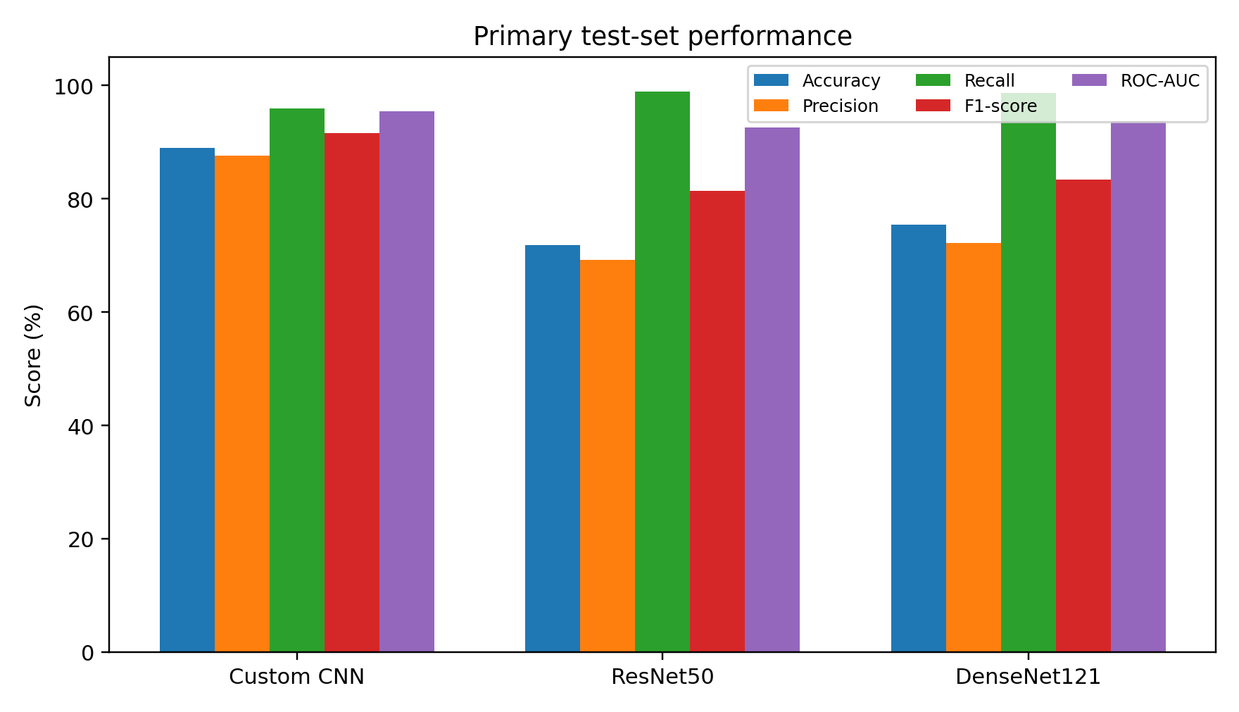
Fig. 1. Comparison of primary test-set metrics across the three models.
Custom CNN delivered the best accuracy (88.94%), and the best performance in terms of pneumonia precision (87.59%), pneumonia F1-score (91.55%) and ROC-AUC (95.44%). DenseNet121 came second for accuracy and F1-score, while ResNet50 was rated worst for overall accuracy. ResNet50 had the best recall for pneumonia (98.97%), marginally ahead of DenseNet121 (98.72%).
The better overall performance of the Custom CNN indicates that, given the dataset and training setup, a task-specific feature extractor could give a more balanced decision boundary. Do not draw the conclusion from this experiment that custom CNNs are always better than pretrained models. Both pretrained backbones are frozen, so I am doing a feature-extraction baseline, not a
full transfer-learned system. The class imbalance during training and tiny validation set likely impacted the choice of operating point and model.

B. Confusion Matrices and Class-Wise Errors
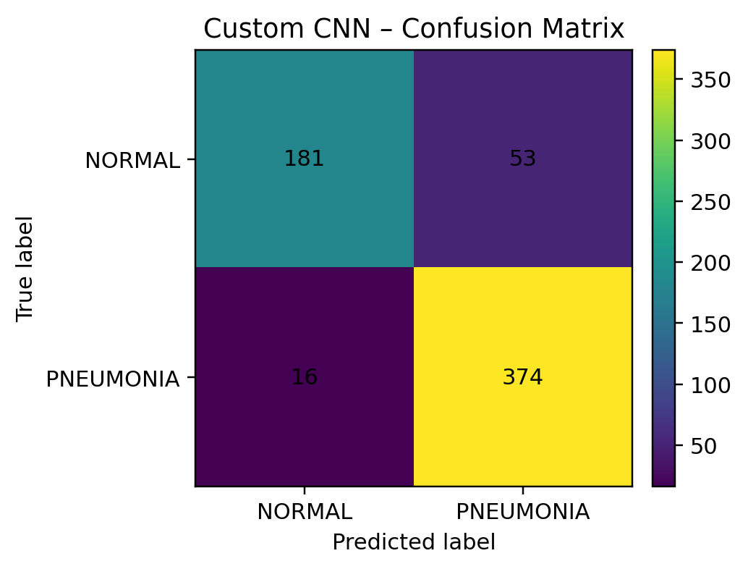
Fig. 2. Custom CNN confusion matrix (rows: true class; columns: predicted class).
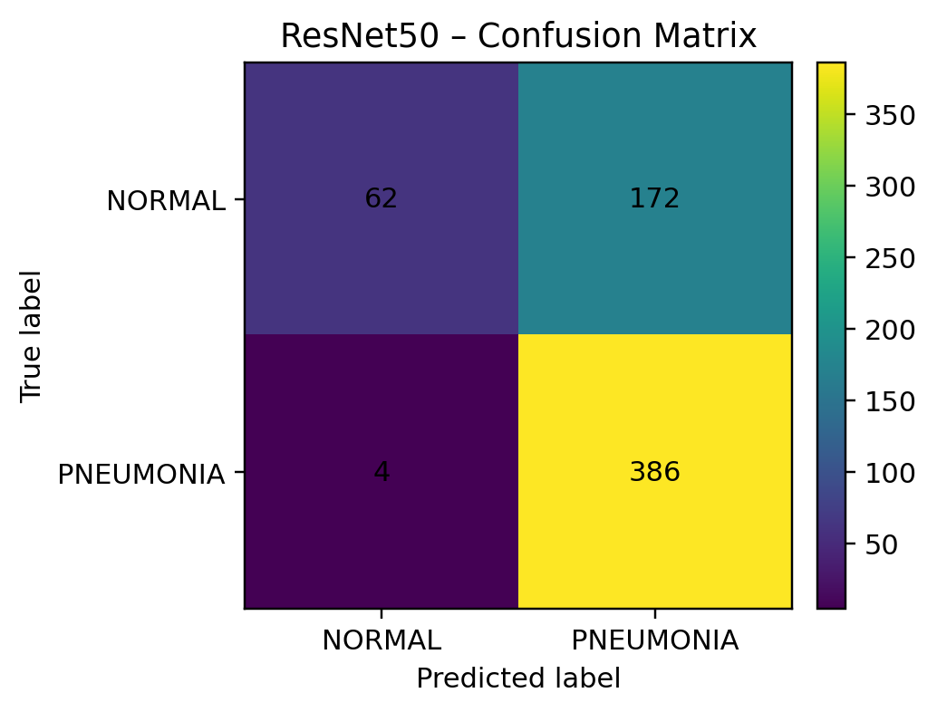
Fig. 3. ResNet50 confusion matrix (rows: true class; columns: predicted class).
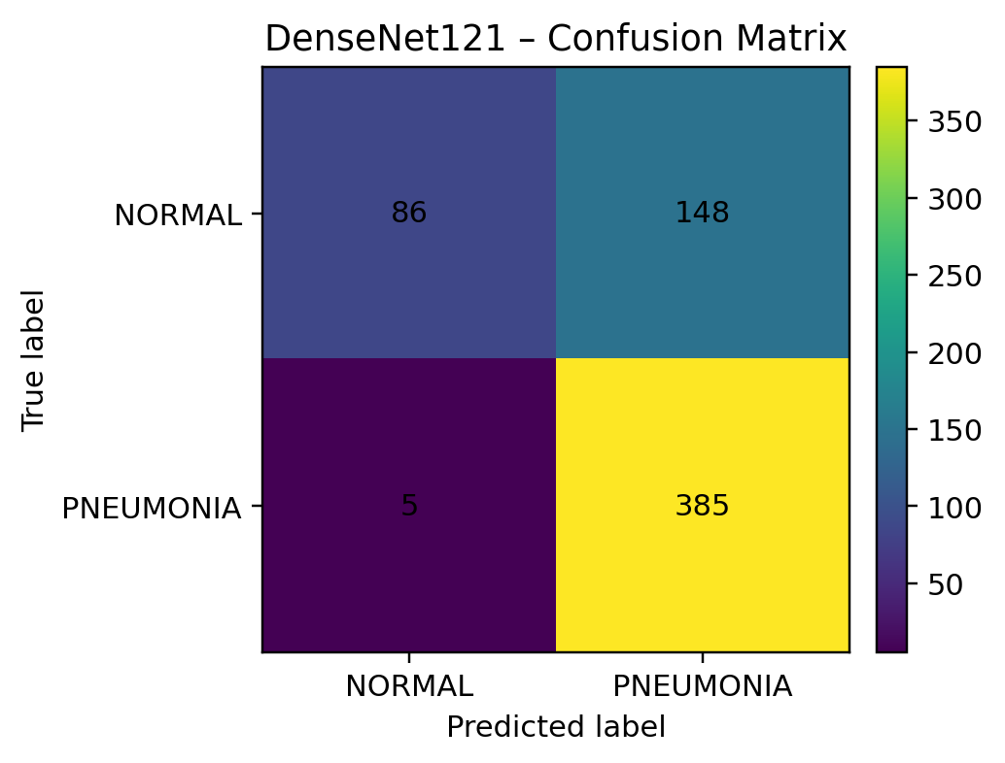
Fig. 4. DenseNet121 confusion matrix (rows: true class; columns: predicted class)

For the Custom CNN, we get the confusion matrix of 181 correct NORMAL predictions, 53 NORMAL images predicted as PNEUMONIA, 16 PNEUMONIA images predicted as NORMAL and 374 correct PNEUMONIA predictions. Its NORMAL recall is 77.35%, PNEUMONIA recall is 95.90%.
ResNet50 identified 62 of the NORMAL images correctly and 386 of the PNEUMONIA images correctly. It mis-identified 172 NORMAL images as PNEUMONIA, and four PNEUMONIA images as NORMAL. This would give it a high pneumonia recall, 98.97%, and a low normal recall, 26.50%.
Among the training data, DenseNet121 accurately predicted 86 NORMAL and 385 PNEUMONIA images. It incorrectly labeled 148 images as PNEUMONIA, and five images as NORMAL. Although positive-class recall is impressive (98.72%), the normal recall is only 36.75%. Both pretrained models exhibited a high number of false positives in the face of impressive positive recall.

C. Grad-CAM-Based Qualitative Error Analysis
Grad-CAMs were produced for DenseNet121 to visualize the areas of images which led to the picked classification. Four examples were chosen: a true positive NORMAL (pneumonia probability 0.3426), a false positive (0.6576), a true positive PNEUMONIA (0.8363) and a false negative (0.2498). The heatmaps depicted varying spatial focus across the examples, such as wide chest-region focus in the true positive pneumonia example and central or outer focus in some of the errors.
These examples are for illustration and are purely qualitative. Grad-CAM provides visual evidence of image areas relevant to a model score, it does not confirm that a network has learned a diagnostically-significant lesion, or that its reasoning is diagnostically-valid [6]. Thus the areas of activation in these cases can be considered as guides to inspection rather than localization evidence. This explains the need for multiple measures such as false-positives and false-negatives.
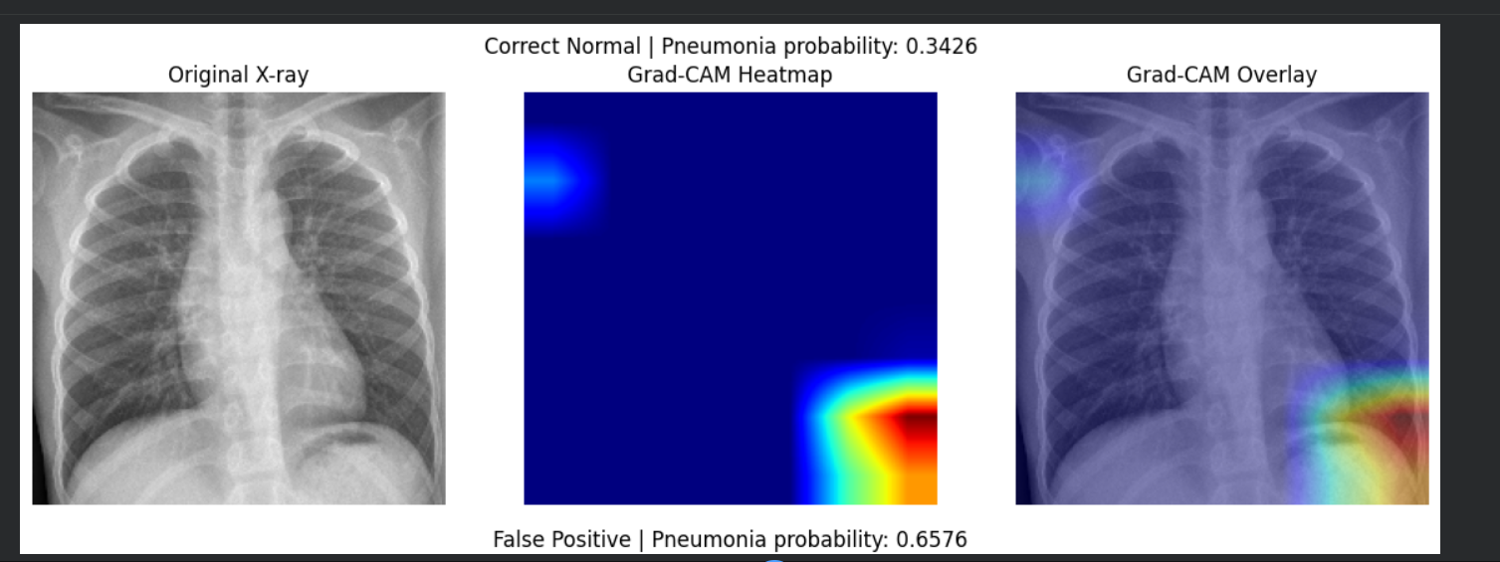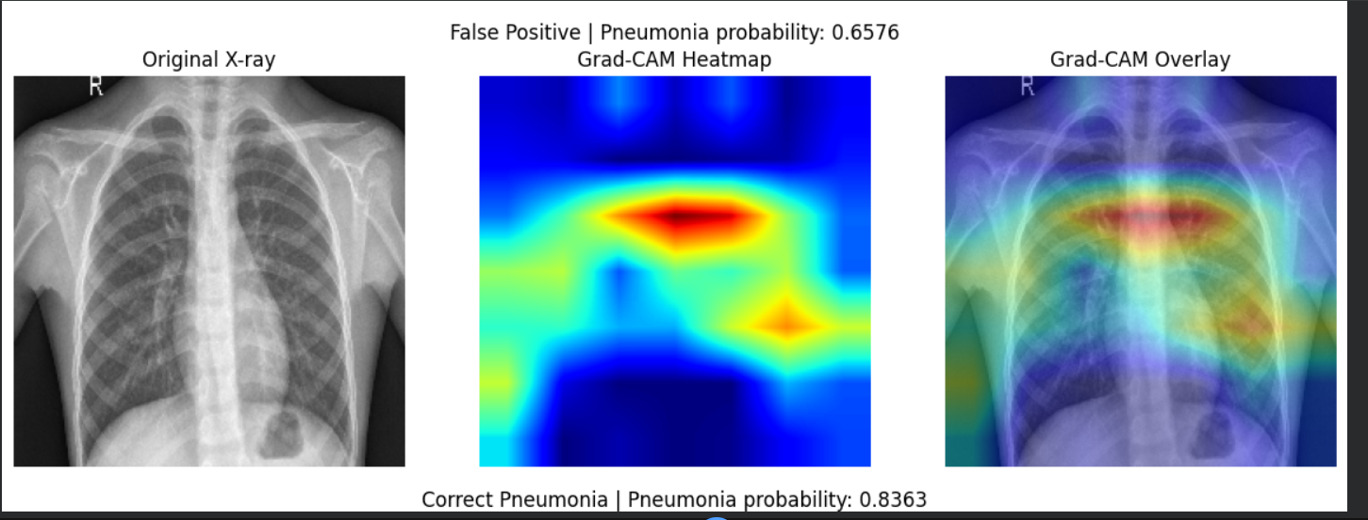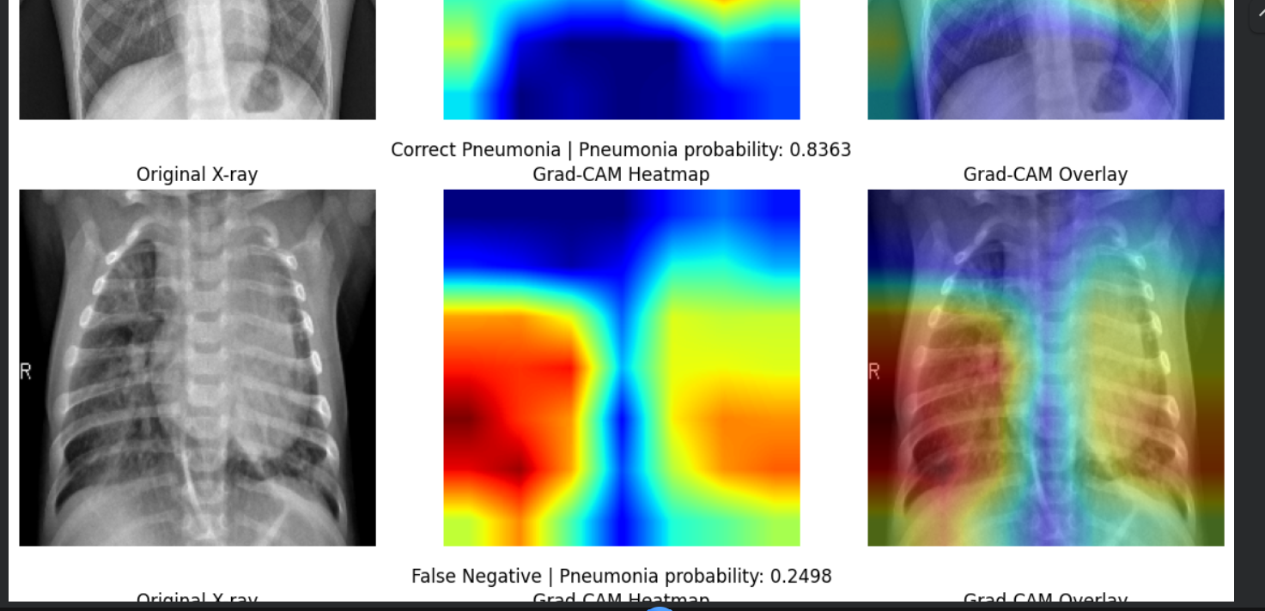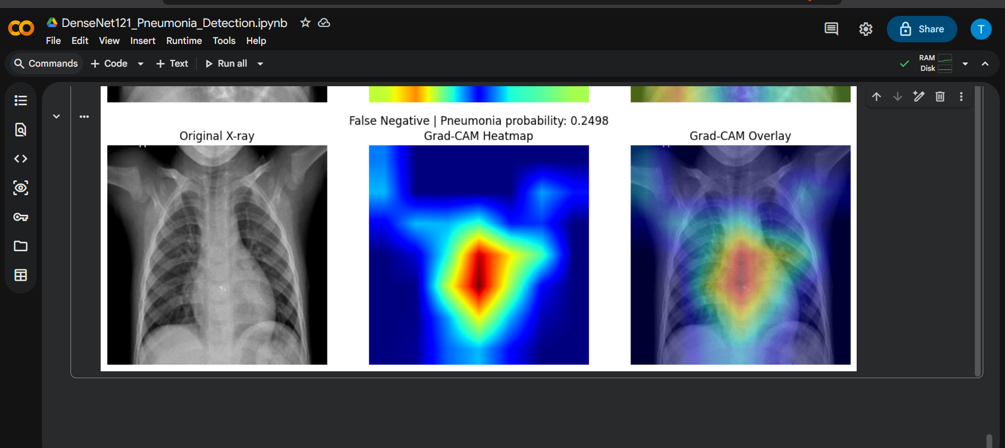

D. Model Efficiency
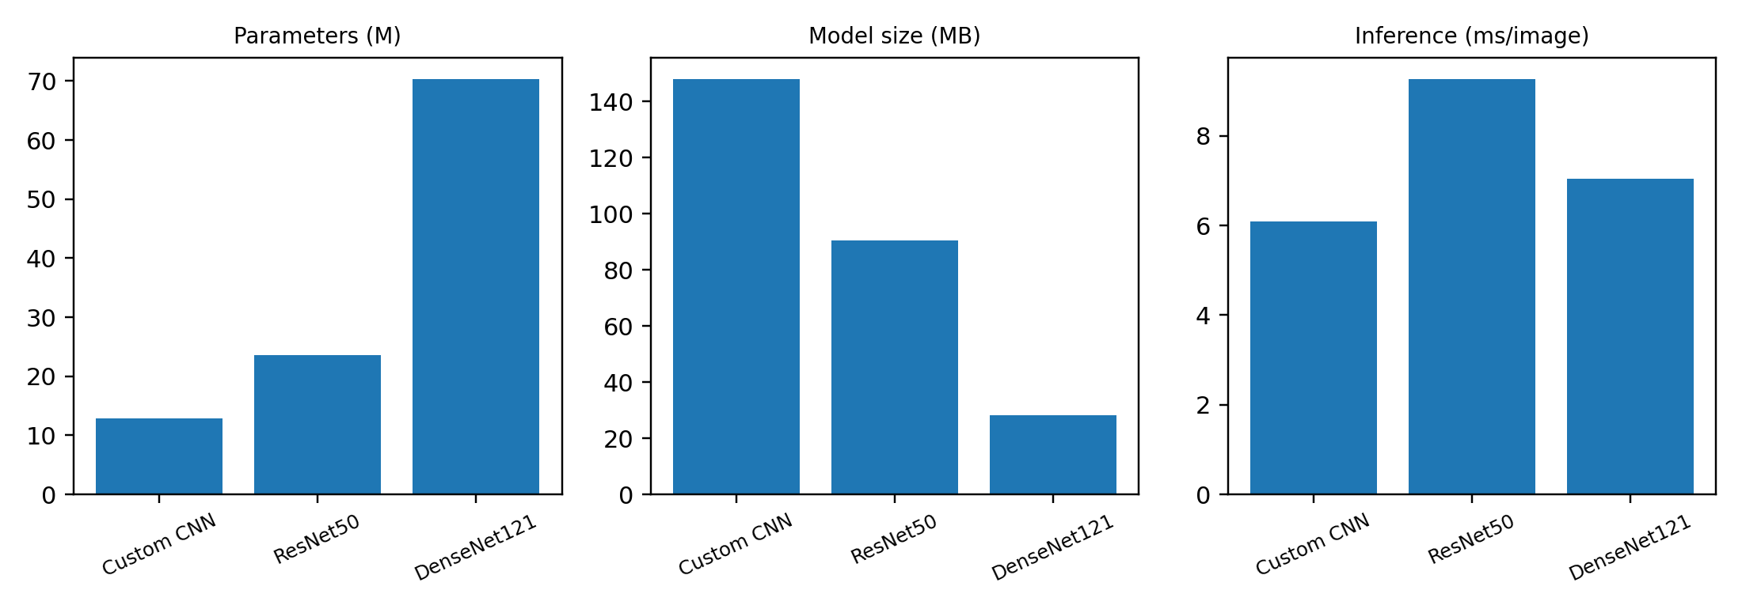
Fig. 5. Model parameter count, saved model size and inference time (separate scales)
Custom CNN has the least number of parameters (12.94 million), smallest size (28.32 MB) and fastest inference time (6.10 ms per image), however is the largest saved size (148.13 MB). ResNet50 has the most parameters (23.59 million) and the slowest inference time (9.27 ms per image). DenseNet121 has 70.39 million parameters, a size of 28.32 MB and an inference time of 7.04 ms per image. These measures are for this saved implementation and benchmark environment, not an absolute ranking of these networks for speed or memory.

E. Supplementary External Evaluation on NIH ChestX-ray14
With the three models saved earlier, we evaluated them for cross-dataset behaviour after training on a set of 200 images from the NIH ChestX-ray14 set. The test set comprising of 200 patient ids, with 100 labeled as containing Pneumonia and remaining with an empty label list were extracted from the 200 unique patient ids in the dataset. These images were resized to 224 × 224 × 3, a constant threshold of 0.5 was used and the raw resized images were given to the models since the saving pipeline included normalization/preprocessing steps.
•For this experiment, the empty-label group was used as a proxy negative class and called "No Finding" in the evaluation output. Again, this does not mean a true clinically normal set. Since NIH labels are extracted by text from radiology reports they are imperfect and noisy, and an empty label set should not be mistaken as a "zero finding" assertion. Our external experiment is therefore supplementary and cannot directly match the main NORMAL/PNEUMONIA benchmark.

TABLE II. SUPPLEMENTARY NIH SUBSET EXTERNAL-EVALUATION RESULTS
Model | Accuracy | Precision | Recall | F1-score | ROC-AUC
Custom CNN | 57.50% | 57.28% | 59.00% | 58.13% | 55.92%
ResNet50 | 49.50% | 49.75% | 98.00% | 65.99% | 65.83%
DenseNet121 | 48.50% | 49.24% | 97.00% | 65.32% | 64.82%

For this subset, Custom CNN gained the greatest accuracy (57.50%) and ROC-AUC (55.92%). ResNet50 and DenseNet121 achieved pneumonia recall of 98.00% and 97.00%, respectively, but incorrectly classified 99 and 100 of 100 proxy-negative images as pneumonia. The excellent positive-class recall for these models was not associated with balanced discrimination.
These findings are mirrored in the mean predicted pneumonia probability. In the custom CNN, the mean probability for the proxy-negative group was 0.4973, and the pneumonia-labelled group was 0.5787. For ResNet50, the means were 0.8782 and 0.9251 respectively; in DenseNet121, 0.8020 and 0.8522 respectively. The pretrained models gave pneumonia-high scores for both groups in this particular set of images.
Shifted results compared to the main test set are well in line with a cross-dataset distribution shift, but that experiment cannot determine its origin. Source population, image acquisition, label extraction, and class definition can all have an impact. The subset is small and was not used for model selection or threshold tuning. These should be reported as a preliminary external validation study.

VII. CONCLUSION
We used and compared three different architectures for binary chest X-ray classification. Custom CNN achieved the best overall performance on the original test set of 624 images, with 88.94% accuracy, 91.55% pneumonia F1-score and 95.44% ROC-AUC. ResNet50 and DenseNet121 had higher pneumonia recall, but confusion matrices demonstrated many false positive predictions for NORMAL images. The class-specific metrics vary significantly among the different models.
The additional NIH assessment revealed a substantial decrease in accuracy, notably among the two frozen pretrained models. Since the NIH negative test set used empty report-derived labels rather than verified normal images, this outcome should be viewed with a degree of skepticism. To sum up, the project proves that exceptional results on one publicly available data set do not mean models will generalize to a different data set. None of the models is meant for use in practice.

VIII. FUTURE WORK
- Fine-tune some layers of ResNet50 and DenseNet121, and compare the above results with the frozen-backbone baselines.
- Handle class imbalance by stratified sample or class weighting, and select your model with a generous validation set.
- Assess on larger, carefully curated external datasets with clinically relevant labels and patient level separation.
- Calibration/thresholding. Study calibration/thresholding on the development/validation data, rather than the external test set subset.
- Expand the error analysis with more false-positives and false-negatives, and review the Grad-CAM maps with a domain expert where available.
- Run and test Vision Transformer if time and compute allow it, only using the same primary split and metrics.

IX. ACKNOWLEDGEMENT
We acknowledge the course instructor and the School of Computer Engineering, Manipal Institute of Technology for providing us this wonderful opportunity of undertaking this project. We also acknowledge the researchers and institutes who have made the datasets of chest X-ray and basic deep learning algorithms available in the public domain.

REFERENCES
[1] D. S. Kermany et al., “Identifying medical diagnoses and treatable diseases by image-based deep learning,” Cell, vol. 172, no. 5, pp. 1122–1131.e9, 2018, doi: 10.1016/j.cell.2018.02.010.
[2] P. Rajpurkar et al., “CheXNet: Radiologist-level pneumonia detection on chest X-rays with deep learning,” arXiv:1711.05225, 2017.
[3] K. He, X. Zhang, S. Ren, and J. Sun, “Deep residual learning for image recognition,” in Proc. IEEE Conf. Computer Vision and Pattern Recognition (CVPR), 2016, pp. 770–778, doi: 10.1109/CVPR.2016.90.
[4] G. Huang, Z. Liu, L. van der Maaten, and K. Q. Weinberger, “Densely connected convolutional networks,” in Proc. IEEE Conf. Computer Vision and Pattern Recognition (CVPR), 2017, pp. 4700–4708.
[5] X. Wang et al., “ChestX-ray8: Hospital-scale chest X-ray database and benchmarks on weakly-supervised classification and localization of common thorax diseases,” in Proc. IEEE Conf. Computer Vision and Pattern Recognition (CVPR), 2017, pp. 2097–2106, doi: 10.1109/CVPR.2017.369.
[6] R. R. Selvaraju et al., “Grad-CAM: Visual explanations from deep networks via gradient-based localization,” in Proc. IEEE Int. Conf. Computer Vision (ICCV), 2017, pp. 618–626, doi: 10.1109/ICCV.2017.74.
[7] J. R. Zech et al., “Variable generalization performance of a deep learning model to detect pneumonia in chest radiographs: A cross-sectional study,” PLoS Med., vol. 15, no. 11, e1002683, 2018, doi: 10.1371/journal.pmed.1002683.
[8] M. Roberts et al., “Common pitfalls and recommendations for using machine learning to detect and prognosticate for COVID-19 using chest radiographs and CT scans,” Nat. Mach. Intell., vol. 3, pp. 199–217, 2021, doi: 10.1038/s42256-021-00307-0.
[9] A. J. DeGrave, J. D. Janizek, and S.-I. Lee, “AI for radiographic COVID-19 detection selects shortcuts over signal,” Nat. Mach. Intell., vol. 3, pp. 610–619, 2021, doi: 10.1038/s42256-021-00338-7.
[10] L. Oakden-Rayner et al., “Hidden stratification causes clinically meaningful failures in machine learning for medical imaging,” in Proc. ACM Conf. Health, Inference, and Learning (CHIL), 2020, pp. 151–159, doi: 10.1145/3368555.3384468.
[11] C. Shorten and T. M. Khoshgoftaar, “A survey on image data augmentation for deep learning,” J. Big Data, vol. 6, art. no. 60, 2019, doi: 10.1186/s40537-019-0197-0.
[12] A. Dosovitskiy et al., “An image is worth 16×16 words: Transformers for image recognition at scale,” in Proc. Int. Conf. Learning Representations (ICLR), 2021.

DECLARATION OF TOOL ASSISTANCE
Copy-editing: support from ChatGPT (OpenAI) was used to articulate the reporting structure, edit text and format the project result summaries.

GITHUB REPO LINK:
https://github.com/thegde/DL-MINI-PROJECT

C.3 INDIVIDUAL CONTRIBUTION STATEMENT

Member | Registration No. | Model / Task Owned | Key Contributions
Tanushree Ashok Hegde | 210953381 | Custom CNN; ResNet50; DenseNet121 | Implementation/training and evaluation of the three listed models; comparative analysis and report preparation. Grad Cam error analysis.
Sathwik | 220953008 | Report Formatting  Datasets collection | Report formatting and finding and collecting datasets

