OEC001
UNIT-4
The action of making the choices to pursue the action or to start the action is called decision making. It includes the gathering of information and also observing and accessing the useful alternatives.

TYPES OF DECISION MAKING

1. Programmed vs. Non-Programmed Decisions:
- Programmed Decisions:
These are repetitive, routine decisions that follow established procedures or rules. They are often made at lower levels of the organization.
- Non-Programmed Decisions:
These address novel, unstructured problems that require more analysis, creativity, and judgment. They are typically made at higher levels of the organization.
2. Strategic vs. Tactical Decisions:
- Strategic Decisions:
These are long-term, high-level choices that shape the organization's overall direction, mission, and competitive advantage. They have a significant impact on the organization's future.
- Tactical Decisions:
These are shorter-term, mid-level decisions that focus on implementing the strategic plan and achieving specific objectives. They support the execution of strategic goals.
- Operational Decisions:
These are day-to-day, low-level decisions that focus on the day-to-day functioning of the organization. They are made by employees at the bottom of the organizational structure.
3. Individual vs. Group Decisions:
- Individual Decisions:
Made by a single person, often relying on their own expertise and judgment. They can be quick and efficient, but may lack the diversity of perspectives and insights that a group can provide.
- Group Decisions:
Made by multiple individuals working together. They can benefit from a wider range of perspectives, knowledge, and skills, but may also be slower and more prone to conflict or groupthink.

IMPORTANCE OF DECISION MAKING
Decision making is important for every human being. It is the reflection of one’s thought process and personality. Decision making reveals the psychological behaviour and related reaction of the person, therefore the importance of decision making varies from situation to situation and person to person.

Importance of decision making for working professionals

- Career Advancement:
Making sound decisions, especially in challenging situations, can demonstrate confidence, decisiveness, and problem-solving skills, all of which are highly valued in leadership roles and can lead to career growth.
- Improved Workplace Performance:
Strong decision-making skills enable professionals to efficiently allocate resources, manage time, and make informed choices that lead to positive outcomes, ultimately improving overall workplace efficiency.
- Contribution to Organizational Success:
By making effective decisions, professionals contribute to achieving organizational goals, solving problems, and adapting to change, all of which are vital for long-term success.
- Enhanced Problem-Solving:
Good decision-making skills are essential for identifying, analyzing, and resolving workplace issues, allowing professionals to find effective solutions and improve processes.
- Increased Efficiency and Productivity:
Making informed decisions can save time and resources, leading to increased efficiency and productivity, both for the individual and the organization as a whole.
- Improved Communication and Collaboration:
Decision-making processes can foster better communication and collaboration within teams, as it helps to set clear expectations and reduce misunderstandings.
- Adaptability and Innovation:
The ability to make quick and effective decisions in response to changing circumstances is crucial for staying ahead of the competition and adapting to dynamic work environments.
- Reduced Conflict and Increased Morale:
Well-structured decision-making processes can minimize conflict and improve employee morale by ensuring fairness and transparency.
- Leadership and Influence:
Effective decision-makers demonstrate leadership qualities, inspire others, and can influence outcomes, making them valuable assets to any organization.
- Risk Management:
Decision-makers need to be able to assess risks and make informed choices that minimize potential negative outcomes, protectin
Importance of Decision Making for students

- Academic Success:
Students who can make informed decisions about their studies, like choosing the right courses or managing their time effectively, are more likely to succeed in their academic pursuits.
- Career Choices:
Making decisions about future career paths, educational choices, and job applications requires strong decision-making skills.
- Personal Growth:
Decision-making is a vital skill for personal growth, helping students develop confidence, self-awareness, and resilience.
- Problem-Solving:
Decision-making is closely linked to problem-solving, as students learn to identify problems, analyze potential solutions, and choose the best course of action.
- Resilience and Adaptability:
Life is full of uncertainties, and students who can make effective decisions in challenging situations become more adaptable and resilient.
- Independent Thinking:
Learning to make their own choices empowers students to be more independent and responsible.
- Financial Management:
Decision-making skills are also crucial for managing personal finances and making responsible financial choices.
- Social Skills:
Students learn to consider different perspectives and evaluate consequences when making decisions, which helps them develop empathy and responsible social behavior.
Importance of Decision Making in Life Skill

- Problem-solving and critical thinking:
Decision-making requires analyzing situations, identifying problems, evaluating potential solutions, and choosing the best course of action. This process enhances critical thinking skills, allowing individuals to assess information, consider multiple perspectives, and make informed decisions.
- Building confidence and self-reliance:
Learning to make decisions independently and taking responsibility for actions contributes to a sense of autonomy and fulfillment. Confidence in one's ability to make sound choices leads to greater self-reliance and a belief in one's own judgment.
- Managing stress and improving emotional intelligence:
Effective decision-making helps individuals navigate complex situations and reduce stress by providing a framework for analyzing options and choosing the best path. It also promotes emotional intelligence by encouraging individuals to consider the impact of their decisions on others and to manage their emotions during the decision-making process.
- Achieving goals and building a fulfilling life:
Decision-making is essential for setting goals, developing plans, and taking action to achieve desired outcomes. The ability to make informed choices empowers individuals to live more purposefully and build a fulfilling life.
- Developing strong relationships:
Decision-making skills are crucial for forming and maintaining positive relationships. It involves evaluating interactions, understanding social dynamics, and making choices that foster trust and support.
- Adapting to change and navigating uncertainty:
The ability to make sound decisions is essential for adapting to changing circumstances and navigating uncertainty. It requires flexibility, adaptability, and the willingness to reassess and adjust plans as needed.
- Enhancing leadership and teamwork:
Decision-making is a key leadership skill, enabling individuals to guide teams, delegate tasks, and make strategic choices that benefit the group. Strong decision-makers are also more effective team members, as they are able to contribute to problem-solving and work collaboratively towards shared goals.
MODELS OF DECISION MAKING

RATIONAL DECISION MAKING

The rational decision-making model assumes first that the person is fully informed about the problem, the various possible solutions, and all the outcomes of each solution option. But the situation in life is exactly opposite to it, since people are frequently forced to make decisions based on incomplete information.

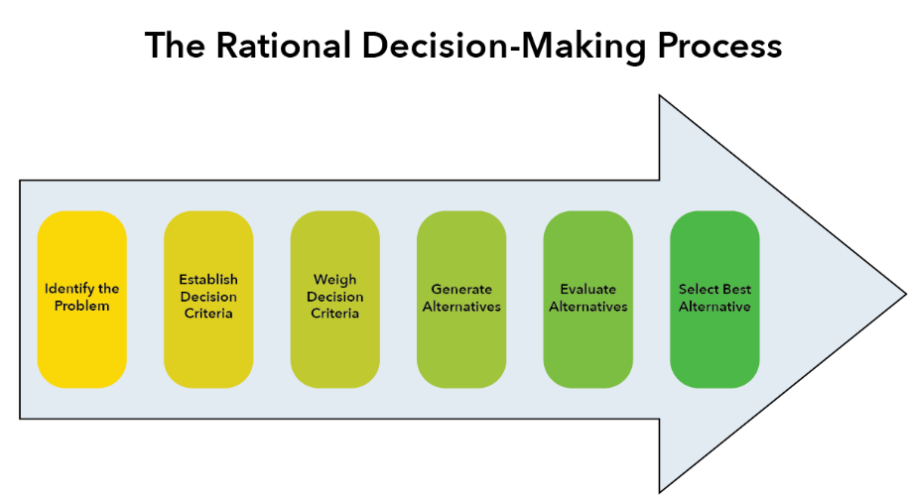
BOUNDED RATIONALITY

Bounded rationality describes the way that humans make decisions that depart from perfect economic rationality since we are limited by our mental capacity, the information available to us, and time. Instead of striving to make the “best” choices, we often settle on making merely satisfactory choices.

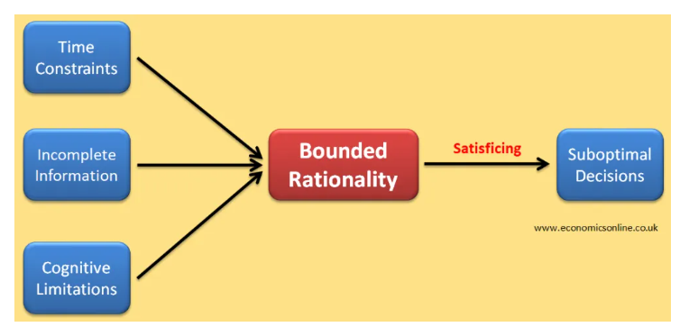

INTUITIVE DECISION MAKING

The intuitive decision-making model relies on gut feelings, instinct, and experience to make decisions quickly, often when information is limited or time is short. It's a less structured approach compared to rational decision-making, focusing on recognizing patterns and leveraging past knowledge to generate a solution.
Key aspects of the intuitive decision-making model:
- Reliance on intuition:
The model emphasizes using gut feelings and instincts as a primary basis for decision-making.
- Pattern recognition:
Intuitive decision-makers often rely on recognizing patterns from past experiences to guide their choices.
- Less structured process:
The process is less formal and may involve quickly scanning the situation and drawing on prior knowledge to arrive at a decision.
- Speed and adaptability:
Intuitive decisions can be made rapidly, making this model suitable for situations where quick action is needed.
- Potential biases:
Intuition can be influenced by personal biases and may not always be based on objective information.
CREATIVE DECISION MAKING

The creative decision-making model involves the use of new, innovative ideas in finding solutions to problems. Unlike other models, which stress looking at what has worked in the past, the creative decision-making model brainstorms new possibilities for solving issues.

CONFLICT
Conflict in a simpler concept can be explained as the integral part of life. Each time when there is a clash or difference of opinion conflict arises. Therefore, it is very important to resolve conflict whenever it arises.

types of conflict
- Internal conflict
- External conflict

Internal Conflict:
- Intrapersonal Conflict:
This occurs within an individual, often involving internal struggles with beliefs, values, or goals.
- Man vs. Self:
A classic type of internal conflict where a character grapples with their own inner demons or moral dilemmas.
- Goal Conflict:
A type of intrapersonal conflict where an individual faces a choice between different goals or conflicting desires.
- Affective Conflict:
This involves emotional clashes and disagreements within an individual, often stemming from personal feelings or biases.
External Conflict:
- Interpersonal Conflict: This type of conflict occurs between two or more individuals.

- Intragroup Conflict: This involves conflicts within a team or group.

- Intergroup Conflict: This occurs between different groups or teams, often involving competing interests or goals.

- Organizational Conflict: This type of conflict arises within an organization, potentially due to different departments or hierarchical structures.

- Intercultural Conflict: This type of conflict arises from misunderstandings or clashes between people from different cultural backgrounds.

some key conflict resolution methods:
1. Negotiation:
- Parties involved communicate directly to reach a mutually acceptable agreement.

- This can involve back-and-forth discussions, exploring different options, and potentially making concessions.

2. Mediation:
- A neutral third party facilitates communication between disputing parties, helping them explore their concerns and find common ground.
- The mediator does not make decisions but guides the process, encouraging parties to reach their own agreement.
3. Arbitration:
- A neutral third party (arbitrator) hears both sides of the case and makes a binding decision.
- Arbitration is often used as a faster alternative to litigation, particularly in commercial disputes.
4. Problem-Solving:
- Parties identify the root causes of the conflict, brainstorm potential solutions, and evaluate the pros and cons of each option.
- This approach focuses on finding creative and constructive solutions that address the underlying issues.
5. Compromise:
- Each party makes concessions to find a solution that meets the needs of both, albeit not perfectly.
- This can be a useful strategy when cooperation is difficult but a complete resolution is still desired.
6. Collaboration:
- Parties work together to find a solution that benefits all involved, often involving brainstorming and creative thinking.
- This approach requires trust, open communication, and a willingness to consider different perspectives.
7. Accommodation:
- One party yields to the interests of the other, often in situations where maintaining a positive relationship is a priority.
- While this can resolve immediate issues, it may not address the underlying causes of the conflict and could lead to resentment later on.
8. Litigation:
- Parties seek legal resolution through a court of law, often when other methods have failed.
- Litigation can be time-consuming and costly but is necessary in some cases, particularly when legal rights are at stake.
9. Conflict Resolution Training:
- Providing employees or individuals with training on conflict resolution skills can equip them with the tools to effectively manage and resolve disagreements.

- Such training can cover topics like active listening, empathy, and communication skills.

10. Active Listening:
- Practicing active listening involves paying close attention to what others are saying, showing empathy, and avoiding interruptions.
- Active listening can help parties feel heard and understood, fostering a more constructive environment for resolving conflicts.
Stress
Stress is basically a psychological term which in general concept means the unwanted mental pressure that one can carry due to several reasons. But the most elementary reason could be coming across too many conflicts and further not being able to resolve it.

TYPES OF STRESS
There are three main kinds of stress: acute, episodic, acute and chronic.
- Acute stress: Acute stress is short-term stress that comes and goes quickly. It can be positive or negative. It’s the feeling you get when you’re riding on a rollercoaster or having a fight with your boyfriend. Everyone experiences acute stress from time to time.
- Episodic acute stress: Episodic acute stress is when you experience acute stress on a regular basis. With this kind of stress, you don’t ever get the time you need to return to a calm, relaxed state. Episodic stress frequently affects people working in certain professions, like healthcare providers.
- Chronic stress: Chronic stress is long-term stress that goes on for weeks or months. You may experience chronic stress due to marriage troubles, issues at work or financial problems. It’s important to find ways to manage chronic stress because it can lead to health issues.

SYMPTOMS OF STRESS

Physical symptoms
Physical symptoms of stress may include:
- Aches and pains.
- Chest pain or a feeling like your heart is racing.
- Exhaustion or trouble sleeping.
- Headaches, dizziness or shaking.
- High blood pressure (hypertension).
- Muscle tension or jaw clenching.
- Stomach or digestive problems.
- Trouble having sex.
- Weakened immune system.
Psychological symptoms
Stress can lead to emotional and mental (psychological) symptoms, like:
- Anxiety or irritability.
- Depression.
- Panic attacks.
- Sadness.
Behavioral symptoms
Often, people with chronic stress try different things to cope. And some of those things are habit-forming and can have an impact on your health. These may include:
- Alcohol use disorder.
- Gambling disorder.
- Overeating or developing an eating disorder.
- Participating compulsively in sex, shopping or internet browsing.
- Smoking.
- Substance use disorder.

What causes stress?
Stress is how your body reacts to a change or challenge, and many different things can lead to it. Stressors can also be positive or negative. For instance, getting a new job or losing a job can both cause stress. Other causes of stress include:
- An illness or death of a loved one.
- Marriage, separation or divorce.
- Financial issues.
- Moving to a new house.
- Going on vacation.
- Having a baby.
- Retiring.
Stress can also be acute, meaning short term. Causes of acute stress may include everyday stressors, like:
- Studying for a big test.
- Getting ready for a work presentation.
- Having an argument with a friend or loved one.
- Needing to get a lot completed in a short amount of time.
- Experiencing many small problems all at once, like getting in a traffic jam, spilling coffee all over yourself and running late.
How is stress diagnosed?
Stress is subjective — not measurable with tests. Only the person experiencing it can determine whether it’s present and how severe it feels. A healthcare provider may use questionnaires to understand your stress and how it affects your life.
If you have chronic stress, your healthcare provider can evaluate symptoms that result from stress. For example, they can diagnose and treat high blood pressure.

Management and Treatment
Stress cannot be ignored. But it can be reduced and managed. Acceptance of the presence of stress is the biggest strength to fight against stress.
- Stress management starts with feeling good physically. Try getting some form of physical activity if the symptoms of stress develop. Even a short walk can boost the mood. At the end of each day, take a moment to think about what has been accomplished — not what has not been done.
- Set goals for day, week and month. Narrowing your view can help you feel more in control of the moment and long-term tasks.
- Consider talking to a therapist or a healthcare provider about your worries.
PREVENTION
Many daily strategies can help you keep stress at bay:
- Try relaxation activities, like yoga, meditation, breathing exercises and muscle relaxation. Take good care of your body each day. Eating right, participating in physical activity and getting enough sleep can help your body handle stress much better.
- Stay positive and practice gratitude, acknowledging the good parts of your day or life.
- Accept that you can’t control everything. Find ways to let go of worry about situations you can’t change.
- Learn to say ‘No’ to additional responsibilities when you’re too busy or stressed.
- Stay connected with people who keep you calm, make you happy, provide emotional support and help you with practical things. A friend, family member or neighbor can become a good listener or share responsibilities so stress doesn’t become overwhelming.
LEADERSHIP AND ASSERTIVENESS SKILL
Assertive leadership involves expressing oneself confidently and directly while respecting others’ opinions and boundaries. It's a crucial skill for effective leadership, enabling leaders to communicate clearly, make decisions, and address conflicts constructively. Assertive leaders build trust, motivate teams, and achieve goals more effectively.
Key aspects of assertive leadership:
- Clear Communication:
Assertive leaders communicate their expectations and feedback directly and openly, fostering understanding and clarity.
- Confidence in Decision-Making:
They make decisions decisively and confidently, providing direction and guidance to their teams.
- Respect for Others:
They acknowledge and value the perspectives and contributions of others, even when disagreeing.
- Emotional Intelligence:
Assertive leaders understand and manage their emotions effectively, creating a positive and productive work environment.
- Conflict Resolution:
They address conflicts constructively and fairly, seeking mutually beneficial solutions.
- Building Trust:
By being honest, transparent, and respectful, assertive leaders build trust and credibility within their teams.
Benefits of assertive leadership:
- Improved Team Performance:
Assertive leaders motivate and inspire their teams to achieve goals, leading to increased productivity and success.
- Stronger Relationships:
They foster positive and respectful relationships with team members, promoting collaboration and teamwork.
- Reduced Stress and Anxiety:
Assertive leaders are less likely to feel overwhelmed or anxious in stressful situations, making them more resilient and effective.
- Increased Respect and Influence:
Assertive individuals are often perceived as more competent and credible, leading to greater respect and influence within an organization.
Developing Assertive Leadership Skills:
- Practice Active Listening: Pay attention to others' perspectives and show empathy.

- Communicate Clearly and Concisely: Express yourself directly and avoid vague language.

- Set Boundaries: Learn to say "no" when necessary and protect your time and energy.

- Seek Feedback: Ask for feedback from your team members and use it to improve your communication and leadership style.

- Be Open to Change: Embrace new ideas and challenges, and be willing to adapt your leadership approach as needed.

OBSTACLES OF ASSERTIVENESS AT WORKPLACE
- They don’t know what they want.
- They aren’t sure of their emotions and assume everything is anger.
- They feel like their needs don’t matter.
- They want to be liked at all costs.
- They become flustered and cannot communicate effectively.
- They are uncertain or insecure about their abilities, skills, and talents.
- They have experienced excessive criticism in the past.
- They are scared of saying the wrong thing.
- They are worried about hurting or offending others.
- They are afraid they will be “found out”
- They are afraid of being challenged.
- They fear retaliation.
- They are afraid of what people will think.
Assertiveness, especially in challenging environments, has many benefits, including the following:
- Increases self-confidence, self-love, and self-respect
- Increases the effectiveness of communication during conflict or confrontation
- Earns respect from peers
- Enables you to get what you need without trampling on others
- Improves decision making that comes from increased confidence
- Helps you become a better negotiator
- Helps you become a better leader
- Improves positive relationships with your colleagues

