OEC001
UNIT-1
Understanding what is Skill and the difference between Hard Skill & Soft Skill.
The skills are the set of traits which every individual carries within himself. These are the traits which makes person a unique entity with different abilities. The skills are attained by every individual in multiple ways but at the basic level it is attained in two ways.
- Inborn skills which are inside us since birth whom we also call God-gifted skills
- The skills which we develop through the social, academic, emotional and relational grooming
Category of Need of Skill- i. Skill for Students/ personal life ii. Skill for Professional

SKILL FOR STUDENTS
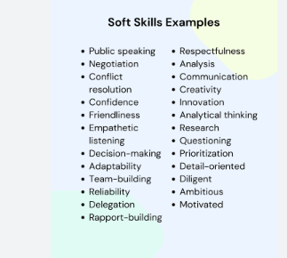 the 24 sets…

7 important professional skills

- Communication
- Problem-Solving
- Adaptability
- Leadership
- Teamwork
- Time-management
- Critical thinking

What are 21st century skills? Why do we need them?
- Critical thinking
- Communication skill
- Creativity
- Problem Solving
- Perseverance
- Collaboration
- Information literacy
- Technology & Digital Literacy
ii. List out the significance of Soft skills and create a group of skills which falls in the same category.
iii. Mention the professionals where skills are very much needed.

PROCESS OF SOFT SKILL
- Self-Assessment
- Goal Setting
- Targeted Practice
- Feedback Mechanism
- Continuous Improvement
- Strategies for overcoming Challenges

BARRIERS OF SOFT SKILL
- Lack of self-awareness
- Poor feedback culture
- Negative work Environment
- Lack of Training Opportunities
- Resistance to change
- Cultural differences
- Personal insecurities
- Inadequate guidance or leadership support
- Difficulty in measuring soft skill proficiency
- Not able to keep a self-check

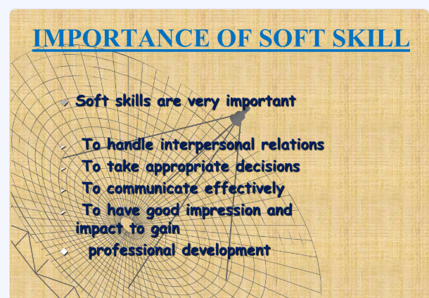

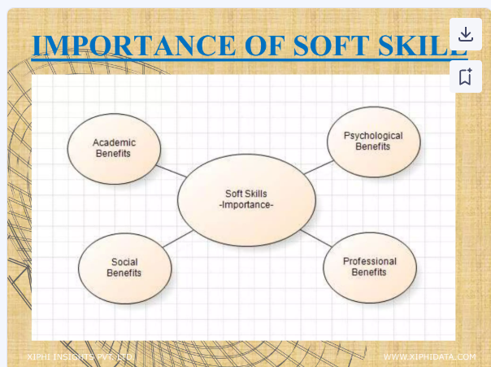

Introductory questions to understand the overview of SSIPC
- Identify the approach of soft skill.
- What do you mean by approach?
- What makes the approach of soft skill unique and difficult?
- Is there any difference between communication and interpersonal communication? How and why?
- What is more complicated; communication or interpersonal communication? How?

Co-relation between the interpersonal communication & self discovery

Co-relation is mutual dependence for the sake of attaining personal interests/goals.

Self- discovery is a journey of knowing ourselves through our own action, behaviour, circumstances and nature; where in the action behaviour, circumstances and nature are never fixed and keep changing frequently.

Can we ensure that there is a fixed point to achieve self-discovery? Justify with real case study.

Difference between communication and conversation

Conversation can be formal or informal and is usually confined to a limited number of people. It includes only 2 skills- listening and speaking.

Communication mostly either has a formal set-up and if not then there’s always an objective to attain through it. Communication has a wider perspective than conversation hence, it includes all the four skills, that is, LSRW. This is the reason which makes communication an important soft skill.

- What is the role/impact of co-relation in the corporate work sector?
- Mention those examples which could be counted as interpersonal communication when it is done between more people.

Complementary status of soft skill & Self Discovery

The word complement means to act as the integral part of something so as to enhance and complete the overall idea.

SKILL- this word has been quite overrated in the present context of time. Although the existence of this word has been there for generations, with time only the relevance of the word has increased and has been accepted too.

Skill is of two types- HARD & SOFT

HARD SKILL- is related to technical learnings to that level so as to be able to execute it at our personal level to gain professional benefit. It is gained only through learning and training.

SOFT SKILL- is related to in-born quality/talent which everyone carries in themselves. It is that unique approach of an individual allows the person to deal with the odd situations and circumstances. The stronger is the soft skill inside a person the stronger is the coping mechanism inside the person.

Beliefs, Values, Attitude & Virtue

Beliefs related to skill
- It is related to the personal judgement
- It always has the scope of improvisation
- It can never be completely aligned with others
- It acts as the unique identity of an individual
- At times acts the point of deviation, as a low skilled person overestimates himself while the high skilled person underestimates himself.

Values related to skills
- Following the instructions
- Open interaction with all
- Acceptance of mistakes
- Sincere listening to every opinion/statement irrespective of the post and position
- Never comment for the things which lies beyond your work domain

Attitude related to skills
- Showing the required amount of behaviour
- Having the balance behaviour in every circumstance
- Keeping the belief that every problem (different versions of problem- challenges, rejection, uncooperative senior) has a solution
- Keeping the optimum distance and connection with colleagues whom we don’t know much
- Having the understanding when and how to say ‘NO’

Virtue related to skills
- Understanding that behaviour is shaped by situation
- Knowing that perfection of skill is not possible so always be ready to improve
- Use your skills as strength not as a saviour or escape from the problem

Complementary status of Interpersonal relation & Interpersonal communication

Public Speaking & Team Building
Gets ease of growth through hard skill, as it helps to develop the KNOWING, DOING & THE WILLINGNESS TO GAIN MORE, thus increasing curiosity, with curiosity comes the desire to ask questions, to ask questions communication is important and to communicate confidence is required.

Therefore, hard skill helps to gain confidence & communication. communication creates the base of presentation thus helps to build the base of public speaking.

Public speaking skill is aligned with team building. How?
Compare soft skills needed for the sake of public speaking and team building.

