Verification Architecture v2
AI-Evaluator Engine
SUPERSEDES — verification only
This document replaces the verification design in the V1 Build Plan (Unified v2) — specifically §3.8, §3.9, §3.10, and §3.11 — on every point where they differ. Those sections remain valid only as the history of how the design evolved. As far as verification is concerned, the old plan is changed; for the current architecture refer to this document.
Does not touch: MISMO import (§1.5), document handling (§2), calculators (§3.5), communication (§4), conditions (§4.5), or any non-verification phase. Those stand as written.

1. Why this exists
The earlier plan built verification as a deterministic Python rules spine, with AI confined to perception (extraction and classification) plus a cross-source discovery pass. Real build experience showed the deterministic-per-rule approach does not scale to the diversity of real loan files: encoding a decision path for every edge case is not achievable, and the determinations that actually matter — what income qualifies, whether a deposit is sourced, whether a story is plausible — are judgment, not arithmetic.
This document inverts the default. AI evaluates the rules; deterministic code is demoted to a narrow integrity check.

2. The inversion
Old default (superseded): deterministic Python is the evaluator spine; AI only perceives.
New default: AI is the evaluator for all ~130 rules. Each rule is a spec — its description, fire-condition, required inputs, and threshold parameter — and the AI reads the frozen snapshot (and underlying documents) and renders the verdict against that spec. Deterministic code is demoted from the spine to a thin numeric-integrity check that re-runs only the final arithmetic comparison for threshold rules, because that single step is the one thing LLMs do unreliably.
What stays deterministic — and only this:
- Snapshot freeze — facts are assembled once and frozen, so a run is replayable.
- Numeric-integrity check — for a rule whose verdict rests on “X compared to Y,” code re-runs that comparison on the values the AI surfaced. Not the income computation, not the sourcing judgment — only the terminal compare.
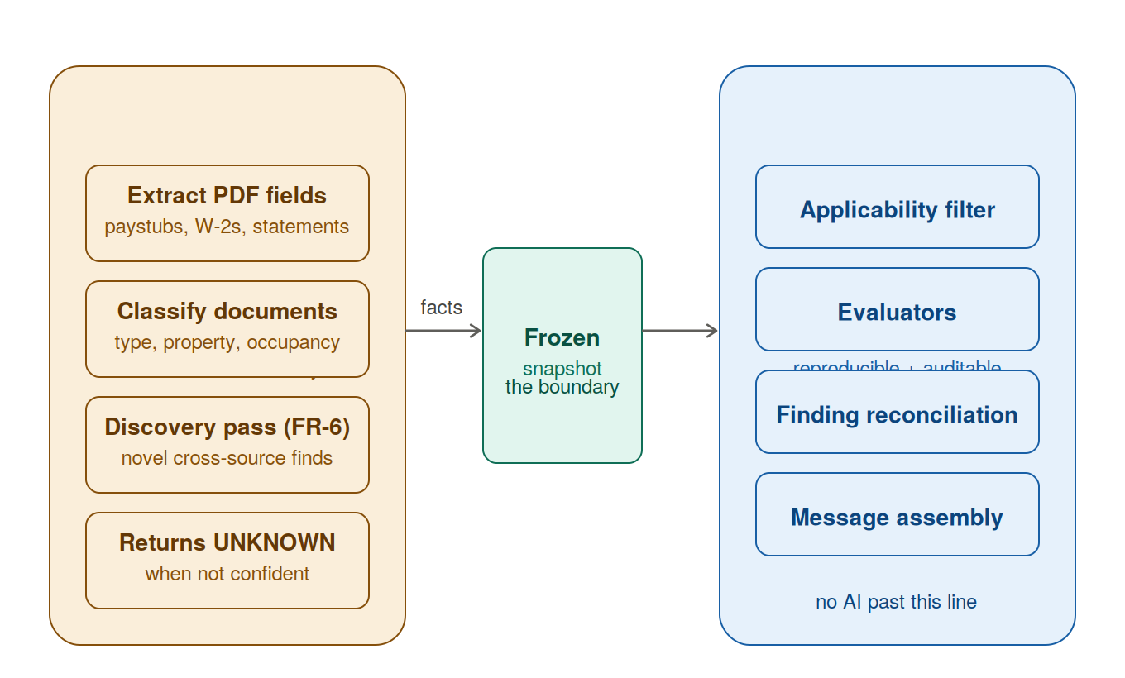
Figure 1 — AI lives at the edge producing facts; the deterministic core owns decisions. The frozen snapshot is the boundary.
STATUS — what is current vs deprecated vs to-build (read this first)
CURRENT authoritative Stage-2 design: §3D (The Fact-Tag Architecture). The original per-rule-AI-evaluator design (old §3C/§5/§5A/§6) is DEPRECATED and moved to Appendix A — do not build to it.

Build status by section:
• §3B Snapshot (raw layer) — BUILT (Stage 1).
• §3D Fact-Tag Architecture — IN PROGRESS (the tag layer, tag production, thin rules, findings). The core engine.
• §4 Run trigger — PARTIAL (engine runs; the trigger UX / auto-run is product work, not finished).
• §7 Cross-source discovery lane + observation channel — TO BUILD (planned: observation channel + graduation).
• §8 Finding lifecycle (four states) — PARTIAL (outcome states + provenance built single-run; the four-TAB surface is UI, not built; full lifecycle needs cross-run reconciliation).
• §9 Identity / immortality / reconciliation — TO BUILD (cross-run finding reconciliation).
• §10 Action buttons on findings — TO BUILD (UI; no UI exists yet).
• UI / findings surface (the four tabs, finding detail, upload+re-run, resolve/override) — NOT STARTED. The biggest remaining gap between engine and product.
• §1 §2 §11 §12 — narrative/rationale (nothing to build).
Separately: Fannie/Freddie is the DEFAULT source of truth for thresholds (agency values are authoritative as encoded in the spec); Priya confirms only lender OVERLAYS/deviations, not all 130. Findings cite the guideline (from the spec's encoded reference), never AI-recalled at runtime.

3. Full pipeline (every run)
Every verification run rebuilds the snapshot from scratch and flows the whole way through to findings. The snapshot is stateless — born and discarded each run. Findings are stateful — they persist across runs, matched by identity. The run is a pure function; the final reconciliation step is where the stateless run updates the persistent finding history.
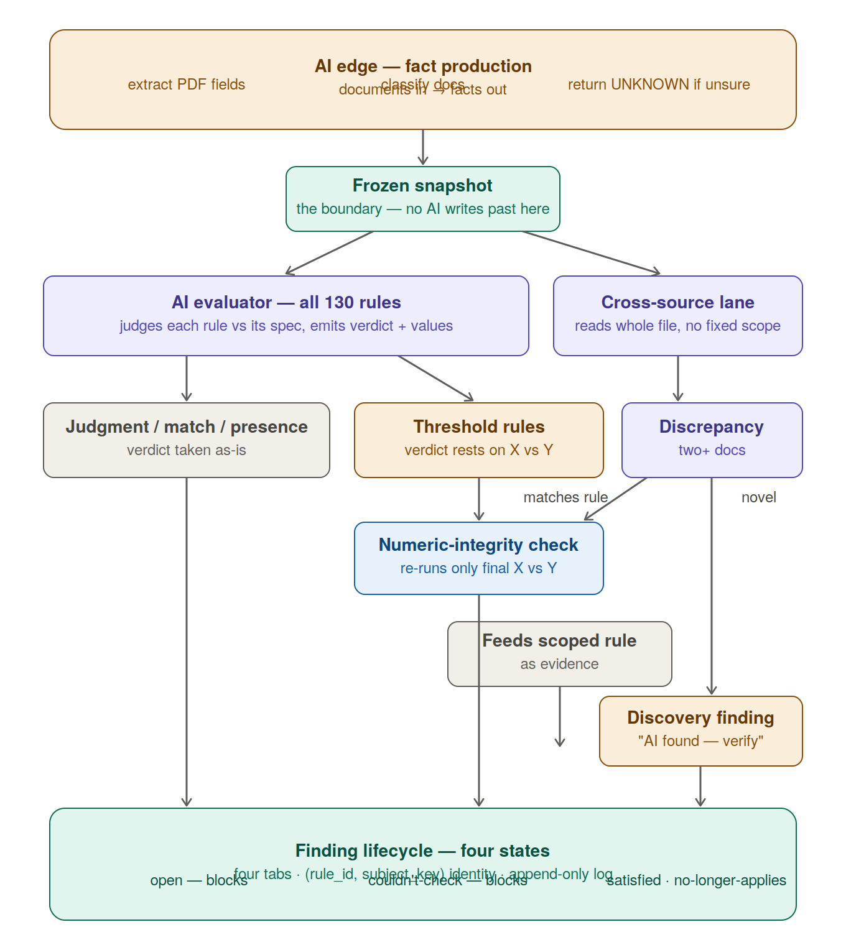
Figure 2 — The full engine: AI edge → frozen snapshot → AI evaluator + cross-source lane → numeric check → finding lifecycle.
3A. Pipeline stages (build map)
The pipeline in data-flow order. This map reflects the CURRENT (fact-tag) architecture — §3D. (The earlier per-rule-AI-evaluator build map is deprecated; see Appendix A.)

Stage 0 — Ingestion
The AI edge (classification/extraction) is upstream and already exists. The rebuild starts at the snapshot, not the extraction layer.
Stage 1 — Build and freeze the snapshot (RAW layer)
One immutable, per-run snapshot: MISMO section + documents section + calculations section; provenance on every fact; absent ≠ empty; rebuilt fresh each run; versioned. This is §3B — settled, and it becomes the RAW layer the tags sit on. BUILT.
Stage 2 — Tag production (the AI structures raw into fact-tags)
AI turns messy raw facts into clean, structured FACT-TAGS in a tags layer over the raw layer. Stage A = per-entity atomic tags (is_money_in, amount, apparent_category); Stage B = cross-entity correlation tags (has_identified_source, is_retained_reo…) via deterministic candidate-search + AI judgment. Every tag carries value/confidence/reasoning/source_facts (stable content-ids). §3D.
Stage 3 — Rule evaluation (thin, deterministic, over the tags)
Rules QUERY the tags + do arithmetic — no per-rule AI evaluator. Rule KIND routes: calculative/structural rules are thin deterministic queries; the ~36 judgment rules are AI-at-rule-time with MANDATORY human ratification, reasoning over tags (not raw docs). A generic fail-closed gate runs before every rule (required tag absent/unknown → couldnt_check; below-confidence/contradiction → needs_review; never a silent satisfied). §3D.
Stage 4 — Calculators as structured tags
The snapshot calculators (DTI, LTV [emits CLTV/HCLTV], MI, reserves — the four that feed the snapshot) expose a value + a breakdown whose every line traces to the fact-tag that produced it (from_tag). Confidence propagates and fail-closed reaches THROUGH the calc (an unknown input → the calc gates to couldnt_check, not a confident-but-wrong number). §3D.
Stage 5 — Cross-source discovery lane + observation channel
Runs whole-file, no fixed scope. Known cross-source correlations are Stage-B tags; genuinely novel tensions become structured OBSERVATIONS that fail closed to human review and feed a graduation log (recurring → a human formalizes into a tag+rule). Observations INFORM, never auto-resolve. §7.
Stage 6 — Finding reconciliation & lifecycle
Results → durable findings; identity (rule_id, subject_key) from STABLE content-ids; unique per (loan_id, rule_id, subject_key); matched across runs (carry-forward / mint / retire); five outcome states surfaced in four tabs; append-only per-finding event log; immortality. §8/§9.
Stage 7 — Processor surface (tabs + actions) — TO BUILD (UI)
Findings render into four tabs (needs-attention = open + couldnt_check + needs_review; satisfied; no-longer-applies; not-applicable); per-finding actions (Override, Accept-risk, Add note, Request-docs, View-fix, Undo). The UI does not exist yet — the biggest remaining gap. §8/§10.
Stage 8 — Eval harness (cross-cutting)
Golden-file eval at BOTH tag level and finding level + calibration (unknown rate + accuracy-when-concrete). Must exist early (alongside the first rule), not at the end — the guarantee against silent regression. §3D.
Run model: every run rebuilds the snapshot from scratch and flows Stage 1 → 6. Snapshot is stateless (discarded each run); findings are stateful (persist, matched by identity). Trigger manual today, automated later.

3B. Stage 1 — Snapshot design (detailed, settled)
This is the settled design for Stage 1, the per-run frozen snapshot. Goal: give a full, faithful picture of the loan file — every extracted data point, from MISMO and from every document — so that an AI evaluator or a human can see exactly what is in the file. Guiding principle: the snapshot records; it does not correlate or judge. Everything is raw, unlinked, and unreconciled — correlation and reconciliation are downstream pipeline jobs (the rules).
Structure — three sections
- 1. MISMO section — every field parsed from the MISMO/1003, as flat key→value pairs, raw. Borrower names, SSN, income, liabilities, assets, transaction, property, loan terms — all of it.
- 2. Documents section — a list, one entry per document. Each entry: documentType (paystub, W-2, bank statement, credit report, appraisal…), belongsTo (the borrower name if the document identifies one; null if it does not), and every extracted field as key→value.
- 3. Calculations section — DTI, LTV, MI, reserves, each produced by the existing calculators, each shown with its full breakdown including the per-line source tag.
Field shape
- Every field carries value + confidence + source (source = parsed | extracted). Confidence on MISMO-parsed fields is effectively 1.0; extracted fields carry the extractor’s confidence.
- PII fields (SSN, account numbers) are masked for display, hashed for matching — they carry a display value (last-4, e.g. ****3312) and a match_hash of the full value. Rules match on the hash (proving “this deposit cleared the account listed as an asset”) without the full PII ever being shown or stored in the clear. (Implementation note: hash salted per-loan-file so the same SSN across two files does not collide.)
Example
snapshot:
loan_file_id: LF-2024-0148
run_id: run_20260709_1
as_of: 2026-07-09

mismo: # section 1 — every MISMO field, raw
borrower.1.first_name: { value: "Jane", confidence: 1.0, source: parsed }
borrower.1.ssn: { display: "***-**-4821", match_hash: "a3f9…", confidence: 1.0, source: parsed }
borrower.1.income.base_monthly: { value: 6000, confidence: 1.0, source: parsed }
transaction.purpose: { value: "purchase", confidence: 1.0, source: parsed }
transaction.purchase_price: { value: 480000, confidence: 1.0, source: parsed }
loan.amount: { value: 384000, confidence: 1.0, source: parsed }
asset.1.account: { display: "****3312", match_hash: "b71c…", confidence: 1.0, source: parsed }
… every MISMO field …

documents: # section 2 — one entry per document
- documentType: paystub
belongsTo: "Jane Smith"
fields:
income.base_monthly: { value: 5700, confidence: 0.94 }
income.ytd: { value: 34200, confidence: 0.97 }
employer.name: { value: "Acme Corp", confidence: 0.99 }
- documentType: appraisal
belongsTo: null # no borrower named → null (still fully shown)
fields:
appraised_value: { value: 485000, confidence: 0.96 }

calculations: # section 3 — via existing calculators, with breakdown
dti:
value: 38.2
breakdown:
income: { amount: 6000, source: stated } # MISMO baseline
property_tax: { amount: 290, source: extracted } # from property_tax_bill
mi: { amount: 210, source: computed }
result: "2300 / 6000 × 100 = 38.2%"
ltv:
value: 80.0
breakdown:
loan_amount: { amount: 384000, source: stated }
appraised_value: { amount: 485000, source: stated } # valuation_amount (MISMO/manual)
basis: 480000 # min(purchase_price, appraised)
result: "384000 / 480000 × 100 = 80.0%"
Key decisions (settled)
- Raw and unlinked. The same fact from two sources (MISMO income 6000 vs paystub income 5700) appears in both sections, side by side, with NO marker that they are the same field. Connecting and comparing them is the downstream pipeline’s job.
- No reconciliation in the snapshot. The snapshot never decides which value is “correct.” Disagreements are surfaced as findings by the rule engine, not resolved here.
- belongsTo is null when no borrower is named (appraisal, standalone contract). The document is still fully displayed; only the ownership tag is empty.
- Calculations reuse the existing calculators (DTI, LTV, MI, reserves), which already return rich breakdowns whose line items are tagged stated / extracted / computed / manual. The snapshot surfaces those tags directly, giving input-traceability for free.
- Calculators compute from the MISMO/stated baseline (with DTI’s escrow lines — property tax, homeowners insurance, HOA — sourced from extraction, as they do today). A stated-vs-extracted mismatch (e.g. income 6000 vs 5700) is a rule/finding concern, not the snapshot’s: DTI uses 6000, tags it stated, and a rule flags the disagreement.
- Rebuilt fresh per run, frozen, versioned. The run record stores the exact snapshot version it ran against.
In scope for Stage 1
- MISMO section (all parsed fields), Documents section (per-doc: documentType + belongsTo + all extracted fields), Calculations section (DTI, LTV, MI, reserves with breakdown + source tags).
- Confidence on every field; source tag (parsed | extracted).
- PII masking (last-4 display) + full-value match_hash for rule matching.
- Reuse of the four existing calculators and their breakdowns.
NOT in scope for Stage 1
- Cash-to-close — does not exist in the codebase today (no calculator/service/endpoint; only fragments: a manual closing_costs input and a down_payment equity proxy). It is net-new, not a reuse, and is deferred — not built in Stage 1.
- Linking or correlating facts across sections — deliberately downstream. The snapshot does not tag “same field” across MISMO and documents.
- Reconciliation / choosing a “true” value — a rule-engine job, not the snapshot’s.
- Entity-graph relationships (asset→borrower, income→employer as explicit linked references) — the snapshot is section-based (MISMO / documents / calculations), not a linked entity graph. Relationship modeling is not part of Stage 1 as settled.
Deferred notes (carry forward)
- Disagreeing inputs to a calculator. When two sources disagree on a calculator input (income 6000 vs 5700), the calculator uses the stated (MISMO) value and tags it; the mismatch is a finding. Largely resolved by the existing per-line source tags. Open sub-question, deferred: whether the breakdown should also show the alternative (e.g. paystub) value inline, or leave that entirely to the finding. Current lean: snapshot shows the MISMO-based calc with source tags; the finding owns the mismatch.
- Appraised-value source for LTV. Today LTV’s appraised value comes from Property.valuation_amount (MISMO/manual), NOT an extracted appraisal (no appraisal extractor exists). When an appraisal extractor is built, LTV may mix a MISMO loan amount with an extracted appraised value — revisit the breakdown’s source tagging then.
- Hash salting detail — per-loan-file salt for PII match_hash; finalize at implementation.
- Income-variance deterministic check is currently dormant (documented_income_monthly not yet populated); in the new architecture the AI evaluator handles this, so it is moot — noted for continuity.

3D. The Fact-Tag Architecture (supersedes per-rule AI evaluation)
A bug in the first AS-1 spec (a hardcoded direction==“credit” filter that silently dropped ambiguously-labelled deposits) proved a deeper point: deterministic string-matching on raw, messy data fails systematically and invisibly on the cases no one enumerated. The resolution reshapes Stage 2 around a single principle.
The principle
AI turns messy reality into clean, structured FACT-TAGS; deterministic code QUERIES those tags and does arithmetic. Deterministic is only reliable on data AI has already structured — so make the snapshot so well-structured that deterministic code can just read it and be correct. Crucially: AI tags the FACTS (txn.is_money_in, amount, has_identified_source), NOT the CONCLUSIONS (is_large_deposit). The conclusion is derived by deterministic code from the fact-tags plus the spec’s Priya-validated threshold. This resolves the AI-vs-deterministic tension: it is BOTH, in sequence — AI makes the data safe for determinism.
The error profiles are not equivalent, which is why this is correct: deterministic-on-raw-data fails systematically, silently, and totally on unanticipated cases; AI fails occasionally, visibly, and scattered, and it GENERALISES to inputs no one enumerated. For a system that must not miss what the underwriter will catch, visible-and-scattered is survivable; silent-and-total is not.
Snapshot shape — one artifact, two layers
The snapshot is ONE frozen artifact with a raw layer (exactly what Stage 1 builds — MISMO facts, documents, transactions, calculations; unchanged, now the substrate) and a tags layer (the new AI-structuring layer produced OVER raw, every tag citing raw facts in source_facts). Stage 1 is not scrapped; it becomes the raw layer. Every tag is a uniform honest object:
{ "value": "no", // domain ALWAYS includes "unknown"; never fabricated
"confidence": 0.62, // nullable; null for parsed, number for AI, never invented
"reasoning": "no matching payroll or own-account transfer within window",
"source_facts": ["txn_002"], // STABLE content-ids into the raw layer (never array position)
"produced_by": "ai", // parsed | ai | derived | spec
"tag_role": "structural_fact", // structural_fact (many rules) | rule_judgment (one rule)
"tag_version": 1, // additive-only vocabulary version
"stage": "B" } // A = per-entity atomic; B = cross-entity correlation
Entities (transactions, liabilities, income, properties…) are lists of instances, each carrying its tags. The four calculators that feed the snapshot (DTI, LTV [which emits CLTV/HCLTV as ratios], MI, reserves) are stored as structured tags: value + a breakdown where EACH line carries source (stated/extracted/computed/manual) and from_tag (the fact-tag that produced it) — so deterministic code sees not just the number but HOW it was built and can trace every line to a tag with its confidence. (max_loan and self_employed exist but are API-only, not in the snapshot; there is no cash-to-close calculator.)
Staged production; correlation via candidate-then-judge
- Stage A — per-entity atomic tags (is_money_in, amount, apparent_category) produced from a single entity’s raw facts.
- Stage B — cross-entity correlation tags (has_identified_source, is_retained_reo, liab.in_application, identity consistency). These ARE the cross-source findings, promoted to first-class structured tags. Production follows the tag DEPENDENCY DAG (each tag declares depends_on); a tag is never produced before its inputs exist, and confidence propagates along the DAG (a tag is never more confident than its shakiest input).
Correlation tags scale by deterministic candidate-search + AI judgment: to source a deposit, deterministic code finds candidate matches (transactions of similar amount/date across accounts — mechanical, scales to any file size), then the AI judges whether a candidate is a genuine source on a SMALL set. The AI never searches the whole file; it only judges. Same bookend philosophy — code does the mechanical search, AI does the meaning.
The armor (why a wrong tag can’t become a silent false-green)
- Provenance propagates tag → finding. Every finding carries the load-bearing tags it relied on, WITH their reasoning + confidence inline — so the human reviewing the finding sees the tag’s reasoning. A finding never cites a bare number.
- Confidence gates the verdict. verdict_confidence = min(load-bearing tag confidence). A low-confidence or unknown load-bearing tag CANNOT yield a confident “satisfied” — it degrades to couldnt_check / needs_review. Uncertainty propagates instead of being flattened.
- Fail-closed. Every degradation path — unknown tag, below-confidence tag, contradiction, failed tag production, unclassified document — routes to couldnt_check / needs_review / discovery, NEVER to a silent satisfied. A file reaches “satisfied” only by EARNING it: present, high-confidence, non-contradictory tags. The default is doubt.
- Tag-level eval + contradiction audit. Golden labels on the TAGS themselves (not just findings), so a systematically-wrong tag is caught upstream. Deterministic cross-checks (statement balance reconciles to transaction sum; retained_pitia present ⇔ is_retained_reo=yes) flag AI incoherence.
- Frozen once; reproducible. Tags are produced once and frozen into the snapshot, NEVER re-derived on load (loading reads stored tags, it does not re-run the AI). The snapshot records the model + tag-vocabulary version that produced its tags — separating frozen historical truth from re-analyse-with-today’s-model.
Edge cases resolved (the hardening review)
- Absent tag ≠ unknown tag. Most real couldn’t-checks come from ABSENT documents (no appraisal/credit report/binder). Each rule DECLARES its required tags; the engine checks they exist and are non-unknown before evaluating. A required tag that is absent → couldn’t-check (“no appraisal in file”), exactly like unknown. A rule must never read an absent tag as false/zero.
- Tags bound to a raw-layer version; content-id references. source_facts reference raw facts by STABLE content-id, never array position. A tag’s cache key includes the fingerprint of the raw facts it depends on — if any cited raw fact changed, the tag is invalidated and re-produced. Prevents stale tags citing shifted raw facts.
- Source conflicts surface as findings. When sources disagree (paystub vs W-2 vs stated income), the AI does NOT silently pick — the tag carries the conflict (chosen value + reasoning + conflicting_sources + a conflict signal), and a deterministic rule (IN-1 / consistency) fires a normal “reconcile inconsistent sources” finding. The conflict flows through the pipeline as a fact → rule → finding, not an invisible internal resolution.
- AI-at-rule-time rules get first-class safety. The ~36 genuine-judgment rules (occupancy reasonableness, altered documents, appraisal condition, fraud) are the highest-stakes and get the LEAST tag armor — so they require MANDATORY human ratification (not optional), are confidence-gated (a low-confidence fraud judgment escalates), and reason over structured TAGS (not raw documents) so they stay consistent and reviewable.
- Partial-snapshot semantics. If a tag-production call fails (timeout/parse), the snapshot does NOT fail wholesale — those tags are absent-with-reason (“production failed”), rules needing them → couldn’t-check, and rules not depending on them still run. Graceful degradation of the structuring pass itself.
- Findings survive across runs. A finding’s subject_key is built from STABLE tag values (durable ids/dates, not re-extracted amounts) so run N+1 recognises “the same finding” and can evolve it (open→satisfied when a gift letter arrives) or retire it (→no-longer-needed). Finding identity rests on tag stability.
- Raw-layer trust (documented limitation). The raw layer is itself AI-extracted and can contain extraction errors a faithfully-sourced tag will inherit. Deferred: a future raw-layer contradiction audit (balances reconcile, cross-document facts agree). Noted so provenance is not mistaken for ground-truth.
The unbounded real world — the observation channel
The tag vocabulary cannot enumerate every document type (gift letters, divorce decrees, trust agreements…). Resolution is neither a fixed vocabulary nor AI free-inventing tags (which would break the queryable contract). When the AI meets something not in the vocabulary it records a structured observation — a schemaless-but-structured envelope (about / type / value / structured / relates_to / confidence / reasoning / needs_tag) — never inventing a formal tag, never dropping the information. An observation that relates to a finding FAILS CLOSED to human review (useful day one). Recurring observation types are logged as GRADUATION CANDIDATES; a human (with Priya) formalises them into governed tags + a deterministic rule, after which the case is fully automated. Extensible (AI observes anything), governed (only humans create formal tags), self-improving (production frequency ranks what to formalise next). Observations INFORM humans and graduation; only governed tags drive automated resolution — that boundary keeps extensibility from becoming a false-green vector.
Storage — how rules and tags live in the system
- Rule specs → version-controlled FILES. One spec file per rule (behind load_rule_spec), declaring: criteria, applicability, REQUIRED TAGS, kind, reference_values (Priya-validated thresholds), confidence floor, evidence_required. Rationale: specs are regulatory thresholds needing an audit trail and Priya sign-off, and git history IS that audit trail (which PR changed which threshold, when, approved by whom). Priya reviews/approves, a developer commits. Files > DB for this.
- Tag VOCABULARY → version-controlled file (the registry). The definition of every tag (name, entity, type/allowed-values, description, depends_on, tag_role) is a governed, versioned file — the contract between the structuring layer and the rules. Additive-only; never redefine a tag’s meaning. CI consistency checks (future): every tag a rule reads is produced; no dead tags; allowed-values match; depends_on is a valid DAG.
- Tag VALUES (per loan file) → in the snapshot artifact, in the DB. The produced tag values live in the tags layer of the frozen snapshot, persisted as the immutable per-run JSON blob (Stage 1’s persistence). Vocabulary = the schema (files); tag values = the data (snapshot rows). Rule specs = the policy (files); findings = the results (DB).
- Observations + graduation log → DB. Structured observations are stored per run (they relate to findings); the graduation-candidate frequency log is a running DB tally that ranks which unknowns to formalise next.
- The clean separation: SCHEMA/POLICY (tag vocabulary + rule specs) lives in git as files — human-governed, audit-trailed, Priya-signed. DATA/RESULTS (tag values in snapshots, findings, observations) lives in the DB — per loan file, per run, immutable. Neither is a substitute for the other.

4. Run trigger
- Today: manual. A “Run verification” button. When any document changes the verification is marked STALE; the processor triggers the run, which fires the whole run — snapshot rebuild through findings — not a step after the snapshot.
- Unchanged re-runs are cache-served. If inputs are unchanged, a re-run returns existing findings without calling the AI (input-fingerprint cache), with a force-rerun escape hatch.
- Future: automated. Re-run on document change is a later phase, as the old plan already anticipated.

7. Cross-source discovery lane
Structurally different from the scoped rules: its value is that it does not declare its inputs. It reads the whole file and surfaces tensions no rule anticipated. Runs last, over the same frozen snapshot. Each claimed discrepancy must name the specific documents and values in tension — a discrepancy it can’t point at is a hallucination.
Output splits three ways:
- Matches an existing rule → routed into that rule as evidence; surfaces under that rule’s identity, not as a duplicate.
- Genuinely novel → its own finding, labeled “AI found — verify,” medium-trust, source documents shown. Enters the same lifecycle.
- Recurring across files → graduates into a scoped rule. FR-5 already made this trip.
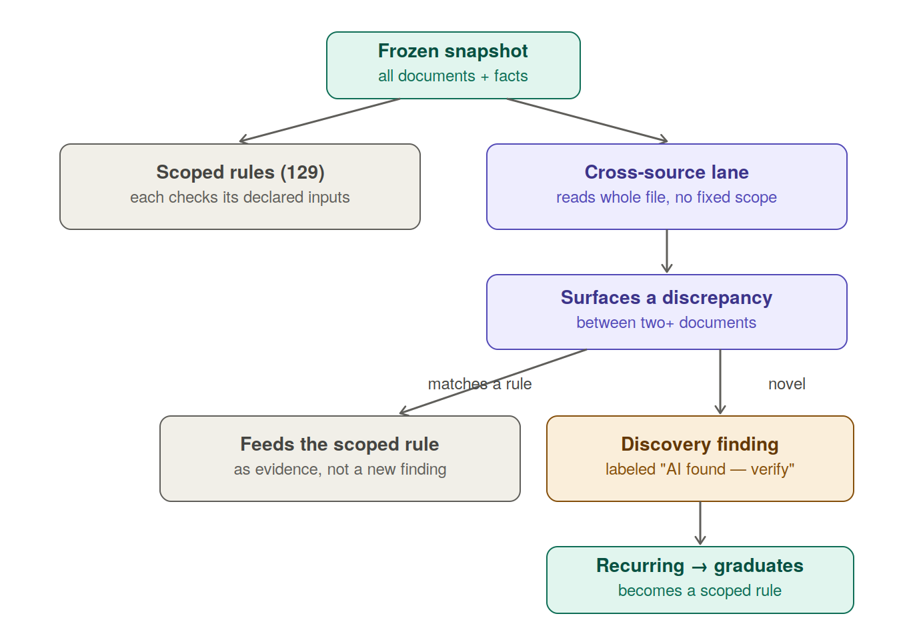
Figure 4 — The cross-source lane routes matches into existing rules and raises labeled discovery findings for the novel rest.
Caution (locked)
This lane is the least reproducible, least auditable part of the engine, by design. It is acceptable only because discovery findings are labeled and human-verified — they never block submission on their own authority the way a validated scoped rule does. Advisory-with-teeth: loud enough a real discrepancy can’t be missed, gated enough a hallucinated one can’t silently sink a file.
8. Finding lifecycle — five outcome states, four tabs
Every finding carries an EVALUATION OUTCOME (what the engine concluded) and is shown in one of four TABS (the human's view, grouping outcomes by 'what do I need to do'). Outcomes and tabs are NOT one-to-one — the 'needs attention' tab is the union of every outcome that requires a human.

The five evaluation outcomes (from the rule engine / LP-316):
• open — the rule FIRED; something is wrong and unresolved. Needs attention.
• couldnt_check — the rule APPLIES, but a required/load-bearing tag is absent or unknown, so we could not judge. Blocks. NEVER disguised as a pass (the false-green guard).
• needs_review — the verdict is degraded/ambiguous, or an AI-judgment rule is ratification-pending (e.g. a self-asserted large transfer with no matching debit; a below-confidence-floor result). A human must confirm.
• satisfied — the check passed, evidence shown.
• no_longer_applies — was a finding, but its subject left the file (the deposit/tradeline/property is gone). Retired.

The four tabs (the human's view):
1. Needs attention — open + couldnt_check + needs_review. Everything requiring a human's eyes, in one pile. couldnt_check sits HERE, never in Satisfied — the false-green guard.
2. Satisfied — passed, evidence shown.
3. No-longer-applies — retired findings whose subject left the file (history).
4. Not applicable — the rule is irrelevant to the NATURE OF THE FILE (e.g. a condo-master-policy rule on a single-family home; an FHA rule on a conventional loan). Scope was false from the first run; it was NEVER a finding. Each shows its skip reason.

Outcome → tab mapping:
• open → Tab 1 (needs attention)
• couldnt_check → Tab 1 (needs attention)
• needs_review → Tab 1 (needs attention)
• satisfied → Tab 2 (satisfied)
• no_longer_applies → Tab 3 (no-longer-applies)
• not_applicable (scope false for the file's nature) → Tab 4 (not applicable)

The three 'not firing' cases MUST stay distinct (the core honesty contract):
• Lost visibility → couldnt_check (Tab 1) — rule applies, the thing might exist, we can't see it. BLOCKS.
• Stopped existing → no_longer_applies (Tab 3) — was a finding, subject left the file.
• Never relevant → not_applicable (Tab 4) — scope false from the first run, never a finding, irrelevant to the file's nature.
Collapsing any of these into another is the core failure mode. In particular, NOT-APPLICABLE (scope-false, nature-of-file) must NEVER absorb COULDNT-CHECK (data-missing) — 'this rule doesn't apply to this file' and 'this rule applies but we couldn't verify it' are completely different, and conflating them hides a real gap behind a false 'not applicable'. That distinction is the whole honesty contract.

9. Identity, immortality, reconciliation
- Identity = (rule_id, subject_key). rule_id = the check (~130, fixed). subject_key = the specific deposit/borrower/tradeline/property (or whole_file). Derived from durable attributes, never array position, so it’s stable across runs.
- Uniqueness: (loan_id, rule_id, subject_key) — one live finding per check-per-subject-per-file. Enables per-borrower scoping.
- Reconciliation each run: compute subject_key; match against the prior run’s live findings; found → carry forward (keep id + history, update state); not found → mint a new finding.
- Immortality: once a finding fires it never leaves the surface silently — it only moves to a visible, labeled state with a reason + timestamp. No “gone” state. Append-only event log per finding.
- Retire / revive: a retired finding stays retired; only an exact subject_key match revives it; a genuinely different subject → new finding. Retiring never suppresses future firing of that rule class.

10. Action buttons on findings (retained)
- Override (with reason), Accept risk (with reason), Add note.
- Request docs — creates a needs-list item; the finding stays open until satisfied. This is the self-heal seam: finding → spawns a need → need satisfied → finding re-resolves on the next run.
- View fix (for findings with an apply-spec) — opens an itemized before/after preview before confirming.
- Undo on resolved findings — reverses an applied data change and recomputes, or flips an accept-risk/override back to open.

11. What did NOT change
- AI edge — classification and extraction — this is what the edge does in current development (not a fuller canonicalization role). It classifies documents and extracts field values into the snapshot; facts are not fully normalized at the edge, which is part of why applicability must be AI-reasoned rather than a field-compare (see §5A).
- Snapshot as an immutable per-run frozen artifact — same, with absent ≠ empty and provenance on every fact.
- Rules-as-data — verification_rules table, git-tracked seed, rule_change_audit, thresholds editable live and Priya-validated. What changed is that the evaluator a rule points to is now an AI-judged spec kind by default.
- Calculators — DTI/LTV/MI/reserves stay deterministic; the cross-source lane stays out of their territory.
- AU-2 keystone — “whatever DU findings require” still routes through AUS reconciliation.
- Blocked rules + golden-file eval set (LP-143) — still gated on blocker-doc extractors, and now more load-bearing: since AI evaluation is probabilistic, the eval set is the primary guarantee against silent regressions.

12. The three risks this architecture must manage
Inverting the default moves the hard problems rather than erasing them.
- Values must be exposed. If the AI returns a bare verdict, both the numeric check and auditability are lost. The spec format must require structured operative values.
- UNKNOWN discipline is on the AI. A false pass on missing data is invisible. Mitigation: the harness checks required inputs are present before asking the AI to judge.
- Reproducibility is now probabilistic. The golden-file eval set becomes the spine of trust — every rule spec needs golden files with known verdicts, run continuously. In the old design the code was the guarantee; here the eval set is.

Appendix — pointer to place in the old plan
Add this banner at the start of §3.8 (and a one-line version at the head of §3.9–3.11):
SUPERSEDED — verification architecture changed
The verification design in this section and in §3.9–3.11 has been superseded. The engine was inverted from a deterministic-Python rules spine (AI only perceives) to an AI-evaluator engine: AI evaluates all ~130 rules against their specs, and deterministic code is demoted to a narrow numeric-integrity check plus the snapshot freeze. The finding surface also changed from two tabs / three states to four states and four tabs (needs-attention, satisfied, no-longer-needed, not-applicable). For the current architecture, refer to Verification Architecture v2. The sections below remain valid only as the history of how the design evolved.

APPENDIX A — DEPRECATED (superseded by §3D, the Fact-Tag Architecture)
The sections below describe the ORIGINAL Stage-2 design: a per-rule AI evaluator (one shared prompt spine + three bodies, ~130 rules each AI-evaluated, with a deterministic numeric bookend). SUPERSEDED by §3D after the direction=="credit" bug proved deterministic string-matching on raw data fails silently — the correct design is: AI structures messy reality into fact-tags; deterministic code queries the tags. Retained for historical rationale ONLY. Do NOT build to these. The current authoritative Stage-2 design is §3D.

Superseded → replaced by, at a glance:
• §3C (Stage-2 kind-routing + bookend) → §3D. Rule KIND still informs deterministic-vs-judgment, but rules are thin tag queries, not per-rule AI evaluators.
• §5 / §5A (per-rule AI evaluator + applicability in one AI pass) → §3D tag production (Stage A/B) + thin deterministic rules; applicability is now the required-tags gate (absent/unknown required tag → couldnt_check).
• §6 (numeric bookend re-running the AI's comparison) → §3D deterministic rules + calculator confidence-propagation / fail-closed.

[DEPRECATED] 3C. Stage 2 — Rule evaluation design (settled)

[DEPRECATED] 5. The AI evaluator

[DEPRECATED] 5A. Applicability — decided per rule, inside the same AI pass

[DEPRECATED] 6. The numeric-integrity check
Stage 2 evaluates the ~130 rules against the frozen snapshot and routes each result to one of the four surfaces. The design refines the “AI evaluates everything” framing into a more precise, cheaper, and more reliable one: AI evaluates everything that requires judgment; deterministic code handles the arithmetic and the exact-matches, because it is better at those.
Every rule is classified by KIND (see the stage2-rule-classification sheet)
All 130 rules are tagged by kind in the companion artifact stage2-rule-classification.xlsx (rule_id → kind, evaluation path, numeric-check flag), Priya-validated. The kind tag routes each rule to its evaluation path:
- Calculative (~18-20) — rules with a real arithmetic comparison (DTI, LTV, large-deposit, seasoning, IPC, conforming-limit, income variance). Path: deterministic bookend + AI judgment. Deterministic pre-computes the arithmetic from unambiguous inputs and the spec’s reference threshold; the AI judges WHICH inputs correctly apply and surfaces the operands (X, Y); deterministic re-verifies the final X-vs-Y comparison. These carry the numeric-integrity check.
- Structural (~25-30) — presence / exact-match / count / date checks. Path: deterministic check, AI only for fuzzy matches. Exact-match rules (SSN, DOB, purchase price) are deterministic-only — no AI call (an LLM is slower, costlier, and LESS reliable at “is 3207 == 3207”). Fuzzy matches (name, address, employer) use a narrow AI entity-match prompt.
- Judgmental (~30-40) — rules that read unstructured content and reason about adequacy/sufficiency/meaning (occupancy reasonableness, altered documents, appraisal condition, the fraud passes). Path: pure AI + human ratify. No deterministic component; the human backstop ratifies.
- Out-of-scope (~15) — external service (OFAC), LOS-owned TRID (DC-*), post-submission/close (CL-*), unsupported programs (PE-5). Filtered statically before any AI call → not-applicable.
The deterministic bookend (calculative rules) — refined from a post-check
The numeric-integrity check evolved from a pure post-check into a bookend: deterministic computes the arithmetic FIRST (so the AI reasons on correct figures, never anchoring on self-computed wrong math), the AI does the input JUDGMENT in the middle, and deterministic RE-VERIFIES the final comparison. Disagreement splits two ways: a pure arithmetic slip → deterministic silently corrects; an input-SELECTION difference (the AI used different inputs than the pre-compute) → surface to the human, never auto-override the AI — because the AI may be right that the calculator used the wrong inputs. The hard line: deterministic computes CANDIDATE sub-results, never selects the judgment-laden inputs — that is the AI’s job, and selecting inputs deterministically is exactly the slide back to the deterministic-per-rule approach that was abandoned.
Applicability — three-valued, routes the four tabs
Every rule first gets an applicability decision, folded into the same AI pass as the evaluation (option 2). Three-valued, and the routing is load-bearing: scope/trigger FALSE → Not-Applicable tab (clean skip, benign); APPLIES → evaluate by kind; CAN’T-TELL if it applies → couldn’t-check (Needs-Attention surface, blocks) — NOT Not-Applicable. Collapsing “can’t tell if it applies” into “not applicable” would hide rules that might apply — a silent false-green. Out-of-scope rules are the exception: statically known, filtered before any AI call.
One shared prompt spine + three bodies + two no-AI paths
There is NO separate hand-written prompt per rule (130 bespoke prompts = maintenance and consistency failure). The evaluator uses one shared spine (the senior-processor role, the honesty rules, the three-valued applicability logic, the structured JSON output contract — written once) plus three kind-specific bodies (judgmental = full reasoning; calculative = constrained input-judgment + operand surfacing for the bookend; structural-fuzzy = narrow entity match) plus two no-AI paths (structural-exact = deterministic compare; out-of-scope = static filter). The prompt for any rule is assembled at runtime as spine + kind body + the injected rule SPEC + the snapshot. See the companion artifact
The rule SPEC is what varies per rule (a version-controlled file); the prompt
scaffold is shared. You author 130 SPECS (structured data), not 130 PROMPTS.

evaluate(rule_id, snapshot):
spec = load_rule_spec(rule_id) # version-controlled file
if spec.kind == 'out_of_scope': # static filter, no AI
return not_applicable
if spec.kind == 'structural' and spec.exact_match:
return deterministic_compare(spec, snapshot) # no AI
template = spine + body_for(spec.kind) # shared spine + kind body
prompt = template.render(spec, snapshot)
result = ai_call(prompt) # applicability + verdict, one pass
if spec.numeric_check: # calculative → bookend
result = numeric_verify(result, spec) # re-check X vs Y
return to_finding(result)
The senior-processor prompt — key design points
The evaluator prompt (full text in the companion artifact) instructs the model to be a senior loan processor assisting the real human, whose north star is ACCURACY that makes the human’s job easier. Its load-bearing guards, drawn from real failures observed while hand-evaluating LF-6T3N:
- Prefer couldn’t-check over a guess. A false “looks fine” sends a bad file to the underwriter and returns as conditions — worse than an honest gap. “Satisfied” must be EARNED with named evidence.
- Never recall regulatory numbers. Thresholds/limits/windows come from the spec’s reference values, never the model’s memory. (A competing tool missed the jumbo/conforming-limit issue by trying to recall the limit; the spec supplies it so the model reasons about the guideline’s MEANING, not its numbers.)
- Reason for every decision. Every verdict exposes its reasoning path and the evidence it rests on — this is how the human catches a wrong call, and it is the primary guard against the false-green.
- Structured JSON output (verdict, applicability, operative_values, evidence, reasoning, how_to_fix) so the numeric bookend can read the operands and the finding-router can route the surfaces.
Where the rules live
Rule specs reside as version-controlled files behind a load_rule_spec() interface — not a DB table. Rationale: the specs are regulatory thresholds needing an audit trail and Priya’s sign-off, and git history IS that audit trail (which PR changed which threshold, when, approved by whom). Priya reviews-and-approves; a developer commits — so files-in-git is better than a DB for this workflow. A files-canonical + DB-runtime hybrid is a later option if runtime querying demands it; the evaluator reads through the load interface either way.
Build strategy — thin vertical slice first
Stage 2 is built as a thin vertical slice — the entire pipeline (spec → evaluator → numeric bookend → finding → eval harness) for ONE rule end-to-end, validated against LF-6T3N, before scaling. AS-1 (large deposit) is the first rule: it is calculative (exercises the bookend), has per-deposit subject enumeration, and has an existing deterministic evaluator to check against. Then one structural and one judgmental rule prove the pattern across all three kinds (the go/no-go), then orchestration + discovery lane + reconciliation, then the remaining ~125 specs in category waves. The golden-file eval harness is built WITH the first rule, not after — because AI evaluation is probabilistic and needs a regression guard from day one.
Each rule spec must force the model to expose its work — that is what makes both the integrity check and the audit trail possible.
- Verdict — fired / satisfied / couldn’t-check.
- Operative values — the specific numbers/facts the verdict rests on (e.g. deposit $12,000; unsourced remainder $12,000; monthly qualifying income $8,000; threshold $4,000). A verdict without exposed values is not acceptable.
- Evidence — the documents/snippets the verdict relied on.
- UNKNOWN discipline — if a required input is missing, the AI must emit couldn’t-check, not confabulate a pass. The harness checks required inputs are present before asking the AI to judge, so absence is caught mechanically.
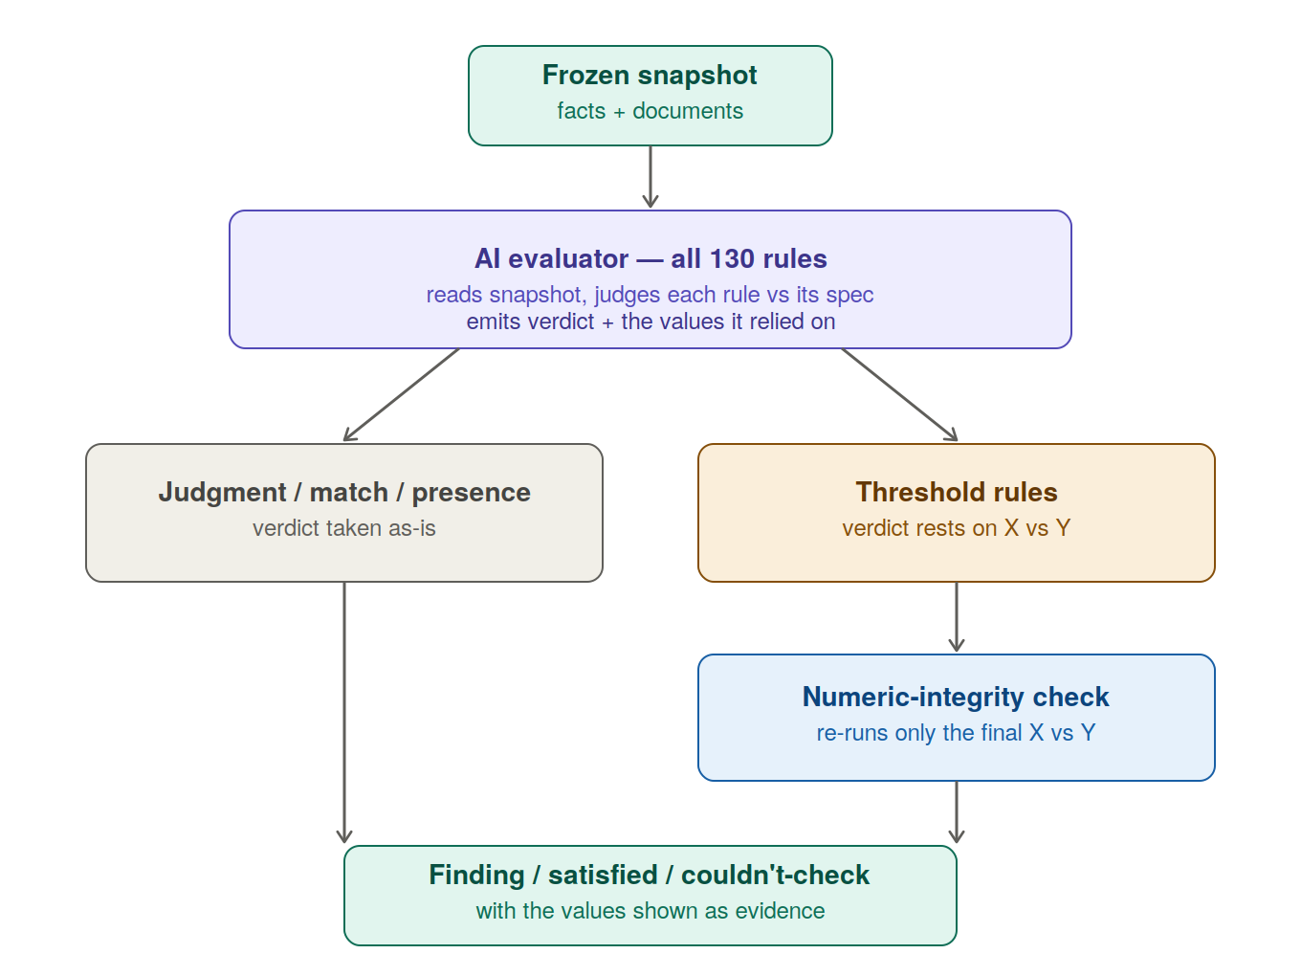
Figure 3 — AI evaluates every rule; only threshold rules pass through the deterministic numeric check.
Not every rule applies to every file. The engine decides applicability inside each rule’s single AI evaluation — not as a separate up-front pass. One AI call per rule does both jobs: first “does this rule apply to this file?”, then, if yes, “produce the finding.”
Why folded in, not a separate pass: with an AI evaluator, a separate applicability pass would be a second full AI sweep (130 applicability calls, then N finding calls). Folding applicability into the finding call collapses that to one 130-call pass — strictly cheaper, and the applicability reasoning and finding reasoning share the same context rather than re-reading the file twice.
Why applicability is AI, not a deterministic field-compare: applicability reads the same messy facts the finding does. Today the AI edge does classification and extraction only — it does not fully canonicalize facts — so the snapshot holds surface forms that are not normalized (“condo” in several variants, a property titled as a PUD that is a condo project for warrantability, MISMO and the appraisal disagreeing). A literal property.type == “condo” compare is the brittle string-matching already rejected for evaluation; applicability inherits the same problem and gets the same answer — the AI reasons it out. Deterministic gates hold only for the genuinely clean cases (e.g. program == FHA), not worth a separate mechanism when the AI visits every rule anyway.
Three-valued output, reasoning exposed:
- Yes → the AI proceeds to the finding in the same call.
- No → not-applicable, with the explanation why (“single-family per MISMO and appraisal, so the condo master-policy rule doesn’t apply”). Reasoning and the facts relied on are surfaced, not hidden.
- Can’t-tell → the file is ambiguous about whether the rule applies → couldn’t-check, which blocks and goes to the processor. The AI does not guess applicability; ambiguity routes to a human.
Accuracy guarantee = AI reasoning + existing human review. The AI reasons over what it finds and attaches its warning; it does not get the final word. The loan processor already reviews every run and already has Accept-risk, Waive, and Override (built features). The posture is warn, don’t silently decide: the AI’s obligation is to expose its applicability reasoning and evidence so the processor can confirm, waive, or override. Accuracy is guaranteed by AI-reasoning-plus-mandatory-human-review, not AI alone.
Recomputes every run. Applicability is a function of the current snapshot, not a fixed property of the file — a new document can change it (a condo rider appears, occupancy is corrected). So the per-rule applicability judgment re-runs on each verification pass, correctly, because the answer can change when the facts change.
What this gives up (honestly). There is no cheap up-front “here’s what we’ll check” list — the applicable-set only exists after the pass runs, since applicability is decided inside each rule’s AI call. Given cost priority, this is an accepted trade. And AI-judged applicability means a wrong applicability call is possible — mitigated by exposed reasoning, honest can’t-tell, the existing processor review with waive/override, and extending the golden-file eval set (LP-143) to cover applicability decisions, not just findings.
For threshold rules, a single shared check re-runs the final comparison on the values the AI surfaced — confirming, e.g., $12,000 > $4,000. It is not a per-rule evaluator, does not recompute income or re-judge sourcing, and exists solely to catch the silent arithmetic slip LLMs are prone to. One function, not 130.

