Myntra Wishlist Conversion Engine
Part 2: Business Metric Decomposition & Opportunity Analysis Document
Company: Myntra (Fashion E-Commerce) | Role: Product Manager (Growth)
North Star Target: +350 bps Lift (12.0% -> 15.5%) | Constraint: 100% Non-Monetary (Zero Discounts)
---------------------------------------------------------------------------
Visual Metric Decomposition Chart
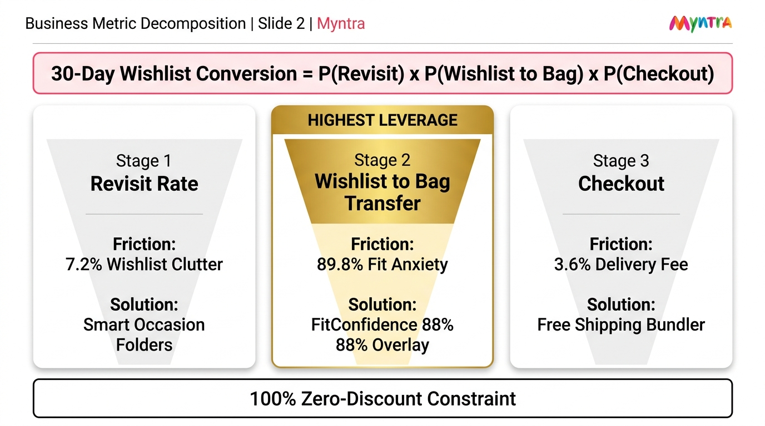
Figure 1: 3-Stage Mathematical Funnel & Conversion Leverage Analysis for Myntra Wishlist Engine.
---------------------------------------------------------------------------

1. Top-Level Metric Definition & Strategic Constraint
In fashion e-commerce, a wishlist represents an explicit high-intent signal: the user loves a product but stops short of completing checkout. Over time, shoppers accumulate 35–120 saved items while 82% cool off unpurchased after 30 days.
Our North Star Metric is defined as:
30-Day Wishlist Conversion Rate (W2PCR) = (Unique Users Purchasing >=1 Wishlisted Item in 30 Days) / (Total Unique Wishlist Accumulators) × 100
💡 Layman Explanation (In Simple Words):
"Out of 100 shoppers who save clothes to their wishlist, how many actually end up buying at least one item within a month?"
Our goal is to increase buyers from 12 out of 100 to 15-16 out of 100 (+350 bps lift), without giving any discounts.
Strategic Constraint: We CANNOT offer monetary discounts, coupons, price cuts, or cashback. All conversion lift must be 100% product-led.

2. The 3-Stage Mathematical Probability Funnel
The 30-Day Wishlist Conversion Rate decomposes into a multiplicative chain across 3 distinct user behaviors:
30-Day Conversion = P(Stage 1: Revisit) × P(Stage 2: Wishlist -> Bag | Revisit) × P(Stage 3: Checkout | Bag)
• Stage 1: Wishlist Retrieval & Revisit Rate - P(Stage 1)
Friction Signal: 181 Signals (7.2% of friction) - Wishlist Clutter & Organization.
User Behavior: Shoppers save 50–120+ items, causing flat list scroll fatigue. High-intent items get buried and forgotten.
Product Solution: Smart Occasion Folders ('Workwear', 'Festive', 'College') + Size S Filter.
💡 Layman Meaning: 'How easily can a shopper find an item they saved 2 weeks ago without getting lost in a mess of 100 saved clothes?'
• Stage 2: Wishlist-to-Bag Transfer Rate - P(Stage 2 | Stage 1) [⭐ HIGHEST LEVERAGE - 89.8%]
Friction Signal: 2,252 Signals (89.8% of all friction!) - Fit & Fabric Anxiety.
User Behavior: Shoppers reopen their wishlist, love an item, but freeze because sizing charts are flat and fabric quality is uncertain.
Product Solution: FitConfidence 88% Overlay Card & Height (5'4") / Weight (52kg) Buyer Photo Reels.
💡 Layman Meaning: 'Once a shopper sees their saved item, do they feel confident enough in the size and quality to move it into their shopping cart?'
• Stage 3: Bag-to-Order Checkout Completion Rate - P(Stage 3 | Stage 2)
Friction Signal: 91 Signals (3.6% of friction) - Delivery & Shipping Charges.
User Behavior: Shoppers move a single ₹599 wishlisted item to cart, but abandon when hit by an added ₹99 delivery charge below ₹799.
Product Solution: Free Delivery Threshold Bundler & 1-Click Move-to-Bag.
💡 Layman Meaning: 'When a shopper tries to checkout a single saved item, does an added shipping fee scare them away from placing the order?'

3. Opportunity Sizing & Conversion Leverage Analysis
Combining our metric decomposition with our 20,703 customer review dataset reveals where the highest conversion leverage exists:
Funnel Stage | Customer Signals & Friction | Target Product Solution | Conversion Leverage & PM Priority
Stage 1: Revisit Rate | 181 Signals (7.2%)  Wishlist Clutter | Smart Occasion Folders  ('Workwear', 'Festive') | Moderate Leverage  Brings users back, but if fit doubt remains, they still don't buy.
Stage 2: Wishlist-to-Bag Transfer | 2,252 Signals (89.8%)  Fit & Fabric Anxiety | FitConfidence 88% Overlay &  Height/Weight Buyer Photos | HIGHEST LEVERAGE ⭐  Core lever that unblocks checkout without discounts.
Stage 3: Checkout Completion | 91 Signals (3.6%)  Delivery Fee Friction | Free Shipping Bundler &  1-Click Size Bag Transfer | High Secondary Leverage  Unlocks single-item checkout abandoners below threshold.

4. Strategic PM Synthesis & Recommendation
Conclusion & Focus Area:
1. Stage 2 (Fit & Fabric Anxiety) represents 89.8% of all customer friction in our dataset (2,252 verified signals).
2. Resolving sizing uncertainty directly on wishlist cards via FitConfidence 88% scores and height/weight matched buyer photo reels provides the single highest mathematical leverage to hit our +350 bps North Star target.
3. Supporting Stage 1 (Smart Occasion Folders) and Stage 3 (Free Shipping Bundler) ensures high retrieval and zero-friction checkout completion.

