Myntra Wishlist Conversion Engine
Part 2: Business Metric Decomposition Flow Diagram & Analysis Document
Target Metric: 30-Day Wishlist Conversion Rate (+350 bps lift / 12% -> 15.5%)
Strategic Constraint: 100% Zero Monetary Incentives (No discounts, coupons, or cashback)
---------------------------------------------------------------------------

1. Part 2: Visual Metric Decomposition Flow Diagram
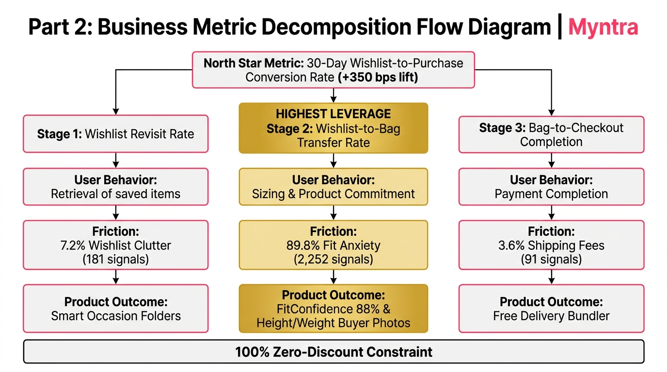
Figure 1: Business Metric Decomposition Flow Diagram linking Funnel Stages, User Behaviors, Customer Friction Signals, and Target Product Outcomes.
---------------------------------------------------------------------------

2. Mathematical Funnel Breakdown & User Behaviors
30-Day Conversion = P(Stage 1: Revisit) × P(Stage 2: Wishlist -> Bag | Revisit) × P(Stage 3: Checkout | Bag)
To improve the North Star Metric, we must understand what needs to change across user behaviors at each stage:
1. STAGE 1: Wishlist Revisit Rate - P(Stage 1)
• User Behavior: Shoppers save 35–120+ items over time, causing flat list scroll fatigue. High-intent items get buried and forgotten.
• Customer Friction: 181 Signals (7.2% of friction) under Wishlist Clutter & Organization.
• Product Outcome: Smart Occasion Folders ('Workwear', 'Festive', 'College') reducing retrieval time from 45s to <5s.
2. STAGE 2: Wishlist-to-Bag Transfer Rate - P(Stage 2 | Stage 1) [⭐ HIGHEST LEVERAGE - 89.8%]
• User Behavior: Shoppers reopen their wishlist, love an item, but freeze because sizing charts are flat and fabric quality is uncertain.
• Customer Friction: 2,252 Signals (89.8% of all friction!) under Fit & Fabric Anxiety.
• Product Outcome: FitConfidence 88% Overlay Card & Height (5'4") / Weight (52kg) Buyer Photos.
3. STAGE 3: Bag-to-Checkout Completion Rate - P(Stage 3 | Stage 2)
• User Behavior: Shoppers move a single ₹599 wishlisted item to cart, but abandon when hit by an added ₹99 delivery fee below ₹799.
• Customer Friction: 91 Signals (3.6% of friction) under Delivery Fee Friction.
• Product Outcome: Free Delivery Threshold Bundler & 1-Click Move-to-Bag.

3. Opportunity Sizing & PM Leverage Table
Funnel Stage | Customer Signals & Friction | Target Product Solution | Conversion Leverage & PM Priority
Stage 1: Revisit Rate | 181 Signals (7.2%)  Wishlist Clutter | Smart Occasion Folders  ('Workwear', 'Festive') | Moderate Leverage  Brings users back, but fit doubt still halts buying.
Stage 2: Wishlist-to-Bag Transfer | 2,252 Signals (89.8%)  Fit & Fabric Anxiety | FitConfidence 88% Overlay &  Height/Weight Buyer Photos | HIGHEST LEVERAGE ⭐  Core lever that unblocks checkout without discounts.
Stage 3: Checkout Completion | 91 Signals (3.6%)  Delivery Fee Friction | Free Shipping Bundler &  1-Click Size Bag Transfer | High Secondary Leverage  Unlocks single-item checkout abandoners below threshold.

