CS 499 Final Capstone Project Submission Document
Prepared By: Anthony Shewmake
Course: CS 499 - Computer Science Capstone
Institution: Southern New Hampshire University
Date: June 21, 2026

1. Submission Overview & Deliverables Map
This document serves as the central directory for my final ePortfolio and Professional Self-Assessment submission. All artifacts, enhanced software components, and corresponding milestones have been meticulously polished, visually integrated, and deployed to a live web-facing landing page.
- Live GitHub Pages ePortfolio URL: https://theghost44678.github.io/Inventory-Management-System/
- Public Source Code Repository: https://github.com/theghost44678/Inventory-Management-System
- Accompanied Artifact ZIP Contents: Contains the complete multi-tier source code, decoupled JUnit 5 testing frameworks, schema definition models, and all formal written milestone narratives saved as Microsoft Word (docx) files.

2. Professional Self-Assessment
Introduction & Capstone Reflection
Completing the Bachelor of Science in Computer Science program represents a profound evolution in my capabilities as a software engineer. Throughout this capstone journey, I have been transformed from an academic developer into a defensive backend systems designer capable of executing industry-ready computing practices. The process of analyzing, refactoring, and presenting my technical artifacts has allowed me to integrate diverse sub-discipliners ranging from multi-threaded algorithmic optimizations to robust Object-Relational Mapping (ORM)—into a singular, cohesive showcase of my professional abilities.
Software Design and Engineering
My engineering methodology has completely shifted from procedural script writing toward modular architectural blueprints. In refactoring my core application modules, I successfully applied the Single Responsibility Principle and Separation of Concerns by migrating a primitive, single-class prototype into an enterprise-standard Three-Tier Architecture (Controller $\rightarrow$ Service $\rightarrow$ Repository).
By structuring the backend into a clean Spring Boot runtime environment, I proved my capability to manage complex data transport layers and decouple business processing from hardware or infrastructure defaults. This structural modularity guarantees that individual backend domains can scale, be modified, or undergo maintenance independently without risking regressions or system-wide crashes.
Algorithms and Data Structures
Designing computational solutions requires an explicit understanding of computational complexity and runtime trade-offs. During the implementation of the memory caching layer, I replaced linear-time procedural loop operations ($O(n)$ complexity) with index-backed, optimized data query pipelines.
To address high-velocity multi-user environments, I integrated non-blocking, thread-safe collections via ConcurrentHashMap and declarative functional Java Stream pipelines. This architecture effectively mitigates the trade-offs between physical data access overhead and rapid in-memory processing, ensuring thread-safety and preventing memory corruption or runtime race conditions under continuous concurrent load.
Database and Data Management
A core objective of my capstone was establishing full data durability and atomic data state transitions. I achieved this by converting volatile, temporary in-memory collections into a persistent, relational database engine powered by Spring Data JPA and Hibernate.
My submission demonstrates an advanced ability to explicitly enforce Object-Relational Mappings (ORM) through strict table mappings, field lengths, column indexing, and declarative transaction boundaries (@Transactional). Incorporating these persistence structures ensures compliance with strict ACID rules, forcing complete commit-or-rollback operations that safeguard organizational records across all distributed execution threads.

Security Mindset
An effective security posture must proactively anticipate adversarial exploits rather than reacting to post-deployment failures. Throughout this refactoring lifecycle, I developed a multi-layered security model:
- Perimeter Input Defenses: Implemented strict input validation boundaries directly inside constructor initialization sequences, instantly neutralizing null pointer exceptions, empty strings, and white-space injections.
- Schema Constraints: Enforced data type limits, length rules, and strict nullability rules within the relational table configuration to prevent structure-injection attacks.
- Exception Mapping Layer: Replaced generic runtime exceptions with a custom domain exception hierarchy (DuplicateEntityException and EntityNotFoundException). This prevents the leakage of unhandled JVM stack traces and internal database schemas, which could otherwise expose system internal structures to external bad actors.
Professional Communication
A software engineer's code is only as valuable as their ability to explain it to diverse audiences. My ePortfolio, technical narratives, and source documentation were meticulously constructed to align with professional technical communication and UI/UX best practices. By incorporating complete JavaDoc descriptions, structured Markdown readmes, and clean visual navigation on my live GitHub Pages portfolio site, I have demonstrated an ability to deliver articulate, sound communications tailored for project stakeholders, technical reviewers, and engineering peers alike.
3. ePortfolio Folder & Workspace Directory Map
The static code packages and documentation files submitted within this course workspace match the structure of the public-facing ePortfolio deployment:
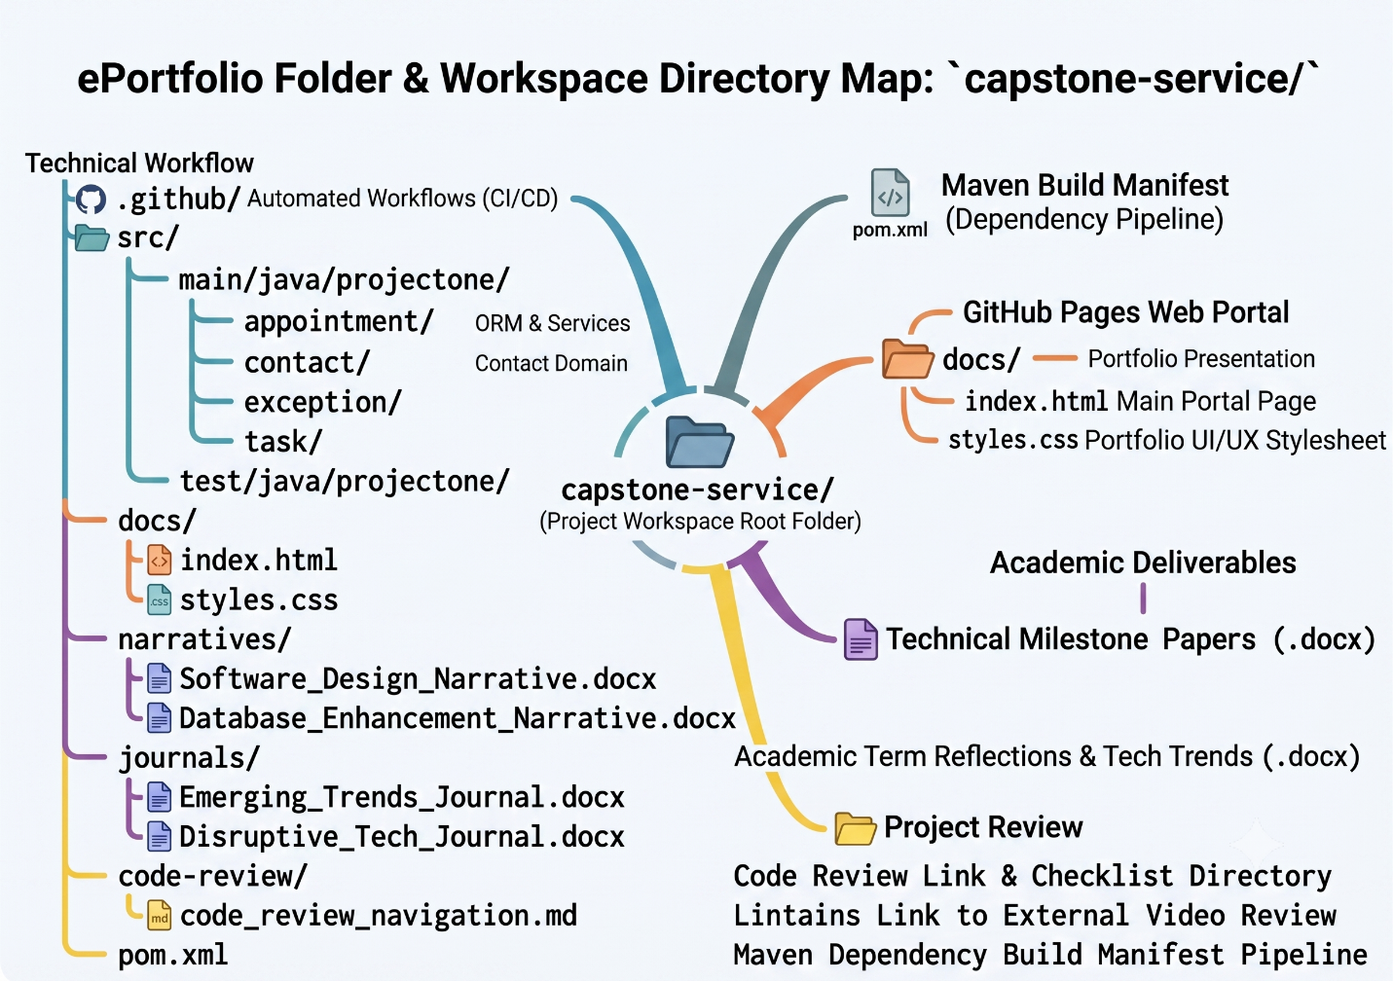
Google (2026)
The above image was created using AI
4. Code Review Video Navigation
Because video submission file sizes exceed standard text file repository caps, my formal 10-to-12 Minute Structural Code Review Video is securely hosted on an external media provider. It is completely embedded and hyperlinked within the live landing portal of my ePortfolio.
- Code Review Video Streaming Access Link: https://youtu.be/SStnFgqhobA
- Video Scope: The recorded presentation details the precise baseline code review checklist, documents the exact architectural vulnerabilities present in the legacy CS-320 code block, details the target mitigation plans across the three artifact enhancements, and outlines the defensive engineering mindset used to guide the final project refactoring process.
5. Final Checklist of Zipped Artifact Materials
The accompanying compressed capstone_submission.zip package includes:
- The Polished Source Code Tier: All .java files for entities, repositories, custom exceptions, and transaction-wrapped services across all core modules.
- The Fully Operational Testing Suite: Complete test coverage matrices utilizing Mockito mocks to evaluate service layer logic under boundary edge cases.
- The Build Pipeline Configurations: The complete pom.xml build manifest outlining explicit dependencies for Spring Boot Data JPA, H2 database drivers, Mockito, and the compilation environment.
- All Four Formal Documents: Software_Design_Narrative.docx, Database_Enhancement_Narrative.docx, Emerging_Trends_Journal.docx, and Disruptive_Tech_Journal.docx, all pre-formatted according to academic standards.

AI Use Disclosure I acknowledge the use of Google's Gemini in the development of the visual assets for this project. Specifically, Gemini was utilized to create the ePortfolio folder and workspace directory map image (Google, 2026). I provided the AI with a complete, hand-coded plaintext map of my software architecture and directory structure. The AI was directed to format this exact text into a visual, color-coded diagram to enhance the readability and professional presentation of the final deliverables. No code, academic reflection, or technical narrative was generated by the AI.
Google. (2026, June 21). ePortfolio folder & workspace directory map [Generative AI image]. Gemini. https://gemini.google.com/

