Alone in a Role Playing Game

Based on Alone Among the Stars, by Takuma Okada

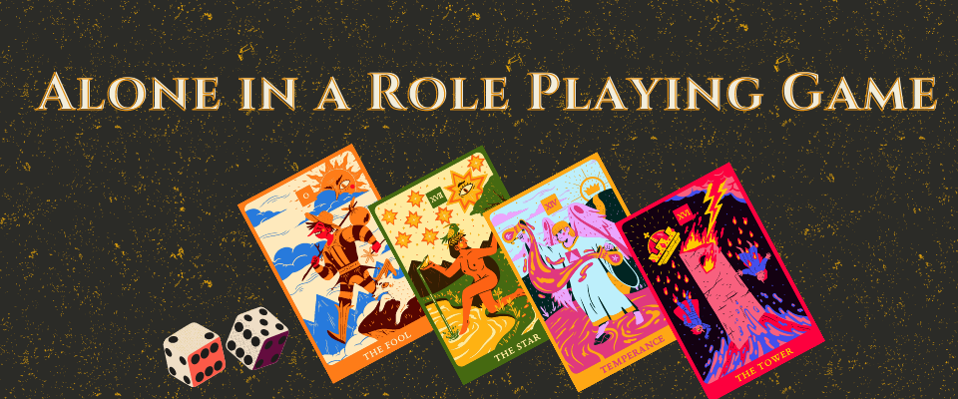

When you are playing a role playing game alone, or with friends, you may need some help establishing a scene or a backdrop for the characters.

## Procedure

In order to create a new scene, follow these steps:

* Roll 1d6;
* Draw that many cards, spreading them side by side, and face down;
* Flip a card and roll 1d6 on the Major or Minor arcana table;
* Look at the keyword tables;
* Interpret the result and add it to the scene;
* When you want to, or when you are stuck, add the next card to the scene;
* After the last card on the scene, when you feel you've completed it, start a new scene.

Minor Arcana

* 1 – 2: an individual or a group
* 3 – 4: this place and its features
* 5 – 6: something happens or happened

Major Arcana

* 1 – 2: a wild, mystical, or humane entity
* 3 – 4: an offer or opportunity
* 5 – 6: an incident or sudden change

# Interpreting Cards

## Minor Arcana

|  |  |  |
| --- | --- | --- |
| Suit | Keywords | Drives |
| Wands | Fire, movement, action, invention, energy | Will turned into action |
| Cups | Water, feelings, emotions, intuition, and relationships | Understanding and processing |
| Swords | Air, challenges, rationality, logic, mindfulness | Harnessing strength |
| Pentacles | Earth, Mundane, Bodily, Tangible, Physical, resources | Planning and Preparing |

|  |  |
| --- | --- |
| Rank | Keywords |
| Ace | Beginnings, initiative |
| 2 | Balance, dichotomy |
| 3 | Communication, interactions |
| 4 | A break or rest period |
| 5 | Adversity, conflict, loss |
| 6 | Growth, overcoming, moving on |
| 7 | Confidence, trust, self-esteem |
| 8 | Labour, change |
| 9 | Fruition, assessment |
| 10 | Closure, results |
| Page | Messages, gathering information |
| Knight | Movement, initiative |
| Queen | Potential, wisdom |
| King | Authority, power |

## Major Arcana

|  |  |  |
| --- | --- | --- |
| Card | Upright | Reversed |
| The Fool | innocence, free spirit, fresh start | recklessness, holding back, missing opportunities |
| The Magician | intelligence, resourcefulness, inspiration, overt power | wasted talents, lost resources, pride, condescension |
| The High Priestess | intuition, dreams, patience, subtle power | secrecy, omission, manipulation |
| The Empress | nurturing, abundance, beauty, nature | timid, dependent, neglect |
| The Emperor | guidance, leadership, structure | authority, control, stubbornness |
| The Hierophant | tradition, study, freedom, departure | conformity, conservativism, inflexibility |
| The Lovers | bonds, balance, aligned values | narcissism, disharmony, imbalance |
| The Chariot | determination, strong will, fulfilment | helplessness, lack of support, opposition |
| Justice | compassion, courage, empowerment | doubt, hesitation |
| The Hermit | introspection, inner wisdom, self-esteem | loneliness, isolation, fear |
| Wheel of Fortune | cycles, turning point, destiny, fortune | struggle, resistance, fighting change |
| Strength | strength, courage, persuasion, compassion | force, self-doubt, low energy, raw emotion |
| The Hanged Man | surrender, re-examination, release, a pause | indecisiveness, delay, stalling |
| Death | transformation, endings, transition, rites of passage, upheaval | being stuck, repeating negative patterns, resisting change, dependency |
| Temperance | moderation, balance, patience, kindness | excess, imbalances, realignment, wounds |
| The Devil | exploring shadows, detachment, breaking away | cunning, excess, restriction, flaw |
| The Tower | chaos, change, revelation, upheaval, avoid disaster | tragedy, turmoil, fear, unexpected turn of events |
| The Star | guidance, hope, patterns | being lost, hopelessness, void |
| The Moon | intuition, subconscious, embracing fear | repression, inner turmoil, hesitation |
| The Sun | vitality, energy, warmth | gloom, trauma, suspension |
| Judgement | judgement call, absolution, resolution | judgemental, mistrust, doubt |
| The World | completion, travel, closure | delays, shortcuts, open ended |

# Optional Procedures

You may use these extra procedures in your runs if you like.

## Complexity

When rolling a die to draw cards, roll the die twice and keep the higher result for a more complex scene, or the lowest result for a simpler scene.

## Unique Spreads

After each scene you may set the cards you drew aside, not reshuffling them after each scene. Once the draw pile is empty or nearly empty, shuffle all the cards together.

# Credits

[Takuma Okada's Alone Among the Stars](https://noroadhome.itch.io/alone-among-the-stars)

# License

Alone in a Role Playing Game is made available under the [Anti-Capitalist Co-op License](https://noroadhome.itch.io/acaclicense)

If you create something based on this work, make sure to credit "Gabriel Caetano", including with a link to my itch page, and make sure to use the same license.