QAC300 - Assignment 1: WesRide Solutions
Probabilities are rounded to four decimals, other quantities to two. Where the assignment asks "which class does this draw on", the concept names are given; the lecture numbers are not in the assignment sheet, so swap in your course's labels.

Problem 1 - Counting, conditioning and odds
(a) Ana alone. Cardano: P = favorable / possible. Numerator = 1 (only station 4); denominator = 5 (stations 1-5, all equally likely). P(Ana = 4) = 1/5 = 0.2000.
(b) Both riders. 5 x 5 = 25 ordered pairs (Ana's station, Ben's station).
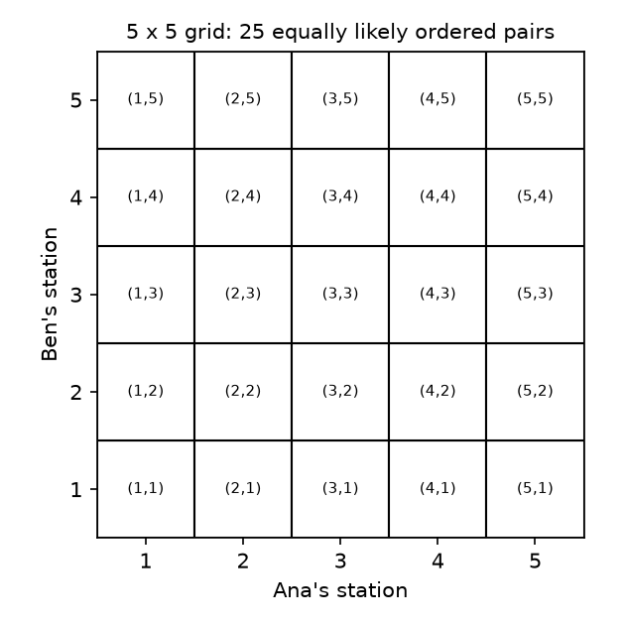
(c) Same station: the diagonal (1,1),(2,2),(3,3),(4,4),(5,5) = 5 cells. P = 5/25 = 0.2000.
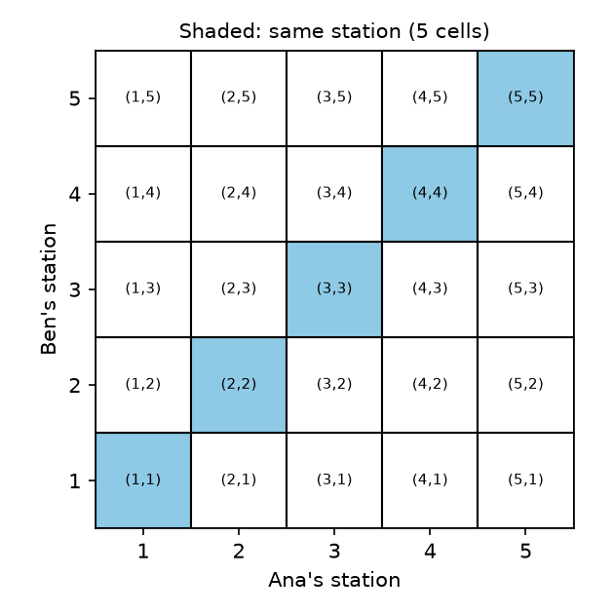
(d) Zone total = 6: (1,5),(2,4),(3,3),(4,2),(5,1) = 5 cells. P = 5/25 = 0.2000.
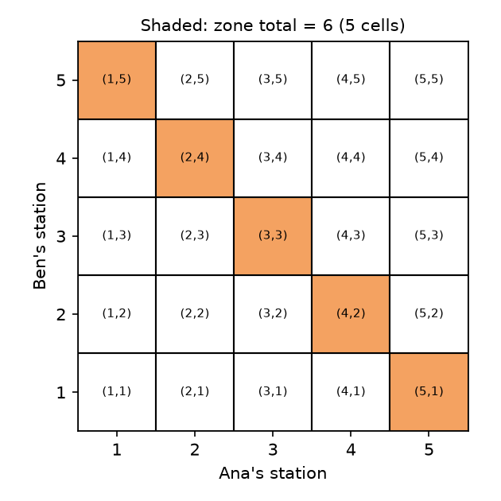
(e) Probability under equally likely outcomes is just the number of cells, not their arrangement. "Same station" is the main diagonal (top-left to bottom-right); "total = 6" is the anti-diagonal. Different shapes, but each has 5 of 25 cells, so each has probability 0.2000.
(f) P(total = 6) = 5/25 = 0.2000; P(total != 6) = 20/25 = 0.8000; sum = 1.0000. This reflects the axiom that P(S) = 1 (together with additivity for disjoint events - an event and its complement are disjoint and cover S).
(g) Total >= 8: (3,5),(4,4),(5,3),(4,5),(5,4),(5,5) = 6 cells. P = 6/25 = 0.2400.
(h) At least one rider has station 1. Count: row Ana = 1 gives 5 cells, column Ben = 1 gives 5 cells, overlap (1,1) counted twice, so 5 + 5 - 1 = 9 cells; P = 9/25 = 0.3600. Complement: neither has station 1 = 4 x 4 = 16 cells, so P = 1 - 16/25 = 9/25 = 0.3600. They agree.
(i) P(G) = P(H) = 1/5. G and H are independent, so P(G and H) = 1/25. Union rule: P(G or H) = 1/5 + 1/5 - 1/25 = 9/25 = 0.3600, matching (h).
(j) Zone total = 7: (2,5),(3,4),(4,3),(5,2) -> P(S) = 4/25 = 0.1600. Same station means total = 2a, which is always even, so it can never equal 7: D and S share no cells, so P(D and S) = 0.0000.
Disjoint? Yes (no common cell). Independent? No: independence needs P(D and S) = P(D)P(S) = 0.2000 x 0.1600 = 0.0320, but the actual value is 0. Disjoint means the events cannot both happen, so knowing S happened tells you D did not - that is strong dependence. Disjoint events with positive probabilities are never independent.
(k) P(total >= 8 | Ana = 5): restrict to Ana's row 5 (5 cells). Within it, Ben = 3, 4, 5 give total >= 8: 3 cells. P = 3/5 = 0.6000.
(l) P(Ana = 5 | total >= 8): restrict to the 6 cells with total >= 8, i.e. (3,5),(4,4),(5,3),(4,5),(5,4),(5,5). Those with Ana = 5 are (5,3),(5,4),(5,5): 3 of 6. P = 0.5000.
(m) Bayes: P(A5 | T) = P(T | A5) P(A5) / P(T) = (0.6000)(0.2000)/(0.2400) = 0.5000, matching (l).
(n) Cardano's counting rule requires equally likely outcomes. If station 1 is assigned twice as often as station 5, the 25 cells are no longer equally likely, so every answer obtained by counting cells / 25 is no longer valid (c, d, g, h, j, k, l and the odds numbers). What still holds: the grid as a sample space, the axioms, complement rule, union rule, definition of conditional probability, Bayes' theorem, the logic of disjoint vs independent (D and S are still disjoint), and the explanation in (e) that shape does not matter. Instead of a count, you need a probability weight for each station (e.g. p1 = 2p5, weights summing to 1), then each cell's probability is p(Ana's station) x p(Ben's station) by independence, and an event's probability is the sum of its cells' weights.

Odds
(o) Same station: 5 favorable cells : 20 unfavorable = 5:20 = 1:4. Probability = 1/(1+4) = 0.2000, matching (c).
(p) Odds against zone total 6: 20 : 5 = 4:1.
(q) At least one station 1: 9 : 16 odds in favor.
(r) The classmate confuses probability with odds: "1 in 5" compares favorable to all outcomes (probability 1/5), whereas odds compare favorable to unfavorable, which is 1 to 4.
(s) Odds 3:17 -> probability = 3/(3+17) = 3/20 = 0.1500.
(t) Win (probability 0.2): gain +$3 per $1; lose (probability 0.8): gain -$1. E[gain] = 3(0.2) + (-1)(0.8) = 0.60 - 0.80 = -$0.20 per dollar staked. A fair bet has zero expected gain: payout b with b(0.2) = 0.8 gives b = 4, i.e. 4-to-1. That is exactly the odds against matching (4:1, from (o)/(r)); it also equals the answer to (p), since P(total = 6) happens to be 0.2 too. The gambler's 3-to-1 is below the fair 4-to-1, which is his edge.
(u) Concepts: Cardano's equally-likely counting; sample space & events; axioms/complement; union rule; independence vs disjointness; conditional probability and Bayes; odds and expected gain (fair bets).

Problem 2 - Conditional probability and Bayes

Part A - The depot roster
From the list: 16 bikes; e-bikes (6): Fir, Nutmeg, Cedar, Kestrel, Olive, Poplar; new fleet (8): Alder, Elm, Ironwood, Maple, Fir, Cedar, Kestrel, Olive; both (4): Fir, Cedar, Kestrel, Olive. P(e) = 6/16 = 0.3750, P(new) = 8/16 = 0.5000.
(a) P(Kestrel | e-bike) = 1/6 = 0.1667. P(e-bike | Kestrel) = 1/1 = 1.0000. Kestrel is itself an e-bike, so the event "Kestrel" is a subset of "e-bike": given Kestrel, being an e-bike is certain.
(b) P(new | e) = 4/6 = 0.6667. P(e | new) = 4/8 = 0.5000. Here neither event is a subset of the other: they only partially overlap (4 shared bikes), so some e-bikes are not new and some new bikes are not e-bikes. The conditionals differ only because the conditioning groups have different sizes (6 vs 8).
(c) Bayes: P(new | e) = P(e | new)P(new)/P(e) = (0.5000)(0.5000)/(0.3750) = 0.6667. Matches (b).
(d) Independence check: P(e and new) = 4/16 = 0.2500 vs P(e)P(new) = 0.3750 x 0.5000 = 0.1875. Not equal (equivalently P(new | e) = 0.6667 != P(new) = 0.5000). Not independent: e-bikes are more likely than average to be new fleet.

Part B - The maintenance sensor
R = needs repair (P = 0.08); F = flagged. P(F | R) = 0.90, P(F | not R) = 0.05.
(e) Two ways to be flagged: P(F) = P(F|R)P(R) + P(F|not R)P(not R) = (0.90)(0.08) + (0.05)(0.92) = 0.0720 + 0.0460 = 0.1180.
(f) P(R | F) = 0.0720 / 0.1180 = 0.6102.
(g) Most bikes are fine (92%), so even a small 5% false-alarm rate on that big group produces 0.046 of all bikes flagged, which is a large share compared with the 0.072 that are truly bad. So about 39% of flagged bikes are false alarms, even though the sensor catches 90% of real problems.
(h) (connect) P(F | R) = 0.9000 vs P(R | F) = 0.6102. This is more like Part A (b): neither event contains the other (some repair bikes are missed, some fine bikes are flagged), so neither conditional is 1, and the asymmetry is just from the two groups having different sizes (flagged bikes 11.8% of fleet vs repair bikes 8%), not from a subset relationship as in (a).
(i) With P(R) = 0.25: P(F) = (0.90)(0.25) + (0.05)(0.75) = 0.2250 + 0.0375 = 0.2625; P(R | F) = 0.2250/0.2625 = 0.8571. The same sensor looks much more trustworthy when the condition is more common: a diagnostic's usefulness depends on the base rate (prevalence) as well as its accuracy.
(j) Concept: Bayes' theorem / law of total probability and base rates (inverting a conditional).

Problem 3 - From a sample space to a density

Part A - The sample space
(a) S = {OOO, OOL, OLO, LOO, OLL, LOL, LLO, LLL}: 8 outcomes = 2^3.
(b) E (exactly two late) = {OLL, LOL, LLO}. E^c = {OOO, OOL, OLO, LOO, LLL} (5 outcomes).
(c) The classmate assumes all 8 outcomes are equally likely. With P(late) = 0.3 independently: P(LLO) = 0.3 x 0.3 x 0.7 = 0.0630; P(OOO) = 0.7^3 = 0.3430. They are unequal, so counting outcomes fails; each outcome must be weighted by its own probability. Correct: P(E) = 3(0.0630) = 0.1890, not 3/8 = 0.3750.

Part B - The random variable and its PMF
(d) X maps each outcome in S (a string of O/L) to a number: X: S -> {0, 1, 2, 3}, the count of L's.
(e) X = 2 for OLL, LOL, LLO. P(X = 2) = 3(0.3)^2(0.7) = 0.1890.
(f) PMF of X:
x | 0 | 1 | 2 | 3
Outcomes | OOO | OOL, OLO, LOO | OLL, LOL, LLO | LLL
P(X = x) | 0.3430 | 0.4410 | 0.1890 | 0.0270

Requirements: every P(x) >= 0 (yes) and the sum = 0.3430 + 0.4410 + 0.1890 + 0.0270 = 1.0000.
(g) E[X] = 0(0.343) + 1(0.441) + 2(0.189) + 3(0.027) = 0.441 + 0.378 + 0.081 = 0.90. E[X^2] = 0.441 + 4(0.189) + 9(0.027) = 0.441 + 0.756 + 0.243 = 1.44. Var = 1.44 - 0.81 = 0.63. sigma = sqrt(0.63) = 0.79. (Check: np = 0.9, np(1-p) = 0.63.) The standard deviation is in the original units (trips) so a director can interpret it directly; variance is in squared trips.

Part C - The CDF
(h) F(x) = 0 for x < 0; 0.3430 for 0 <= x < 1; 0.7840 for 1 <= x < 2; 0.9730 for 2 <= x < 3; 1 for x >= 3. The graph is a non-decreasing right-continuous step function (jumps of size P(X = x) at x = 0, 1, 2, 3).
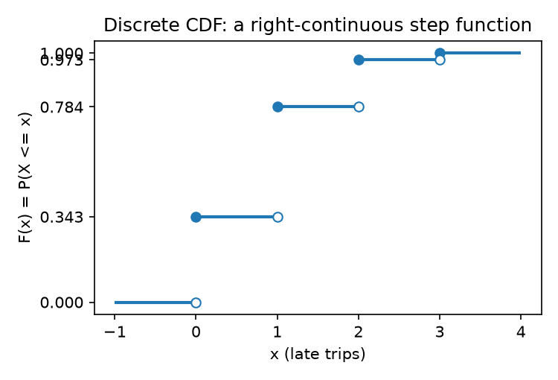
(i) P(X <= 1) = F(1) = 0.7840. P(X >= 1) = 1 - F(0) = 1 - 0.3430 = 0.6570. They are not complements because both include X = 1 (0.4410): the complement of X <= 1 is X >= 2 (0.2160). Indeed 0.7840 + 0.6570 = 1.4410 = 1 + P(X = 1).
(j) P(X = x) = F(x) - F(x-1), the jump size. P(X = 2) = 0.9730 - 0.7840 = 0.1890.

Part D - Going continuous
(k) The density rises linearly from (0,0) to (4, 0.5). Triangle area = (1/2)(4)(0.5) = 1.00. It must equal 1 because total probability over all possible values is 1.
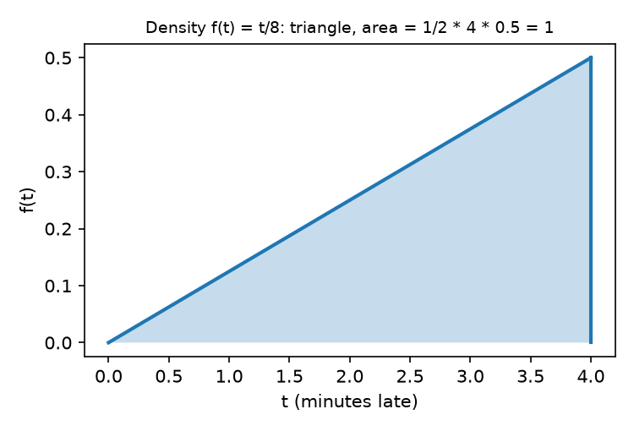
(l) F(0) = 0, F(1) = 1/16 = 0.0625, F(2) = 4/16 = 0.2500, F(3) = 9/16 = 0.5625, F(4) = 1.
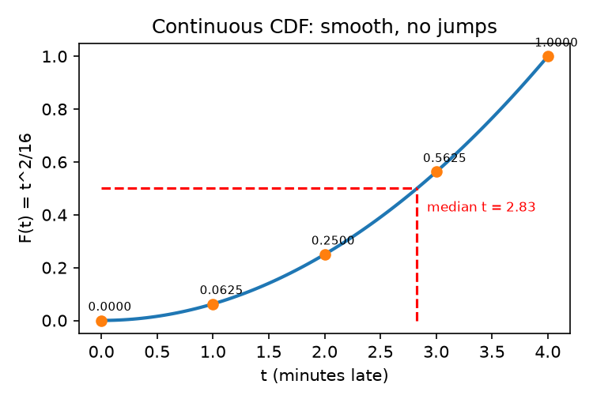
A discrete CDF moves in jumps (flat between values); a continuous CDF is a smooth, continuous curve with no jumps because single points carry no probability.
(m) P(T > 3) = 1 - F(3) = 1 - 0.5625 = 0.4375. P(1 < T < 3) = F(3) - F(1) = 0.5625 - 0.0625 = 0.5000.
(n) F(3.5) = 12.25/16 = 0.7656; F(2.5) = 6.25/16 = 0.3906. P(2.5 <= T <= 3.5) = 0.7656 - 0.3906 = 0.3750.
(o) P(T = 2) = 0 (continuous: the area above a single point has zero width; equivalently F(2) - F(2) = 0). P(X = 2) = 0.1890 from Part B. A discrete variable puts positive mass on individual values, which is what the jumps in its CDF show; a continuous variable spreads probability over intervals, so only intervals get positive probability.
(p) Median: t^2/16 = 0.5 -> t^2 = 8 -> t = 2.83 minutes (marked on the F(t) sketch, height 0.5 at t = 2.83).
(q) f(3.9) = 0.4875 is a density (probability per minute), not a probability. Probability is the area under f, so you must integrate over an interval, e.g. multiply by an interval width (about 0.4875 x 0.1 = 0.0488 for a 0.1-minute slice near 3.9) or use F(b) - F(a). For a single point the probability is 0. (A density can even exceed 1.)

Part E - Connect
(r) In order: (1) Sample space - lists every possible outcome so we can assign probabilities to events. (2) Random variable - turns outcomes into numbers so we can compute with them (means, variances). (3) PMF - gives the probability of each specific value of a discrete variable. (4) CDF - accumulates probability so we can answer "at most / between" questions for any variable and recover the PMF. (5) PDF - describes how probability is spread over a continuous range where individual points have probability 0, and gives probabilities as areas.
(s) The CDF exists for both discrete and continuous variables; the PMF is specific to discrete and the PDF specific to continuous. Statisticians prefer the CDF because it has one definition for every type of variable, directly gives P(a < X <= b) = F(b) - F(a) and quantiles (like the median), and does not need to be rewritten as a sum or an integral.
(t) Concepts: A - sample space, events and the equally-likely assumption; B - random variables, PMF, mean and variance; C - the cumulative distribution function (discrete); D - continuous variables, PDF as density and area; E - unifying the five objects (PMF/PDF/CDF relationships).

Problem 4 - Which distribution?
(a) Poisson: count of events in a fixed interval at a constant average rate. Rate 12/hour -> 10 minutes = 1/6 hour, lambda = 2. P(X = 3) = e^-2 2^3 / 3! = 0.1353(8)/6 = 0.1804. Mean = 2, variance = 2.
(b) Same Poisson (lambda = 2): P(X = 0) = e^-2 = 0.1353. Mean = variance = 2.
(c) Exponential: waiting time between events of a Poisson process, rate = 12 per hour (equivalently 0.2 per minute). P(wait > 10 min) = e^(-0.2 x 10) = e^-2 = 0.1353. Mean = 1/12 hour = 5 minutes; variance = 1/144 hr^2 = 25 min^2 (sd = 5 min).
(d) They are the same event described two ways: no ride begins in the 10 minutes after one begins <=> the next waiting time exceeds 10 minutes. Poisson counts the events in a window and exponential measures the time between them for the same process, so P(Poisson count = 0 in t) = P(Exponential > t).
(e) Geometric: number of independent trials until the first success, p = 0.15. P(X = 4) = (0.85)^3(0.15) = 0.0921. Mean = 1/p = 6.67; variance = (1-p)/p^2 = 0.85/0.0225 = 37.78.
(f) Binomial: fixed n = 25 independent trials, p = 0.12. P(X = 2) = C(25,2)(0.12)^2(0.88)^23 = 300(0.0144)(0.0529) = 0.2283. Mean = np = 3.00; variance = np(1-p) = 2.64.
(g) Continuous Uniform(0, 12): equally likely over an interval. Mean = (0+12)/2 = 6.00 min; variance = (12-0)^2/12 = 12.00 min^2; sd = sqrt(12) = 3.46 min.
(h) Memoryless: the exponential (continuous) and the geometric (discrete). Binomial, Poisson and uniform are not.
(i) The Poisson has variance = mean (lambda). Worth remembering because it is a quick check on count data: if the observed variance is much larger than the mean (overdispersion) a Poisson model is inappropriate, and it means only one parameter is needed.
(j) Concept: named probability distributions (Poisson/exponential/geometric/binomial/uniform) and matching a situation to the right one.

Problem 5 - Joint distributions
 | Commute | Leisure | Row total (weather)
Dry | 0.35 | 0.30 | 0.65
Rain | 0.25 | 0.10 | 0.35
Column total (purpose) | 0.60 | 0.40 | 1.00

(a) Valid: all entries >= 0 and 0.35 + 0.30 + 0.25 + 0.10 = 1.00. Marginals: P(Dry) = 0.65 and P(Rain) = 0.35 (sum across each row, over purpose); P(Commute) = 0.60 and P(Leisure) = 0.40 (sum down each column, over weather).
(b) Independence needs P(w, p) = P(w)P(p) for every cell. P(Dry, Commute) = 0.35, but P(Dry)P(Commute) = 0.65 x 0.60 = 0.39. Not equal, so weather and purpose are not independent.
(c) P(Commute | Rain) = 0.25/0.35 = 0.7143. P(Commute | Dry) = 0.35/0.65 = 0.5385. In rain, a larger share of rides are commutes: people still travel to work/class in rain, while leisure riders stay home.
(d) Summing the joint over one variable discards information about how the variables relate, and many different joint tables share the same marginals (e.g. the actual table and the independent one 0.39/0.26/0.21/0.14 have the same marginals). To rebuild the joint from the marginals you would need to assume independence, so joint = product of marginals - which (b) shows is false here.
(e) Concept: joint, marginal and conditional distributions, and independence.

Problem 6 - The curse of dimensionality
(a) 2 x 2 x 12 x 4 x 3 = 576 cells.
(b) 5,000 / 576 = 8.68 rides per cell on average.
(c) An average hides the uneven spread: rides cluster in popular combinations (dry weather, commute, central stations, rush hour), leaving many other cells nearly empty. Example: rain x leisure x a remote station x late night x a rare membership type will have about 0 rides, so probabilities for that cell can't be estimated reliably.
(d) A 5-category variable multiplies cells: 576 x 5 = 2,880 cells, giving 5,000/2,880 = 1.74 rides per cell. Cell count grows multiplicatively (exponentially in the number of variables), while doubling the survey budget only doubles the sample size (5,000 -> 10,000, about 3.47 per cell, still below the old 8.68). Keeping 8.68 per cell would need about 25,000 rides.
(e) Concept: the curse of dimensionality (sparse data in high-dimensional joint distributions).

