SIMATS ENGINEERING
ASSESSMENT TOOL 2

COURSE NAME: CSA16 COURSE CODE: Data Warehousing and Data Mining

COURSE OUTCOME COVERED

CO4: Examine the applicability of clustering algorithms in real-world scenarios, presenting findings through clear reports with effective visualizations.
Assessment Tool Weightage: 40%

QUESTIONS: 05 Total Marks:50

Annexure A

Industry Problem Solving Task

Criteria | Understanding of Industry Problem (2) | Application of Engineering Concepts (2.5) | Solution Design (2.5) | Use of Tools (2) | Analysis (1) | Total(10)
Weightage | 20% | 25% | 25% | 20% | 10% | 100%
Q1
Q2
Q3
Q4
Q5

Code of Conduct:

I ____________________ (Name / Reg No) certify that this submission is my original work and that I have adhered to the guidelines specified for this assessment.
I understand that any violation of academic integrity rules will result in disciplinary action.

Signature of the student:

RUBRICS FOR CALCULATION:

Criteria | Weightage | Level 4 – Exemplary | Level 3 – Proficient | Level 2 – Developing | Level 1 – Beginning
Criteria | Weightage | Level 4 – Exemplary | Level 3 – Proficient | Level 2 – Developing | Level 1 – Beginning
Understanding of Industry Problem | 20% | Comprehensive understanding of real-world problem and constraints | Good understanding with minor gaps in requirements | Basic understanding; some requirements unclear | Poor understanding; misinterprets problem context
Application of Engineering Concepts | 25% | Applies advanced and relevant concepts effectively to solve the problem | Applies appropriate concepts with minor errors | Limited application of concepts | Incorrect or no application of concepts
Solution Design | 25% | Innovative, practical, and feasible solution aligned with industry standards | Logical and feasible solution with minor gaps | Basic solution with limited feasibility | Unclear or impractical solution
Use of Tools | 15% | Effective use of modern tools, technologies, and real data | Appropriate use of tools with correct implementation | Limited or inconsistent use of tools | Minimal or incorrect use of tools
Analysis | 10% | Thorough analysis with validated results and performance evaluation | Good analysis with reasonable validation | Basic analysis with limited validation | Poor or no analysis
Professionalism | 5% | Highly professional, well-documented, and clearly presented work | Good documentation and presentation | Basic documentation with some gaps | Poor documentation and presentation

Annexure A

Q1 . Dataset: Supermarket Purchases
Customer | Visits/Month | Avg Spend (₹) | Items Bought
C1 | 10 | 2000 | 15
C2 | 4 | 5000 | 8
C3 | 12 | 1800 | 18
C4 | 3 | 6000 | 6
C5 | 11 | 2100 | 16
Question:
Using the above dataset, propose a clustering approach to segment customers and explain how it supports targeted marketing. (BL3 – 7 Marks)
Manual Calculations:

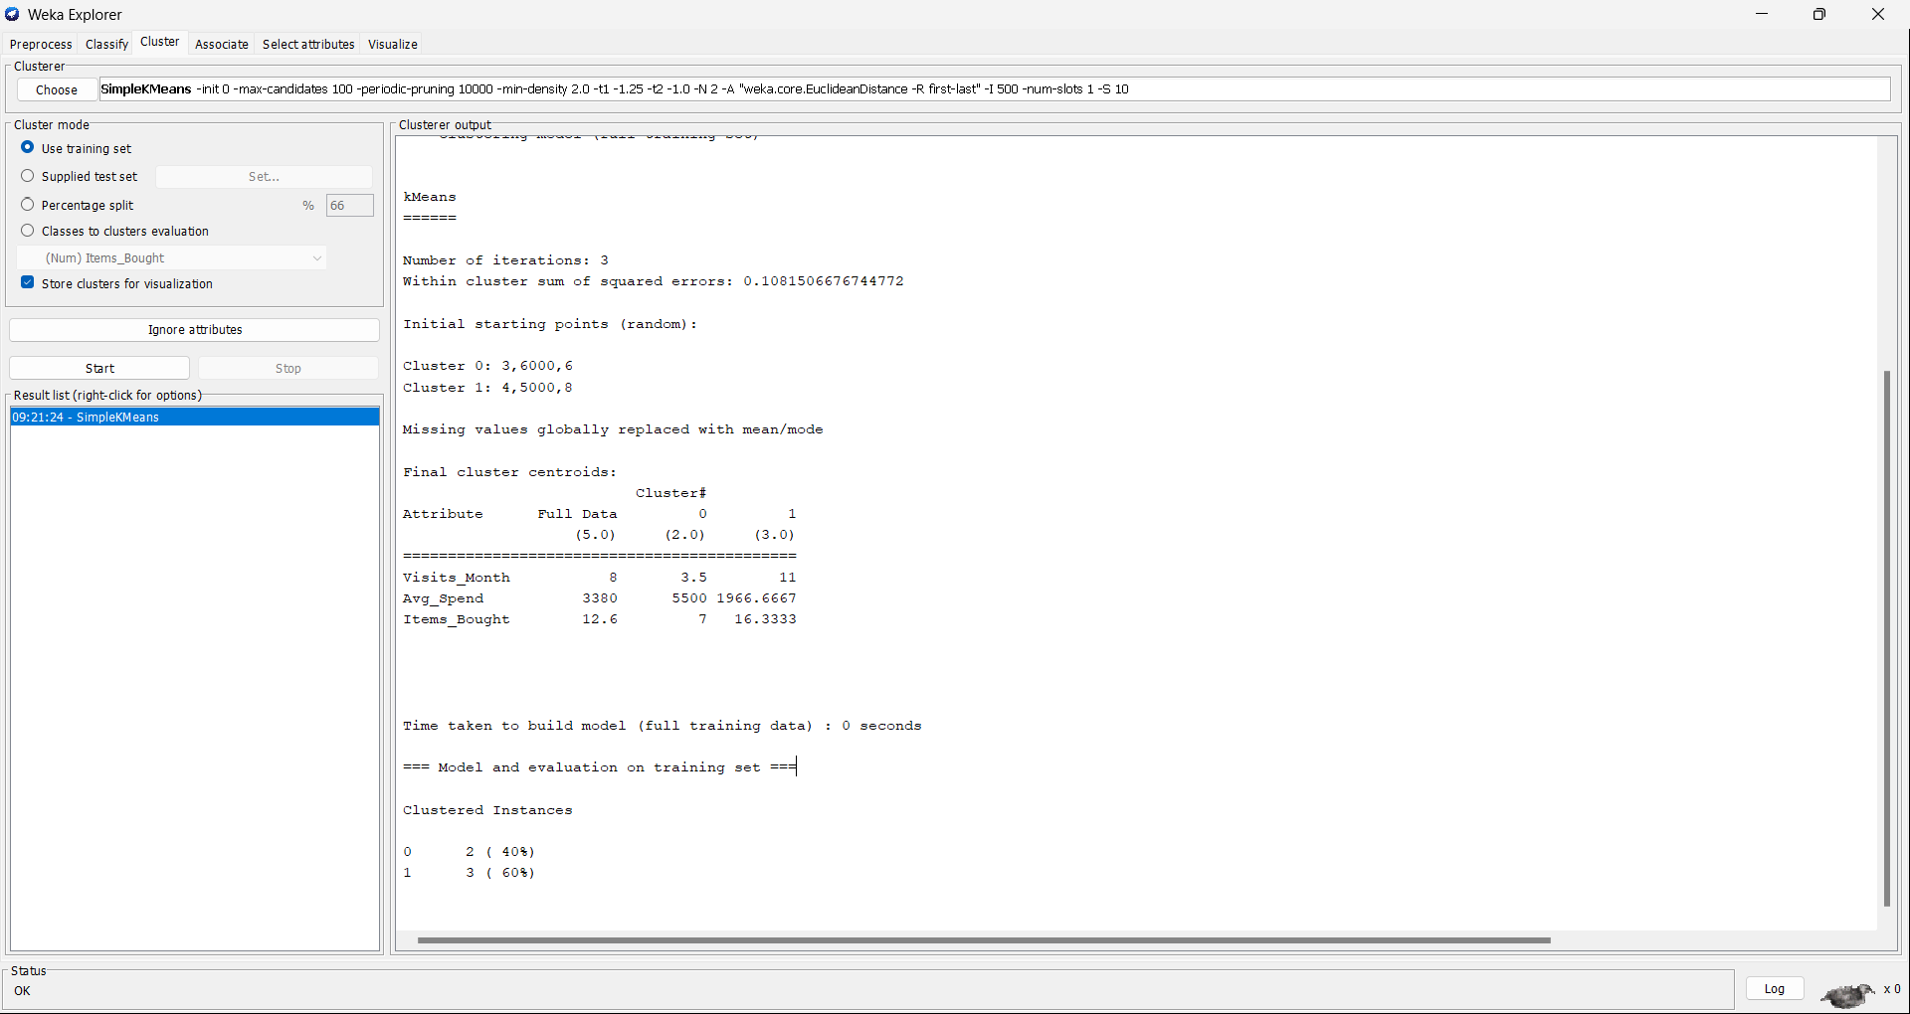
Output:
Q2. Dataset: Credit Card Transactions
Transaction | Amount (₹) | Location | Time (hrs)
T1 | 200 | Chennai | 10
T2 | 5000 | Delhi | 2
T3 | 150 | Chennai | 11
T4 | 7000 | Mumbai | 1
T5 | 180 | Chennai | 12
Question:Design a clustering-based solution using this dataset to detect unusual or fraudulent transactions. (BL4 – 7 Marks)
Manual Calculations:

Output: 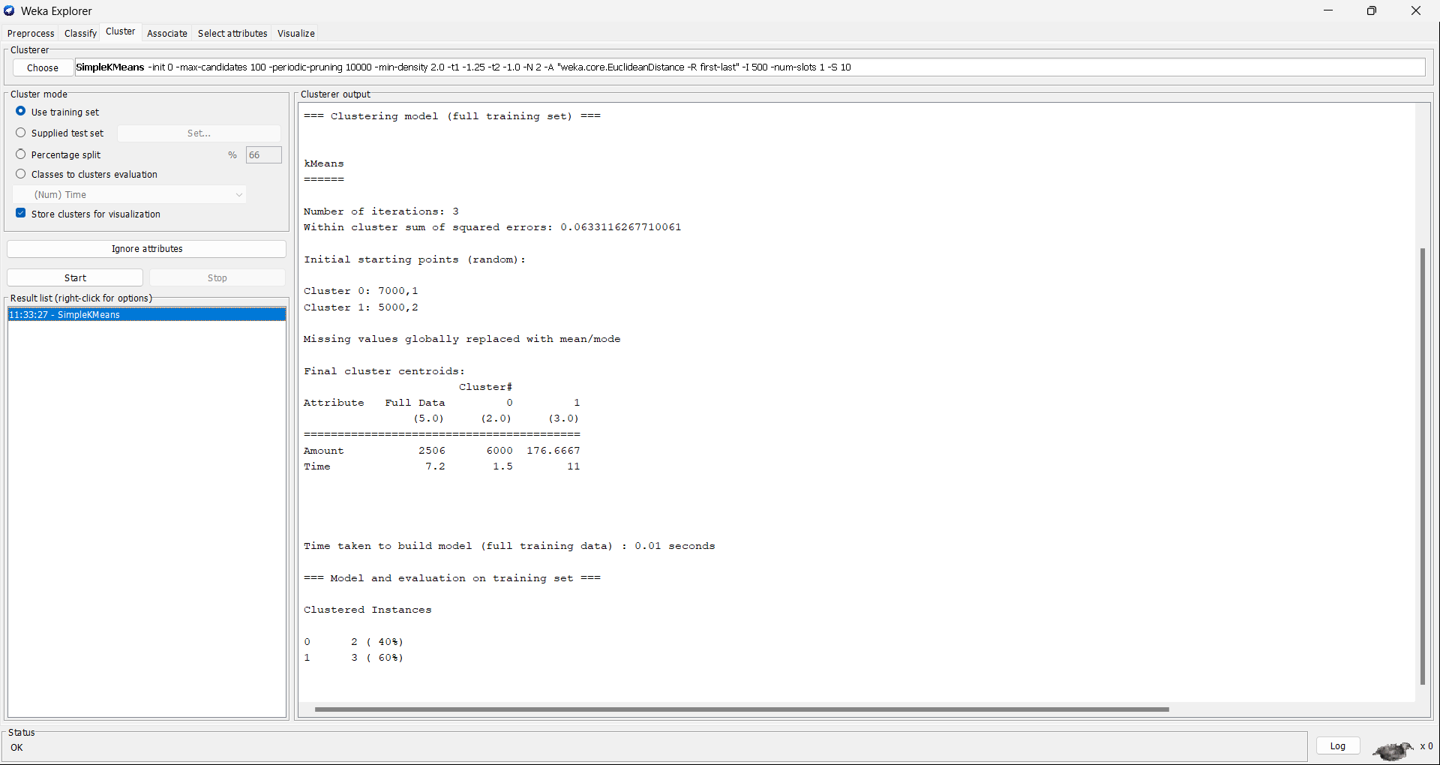
Q3. Dataset: Telecom Usage
User | Call Duration (min) | Data Usage (GB) | Recharge (₹)
U1 | 300 | 5 | 200
U2 | 100 | 2 | 100
U3 | 350 | 6 | 220
U4 | 80 | 1 | 90
U5 | 320 | 5.5 | 210
Question: Explain how clustering can be applied to identify churn-prone users and improve customer retention strategies. (BL4 – 7 Marks)
Manual Calculation:

Outputs: 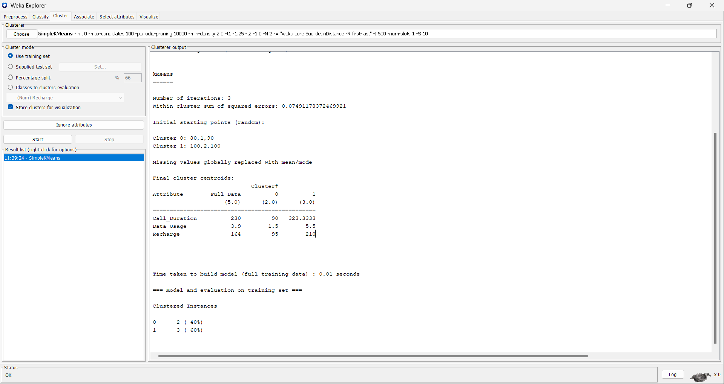
Q4. Dataset: E-commerce Behavior
User | Product Views | Clicks | Purchases
U1 | 50 | 20 | 5
U2 | 30 | 10 | 2
U3 | 60 | 25 | 6
U4 | 20 | 8 | 1
U5 | 55 | 22 | 5
Question: Suggest a clustering technique to group users and explain how it improves recommendation systems. (BL3 – 7 Marks)
Manual Calculations:

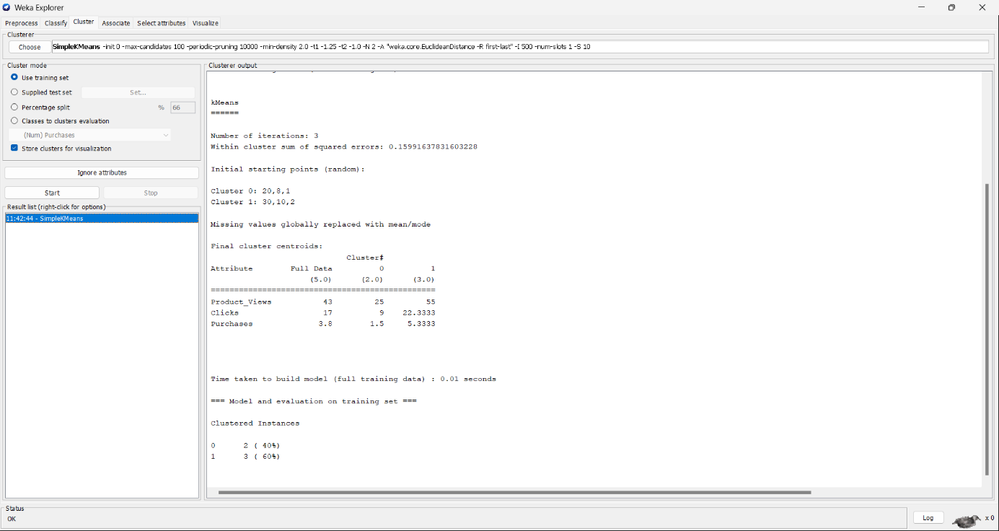
Output:
Q5. Dataset: Traffic Data
Location | Vehicle Count | Avg Speed (km/h) | Delay (min)
L1 | 200 | 30 | 10
L2 | 500 | 15 | 25
L3 | 220 | 28 | 12
L4 | 600 | 10 | 30
L5 | 210 | 32 | 9
Question: Design a clustering-based solution to identify traffic congestion zones and explain how it helps in traffic management. (BL4 – 7 Marks)
Manual Calculation:

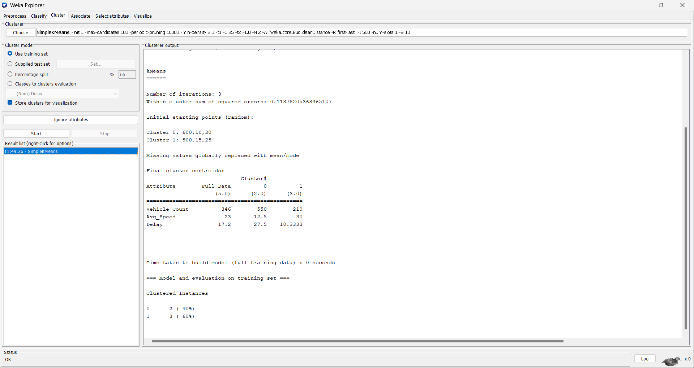
Output:

