SOC LOG PIPELINE
Splunk Detection & Monitoring Report
Python-generated security telemetry • JSON ingestion • SPL detections • SOC dashboard

Platform | Splunk Enterprise
Data source | Synthetic JSON security events generated by Python
Detection scope | Authentication, PowerShell/process activity, network connections
Project goal | Demonstrate an end-to-end junior SOC monitoring workflow
Portfolio Documentation

1. Project Overview
This project demonstrates a compact SOC monitoring pipeline in which Python-generated security events are written as structured JSON, ingested into Splunk Enterprise, analyzed with SPL, and surfaced through detection searches and a security dashboard.
The purpose is not to emulate a full production SIEM. Instead, the lab shows the complete analyst workflow: telemetry creation → ingestion → field extraction → detection logic → investigation context → dashboard visibility.
Architecture
Python  Generator | JSON  Events | Splunk  Ingestion | SPL  Detections | SOC  Dashboard
Security telemetry used
- Authentication activity: failed and successful logins.
- Process execution: PowerShell command-line activity.
- Network activity: source/destination IPs, destination ports and protocols.
- Context fields visible in Splunk include timestamp, user, host, src_ip, dest_ip, process, command_line, status and event_type.
Evidence of ingestion
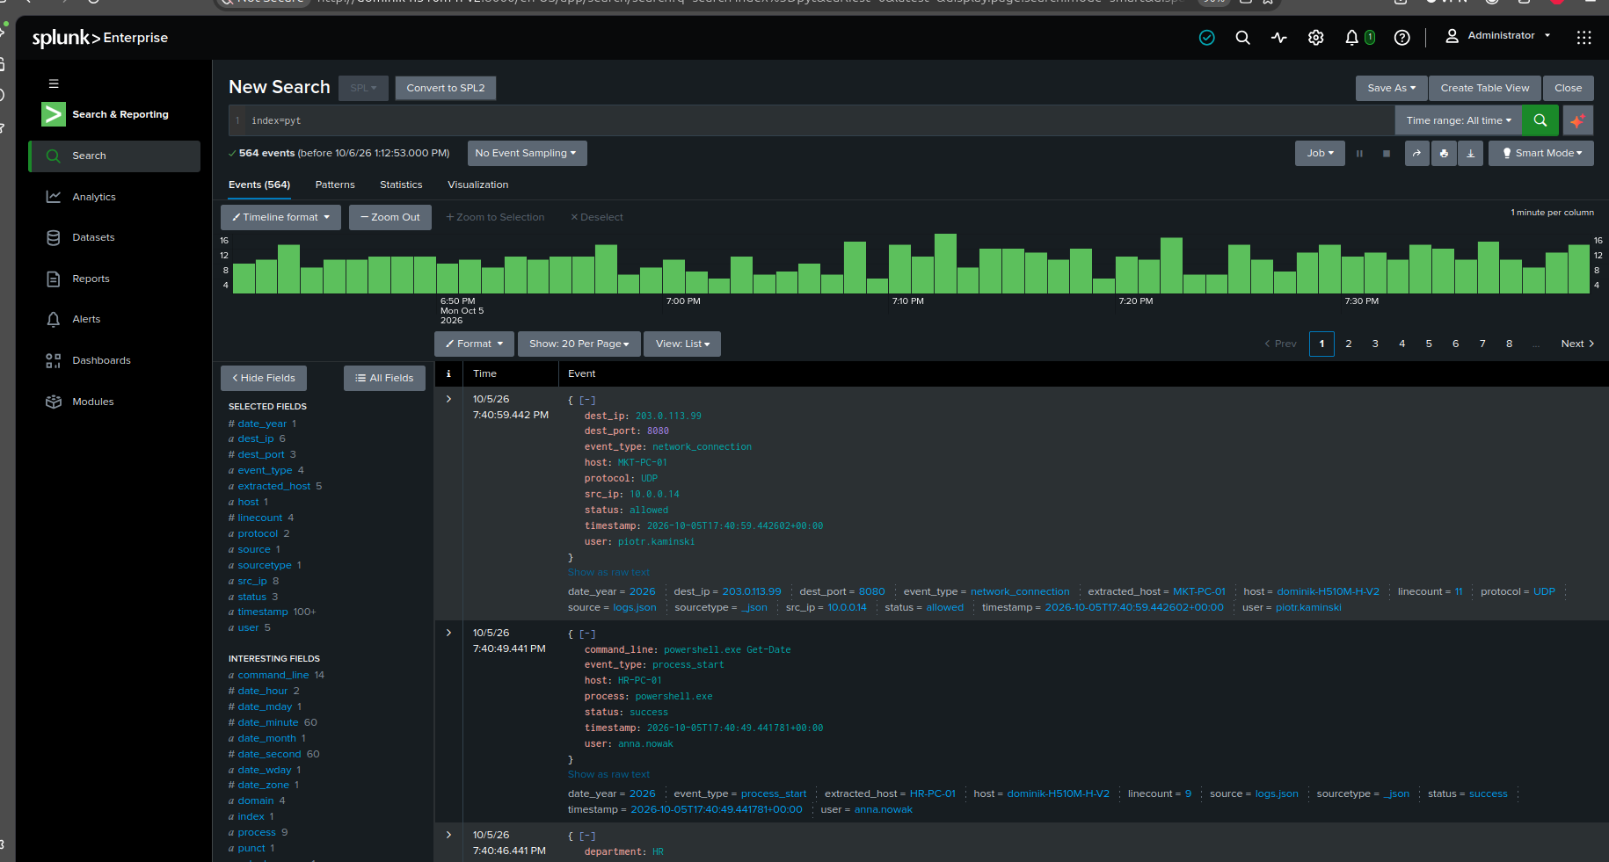
Figure 1. JSON events successfully indexed in Splunk with extracted fields and searchable event metadata.

2. Detection Use Case — Brute Force
Objective: identify repeated failed authentication attempts grouped by time, user and source IP. The search aggregates failed logins and retains the observed failure reasons to give an analyst immediate context.
Detection logic
- Filter authentication telemetry to event_type="failed_login".
- Bucket events into a time window.
- Count failures by user and source IP.
- Return only groups meeting the configured laboratory threshold.
- Sort by the number of failed attempts so the highest-volume activity is reviewed first.
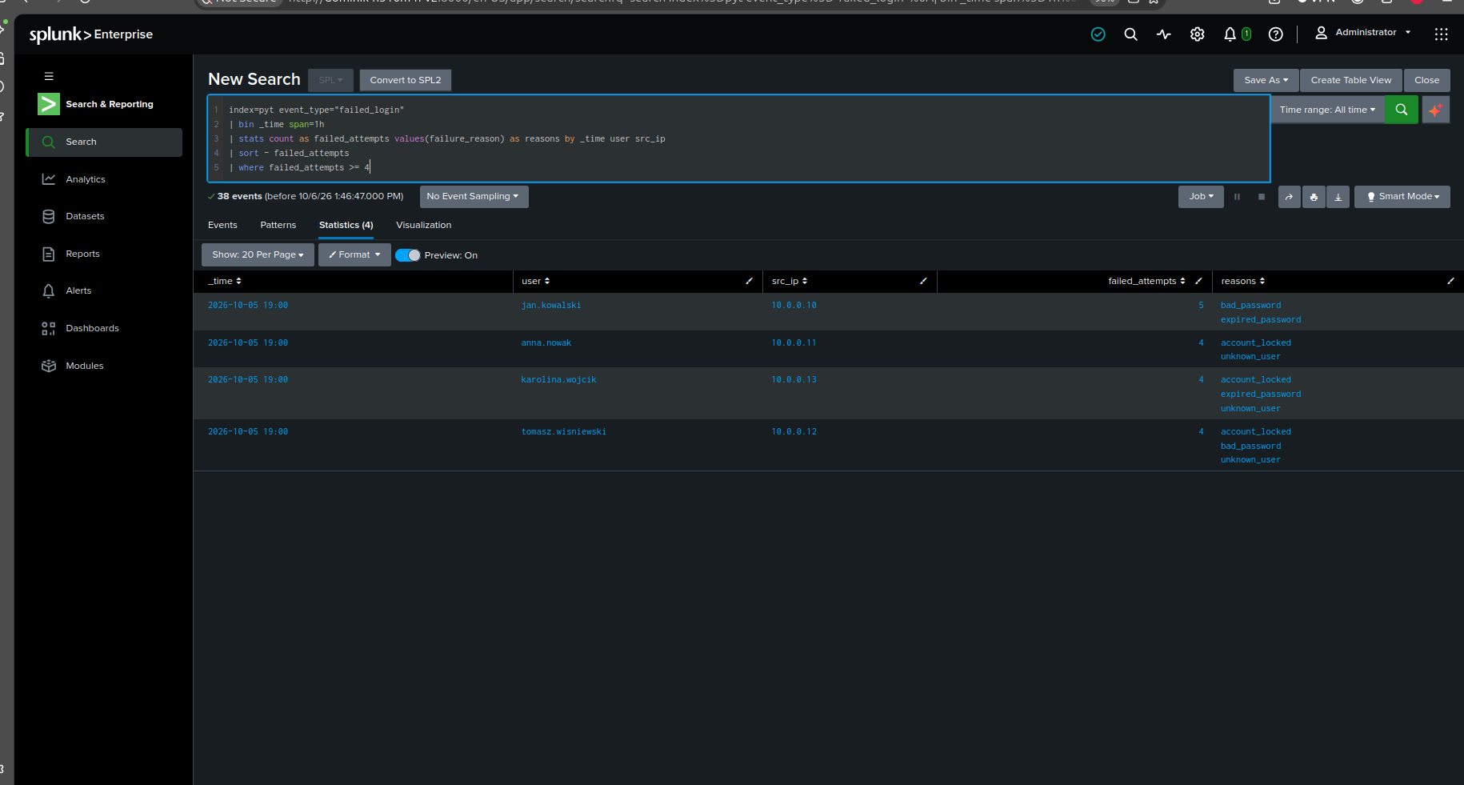
Figure 2. Brute-force detection search and results. The search returns multiple users with repeated failed attempts and associated failure reasons.
Analyst interpretation
A threshold hit is a detection candidate, not automatic proof of compromise. The analyst should validate the source IP, targeted account, host, failure reasons, whether a success followed the failures, and whether the activity could be explained by saved credentials, user error, or a misconfigured service.
MITRE ATT&CK mapping: T1110 — Brute Force.

3. Detection Use Case — Suspicious PowerShell
Objective: identify PowerShell executions containing command-line patterns commonly associated with higher-risk behavior. The lab classifies the matching command line so the reason for the detection is visible directly in the result set.
Observed indicators
- ExecutionPolicy Bypass
- WindowStyle Hidden
- EncodedCommand
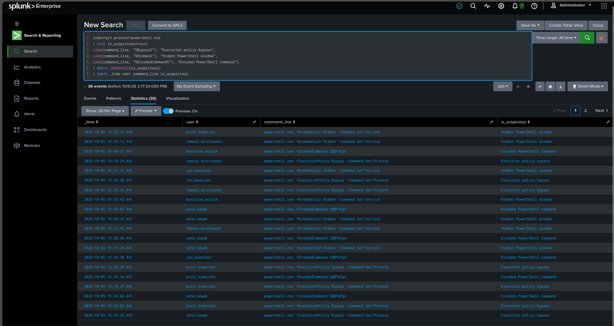
Figure 3. Suspicious PowerShell detection showing the user, command line and classification assigned by the SPL logic.
Analyst interpretation
PowerShell is a legitimate administrative tool, so the presence of powershell.exe alone is not malicious. Investigation should focus on the exact command line, user, host, execution context, related authentication activity, and any network connections occurring around the same time.
MITRE ATT&CK mapping: T1059.001 — PowerShell.

4. Detection Use Case — Suspicious Network Connections
Objective: distinguish known laboratory destinations from destinations classified as suspicious and surface the network events requiring review.
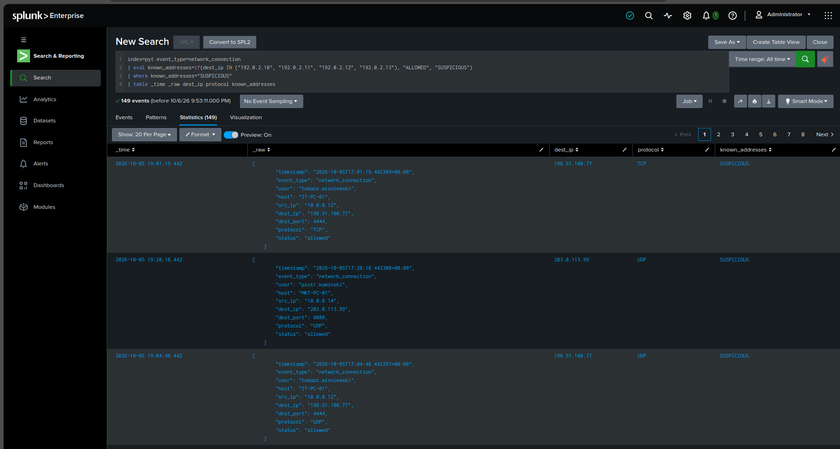
Figure 4. Network detection classifying destination addresses and returning connections marked as suspicious.
Investigation fields
- src_ip — originating endpoint address.
- dest_ip — remote destination.
- dest_port — destination service/port.
- protocol — transport protocol.
- user and host — endpoint context available in the underlying JSON event.
- status — whether the simulated connection was allowed.
In a real SOC, an unfamiliar IP or unusual port is not sufficient by itself to declare an incident. The analyst would enrich the destination, compare it with expected business traffic, inspect the initiating process, and correlate it with authentication and endpoint activity.

5. Correlation Use Case — Successful Login After Multiple Failures
This detection is the strongest correlation use case in the lab. It searches both failed and successful authentication events, orders them by time, maintains a rolling 30-minute failure count per user, and returns successful logins that occur after the configured number of failures.
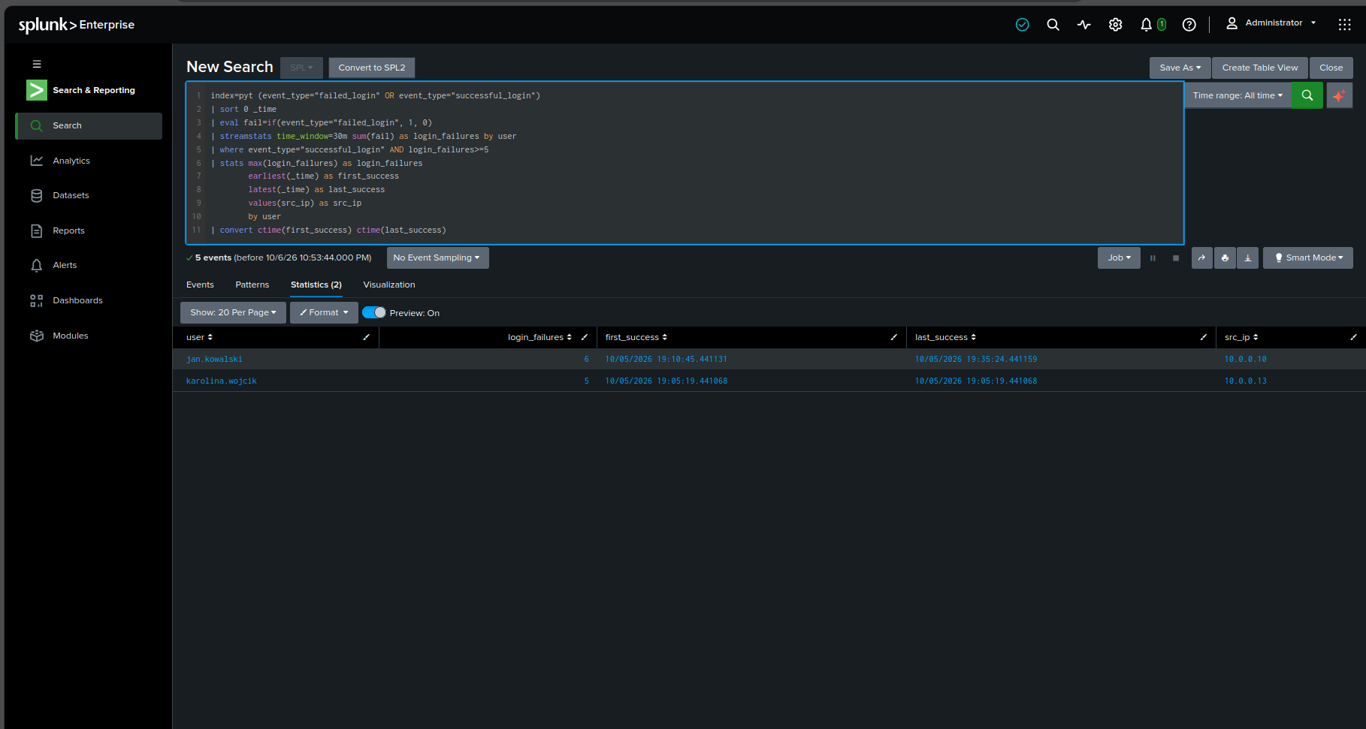
Figure 5. Correlation search returning successful authentications that followed multiple failures within the rolling time window.
Why this matters
A successful login after repeated failures can indicate that credentials were eventually guessed or obtained. It can also be benign, so the analyst should validate the source IP, account, first/last success timestamps, host, and post-login activity before escalation.
Recommended alerting strategy
This correlation and the brute-force detection are the two best candidates for scheduled alerts in this project. A practical lab configuration is to run the searches on a short schedule and trigger when the search returns one or more results. Exact schedules, severities and trigger settings should be documented only after they are configured and captured in Splunk.

6. SOC Security Overview Dashboard
The dashboard consolidates the main detection results into one analyst view. It provides authentication context alongside suspicious PowerShell and network activity, reducing the need to open each search independently during triage.
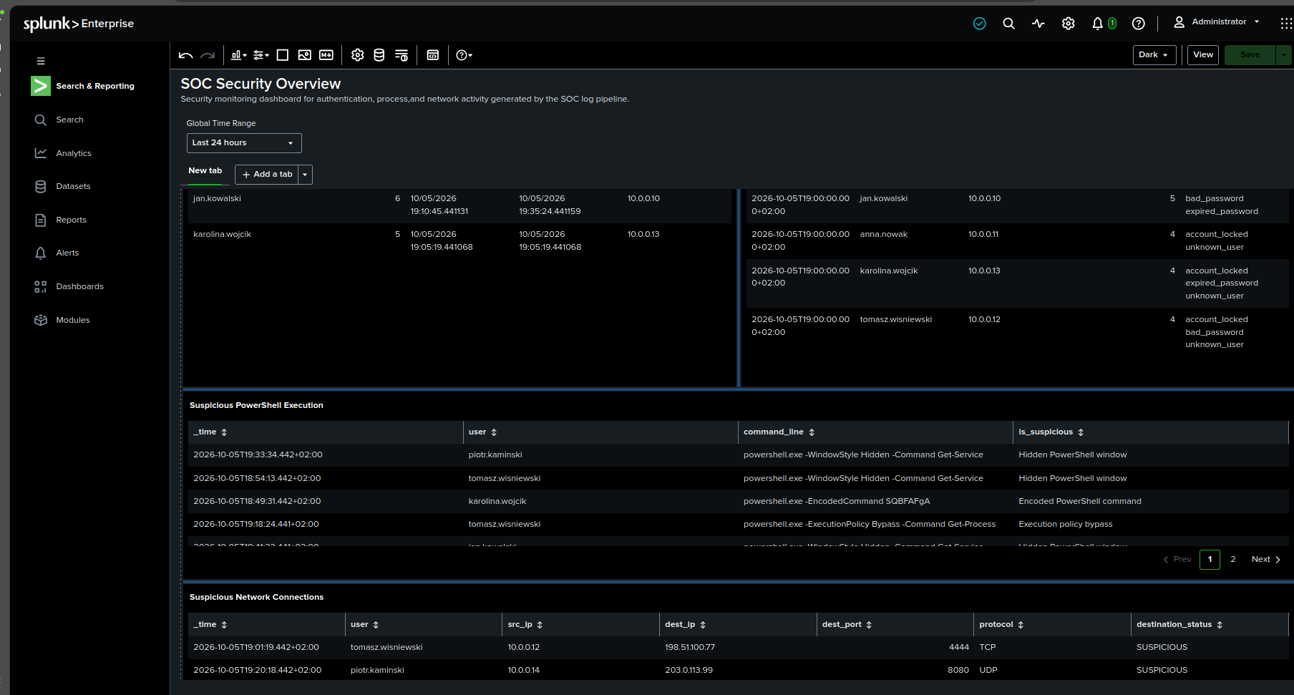
Figure 6. SOC Security Overview dashboard combining authentication detections, suspicious PowerShell activity and suspicious network connections.
Dashboard value
- Authentication detection details support rapid review of users, source IPs and failure counts.
- Suspicious PowerShell results expose command-line evidence and the reason each event matched.
- Suspicious network results provide destination IP, port and protocol context.
- The global time range enables the analyst to scope the investigation consistently across panels.

7. SOC L1 Investigation Workflow
A detection should start an investigation rather than end it. The following workflow is appropriate for this lab and can be explained during a junior SOC interview:
Step | Analyst action | Purpose
1 | Validate the alert | Confirm the search result, time window, threshold and affected user/source.
2 | Review authentication | Check the volume of failures and whether a successful login followed.
3 | Pivot to endpoint activity | Review process execution for the affected user/host, especially suspicious PowerShell.
4 | Pivot to network activity | Check outbound destinations, ports and protocols after the authentication event.
5 | Consider false positives | Saved credentials, user mistakes, automation and legitimate administration can trigger detections.
6 | Decide and document | Escalate when the combined evidence suggests compromise; otherwise document why the activity is benign.
Example escalation rationale
Escalation is justified when several signals align — for example, repeated authentication failures followed by a successful login, suspicious PowerShell execution, and an unusual outbound connection associated with the same user or host. A single weak indicator should be treated more cautiously.

8. Scope, Limitations and Portfolio Value
This is a controlled laboratory project using synthetic telemetry. The thresholds and known/suspicious destination logic are designed for demonstration and should not be presented as production-ready detection engineering.
What the project demonstrates
- Python-based generation of structured security telemetry.
- JSON ingestion and field extraction in Splunk Enterprise.
- SPL filtering, aggregation, classification and time-based correlation.
- Detection development for authentication, process and network activity.
- Dashboard construction for SOC monitoring.
- SOC L1 investigation thinking, false-positive analysis and escalation logic.
Recommended repository evidence
For GitHub, keep the Python source, a sample dataset, SPL files, detection notes, the final dashboard screenshot, and selected screenshots from this report. Add alert-configuration screenshots only when those alerts are actually configured. This keeps the repository evidence-based and avoids claiming functionality that is not shown in the supplied material.
Conclusion
The project demonstrates an end-to-end security monitoring workflow rather than isolated Splunk searches. Its strongest portfolio value comes from connecting telemetry generation, detection logic, correlation, dashboard visibility and analyst investigation into one coherent SOC use case.

