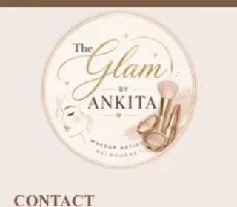  Contact  Melbourne, VIC  +61 451 977 581  nishankn.ankita@gmail.com  Portfolio  theglambyankita.com  @theglambyankita  Skills  - Soft Glam Makeup  - Party Makeup  - Bridal Makeup  - Editorial & Fashion Makeup  - Airbrush Makeup  - Client Consultation  - Colour Matching  - Product Knowledge  - Hygiene & Sanitisation  - Customer Service  - Time Management  - Teamwork | ANKITA AWASTHI  MAKEUP ARTIST • MELBOURNE  Professional Summary  Certified and passionate makeup artist with hands-on experience in fashion events, editorial projects, and special occasion makeup. Skilled across soft glam, bridal, editorial and airbrush techniques, with a continued focus on refining technical craft and delivering exceptional client experiences. Brings over three years of professional Human Resources experience, contributing strong communication, organisation, attention to detail, and customer service to every client interaction.  Makeup Experience  Makeup Artist (Freelance) 2026 – Present  - Certified Makeup Artist providing professional makeup services for special occasions.  - Assisting with runway and fashion event makeup.  - Creating content and showcasing makeup work through a professional portfolio and Instagram.  - Maintaining high standards of hygiene and sanitation.  - Conducting client consultations to achieve personalised looks.  Industry Placements & Events | via Elite Hair and Makeup Academy  - This Is Me event — makeup artistry.  - Indonesian Modest Fashion Week Melbourne — backstage makeup artistry.  - p.Relude Fashion Design Runway, RMIT Brunswick — runway makeup artistry.  - Portfolio photoshoots with professional beauty photographers.  Makeup Education  Certified Makeup Artist — Professional Makeup Artistry (incl. Airbrush Makeup)  Elite Hair and Makeup Academy Certified Course  - Curriculum: skin prep & base, eye makeup, contouring, lips & lashes, colour theory, smoky eyes, airbrushing, 1950s glam, bridal & red carpet looks.  Previous Professional Experience  HR Associate | Infosys (Portland Group Account) Nov 2023 – Dec 2025  - Recruitment and onboarding  - Interview coordination  - Employee lifecycle administration  - Employee support and stakeholder communication  - Documentation and HR compliance  - Strong organisational and customer service skills

