Summary Report COVID Contact Tracing Côte d’Ivoire

Table of Contents

1.1. Value box summaries 2

2. All contacts 3

2.1. Total contacts per region 3

2.2. Table 3

2.3. Plot 4

## Value box summaries

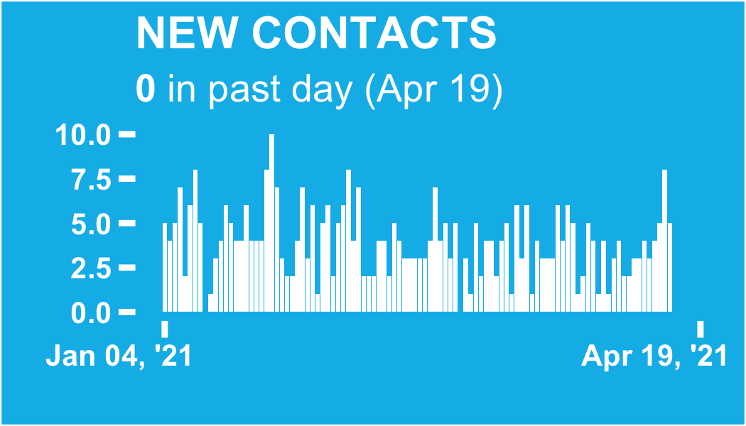

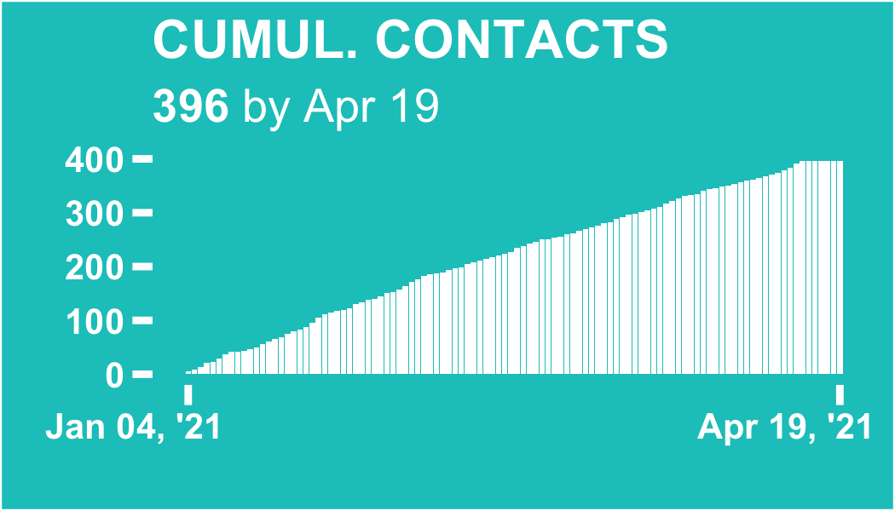

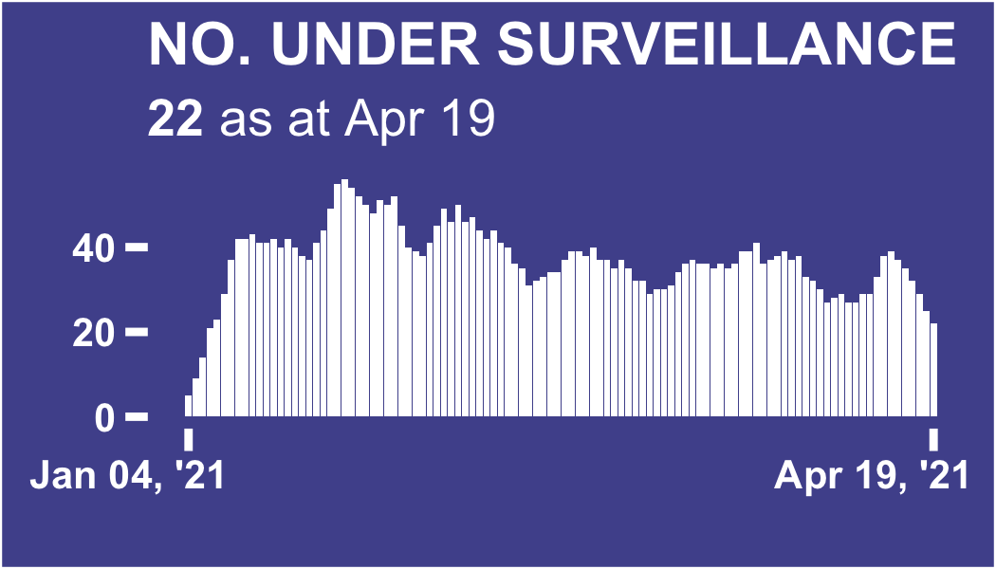

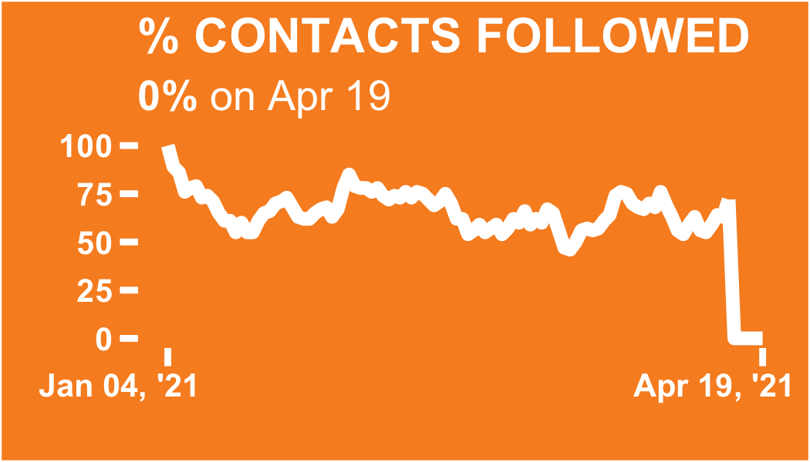

# All contacts

## Total contacts per region

### Heading 3

ℹ: The table and plot show the count of all contacts recorded in each region since database inception.

The region with the most total contacts since database inception is Abidjan 2, with 193 contacts (48.7% of the total)

## Table

|  |  |  |  |
| --- | --- | --- | --- |
| **Region** | **District** | **Total contacts** | **%** |
| Abidjan 2 | Adjame & plateau & attecoube | 50 | 12.6 |
| Port bouet & vridi | 41 | 10.3 |
| Cocody bingerville | 40 | 10.1 |
| Koumassi | 33 | 8.33 |
| Trechville & marcory | 29 | 7.32 |
| Abidjan 1 | Yopougan est | 50 | 12.6 |
| Abobo est | 48 | 12.1 |
| Anyama | 42 | 10.6 |
| Yopougan ouest | 29 | 7.32 |
| Abobo ouest | 23 | 5.81 |
| Manquant |  | 11 | 2.78 |
| Total | - | 396 | 100 |

## Plot

