COVID-19 Contact Tracing Report

Table of Contents

# VALUE BOX SUMMARIES

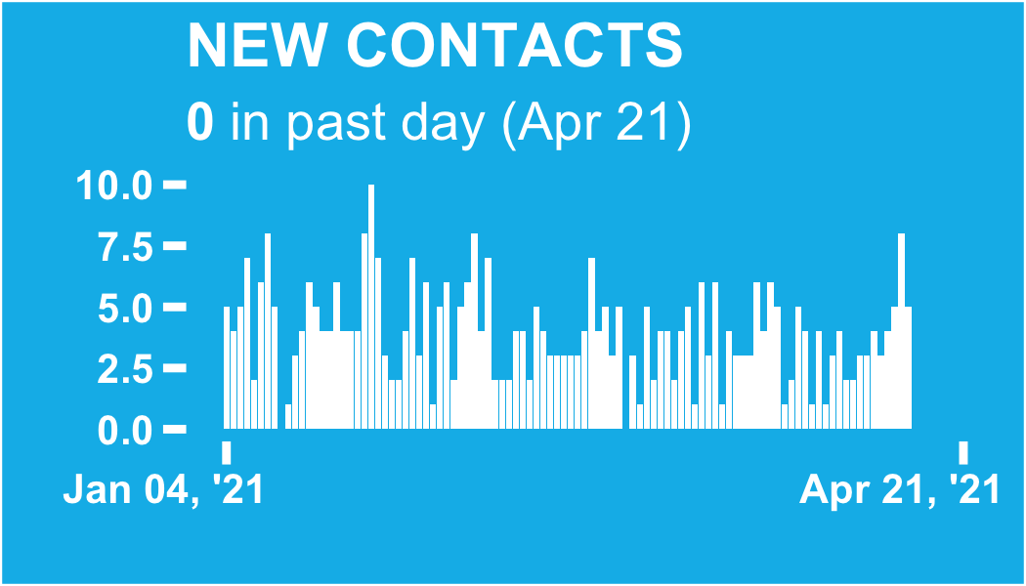

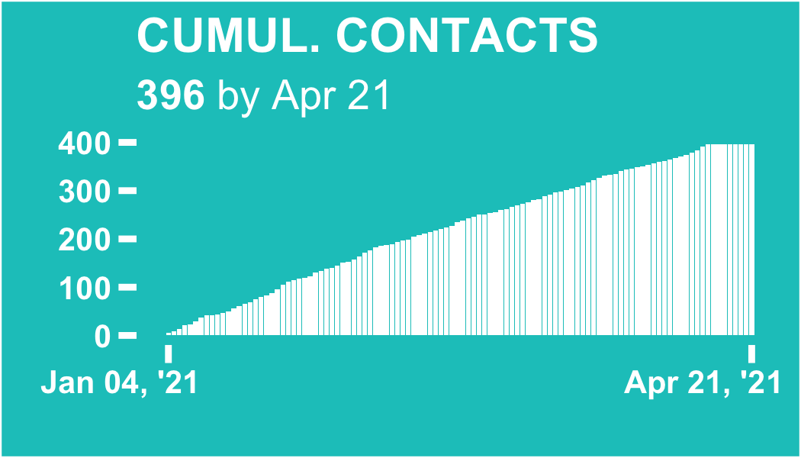

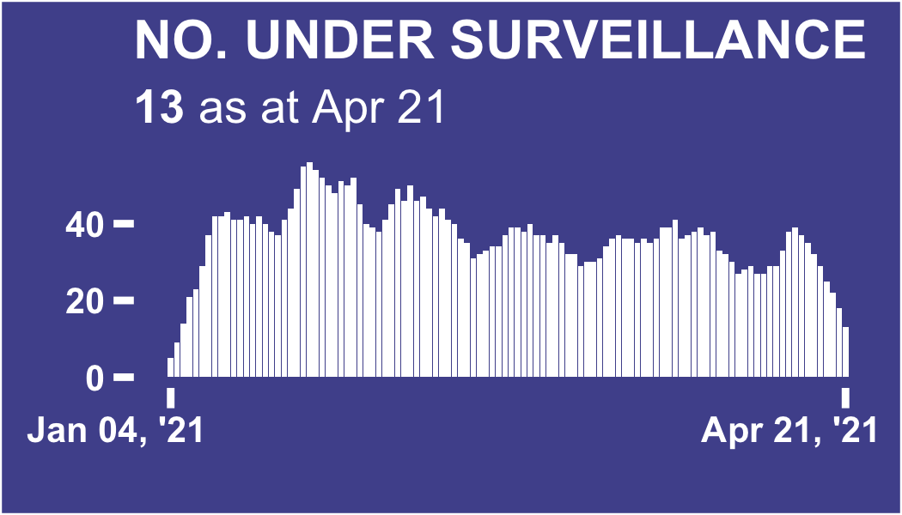

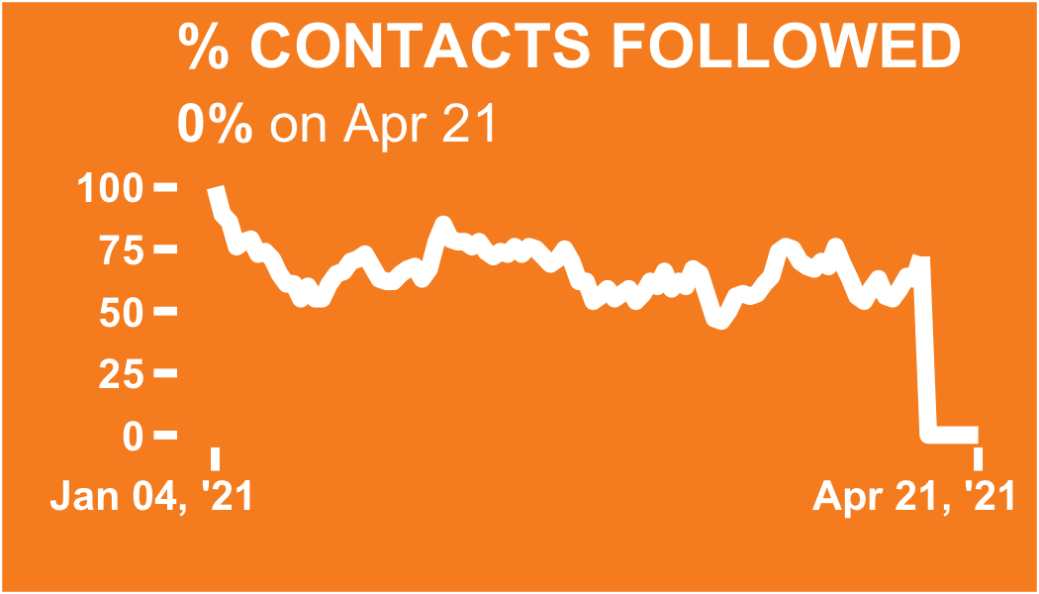

# ALL CONTACTS

# Regional breakdown

ℹ: The table and plots show the count of all contacts recorded in each region since database inception.

The region with the most total contacts since database inception is Abidjan 2, with 193 contacts (48.7% of the total)

## Regional breakdown bar chart

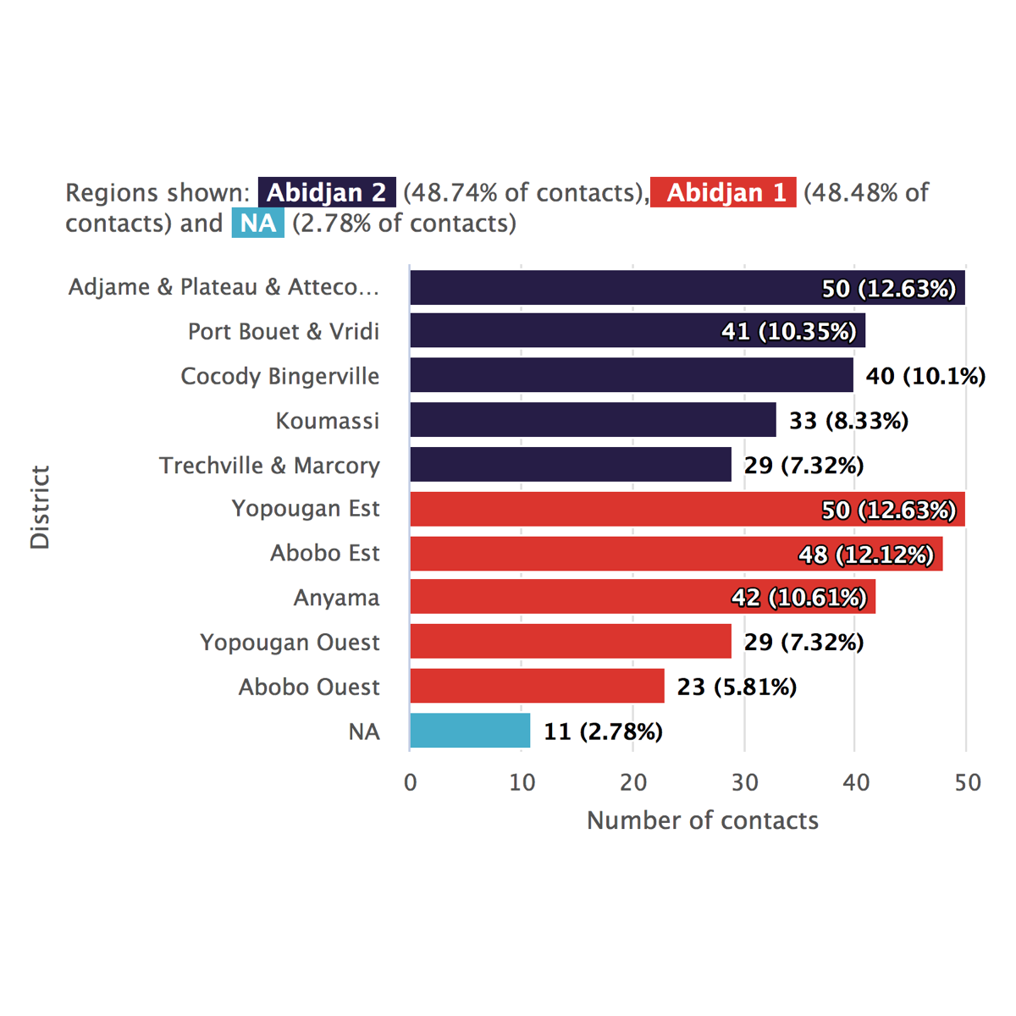

## NULL

## Regional breakdown sunburst plot

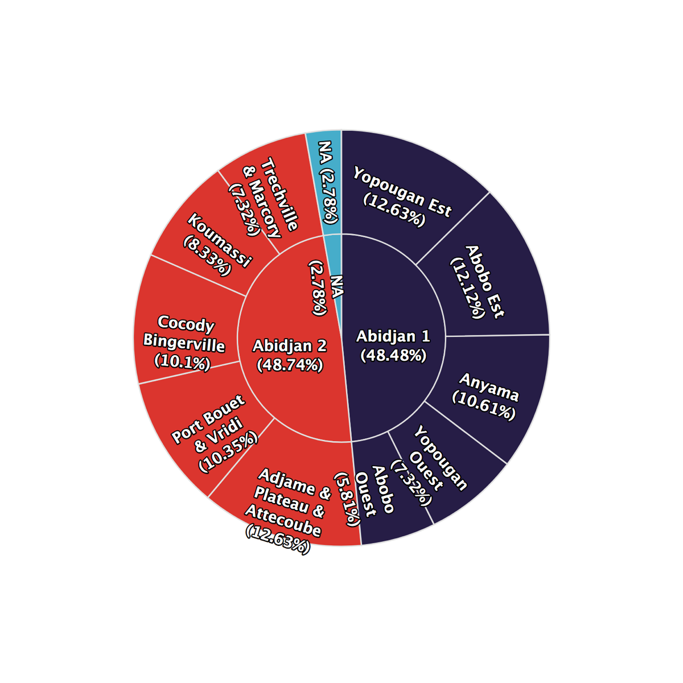

## NULL

## Regional breakdown table

|  |  |  |  |
| --- | --- | --- | --- |
| **Region** | **District** | **Total contacts** | **%** |
| Abidjan 2 | Adjame & Plateau & Attecoube | 50 | 12.6 |
| Port Bouet & Vridi | 41 | 10.3 |
| Cocody Bingerville | 40 | 10.1 |
| Koumassi | 33 | 8.33 |
| Trechville & Marcory | 29 | 7.32 |
| Abidjan 1 | Yopougan Est | 50 | 12.6 |
| Abobo Est | 48 | 12.1 |
| Anyama | 42 | 10.6 |
| Yopougan Ouest | 29 | 7.32 |
| Abobo Ouest | 23 | 5.81 |
| NA | NA | 11 | 2.78 |
| Total | - | 396 | 100 |

# Regional trends

##   
##   
## ℹ: The plots show the number of contacts under surveillance on each day, whether or not they were successfully contacted.  
##   
## The day on which the highest number contacts were under surveillance was Jan 26, 2021, with 56 contacts under surveillance.

## NULL

## Regional trends absolute counts

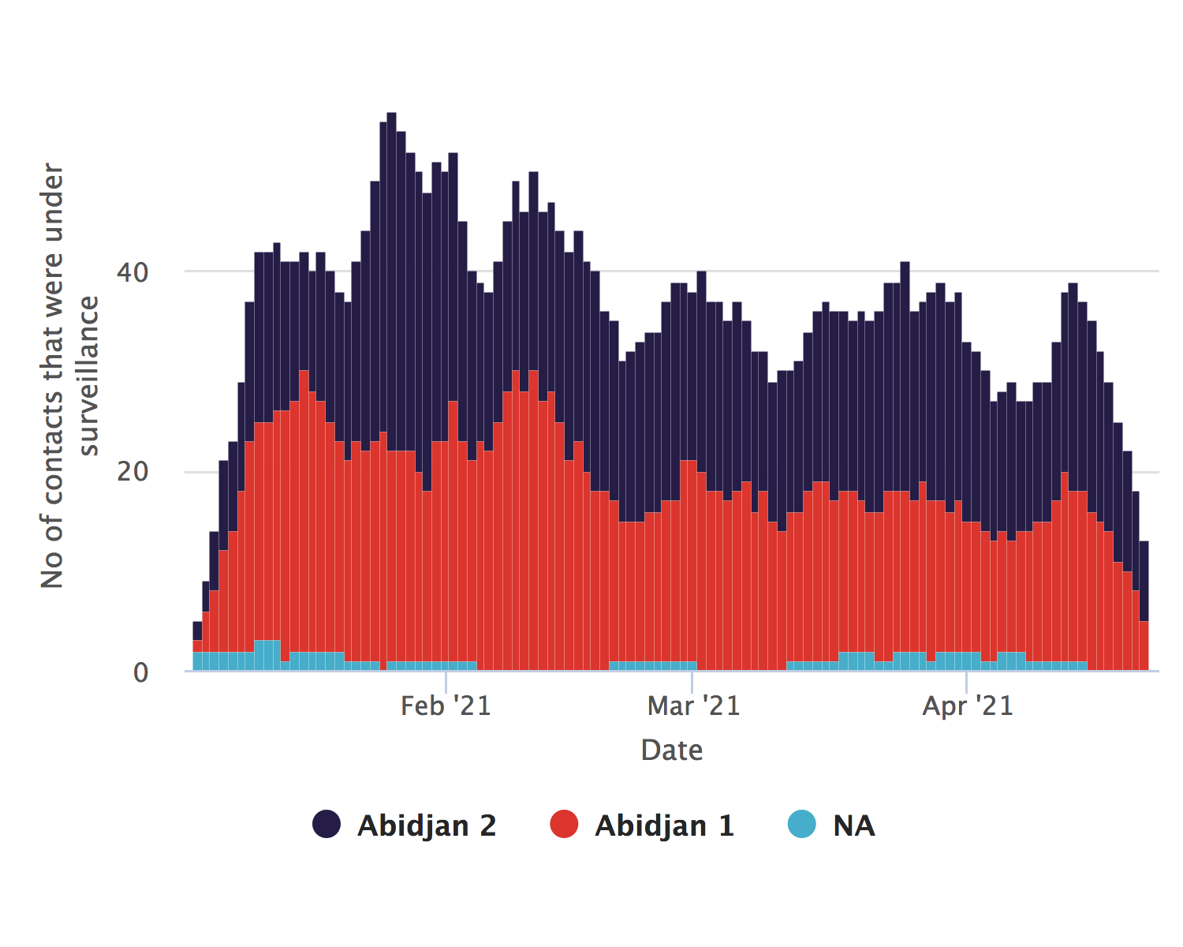

## NULL

## Regional trends relative proportions

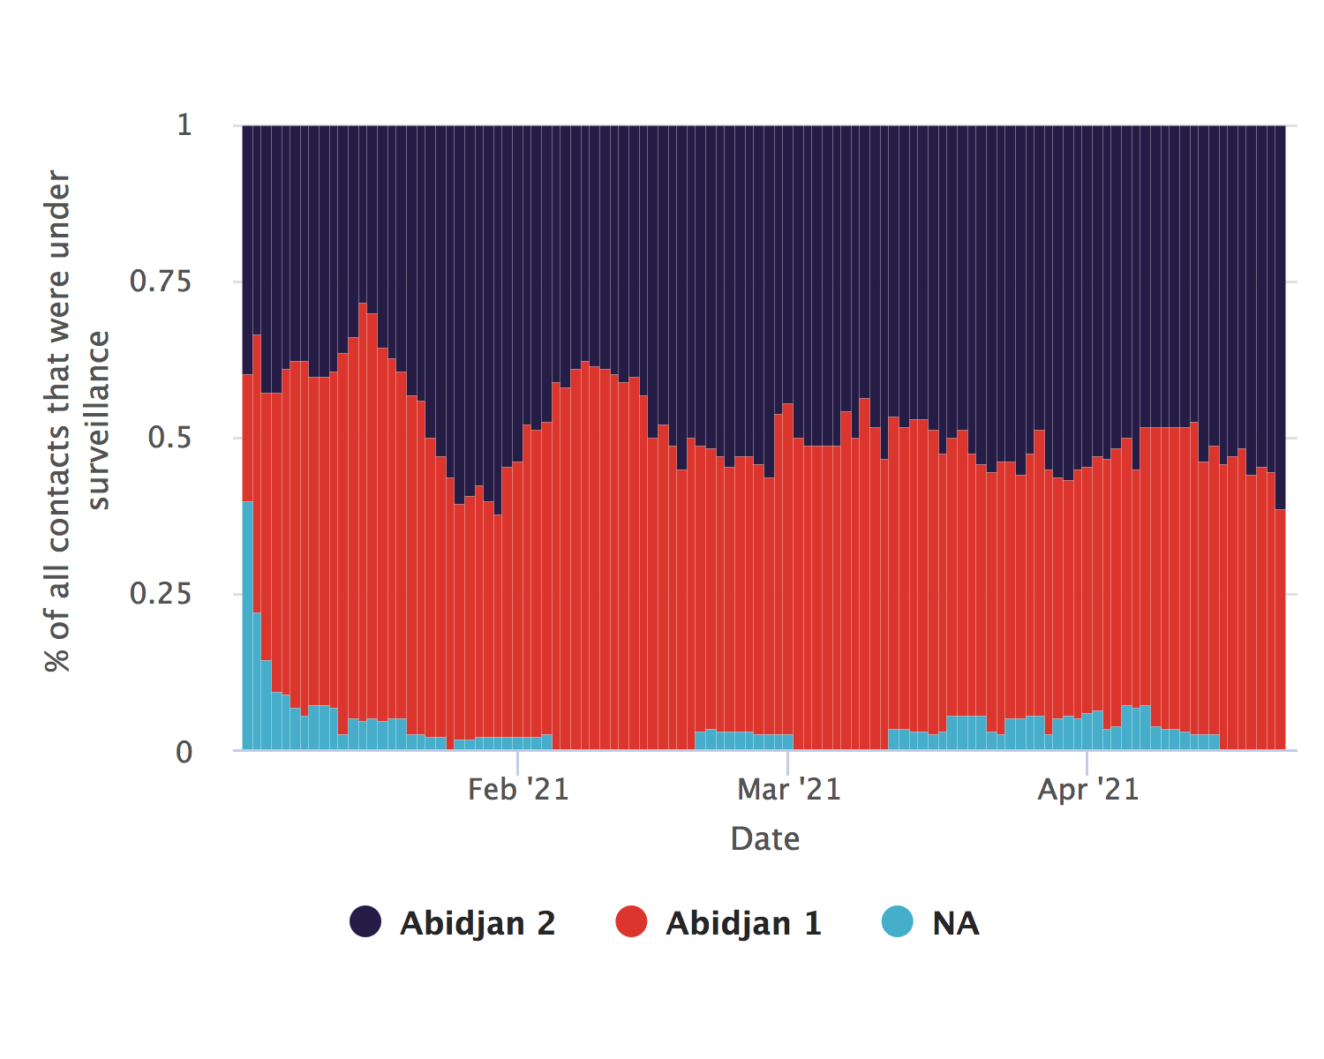

## NULL

# Contacts per case

##   
##   
## ℹ: The plots show the number of contacts linked to each case.  
##   
## The mean number of contacts per case is 12.8, (SD:5.3) with a minimum of 2 and a maximum of 24

## NULL

## Contacts per case donut plot

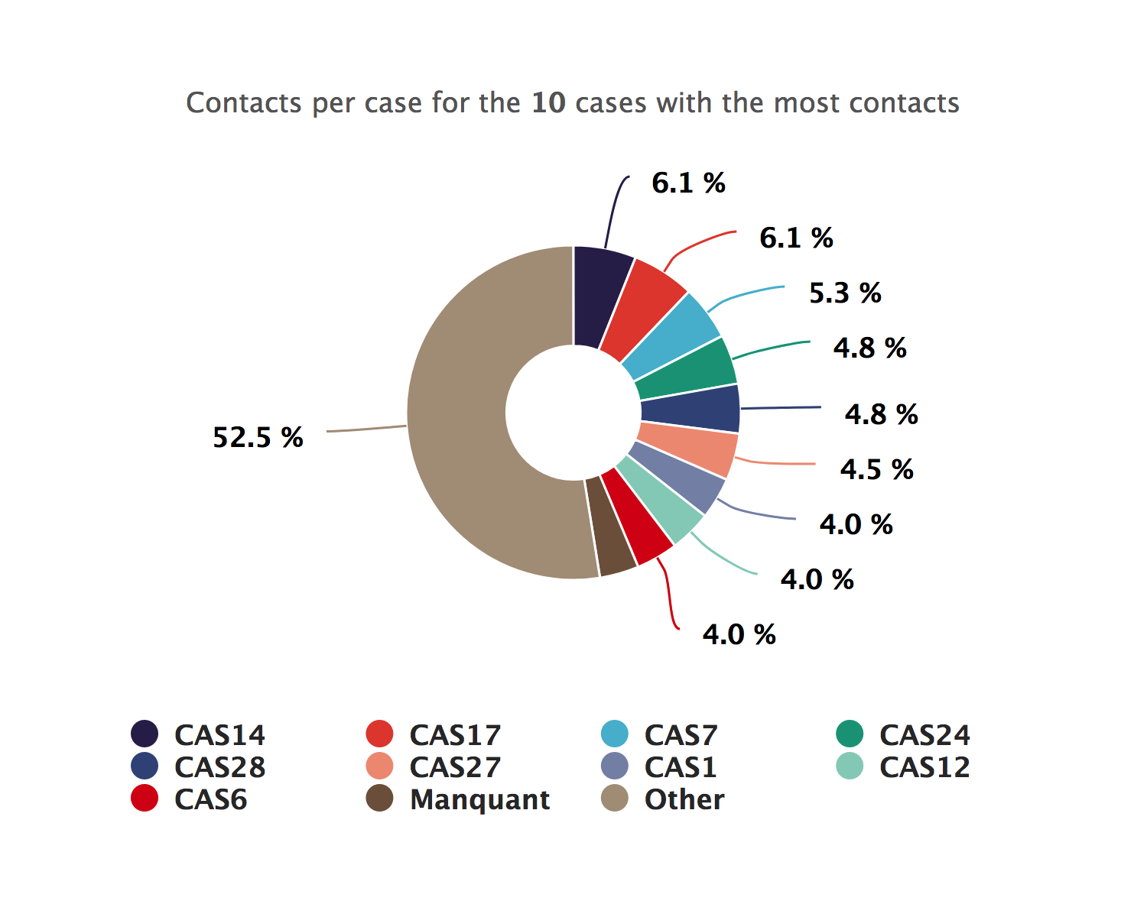

## NULL

## Contacts per case bar chart

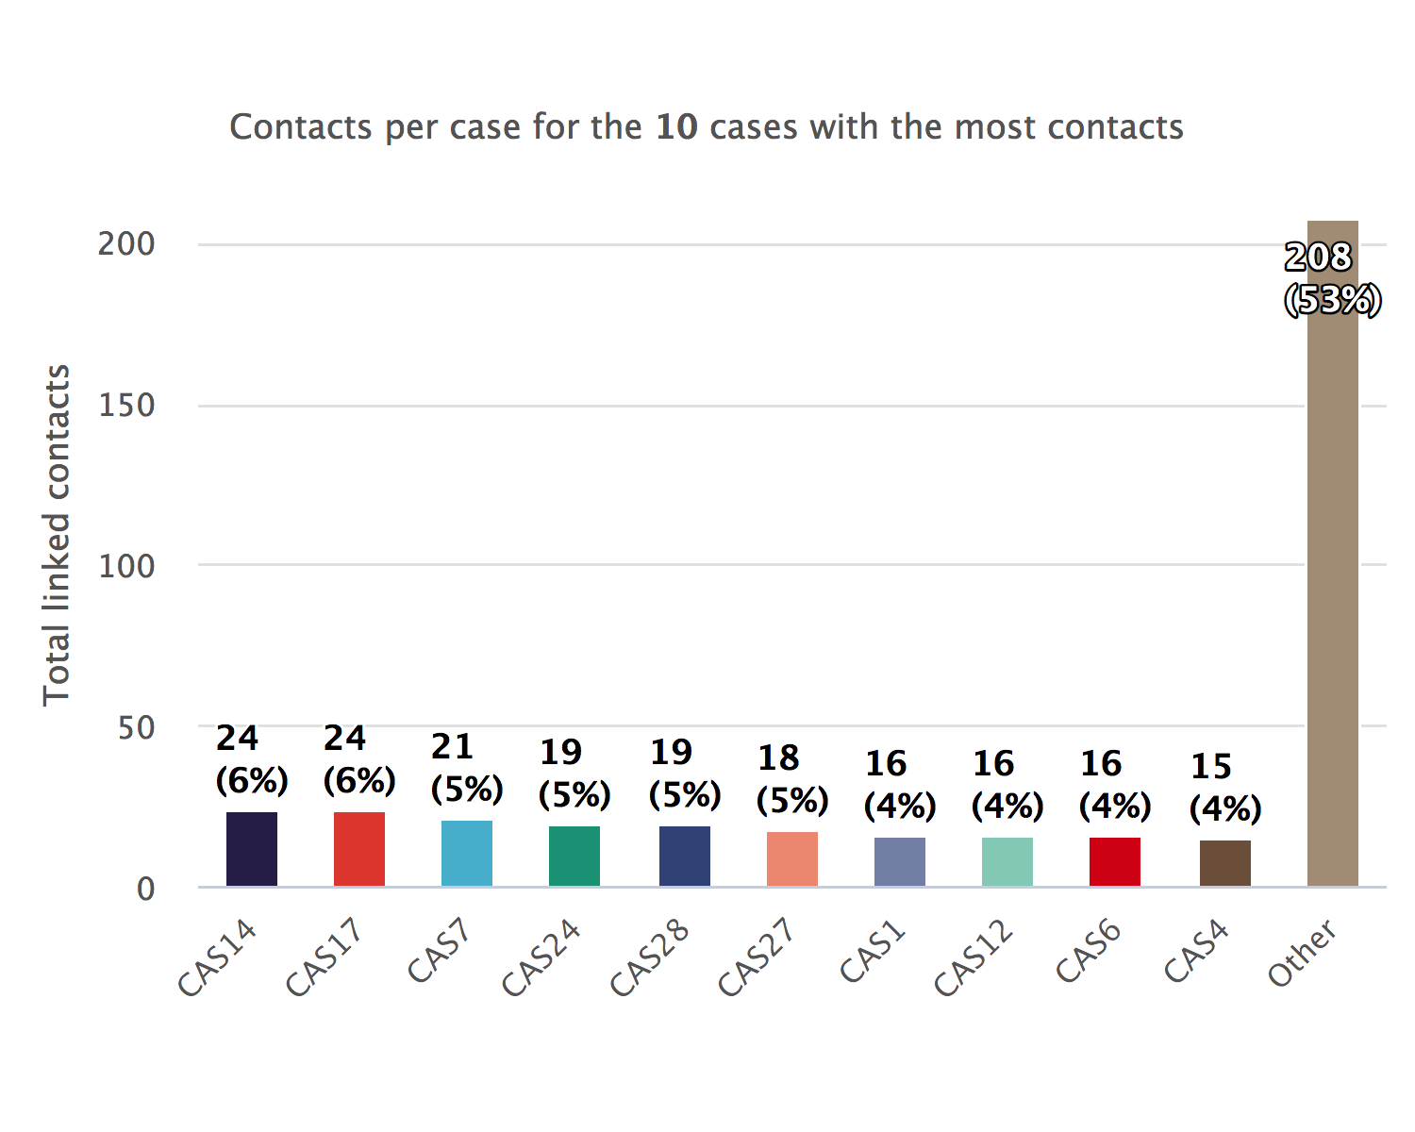

## NULL

# Link type between contacts and cases

##   
##   
## ℹ: The plots show the number of contacts per type of type of link. The categories have been cleaned and condensed. Access the data in tabular form by clicking on the top-right button.  
##   
## The most common link category is 'parent proche', with 66 contacts (16.67%).

## NULL

## Link type donut plot

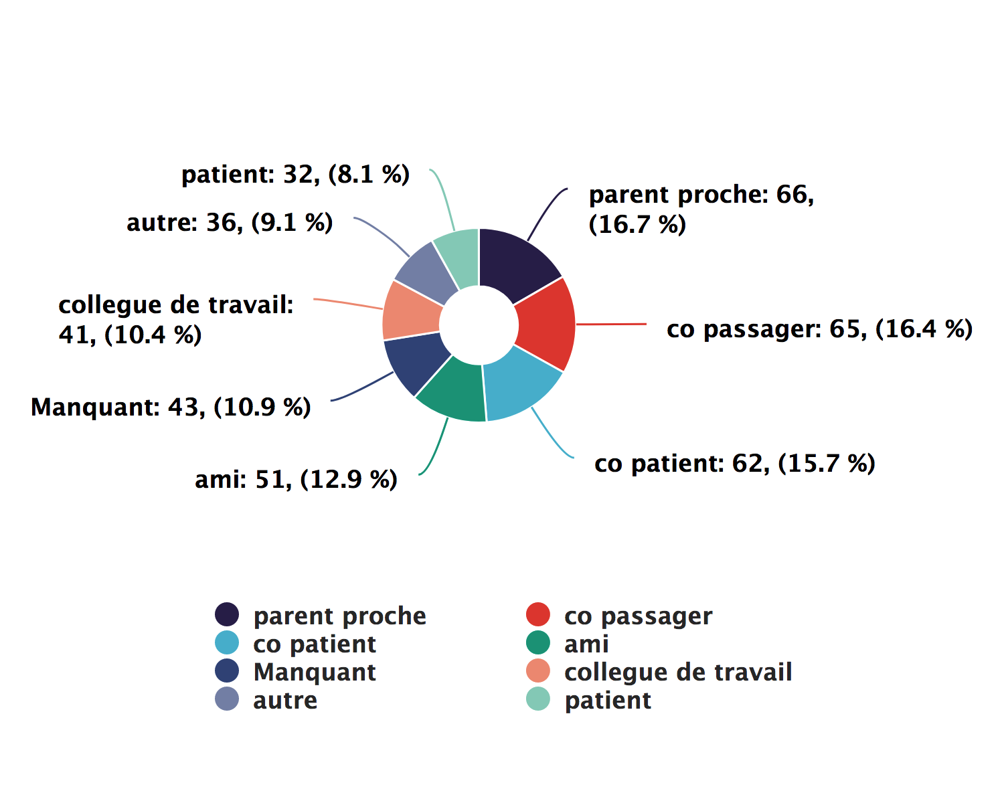

## NULL

## Link type bar chart

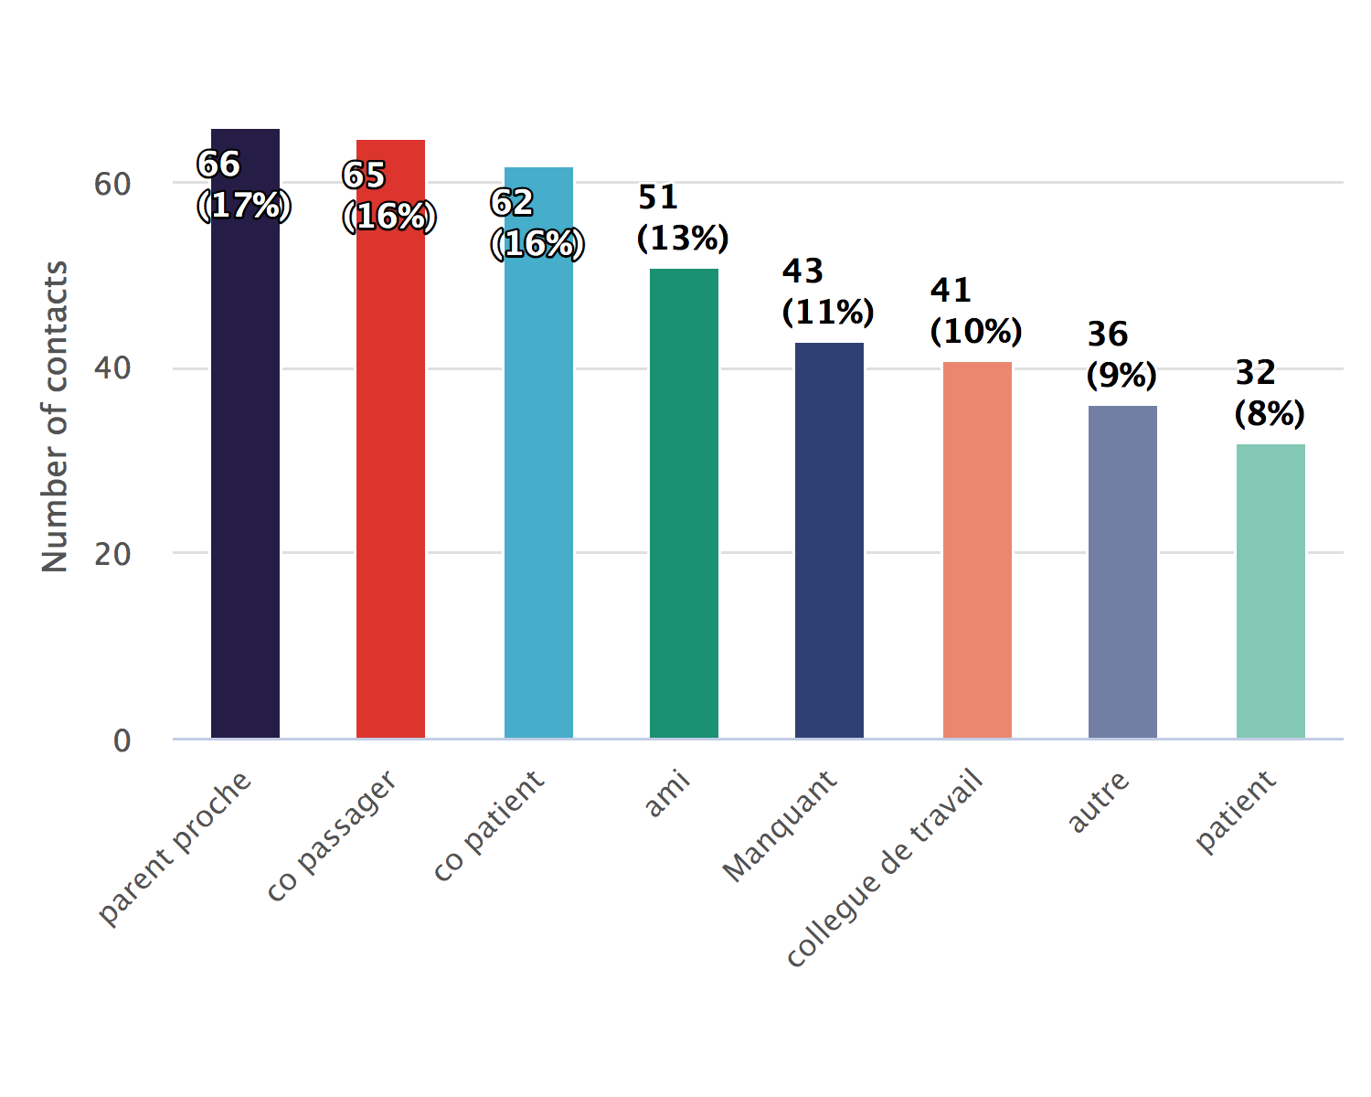

## NULL

# ACTIVE CONTACTS

## Follow-up timelines

##   
##   
## There are 13 active contacts

## NULL

## Follow-up timeline snake plot

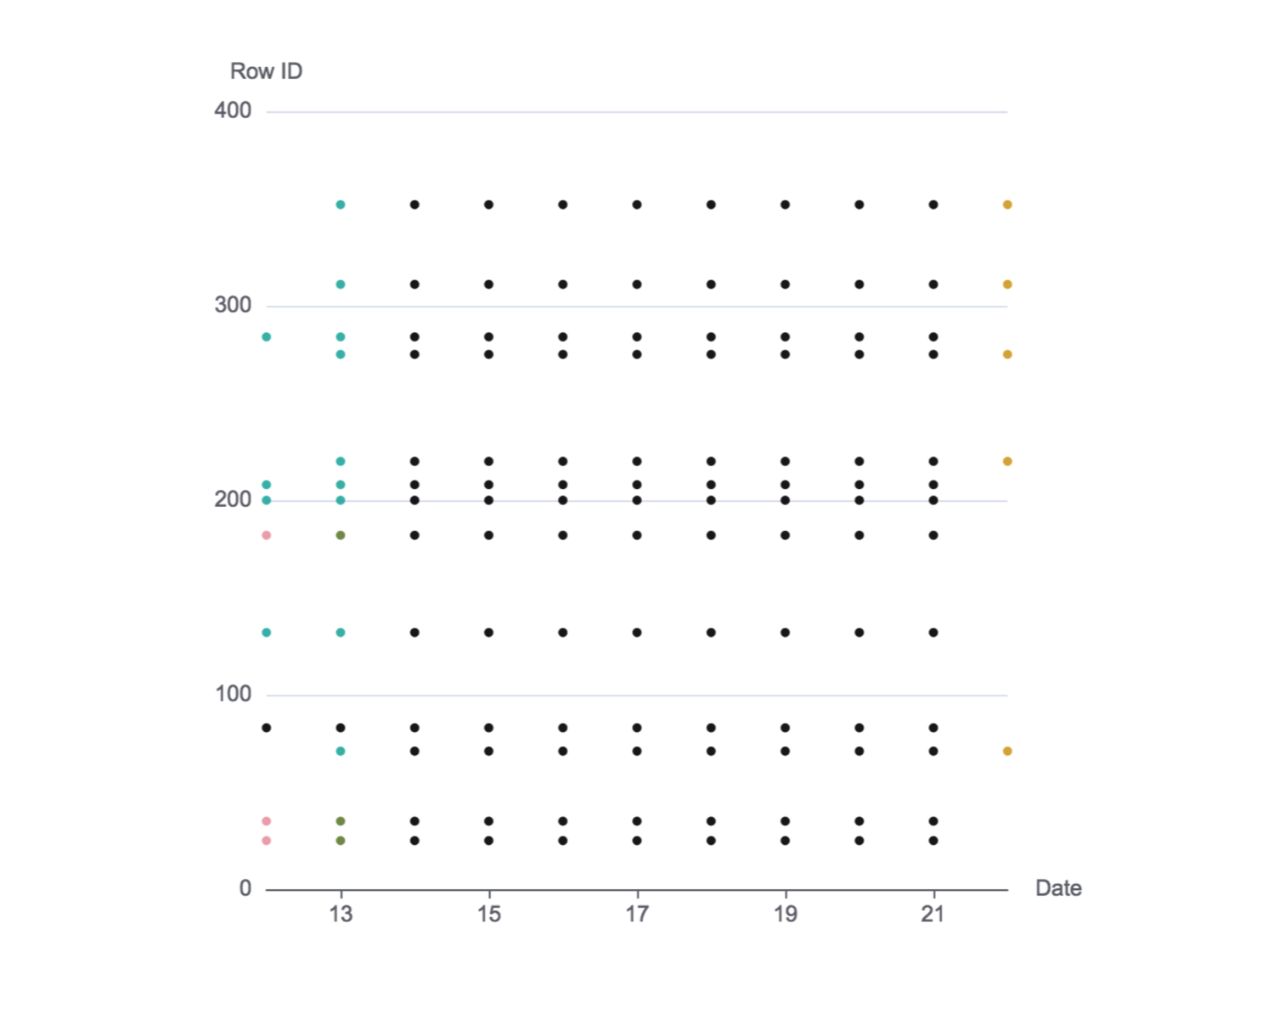

## NULL

## Follow-up timeline summary bar chart