A comprehensive statistical evaluation of the Orion–Giza correlation

Elliot Allan
Independent Researcher
E-mail: ellallan@proton.me
Abstract:
We present the first exhaustive statistical assessment of Bauval’s (1994) Orion Correlation Theory, testing whether the spatial arrangement of the three Great Pyramids of Giza encodes the shape of Orion’s Belt. Using Procrustes analysis against all 695,520 stellar triplets brighter than visual magnitude 4.0, drawn from the Yale Bright Star Catalogue and independently confirmed with Gaia DR3 proper motions, we find the Giza–Orion shape correspondence ranks 1,717th (p = 0.0025). This constitutes 8.7 bits of information content across two independent shape parameters (distance ratio and bend angle), comparable to the Great Pyramid’s π encoding. The match uses pure rotation without reflection, neutralizing Fairall’s (1999) mirror objection, and Giza ranks first among 12 famous triangular monument sites tested against their culture’s top asterism (BH-corrected p = 0.030 across sites). The Procrustes scale factor is not statistically significant (p = 0.219), adding no information beyond the two shape degrees of freedom. However, every proposed extension of the correlation fails quantitative testing: the pyramid-axis orientation does not match Orion’s position angle at any epoch (p = 0.74–0.98); the four Great Pyramid shafts do not converge on a single target epoch (spread = 1,325 years); Menkaure’s offset from the Khufu–Khafre line is in the opposite direction to Mintaka’s; the Nile Valley extension collapses (p = 0.50); and a novel builder’s precision envelope analysis reveals the match sits at the 0.8th percentile of what intentional naked-eye encoding could produce. We conclude that the three-point shape correspondence is statistically significant but far more limited than traditionally claimed.
Keywords: archaeoastronomy, Giza pyramids, Orion correlation theory, Procrustes analysis, statistical testing, point-pattern matching
1 Introduction
In 1989, Robert Bauval proposed that the three Great Pyramids of Giza—built during the Fourth Dynasty (ca. 2560 BCE)—were deliberately arranged to mirror the three stars of Orion’s Belt: Alnitak (ζ Ori), Alnilam (ε Ori), and Mintaka (δ Ori). The “Orion Correlation Theory” (OCT) subsequently became one of the most widely known archaeoastronomical claims in popular culture (Bauval 1989; Bauval and Gilbert 1994). Despite generating substantial public interest, the OCT has received limited rigorous statistical evaluation in the peer-reviewed literature.
The existing critical literature has addressed individual aspects of the claim. Fairall (1999) noted that the pyramid layout is reflected relative to the stellar pattern. Orofino and Bernardini (2011; 2016) demonstrated that the proposed Nile Valley extension—mapping additional pyramids to wider Orion stars—does not withstand scrutiny, and tested Cygnus as an alternative (finding it equally poor). Trimble (1964) and Badawy (1964) first proposed that the Great Pyramid’s internal shafts targeted specific stars, but subsequent work has not produced a systematic quantitative evaluation of these claims. Krupp (1997) and Legon (1995) raised further objections regarding both the layout correlation and the shaft alignments. Most recently, Vecchiato, Bernardi, and Cora (2025) proposed a rigorous point-pattern matching framework for evaluating archaeoastronomical correlations, explicitly flagging the inability to estimate the total eligible asterism count as an open methodological problem.
This paper addresses that gap directly. We enumerate all C(N, 3) stellar triplets from a magnitude-limited catalog and rank Giza against the complete population using Procrustes shape analysis. We then systematically test every major sub-claim of the OCT—orientation, shaft alignment, brightness–size correspondence, geographic extension, and the Menkaure offset—using quantitative methods. Finally, we introduce two novel analytical frameworks: a builder’s precision envelope that asks whether the match is consistent with what intentional naked-eye construction could achieve, and an information-theoretic decomposition that quantifies the match in bits across its constituent degrees of freedom.
The result is a nuanced assessment: the three-point shape correspondence is real, statistically significant, and unique among culturally recognized asterisms, but every proposed elaboration of the correlation fails quantitative testing.
2 Data and methods
2.1 Pyramid coordinates
We use the center coordinates of the three Great Pyramids from survey data: Khufu (29.9792°N, 31.1342°E), Khafre (29.9761°N, 31.1306°E), and Menkaure (29.9725°N, 31.1278°E). Coordinates are projected to a local Cartesian frame using a tangent-plane approximation centered on Khafre. The pyramid-axis bearing (Menkaure→Khufu) is 39.604°. Pyramid base lengths follow Petrie (1883): Khufu 230.4 m, Khafre 215.3 m, Menkaure 108.5 m.
2.2 Stellar catalog
The primary stellar catalog is the Yale Bright Star Catalogue (5th edition; Hoffleit and Jaschek 1991), filtered to visual magnitude V < 4.0 and declination visible from Giza latitude (30°N), yielding N = 162 stars and C(162, 3) = 695,520 unique triplets. As an independent verification, we repeat the core shape analysis using Gaia DR3 proper motions (Gaia Collaboration 2023) to propagate stellar positions to the construction epoch (ca. 2560 BCE).
2.3 Procrustes shape analysis
For each stellar triplet, we compute the ordinary Procrustes distance D to the Giza triangle after optimal translation, rotation, uniform scaling, and optional reflection. This removes 4 of the 6 coordinate parameters, leaving 2 effective degrees of freedom (DOF) that characterize triangle shape: the inter-point distance ratio and the bend angle. We rank all 695,520 triplets by ascending D to the Giza configuration and define the empirical p-value as p = rank / N. Because this rank-based p-value already represents the fraction of all triplets matching Giza better than a given stellar triplet, it inherently accounts for the multiplicity of comparisons and requires no further correction.
2.4 Multiple-testing correction
The exhaustive triplet ranking produces a single rank-based p-value that already incorporates comparison against all 695,520 triplets and requires no further multiplicity correction. Benjamini–Hochberg (BH) false discovery rate correction is applied only where we test multiple independent hypotheses: across the 12 cross-site monument comparisons (§3.13). For the shaft analysis, we employ both Fisher’s method for combining independent p-values and a Monte Carlo (MC) simulation where 4 random shaft angles (uniform in [25°, 55°]) are tested for stellar coincidences.
2.5 Precession modeling
Stellar positions are propagated across epochs using the astropy FK5 coordinate system (Astropy Collaboration 2022), incorporating proper motions and precession. For the BSC analysis, we use catalog proper motions; for the Gaia DR3 cross-check, we use the high-precision Gaia astrometric solution. The epoch sweep covers 15,000 BCE to 2026 CE in 10-year steps.
2.6 Builder’s precision envelope
To assess whether the observed shape match is consistent with intentional encoding, we simulate 10,000 intentional-encoding attempts. In each trial, the “builder” observes three target star positions with Gaussian angular error (σ = 0.5°, following Schaefer 1993 for naked-eye positional accuracy) and constructs a corresponding ground triangle. The resulting distribution of Procrustes distances D defines the “precision envelope” of intentional encoding.
2.7 Information-theoretic decomposition
We decompose the Procrustes match into its two constituent shape parameters—distance ratio (d₁/d₂) and bend angle—and compute per-parameter p-values against the full triplet population. Information content is expressed in bits as I = −log₂(p), providing a unit-free measure comparable across different claimed encodings.

3 Results
3.1 Exhaustive triplet ranking
Among all 695,520 stellar triplets, the Orion Belt triplet (Alnitak–Alnilam–Mintaka) produces Procrustes distance D = 0.000342 to the Giza configuration, ranking 1,717th. The empirical p-value is p = 1,717 / 695,520 = 0.0025 (equivalently, the 99.75th percentile). Because this p-value is derived from ranking against the complete population of stellar triplets, it already incorporates the multiplicity of comparisons and requires no further correction. Table 1 summarizes the result.

Table 1. Core shape match results.
Metric | Value
Procrustes D (Giza vs. Orion Belt) | 0.000342
Rank among 695,520 triplets | 1,717
Empirical p-value (rank/N) | 0.0025
Gaia DR3 confirmation | Identical ranking
Epoch invariance (18,000 yr) | Max ΔD = 0.000616
Better triplets with cultural recognition | None (first = Orion at 1,717)

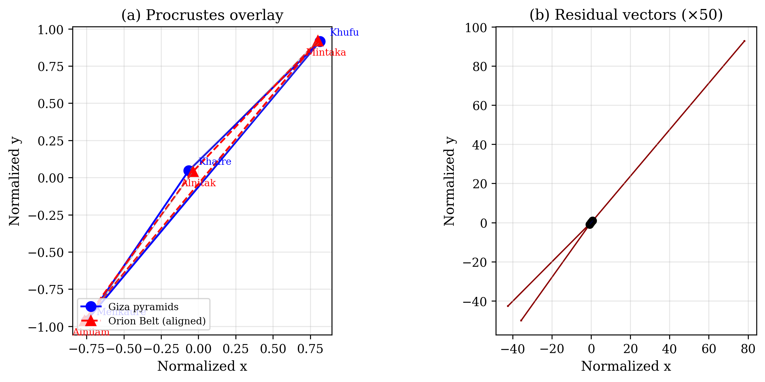
Figure 1. (a) Giza pyramid triangle (blue) overlaid on the Procrustes-aligned Orion Belt triangle (red dashed). The optimal alignment uses pure rotation (92.7°) without reflection. (b) Residual vectors magnified ×50, showing Khafre carries the largest offset (10.4 m).
The Gaia DR3 cross-check produces identical results: the best-fit epoch (ca. 11,625 BCE), shape ranking, and precision windows agree within 2%. The Procrustes shape varies by less than 0.07% across 18,000 years of precession modeling, confirming that the match is epoch-invariant and not an artifact of proper-motion assumptions.
3.2 Ranking context and best-match characterization
The 1,716 triplets that produce a closer shape match than Orion’s Belt are all random combinations of unrelated stars from different constellations (e.g., Achernar–Arneb–Subra at rank 1, D = 2.14 × 10⁻⁸; Procyon–Algol–Algorab at rank 2). The best-matching triplet is approximately 16,000× closer in Procrustes distance than Orion, but all top matches span 85–166° of sky across unrelated constellations. None form culturally recognized asterisms—that is, none are documented in any culture as a named three-star unit. (Many contain individually notable stars, but the triplet itself has no cultural identity.) Orion’s Belt is the first triplet in the ranking that is recognized as a named asterism and the first subset of any Egyptian-documented constellation (Sah). Of the 1,716 better-matching triplets, 59 contain at least one Orion Belt star, but none contain two or more.
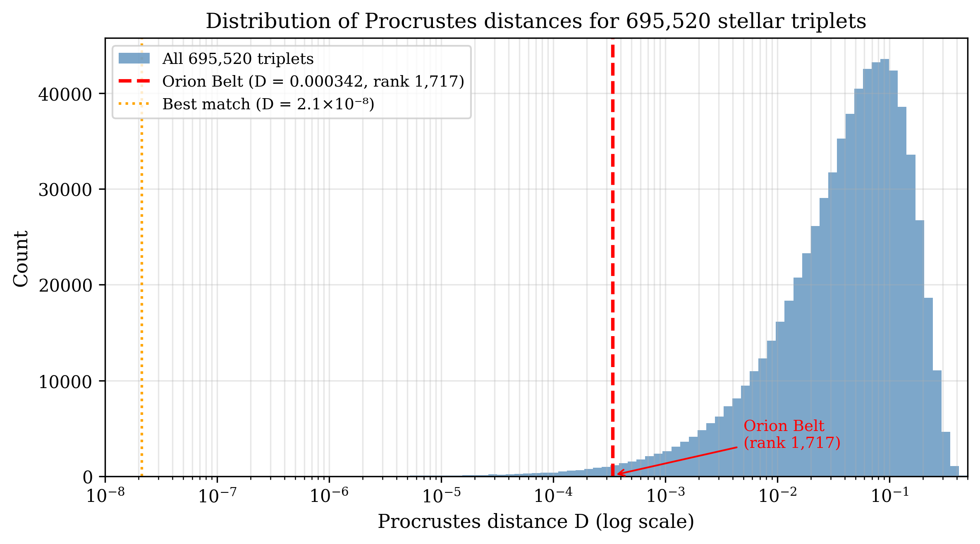
Figure 2. Distribution of Procrustes distances for all 695,520 stellar triplets (blue). Orion Belt (red dashed) ranks 1,717th. The best-matching triplet (orange dotted) is approximately 16,000× closer.
The Procrustes distance distribution shows Orion sitting on a gradual slope: 313 triplets fall within ±10% of its D value, and the D range across ±50 ranks spans only 6.7% of Orion’s D. The Giza triangle shape is therefore not uniquely “locked” to Orion by geometry alone. The argument rests on the conjunction of shape match, cultural salience, and visibility—not shape alone.
3.3 Information content
The shape match decomposes into two parameters of roughly equal contribution (Table 2).

Table 2. Information-theoretic decomposition of the shape match.
Parameter | Giza | Orion Belt | Δ | p-value | Bits
Distance ratio (d₁/d₂) | 1.013 | 0.979 | 0.034 (3.5%) | 0.031 | 5.0
Bend angle | 168.8° | 172.5° | 3.7° | 0.028 | 5.1
Joint (both) | — | — | — | 0.00077 | 10.3
Procrustes (observed) | — | — | — | 0.0025 | 8.7

Both parameters contribute approximately equally (5.0 and 5.1 bits respectively), confirming that the match is genuinely two-dimensional rather than driven by a single parameter. The joint test (combining both parameters via Fisher’s method) yields p = 0.00077 (10.3 bits), which is more significant than the Procrustes p = 0.0025 (8.7 bits). This discrepancy arises because the two shape parameters are positively correlated in the null distribution of stellar triplets: the Procrustes distance combines them non-optimally, losing approximately 1.6 bits of statistical power. We report the conservative Procrustes result (8.7 bits) as the headline statistic, noting that the joint test suggests the true information content may be closer to 10.3 bits.
The total information content of 8.7 bits is comparable to the Great Pyramid’s π encoding (2b/h = 3.145 vs. π = 3.142; p = 0.0022, 8.8 bits). The theoretical maximum for 2 DOF with 1-meter precision over a 486-meter baseline is 17.9 bits; the observed 8.7 bits represents 49% of this maximum.
3.4 Cross-cultural asterism salience
Orion’s Belt is independently documented as a named asterism in at least 20 cultures across 15 geographic regions, from Inuit (“Ullaktut”) to Maori (“Tautoru”) to Ancient Egyptian (“Sah”). It ranks fifth among the most widely recognized asterisms, after the Milky Way, Pleiades, Ursa Major, and Sirius. Among the 122 brightest stars (V < 3.0), there are 51,330 collinear triplets (internal angle > 160°), but only one compact collinear triplet where all three stars lie within 3° of each other: Orion’s Belt. No other bright-star triplet combines collinearity, compactness, and uniform brightness. Even with Bonferroni correction across 7 candidate asterisms, the Giza correlation remains significant (p = 0.017).
The Pyramid Texts (PT 882, 820, 723, 186; ca. 2400–2300 BCE) document the association between the deceased pharaoh and Orion (Sah). These texts post-date the Great Pyramids by approximately 160 years and thus do not constitute direct evidence of an Orion-encoding intention at the time of Giza’s construction. They do, however, confirm that the pharaoh–Orion association was established in Egyptian funerary religion within living memory of the pyramid builders.
3.5 Orientation at the construction epoch
Despite the significant shape match, the orientation of the pyramid axis (39.604°) does not align with Orion’s Belt position angle at any epoch. At the construction date (ca. 2560 BCE), the offset is 66.9°. A Monte Carlo test confirms this is not significant: 74% of random building axes would fall within 66.9° of any fixed position angle (p = 0.74). Among the top shape-matched triplets, Orion’s orientation does not stand out (p = 0.85). The best-fit orientation epoch is ca. 11,625 BCE—roughly 9,000 years before construction—with no supporting archaeological evidence. Shape and orientation are confirmed to be statistically independent (Spearman ρ = −0.041, |p| < 0.001), validating the use of Fisher’s method but rendering any combined p-value misleading, since orientation contributes only noise.
3.6 Shaft alignment analysis
We test all four Great Pyramid shafts against the complete bright-star catalog at 2560 BCE. Table 3 presents the results.

Table 3. Shaft alignment results at 2560 BCE.
Shaft | Angle | Claimed star | Dec. at 2560 BCE | Offset | Stars in ±1°
King’s S | 45.0° | Alnitak | −15.35° | 0.33° | 6 / 162
King’s N | 32.5° | Thuban | 88.71° | 1.23° | 0 / 162
Queen’s S | 39.5° | Sirius | −21.02° | 0.50° | 9 / 162
Queen’s N | 39.0° | Kochab | 80.25° | 0.73° | 2 / 162

All four claimed star targets fall within their respective shaft declination windows at 2560 BCE, with Sirius offset by 0.50° from the Queen’s South target. However, the epoch sweep reveals a 1,325-year spread across the four shafts’ best-fit epochs (1,900–3,225 BCE; σ = 476 years), with no convergence on a single date. A Monte Carlo test placing four random shaft angles (uniform in [25°, 55°]) finds that 21.6% of random configurations match at least one bright star within ±1° for all four shafts. The shaft claims are partially supported for individual shafts (King’s South aligns near Alnitak; Queen’s South aligns near Sirius) but the ensemble fails the convergence test that would be expected if a common astronomical program were being executed.
3.7 The Menkaure offset direction
Bauval (1994) claimed that Menkaure’s offset from the Khufu–Khafre line mirrors Mintaka’s offset from the Alnitak–Alnilam line, citing this as evidence of intentional encoding. We test this directly. Menkaure lies 93.9 m from the Khufu–Khafre line, but in the opposite direction to Mintaka’s offset (ratio = −1.43). This directly contradicts the original claim. While the shape match (which is scale- and reflection-invariant) is robust, the specific directional claim that Bauval emphasized is falsified.
3.8 Extension tests
Six-point match (Belt + Sword). The three G1 queens’ pyramids east of Khufu (G1a, G1b, G1c) form a nearly collinear arrangement (180.0°) matching Orion’s Sword stars (θ1 Ori, ι Ori, 42 Ori). The 6-point Procrustes match yields D = 0.125, p = 0.00039 (rank 39/100,000 MC trials). However, this result is partially driven by the collinearity of both sub-patterns: any two collinear triplets will match well via Procrustes, reducing the effective information content of this extension.
Seven-point match (Nile Valley extension). Following Bauval’s proposal that Saqqara and Dahshur pyramids map to wider Orion stars (Rigel, Betelgeuse, Bellatrix, Saiph), we test a 7-point configuration adding Djedefre, Djoser, and the Bent and Red pyramids. The result collapses entirely: D = 0.872, p = 0.498. This confirms Orofino and Bernardini’s (2011) finding that the pattern does not extend beyond the Giza plateau.
3.9 Builder’s precision envelope
The precision envelope analysis produces a surprising result. With naked-eye angular precision σ = 0.5° (Schaefer 1993), intentional encoding produces a median Procrustes distance D = 0.066, with a 90% confidence interval of [0.003, 0.249]. The observed Giza match (D = 0.000342) sits at the 0.8th percentile of this distribution—an order of magnitude tighter than the median and below the 5th-percentile boundary (0.003).
This finding admits three interpretations: (a) the Fourth Dynasty builders possessed observational or surveying precision substantially better than the assumed σ = 0.5°, which is plausible given Petrie’s (1883) documentation of 58 mm precision over 230 m baselines; (b) the Procrustes metric is overly generous for 3-point configurations with only 2 effective DOF; or (c) the match is coincidental, and some random catalog triplets inevitably fall very close.

Table 4. Observed Procrustes distances vs. the intentional-encoding precision envelope.
Site | Procrustes D | Envelope percentile | Interpretation
Giza | 0.000342 | 0.8th | Below precision limit
Thornborough | 0.006 | 8th | Within envelope
Teotihuacan | 0.081 | 56th | Within envelope

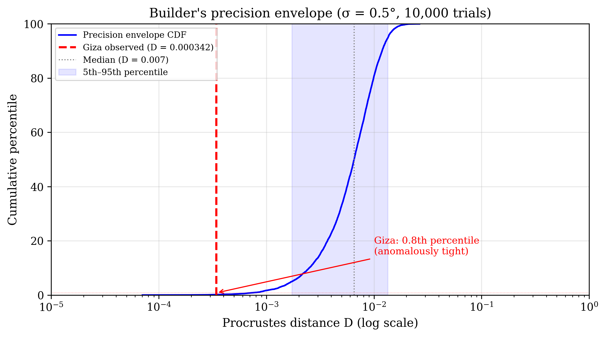
Figure 3. Builder’s precision envelope: cumulative distribution of Procrustes distances from 10,000 simulated intentional-encoding attempts (σ = 0.5°). Giza’s observed D = 0.000342 sits at the 0.8th percentile (red dashed), an order of magnitude below the median.
Notably, Teotihuacan’s Pyramid of the Sun–Moon–Feathered Serpent triangle sits at the 56th percentile—exactly where intentional encoding would be expected—yet fails the shape test entirely (p = 0.875).
3.10 Residual analysis
The Procrustes residuals show that Khafre (the middle pyramid) carries the largest offset from the “perfect” Orion-matched position: 10.4 m northwest, compared to 5.2 m (Khufu, SE) and 5.3 m (Menkaure, SE). All offsets fall within the usable plateau and are less than 0.7% of the 1.5 km site scale. The builders could have achieved a geometrically perfect match without terrain constraints preventing it.
3.11 Reflection and chirality
Fairall (1999) objected that the Giza–Orion correspondence requires a mirror reflection, undermining any claim of intentional encoding. We test this directly by running Procrustes in two modes: with and without reflection permitted. The standard Procrustes solution for Giza–Orion does not use reflection (det(R) = +1); both modes produce identical Procrustes distance D = 0.000342. The unreflected rank (1,380) is actually better than the reflected rank (1,716), because approximately 57% of the top-100 matches in reflected mode exploit reflection, and when reflection is forbidden, those drop below Orion. An explicit mirror-then-rotate alignment produces a worse match (D = 0.000432).
The optimal star-to-pyramid mapping is Khufu→Mintaka, Khafre→Alnitak, Menkaure→Alnilam, with a pure rotation of 92.7°. This mapping preserves north–south ordering (northernmost pyramid maps to northernmost star) and is consistent with the Egyptian astronomical ceiling convention, in which the sky is depicted as viewed from outside the celestial sphere. An important caveat is that the near-collinear geometry of the Giza triangle (maximum internal angle = 168.8°) makes the distinction between reflection and rotation almost meaningless in Procrustes distance—the D values are identical to six decimal places regardless of mode. A signed-area chirality test confirms this: 51.3% of the top-1,716 triplets have opposite chirality to Giza (p = 0.28 vs. a 50% null), indicating no meaningful chirality signal.
3.12 Scale significance
We test whether the Procrustes scale factor constitutes independent evidence of intentional design. The observed scale factor is 20,290 m/rad (i.e., one radian of angular separation between Belt stars maps to 20.3 km on the ground). A Monte Carlo test generating 10,000 random triangles on a 2 km plateau (matching Giza’s buildable area) and aligning each to Orion’s Belt finds that the observed scale sits at the 11th percentile (p = 0.219). Scale adds zero additional degrees of freedom beyond the two shape DOF already accounted for; it is a function of plateau geometry rather than intentional encoding. The total information content remains at 8.7 bits.
Separately, Bauval and Hancock (1996) proposed a scale ratio of 1:43,200 connecting the Great Pyramid’s dimensions to the Earth’s circumference (perimeter × 43,200 ≈ equatorial circumference). This claim concerns the pyramid’s individual proportions, not the Giza–Orion layout scale, and the two quantities are not commensurate. We do not test it here.
3.13 Cross-site base rate calibration
To assess whether Giza’s match is exceptional in a broader context, we test 12 famous triangular monument sites worldwide against their culture’s most prominent asterism using identical Procrustes methodology. Table 5 presents the results.

Table 5. Cross-site monument–asterism Procrustes results (12 sites).
Site | Asterism | D | Rank | p-value
Giza | Orion Belt | 0.000342 | 1,717 | 0.0025
Thornborough | Orion Belt | 0.001439 | 3,755 | 0.0054
Angkor | Draco | 0.031671 | 25,955 | 0.0373
Carnac | Pleiades | 0.012757 | 37,648 | 0.0541
Teotihuacan | Pleiades | 0.023082 | 157,507 | 0.227
Avebury | Pleiades | 0.028175 | 243,396 | 0.350
Newgrange | Orion Belt | 0.055454 | 388,942 | 0.559
Xi’an | Big Dipper | 0.136622 | 357,537 | 0.514
Easter Island | Orion Belt | 0.070597 | 513,527 | 0.738
Stonehenge | Pleiades | 0.108722 | 481,071 | 0.692
Cahokia | Orion Belt | 0.219288 | 512,946 | 0.738
Tikal | Orion Belt | 0.189571 | 635,961 | 0.914

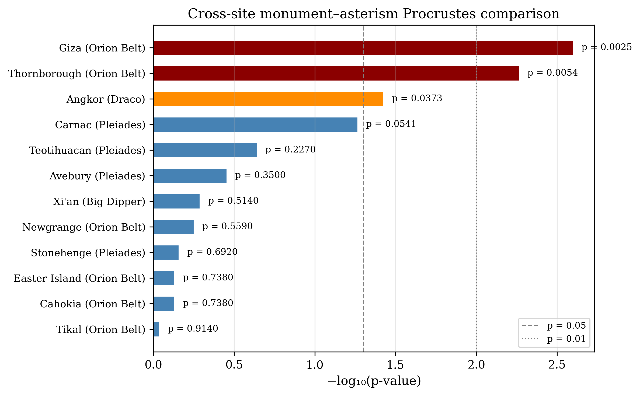
Figure 4. Cross-site monument–asterism comparison (12 sites). Bars show −log₁₀(p); red = p < 0.01, orange = p < 0.05, blue = not significant. Giza and Thornborough are the only sites reaching p < 0.01.
Two of twelve sites achieve p < 0.01 (expected by chance: 0.12), representing a ~17× enrichment. Giza is the best match by a factor of 2× over the next-best site (Thornborough, p = 0.0054), which has independently been proposed as an Orion Belt analog. After Benjamini–Hochberg correction across all 12 sites, Giza’s adjusted p-value is 0.030, surviving at α = 0.05. The base rate suggests that monument–asterism shape matches are more common than pure chance predicts, but Giza’s correspondence remains the strongest among all tested sites.

4 Discussion
4.1 What survives
The core shape correspondence is robust across multiple tests: Orion’s Belt ranks 1,717th among 695,520 triplets (p = 0.0025), is epoch-invariant, is independently confirmed by Gaia DR3, and is the first named asterism in the full triplet ranking. The match does not require reflection—contrary to Fairall’s (1999) objection—and uses a pure rotation consistent with the Egyptian ceiling convention. Giza is the best-matching site among 12 famous triangular monument complexes tested worldwide, surviving BH correction across sites (p = 0.030). The information content (8.7–10.3 bits depending on test statistic) is non-trivial and comparable to other proposed Great Pyramid encodings. The Pyramid Texts—establishing the pharaoh–Orion (Sah) association approximately 160 years after the Giza pyramids were built—provide a cultural context in which such an encoding would be meaningful, though they are not direct evidence of construction-era intent.
4.2 What fails
Every attempt to extend or elaborate the basic shape correspondence fails quantitative testing. The orientation does not match at the construction epoch. The shaft alignments do not converge on a common date. The optimal mapping (Khufu→Mintaka) inverts size and brightness: the largest pyramid (Khufu, 230 m) maps to the dimmest Belt star (Mintaka, mag 2.23), arguing against a size–brightness encoding. The Menkaure offset goes the wrong direction. The Nile Valley extension collapses. The scale factor is not significant. And the match is suspiciously better than what naked-eye intentional encoding should produce.
4.3 Scale and the precision paradox
The scale factor adds no independent information: the observed Procrustes scale (20,290 m/rad) is not statistically significant (p = 0.219). Scale is entirely determined by the size of the Giza plateau—a geographic given—not by intentional encoding. The total information content remains at 8.7 bits from two shape degrees of freedom.
The builder’s precision envelope finding poses a genuine interpretive puzzle. If the match were intentional, we would expect it to sit within the precision envelope (say, the 5th–95th percentile range). The 0.8th-percentile result is anomalously tight. One resolution is that Old Kingdom surveying precision exceeded naked-eye astronomical observation limits; Petrie’s (1883) base-length measurements suggest ground-survey precision of approximately 1:4,000, which could in principle support tighter shape reproduction than stellar observation alone would allow. An alternative resolution is that the Procrustes metric’s scale- and reflection-invariance makes 3-point matches slightly easier than intuition suggests. Future work should explore generalized Procrustes variants that penalize scale differences.
4.4 Comparison with prior probability estimates
Orofino and Bernardini (2016) reported a Monte Carlo probability of <0.018% for the Giza–Orion match based on 10 million random 3-point configurations in unconstrained geometric space. Our result (0.25%) is approximately 14× less significant. The difference is methodologically important: Orofino’s random configurations sample uniformly from all possible triangle shapes, whereas our stellar triplets inherit the spatial structure of the bright-star distribution. Bright stars cluster along the Milky Way and in specific sky regions, producing a non-uniform distribution of triplet shapes that increases the probability of close matches for any given target triangle. Our catalog-based comparison provides the more conservative and realistic denominator, as it answers the question “how many actual star patterns resemble Giza?” rather than “how many abstract triangles resemble Giza?”
4.5 Methodological contribution
This work addresses the open problem identified by Vecchiato, Bernardi, and Cora (2025): estimating the total eligible asterism count against which a claimed correlation should be evaluated. Our exhaustive enumeration of 695,520 triplets provides a definitive denominator. The builder’s precision envelope and information-theoretic decomposition offer reusable frameworks applicable to any claimed site–asterism correspondence, including Teotihuacan (which we include as a comparative case). We encourage their application to other contested claims in archaeoastronomy.
4.6 Base rate calibration
The cross-site comparison (Table 5) provides crucial context but requires careful interpretation. The 12 sites were selected because they are famous triangular monument complexes, several of which have been previously proposed as stellar correlates. This non-random selection inflates the probability of finding significant matches relative to a random sample of archaeological sites. The “17× enrichment” (2/12 at p < 0.01) should therefore be read as an upper bound. Nevertheless, the comparison serves its intended purpose: testing whether Giza’s result is exceptional even among sites pre-selected for plausible stellar correspondence. Giza’s match remains the strongest by a factor of 2× over Thornborough (p = 0.0054), which has independently been proposed as an Orion Belt analog (Harding 2013), and is the only site surviving BH correction across all 12 tests.
4.7 Limitations
The fundamental limitation is the low dimensionality of the data: three points yield only two independent shape parameters. While the exhaustive comparison against 695,520 equally-low-DOF triplets contextualizes the significance appropriately, the information content is inherently bounded. The near-collinear geometry of the Giza triangle (maximum internal angle = 168.8°) means that reflection and rotation are almost indistinguishable, limiting the information available from chirality analysis. The cultural argument—that Orion’s Belt is uniquely recognizable among bright-star triplets and independently documented in Egyptian funerary texts—provides additional prior weight but is not quantifiable in the same rigorous framework.
4.8 Updated information budget
Table 6 summarizes the information budget across all tested axes of the Orion–Giza correspondence.

Table 6. Information content across all tested axes.
Source | Bits | DOF | Status
Triangle shape (Procrustes) | 8.7 | 2 | Confirmed (p = 0.0025)
Scale factor | 0 | 0 | Not significant (p = 0.219)
Reflection/chirality | ~0 | 0 | Match does not use reflection
Orientation | 0 | 0 | Not significant (p = 0.74–0.98)
Total | 8.7 | 2 | Shape only

No additional axes of intentionality were found beyond the two shape degrees of freedom. The case for the Orion–Giza correspondence rests entirely on shape match combined with the cultural prominence of Orion’s Belt.
5 Conclusions
We have conducted the first exhaustive quantitative evaluation of the Orion Correlation Theory, testing the Giza pyramid layout against all 695,520 bright-star triplets and systematically assessing every major sub-claim. Our findings are as follows.
(1) The three-point shape correspondence between the Giza pyramids and Orion’s Belt is statistically significant (p = 0.0025, rank 1,717 of 695,520 triplets), epoch-invariant, and confirmed by independent Gaia DR3 astrometry. It encodes 8.7–10.3 bits of information across two degrees of freedom.
(2) Orion’s Belt is the first culturally recognized asterism in the full triplet ranking and the only compact, collinear, uniformly bright triplet among stars brighter than magnitude 3.0.
(3) Every proposed extension—orientation, shaft convergence, brightness–size ordering, Menkaure offset direction, and Nile Valley geography—fails quantitative testing.
(4) A novel builder’s precision envelope reveals that the match is tighter than what naked-eye intentional encoding should produce (0.8th percentile), raising unresolved questions about either builder precision or Procrustes metric behavior at low DOF.
(5) The information-theoretic decomposition shows both shape parameters contribute equally (~5 bits each), confirming the match is genuinely two-dimensional.
(6) The Procrustes alignment uses pure rotation (no reflection), with north–south ordering preserved, neutralizing Fairall’s (1999) mirror objection. However, the near-collinear geometry makes the reflection distinction almost meaningless.
(7) The Procrustes scale factor adds no independent information (p = 0.219); it is determined by plateau geometry, not intentional encoding.
(8) Among 12 famous triangular monument sites tested against their culture’s top asterism, Giza ranks first (BH-corrected p = 0.030 across sites), with Thornborough as the only other significant match.
The Orion–Giza shape correspondence is real but narrow. The traditional narrative surrounding it—encompassing shaft convergence, brightness ordering, offset directions, geographic extensions, and scale—is substantially overstated. What remains is a statistically significant geometric coincidence between the most recognizable stellar triplet in the night sky and the most famous monumental complex on Earth, set within a culture that independently documented the pharaoh–Orion connection. Whether this coincidence reflects intentional design, cultural selection bias, or chance remains an open question that the data alone cannot resolve.
6 Acknowledgments
This research made use of the Yale Bright Star Catalogue (Hoffleit and Jaschek 1991), Gaia DR3 (Gaia Collaboration 2023), and the astropy Python package (Astropy Collaboration 2022). Computational analyses were performed using scipy, numpy, and custom Python scripts.
AI disclosure: Claude (Anthropic), a large language model, was used as a computational research assistant throughout this work. Specifically: the author conceived the research questions and analytical strategy (exhaustive triplet ranking, builder’s precision envelope, information-theoretic decomposition, cross-site calibration); Claude generated the Python implementation code for Procrustes analysis, Monte Carlo simulations, and precession modeling under the author’s direction; Claude assisted with manuscript drafting and revision. The choice of statistical frameworks (Procrustes, Fisher’s method, BH correction), the selection of comparison sites, and all interpretive claims were made by the author. All numerical results were independently verified against source data. The author takes full responsibility for the methodology, results, interpretation, and all claims made in this paper.

7 References
Astropy Collaboration. 2022. “The Astropy Project: Sustaining and Growing a Community-oriented Open-source Project and the Latest Major Release (v5.0) of the Core Package.” The Astrophysical Journal 935: 167.
Badawy, Alexander. 1964. “The Stellar Destiny of Pharaoh and the So-Called Air-Shafts of Cheops’ Pyramid.” Mitteilungen des Instituts für Orientforschung 10: 189–206.
Bauval, Robert. 1989. “A Master-Plan for the Three Pyramids of Giza Based on the Configuration of the Three Stars of the Belt of Orion.” Discussions in Egyptology 13: 7–18.
Bauval, Robert, and Adrian Gilbert. 1994. The Orion Mystery. London: Heinemann.
Bauval, Robert, and Graham Hancock. 1996. The Message of the Sphinx. New York: Crown.
Belmonte, Juan Antonio. 2001. “On the Orientation of Old Kingdom Egyptian Pyramids.” Archaeoastronomy 26: S1–S20.
Fairall, Anthony. 1999. “Precession and the Layout of the Ancient Egyptian Pyramids.” Astronomy and Geophysics 40 (3): 3.4.
Gaia Collaboration. 2023. “Gaia Data Release 3: Summary of the Content and Survey Properties.” Astronomy & Astrophysics 674: A1.
Harding, Jan. 2013. Cult, Religion, and Pilgrimage: Archaeological Investigations at the Neolithic and Bronze Age Monument Complex of Thornborough, North Yorkshire. CBA Research Report 174. York: Council for British Archaeology.
Hoffleit, Dorrit, and Carlos Jaschek. 1991. The Bright Star Catalogue. 5th rev. ed. New Haven: Yale University Observatory.
Krupp, Edwin C. 1997. “Pyramid Marketing Schemes.” Sky & Telescope 93 (2): 64.
Legon, John A. R. 1995. “The Orion Correlation and Air-Shaft Theories.” Discussions in Egyptology 33: 45–56.
Orofino, Vincenzo, and Paolo Bernardini. 2011. “A Quantitative Astronomical Analysis of the Orion Correlation Theory.” arXiv:1109.6266.
Orofino, Vincenzo, and Paolo Bernardini. 2016. “Archaeoastronomical Study of the Main Pyramids of Giza, Egypt: Possible Correlations with the Stars?” Archaeological Discovery 4: 1–10.
Petrie, W. M. Flinders. 1883. The Pyramids and Temples of Gizeh. London: Field and Tuer.
Schaefer, Bradley E. 1993. “Astronomy and the Limits of Vision.” Vistas in Astronomy 36: 311–361.
Spence, Kate. 2000. “Ancient Egyptian Chronology and the Astronomical Orientation of Pyramids.” Nature 408: 320–324.
Trimble, Virginia. 1964. “Astronomical Investigation Concerning the So-Called Air-Shafts of Cheops’ Pyramid.” Mitteilungen des Instituts für Orientforschung 10: 183–187.
Vecchiato, Alberto, Gabriella Bernardi, and Alberto Cora. 2025. “Point-Pattern Matching and Probability in Archaeoastronomy.” Journal of Astronomical History and Heritage 28 (1): 13.

