Sorted.ai proof of concept
What a development house must build
14 November 2026. This brief is the build. It sets no price and no service level.

1. Purpose and POC outcome
Build a proof of concept for Sorted.ai that takes incoming customer-service work and scores it. Deliver intake for voice recordings and for transcripts, transcription of the recordings, scores for NPS, CSAT, and vulnerable customers, a detractor drill-in, and a live site that shows the scores.
A transaction is one voice recording or one transcript, from the drop through a stored score. The build is enterprise grade and sized for more than 10,000 transactions a day. Voice and transcripts count together.
Done means a demonstration can show all of the following.
- A recording is dropped, transcribed, and scored. On a two-track file the agent and the caller remain separate speakers. The transcript is then scored the same way as a dropped transcript.
- A transcript dropped as JSON or plain text is scored, with no transcription step.
- The live site shows predicted NPS, CSAT, and Vulnerable Customers.
- A top detractor opens through to that call.
- Vulnerable Customers is its own page. Each row is the person, the reason they were listed, and a suggested next step.
- A failed transaction is retried or set aside with an audit record, and later transactions still complete.
- Ingest, transcription, scoring, storage, and the site are the same path that carries more than 10,000 transactions a day.
Transcription uses the customer's existing Deepgram license. The customer will supply the key. Keep it in a secret store. Leave it out of source and out of the site.

2. Users and the live site
People use the system in two ways.
Submitting work. A person or an upstream system puts a recording or a transcript into intake. The live site has no public upload form.
Reading scores. Authorised people open the live site. The browser does not score files. It shows stored scores. The site is limited to those users.
Page | What it is for
Overview | Company NPS from −100 to +100, average CSAT from 1 to 5, the top detractor reasons, and one evidence quote. Choosing a top detractor opens that call.
Call | The file, the reason, the quote, the NPS band, and CSAT. This is the detractor drill-in.
Vulnerable Customers | Its own page, not a tab on the call list. The person, why they were listed, and a suggested next step. NPS and CSAT stay on the page.

The overview lists detractor reasons, highest count first. Choosing a reason lists the detractor calls for that reason. Choosing one call opens it. The evidence quote opens the call it was taken from.
The site shows new scores without asking the reader to rebuild the page. State the refresh in the quote. A refresh interval is not a service level.

3. Capacity and enterprise properties
Size ingest, transcription, scoring, storage, and the site for more than 10,000 transactions a day. That is the floor the design is built for. The queue absorbs a busy hour so a burst does not drop work. The house chooses the enterprise services and may swap any of them for an equivalent. This brief names no cloud.
Property | What is required
Durable queue | Intake stores the file durably and enqueues the transaction. The queue message is finished only after that step has stored its result. Stopping a worker does not lose the transaction.
Retries | A failed transcription or score is retried. A repeated failure is written to the audit and set aside. Later transactions continue. The house states the retry limit in the quote.
Audit | Each transaction keeps an identifier, the source file, the transcript, the time it was received, each attempt, any error, and the score when scoring succeeds. A score on the site traces back to that source.
Access control | Intake, the queue, stored calls, and scores are limited to authorised services and operators. The live site is limited to authorised users. The Deepgram key is a secret.
Monitoring | Operators can see transactions received, queue depth, transcription failures, scoring failures, and the age of the oldest queued item. The house states alert thresholds in the quote.

These five properties apply to ingest, transcription, scoring, storage, and the site. This brief sets no price and no service level. If the house offers either, it belongs in the quote, against the capacity above.

4. Ingest: voice and transcripts
Provide two intakes into one durable queue. Both are sized for the daily volume in section 3. A finished transaction is not processed again. Submitting the same work again is a new transaction and is scored again.

Transcripts
A transcript is text. Accept JSON and plain text. JSON may be a lines array of objects with text and a speaker, or a text or transcript string. Plain text may use lines that start with agent:, caller:, customer:, or advisor:.
An optional company is the person's name on Vulnerable Customers. When company is absent, the person is the file name without its extension. An optional survey number in the file is stored beside the estimate. It is not predicted NPS, and the site does not show it as NPS.
The text passed to scoring is non-empty. The house states the maximum text size in the quote. This is the shape a dropped transcript uses, and the shape transcription must produce:
{
"company": "Example Clinic",
"lines": [
{ "speaker": "agent", "text": "Thanks for calling. How can I help?" },
{ "speaker": "caller", "text": "I can't afford the payment this month." }
]
}

Voice
A recording is submitted to the voice intake and placed on the same queue. Send it to Deepgram with the customer's license. When the file has two tracks, transcribe the tracks separately and keep the agent and the caller as separate speakers. Label them agent and caller. Do not merge the two tracks into one speaker. If the recordings put the agent on a fixed track, use that order. Ask for the track order before building if it is not known.
A single-track recording is still transcribed and scored. It may have no speaker labels. The transcript uses the shape above, with the speaker labels still on the lines, and then follows the scoring path in section 5. Transcription is queued and retried, and it is sized for more than 10,000 transactions a day, not for one file at a time.
The acceptance recording is a two-channel WAV. Also accept a common compressed recording such as MP3. State any further types and the maximum audio size in the quote.
On success, store the source, the transcript, and the score, and finish the queue message. On failure, retry as in section 3. The audit records the error. The source is kept. A set-aside item can be put back on the queue. Use distinct file names for recordings and transcripts so each transaction has one score.

5. Scoring and the vulnerable rule
Score every transcript once, including a transcript produced from audio. Scoring workers take from the queue and are sized for more than 10,000 transactions a day. The result is strict structured data from an enterprise model service. The house chooses that service and may swap it for an equivalent that returns the same fields. A keyword list is not the scorer.
Return these fields:
- Predicted NPS, a whole number from 0 to 10. An estimate, not a survey score.
- Band: promoter, passive, or detractor.
- CSAT, a whole number from 1 to 5.
- Reason, one short sentence.
- Evidence, one sentence copied from the transcript.
- Summary, one or two sentences on the outcome.
- Vulnerable, true or false.
- Vulnerability reason and next step. Filled when vulnerable is true. Empty when it is false.
Judge the whole call and weigh the ending. A booked, paid close is not a detractor. A caller who books and pays after disliking the price or the wait is a promoter at 9 with CSAT 4. A clearly pleased close can be 10 with CSAT 5. An unresolved complaint, a refusal, a cancellation, or an angry ending is a detractor: predicted NPS 0 to 6 and CSAT 1 or 2. A genuinely undecided caller is passive: predicted NPS 7 or 8 and CSAT 3.
Keep these pairs. A result that breaks a pair is a scoring failure and follows the retry rule.
- Promoter: predicted NPS 9–10, and CSAT 4 or 5.
- Passive: predicted NPS 7–8, and CSAT 3.
- Detractor: predicted NPS 0–6, and CSAT 1 or 2.
Evidence is a verbatim sentence from the transcript, at least four words and at most 280 characters. A fragment such as “Yes.” does not qualify. The sentence has to occur in the transcript.

Company NPS and CSAT
Predicted NPS is an estimate, not a survey score. Promoters are 9–10. Passives are 7–8. Detractors are 0–6.
Company NPS is the percentage of promoters minus the percentage of detractors. Passives stay in the total and are left out of the subtraction.
NPS = round( (promoters − detractors) / total × 100 )
The figure runs from −100 to +100. With no scored transactions it stays empty. One promoter and two passives is a total of 3, so NPS is 33. CSAT on the site is the average of the per-call 1–5 estimates, to one decimal place.

Vulnerable customers
Vulnerable is true only when the caller has trouble paying, is late on a payment, or describes a change in circumstances that means they cannot pay. Saying they cannot afford the service, including “I can't afford that”, is trouble paying.
Ordinary price dislike is a high or unfair price when the caller can still pay. That call is not vulnerable.
When vulnerable is false, the reason and the next step are empty. When it is true, the reason is one short sentence on why they were listed, and the next step is one short suggestion for the team. Both are required. The page omits a person who is missing either one.
When the text shows the caller cannot afford, cannot pay, or is late on payments, store the result as vulnerable and fill both strings, including when the model result omitted them. A change in circumstances that means they cannot pay still needs a reason and a next step.

6. Data the site shows
The site reads stored scores. It does not call the model, and it does not score on the request, so a busy day does not make the page wait on transcription or on the model. Storage keeps the source, the transcript, the score, and the audit at the volume in section 3.
The overview and the drill-in need:
- The count of scored transactions, and the counts of promoters, passives, and detractors.
- Company NPS, from the formula in section 5, and average CSAT.
- Detractor reasons with a count, highest first, and the calls for each reason.
- For each detractor call: file, time, NPS band, CSAT, reason, and the evidence quote.
- One evidence quote on the overview, linked to its call.
Vulnerable Customers needs:
- Person, file, reason, suggested next step, and time.
- The same NPS and CSAT figures as the overview.
The site does not show a channel, and it does not show a survey number as NPS. Store the following for audit even when the page hides some of it: transaction id, source type (voice or transcript), received time, attempt history, and any error.

7. Scope, out of scope, and acceptance checks

What to build
1. Voice intake and transcript intake into one durable queue.
2. Deepgram transcription with the customer's license, separate speakers on a two-track file, then the same scoring path as a transcript.
3. Scoring for predicted NPS, CSAT, and vulnerable customers, with the rules in section 5.
4. Durable storage of the source, the transcript, the score, and the audit.
5. A live site with the overview, the detractor drill-in, and Vulnerable Customers as its own page.
6. Retries, access control, and monitoring on ingest, transcription, scoring, storage, and the site, sized for more than 10,000 transactions a day.
The house may swap the queue, the store, the model service, or the identity service for an equivalent enterprise service. Transcription stays on the customer's Deepgram license.

Out of scope
- A scripted demo or a keyword scorer. Demo is out of scope.
- Email and WhatsApp as separate channels.
- Collecting a survey NPS. Predicted NPS is the estimate.
- A named cloud, a price, or a service level. Those belong in the house's quote if it offers them.
- Secrets in source or in the site, including the Deepgram key.

Acceptance checks
Show the product path with sample files. Show the enterprise properties on that same path. A scripted demo is not the demonstration.
1. Drop a JSON transcript. It is scored and stored, and the overview shows company NPS and average CSAT.
2. Score a pleased close, an unresolved or angry ending, and an undecided caller. Bands follow the number: 9–10 promoter, 7–8 passive, 0–6 detractor. CSAT is 4–5, 3, and 1–2 for those bands. Company NPS matches the formula in section 5. A booked, paid close is not a detractor.
3. Drop a transcript where the caller cannot afford it, cannot pay, is late on payments, or describes a change in circumstances that means they cannot pay. That person appears on Vulnerable Customers with a reason and a suggested next step. Drop a transcript that only objects to the price, where they can still pay. That person is absent.
4. On the overview, open a top detractor through to that call. The call shows the file, the reason, the quote, the NPS band, and CSAT. The evidence quote opens its call.
5. Vulnerable Customers is its own page, not a tab on the call list.
6. Drop a two-channel WAV. The stored transcript has the agent and the caller on separate lines, and the call then appears on the site the same way as a dropped transcript. A single-track file is transcribed and scored as well.
7. A failed transcription or score is retried. A repeated failure is set aside with the file, the error, and the time in the audit, and later transactions still complete. The source is kept.
8. A finished transaction is not scored again. Submitting it again scores it again.
9. Ingest, transcription, scoring, storage, and the site use a durable queue, retries, audit, access control, and monitoring, and the design is sized for more than 10,000 transactions a day.
10. The handover contains no demo walkthrough, no API key, and no Deepgram key.

8. Architecture
Voice and transcripts enter one queue. Voice is transcribed, then scored. A transcript skips transcription and is scored on the same path. The site reads stored scores.
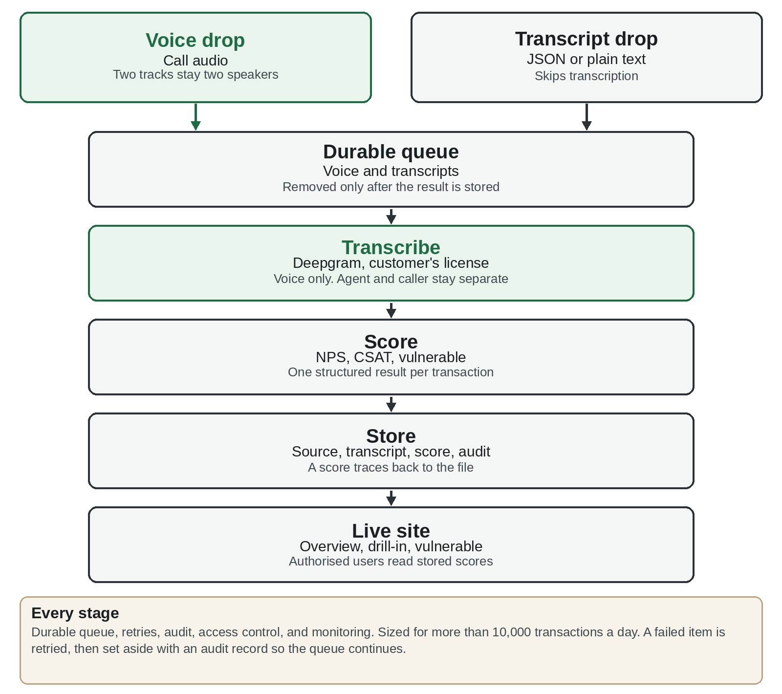
Figure 1. Drop, queue, transcribe, score, store, and the live site. Transcripts join the queue and skip transcription. The footer is the enterprise requirement on every stage: a durable queue, retries, audit, access control, and monitoring, sized for more than 10,000 transactions a day.

