**THE REQUIREMENTS DOCUMENT**

**Project: DPM Robot Design and Competition**

**Task**: An autonomous robot will be designed, tested, and created using a Lego NXT kit. It will need to be programmed, with the LeJos language, to localize its position and navigate on a field with obstacles, and then to launch ballistics (ping-pong balls) at a defined target outside the grid. The robot must be capable of identifying its position and navigating to specific points from other points within a square grid. The obstacle course is to be completed in the shortest time possible, with the robot being involved in a competition with a defined set of rules.

**Details**

* The enclosure will be a 12’ x 12’ square grid, with obstacles. Origin is (0, 0) as labeled in diagram (SEE APPENDIX BELOW). The north edge of this point is y = 11, south edge is y=-1, the East edge is x=11, and the West edge is x=-1.
* There will be 9 tiles total, with the origin in the bottom left tile’s center, and the launching position in the top right. Coordinates range from -1 to 14 for both x and y axes.
* Up to 6 ping-pong balls will be provided to the robot.
* Before the robot is to be set in motion, integer values will be given which will determine what the exact coordinates of the targets to be fired at are.
* Three different maps throughout the competition in terms of the obstacle positions.
* A time limit on particular portions of the task will be given.
* It will shoot 1 or more ping-pong balls at 2 targets located outside the grid – these targets will be specified in advance. A maximum of 3 ping pong balls allowed per target. Shooting is permitted from the green area only.
* The minimum distance between unconnected obstacles will be one square (or 30 cm).
* Robot will start with **random orientation** in lower left of origin tile (yellow zone in diagram in appendix). Localize itself and head towards shooting zone.
* Obstacles will be at identified positions in certain tiles, and at unidentified positions in other tiles

Areas 2, 3, 4 & 7 will contain obstacles with known positions. Areas 5, 6 & 8 will contain obstacles with unknown positions. MINIMUM distance between unconnected obstacles = 30cm/1 square.

* After shooting must return to (0, 0) and face north.

Note that particular subtasks are given in the Gantt chart, e.g. for a week-long event like ‘Documentation and budget updates’ in the notes on the task every member is given something to do. NB we are currently using the version ‘GanttTeam18.gan’ (the other is for practice).

**Document Version Number: 7**

**Date: April 6, 2015**

**Author: Team 18**

Note: changes for this week (week 6) are outlined in magenta. Previous changes have been changed to black so that this version’s changes are more apparent.

**1.0 TABLE OF CONTENTS**

* **2.0 Capabilities**
* **3.0 Compatibility**
* **4.0 Glossary of terms**
* **5.0 Checklist**

**2.0 CAPABILITIES**

**2.1 PURPOSE**

Specification given by client: Construct an autonomous robot capable of identifying its position and navigating to specific points when placed within a 12’ x 12’ enclosure containing several obstacles (Figure 1). The task of the robot will be to localize on its position, travel to a specified area to shoot one or more ping-pong balls at two targets located outside the 12’ x 12’ enclosure. The goal is to perform the task in the shortest time possible. There will be time limits on some phases of the task.

* Creating an autonomous vehicle capable of navigating, localizing its position, and shooting ping-pong balls at specific targets, all within a square grid.
* Other details outlined in Task section
* Information on Competition in Performance

**2.2 SCOPE**

* The grid of operation is 12’ by 12’.
* There will be time limits on certain tasks as mentioned
* The final competition is described above in ‘Task’ and ‘Purpose’
* This is intended to be a final project but may serve as a future model or prototype if successful
* There are a little less than 3 months to complete the project – starting Feb 18 and ending April 8th (Double check)
* Competition information outlined in performance

**2.3 CONSTRAINTS**

* The robot must fit within one grid; it may be as tall as desired
* Robot footprint must be 30cm long by 30 cm wide in order to move through obstacle gaps (what does this mean exactly?)
* There is a time budget of 9 hours/week/ person
* The robot must be built from 3 Lego NXT kits
* The robot must be able to navigate in 3 different maps (labelled 1, 2 & 3 and with different obstacle positions) and must be able to shoot at whatever target coordinates it is provided with.
* How much weight will the Lego base of the robot be able to tolerate without obstructing movement?

**2.4 USER FUNCTIONS**

* The robot is usually turned on/managed by pressing a button on the NXT brick interface.
* It is assumed that the robot is autonomous and cannot be touched after it is set off (during the competition) until it returns to its initial position, or the origin.

**2.5 OPERATING ENVIRONMENT**

* The floor consists of nine 4’x 4’ hardwood-covered metal panels that lock together.
* The surface of each panel is marked with a 4’x4’ grid that aligns precisely with adjacent panels.
* Targets are outside main floor. Located in *"areas: Area A: 7<x<= 11, 11<y<=14, Area B: 11<x<=14, 11<y<=14, Area C: 11<x<=14, 7<y<=1"* (explanation?)
* Shoot over wall from green area.
* The target board is a few centimeters below the navigating board.
* Target locations can vary. They will be located in the following areas: Area A: 6<x<= 12, 12<y<=15, Area B: 12<x<=15, 12<y<=15, Area C: 12<x<=15, 6<y<=12.

**Issues:**

* NOT guaranteed that floor will be level between panels. Might have edge of 2mm between panels. (Care needed?)
* How will the lighting be in the competition environment?
* Where exactly will the final competition be held? 2nd floor in Trottier.
* Important: Is there a similar environment available for testing the robot throughout the semester?
* Around how many blocks?(see map)
* Blocks are sand-filled cardboard boxes.

**2.6 PERFORMANCE**

-Robot will have to travel, at the very least, 17(2) =34 (using basic trig across diagonal, traversed twice with return)

-Robot has to '*proceed as quickly as possible to the shooting zone*'? So longer but safer routes not allowed? No, they are allowed but there are certain time limits.

-Robot has to localize in LESS than 1minute!

-Must keep centre of rotation within 1 tile.

-Different battery levels may work differently?

-Can we purchase rechargeable batteries?

**Competition:**

Competition proceeds in 3 rounds, each robot getting a turn in each round for a total of 3 runs. Passing would require successful capabilities of localization navigation, obstacle avoidance, reaching the shooting zone, firing a single ping-pong ball at one target, returning to (0,0)) at least once during the 3 runs.

-A series of coordinates for the targets will be given right before the final demo, and these will have to be put into the robot within 1 minute.

- The time limit for a run on the course will be 7 minutes. (A total of 8 minutes counting the time for loading data).

-double check date/scoring

-Winner is robot with most points.

*"3 teams with the most points will be awarded prizes and bragging rights."*

**SCORING**:

Points for:

* time to complete lap
* number of balls that hit target
* each capability demonstrated

**3.0 COMPATIBILITY**

**3.1 COMPONENT RE-USE**

* Have some code to use from labs; it is likely that we will integrate such code into the project, while also adding new classes.

**3.2 COMPATIBILITY WITH THIRD PARTY PRODUCTS**

-Bluetooth is possible

- Assume balls are from NXT kit? Or are they from elsewhere? Regulation Ping-Pong balls will be used (Eastpoint).

-Will need to know external components like Ping-Pong so that they fit on launcher.

**4.0 GLOSSARY OF TERMS**

None for the moment.

*These points regarding the robot design came up during initial group meetings and needed to be addressed:*

* 4 wheeled robot is difficult to operate with turns. NO 4 wheels. ✓
* Best would be to use similar design to what we currently have, with 2 front wheels, and possibly 2 back trailer wheels. Need to watch number of total gears. ✓
* Can we get more gears? Maybe with 3d printing. (NEED INSTRUCTORS PERMISSION!). ✗
* Hardware has more limitations than software. ✗
* Rules on 3d printing. ✗
* What exactly is the evaluation on? Asked Prof last week. Mostly on organization.
* maximum 2 processors, additional will add bulk. ✓
* We don’t want the robot to be too large – positioning of launcher is likely to be center back, not sticking out too much. ✓
* 1 launcher design so far: will upload pictures – from matt/Josh. ✓
* Bobak/clara have simple catapult using string/elastics. ✗
* 3rd can be classic catapult based on image in dropbox. ✗
* 1 NXT for shooting (and angling). ✓
* 1 NXT for navigation/aiming. ✓
* Are targets same distance? ✓
* we already have a robot that works 2 wheels, small size. ✓
* For the launcher, may use 2 wheels to ‘spit’ the balls out, angle the trajectory with a ramp; will want to test how accurate this is. Alternative is catapult. Also want to be able to control projection speed. ✗
* Spin of balls to take into account. ✓
* recoil must be considered later on. ✓
* May also use a spring – elastics are permitted. ✗
* More than one ultrasonic sensor, extra light sensor. ✓
* This can already fill up all of the ports; limited number of ports. ✓
* sensors may interfere with each other, need to consider. ✓
* May want synchronizing between different NXTs. ✗
* NXT brick weighs approx. 148 grams; without batteries, which may also vary in weight
* Consider tread wheels instead of regular wheels. ✗
* Chassis: make approximately same size as robot in labs. Wheel base, nxt placement is important. ✓
* Final position is measured from origin or grid lines? ✓
* Will there for sure be a known path that does not encounter obstacles at all? ✓
* Will the grid be bound by a wall entirely or just on portions of the grid? Can use a wall follower. ✓
* Need localization at beginning in 1 and in 9.

**5.0 CHECKLIST:**

**5.1 General Checklist:**

* Choose launcher ✓

Flicker chosen ✓

* Develop reloading mechanism ✓  

Model 1: address issues ✓

Model 2: address issues ✓

Combination: address issues ✓

* Simultaneously test various components of the robot

Test Launcher ✓

Test Odometer ✓

Test Ultrasonic Sensor ✓

Test Navigation ?

Run Integration Tests ?

* Test and implement software on the robot

Test localization ✓

Test Navigation ?

Test Obstacle avoidance ?

Test launching ✓

* Develop Poster ✓

**5.2 Checklist before Competition:**

* Batteries (AA)
* Connection of cables
* Duct tape/scissors
* Battery tester
* Regulation
* Ping pong balls
* Poster
* Importing the 3 maps into the NXT

# Appendix

***Field***

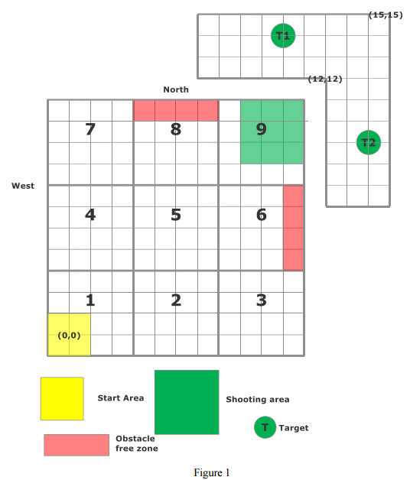

*A small last minute change was made to the competition field: the target board seems to be moved away from the field of navigation by a small distance.*