Mr John Jones, an expert in A Level Biology, has decided to create a batch for his digital classroom at Edutech. He heads over to the sidebar and selects the ‘Batches’ tab. As he enters this tab, he finds his selection of A Level Biology already present. He himself had created this when signing up at Edutech and selecting a curriculum and a subject of choice. He had chosen only one curriculum and one subject, but he could have chosen multiple ones.

Note, if Mr Jones decides he also wants to teach a different subject altogether, say SSC Biology, he can do so by heading over to the Settings tab on the sidebar and going under SUBJECT:

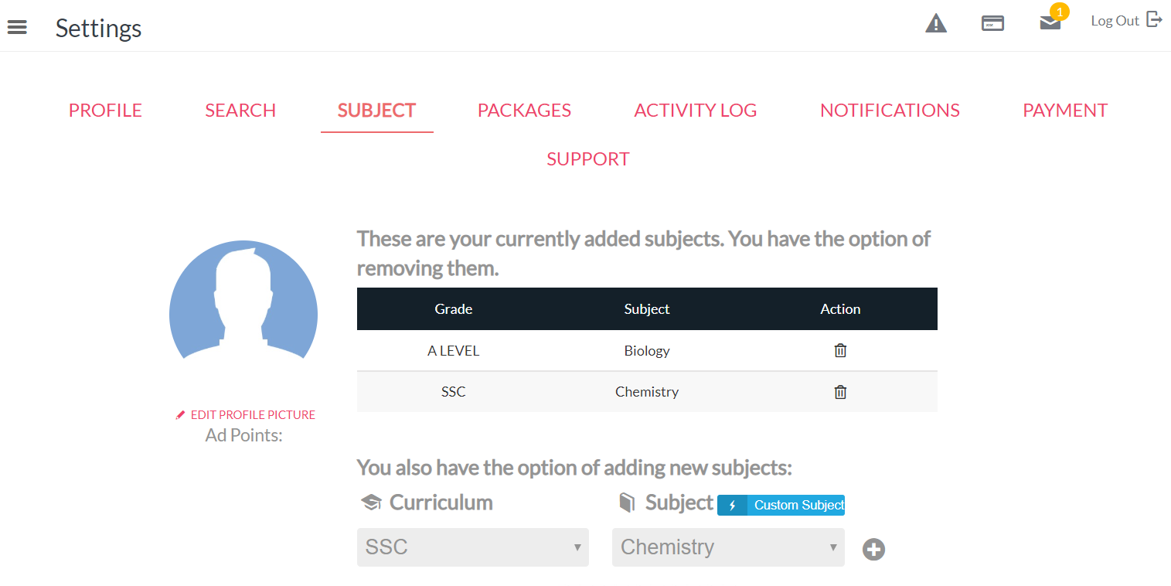

But let’s imagine Mr Jones sticks to A Level Biology for now. Mr Jones would now have to setup this batch and add the specifics such as timing, number of students, student tuition, etc.

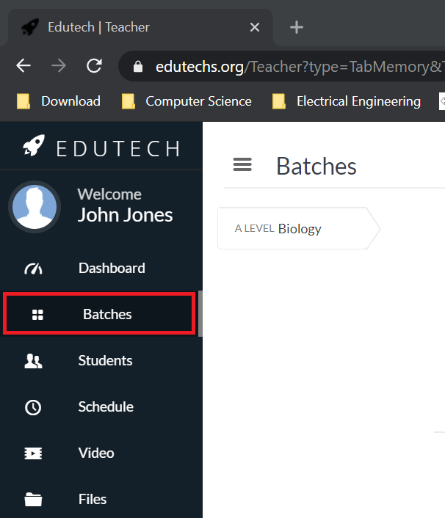

Now for the specifics of the batch. Each batch can have two types of students: in-person class students, who will be traveling to attend the teacher’s lectures directly, and remote digital students, who can attend the lectures from outside the classroom via internet connection and the streaming process facilitated by Edutech. Upon clicking on the ‘Create New Batch’ option to the upper left, Mr Jones finds the following form:

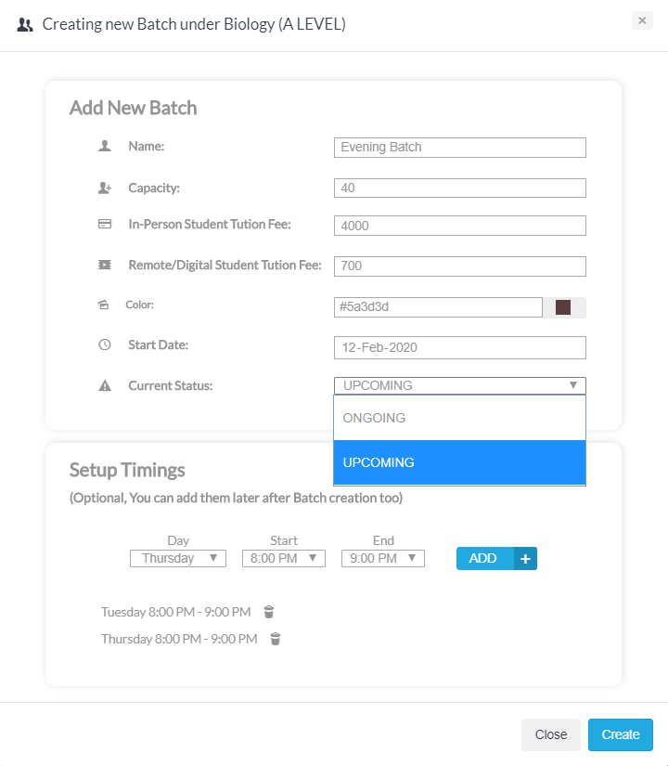

He fills the form in with the specifics. Notice that Mr Jones is able to select two different tuition rates for his two types of students, in-person and remote-digital.

The ‘Current Status’ can be selected in one of two ways: ONGOING – which means Mr Jones is either already conducting this class or will be doing so very soon. Batches that are created with the ONGOING status can be found in Mr Jones’ schedule at Edutech. On the other hand, UPCOMING indicates that this type of a batch will be started some time later, and hence will not show up on Mr Jones’ Edutech schedule now, but Mr Jones just wanted to keep things clear by saving the plan at Edutech.

Finally, whatever timing is selected from the dropdowns, are confirmed by clicking on ‘ADD’ and once all the timings are selected, Mr Jones clicks CREATE to the bottom right to register the batch.

The Evening Batch has been created! Mr Jones finds the following box under his Batch Configurations section:

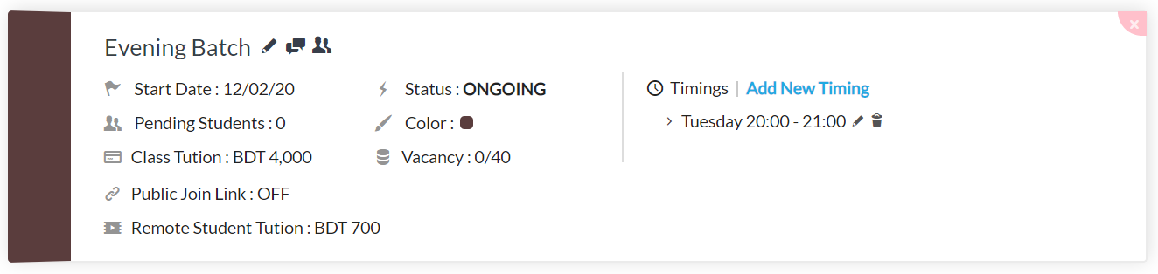
Now, for a few important things. At any time if Mr Jones wishes to update the specifics of this batch, he can simple click on any of the descriptions in this box. Thus, clicking on the Start Date, the Class Tuition, the Public Join Link, the Timings, etc. enables Mr Jones to update each of these settings.

The Pending Students description indicates that number of students who have found Mr Jones’ batch at Edutech, have applied (or signed up) for this batch, but have not been accepted yet by Mr Jones.

The Public Join Link, currently set to OFF, is a special one. Mr Jones can set this to ON and upon doing so will be provided with a link that he can share with anyone over the internet. The receiver of this link will be directly registered as a remote student*** to the Evening Batch of Mr Jones.

Note the three icons besides the label ‘Evening Batch’. The pen icon allows renaming this batch, the message icon allows Mr Jones to message everyone, all his students, in this batch and the last icon - ‘Enrolled Student Information’ takes Mr Jones to the Student tab on the sidebar to view such information.

Finally, Mr Jones is able to add a Youtube video intro/briefing for students of all his batches under A Level Biology. Clicking on the ‘Add Video Intro’ at the upper right sets him up for this.

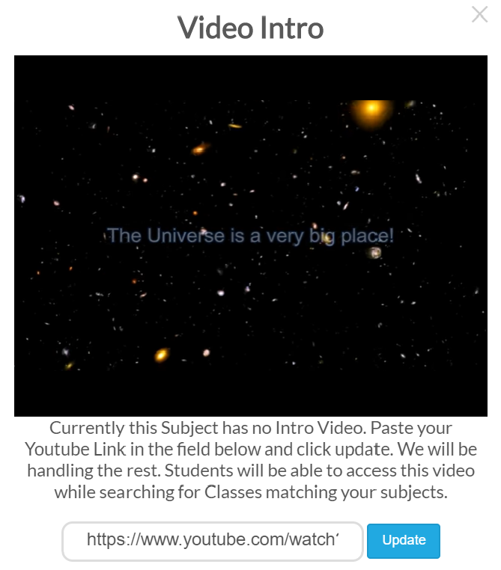

Mr Jones has set up his batch for students to find it on Edutech and join. When students attempt to join his batch, he will receive a notification about it. Mr Jones can accept the student readily from the notifications list by pressing the green icon, or move to the Students tab on the sidebar to view more details about this student. The Students tab presents a comprehensive profile for each student in Mr Jones’ batch.

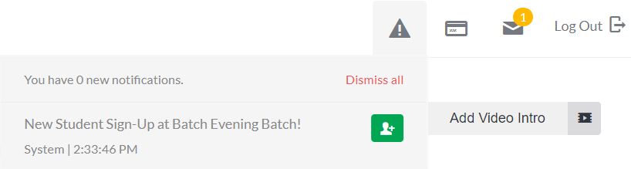

Upon visiting the Students tab on the sidebar, selecting the correct batch by its name (note you can rename batches anytime from the Batches section on the sidebar) and clicking on the Pending option to the right, also lists the students who have applied to join the batch but have not been accepted yet.

Currently, a student by the name of Neelim Khan is on the Pending list. There are three options available to Mr Jones:

1) Accept the student – for totally new students, who could be either in-person or remote-digital.
2) Accept and Migrate – for students who already attend Mr Jones’ real life classes but Mr Jones would now like to have their records on Edutech databases*** as well.
3) Dismissing – if Mr Jones does not wish to accept the student into the batch.
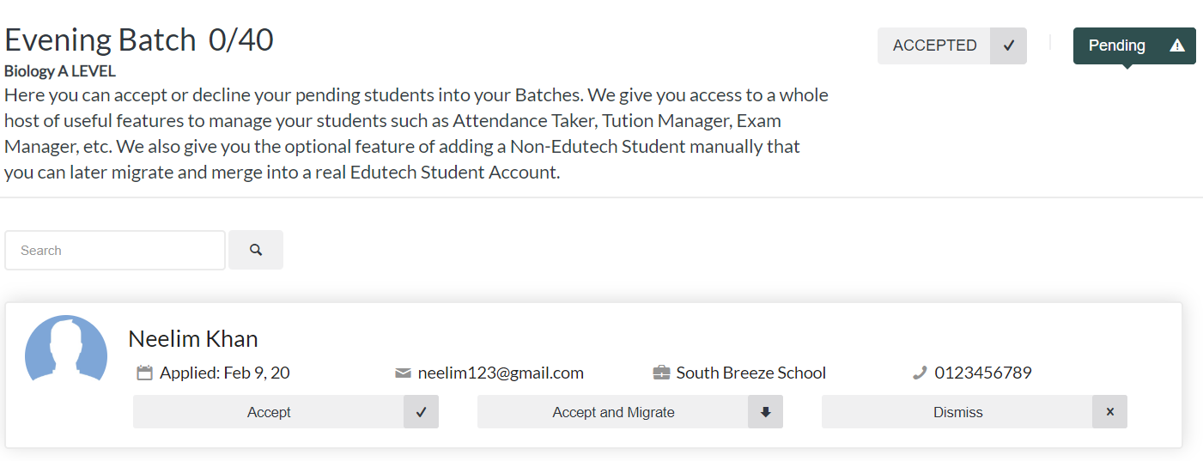

Accepting the student reveals that the student had applied for an in-person seat into the batch. The default setting of Video Permission to ‘Denied’ indicates this. Video Streaming is by default only available for students who apply as remote-digital students and who pay remote-digital tuition, which is different from in-person or live students. Accepting the student also moves this student to the Accepted list from the Pending list, here at this Student tab section of the sidebar. Note that Edutech also allows you to register students into batches manually – without the students themselves having to send a join request. The ‘Add Student Manually’ option enables this.

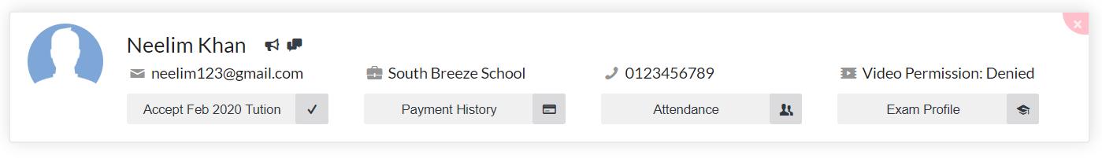

Interaction with registered students via Edutech:

Interaction with students is critical to their learning and Edutech facilitates this very smoothly. As a teacher, Mr Jones is able to:

- Communicate one on one with his students,
- Message them all together,
- Take roll calls,
- Live Stream Videos
- Provide a store of study materials and links to external pages from the Files tab on the sidebar,
- Have discussions on specific topics of lecture, at the Discussions tab on the sidebar***,
- Receive tuition online (via Edutech)

The Students tab allows the first three from this list. The Message All option sends a message to everyone, while individual messages can be communicated using the two icons to the right of the students name. The first of this icon, is a tuition reminder for the student. The second is the direct, individual messaging option. Mr Jones is also able to take roll call of each of his students for the day.

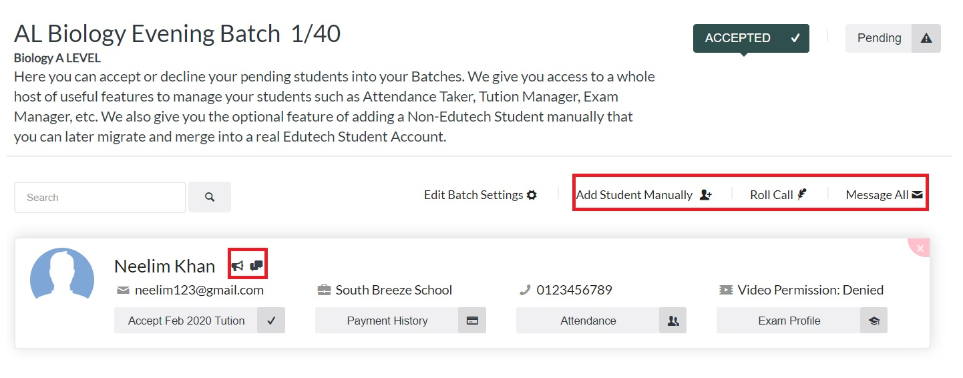
The Student tab also allows checking the Payment History***, Attendance History and Exam Profile of each registered student.

