Edutech makes it really easy for a student to find a teacher or mentor and begin classes for their desired topic of knowledge or skill.

Once you <a>sign up</a>, and sign in you will find yourself in the Dashboard. Consider this to be your home at Edutech from where you get a quick glimpse of useful metrics such as your exam performances in joined batches, records of paid tuition, your attendance in joined classes, upcoming events, to-do lists, etc.

Head over to the sidebar to the left and find the tab ‘Search/Signup’:

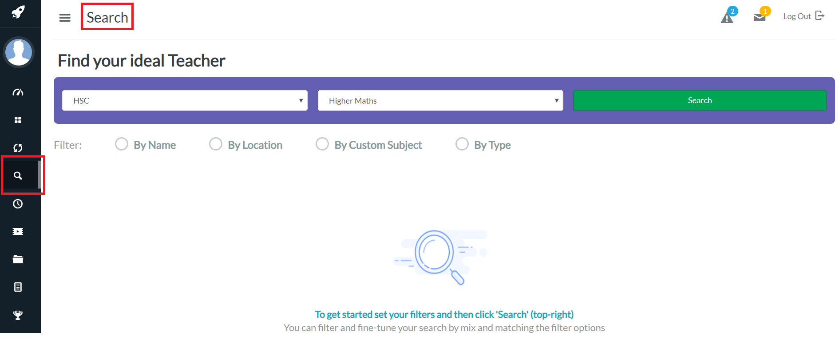
From here, simply select your curriculum and subject of choice and hit search. For example, searching for A’Level Biology brings up Mr Jones from Sunset Education. You can see the subjects that he specializes in, his contact addresses, number of current students, location, timings for batches, and his tuition charges for Live (in-person, physically attending classes) and Digital classes (learning online through the education management tools and streaming services provided by Edutech). (see the <a>sign up</a> article for understanding the differences between the two in more detail).

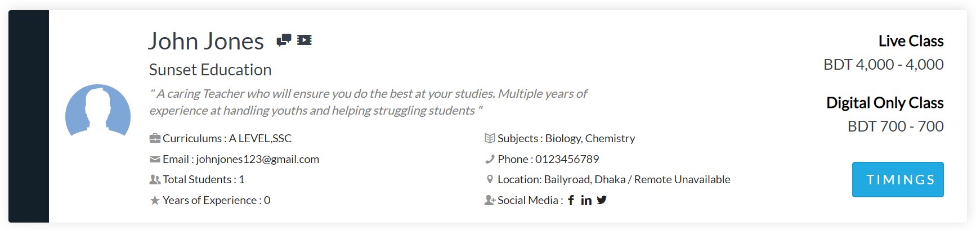
In order to join one of Mr Jones’ batches, take a look at his class schedule by clicking on ‘Timings’:

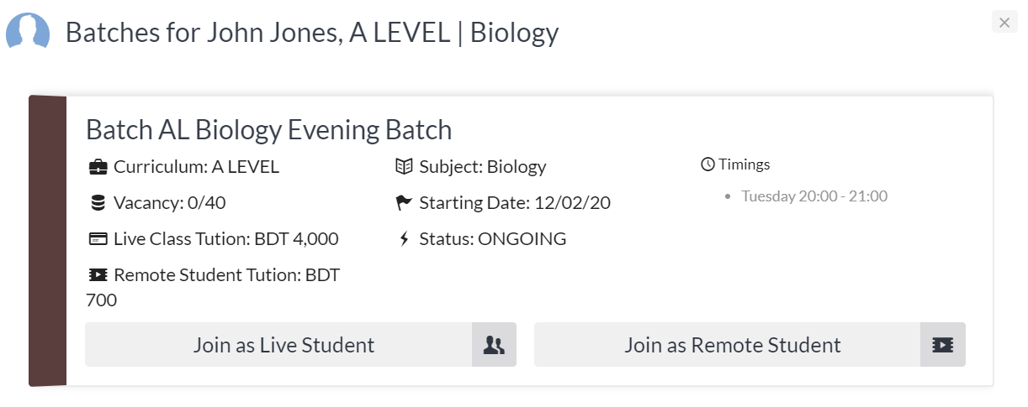
From here, you get information specific to Mr Jones’ A’Level Biology Evening Batch and you can request to join as a Live or Remote Student. Mr Jones will immediately receive a notification on his account about your request to join and he can then confirm your seat in his batch. To make sure that your request has reached Mr Jones, you can go to the Pending Classes section on the sidebar and find the list of your requests to join different batches. You could also try contacting Mr Jones himself.

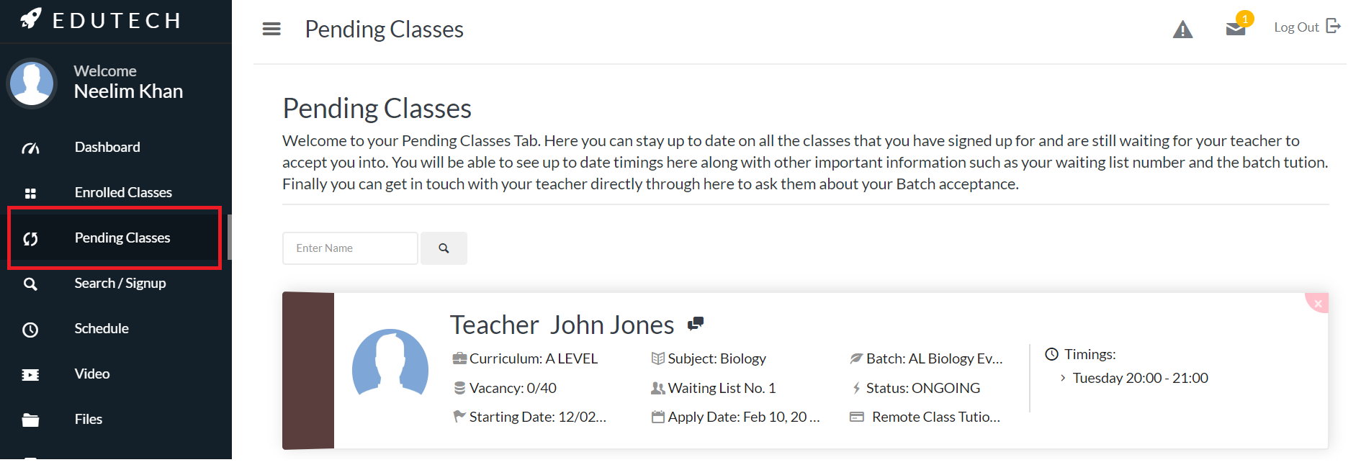
As soon as he accepts your request, this item on this list will clear and you will find a new item in your Enrolled Classes section on the sidebar and the timings automatically incorporated into your Edutech Schedule (also on the sidebar).

