You can register as two types of studentsk at Edutech:

- Live/in-person student: attends class lectures directly with teacher in traditional classroom environments.
- Remote-digital students: attends class lectures via online video streams started by teacher.

You can sign up as a student in three ways at Edutech. This article will explain them all:

<b>Firstly</b>, you can simply visit our landing page at https://edutechs.org/ and find the ‘Signup/Login’ button on the upper right corner of the screen. You will then be taken to the registration page where you could sign up since you do not already have an account. Clicking ‘Sign up’ will present you with the following prompt, where you may click on ‘Student’ as depicted below:

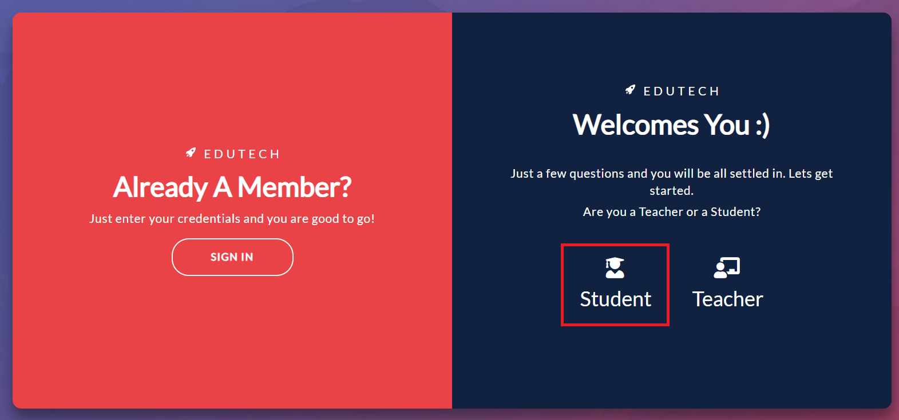
You will then be required to provide a few basic information such as your name, institution (if any), phone number, email address and a strong login password for your account at Edutech. Click on ‘Sign Up’ once you are done.
There you go! You now have a student account at Edutech and may go on to find a teacher for the subject or skill of your desire.

The <b> second </b> way that you may sign up at Edutech is if you click on a Edutech ‘Public Join Link’ that was generated and shared by a teacher at Edutech. This will automatically sign you up as a remote digital student. There are differences

The <b> third </b> way is more manual. If your current teacher registers at Edutech, he can manually add you as an Edutech student under his batch. You will then most likely be registered as an in-person student at Edutech (since you are already visiting your teacher at his teaching place).

