In this guide, we will go over how you as a teacher can use Edutech to:

- create batches for your classes
- acquire students
- interact with students

Creating Batches for Your Classes

Now that you are a registered teacher at Edutech, people willing to learn from you can find you by looking under the subjects that you have chosen. From there they can join the batches that you create from inside Edutech. If you already have students, you could ask them to sign up at Edutech. Together you and your class can benefit from the array of Education management tools that we provide here, free of cost. Students can sign up in one of two types at Edutech: in-person/live students – who attend classes physically and digital/remote students – who attend classes online only through Edutech.

Consider as an example that you are an expert in A Level Biology, and have decided to create a batch for his digital classroom at Edutech. For the purposes of demonstration, you are given the name Mr John Jones in the images below.

You can head over to the sidebar and select the ‘Batches’ tab. As you enter this tab, you find your selection of A Level Biology already present. You created this when signing up at Edutech and selecting a curriculum and a subject of choice.

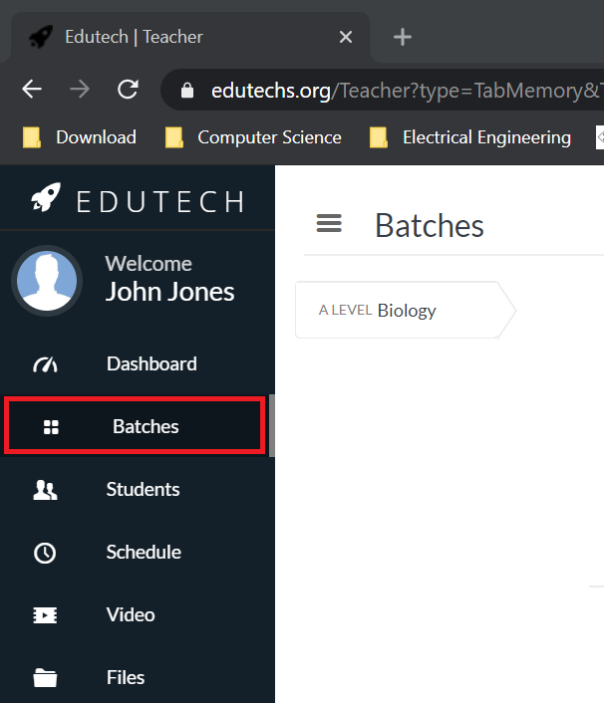

Note, you can always add newer subjects and curriculum to your teaching list. If you want to add more e.g. SSC Biology, you can do so by heading over to the Settings tab on the sidebar and going under SUBJECT:

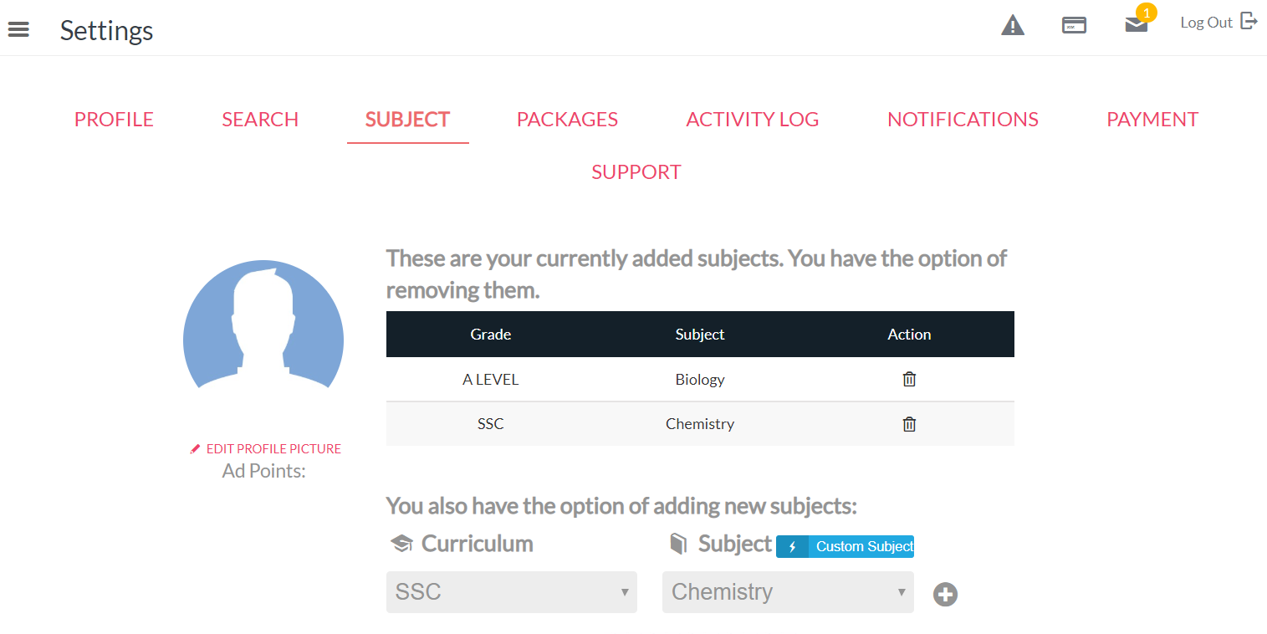

But let’s imagine you are sticking to A Level Biology for now. You can finish setting up this batch by adding the specifics such as timing, number of students, student tuition, etc.

Regarding the specifics of the batch: each batch can have two types of students: in-person class students, who will be traveling to attend the teacher’s lectures directly, and remote digital students, who can attend the lectures from outside the classroom via internet connection and the streaming process facilitated by Edutech. Upon clicking on the ‘Create New Batch’ option to the upper left, you will find the following form:

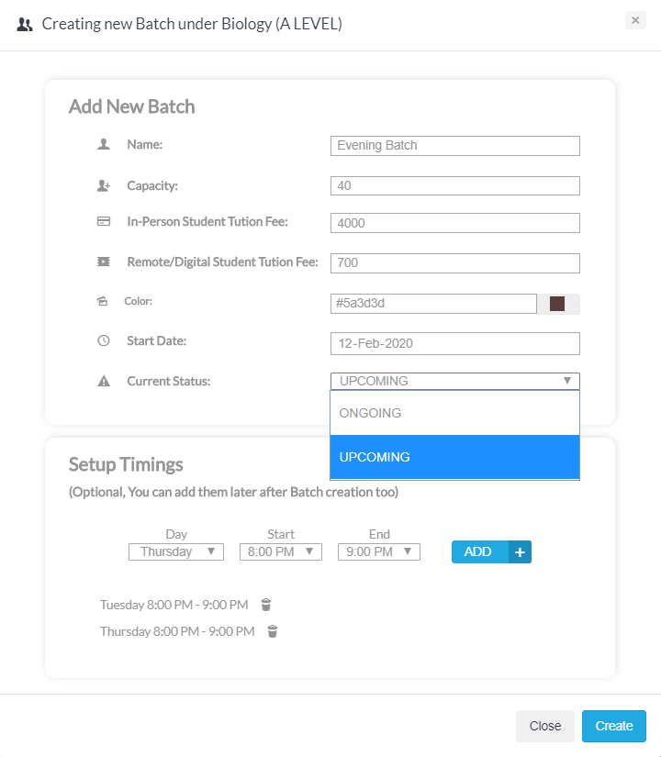

You can fill the form in with the specifics. Notice that you are able to select two different tuition rates for his two types of students, in-person and remote-digital.

The ‘Current Status’ can be selected in one of two ways: ONGOING – which means you are either already conducting this class or will be doing so very soon. Batches that are created with the ONGOING status can be found in your schedule at Edutech. On the other hand, UPCOMING indicates that this type of a batch will be started some time later, and hence will not show up on your Edutech schedule now, but you just want to keep things clear by saving the plan at Edutech.

Finally, whatever timing is selected from the dropdowns, are confirmed by clicking on ‘ADD’ and once all the timings are selected, you click CREATE to the bottom right to register the batch.

The Evening Batch has been created! You will now find the following box under your Batch Configurations section:

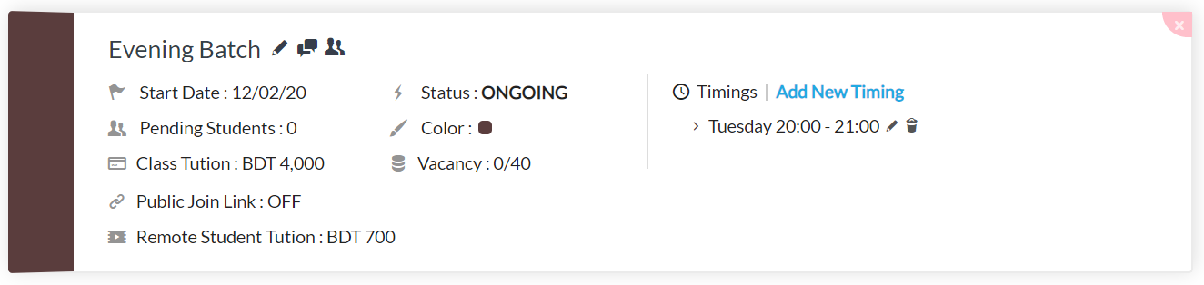
Now, for a few important things. At any time if you wish to update the specifics of this batch, you can simple click on any of the descriptions in this box. Thus, clicking on the Start Date, the Class Tuition, the Public Join Link, the Timings, etc. enables you to update each of these settings.

The Pending Students description indicates that number of students who have found your batch at Edutech, have applied (or signed up) for this batch, but have not been accepted yet by you.

The Public Join Link, currently set to OFF, is a special one. You can set this to ON and upon doing so will be provided with a link that he can share with anyone over the internet. The receiver of this link will be directly registered as a remote student*** to your Evening Batch.

Note the three icons besides the label ‘Evening Batch’. The pen icon allows renaming this batch, the message icon allows you to message everyone, all his students, in this batch and the last icon - ‘Enrolled Student Information’ takes you to the Student tab on the sidebar to view such information.

Finally, you are able to add a Youtube video intro/briefing for students of all your batches under A Level Biology. Clicking on the ‘Add Video Intro’ at the upper right sets you up for this.

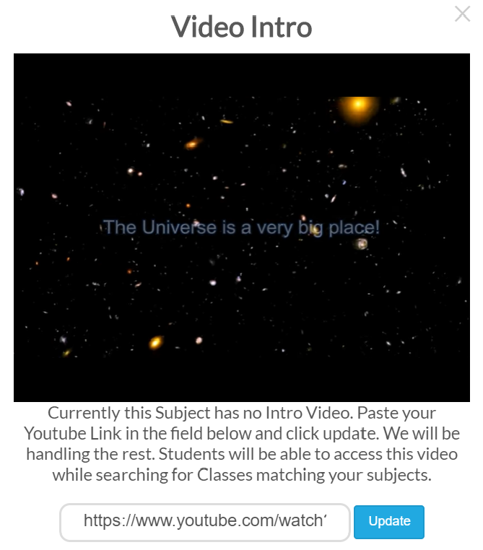

Connecting with students:

Wonderful! You have set up your batch for students to find it on Edutech and join. When students attempt to join your batch, you will receive a notification about it. You can accept the student readily from the notifications list by pressing the green icon, or move to the Students tab on the sidebar to view more details about this student. The Students tab presents a comprehensive profile for each student in your batch.

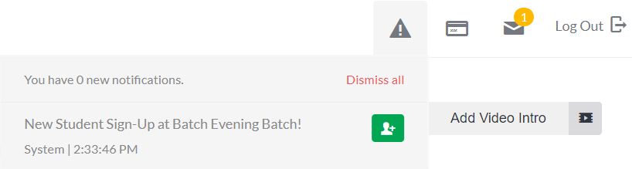

You can go to the Settings section on your sidebar (bottom left) and under the Search tab you will find information on how you appear in searches.

The card below is an example of what students will see when they search for a Teacher matching your subjects / credentials. We are actively working on more customizable options here that will help you better showcase yourself as a Teacher to prospective students. For now you could add a short intro to be read by your future students.

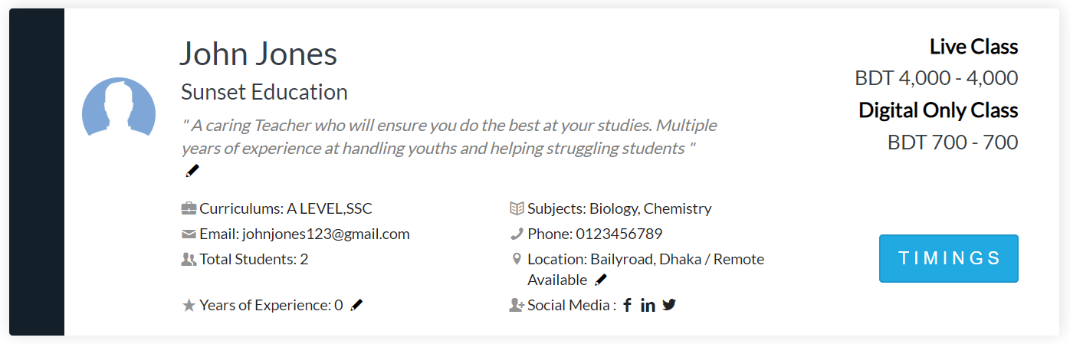

Furthermore, in order to assist you acquire more students for batches Edutech offers the following two services, as can also be seen under the Search tab:

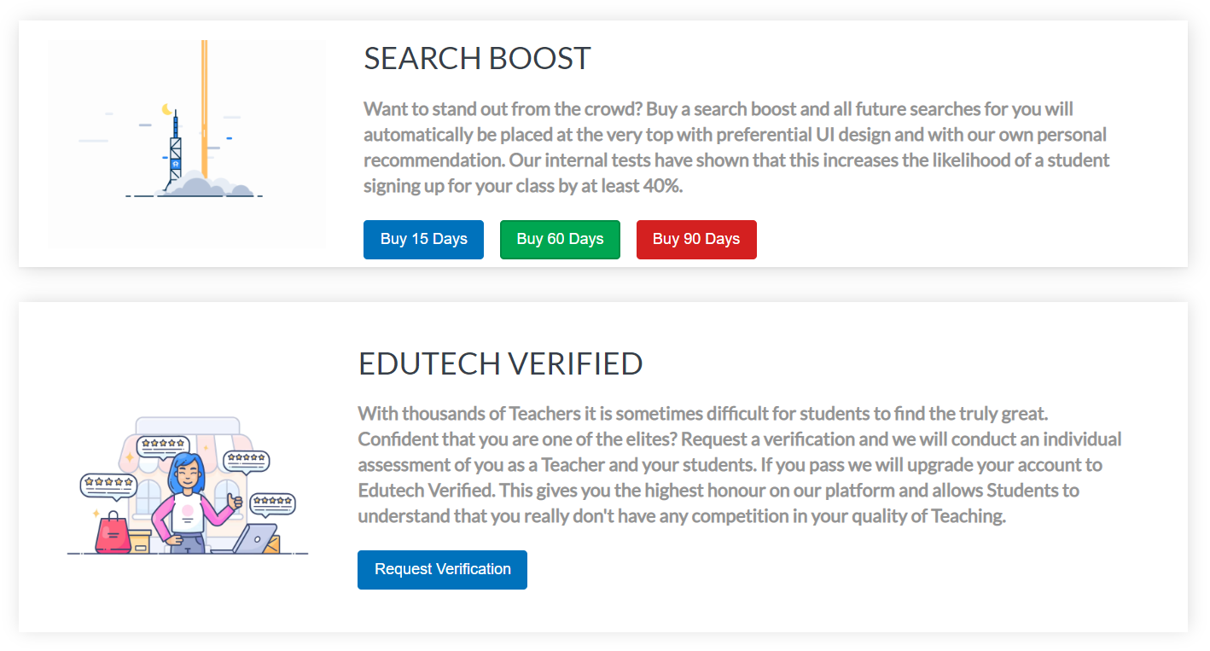

Upon visiting the Students tab on the sidebar, selecting the correct batch by its name (note you can rename batches anytime from the Batches section on the sidebar) and clicking on the Pending option to the right, also lists the students who have applied to join the batch but have not been accepted yet.

Currently, a student by the name of Neelim Khan is on the Pending list. There are three options available to you:

1) Accept the student – for totally new students, who could be either in-person or remote-digital.
2) Accept and Migrate – for students who already attend your real life classes but you would now like to have their records on Edutech databases*** as well.
3) Dismiss – if you do not wish to accept the student into the batch.
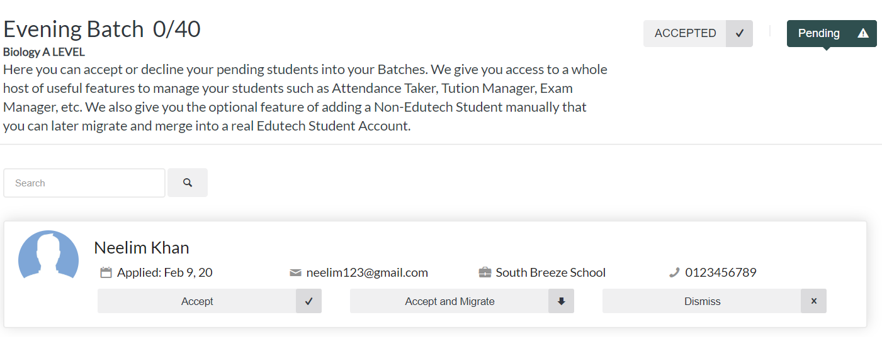

Accepting the student reveals that the student had applied for an in-person seat into the batch. The default setting of Video Permission to ‘Denied’ indicates this. Video Streaming is by default only available for students who apply as remote-digital students and who pay remote-digital tuition, which is different from in-person or live students. Accepting the student also moves this student to the Accepted list from the Pending list, here at this Student tab section of the sidebar. Note that Edutech also allows you to register students into batches manually – without the students themselves having to send a join request. The ‘Add Student Manually’ option enables this.

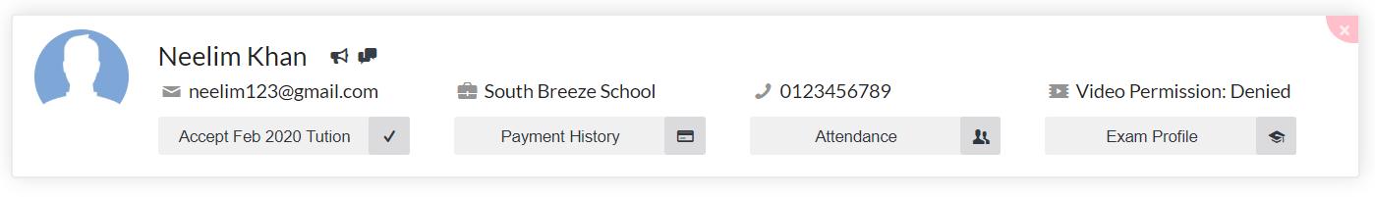

Interaction with registered students via Edutech:

Interaction with students is critical to their learning and Edutech facilitates this very smoothly. As a teacher, you are able to:

- Communicate one on one with his students,
- Message them all together,
- Take roll calls,
- Live Stream Videos
- Provide a store of study materials and links to external pages from the Files tab on the sidebar,
- Have discussions on specific topics of lecture, at the Discussions tab on the sidebar***,
- Receive tuition online (via Edutech)

You can do the first three from this list from the Students tab on the sidebar. In the image below, the Message All option sends a message to everyone, while individual messages can be communicated using the two icons to the right of the students name. The first of this icon, is a tuition reminder for the student. The second is the direct, individual messaging option. You are also able to take roll call of each of your students for the day.

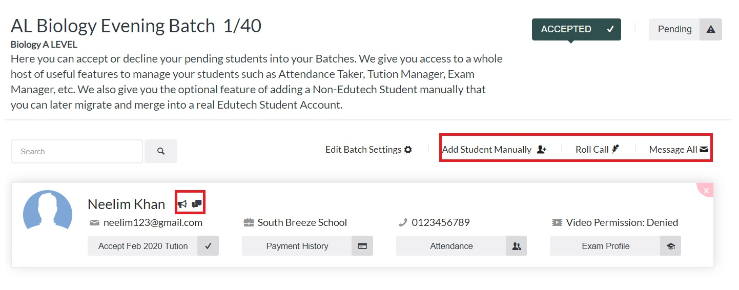
The Student tab also allows checking the Payment History***, Attendance History and Exam Profile of each of your registered students.

For the other means of interaction, check out the following from our guides:

- Going Live!
- Digital Classroom Tools
- Receiving Payment!

