Tools for your digital classroom:

Edutech brings you a complete array of tools for your digital classroom. For smaller classrooms all of this is absolutely free.

- Edutech Schedule
- Video
- File Manager
- Discussions
- Exams
- Assignments
- Personal Notes

The Edutech Schedule

Edutech provides a useful schedule for managing your routine and keeping track of various events. You can find the schedule on your sidebar as shown below:

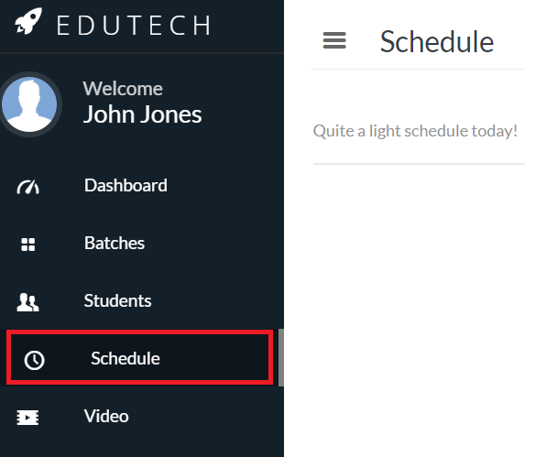

The schedule can be viewed in 3 different modes of Day, Week and Month. As a teacher, whenever you create an ONGOING (not UPCOMING) batch, your batch timings will be automatically placed on your schedule. For example for the teacher Mr Jones, because he had specified a class time of 3:00pm to 4:00pm on Mondays for his Afternoon Batch of SSC Chemistry, he finds the following on the Day mode of his schedule:

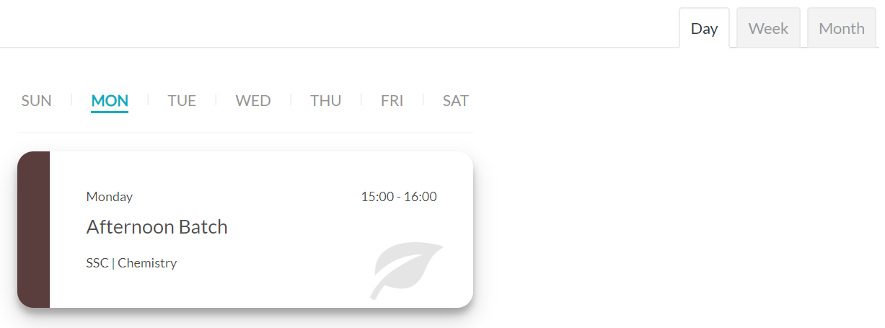

When students request to join a batch and have then been accepted by the corresponding teacher, they too will find the class timings automatically added to their schedule. If you have joined a batch but do not see timings on your schedule, your teacher probably has not decided on the timings yet.

Both teachers and students can add personal events and tasks to their schedule too, such as a meeting with a friend, visiting a certain place, going to the gym, etc. This can be done by using the blue button at the lower right of the Schedule section:

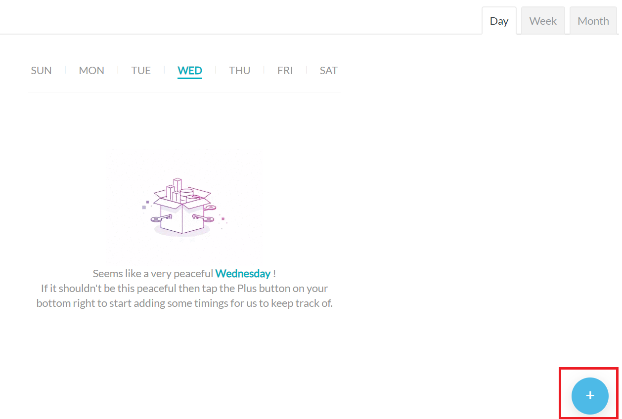

Teachers can also modify existing batch timings right here from the Schedule section using this button. This will mass update the batch timings everywhere automatically, including on the sides of the students as well.

On the weekly view of your schedule, you can drag events to new timings and dates using your cursor.

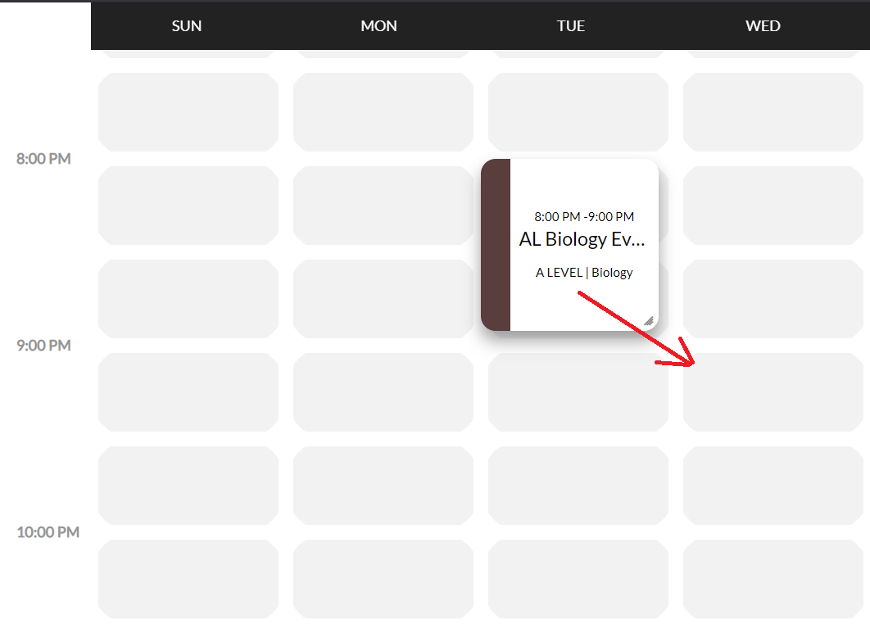
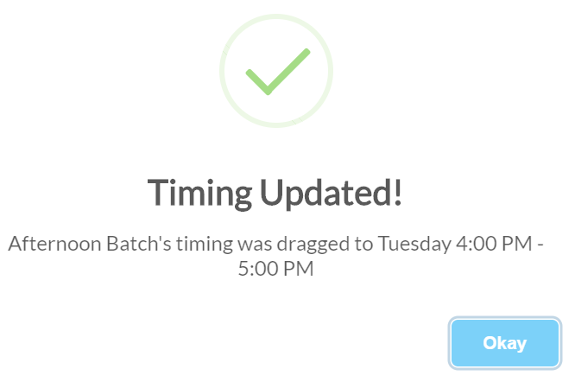
After dragging and dropping, you should find the following confirmation:

Video:

Edutech enables the ultimate digital classroom experience with its One-Click Digital Streaming Technology.

We have a separate <a>guide</a> dedicated on ‘Going Live’ for teachers that covers more details on the features available to them for streaming their lectures or sharing their computer screens.

For students, whenever your teacher goes live, you should receive a notification (upper right corner) that informs you of this. The image below shows this:

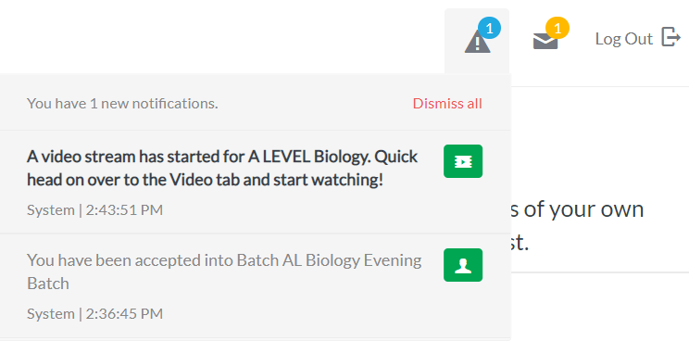

You could head over to the Video section on your sidebar on the left and start attending classes:

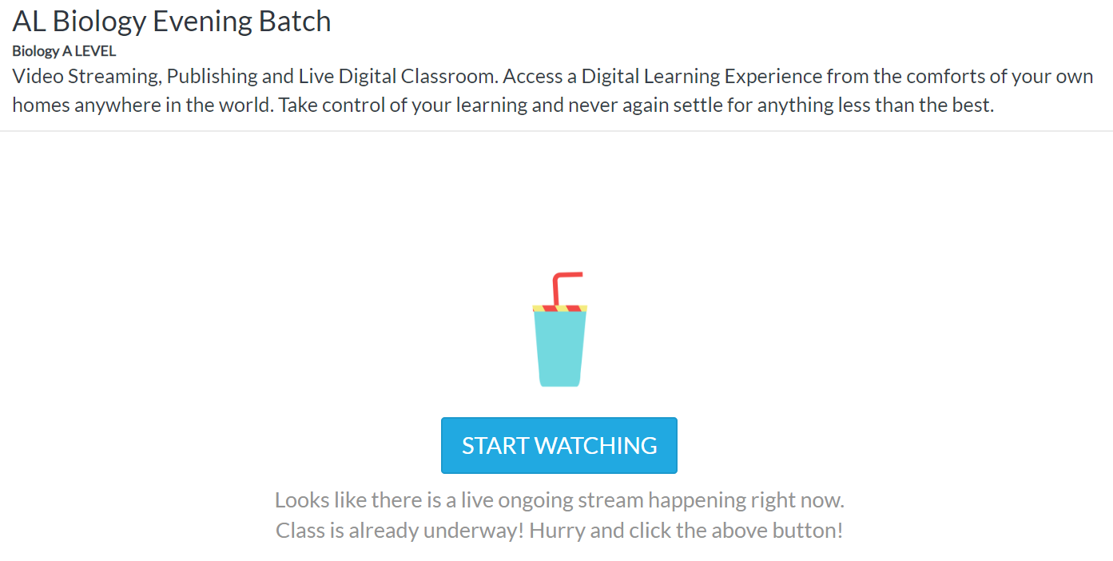

Once you start watching, you can interact with your teacher using the live chat system.
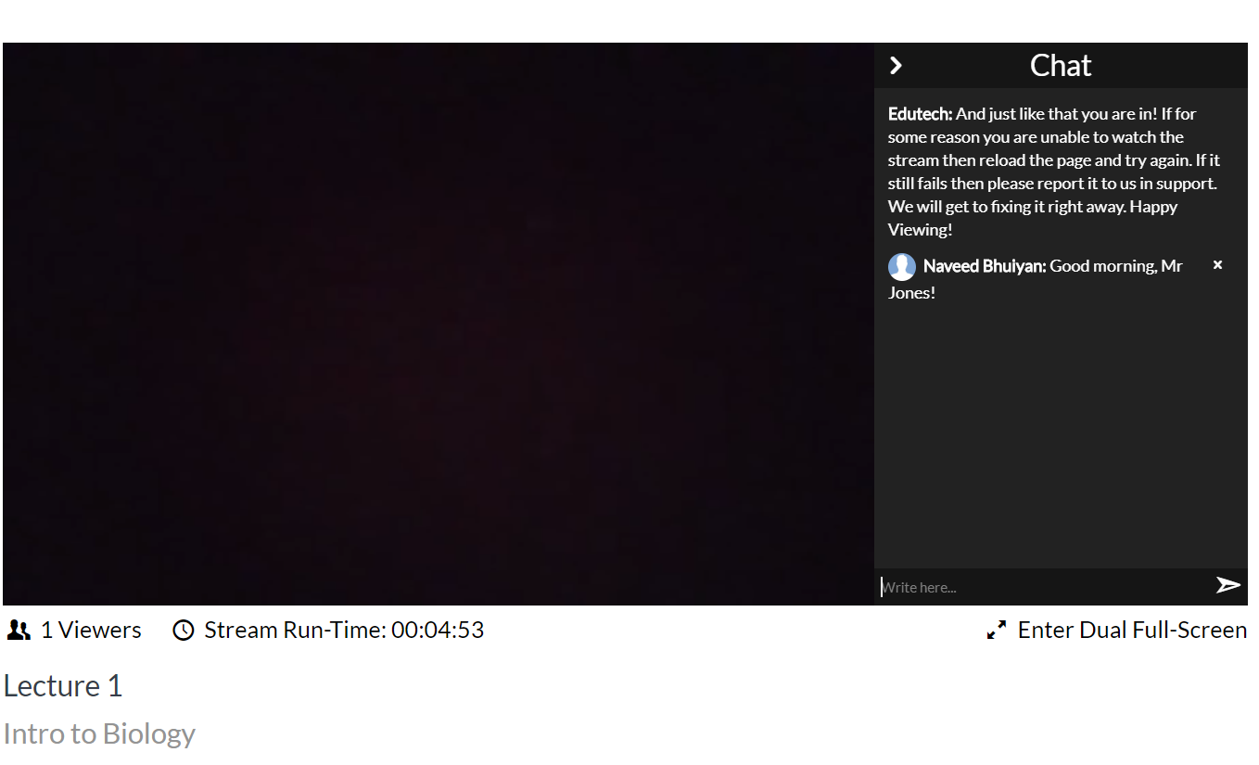
That covered our guide on attending live lectures at Edutech.

File Management:

Edutech offers teachers the ability to share resources and study materials with students. Consider paying a visit the File tab on the sidebar.

As a teacher you have complete control over this. Feel free to divide up your materials in sensible folder like structures and empower your students with up-to date notes at their fingertips. Easy to access notes has experimentally been proven to accelerate student learning. The following picture shows the short guide that is already provided on the File tab:

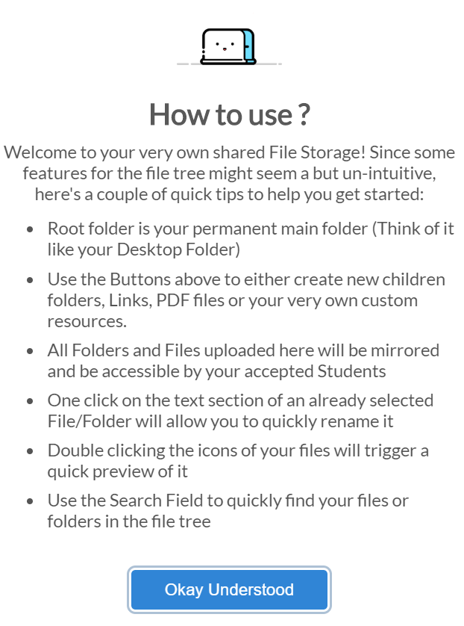

The ‘buttons’ referred to for creating children folders, adding links, uploading PDF files or writing your custom notes straight from the Edutech web application are on the upper right of the following picture. As an example, the picture shows the file structure that a teacher has used for his batch. He has three folders under his ‘root’ folder. Inside the first folder, ‘Chapter 1’ he has added three resources, an external link, a PDF file, and a customized note written for his students.

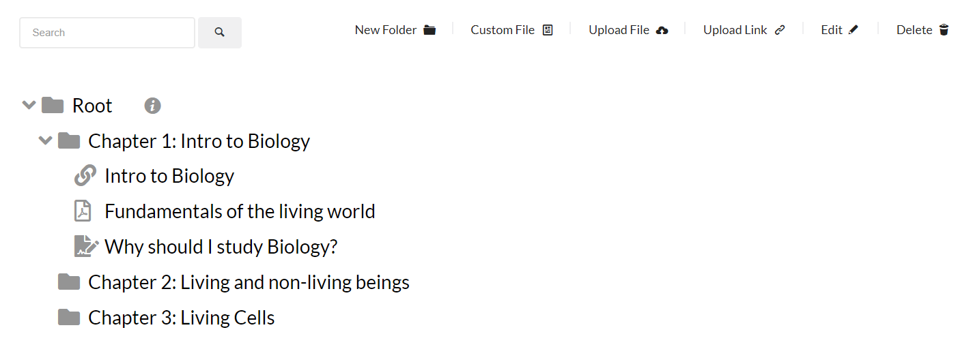

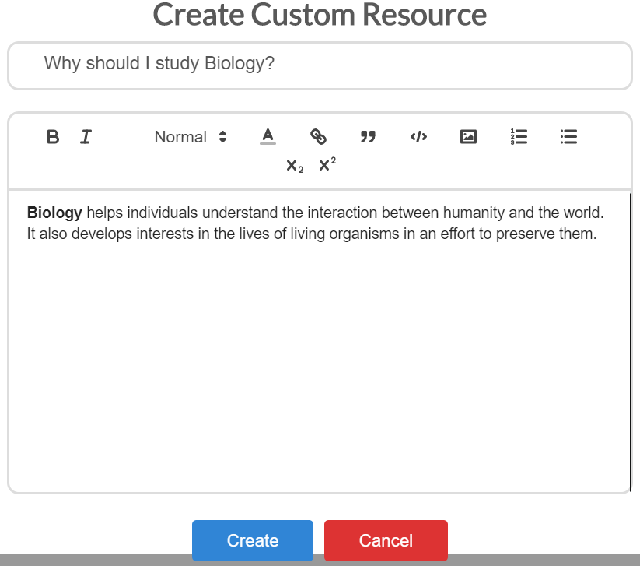
Custom resources are created using the ‘Custom File’ button. The following box appears when clicked:

Discussions:

The Discussions tab on the sidebar enables members of the Edutech digital classroom to engage in topic based discussions. We believe that learning begins with questioning and have therefore attempted to facilitate making learning via Edutech as interactive as possible. The teacher of the subject has the liberty on how he wants to organize these discussions. The discussions can happen in real time in the chat room between all the members of the batch: teacher and students. The teacher can also have frequently asked questions on a topic answered and posted separately.

As an example, the image below shows how a teacher of A Level Biology has structured discussions around the chapters of study. Use the ‘Add New Topic’ button to keep adding new discussion topics.

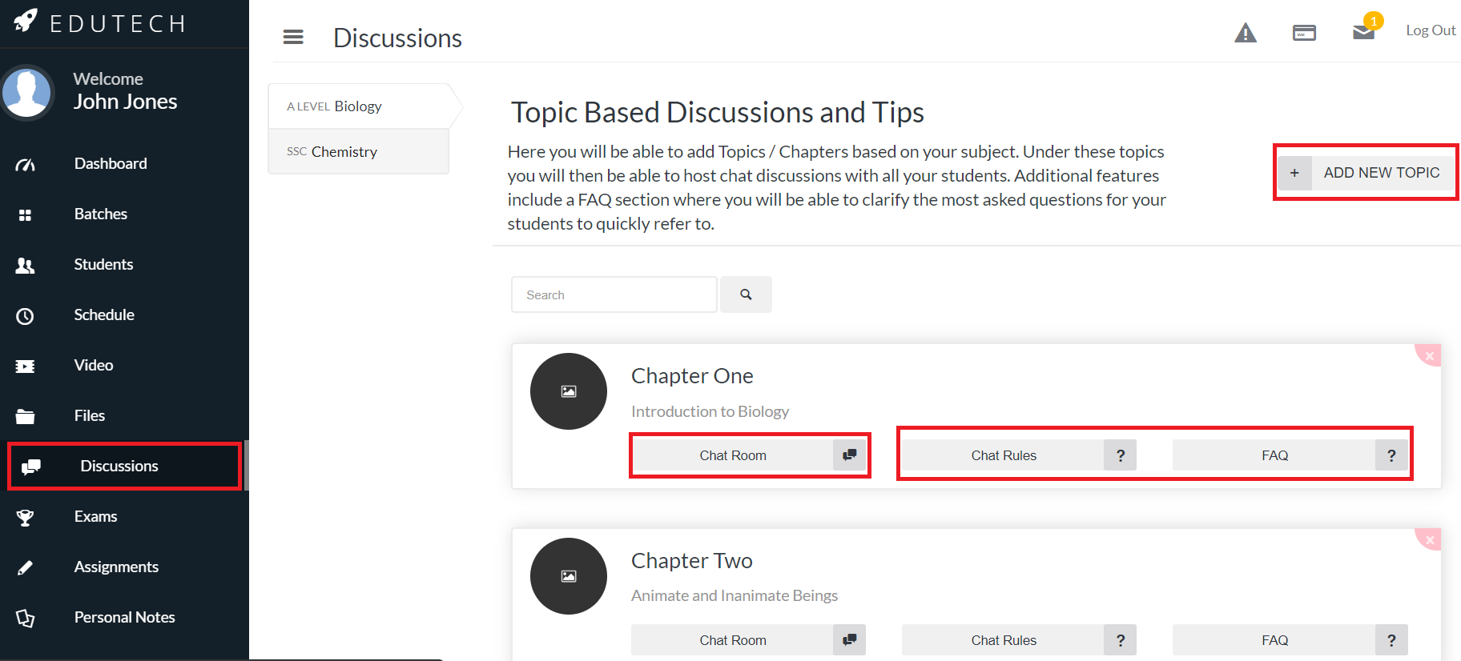

The next picture shows the inside of the chat room:
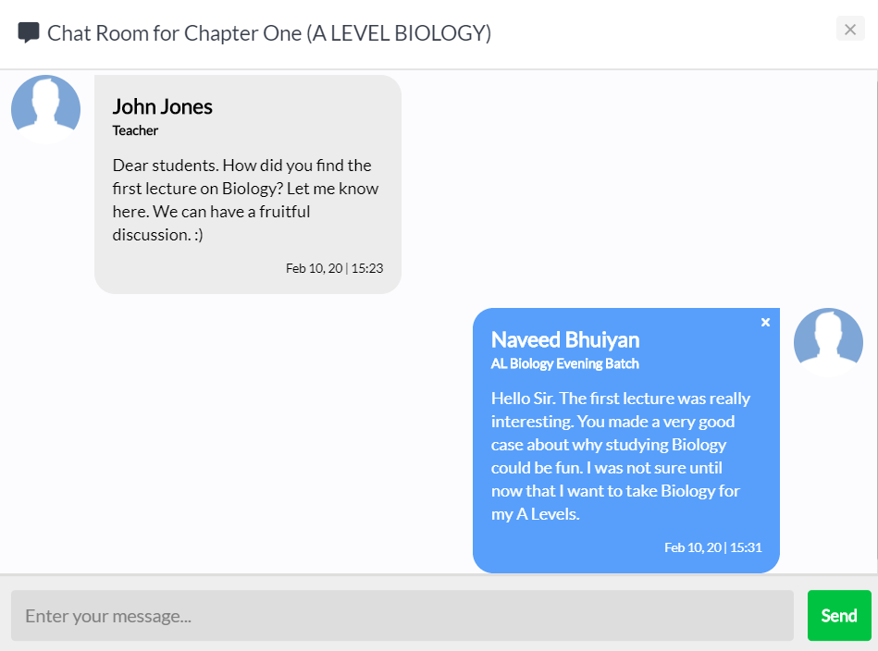

The following shows the Biology teacher has created frequently asked questions:
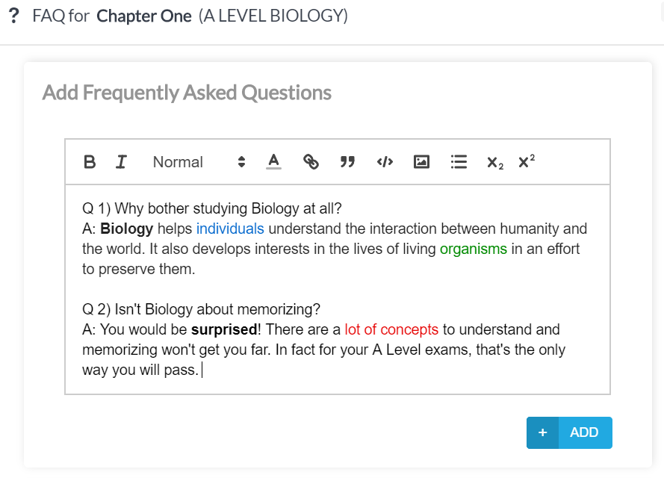

Exams:

Edutech is a completed education management platform. As a teacher you are given the ability to keep track of all your exams that you have taken for your batches. Students are notified when a teacher creates an exam and become aware of the exam topic, date and syllabus. After the exam when the teacher has updated the system with the marks of students, they are able to find their marks for a certain exam and stay abreast of their performance.

The following image shows Mr Jones, teacher of AL Biology has created a class test named ‘Class Test 1’, scheduled to be held on 20/02/2020. In this case, he has already held the exam and has updated the Edutech platform with the marks of his students in the batch.

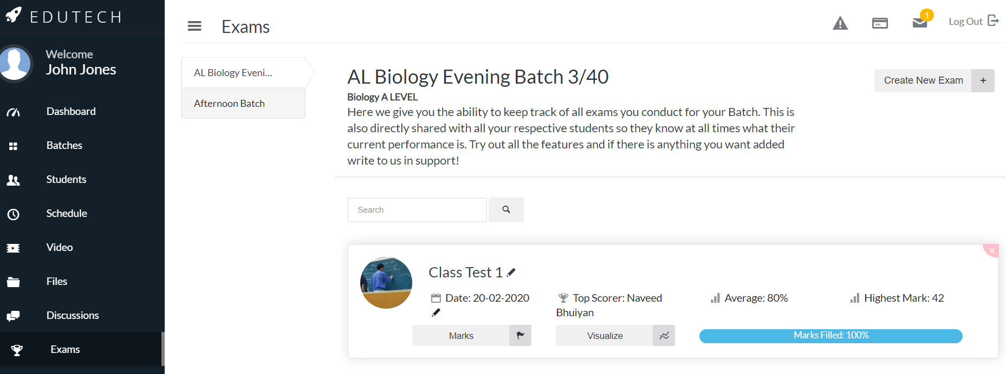
When you, as a teacher, are ready to take an exam, create a new exam by clicking on the ‘Create New Exam’ button. You can edit the name and date of the exam at any time before the scheduled date of the exam. After the exam, to update the marks, click on the Marks button to update marks of every student and pass an optional comment to each student.
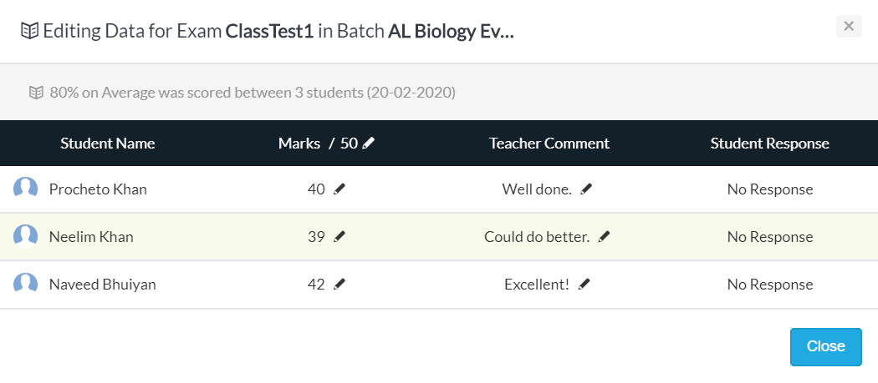
Once you are done updating the marks, you can visualize the status of your class. All you have to do is click ‘Visualize’ and you are provided with a bar chart like the following:

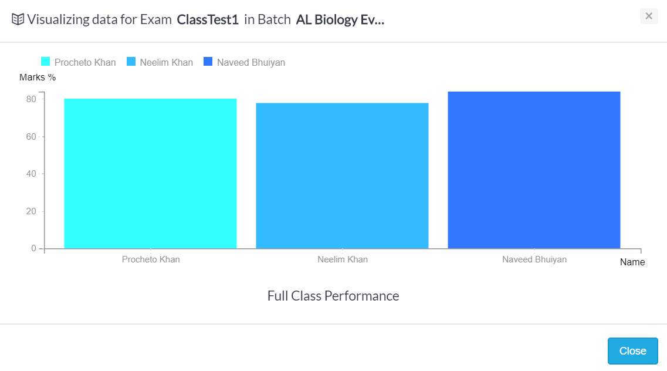
Whether you are a teacher or a student, do write to us about any new feature you feel could be immensely beneficial to you for your digital classroom performance.

Assignments:

Edutech provides teachers the ability to create online digital assignments which will be automatically marked and checked. A teacher can have the option of either creating a document submission portal for Essay Style Assignments or a more fine-tuned per question based Online Assignment. The Online Assignments will be automatically checked, where answers are preset, by the teachers while the Documents uploaded by students will be available to the teachers on all their devices to mark. Students receive a notification of the assignment once assignments are created by the teachers. Just like exams, teachers and students can both view statistics of scores achieved by the class after the marks are updated.

The following is an example of a document submission created when the teacher had clicked on ‘Create Document Submission’. A teacher is able to specify deadlines of submission and the total marks allocated to the assignment.

