Edutech enables the ultimate digital classroom experience with its One-Click Digital Streaming Technology. What does this entail? We shall explore in this guide.

While our platform provides you with all kinds of useful tools for education management such as keeping track of students, organizing your batches, interacting with students, maintaining class schedules and making and receiving payments online, the video streaming feature is special. Physical constraints such as space and location will never again be a barrier to growing your class infinitely.

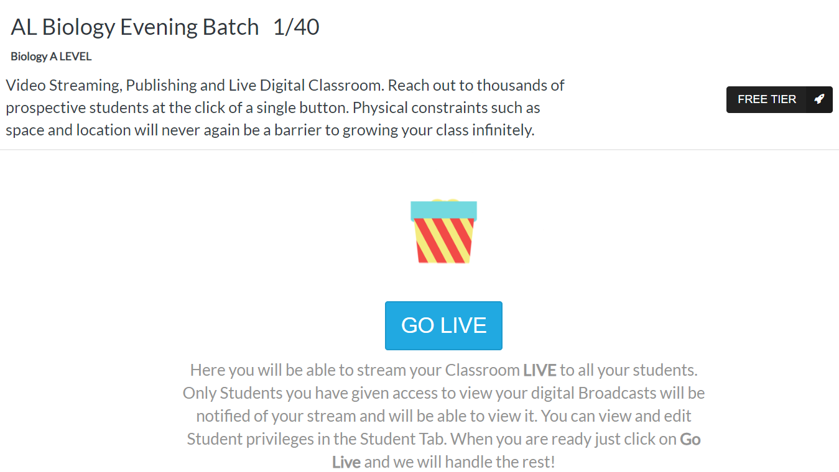

Under the free plan at Edutech, you are able to stream to up to 10 students at a time. Click on the ‘FREE TIER’ if you wish to upgrade for accommodating more students.

You can live stream to all your students with one click. In order to do so, head over to the ‘Video’ section of your sidebar and select the appropriate batch. Only students you have given access to view your digital broadcasts in this batch will be notified of your stream and will be able to view it. You can view and edit student privileges in the Student tab. When you are ready just click on GO LIVE. Your browser will ask you for permitting your camera and microphone to be used. Permissions can be granted upon prompt or manually from the ‘i’ or sometimes lock icon to the left of the URL in the address bar.

You will then be asked to provide a description and title for the stream session suitable to your students. Click start to begin the session.

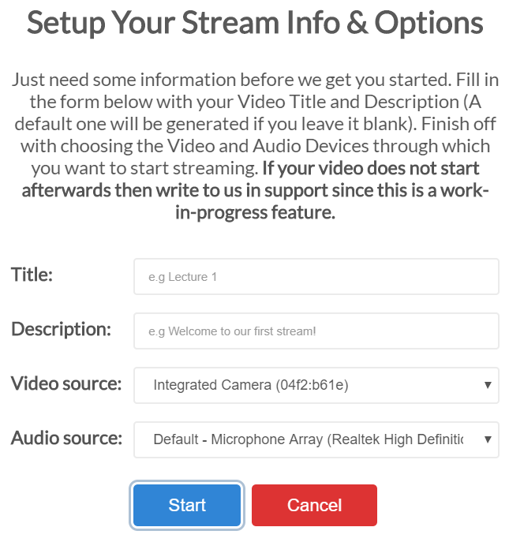

Once you are live, your students are able to not only listen to you lecture but also interact with you via real time messaging. As a teacher you can respond to their questions.

In the image below, the red boxes indicate some other features that come with streaming.

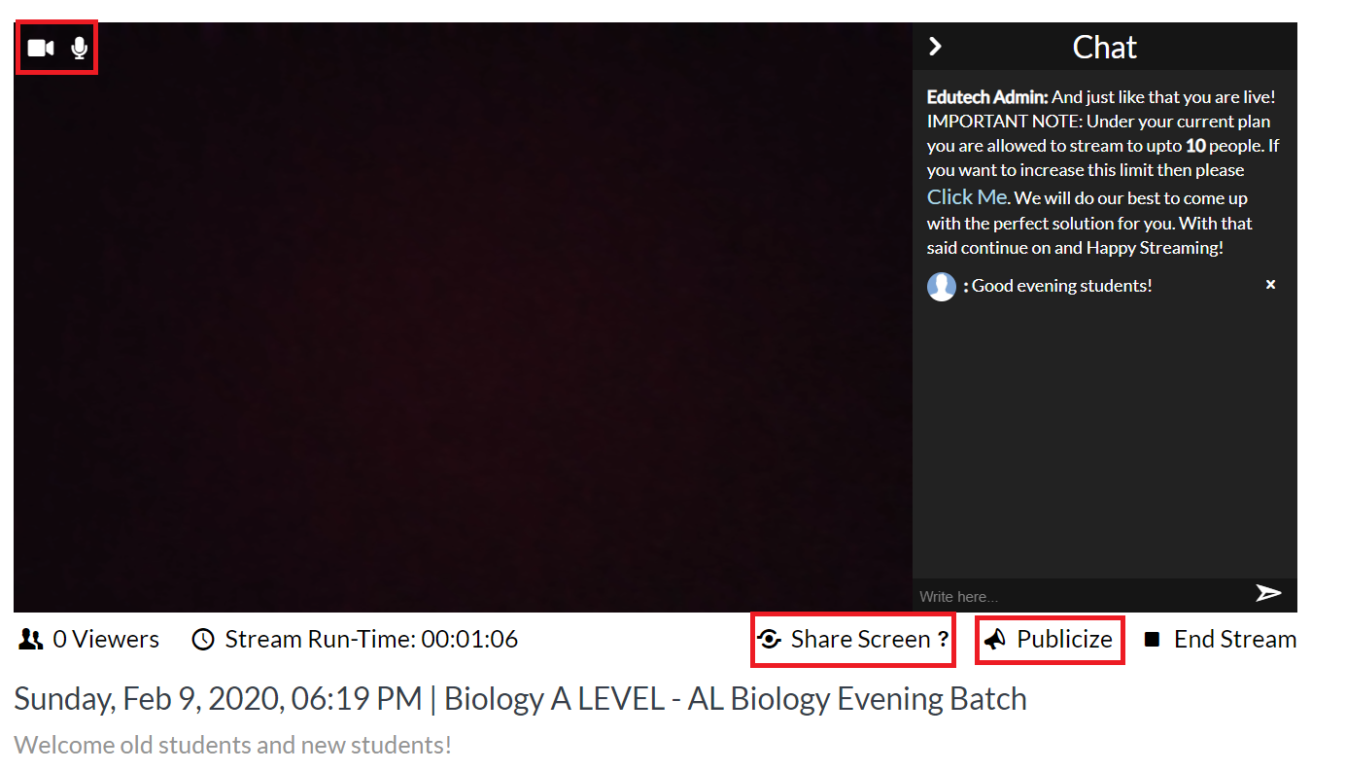

Clicking upon ‘Share Screen’ prompts the user to share their computer screen via which they are streaming. The following image shows all the three modes that Edutech screen sharing currently provides, which are:

- User’s entire screen i.e. the one that is visible to themselves on their own computer.

- A certain application via the Application Window tab

- A certain Chrome Tab which is open on the user’s computer

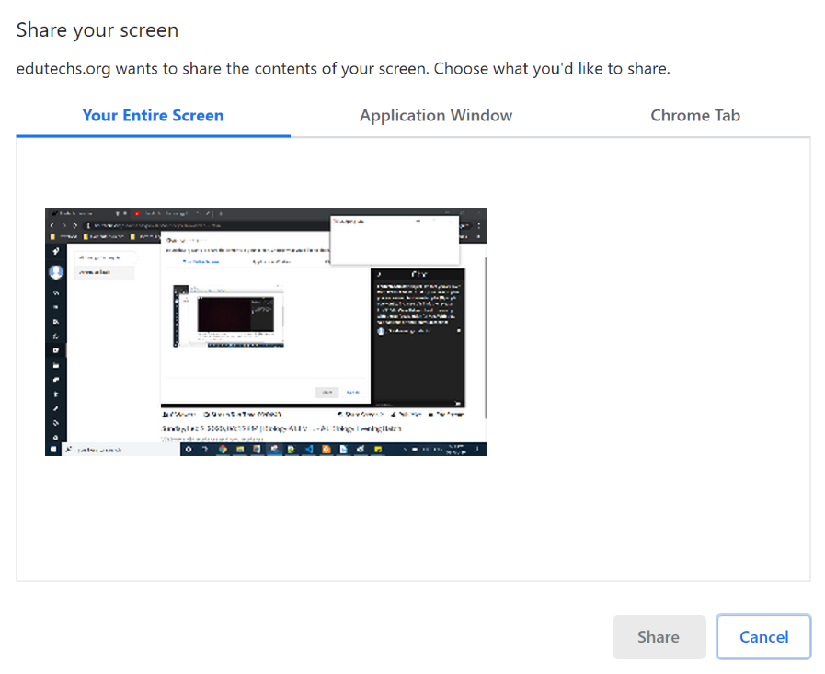

Clicking on the ‘Publicize’ option to the right of ‘Share Screen’ enables generating a link which can be shared with anyone over the internet. Normally, your stream is restricted to only remote-digital students of your batch. If you want to make the stream available without any sign-ups then use this option to generate a public viewable stream link. Then go ahead and share this via social media. People will be able to view your current running stream with this link just like a YouTube video.

When the session is over, click on ‘End Stream’ to shut streaming off.

