This article discusses signing up at Edutech for teachers and once that’s done, how teachers can utilize the Edutech teachers’ dashboard.

You can sign up as a teacher by heading over to our landing page at https://edutechs.org/ and finding the ‘Signup/Login’ button on the upper right corner of the screen. You will then be taken to the registration page where you could sign up since you do not already have an account. Clicking ‘Sign up’ will present you with the following prompt, where you may click on ‘Teacher’ as depicted below:

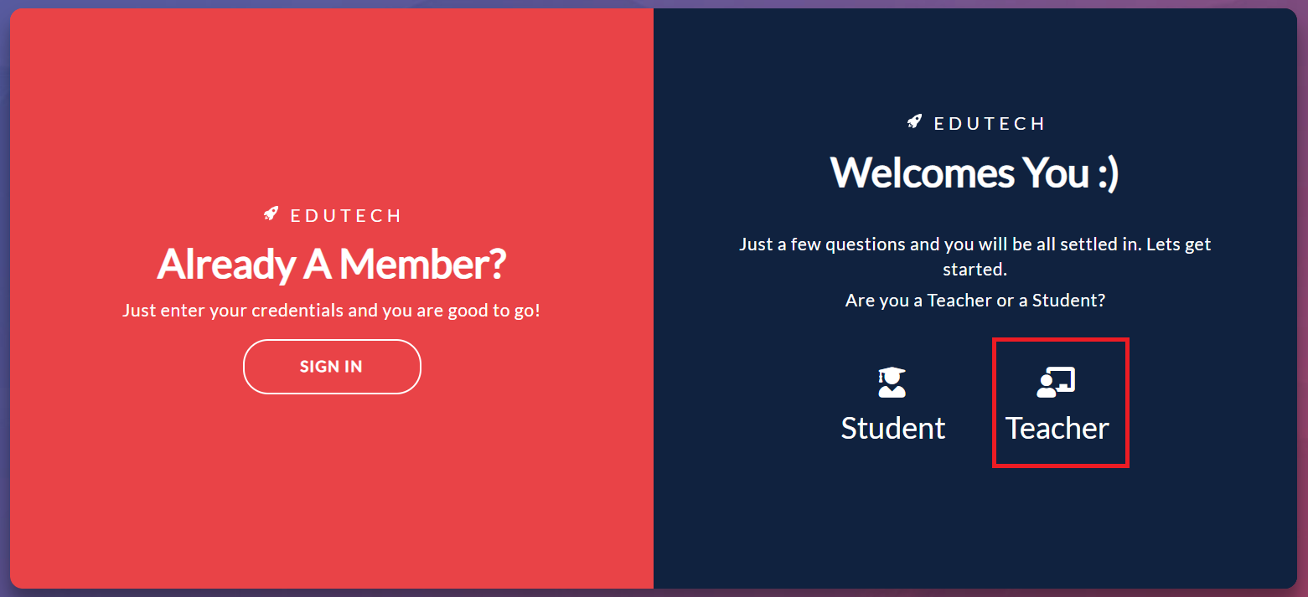

You will then be asked to specify at least one subject that you are interested to instruct from a certain curriculum before signing up. You can select from the ones available from our dropdowns. Curriculum and subject include all the currently popular ones from schools, colleges and universities in Bangladesh such as SSC, HSC, O Levels, A Levels, University admissions, etc. You can also create your custom subject that you intend to teach through Edutech but don’t find it on your dropdown.

You can always change your chosen curriculum and subjects or add new ones once registered. Simply head over to the Settings section on the sidebar (at the bottom left) from your Dashboard once you are inside and you will find the Subject tab to make the necessary changes.

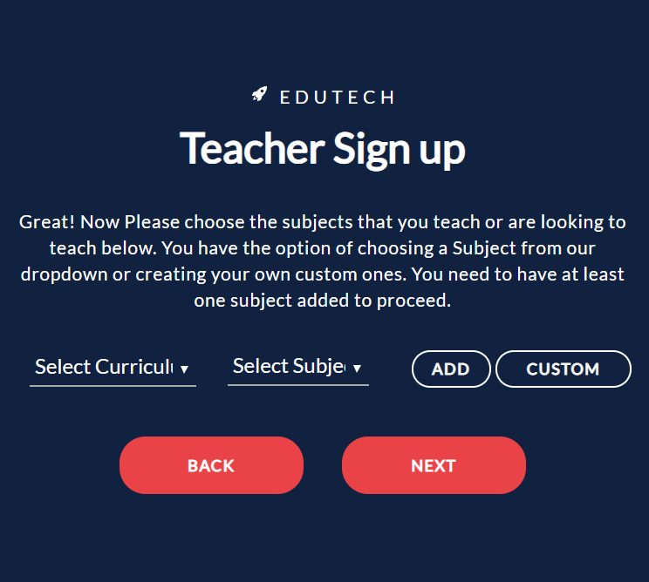

Once you specify your subjects, you will then be required to provide a few basic information such as your name, institution (if any), phone number, email address and a strong login password for your account at Edutech. Click on ‘Sign Up’ once you are done.
There you go! You now have a teacher account at Edutech and may go on to set up your digital classroom with the various features that we provide.

You should find yourself at your dashboard at Edutech. Consider this dashboard your home at Edutech. You get an immediate glimpse of some useful metrics relevant to your digital classrooms. You will also find the sidebar to the left listing all the tools at your disposal to create a digitized classroom. Take a look at this <a>guide</a> to go over these.

Now that you are a registered teacher at Edutech, people willing to learn from you can find you by looking under the subjects that you have chosen. From there they can join the batches that you create from inside Edutech. If you already have students, you could ask them to sign up at Edutech. Together you and your class can benefit from the array of Education management tools that we provide here, free of cost. Students can sign up in one of two types at Edutech: in-person/live students – who attend classes physically and digital/remote students – who attend classes online only through Edutech.

