Animal, dog, or dalmatian? Contextual informativeness, utterance length and utterance frequency affect choice of referring expressions.

Abstract:
The choice of referring expressions is highly context dependent. Whether speakers choose to refer to an object as a "dalmatian", a "dog", or an "animal" is determined partly by the features of the other objects present in the scene, as well as features of the utterance alternatives. The current study within a reference game setting demonstrates that speakers' choice of referring expression is dependent on a rich interplay of the expression's degree of contextual informativeness, its relative length and its relative frequency. If a competitor object of the same category (e.g., dog) as the target object is present in the display, speakers choose a more specific subcategory (e.g., "dalmatian") to refer to the target object. In contrast, when the competitor objects do not share the same (super-) category as the target, speakers are less constrained in choosing an appropriate referring expression. In this event, shorter expressions are preferred over longer ones and more frequent category names are preferred over less frequent ones. The pattern of results is predicted by a production model couched in the Rational Speech Act framework, in which a speaker is modeled as balancing an utterance's contextual informativeness with its cost relative to its alternatives.

Intro … (for this some more lit review is necessary…)

Methods
Participants We recruited 56 participants over Amazon’s Mechanical Turk, who were all native speakers of English and who participated in the experiment in return for reimbursement. The subjects participated in pairs of two.

Materials Stimuli were selected from eight distinct domains. These domains represented basic level categories such as “dog”, for each of which four targets were chosen, which were subcategories of this domain (e.g. “dalmatian”, “pug”, “German Shepherd” and “husky”). Each domain also contained an additional item which belonged to the same basic level category as the targets (e.g. “greyhound”) as well as items which did not belong to the same basic level category, but to the same supercategory (e.g. “elephant” or “squirrel”).

Include picture of example domain?

Design Each trial consisted of a display of three pictures of objects, one of which was designated as the target object. There were four target objects for each of the eight domains, each of which would appear once for every pair, giving rise to a total of 36 trials per pair. There were four conditions which differed in the types of distractors which were shown: (a) distractor12: one distractor of the same basic level and one distractor of the same superlevel were present (e.g. target: “dalmatian”, distractor 1: “greyhound”, distractor 2: “squirrel”), (b) distractor22: two distractors of the same superlevel were present, (c) distractor23: one distractor of the same superlevel and one artifact were present and (d) distractor33: two artifacts were present. The selection of distractors was random for each trial. Furthermore, the experiment contained 36 filler items, in which participants were also asked to produce referential expressions for objects, but here the three pictures illustrated the same stimulus which differed only in size and color. No filler items were reused in the target trials.

→ explain choice of conditions (where? In design section?)

Procedure The experiment was conducted online within a reference game setting. Subjects participated in pairs and were either assigned the speaker or the listener role. Participants would keep their allotted roles for the entire experiment. They were informed that the order of the three pictures which they would both see will be different for the speaker and the listener. Only the speaker could identify the target object by a green square surrounding it. There was a chatbox in which speaker and listener could send messages to each other and communicate. The task was for the speaker to tell the listener which one of the objects is the target and for the listener in turn to select the right object based on this information provided by the speaker.

Annotation Responses were parsed automatically and subsequently checked manually to determine the level of reference used. Incorrect trials were excluded from the analysis, which led to the elimination of 1,1% of trials. Moreover, responses naming the superclass directly as well as responses naming the main attribute of the superclass (e.g. “can fly” for “bird”) were counted as mentioning the superclass.

How do we best justify that we're including the superAttributeMentioned when we're not including sub or BL attributes in analysis?

Results

As shown in Fig. 1, speakers are most likely to refer to the target object with a subcategory label, if their choice of utterance is constrained by a distractor of the same basic level category as the target being present in the scene (i.e. condition distr12, e.g. target: “dalmatian”, distractor 1: “greyhound”). However, when there is no other object of the same basic level category present (as in conditions distr22, distr23 and distr33), subjects are far more likely to choose the basic level term. Interestingly, use of the subcategory term decreases further as there are less or no other distractors present which belong to the same supercategory (e.g. animal). That is, participants are less likely to say “Dalmatian” when there is another animal and an artifact in the display opposed to when there are two animals in the display, and even less likely to say “Dalmatian” when there are no animals in the display. Similarly, the use of the basic level expression steadily increases as the number distractors of the same supercategory decreases. Naming the object by its supercategory term is far less probable than using either the sub- or basiclevel terms, but also increases as the constraints on the speakers utterance choice decrease. Statistical analyses confirmed a main effect of condition...

...running the model in R didn't work on my computer → ask Judith → insert details!

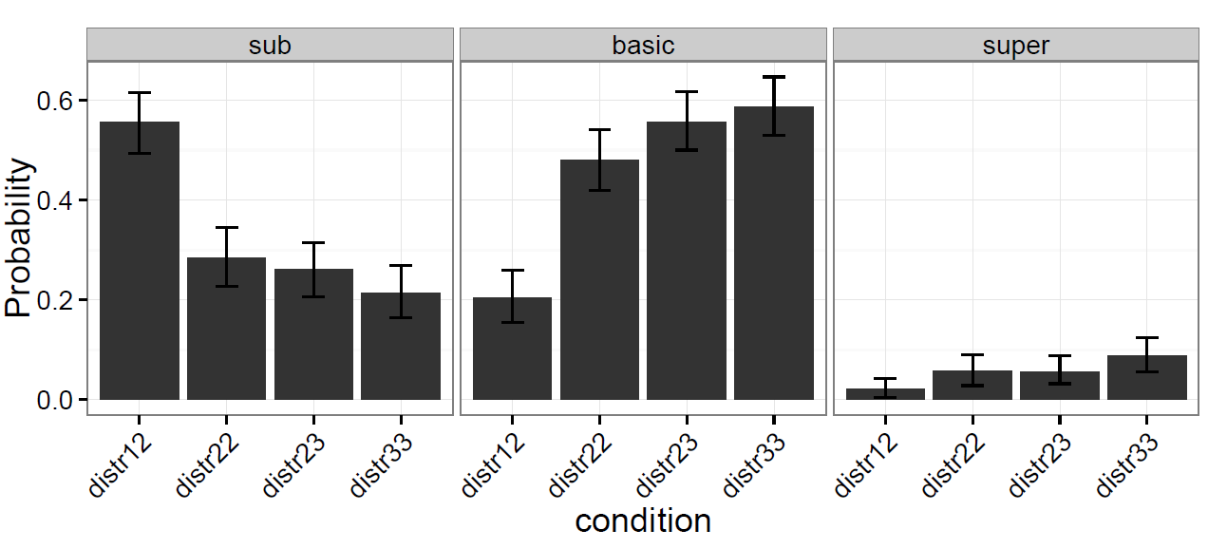
Figure 1: Histogram of probabilities of mentioning the sub-, basic- or superlevel category

Domain-specific results The overall effects were slightly different in the different domains (see Fig. 2). For instance, mentioning the subclass over the basic level term was preferred more in some domains (e.g. in the “candy” domain) than in others. Likewise, some domains had a greater preference for basic level terms (e.g. the “shirt” domain). Using the superclass term also ranged from hardly being observable (e.g. the “flower” domain) to being used more frequently (e.g. in the “bird” domain). Nevertheless, mentioning the sublevel category was always the most frequent choice of utterance in the case where a distractor of the same basic level was displayed. Furthermore, the sublevel term was always mentioned most frequently and the basic level least frequently in just this condition, compared to the other three conditions.

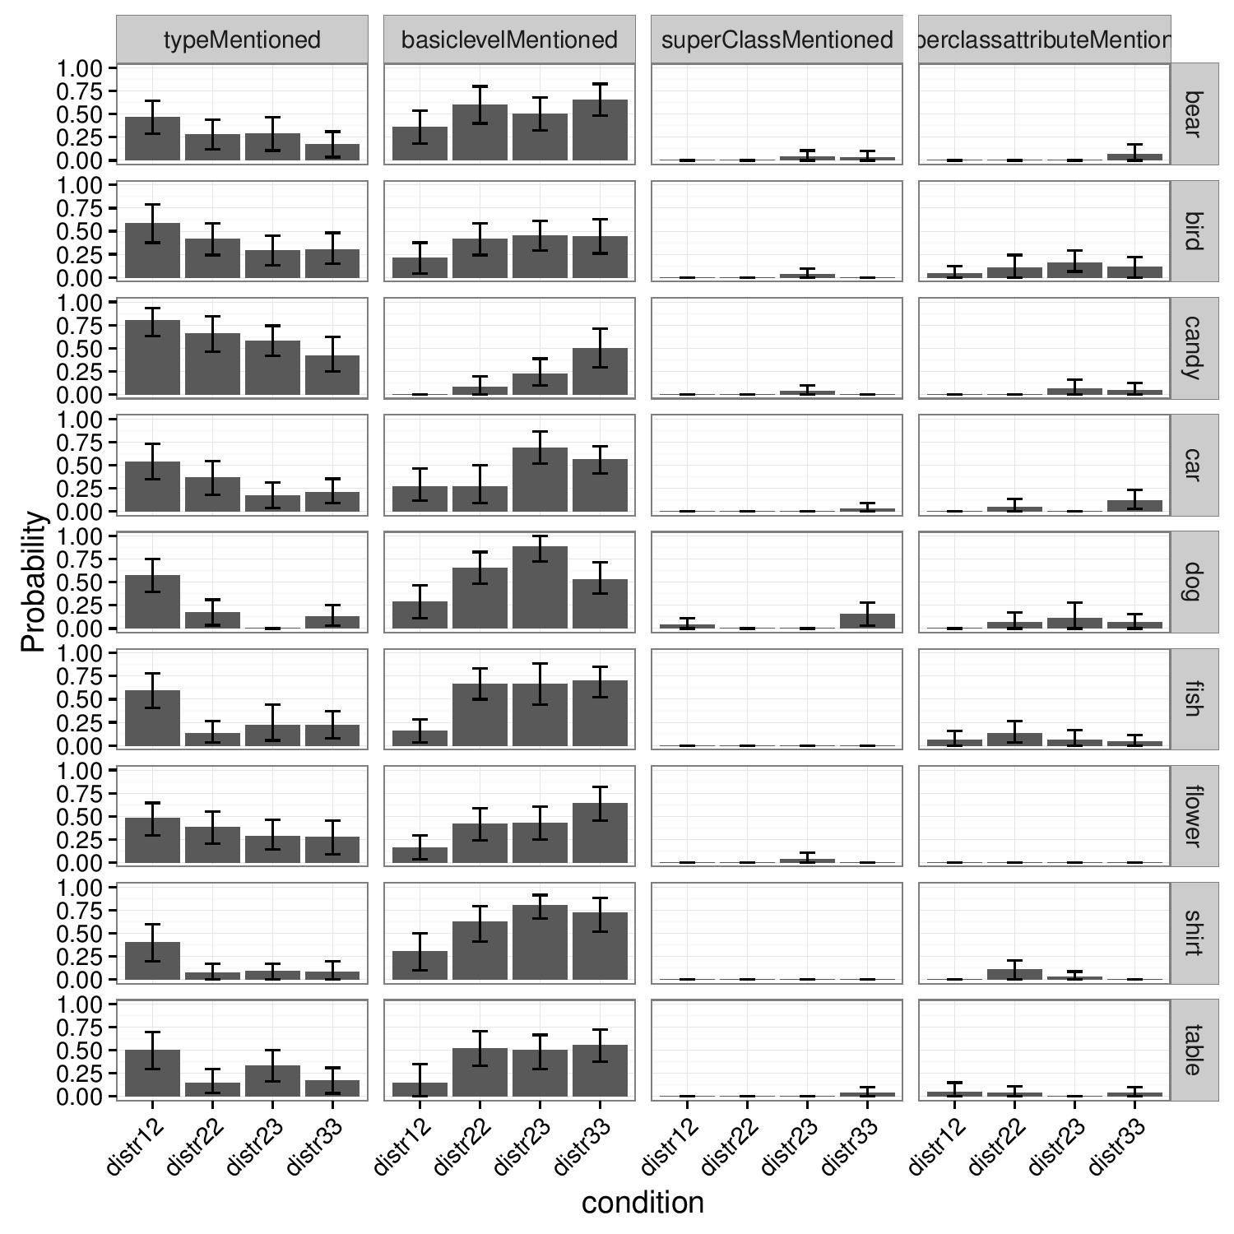
Figure 2: Domain-specific histogram of probabilities of referring to targets with sub-, basic- or superlevel term (change graph labels and combine superclass columns)

Utterance length Another factor contributing to the selection of a level of reference is relative utterance length. As displayed in Fig. 3, speakers are more likely to use the subcategory term if it is relatively short compared to the basic level term (i.e. the ratio sub/basic is relatively small, see blue bars in sublevel column). For example, the length ratio of “chihuahua”/”dog” is bigger than that of “pug”/”dog”, thus the data suggests that “chihuahua” is less frequently used than “pug”. This effect was independent of whether the use of the subcategory was forced by a distractor of the same basic level in the context or not. Furthermore, if the subcategory term was relatively long compared to the basiclevel (i.e. the sub/basic ratio is relatively big, see red bars in basic level column), subjects are more likely to use the basic level referential expression. Statistical tests confirmed ….. → insert statistical details!!!

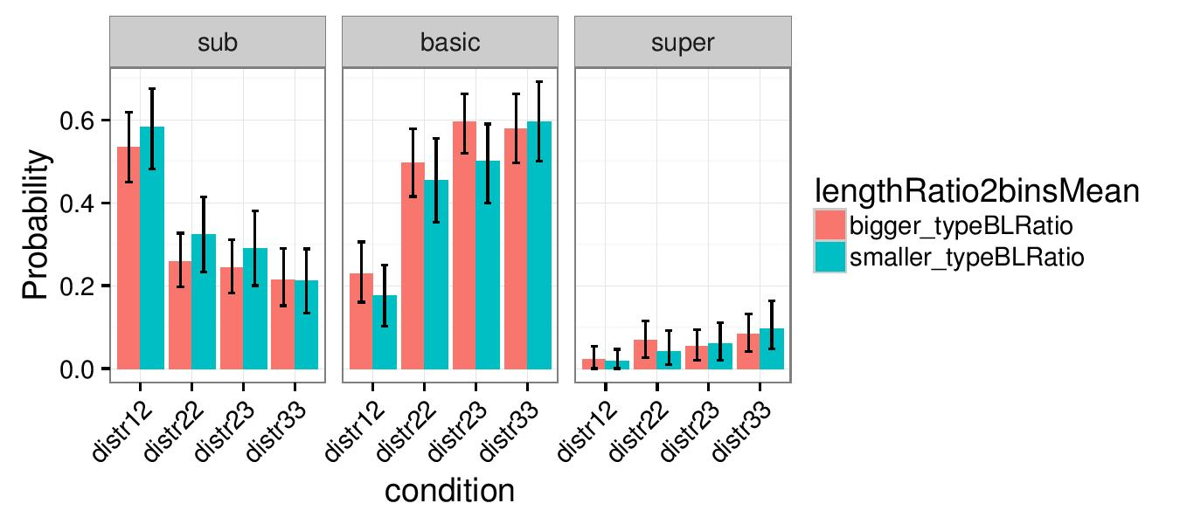
Figure 3: Probability of using sub-, basic- and superlevel terms when the sublevel/basiclevel length ratio is bigger (red) or smaller (blue) than the mean sublevel/basiclevel length ratio (make prettier labels)

Utterance frequency Besides contextual informativeness and utterance length, the frequency of a specific label also plays a role in determining speakers choice in referential expression. Illustrated in Fig. 4, the data suggests that relatively frequent sublevel terms (i.e. those which have a relatively high frequency compared to the frequency of the basic level and thus also have a relatively big frequency ratio) are preferred over more infrequent ones. This is especially the case when the speaker is not forced to use the subcategory term, namely when there is no distractor present which is a member of the same basic level category as the target (conditions distr22, distr23 and distr33). The basic level terms on the other hand are used more often if the competing sublevel alternative is relatively infrequent (see blue bars in basic level column). ….
*insert statistical results!!!

Where to we explain where we got the frequencies from? (also where to say that we used the character length and not syllable length in length analysis?)

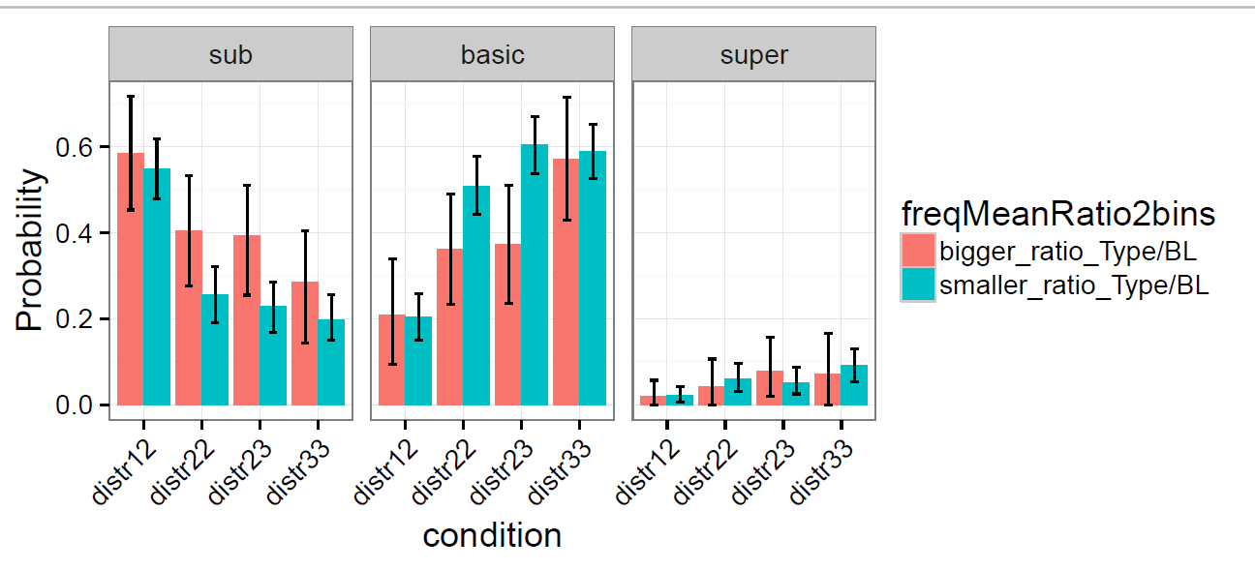
Figure 4: Probability of using sub-, basic- and superlevel terms when the sublevel/basiclevel frequency ratio is bigger (red) or smaller (blue) than the mean sublevel/basiclevel frequency ratio (make prettier labels)

Interaction between length and frequency Furthermore, there was an interaction between length and frequency, such that length had a greater effect on high-frequency than on low-frequency sublevel terms.

Why are (long) high frequency types less likely used than low frequency types???!
The other analyses showed that high frequency subtypes are more likely to be used that low frequency subtypes! (...and this is also what we expected...?)

(maybe this is related to how short, long, low-frequency and high-frequency are defined...)

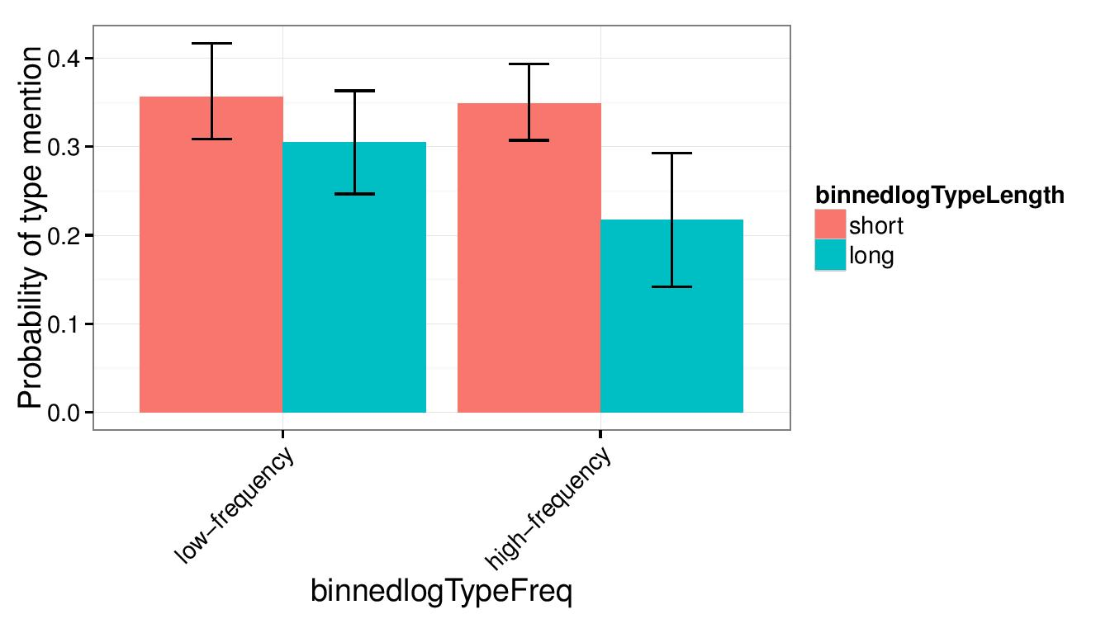

Figure 5: Probability of using a sublevel term when its frequency is high opposed to low and the length short opposed to long, averaged over conditions
* how are “short” and “long” and “low-frequency” and “high-frequency” defined here?

Mixed effects model analysis

Modelling the choice of referential expression in RSA

Discussion and conclusion

* Blocking of category labels can be observed: The selection of a type of label can be manipulated by changing the types of distractors present in a scene
→ Context is essential in order to determine type of referential expression

* Length and frequency of utterance alternatives play an important role in determining the type of referential expression. More frequent as well as shorter labels are preferred.

* However, length and frequency do not account completely for utterance choice, since superclasses are generally more frequent than basic level categories, but are nevertheless strongly dispreferred over the basic level.

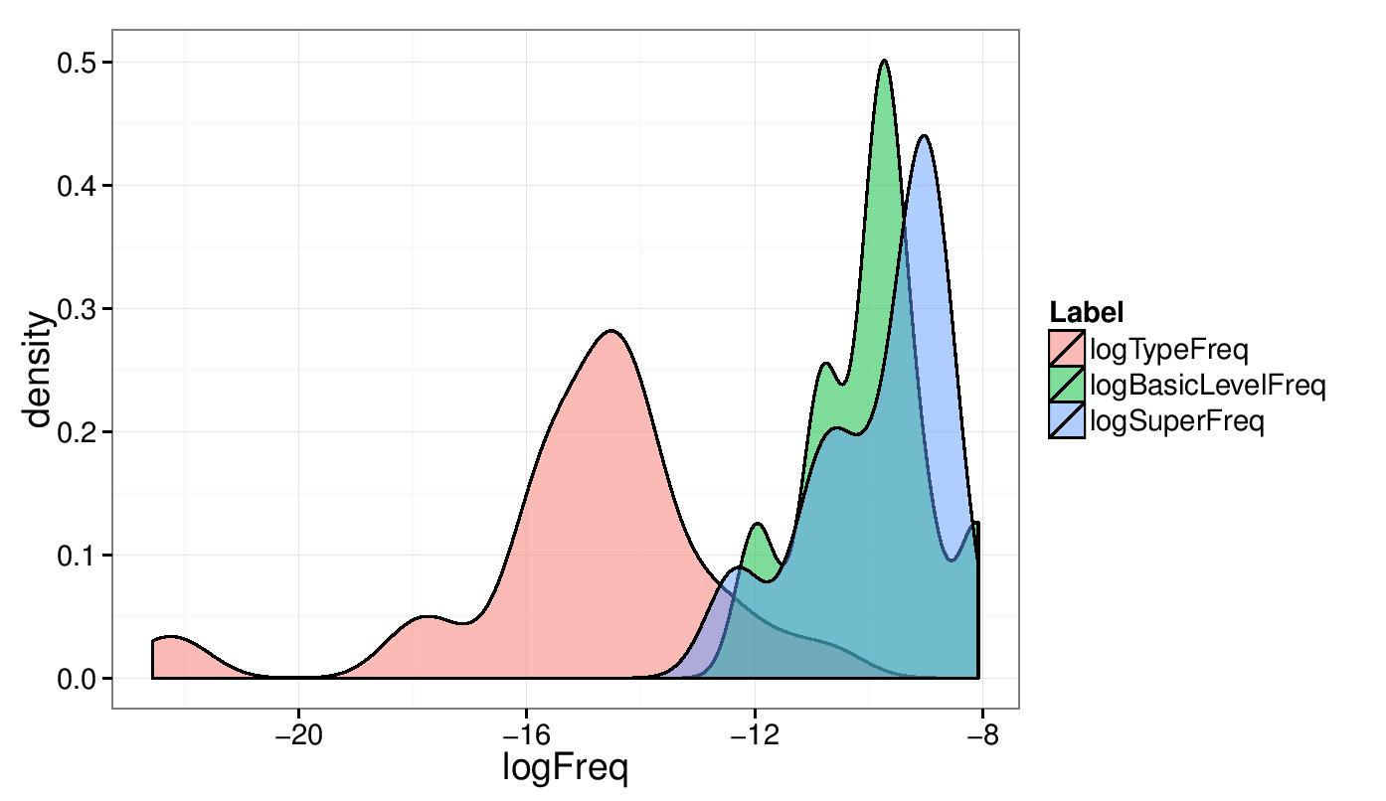

→ Discuss evidence for basic level in lit: e.g. Rosch paper (1976): BL categories...
→ carry the most information
→ possess the highest category cue validity
→ are most differentiable from another
→ are the most inclusive categories for which a concrete image of the category as a whole can be formed
→ Discuss levels of abstraction
→ Discuss cognitive economy in categorization

References

