OUTPUMPER
User Manual & Complete Setup Guide
Version 1.2 | July 2026
Cold Email From Inside Your Outlook
outpumper.com | support@outpumper.com
The Grow Revenue Company Limited

Table of Contents

PART 1 — GETTING STARTED
- 1. What You Need Before You Start
- 2. Setting Up Microsoft 365
- 3. Setting Up Outlook Classic
- 4. Installing OutPumper
- 5. Starting Your Free Trial
- 6. Licensing & Plans

PART 2 — UNDERSTANDING THE INTERFACE
- 7. The Campaign Tab — Your Command Center
- 8. The Mailboxes Tab — Connection & Rotation
- 9. The Dispatcher Tab — Multi-Campaign Engine
- 10. The Verifier Tab — Email Validation
- 11. The OneBox Tab — Reply Management
- 12. The Logs Tab — Activity History
- 13. The Settings Tab — Tracking, License & Support

PART 3 — BUILDING YOUR INFRASTRUCTURE
- 14. Understanding Shared Mailboxes
- 15. Creating Shared Mailboxes
- 16. Adding User Mailbox Licenses (Account Rotation)
- 17. Connecting External Providers (Google Workspace, SendGrid, Mailgun, SMTP)
- 18. Email Authentication (SPF, DKIM, DMARC)
Since February 2024, SPF, DKIM and DMARC are mandatory policy for bulk senders at Google and Yahoo (with spam complaints kept under 0.3 percent), and Microsoft introduced its own high-volume sender requirements in 2025. Unauthenticated cold email is filtered silently. This section is therefore not optional. Complete it before sending your first campaign.

PART 4 — LAUNCHING YOUR FIRST CAMPAIGN
- 19. Building & Verifying Your Email List
- 20. Writing Your First Email (Spintax & Templates)
- 21. Setting Up Multi-Step Sequences
- 22. A/B Testing
- 23. Launching & Monitoring

PART 5 — SCALING & REPUTATION MANAGEMENT
- 24. The Daily Ramp-Up Schedule
- 25. Scaling to Thousands of Emails Per Day
- 26. When Exchange Restricts Your Account
- 27. How Adding More Accounts Affects Outlook Performance
- 28. Keeping Your Reputation High
- 29. Best Practices & Tips

PART 1 — GETTING STARTED

1. What You Need Before You Start
Before installing OutPumper, make sure you have the following ready:
- A Windows PC or laptop (Windows 10 or 11)
- Microsoft 365 Business Basic account ($6/month) or higher
- Outlook Classic desktop app (included with Windows, free download from Microsoft Store)
- One or more domains for sending cold emails (any .com, .io, .co, etc.)
- A verified email list (we strongly recommend verification before sending)
⚠ WARNING: OutPumper runs inside Outlook Classic (the desktop app). It does NOT work with the New Outlook, Outlook Web, or Outlook for Mac. Make sure you have Outlook Classic installed and the 'Try the new Outlook' toggle is turned OFF.

2. Setting Up Microsoft 365
Microsoft 365 is the backbone of your cold email infrastructure. Your emails travel through Microsoft Exchange Online — the same infrastructure used by half the Fortune 500. Here is how to set it up from scratch.

Step 1: Purchase Microsoft 365 Business Basic
- Go to microsoft.com/microsoft-365/business and click 'Buy Now'
- Choose Microsoft 365 Business Basic ($6/month per user) — this is the cheapest plan that includes Exchange email
- Create your admin account (e.g., admin@yourdomain.com)
- Add your sending domain(s) during setup and verify DNS ownership
💡 TIP: You only need ONE Microsoft 365 tenant. All your domains and mailboxes live inside this single tenant. The $6/month covers your admin account. Shared mailboxes are free.

Step 2: Add Your Sending Domain(s)
- In M365 Admin Center (admin.microsoft.com), go to Settings → Domains
- Click 'Add domain' and enter your sending domain (e.g., youroutreach.com)
- Follow the DNS verification steps (usually a TXT record)
- Repeat for each domain you want to send from
💡 TIP: Using 2-3 different domains spreads your sending volume and protects your primary brand. If one domain gets flagged, your others keep running. Cheap .com domains work fine — $10-15/year each.

3. Setting Up Outlook Classic
OutPumper is a VSTO Outlook add-in — it runs inside Outlook Classic on your desktop.

Download Outlook Classic
- Open the Microsoft Store on your Windows PC
- Search for 'Outlook' and install 'Microsoft Outlook' (the classic version)
- If you already have Office installed, Outlook Classic is already on your PC
⚠ WARNING: Do NOT use 'New Outlook' or 'Outlook (new)'. OutPumper requires Outlook Classic. If you see the toggle 'Try the new Outlook' at the top — make sure it is turned OFF.

Add Your Exchange Account to Outlook
- Open Outlook Classic
- Go to File → Add Account
- Enter your M365 admin email (e.g., admin@yourdomain.com) and password
- Outlook will auto-discover the Exchange settings and configure itself
- Wait for the initial sync to complete (this may take a few minutes)
Once your account appears in the left sidebar with Inbox, Sent Items, etc., you are ready to install OutPumper.

4. Installing OutPumper
- Download OutPumper-Setup.exe from outpumper.com/download.html
- Close Outlook completely before running the installer
- Run the installer — it will check for .NET 4.8 and VSTO Runtime (installs them automatically if needed)
- Follow the installation wizard — default settings work fine
- Open Outlook — you should see the OutPumper panel on the right side
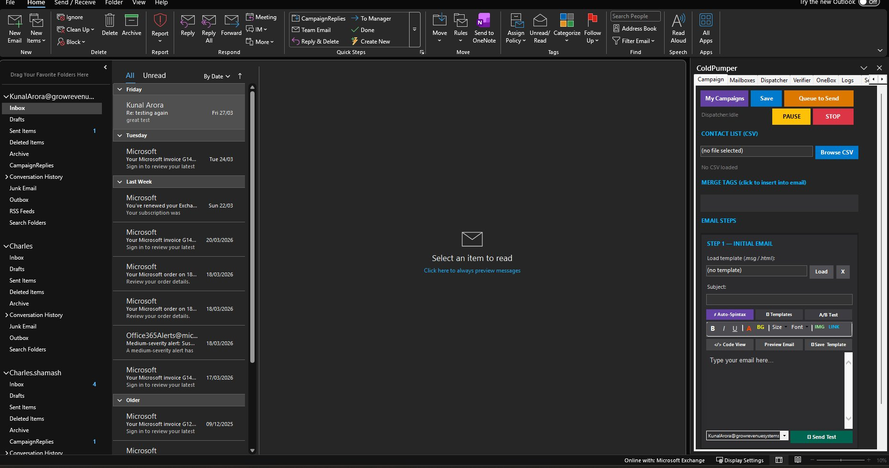
💡 TIP: If Windows SmartScreen shows a warning, click 'More info' then 'Run anyway'. The installer is signed by The Grow Revenue Company Limited with a Certum OV certificate. SmartScreen warnings disappear as more people download the file.
After installation, OutPumper appears as a panel (task pane) on the right side of Outlook with tabs: Campaign, Mailboxes, Dispatcher, Verifier, OneBox, Logs, and Settings.

5. Starting Your Free Trial
When you first open Outlook after installing OutPumper, a license activation window appears.

Trial Activation
- The License Gate window appears automatically on first launch
- Click 'Start 7-Day Free Trial'
- Enter your email address — this is where your license key will be sent after the trial
- Click Activate — your trial begins immediately
During the 7-day trial, you have full access to all OutPumper features. Use this time to set up your mailboxes, verify your email list, and run your first test campaign.

What Happens After the Trial
On Day 8, your card is charged automatically (you entered it during signup on our website). Your license key and password are delivered via email. Enter them in the License Gate to activate your paid license.
You can check your trial status anytime in the Settings tab — it shows 'Status: TRIAL (X days remaining)'.
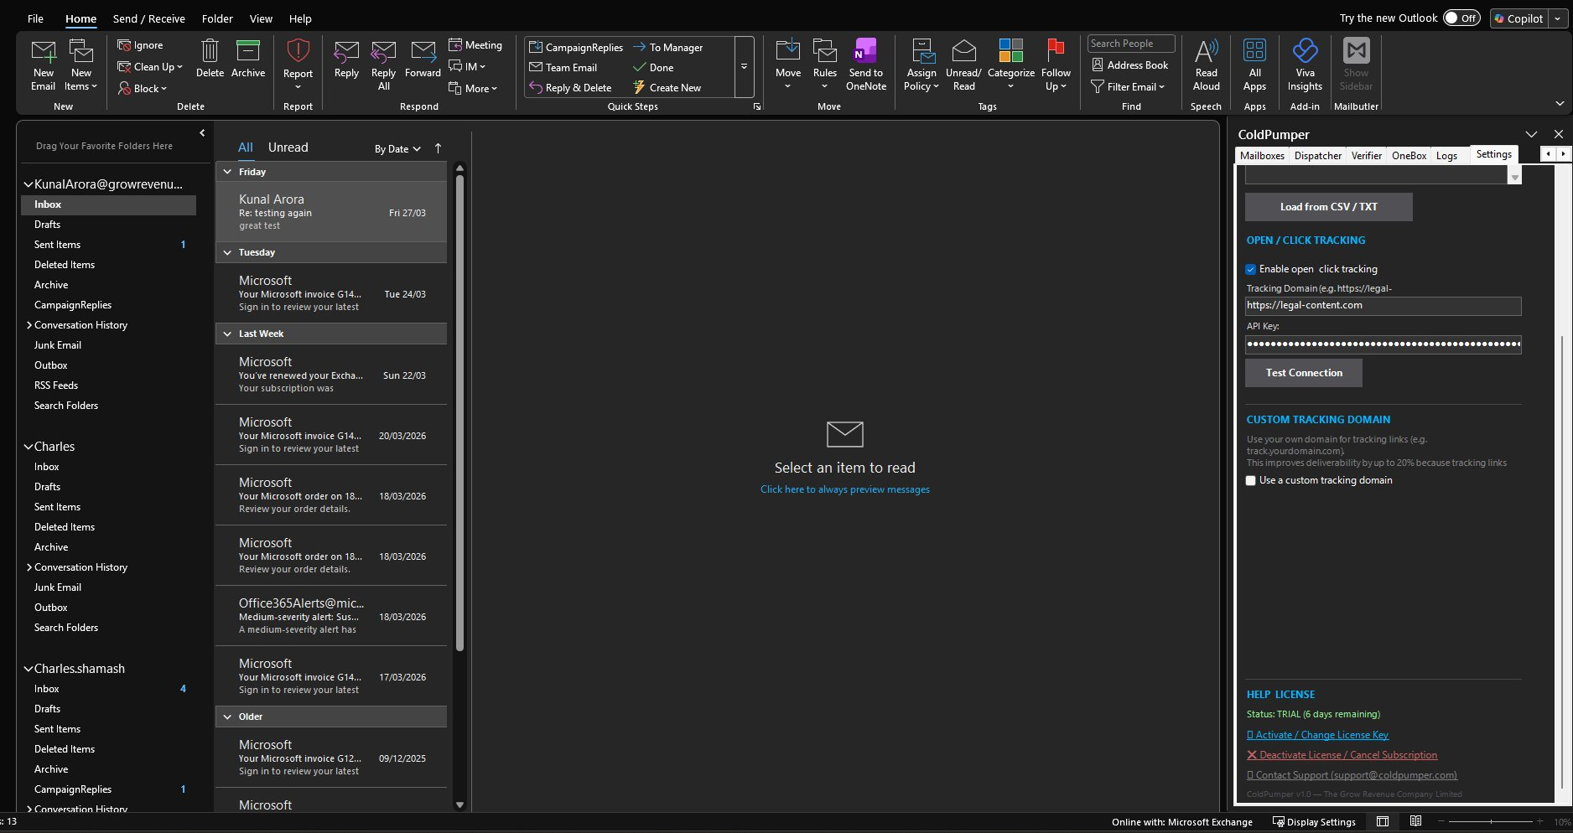

6. Licensing & Plans
Feature | Pro ($49/mo) | Lifetime ($497) | Agency ($49/mo + $15/client)
Mailboxes | Unlimited | Unlimited | Unlimited per client
Emails/Day | Unlimited* | Unlimited* | Unlimited*
External SMTP | Yes | Yes | Yes
Tracking | Full | Full | Full
Machine Activations | 2 | 2 | 2 per product
Support | Email | Email | Priority Email
*Exchange limits apply. Daily volume depends on your M365 infrastructure (number of accounts, domain reputation, ramp-up stage).
💡 TIP: The Lifetime plan is a one-time $497 payment — no recurring charges ever. All future updates included. This is the best value for solo operators and small teams.

PART 2 — UNDERSTANDING THE INTERFACE
OutPumper has 7 tabs across the top of the sidebar panel. Each tab controls a different aspect of your cold email operation. This section explains what each tab does, why it exists, and how to use it.

7. The Campaign Tab — Your Command Center

What It Is
The Campaign tab is where you build, write, and manage your cold email campaigns. This is the tab you will spend 80% of your time in.

Why It Exists
Every cold email operation starts with a campaign — a targeted outreach to a list of prospects with a specific message and follow-up sequence. The Campaign tab gives you everything you need to create, edit, save, queue, and monitor campaigns.


What Each Section Does
Top Buttons
- My Campaigns: Opens a window showing all your saved and running campaigns. You can Resume, Restart, Reset, view Progress, Delete, see Full Reports, filter by Pending Only or Completed status.
- Save: Saves the current campaign (contacts + email content + settings) so you can resume later or run it again.
- Queue to Send: Adds the campaign to the sending queue. It will start sending when you hit Start in the Dispatcher tab (or Send from Campaign tab).
- Pause: Pauses the currently running campaign mid-send. Picks up where it left off when resumed.
- Stop: Stops the campaign completely. Contacts already sent to are marked as 'sent' — remaining contacts are still pending.
Contact List (CSV)
Click 'Browse CSV' to import your prospect list. OutPumper auto-detects columns: email, first_name, last_name, company, title, and any custom fields. After import, the total contact count appears below.
Merge Tags
After importing a CSV, all column headers appear as clickable merge tags. Click any tag to insert it into your email at the cursor position. Common merge tags: {{first_name}}, {{company}}, {{title}}.
Email Steps
This is where you write your email content. Each campaign can have multiple steps (initial email + follow-ups).
- Step 1 — Initial Email: Your first outreach. Write the subject line and body here.
- Load Template: Load a previously saved .msg or .html template file.
- Subject: Your email subject line. Keep it 3-7 words. Use merge tags.
- Auto-Spintax: OutPumper's word variation engine. Click to generate spintax from your text — creates {word1|word2|word3} variations automatically so every email is unique.
- Templates: Browse and load saved templates.
- A/B Test: Create a variant of this email for split testing. 50% of contacts get version A, 50% get version B.
Formatting Toolbar
- B, I, U, A, BG: Bold, Italic, Underline, Text Color, Background Color
- Size, Font: Change font size and font family
- IMG, LINK: Insert image or hyperlink (use sparingly in cold email — plain text performs better)
- Code View: Switch to HTML source code view for advanced editing
- Preview Email: Shows a rendered preview of your email with merge tags populated from the first contact in your CSV
- Save Template: Save the current email as a reusable template
Send Test
At the bottom, select which account to send a test from and click 'Send Test' to send yourself a test email before launching the campaign. Always test before sending to your full list.
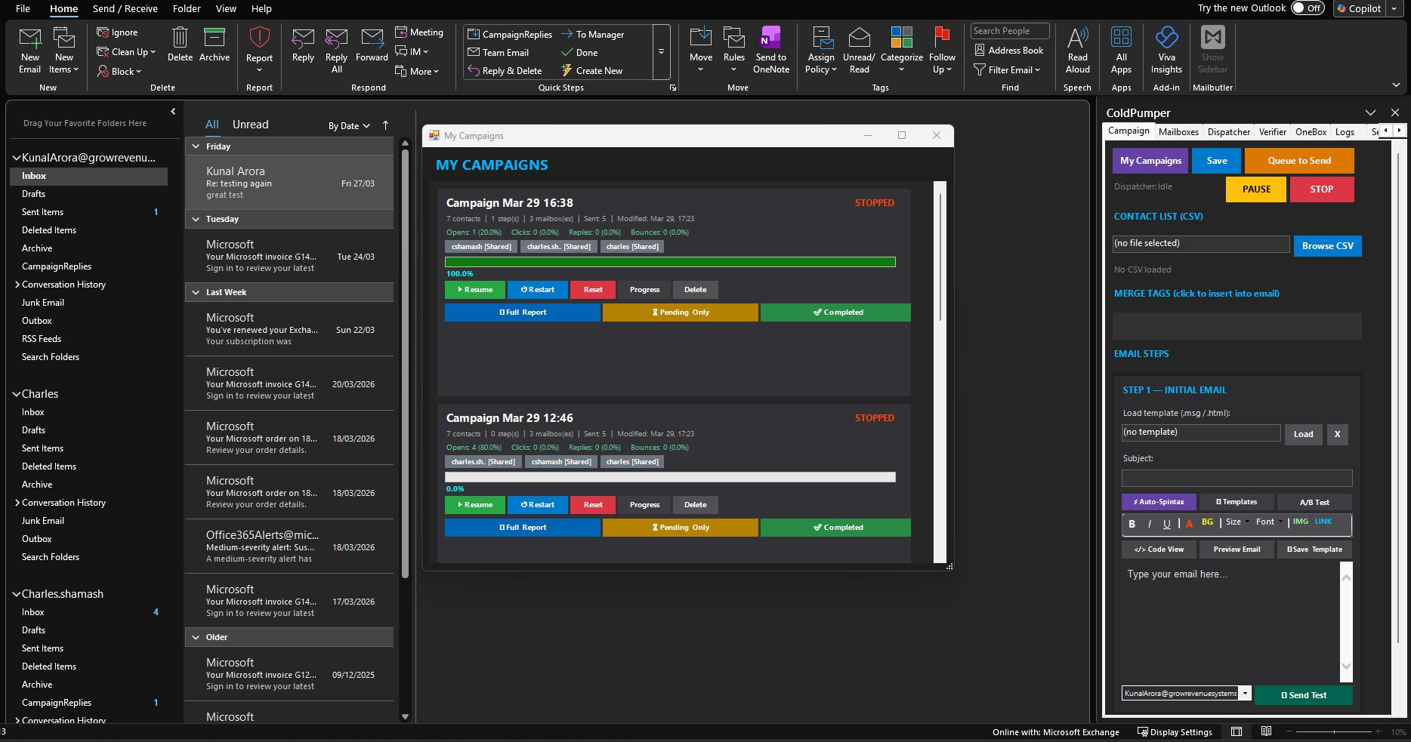

My Campaigns Window
Click 'My Campaigns' to see all your campaigns. Each campaign shows: contact count, steps, mailboxes used, sent/remaining count, open rate, click rate, reply count, bounce count, and status (Running/Stopped/Completed).
- Resume: Continue a paused or stopped campaign from where it left off
- Restart: Start the campaign over from the beginning (re-sends to everyone)
- Reset: Clears all progress — treats all contacts as unsent
- Progress: Shows a detailed per-contact breakdown of sent/pending/bounced/replied
- Delete: Permanently removes the campaign
- Full Report: Exports a detailed CSV report with per-contact status
- Pending Only: Filters to show only contacts who haven't been sent to yet
- Completed: Filters to show only contacts who have been sent all steps

8. The Mailboxes Tab — Connection & Rotation

What It Is
The Mailboxes tab is where you connect your email accounts to OutPumper, configure rotation settings, create shared mailboxes, and add external providers like Google Workspace or private SMTP servers.

Why It Exists
Sending all emails from one address is a red flag. Mailbox rotation spreads your volume across multiple 'From' addresses — making your sending look natural to inbox providers. This tab manages all your sending identities.
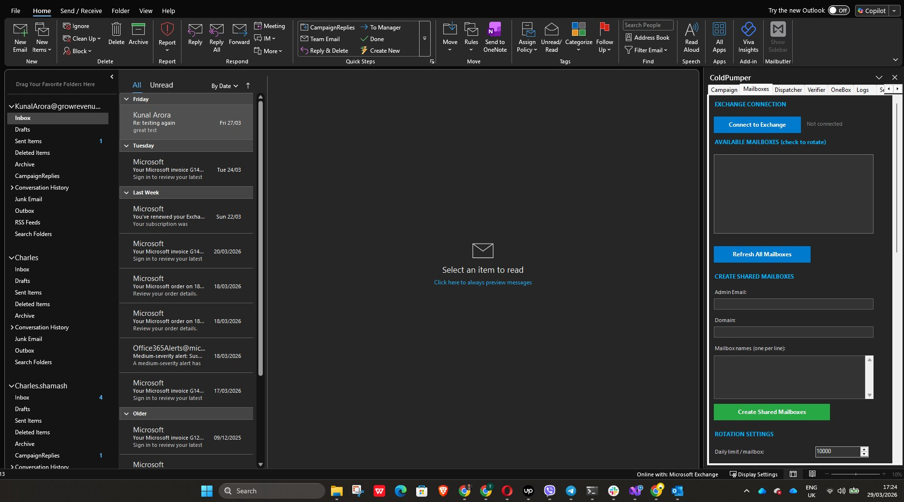

Exchange Connection
At the top, you'll see 'EXCHANGE CONNECTION' with a 'Connect to Exchange' button. Click this to authenticate with your M365 account. Once connected, it shows your available shared mailboxes below.
Available Mailboxes (check to rotate)
After connecting, all shared mailboxes in your tenant appear with checkboxes. Check the ones you want OutPumper to rotate through when sending campaigns. Unchecked mailboxes are ignored.
- Refresh All Mailboxes: Re-scans your M365 tenant for any new shared mailboxes you've created since last connecting.
Create Shared Mailboxes
You can create shared mailboxes directly from OutPumper without going to the M365 admin panel:
- Enter your Admin Email (the account that has admin rights)
- Enter the Domain (e.g., yourdomain.com)
- Enter mailbox names, one per line (e.g., outreach, connect, hello, team)
- Click 'Create Shared Mailboxes'
OutPumper uses the Microsoft Graph API to create them instantly. They appear in the mailbox list above within minutes.
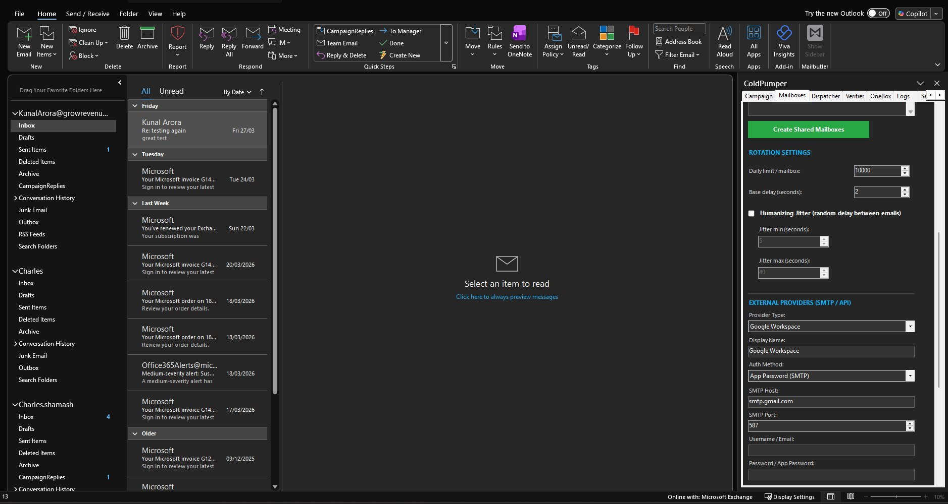
Rotation Settings
- Daily limit / mailbox: Maximum emails to send from each mailbox per day. Default is 10,000 (Exchange's hard limit). For new mailboxes, set this lower (50-200) and increase gradually.
- Base delay (seconds): Minimum seconds between each email send. Default is 2 seconds. Lower = faster but riskier. Recommended: 2-5 seconds.
- Humanizing Jitter: When enabled, adds a random delay BETWEEN the min and max jitter values on top of the base delay. This makes your sending pattern look human instead of robotic.
- Jitter min (seconds): Minimum random additional delay. Default: 5 seconds.
- Jitter max (seconds): Maximum random additional delay. Default: 10 seconds.
With base delay of 2 + jitter between 5-10, each email takes 7-12 seconds on average. This means approximately 5-8 emails per minute — a natural human-like sending speed.
💡 TIP: Jitter is one of the most important anti-detection features. Without it, emails go out at exact intervals (every 2.0 seconds) which looks like a machine. With jitter, the intervals are 7.2s, 11.4s, 8.8s, 9.1s — looks like a human manually sending.

External Providers (SMTP / API)
Below the Exchange section, you can add external email providers to increase your total sending capacity beyond Exchange limits.
Supported Providers
- Google Workspace: SMTP via smtp.gmail.com:587. Use App Passwords (not your regular password). Each Google account adds ~500 emails/day capacity.
- SendGrid: SMTP via smtp.sendgrid.net:587. Use your SendGrid API key as the password. Username is always 'apikey'.
- Mailgun: SMTP via smtp.mailgun.org:587. Use your Mailgun SMTP credentials.
- Amazon SES: SMTP via email-smtp.us-east-1.amazonaws.com:587. Use your SES SMTP credentials (not your AWS access keys).
- Any SMTP Server: Enter custom SMTP host, port, username, password, and auth method.
How to Connect an External Provider
- Select the Provider Type from the dropdown
- Enter a Display Name (e.g., 'Google - outreach@gmail.com')
- Select Auth Method (App Password for Google, API Key for SendGrid, etc.)
- Enter SMTP Host and Port (auto-filled for known providers)
- Enter Username / Email and Password / App Password
- Click 'Test Connection' to verify it works
Once connected, external providers appear in the mailbox rotation list alongside your Exchange mailboxes. OutPumper interleaves sends across all providers.
⚠ WARNING: Adding too many accounts to Outlook can slow it down. Each Exchange account opens a MAPI session that consumes memory. Recommended maximum: 5-7 Exchange accounts in Outlook. External SMTP providers don't affect Outlook performance because they send directly via SMTP, not through the Outlook MAPI spooler.

9. The Dispatcher Tab — Multi-Campaign Engine

What It Is
The Dispatcher is OutPumper's multi-campaign sending engine. It interleaves emails across multiple campaigns and mailboxes simultaneously, ensuring balanced sending that looks natural.

Why It Exists
If you run 3 campaigns manually, you'd need to start one, wait, stop, start the next. The Dispatcher automates this — it queues all campaigns from the Campaign tab and sends them in an interleaved pattern. Campaign A sends email 1, Campaign B sends email 1, Campaign C sends email 1, then back to A for email 2, etc.
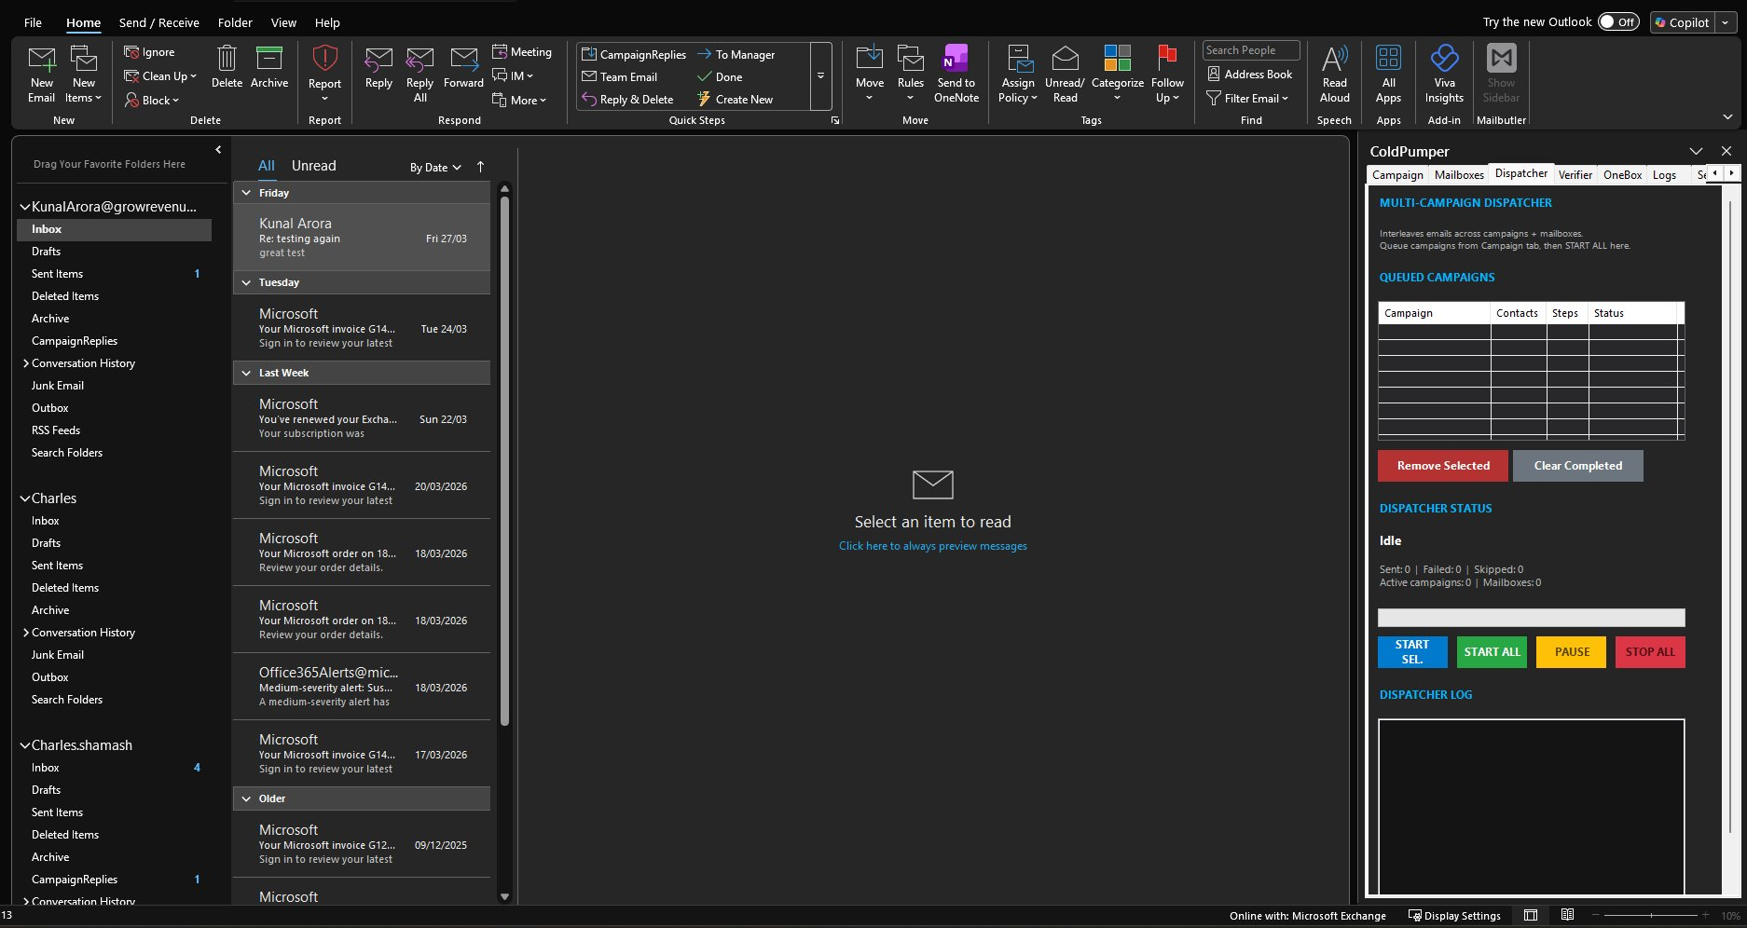

How to Use It
- Create your campaigns in the Campaign tab (import CSV, write email, configure)
- Click 'Queue to Send' for each campaign you want to run
- Switch to the Dispatcher tab — queued campaigns appear in the list
- Click 'START ALL' to begin sending all queued campaigns
Dispatcher Controls
- START SEL.: Start only the selected campaign(s)
- START ALL: Start all queued campaigns
- PAUSE: Pause all sending (can be resumed)
- STOP ALL: Stop all campaigns
Dispatcher Status
Shows real-time stats: Sent count, Failed count, Skipped count, Active Campaigns, Active Mailboxes. The progress bar shows overall completion across all campaigns.
Dispatcher Log
Live feed of every email being sent — shows timestamp, from address, to address, subject, and status (sent/failed/skipped). Useful for monitoring in real-time and debugging issues.
💡 TIP: Queue all your campaigns before clicking START ALL. The Dispatcher handles interleaving automatically — you don't need to manually balance volume across campaigns.

10. The Verifier Tab — Email Validation

What It Is
The Verifier tab is OutPumper's built-in email verification tool. It checks every email address in your CSV for validity before you send, preventing bounces that damage your reputation.

Why It Exists
Bounces are the #1 reputation killer in cold email. A bounce rate above 5% will trigger Exchange restrictions. The Verifier catches invalid addresses BEFORE they can bounce.
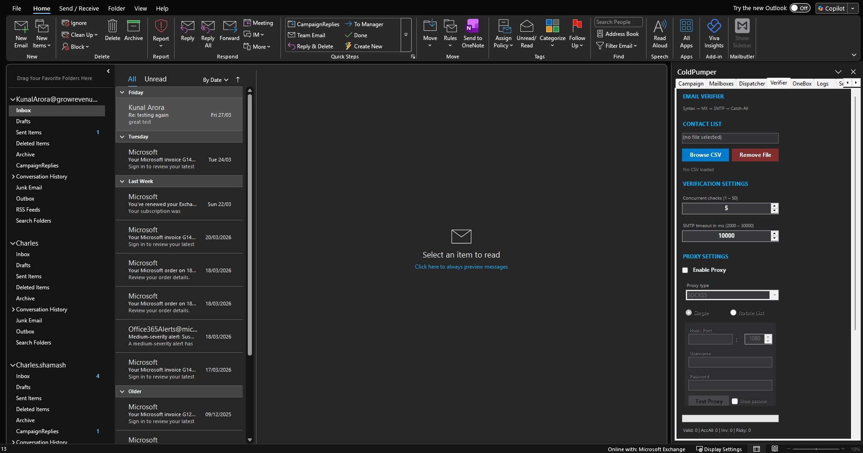

Verification Pipeline
OutPumper runs each email through a 4-step verification process:
Step 1: Syntax Check
Validates the email format — proper structure, no invalid characters, valid TLD.
Step 2: MX Record Lookup
Checks if the domain has mail servers configured. No MX records = the domain doesn't receive email = guaranteed bounce.
Step 3: SMTP Handshake
Connects to the mail server and simulates sending an email (without actually sending). The server responds with whether the specific mailbox exists. This catches 'user not found' bounces.
Step 4: Catch-All Detection
Some domains accept ALL email (catch-all domains). For these, SMTP verification can't confirm specific addresses. OutPumper marks them as 'Accept All' — they might be valid, might not.

Verification Settings
- Concurrent checks (1-50): How many emails to verify simultaneously. Higher = faster but uses more bandwidth. Default: 5. Recommended: 5-15.
- SMTP timeout (2000-30000ms): How long to wait for a mail server response. Default: 10000ms (10 seconds). Slow servers in developing countries may need 15000-20000ms.

Results
After verification, each email is categorized:
- Valid: Confirmed to exist. Safe to send. (Green)
- Accept All: Domain accepts everything — can't confirm specific address. Include but monitor bounce rate. (Yellow)
- Invalid: Does not exist. Guaranteed bounce. REMOVE before sending. (Red)
- Risky: Might exist but verification was inconclusive. Use at your own risk. (Orange)
Results appear at the bottom: Valid count, AccAll count, Inv count, Risky count.

Why Use a Proxy for Verification
When you verify thousands of emails, your IP address makes thousands of connections to mail servers worldwide. Some mail servers detect this pattern and temporarily block your IP. If your IP gets blocked, you can't verify OR send.
A proxy routes verification traffic through a different IP — protecting your main IP from being flagged by overly aggressive mail servers. This is especially important if you're on a residential internet connection.
Proxy Settings
- Enable Proxy: Toggle proxy on/off
- Proxy Type: SOCKS5 (recommended), HTTP, or HTTPS
- Single: Use one proxy for all verification
- Rotate List: Rotate through multiple proxies (paste a list, one per line)
- Host:Port: Enter proxy address and port
- Username/Password: If your proxy requires authentication
- Test Proxy: Verify the proxy works before starting verification
💡 TIP: For residential/home internet connections, ALWAYS use a proxy for email verification. For VPS/datacenter connections, a proxy is less critical but still recommended for large lists (5,000+).

11. The OneBox Tab — Reply Management

What It Is
OneBox is OutPumper's unified reply inbox. It collects all replies from all your campaigns, across all mailboxes, into one centralized view. No more checking 10 different mailboxes manually.

Why It Exists
When you send from outreach@domain1.com, connect@domain2.com, and hello@domain3.com, replies scatter across all those mailboxes. OneBox pulls them all together so you never miss a reply.
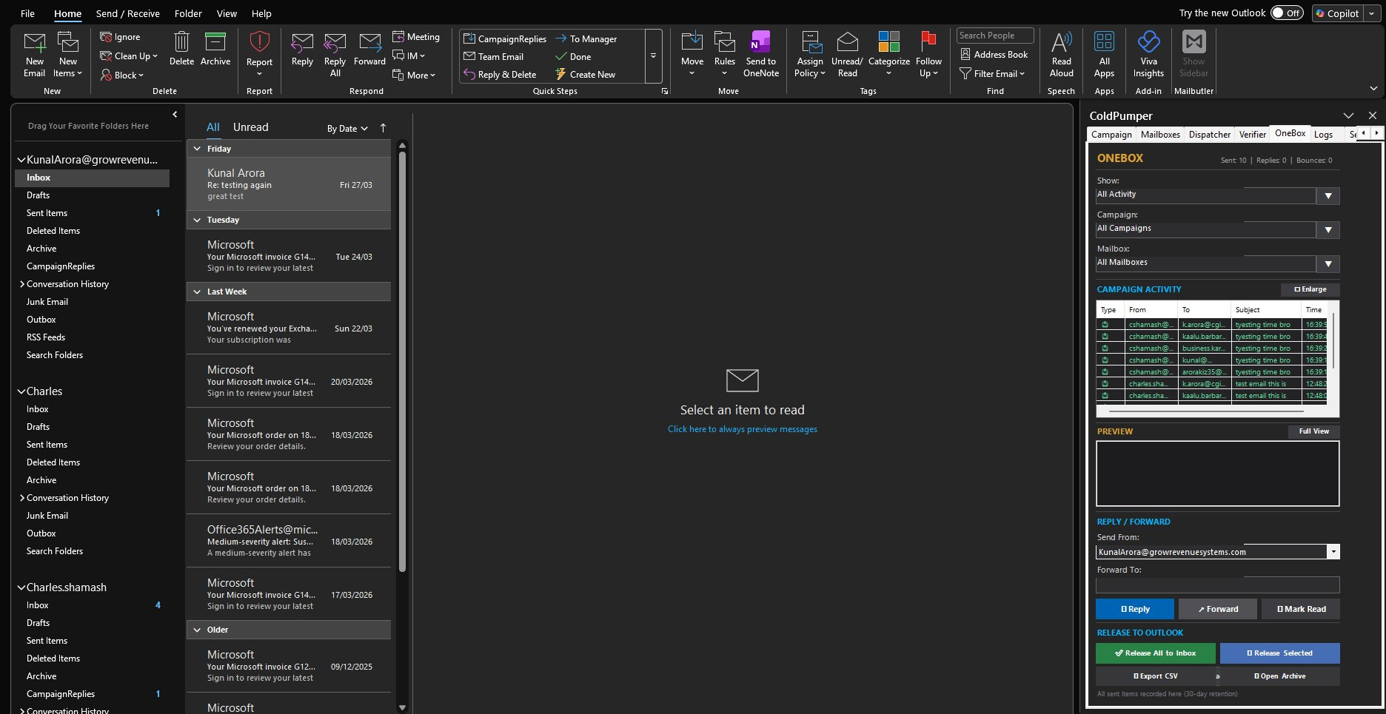

How to Use It
Filters
- Show: Filter by All Activity, Replies Only, Sends Only
- Campaign: Filter by specific campaign or All Campaigns
- Mailbox: Filter by specific mailbox or All Mailboxes
Campaign Activity
Shows a live log of all activity — every email sent, every reply received, with From address, To address, Subject, and Timestamp.
- Green rows: Replies from prospects
- Blue rows: Sent emails from your campaigns
Preview
Click any row to see a preview of the email content below. For replies, this shows what the prospect wrote back.
- Full View: Opens the email in a separate window for easier reading
Reply / Forward
Select a reply and respond directly from OutPumper:
- Send From: Choose which of your mailbox addresses to reply from
- Reply: Send a reply to the prospect
- Forward: Forward the email to a colleague or your CRM
- Mark Read: Mark the reply as read/processed
Release to Outlook
- Release All to Inbox: Move all captured replies to your Outlook inbox for handling in your normal email workflow
- Release Selected: Move only the selected replies to inbox
- Export CSV: Export all reply data as a CSV for your CRM or reporting
- Open Archive: View the archive of all sent items (30-day retention)
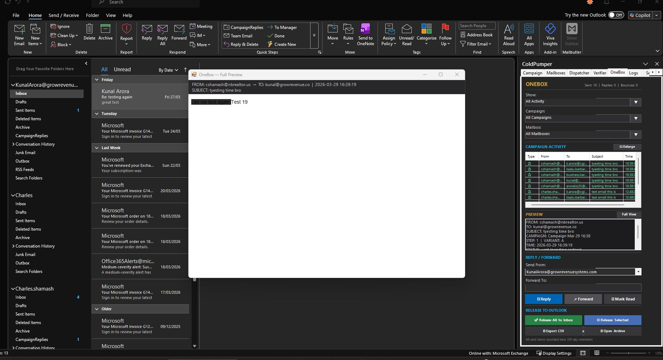
⚠ WARNING: Only check OneBox replies when your campaign is PAUSED or STOPPED — not while actively sending. Scanning for replies while the Dispatcher is sending can interfere with the MAPI spooler and cause send failures. Pause → Check replies → Resume.

12. The Logs Tab — Activity History

What It Is
The Logs tab shows a detailed history of everything OutPumper has done — every email sent, every bounce, every error, every system event.

Why It Exists
When something goes wrong — an email fails to send, a bounce occurs, an account gets restricted — the Logs tab tells you exactly what happened, when, and why.

How to Use It
Logs are displayed in reverse chronological order (newest first). Each entry shows a timestamp, event type (SENT, BOUNCE, ERROR, SYSTEM), and details.
- Filter by type: Show only SENT, BOUNCE, ERROR, or SYSTEM events
- Search: Find specific entries by email address, subject, or error message
- Export: Export logs as a text file for troubleshooting or record-keeping
💡 TIP: Check the Logs tab FIRST when troubleshooting any issue. If emails aren't sending, the error reason is always in the logs.

13. The Settings Tab — Tracking, License & Support

What It Is
The Settings tab controls open/click tracking configuration, your license activation, suppression list management, and support access.

Suppression List
Emails entered here (one per line) will NEVER be sent to — across all campaigns. Use this for people who've unsubscribed, your own email addresses, or specific domains you want to exclude.
- Load from CSV / TXT: Import a bulk suppression list from a file

Open / Click Tracking
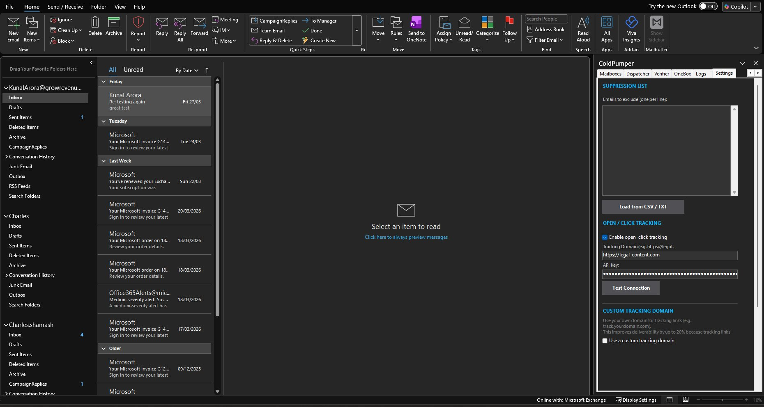
- Enable open & click tracking: Toggle tracking on/off. When enabled, OutPumper inserts a tiny invisible pixel for opens and rewrites links for click tracking.
- Tracking Domain: The domain used for tracking. Default: https://legal-content.com (our tracking server at 164.68.121.163). You can use your own custom tracking domain for better deliverability (see Custom Tracking Domain below).
- API Key: Your tracking server API key. Pre-filled for the default tracking server.
- Test Connection: Verify the tracking server is reachable and the API key is valid.
Custom Tracking Domain
Using your own tracking domain (e.g., track.yourdomain.com) instead of the default improves deliverability by up to 20% because tracking links match your sending domain. To set up:
- Create a CNAME record: track.yourdomain.com → legal-content.com
- Check 'Use a custom tracking domain' in Settings
- Enter your custom domain
- OutPumper will use your domain for all tracking links

Help / License

At the bottom of the Settings tab:
- Status: Shows your current license status — TRIAL (X days remaining) or your plan name
- Activate / Change License Key: Enter a new license key and password to activate or change plans
- Deactivate License / Cancel Subscription: Opens outpumper.com/cancel where you can look up and cancel your subscription
- Contact Support: Opens an email to support@outpumper.com
Version number is shown at the very bottom: 'OutPumper v1.0 — The Grow Revenue Company Limited'

PART 3 — BUILDING YOUR INFRASTRUCTURE

14. Understanding Shared Mailboxes
Shared mailboxes are one of the most powerful features of Microsoft 365 for cold email.
- They are 100% free. Microsoft 365 includes unlimited shared mailboxes at no extra cost. You pay $6/month for your admin account and get as many shared mailboxes as you need.
- They can send and receive email. Each shared mailbox has its own email address (e.g., outreach@yourcompany.com) and can send emails through Exchange.
- They share the MAPI spooler. All shared mailboxes in your tenant route through the same Exchange connection. OutPumper sends through each one in rotation, but they all flow through the Exchange pipe your admin account authenticates.
⚠ WARNING: Because shared mailboxes authenticate through your admin account, Microsoft sees all sending activity under one session. This is why account rotation (covered in Section 16) is recommended for high-volume senders. It spreads the authentication across multiple independent sessions.

15. Creating Shared Mailboxes

Method 1: From M365 Admin Panel
- Go to admin.microsoft.com → Teams & Groups → Shared mailboxes
- Click 'Add a shared mailbox'
- Enter a display name (e.g., 'Outreach') and email (e.g., outreach@yourdomain.com)
- Click Create
- Click on the new mailbox → Members → Add your admin account as a member
- Under Delegation, grant 'Send as' and 'Send on behalf' permissions
- The mailbox will appear in Outlook automatically within 15-30 minutes

Method 2: From OutPumper (Faster)
- Go to the Mailboxes tab in OutPumper
- Scroll to 'CREATE SHARED MAILBOXES'
- Enter your Admin Email and Domain
- Enter mailbox names (one per line): outreach, connect, hello, team, growth
- Click 'Create Shared Mailboxes'
OutPumper creates them instantly via Microsoft Graph API.

Recommended Mailbox Names
Create 3-5 shared mailboxes per domain. Use professional, generic names:
Domain 1 | Domain 2 | Domain 3
outreach@domain1.com | hello@domain2.com | connect@domain3.com
connect@domain1.com | team@domain2.com | outreach@domain3.com
hello@domain1.com | outreach@domain2.com | hello@domain3.com
team@domain1.com | growth@domain2.com | team@domain3.com
💡 TIP: Avoid names like noreply@, sales@, blast@, mass@ — these look spammy. Stick to outreach@, connect@, hello@, team@, growth@, partnerships@.

16. Adding User Mailbox Licenses (Account Rotation)

Why User Mailboxes Matter
Shared mailboxes all authenticate through your admin account. Microsoft sees one session sending from multiple addresses. User mailboxes authenticate independently — Microsoft sees separate, normal users.
With shared mailboxes only: Microsoft sees 1 account sending 600 emails/day from 3 addresses → suspicious
With user mailboxes: Microsoft sees 3 independent accounts each sending 200 emails/day → normal

How to Add User Mailboxes
- Go to admin.microsoft.com → Users → Active Users
- Click 'Add a user'
- Create the user with one of your outreach domains (e.g., outreach@yourdomain.com)
- Assign an Exchange Online Plan 1 license ($4/month)
- Set a password for the account
- In Outlook Classic: File → Add Account → enter the email and password
- The new account appears in Outlook's left sidebar
- In OutPumper Mailboxes tab, the account appears automatically — check it for rotation
OutPumper rotates between all connected accounts. With 3 user accounts + shared mailboxes on each, you get 12-15 different 'From' addresses rotating naturally.
💡 TIP: Start with 2-3 user mailboxes across different domains. This is the single most effective way to avoid Exchange restrictions. Each authenticates independently, so Microsoft sees multiple normal users instead of one power-sender.
⚠ WARNING: Adding too many accounts to Outlook slows it down. Each account opens a MAPI connection that uses memory and CPU. Recommended maximum: 5-7 accounts in Outlook. If you need more capacity, use external SMTP providers (Google, SendGrid) instead of more Exchange accounts.

17. Connecting External Providers
OutPumper supports external email providers alongside Microsoft 365. This lets you scale beyond Exchange limits and add redundancy.

Google Workspace
- Purchase a Google Workspace account ($7/month)
- Enable 2-Factor Authentication on the account
- Go to myaccount.google.com → Security → App passwords
- Create an App Password for 'Mail'
- In OutPumper Mailboxes tab → External Providers, select 'Google Workspace'
- Auth Method: App Password (SMTP)
- SMTP Host: smtp.gmail.com | Port: 587
- Username: your Google email | Password: the App Password you created
- Click 'Test Connection'
Each Google account adds ~500 emails/day of independent sending capacity.

SendGrid
- Create a SendGrid account at sendgrid.com
- Go to Settings → API Keys → Create API Key (Full Access)
- In OutPumper: Provider Type: SendGrid
- SMTP Host: smtp.sendgrid.net | Port: 587
- Username: apikey (literally the word 'apikey') | Password: your API key
- Click 'Test Connection'

Mailgun
- Create a Mailgun account at mailgun.com
- Add and verify your sending domain
- Go to Sending → Domain Settings → SMTP credentials
- In OutPumper: Provider Type: Mailgun
- SMTP Host: smtp.mailgun.org | Port: 587
- Username: your Mailgun SMTP login | Password: your SMTP password
- Click 'Test Connection'

Any Custom SMTP Server
You can connect any SMTP server — your own mail server, a transactional email provider, or any service that provides SMTP credentials.
- In OutPumper: Provider Type: Custom SMTP
- Enter SMTP Host, Port, Auth Method (Login, Plain, or CRAM-MD5)
- Enter Username and Password
- Click 'Test Connection'
💡 TIP: A hybrid setup (3 Exchange + 2 Google + 1 SendGrid) can reliably send 3,000-5,000 emails per day with excellent deliverability. Each provider has independent reputation and limits.

18. Email Authentication (SPF, DKIM, DMARC)
Email authentication is critical for deliverability. Without it, your emails go straight to spam. Set this up for EVERY sending domain.

SPF (Sender Policy Framework)
Tells receiving servers which servers are allowed to send email from your domain.
- Go to your DNS provider (Cloudflare, Namecheap, etc.)
- Add a TXT record for your domain:
Name: @ | Type: TXT | Value: v=spf1 include:spf.protection.outlook.com -all
If you also send from Google Workspace, combine them:
Value: v=spf1 include:spf.protection.outlook.com include:_spf.google.com -all

DKIM (DomainKeys Identified Mail)
- In M365, go to security.microsoft.com → Email & Collaboration → Policies → DKIM
- Select your domain and click to enable DKIM signing
- M365 generates two CNAME records — add them to your DNS
- Wait for DNS propagation (up to 48 hours), then enable DKIM

DMARC (Domain-based Message Authentication)
- Add a TXT record to your DNS:
Name: _dmarc | Type: TXT | Value: v=DMARC1; p=quarantine; rua=mailto:dmarc@yourdomain.com
⚠ WARNING: Do NOT skip email authentication. Without SPF, DKIM, and DMARC, your emails will land in spam regardless of how good your content is.
For a complete step-by-step guide: outpumper.com/deliverability-checker

PART 4 — LAUNCHING YOUR FIRST CAMPAIGN

19. Building & Verifying Your Email List
The quality of your email list directly determines your success.

Building Your List
- LeadPumper: Use our B2B lead generation platform (leadpumper.com) to scrape Google Maps, enrich company data, and export verified prospect lists.
- Manual Research: Company websites, conference attendee lists, industry directories.
- CSV Format: Export your list with columns: email, first_name, last_name, company, title

Verifying Your List
- Go to the Verifier tab in OutPumper
- Click 'Browse CSV' to load your list
- Set Concurrent checks to 5-10 (higher for larger lists)
- Enable Proxy if you have one (recommended for large lists)
- Click 'Start Verification'
- Review results: Remove all Invalid emails. Decide on Accept-All emails based on risk tolerance.
Target: Less than 2% bounce rate on every campaign
Danger zone: Above 5% — Microsoft will restrict your account
⚠ WARNING: ALWAYS verify your list before sending. A clean list of 5,000 verified contacts will generate more replies than a dirty list of 50,000 unverified contacts.

20. Writing Your First Email (Spintax & Templates)

The Basics
Keep cold emails short — 3-5 sentences maximum. Write like a human, not a marketer. No HTML templates, no images. Plain text performs best.

Using Spintax (Word Variations)
Spintax is OutPumper's word variation engine. It creates multiple versions of your email so spam filters can't detect a pattern. Format: {option1|option2|option3}
Example:
{Hi|Hey|Hello} {{first_name}},
{I noticed|I came across|I was looking at} {{company}} and {thought|figured|wanted to see if} it might make sense to {connect|chat|have a quick call}.
{We help|Our team helps|I work with} {companies like yours|businesses in your space|teams in {{industry}}} {reduce|cut|decrease} {churn|customer attrition|lost revenue} by {15-25%|up to 25%|a significant margin}.
{Worth a quick call|Would it make sense to chat|Open to a 15-minute conversation} {this week|sometime soon}?
With enough variations at each point, a single template generates hundreds of unique email combinations.
How to Use Auto-Spintax
- Write your email normally in the Campaign tab editor
- Click the 'Auto-Spintax' button
- OutPumper analyzes your text and automatically generates spintax variations
- Review the generated spintax and adjust as needed
- Click 'Preview Email' to see how randomized versions look

Saving Templates
Click 'Save Template' to save your email for reuse. Templates include subject line, body, and all spintax. Load them later with the 'Templates' button or 'Load' in the template section.

21. Setting Up Multi-Step Sequences
80% of cold email replies come from follow-ups, not the initial email. OutPumper supports multi-step sequences with configurable delays.

Recommended 4-Step Sequence
Step | Timing | Type | Length
Step 1 | Day 0 | Initial outreach — value proposition | 50-80 words
Step 2 | Day 3 | Bump — short reminder | 20-30 words
Step 3 | Day 7 | Value add — share a resource or insight | 40-60 words
Step 4 | Day 14 | Breakup — 'Should I close your file?' | 25-40 words

How to Add Follow-Up Steps
- Write your Step 1 email in the Campaign tab
- Click 'Add Step' below the email editor
- Set the delay (e.g., 3 days after Step 1)
- Write your Step 2 email with its own spintax
- Repeat for Steps 3 and 4
Follow-ups send as replies to the original email (same thread). If a prospect replies to any step, they are automatically removed from subsequent steps.

22. A/B Testing
OutPumper's A/B testing lets you test different subject lines, body copy, or CTAs to find what works best.
- Write your primary email (Version A)
- Click the 'A/B Test' button
- Write your alternative email (Version B)
- OutPumper randomly assigns 50% of contacts to each version
- After sufficient volume (200+ per variant), check reply rates to determine the winner
- Kill the losing variant and scale the winner
⚠ WARNING: You need at least 200 sends per variant for statistically meaningful results. Testing with 50 emails per variant is random noise, not data.

23. Launching & Monitoring

Pre-Launch Checklist
- Email list imported and verified (bounce rate under 2%)
- Shared mailboxes created and checked for rotation
- Email copy written with spintax variations
- Subject line written (3-7 words, merge tags optional)
- Follow-up steps configured with delays
- Test email sent to yourself and reviewed
- SPF, DKIM, DMARC configured for all sending domains
- Daily send limit set according to ramp-up schedule
- Jitter enabled in Mailboxes tab for natural timing

Launch
- Click 'Queue to Send' in the Campaign tab
- Switch to the Dispatcher tab
- Click 'START ALL'
- Monitor the Dispatcher Log for the first 10-20 sends
- Check for any errors or bounces

Daily Monitoring
- Check bounce rate in My Campaigns — should stay under 2%
- Pause campaigns before checking OneBox for replies
- Respond to positive replies within 24 hours
- Check Logs tab for any errors or restrictions
- Gradually increase daily volume per the ramp-up schedule

PART 5 — SCALING & REPUTATION MANAGEMENT

24. The Daily Ramp-Up Schedule
Never start sending at full volume on a new mailbox or domain. Microsoft monitors sending patterns and flags accounts that suddenly send hundreds of emails.
Week | 1 Mailbox | 3 Mailboxes | 5 Mailboxes | 3 User Accounts
Week 1 | 20-30/day | 60-90/day | 100-150/day | 150-250/day
Week 2 | 40-60/day | 120-180/day | 200-300/day | 300-500/day
Week 3 | 70-100/day | 210-300/day | 350-500/day | 500-800/day
Week 4 | 100-150/day | 300-450/day | 500-750/day | 800-1200/day
Week 5 | 150-200/day | 450-600/day | 750-1000/day | 1200-1800/day
Week 6+ | 200-250/day | 600-750/day | 1000-1250/day | 1800-2500/day
⚠ WARNING: These are MAXIMUM numbers. Start at the lower end and increase gradually. If you see any Exchange warnings, reduce volume by 50% and hold for 1 week before increasing again.
💡 TIP: Set the 'Daily limit / mailbox' in the Mailboxes tab rotation settings to enforce these limits automatically.

25. Scaling to Thousands of Emails Per Day
Sending thousands of emails per day is achievable with the right infrastructure stack:
Component | Capacity | Cost | Setup
3 Exchange user accounts | 600-750/day | $12/mo | M365 Admin → Add User
6 Exchange shared mailboxes | Rotation only | Free | M365 Admin or OutPumper
3 Google Workspace accounts | 1,500/day | $21/mo | External Providers tab
2 Private SMTP (SES/SendGrid) | 5,000-8,000/day | $20-50/mo | External Providers tab
TOTAL | ~10,000/day | ~$60-90/mo
This is not a Day 1 setup. Build toward this over 2-3 months as your domains warm up.

26. When Exchange Restricts Your Account
If Microsoft restricts your account, do not panic. This is recoverable.

Step 1: Check If You Are Restricted
- Go to security.microsoft.com/restrictedusers
- If your account is listed, it has been restricted from sending
- Click on the account and click 'Unblock'

Step 2: Resolve Any Active Alerts
- Go to security.microsoft.com → Alerts
- Find alerts with 'Suspicious email sending patterns detected'
- Click on each active alert and click 'Resolve'

Step 3: Wait and Reduce Volume
- After unblocking, wait 24-48 hours before sending again
- When you resume, reduce your daily volume by 50%
- Hold at the reduced volume for 1 full week
- Gradually increase by 20% per week until you reach your target

Step 4: Investigate the Cause
- High bounce rate? Verify your email list more thoroughly
- Too many emails too fast? Follow the ramp-up schedule more conservatively
- Spam complaints? Improve your email copy and targeting
- Only one account sending? Add user mailbox licenses for rotation

Links to Check
- Restricted users: security.microsoft.com/restrictedusers
- Alerts: security.microsoft.com/alerts
- Message trace: admin.exchange.microsoft.com → Mail flow → Message trace
- Check blacklists: mxtoolbox.com/blacklists.aspx
- Google Postmaster: postmaster.google.com (for Gmail deliverability)
⚠ WARNING: If your account gets restricted more than twice in 30 days, stop sending for 1 full week. Add user mailbox licenses, verify your list again, and reduce volume permanently by 30%.

27. How Adding More Accounts Affects Outlook
Each Exchange account added to Outlook opens a MAPI connection. This uses memory and CPU resources:
Accounts | RAM Usage | Performance | Recommendation
1-3 accounts | Normal | Smooth | Ideal for most users
4-5 accounts | +200-400 MB | Slightly slower | Fine with 8GB+ RAM
6-7 accounts | +400-700 MB | Noticeable lag | Recommended maximum
8+ accounts | +700 MB+ | Sluggish, possible freezes | Use external SMTP instead
If Outlook feels slow, consider:
- Removing accounts you don't actively need
- Using Google Workspace or SMTP providers instead of more Exchange accounts (these don't use MAPI)
- Increasing your PC's RAM to 16GB+
- Disabling 'Cached Exchange Mode' for accounts you only use for sending (not reading)

28. Keeping Your Reputation High
Your sender reputation is your most valuable asset. Once damaged, it takes weeks to recover.

The Golden Rules
- Keep bounce rate under 2% — verify every list before sending
- Keep spam complaint rate under 0.3% — target the right people with relevant offers
- Follow the ramp-up schedule — no shortcuts, no sudden volume spikes
- Rotate across multiple mailboxes and domains — never concentrate all volume on one
- Use spintax — every email should be structurally unique
- Send during business hours — 8 AM to 6 PM in the recipient's timezone
- Don't send on weekends — Monday through Thursday is optimal
- Respond to replies quickly — engagement signals boost reputation
- Remove unsubscribes immediately — never email someone who asked to stop
- Monitor your domain reputation — check mxtoolbox.com/blacklists and postmaster.google.com regularly

29. Best Practices & Tips

Email Copy
- Keep emails short — 3-5 sentences maximum
- Use merge tags: {{first_name}}, {{company}}, {{title}}
- Write like a human, not a marketer
- Ask a simple question to encourage replies
- Always include an unsubscribe option
- Never use images or heavy HTML in cold emails

Sending
- Send Monday through Thursday — avoid Fridays and weekends
- Best times: 8-10 AM and 2-4 PM in the recipient's timezone
- Always test before sending to your full list
- Monitor OneBox for replies (while campaign is paused)
- Respond to positive replies within 24 hours

Deliverability
- Never skip SPF, DKIM, and DMARC setup
- Keep bounce rate under 2%
- Warm up new domains for at least 2 weeks
- Rotate across multiple domains and mailboxes
- Use spintax in every campaign — no two emails should be identical

Account Safety
- Convert shared mailboxes to user mailboxes for high volume
- Never send more than 250 emails per mailbox per day on a new domain
- Follow the ramp-up schedule — patience pays off
- If Microsoft sends a warning, reduce volume immediately
- Keep your admin account clean — don't send campaigns from it directly

Need help? Contact us at support@outpumper.com
outpumper.com
© 2026 The Grow Revenue Company Limited

