LISTADO DE PRUEBAS
1. INSPECCION VISUAL | APLICA | NO APLICA
2. TIEMPOS DE OPERACIÓN Y DISCORDANCIA DE FASES | APLICA | NO APLICA

 | DATOS GENERALES
 | CLIENTE: ANDE
 | OBRA/LUGAR: SUBESTACION CAPIATA
 | DESCRIPCION GENERAL
 | FABRICANTE: SIEMENS |  | TENSION ASIGNADA NORMAL: 24kV (VARIABLE)
 | TIPO: 8DA10 (VARIABLE) |  | CORRIENTE ASIGNADA NORMAL: 4000A (VARIABLE)
 | AÑO FABRICACION: 2023 (VARIABLE) |  | CORRIENTE DE CORTOCIRCUITO: 40kA (VARIABLE)
 | NUMERO DE SERIE: CV 563100 – 000020/001 (VARIABLE) |  | FRECUENCIA NOMINAL: 50Hz
1. VERIFICACIÓN VISUAL
Elemento |  | Fase A |  | Fase B | Fase C
Estado de la base portante |  | Buen estado  Mal estado |  | Buen estado  Mal estado | Buen estado  Mal estado
Estado de la unidad del mecanismo de accionamiento |  | Buen estado  Mal estado |  | Buen estado  Mal estado | Buen estado  Mal estado
Estado de la unidad de mando |  | Buen estado  Mal estado |  | Buen estado  Mal estado | Buen estado  Mal estado
Estado indicador de presión |  | Buen estado  Mal estado |  | Buen estado  Mal estado | Buen estado  Mal estado
Comprobar la hermeticidad de los polos |  | Buen estado  Mal estado |  | Buen estado  Mal estado | Buen estado  Mal estado

2. TIEMPOS DE OPERACIÓN DE LOS CONTACTOS PRINCIPALES DEL INTERRUPTOR
Equipo Utilizado para la prueba (VARIABLE, PERO DEJAR COMO DEFAULT)
Descripción | Fabricante | Modelo – Serie No. | Fecha de la última calibración
Oscilógrafo | DV Power | CAT124A – 22U939 | 10-0CT-2025 (VARIABLE)
Ver reporte de pruebas del equipo, en anexo.

OBSERVACIONES

Ninguna.

---------------------------------------------------------------ANEXO---------------------------------------------------------------------

Timing test |  | O1 (Open test)
General parameters |  |  |  | Testing device settings
Execution date/Time |  |  | 2/17/2026 / 10:47 AM | Device model / Serial-no | CAT124A / -
Coil supply voltage |  |  |  | Transducer type | Digital transducer
Measuring time |  |  | 700 ms | Transducer on CBs phase-s | All three
Command pulse |  |  | 80 | Transducer transfer functions | 0mm:0deg
Resolution |  |  | 0.025 ms | Trigger source
Frequency |  |  | 50 Hz | BSG mode
 | 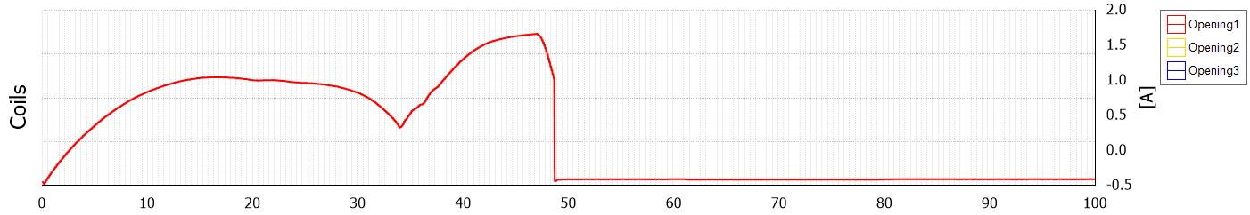
 | 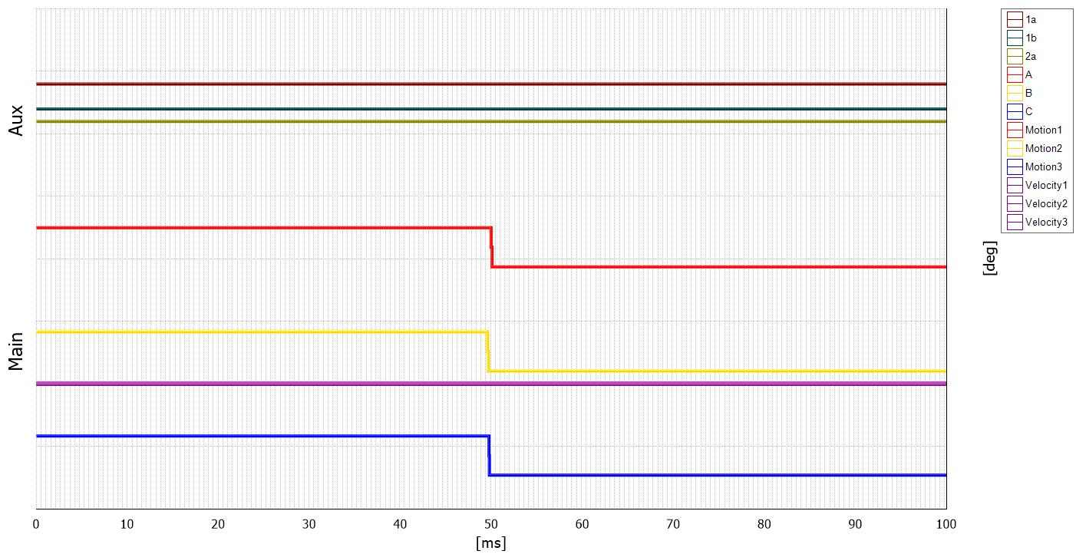

Main contacts timing
Designation | Min | Max | Value | Unit | Pass/Check
Open time(to) | 0 | 0 | 49.95 | ms | Correcto
Open time sync(dto) | 0 | 0 | 0.375 | ms | Correcto
Opening time
Designation | Min | Max | Value | Unit | Pass/Check
Opening time - A | 0 | 0 | 49.95 | ms | Correcto
Opening time - B | 0 | 0 | 49.575 | ms | Correcto
Opening time - C | 0 | 0 | 49.7 | ms | Correcto
Opening coil result 1
Designation | Min | Max | Value | Unit | Pass/Check
Pick-up time | 0 | 0 | 34 | ms | Correcto
Ipmax | 0 | 0 | 1.24 | A | Correcto

Opening coil result 1
Designation | Min | Max | Value | Unit | Pass/Check
Aux | 0 | 0 | 47.53 | ms | Correcto
De-energized coil | 0 | 0 | 48.75 | ms | Correcto
Imax | 0 | 0 | 1.73 | A | Correcto

Timing test | C1 (Close test)
General parameters |  |  | Testing device settings
Execution date/Time |  | 2/17/2026 / 10:50 AM | Device model / Serial-no | CAT124A / -
Coil supply voltage |  |  | Transducer type | Digital transducer
Measuring time |  | 700 ms | Transducer on CBs phase-s | All three
Command pulse |  | 160 | Transducer transfer functions | 0mm:0deg
Resolution |  | 0.025 ms | Trigger source
Frequency |  | 50 Hz | BSG mode

Bounce time
Designation | C1 | Unit
Bounce time-A | 1.925 | ms
Bounce time-B | 1.875 | ms
Bounce time-C | 1.925 | ms
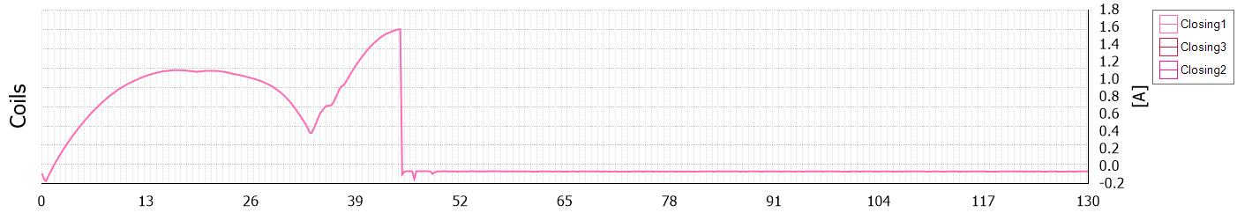

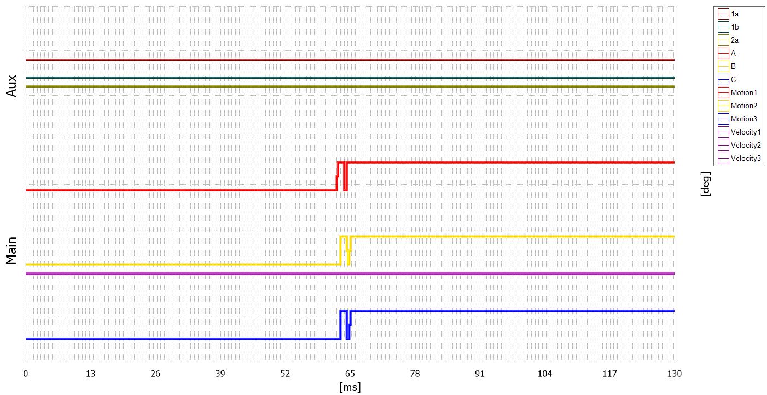
Main contacts timing
Designation | Min | Max | Value | Unit | Pass/Check
Close time(tc) | 0 | 0 | 62.925 | ms | Correcto
Close time sync(dtc) | 0 | 0 | 0.625 | ms | Correcto
Closing time
Designation | Min | Max | Value | Unit | Pass/Check
Close time - A | 0 | 0 | 62.3 | ms | Correcto
Close time - B | 0 | 0 | 62.925 | ms | Correcto
Close time - C | 0 | 0 | 62.85 | ms | Correcto

Timing test | OCO1 (Open-Close-Open test)
General parameters |  |  | Testing device settings
Execution date/Time |  | 2/17/2026 / 10:56 AM | Device model / Serial-no | CAT124A / -
Coil supply voltage |  |  | Transducer type | Digital transducer
Measuring time |  | 700 ms | Transducer on CBs phase-s | All three
Command pulse |  |  | Transducer transfer functions | 0mm:0deg
Resolution |  | 0.025 ms | Trigger source
Frequency |  | 50 Hz | BSG mode
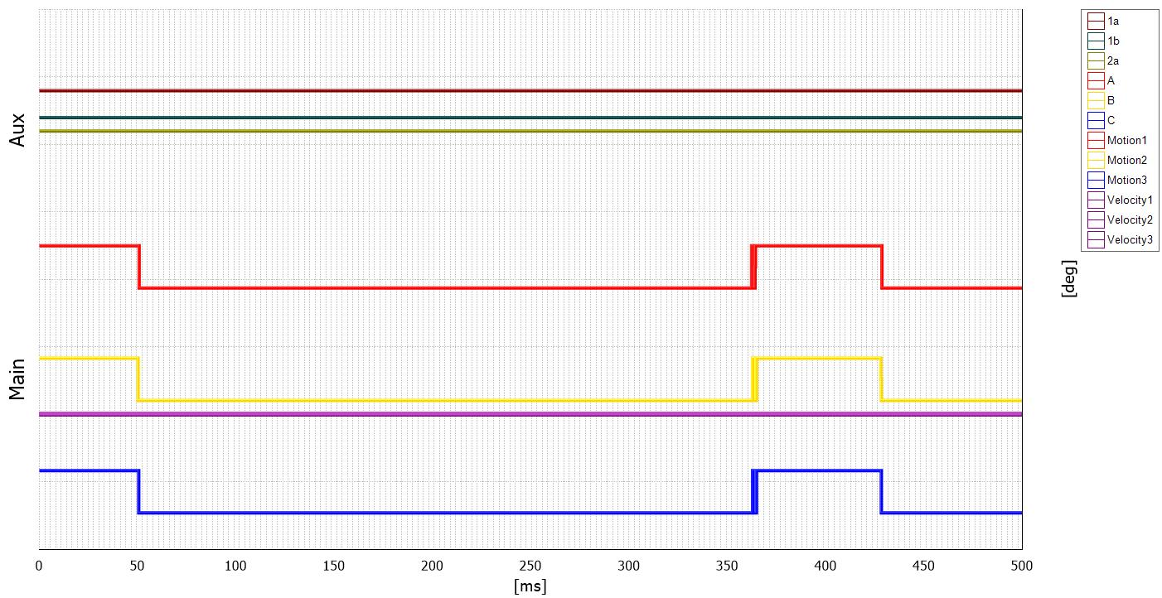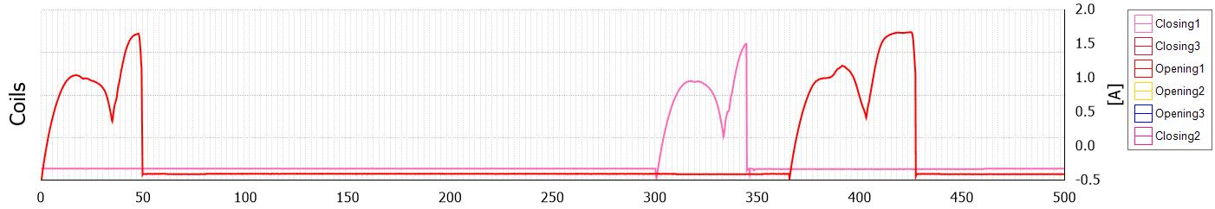

Main contacts timing
Designation | Min | Max | Value | Unit | Pass/Check
Open time(to) | 0 | 0 | 50.525 | ms | Correcto
Reclosing time | 0 | 0 | 362.75 | ms | Correcto
Reclosing time sync | 0 | 0 | 0.625 | ms | Correcto
O1 sync time | 0 | 0 | 0.325 | ms | Correcto
O2 sync time | 0 | 0 | 0.4 | ms | Correcto
Open-Close time(toc) | 0 | 0 | 311.6 | ms | Correcto
Close-Open time(tco) | 0 | 0 | 66.225 | ms | Correcto
Opening time
Designation | Min | Max | Value | Unit | Pass/Check
Opening time - A | 0 | 0 | 50.525 | ms | Correcto
Opening time - B | 0 | 0 | 50.2 | ms | Correcto
Opening time - C | 0 | 0 | 50.275 | ms | Correcto

Timing test | CO1 (Close-Open test)
General parameters |  |  | Testing device settings
Execution date/Time |  | 2/17/2026 / 10:58 AM | Device model / Serial-no | CAT124A / -
Coil supply voltage |  |  | Transducer type | Digital transducer
Measuring time |  | 700 ms | Transducer on CBs phase-s | All three
Command pulse |  |  | Transducer transfer functions | 0mm:0deg
Resolution |  | 0.025 ms | Trigger source
Frequency |  | 50 Hz | BSG mode
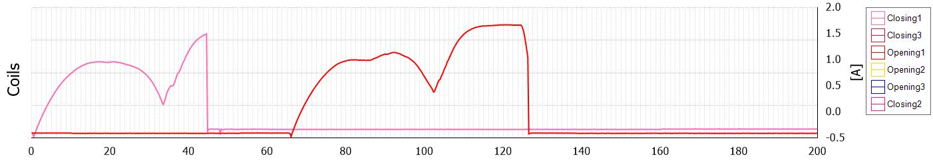

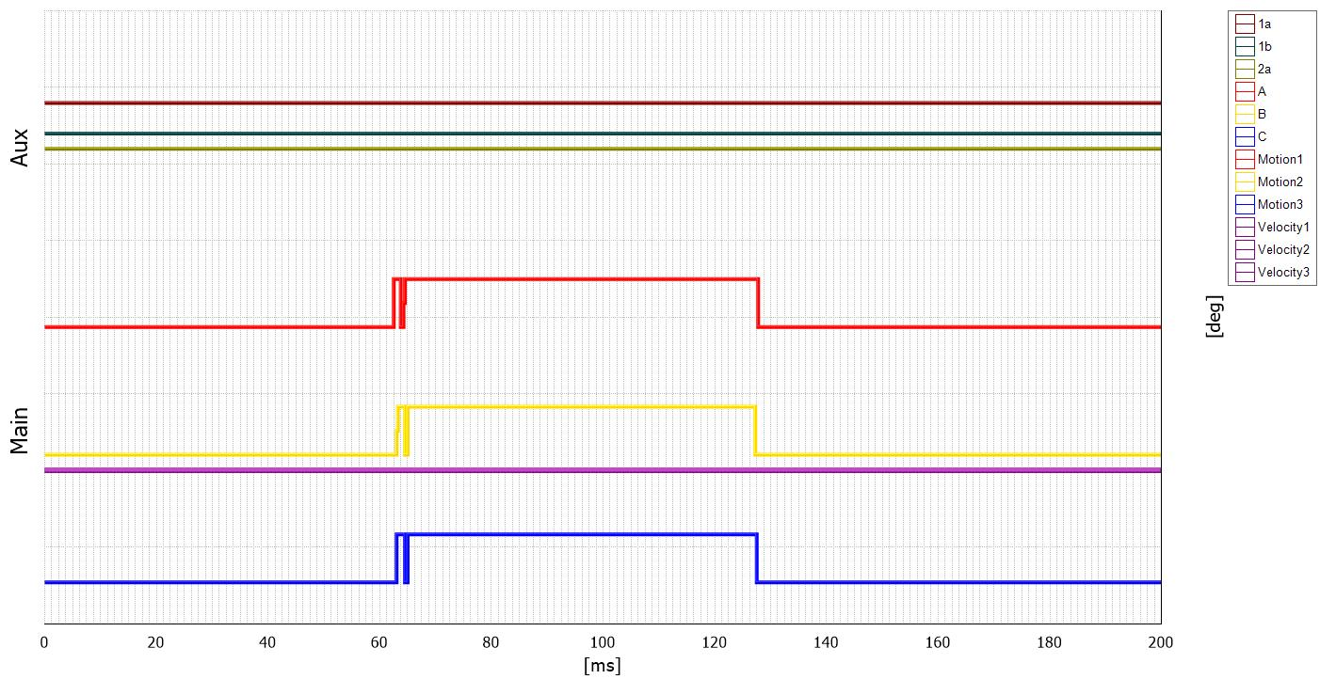
Main contacts timing
Designation | Min | Max | Value | Unit | Pass/Check
Close time(tc) | 0 | 0 | 63.025 | ms | Correcto
Close time sync(dtc) | 0 | 0 | 0.65 | ms | Correcto
Close-Open time(tco) | 0 | 0 | 65.175 | ms | Correcto
Breaker O sync | 0 | 0 | 0.4 | ms | Correcto
Closing time
Designation | Min | Max | Value | Unit | Pass/Check
Close time - A | 0 | 0 | 62.375 | ms | Correcto
Close time - B | 0 | 0 | 63.025 | ms | Correcto
Close time - C | 0 | 0 | 62.925 | ms | Correcto

Coil currents
Coil | Min | Max | Closing coil1 | Closing coil2 | Closing coil3 | Unit | Pass/Check
Max current value | 0 | 0 | 1.601 | 0 | 0 | A | Correcto
Max current time | 0 | 0 | 44.625 | 0 | 0 | ms | Correcto
Coil currents
Coil | Min | Max | Opening coil1 | Opening coil2 | Opening coil3 | Unit | Pass/Check
Max current value | 0 | 0 | 1.739 | 0 | 0 | A | Correcto
Max current time | 0 | 0 | 120.275 | 0 | 0 | ms | Correcto

Timing test | O2 (Open test)
General parameters |  |  | Testing device settings
Execution date/Time |  | 2/17/2026 / 11:04 AM | Device model / Serial-no | CAT124A / -
Coil supply voltage |  |  | Transducer type | Digital transducer
Measuring time |  | 700 ms | Transducer on CBs phase-s | All three
Command pulse |  | 80 | Transducer transfer functions | 0mm:0deg
Resolution |  | 0.025 ms | Trigger source
Frequency |  | 50 Hz | BSG mode
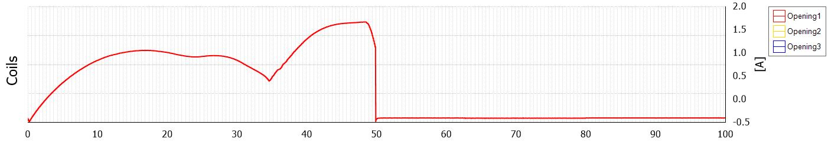

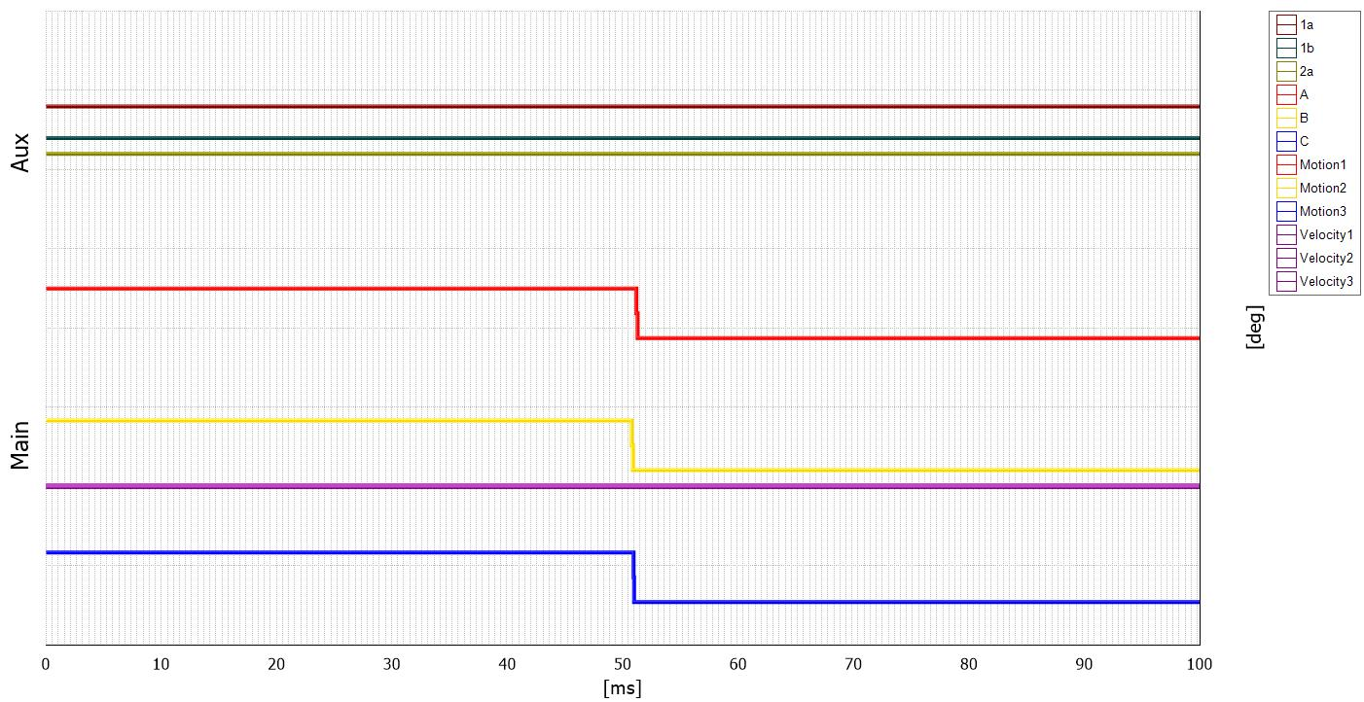
Main contacts timing
Designation | Min | Max | Value | Unit | Pass/Check
Open time(to) | 0 | 0 | 51.175 | ms | Correcto
Open time sync(dto) | 0 | 0 | 0.425 | ms | -
Opening time
Designation | Min | Max | Value | Unit | Pass/Check
Opening time - A | 0 | 0 | 51.175 | ms | -
Opening time - B | 0 | 0 | 50.75 | ms | -
Opening time - C | 0 | 0 | 50.9 | ms | -
Opening coil result 1
Designation | Min | Max | Value | Unit | Pass/Check
Pick-up time | 0 | 0 | 34.6 | ms | -
Ipmax | 0 | 0 | 1.25 | A | -

Opening coil result 1
Designation | Min | Max | Value | Unit | Pass/Check
Aux | 0 | 0 | 48.95 | ms | -
De-energized coil | 0 | 0 | 49.9 | ms | -
Imax | 0 | 0 | 1.74 | A | -

