Exploratory Data Analysis & Data Preparation

Pham Quang Minh | Student ID: 104999568
COS40007 Artificial Intelligence Engineering - Portfolio Assessment 1
Date: 4th October 2026 | Swinburne University of Technology

Generative AI declaration
OpenAI Codex (GPT-6) assisted with debugging, code polishing and the report. The overall structures, interpretations and final say are my own.

Purpose and reproducibility
Investigate how concrete mixture ingredients and curing age relate to measured compressive strength, audit data quality, and prepare a transparent dataset for later modelling. This portfolio addresses Tasks 1-9 of the supplied brief.
Run all cells in order from this notebook's directory. Install the packages in requirements.txt first. The original UCI workbook is included under data/; no network connection is needed to execute the notebook.
GitHub Repository Link: https://github.com/theh9j/COS40007/tree/main/portfolio-1

Report summary
This section follows the supplied report template. The appendix contains every notebook code cell, all recorded outputs, labelled figures and reasoning.

Task 9. Summary report
The following summary follows the supplied Canvas report template. Numerical findings are printed from the executed analysis below rather than entered by hand.

Code cell [11]
print('1. DATASET OVERVIEW') print(f'Raw: {raw.shape[0]} rows x {raw.shape[1]} columns; ' f'prepared: {clean.shape[0]} rows x {clean.shape[1]} columns.') print('Target: strength (MPa), continuous regression; four ordered quartile classes.') print(f'Strength mean={clean.strength.mean():.3f}, ' f'SD={clean.strength.std():.3f}, ' f'range={clean.strength.min():.3f}-{clean.strength.max():.3f} MPa.') print('2. DATA QUALITY') print(f'Missing values: {int(raw.isna().sum().sum())}; ' f'exact extra duplicates removed: {extra_duplicates}.') print(f'IQR flags in {int(flags.any(axis=1).sum())} distinct rows; all retained.') print('3. UNIVARIATE FINDINGS')
print('Age is strongly right-skewed; optional ingredients have zero-heavy distributions.') print('4. MULTIVARIATE FINDINGS') for c, r in top3.Pearson_r.items(): print(f'{c}: Pearson r={r:.4f}') print(f'Predictor pairs with |r| >= 0.70: {len(high_pairs)}.') print('Class counts:', counts.to_dict())
- DATASET OVERVIEW
Raw: 1030 rows x 9 columns; prepared: 1005 rows x 10 columns.
Target: strength (MPa), continuous regression; four ordered quartile classes.
Strength mean=35.250, SD=16.285, range=2.332-82.599 MPa.
- DATA QUALITY
Missing values: 0; exact extra duplicates removed: 25.
IQR flags in 94 distinct rows; all retained.
- UNIVARIATE FINDINGS
Age is strongly right-skewed; optional ingredients have zero-heavy distributions. 4. MULTIVARIATE FINDINGS cement: Pearson r=0.4883 superplasticizer: Pearson r=0.3442 age: Pearson r=0.3374 Predictor pairs with |r| >= 0.70: 0.
Class counts: {'Lower': 252, 'Lower-middle': 252, 'Upper-middle': 250, 'Higher': 251}

5. Initial insights for modelling
Start with all eight predictors; the top correlations are useful signals, not a feature-selection verdict. Compare a regularised linear regression baseline with tree-based regression for nonlinear relationships. For the derived classification task, compare an interpretable classifier with a tree ensemble and consider the ordinal nature of the labels. These are proposed next steps, not implemented models.
Remove or group exact duplicates before splitting. Reserve a test set before any modelling decisions, and keep related recipes together when evaluating generalisation to new mixtures. Fit scalers, transformations, any imputer and data-derived class boundaries only within training folds. Standardisation is useful for linear, distance and margin-based methods; trees generally do not require it. Optional-ingredient zeros are valid. Do not include continuous strength or its class label in the predictor matrix. Report regression MAE/RMSE in MPa; for classification report macro F1, a confusion matrix and errors across ordered classes, alongside class balance.

6. Engineering interpretation
Mixture composition and curing age jointly relate to strength. A nonlinear model may better represent interactions, but descriptive evidence cannot determine which model will generalise best. Domain-guided ratios and age transformations should be compared by validation rather than assumed to improve predictions.

7. Challenges encountered
The central challenges are ambiguous duplicate provenance, legitimate statistical extremes and target discretisation. Decisions preserve an auditable raw dataset and avoid unsupported imputation or automatic outlier removal.

8. Reflection questions
Poor quality can distort estimates and evaluation; laboratory selection and missing curing/material provenance limit transfer. Model outputs must not replace certified testing or structural assessment. Detailed reflections appear in Task 8.

9. Next steps
Compare results with and without deduplication; analyse 28-day strength separately; test binder and age features; investigate recipe-group evaluation and external data. Collect specimen, batch, curing and material-source identifiers where possible.

10. GenAI declaration and references
The declaration at the beginning records the actual assistance. Student review is required before submission, including checking permitted GenAI use.
Yeh, I. (1998). Concrete Compressive Strength [Dataset]. UCI Machine Learning Repository. https://doi.org/10.24432/C5PK67. Dataset page:
https://archive.ics.uci.edu/dataset/165/concrete+compressive+strength. License: CC BY 4.0. The original README and workbook are retained with attribution.
Yeh, I.-C. (1998). Modeling of strength of high-performance concrete using artificial neural networks. Cement and Concrete Research, 28(12), 1797-1808. https://doi.org/10.1016/S0008-8846(98)00165-3.
Course materials: Portfolio Task 1.pdf and Portfolio Task 1 Submission Document.docx, provided in the assignment folder. The supplied colleague example by Hoang Minh Duc was consulted for structure; its Beijing air-quality analysis was not reused.

Complete executed notebook Task 1. Dataset loading and initial exploration
The UCI Concrete Compressive Strength dataset contains laboratory strength measurements for mixture recipes at specified ages. It has eight quantitative predictors and one continuous target. Ingredient quantities are in kg/m^3, age is in days and compressive strength is in MPa. The original problem is regression; the assignment also requests discretised labels for classification.
Source: Yeh, I. (1998). Concrete Compressive Strength [Dataset]. UCI Machine Learning Repository.
https://doi.org/10.24432/C5PK67 (accessed 6 October 2026). UCI reports 1,030 observations and no missing values. These claims are checked against the actual file rather than assumed.

Code cell [1]
from pathlib import Path import hashlib import numpy as np import pandas as pd import matplotlib.pyplot as plt import seaborn as sns from IPython.display import display
pd.set_option('display.max_columns', 12) pd.set_option('display.width', 100) pd.set_option('display.precision', 3) sns.set_theme(style='whitegrid', font_scale=0.9) DATA = Path('data/Concrete_Data.xls') assert DATA.exists(), 'Run from the portfolio-1 directory.' columns = ['cement', 'slag', 'fly_ash', 'water', 'superplasticizer', 'coarse_aggregate', 'fine_aggregate', 'age', 'strength'] raw = pd.read_excel(DATA, engine='xlrd') assert raw.shape == (1030, 9), 'Unexpected source shape.' original_headers = list(raw.columns) raw.columns = columns predictors = columns[:-1] units = {c: 'kg/m^3' for c in predictors[:-1]} units.update(age='days', strength='MPa')
labels = {c: f'{c.replace("_", " ").title()} ({units[c]})' for c in columns} Path('figures').mkdir(exist_ok=True)
def show_plot(name):
plt.savefig(Path('figures') / f'{name}.png', dpi=180, bbox_inches='tight') plt.show() plt.close('all')
def show_table(table): # Text tables are retained verbatim in both notebook and PDF. print(table.to_string())
print('Source: UCI dataset 165, original Concrete_Data.xls') print('SHA-256:', hashlib.sha256(DATA.read_bytes()).hexdigest()) print('Raw shape:', raw.shape) show_table(pd.DataFrame({'original_header': original_headers, 'analysis_name': columns, 'unit': [units[c] for c in columns]}))
Source: UCI dataset 165, original Concrete_Data.xls SHA-256: 710076c66b9ca3f8050e7942f3dcbdbe04013534daeb0077ffd3079a52d8e0c4 Raw shape: (1030, 9) original_header analysis_name unit 0 Cement (component 1)(kg in a m^3 mixture) cement kg/m^3
- Blast Furnace Slag (component 2)(kg in a m^3 mixture) slag kg/m^3
- Fly Ash (component 3)(kg in a m^3 mixture) fly_ash kg/m^3
- Water (component 4)(kg in a m^3 mixture) water kg/m^3
- Superplasticizer (component 5)(kg in a m^3 mixture) superplasticizer kg/m^3
- Coarse Aggregate (component 6)(kg in a m^3 mixture) coarse_aggregate kg/m^3
- Fine Aggregate (component 7)(kg in a m^3 mixture) fine_aggregate kg/m^3
- Age (day) age days
- Concrete compressive strength(MPa, megapascals) strength MPa

Code cell [2]
print('First five observations (original row order):') show_table(raw.head()) print('Data types:') show_table(raw.dtypes.to_frame('dtype')) print('Descriptive statistics:') show_table(raw.describe().T.round(3)) print('Initial missing counts:')
show_table(raw.isna().sum().to_frame('missing'))
First five observations (original row order):
cement slag fly_ash water superplasticizer coarse_aggregate fine_aggregate age strength 0 540.0 0.0 0.0 162.0 2.5 1040.0 676.0 28 79.986
- 540.0 0.0 0.0 162.0 2.5 1055.0 676.0 28 61.887
- 332.5 142.5 0.0 228.0 0.0 932.0 594.0 270 40.270
- 332.5 142.5 0.0 228.0 0.0 932.0 594.0 365 41.053 4 198.6 132.4 0.0 192.0 0.0 978.4 825.5 360 44.296 Data types:
dtype cement float64 slag float64 fly_ash float64 water float64 superplasticizer float64 coarse_aggregate float64 fine_aggregate float64 age int64 strength float64 Descriptive statistics:
count mean std min 25% 50% 75% max cement 1030.0 281.166 104.507 102.000 192.375 272.900 350.000 540.000 slag 1030.0 73.895 86.279 0.000 0.000 22.000 142.950 359.400 fly_ash 1030.0 54.187 63.996 0.000 0.000 0.000 118.270 200.100 water 1030.0 181.566 21.356 121.750 164.900 185.000 192.000 247.000 superplasticizer 1030.0 6.203 5.973 0.000 0.000 6.350 10.160 32.200 coarse_aggregate 1030.0 972.919 77.754 801.000 932.000 968.000 1029.400 1145.000 fine_aggregate 1030.0 773.579 80.175 594.000 730.950 779.510 824.000 992.600 age 1030.0 45.662 63.170 1.000 7.000 28.000 56.000 365.000 strength 1030.0 35.818 16.706 2.332 23.707 34.443 46.136 82.599 Initial missing counts: missing cement 0 slag 0 fly_ash 0 water 0 superplasticizer 0 coarse_aggregate 0 fine_aggregate 0 age 0 strength 0
All source columns are numeric. Short names improve code readability while the mapping above preserves the original headers and units. Numerical storage dtype does not determine measurement meaning: age represents whole days even if a file stores it as a floating-point value. Initial exploration uses all 1,030 raw rows; later analysis uses the explicitly deduplicated dataset.

Task 2. Data quality assessment
Missingness is checked by column and visualised across every raw row. Zero is a valid value for optional ingredients, not a missing-value code. Duplicates are defined across all nine fields, including strength; repeated strength values alone do not identify duplicate observations. Plausibility checks distinguish impossible values from statistically unusual ones.

Code cell [3]
missing = pd.DataFrame({'missing_count': raw.isna().sum(), 'missing_percent': 100 * raw.isna().mean()}) show_table(missing) fig, ax = plt.subplots(figsize=(10, 3.8)) sns.heatmap(raw.isna().astype(int), ax=ax, cmap=['#e5eff8', '#d43d51'], vmin=0, vmax=1, yticklabels=False, cbar_kws={'ticks': [0, 1], 'label': 'Missing indicator (0=no, 1=yes)'}) ax.set(title='Figure 1. Missingness across all 1,030 raw observations', xlabel='Variable', ylabel='Raw observation (source order)') ax.tick_params(axis='x', rotation=35) plt.tight_layout() show_plot('01_missingness')
missing_count missing_percent cement 0 0.0 slag 0 0.0 fly_ash 0 0.0 water 0 0.0 superplasticizer 0 0.0 coarse_aggregate 0 0.0 fine_aggregate 0 0.0 age 0 0.0 strength 0 0.0
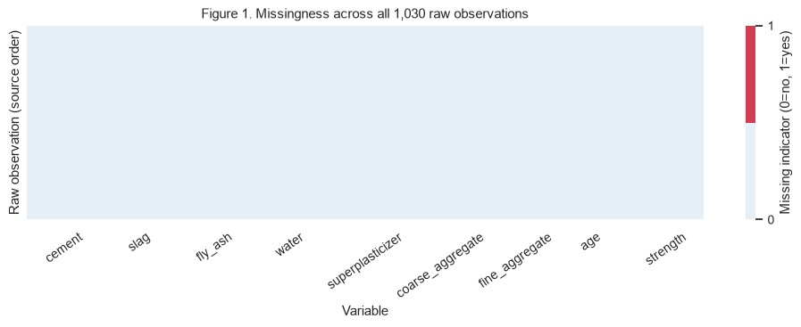

Code cell [4]
extra_duplicates = int(raw.duplicated().sum()) duplicate_members = int(raw.duplicated(keep=False).sum()) print('Extra duplicate rows beyond first occurrence:', extra_duplicates) print('Rows belonging to duplicate groups:', duplicate_members) print('Examples (source row index retained):') show_table(raw.loc[raw.duplicated(keep=False)].sort_values(columns).head(8)) checks = pd.Series({ 'nonfinite_numeric_values': int((~np.isfinite(raw.to_numpy())).sum()),
'negative_ingredient_values': int((raw[predictors[:-1]] < 0).sum().sum()),
'nonpositive_cement_values': int((raw.cement <= 0).sum()),
'nonpositive_water_values': int((raw.water <= 0).sum()),
'ages_outside_documented_1_to_365_days': int((~raw.age.between(1, 365)).sum()),
'noninteger_ages': int((raw.age % 1 != 0).sum()), 'nonpositive_strength_values': int((raw.strength <= 0).sum())}) show_table(checks.to_frame('count')) clean = raw.drop_duplicates().copy() clean['age'] = clean['age'].astype('int64') print('Clean shape:', clean.shape) print('Rows removed:', len(raw) - len(clean)) print('Types after cleaning:') show_table(clean.dtypes.to_frame('dtype'))
Extra duplicate rows beyond first occurrence: 25
Rows belonging to duplicate groups: 36 Examples (source row index retained):
cement slag fly_ash water superplasticizer coarse_aggregate fine_aggregate age strength 801 252.0 0.0 0.0 185.0 0.0 1111.0 784.0 28 19.691
809 252.0 0.0 0.0 185.0 0.0 1111.0 784.0 28 19.691
83 362.6 189.0 0.0 164.9 11.6 944.7 755.8 3 35.301
86 362.6 189.0 0.0 164.9 11.6 944.7 755.8 3 35.301
88 362.6 189.0 0.0 164.9 11.6 944.7 755.8 3 35.301
91 362.6 189.0 0.0 164.9 11.6 944.7 755.8 3 35.301
106 362.6 189.0 0.0 164.9 11.6 944.7 755.8 7 55.896 109 362.6 189.0 0.0 164.9 11.6 944.7 755.8 7 55.896 count nonfinite_numeric_values 0 negative_ingredient_values 0 nonpositive_cement_values 0 nonpositive_water_values 0 ages_outside_documented_1_to_365_days 0 noninteger_ages 0 nonpositive_strength_values 0 Clean shape: (1005, 9)
Rows removed: 25 Types after cleaning:
dtype cement float64 slag float64 fly_ash float64 water float64 superplasticizer float64 coarse_aggregate float64 fine_aggregate float64 age int64 strength float64
Exact repetitions may be repeated tests or accidental duplication; the workbook has no specimen IDs with which to decide. This portfolio keeps one occurrence per identical full record to avoid giving identical observations extra weight. This is an explicit analytical choice, not proof that the source contained recording errors. Distinct tests with identical recipes and different strengths remain. The raw workbook is preserved so the decision can be reversed and assessed in future sensitivity work. No imputation is needed, and zero-valued optional ingredients are retained.

Code cell [5]
fig, axes = plt.subplots(3, 3, figsize=(11, 9)) for c, ax in zip(columns, axes.flat):
sns.boxplot(y=clean[c], ax=ax, color='#86b4ce')
ax.set(title=c.replace('_', ' ').title(), ylabel=labels[c], xlabel='') fig.suptitle('Figure 2. All numerical variables after deduplication', y=1.01) plt.tight_layout() show_plot('02_boxplots')
q1, q3 = clean[columns].quantile(0.25), clean[columns].quantile(0.75) iqr = q3 - q1
flags = (clean[columns] < q1 - 1.5 * iqr) | (clean[columns] > q3 + 1.5 * iqr) outlier_audit = pd.DataFrame({'lower_fence': q1 - 1.5 * iqr, 'upper_fence': q3 + 1.5 * iqr,
'flagged_count': flags.sum(), 'flagged_percent': 100 * flags.mean()}) show_table(outlier_audit.round(3)) print('Distinct rows flagged in at least one variable:', int(flags.any(axis=1).sum()))
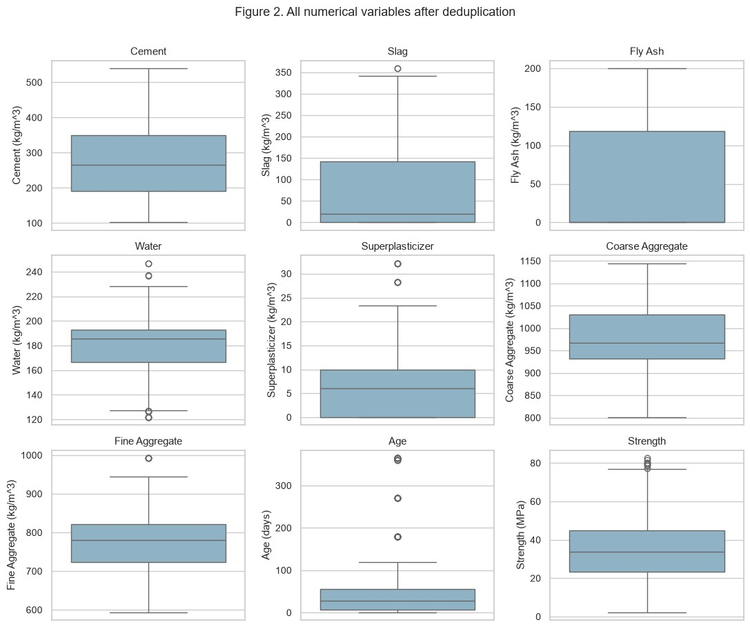
lower_fence upper_fence flagged_count flagged_percent cement -46.800 586.480 0 0.000 slag -213.750 356.250 2 0.199 fly_ash -177.405 295.675 0 0.000 water 127.115 232.435 15 1.493 superplasticizer -15.000 25.000 10 0.995 coarse_aggregate 783.500 1179.500 0 0.000 fine_aggregate 577.450 969.050 5 0.498 age -66.500 129.500 59 5.871 strength -8.494 76.886 8 0.796 Distinct rows flagged in at least one variable: 94
The 1.5-IQR rule is a screening heuristic, not an error detector. Long curing ages and unusual admixture dosages may be legitimate experimental settings. All flagged rows are retained because no supplied provenance establishes them as invalid. Removing them automatically would narrow the engineering range and could bias a future model toward common mixtures. Separate boxplots use each variable's own scale, so differences in units do not hide smaller-valued variables.

Task 3. Target variable preparation
strength is the continuous target in MPa. Its original use is regression. For the required class conversion, four ordered, relative labels are created by equal-frequency binning on the cleaned data: Lower, Lower-middle, Upper-middle and Higher strength. Quartiles are selected to balance class counts without claiming regulatory or structural design thresholds. They describe this sample, not whether a concrete mixture is safe for a particular application.

Code cell [6]
print('Target name: strength; unit: MPa; dtype:', clean.strength.dtype) print('Original task: regression; discretised task: ordered classification') show_table(clean.strength.describe().to_frame('strength_MPa')) print('Target skewness:', round(clean.strength.skew(), 3)) class_labels = ['Lower', 'Lower-middle', 'Upper-middle', 'Higher'] clean['strength_class'], edges = pd.qcut(clean.strength, q=4, labels=class_labels, retbins=True) counts = clean.strength_class.value_counts(sort=False) class_table = pd.DataFrame({'lower_MPa': edges[:-1], 'upper_MPa': edges[1:], 'count': counts.to_numpy(), 'percent': 100 * counts.to_numpy() / len(clean)}, index=class_labels) show_table(class_table.round(4)) print('Exact edges (MPa):', edges.tolist()) print('Intervals: first includes minimum; all subsequent intervals are (lower, upper].') print('Max/min class-count ratio:', round(counts.max() / counts.min(), 3)) assert counts.sum() == len(clean) and clean.strength_class.notna().all() fig, axes = plt.subplots(1, 2, figsize=(11, 4)) sns.histplot(clean.strength, bins=25, ax=axes[0], color='#286c94') for edge in edges[1:-1]:
axes[0].axvline(edge, color='#b94c32', linestyle='--') axes[0].set(title='Figure 3a. Strength and quartile boundaries', xlabel='Compressive strength (MPa)', ylabel='Observation count') axes[1].bar(class_labels, counts.to_numpy(), color='#286c94') for i, count in enumerate(counts):
axes[1].text(i, count + 3, str(count), ha='center') axes[1].set(title='Figure 3b. Four relative strength classes', xlabel='Relative strength class', ylabel='Observation count', ylim=(0, counts.max() * 1.15)) axes[1].tick_params(axis='x', rotation=20) plt.tight_layout() show_plot('03_target_and_classes')
Target name: strength; unit: MPa; dtype: float64 Original task: regression; discretised task: ordered classification strength_MPa count 1005.000 mean 35.250 std 16.285 min 2.332 25% 23.524
50% 33.798 75% 44.868 max 82.599 Target skewness: 0.396
lower_MPa upper_MPa count percent Lower 2.332 23.523 252 25.075
Lower-middle 23.523 33.798 252 25.075
Upper-middle 33.798 44.868 250 24.876
Higher 44.868 82.599 251 24.975
Exact edges (MPa): [2.331807832, 23.523542168, 33.79811352, 44.868340176000004, 82.5992248] Intervals: first includes minimum; all subsequent intervals are (lower, upper].
Max/min class-count ratio: 1.008
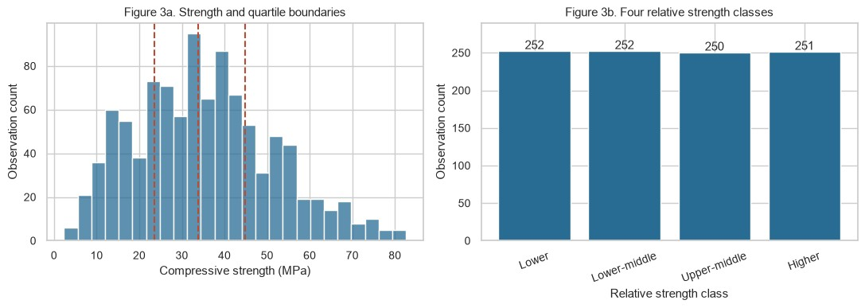
The histogram shows substantial spread in strength, so a single summary value would conceal important variation. Quartile labels sacrifice differences within each interval and make nearly identical strengths on opposite sides of a boundary different classes. Ties can cause slight count differences; the count ratio above quantifies balance. Both target representations are retained, but neither target is permitted as a predictor of the other.
These boundaries are descriptive, computed from the full cleaned dataset for this EDA. For future evaluation, define engineering thresholds in advance or estimate quartiles only on training targets and freeze them for held-out data. Use infinite outer edges for future observations outside the training range. Do not compute new quartiles on a test set or use held-out target information to tune boundaries.

Task 4. Univariate analysis
The eight predictors are cement, slag, fly ash, water, superplasticizer, coarse aggregate, fine aggregate and age. All are quantitative; no categorical predictor encoding is needed. Histograms include units and counts; skewness and the fraction of zero values help distinguish asymmetric distributions from absent ingredients.

Code cell [7]
print('Predictors:', ', '.join(predictors)) summary = clean[predictors].describe().T summary['skewness'] = clean[predictors].skew()
summary['zero_percent'] = 100 * clean[predictors].eq(0).mean() show_table(summary.round(3)) fig, axes = plt.subplots(2, 4, figsize=(13, 7)) for c, ax in zip(predictors, axes.flat):
sns.histplot(clean[c], bins=25, ax=ax, color='#286c94') ax.set(title=c.replace('_', ' ').title(), xlabel=labels[c], ylabel='Count') fig.suptitle('Figure 4. Distributions of all eight predictors', y=1.02) plt.tight_layout()
show_plot('04_predictor_histograms')
Predictors: cement, slag, fly_ash, water, superplasticizer, coarse_aggregate, fine_aggregate, age count mean std min 25% 50% 75% max skewness zero_percent cement 1005.0 278.629 104.345 102.00 190.68 265.0 349.00 540.0 0.565 0.000 slag 1005.0 72.043 86.171 0.00 0.00 20.0 142.50 359.4 0.855 46.269 fly_ash 1005.0 55.535 64.207 0.00 0.00 0.0 118.27 200.1 0.497 53.831 water 1005.0 182.074 21.341 121.75 166.61 185.7 192.94 247.0 0.034 0.000 superplasticizer 1005.0 6.032 5.920 0.00 0.00 6.1 10.00 32.2 0.982 37.612 coarse_aggregate 1005.0 974.376 77.580 801.00 932.00 968.0 1031.00 1145.0 -0.065 0.000 fine_aggregate 1005.0 772.687 80.340 594.00 724.30 780.0 822.20 992.6 -0.252 0.000 age 1005.0 45.857 63.735 1.00 7.00 28.0 56.00 365.0 3.254 0.000
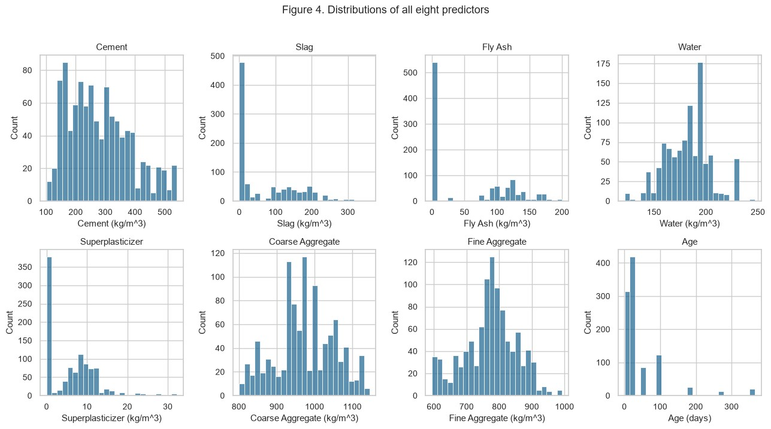
Cement has a broad, asymmetric distribution rather than a single narrow recipe. Slag and fly ash have many zeros and distinct positive ranges, reflecting mixtures with and without supplementary materials.
Superplasticizer is also zero-heavy with a positive tail. Age is discrete and strongly right-skewed: common test ages create spikes and a smaller number of long-age tests extend the tail. Water and aggregate quantities are more concentrated but can reflect several recipe families; visual symmetry alone does not establish normality.
Skewness is descriptive and does not by itself justify deleting observations or transforming every variable.

Task 5. Multivariate analysis
Pearson correlation measures linear association with continuous strength. Features are ranked by absolute correlation, while their signs are preserved. Spearman correlation provides a complementary rank-based view when relations are monotonic but nonlinear. Correlations are descriptive associations, not causal effects.

Code cell [8]
corr = clean[columns].corr(method='pearson') fig, ax = plt.subplots(figsize=(10, 8)) sns.heatmap(corr, annot=True, fmt='.2f', vmin=-1, vmax=1, center=0, cmap='RdBu_r', square=True, ax=ax, cbar_kws={'label': 'Pearson correlation r'}) ax.set(title='Figure 5. Pearson correlations after deduplication', xlabel='Variable', ylabel='Variable') ax.tick_params(axis='x', rotation=40) plt.tight_layout() show_plot('05_correlation_heatmap') ranking = pd.DataFrame({'Pearson_r': corr.loc[predictors, 'strength'], 'Spearman_rho': clean[columns].corr(method='spearman') .loc[predictors, 'strength']}) ranking['absolute_Pearson_r'] = ranking.Pearson_r.abs() ranking = ranking.sort_values('absolute_Pearson_r', ascending=False) print('All features ranked by absolute Pearson correlation:') show_table(ranking.round(4)) top3 = ranking.head(3) print('Top three:', ', '.join(f'{c}: r={r:.4f}' for c, r in top3.Pearson_r.items())) pair_rows = [(a, b, corr.loc[a, b]) for i, a in enumerate(predictors) for b in predictors[i + 1:]] pair_corr = pd.DataFrame(pair_rows, columns=['feature_1', 'feature_2', 'r']) pair_corr['absolute_r'] = pair_corr.r.abs() pair_corr = pair_corr.sort_values('absolute_r', ascending=False) print('Strongest predictor pairs:') show_table(pair_corr.head(6).round(4)) print('High pairwise correlation screen: |r| >= 0.70') high_pairs = pair_corr.loc[pair_corr.absolute_r >= 0.70] print(high_pairs.to_string(index=False) if len(high_pairs) else 'No pairs cross 0.70.')
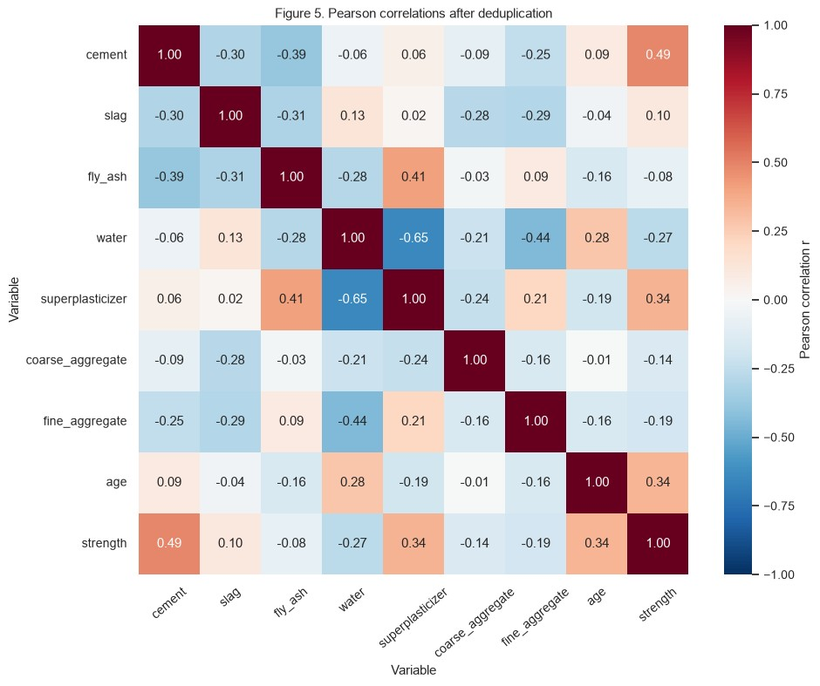
All features ranked by absolute Pearson correlation: Pearson_r Spearman_rho absolute_Pearson_r cement 0.488 0.461 0.488 superplasticizer 0.344 0.322 0.344 age 0.337 0.605 0.337 water -0.270 -0.284 0.270 fine_aggregate -0.186 -0.193 0.186 coarse_aggregate -0.145 -0.163 0.145 slag 0.103 0.139 0.103 fly_ash -0.081 -0.057 0.081 Top three: cement: r=0.4883, superplasticizer: r=0.3442, age: r=0.3374 Strongest predictor pairs:
feature_1 feature_2 r absolute_r 18 water superplasticizer -0.647 0.647
20 water fine_aggregate -0.445 0.445
14 fly_ash superplasticizer 0.414 0.414
1 cement fly_ash -0.386 0.386
7 slag fly_ash -0.312 0.312
0 cement slag -0.303 0.303
High pairwise correlation screen: |r| >= 0.70 No pairs cross 0.70. Code cell [9]
key = list(top3.index) + ['strength'] g = sns.pairplot(clean[key], diag_kind='hist', corner=True, plot_kws={'alpha': 0.35, 's': 12, 'color': '#286c94'}, diag_kws={'color': '#286c94'}) for i, row in enumerate(g.axes): for j, ax in enumerate(row): if ax is not None:
if i == len(key) - 1: ax.set_xlabel(labels[key[j]]) if j == 0 and i > 0: ax.set_ylabel(labels[key[i]])
g.fig.suptitle('Figure 6. Pairplot of top three predictors and strength', y=1.02) show_plot('06_pairplot')
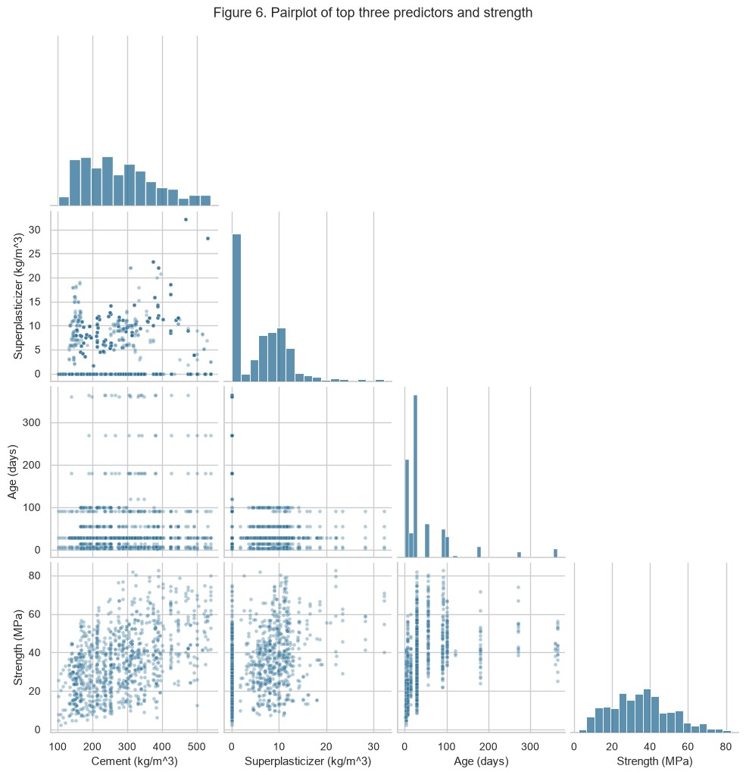
The pairplot complements coefficients by exposing overlapping recipe clusters, dispersion and curved or age-dependent relationships that a straight-line measure can miss. The water-superplasticizer association can reflect mixture design choices: dosage and water are jointly selected, rather than independently assigned. The 0.70 screen is a chosen diagnostic threshold, not a theorem. Absence of a pair above it does not rule out multivariable dependence. Future linear modelling should also check variance inflation and coefficient stability, especially after adding features derived from existing ingredients.

Task 6. Engineering interpretation
What do the correlations mean?
The positive association of cement with strength is compatible with the role of cementitious binder. A negative water-strength association is compatible with the importance of water relative to binder, rather than interpreting water in isolation. Age is associated with the development of strength, but its effect need not be linear. These interpretations are hypotheses consistent with the data, not causal estimates. Superplasticizer's positive association is compatible with its role in mixture workability and water reduction, but dosage may also track high-strength recipe choices. Age has a stronger Spearman association than Pearson association in this sample, supporting investigation of a monotonic, nonlinear age-strength relation.

Unexpected or easily misread patterns
Slag and fly ash may have weak marginal associations despite their engineering relevance. Their amounts, cement replacement, water and curing age vary together, so a small marginal coefficient does not show that a material is unimportant. Different testing ages make unconditional comparisons of mixtures potentially misleading; comparing 28-day specimens would answer a narrower question.

Physical and process relationships
Mixtures are constrained combinations of ingredients. Binder composition and water demand interact, while the age-strength relationship can show diminishing gains. Candidate features include total binder (cement + slag + fly ash), water divided by total binder, and log(1 + age). These require testing; the sum of binder components is a simplification, not an assumption of equal reactivity. Derived features should not be added indiscriminately alongside all originals in a linear model because they can increase dependence.

Important missing features
Curing temperature, curing humidity, specimen geometry, testing protocol, cement type, aggregate grading, laboratory/batch identity and measurement uncertainty are not supplied. These can explain residual variation and affect transfer to new materials or environments. The dataset cannot establish structural suitability.

Task 7. Challenges encountered and data preparation decisions
The legacy .xls format requires xlrd; a packaged source workbook avoids a runtime dependency on UCI availability. Original verbose column names were mapped to readable names with units recorded explicitly. Exact duplicate records cannot be distinguished from repeated tests without specimen identifiers. Outlier flags overlap across columns and are counted both by variable and by distinct row.
Imputing zeros would be unnecessary here and would conflate absent optional ingredients with unknown measurements in a future dataset. Numerical target binning also changes the task: it creates ordered classes, not additional predictors or engineering certification categories. Cleaning decisions are documented and the untouched source remains available for audit.

Code cell [10]
# Export raw and cleaned tables without changing the source workbook. raw.to_csv('data/concrete_raw.csv', index=False) clean.to_csv('data/concrete_prepared.csv', index=False) metadata = { 'source_doi': '10.24432/C5PK67', 'source_rows': len(raw),
'prepared_rows': len(clean), 'removed_exact_duplicates': extra_duplicates,
'predictors': predictors, 'units': units,
'continuous_target': 'strength', 'classification_target': 'strength_class',
'class_labels': class_labels, 'descriptive_class_edges_MPa': edges.tolist(),
'class_boundary_convention': 'right-closed; first interval includes minimum',
'class_edges_scope': 'full cleaned dataset EDA; refit on training for evaluation',
'outlier_policy': 'retain all IQR flags; no confirmed invalid measurements',
'source_sha256': hashlib.sha256(DATA.read_bytes()).hexdigest() } import json Path('data/preparation_metadata.json').write_text(json.dumps(metadata, indent=2)) assert clean[predictors].notna().all().all() assert not clean[columns].duplicated().any() assert len(predictors) == 8 and 'strength' not in predictors assert 'strength_class' not in predictors print('Saved raw CSV, prepared CSV and preparation metadata.') print('Prepared data:', len(clean), 'rows,', len(clean.columns), 'columns') print('Eight predictors; two alternative targets; no imputation or outlier deletion.') print('Integrity checks passed.')
Saved raw CSV, prepared CSV and preparation metadata.
Prepared data: 1005 rows, 10 columns Eight predictors; two alternative targets; no imputation or outlier deletion.
Integrity checks passed.

Task 8. Responsible AI reflection
How could poor quality affect reliability?
Duplicated records may inflate performance if copies cross train/test boundaries. Unknown or misrecorded units can systematically distort predicted strength. Deleting legitimate long-age or unusual mixtures can damage reliability at the edges of the operating range. If recipe families occur at several ages, a random row split can overstate performance on genuinely new recipes; group evaluation by recipe, and preferably batch or laboratory, should be considered.

Ethical and bias issues
The dataset describes selected laboratory mixtures, not a random sample of all concrete used in construction. Ingredient coverage, curing conditions and material sources may differ from local practice. Missing provenance makes subgroup auditing difficult. There are no personal demographic variables, but lack of such variables does not remove representativeness concerns. Predictions could have safety consequences if mistaken for certified test results. External validation, uncertainty reporting and qualified engineering review would be needed before operational use. Balanced relative classes do not imply balanced coverage of laboratories, recipe types or rare safety-critical conditions.

