A Project Report on
Self-Optimizing Power Grid: AI for Real-Time Energy Fraud Detection & Load Balancing
submitted in partial fulfillment of the requirements for the award of the degree of
BACHELOR OF ENGINEERING
By
Haniya Akhtar: 22106130
Nishat Khan: 22106021
Hrishikesh Kharkar: 22106002
Kuheli Das: 22106003
Under the Guidance of
Dr. Bharti Khemani



Department of Computer Science & Engineering (Artificial Intelligence & Machine Learning)
A.P. SHAH INSTITUTE OF TECHNOLOGY, THANE
UNIVERSITY OF MUMBAI
2025-2026


A. P. SHAH INSTITUTE OF TECHNOLOGY, THANE
CERTIFICATE
This is to certify that the project entitled “Self-Optimizing Power Grid: AI for Real-Time Energy Fraud Detection & Load Balancing” is a bonafide work of Haniya Akhtar (22106130), Nishat Khan (22106021), Hrishikesh Kharkar (22106002), Kuheli Das (22106003) submitted to the University of Mumbai in partial fulfilment of the requirement for the award of the degree of Bachelor of Engineering in Computer Science & Engineering (Artificial Intelligence & Machine Learning).

______________ ______________
Dr. Bharti Khemani Prof. Sayali P. Badhan
Guide Project Co-ordinator

______________ ______________
Dr. Jaya Gupta Dr. Uttam D. Kolekar
Head of Department Principal



A. P. SHAH INSTITUTE OF TECHNOLOGY, THANE

Project Report Approval for B.E.

This project report entitled Self-Optimizing Power Grid: AI for Real-Time Energy Fraud Detection & Load Balancing by Haniya Akhtar, Nishat Khan, Hrishikesh Kharkar, Kuheli Das is approved for the degree of Bachelor of Engineering in Computer Science & Engineering (Artificial Intelligence & Machine Learning), 2025-26.

Examiner Name Signature
1.________________ _____________
2._________________ ______________

Date:
Place:

Declaration

We declare that this written submission represents my ideas in my own words and where others' ideas or words have been included, I have adequately cited and referenced the original sources. I also declare that I have adhered to all principles of academic honesty and integrity and have not misrepresented or fabricated or falsified any idea/data/fact/source in my submission. I understand that any violation of the above will be cause for disciplinary action by the Institute and can also evoke penal action from the sources which have thus not been properly cited or from whom proper permission has not been taken when needed.

---------------------------------
(Haniya Akhtar & 22106130)

----------------------------------
(Nishat Khan & 22106021)

----------------------------------
(Hrishikesh Kharkar & 22106002)

----------------------------------
(Kuheli Das & 22106003)

Date:

Abstract
The increasing power demand in urban environments requires an efficient, sustainable, and reliable power system. Modern power grids have become vulnerable to inefficiencies in load balance and prone to malpractices like power theft. Conventional rule-based and manual methods fail to deliver reliability, security, and efficiency under dynamic conditions, creating the need for an AI-driven framework. This report proposes a self-optimizing power grid framework that leverages artificial intelligence for real-time fraud detection and load balancing. This work integrates probabilistic fraud scores from Vertex AI logistic regression directly into PPO-based load balancing states to enable fraud-aware optimization, reducing transformer overloads by 35-45% in Mumbai-like synthetic scenarios. Due to privacy restrictions and the rarity of labeled fraud data, Gaussian-based synthetic datasets were generated to preserve realistic temporal, environmental, and inter-feature correlations characteristic of Mumbai’s urban power grid. For grid management, we applied a Proximal Policy Optimization (PPO) agent that learns how to distribute loads efficiently, while respecting transformer safety limits, maintaining frequency stability, and adapting to patterns in time and renewable energy contribution. Our results show that the approach not only improves fraud detection, achieving an accuracy of 79.91%, but also reduces transformer overload events by 35-45% and mitigates non-technical losses through fraud-aware adjustments, preserving stability and security in a dynamic operating environment. The proposed framework aligns with SDG Goal 7 (Affordable and Clean Energy) and Goal 11 (Sustainable Cities and Communities) by fostering a resilient, secure, and sustainable power infrastructure. The source code, including data generation, model training, and Flask interface.

Keywords- Smart Grid; Big Data Analytics; Reinforcement Learning; Fraud Detection; Synthetic Data Generation; Urban Energy Systems; Proximal Policy Optimization.

Contents
1. Introduction 1
1.1 Organisation of paper 2
1.2 Background study 3
2. Survey/ Existing System 5
2.1 Electricity Theft Detection Using Machine Learning 5
2.2 Reinforcement Learning for Load Scheduling in Power Grids 6
2.3 Research Motivation 8
3. Limitation of Existing System 9
4. Problem Statement and Objective 11
4.1 Parameter Selection and Feature Space 11
4.2 Parameter Selection and Feature Space 11
4.3 Parameter Selection and Feature Space 12
5. Proposed System 13
5.1 Parameter Selection and Feature Space 17
5.2 Synthetic data generation 18
5.3 Fraud Detection Dataset Construction 21
5.4 Load Balancing Dataset Construction 21
5.5 Dataset Preprocessing and Normalization 21
5.6 Dataset Storage and Accessibility 21
5.7 Fraud Detection Methodology 22
5.8 Training Objective and Evaluation Metrics 23
5.8.1 Threshold Selection and Operational Considerations 23
5.8.2 Model Interpretability and Output Integration 24
5.9 Load Balancing Methodology 25
5.9.1 Reinforcement Learning Formulation 25
5.9.2 State, Action, and Reward Design 26
5.9.3 Choice of Proximal Policy Optimization (PPO) 27
5.9.4 Model Training and Deployment 28
5.9.5 Performance Evaluation 28
5.10 Interaction with Fraud Detection Module 30
5.10.1 End-to-End System Workflow 30
5.10.2 Fraud-Aware State Adjustment Mechanism 31
5.10.3 Interaction with the Reinforcement Learning Agent 31
5.10.4 Benefits of the Integrated Framework 32
6. Experimental Setup 33
6.1 Details of Database 34
6.2 Performance Evaluation Parameters (Validation Metrics) 35
6.3 Software and Hardware Setup 36
6.4 Implementation 38
7. Results and Discussion 41
7.1 Quality Evaluation of Synthetic Data 41
7.2 Quantitative Estimation of Improvement in Mumbai’s Electricity Condition 44
8. Conclusion and Future Work 47
References
Publication

LIST OF FIGURES
Fig 1.a : Feature Engineering and Model Training 14
Fig 1.b : Analysis and Results 15
Fig 2 : Dataset Design 16
Fig 3 : Parameter Selection and Feature Space 27
Fig 4 : Correlation matrices between real and synthetic data 18
Fig 5 : Correlation comparison for fraud detection dataset 19
Fig 6 : Correlation comparison load balancing dataset 19
Fig 7 : Copula-based prediction analysis 20
Fig 8 : At threshold 0.5 24
Fig 9 : At threshold 0.62 24
Fig 10 : Original and optimal load balancing analysis 29
Fig 11 : Transformer load distribution 29
Fig 12 : Transformer load over time 30
Fig 13 : End-to-end System Workflow 31
Fig 14 : Benefit of Integrated Framework 2 32
Fig 15 : Login Page 38
Fig 16 : Dashboard Page 38
Fig 17 : Fraud Detection System 39
Fig 18 : Load Balancing System 39
Fig 19 : Smart Grid Risk Visualization Map of Mumbai 39
Fig 20 : Real-time Power Grid Monitoring Dashboard 40
Fig 21 : Renewable Energy Dashboard 40
Fig 22 : Load Demand Forecast System 40
Fig 23 : Gaussian Copula Model Evaluation 42

LIST OF TABLES

Table 1 : Literature Survey of the previous studies 7
Table 2 : Reward Design for the RL Agent 27
Table 3 : Quality Evaluation of Synthetic Data 42
Table 4 : Fraud Detection Model Evaluation 43
Table 5 : Load Balancing Model Evaluation 45

ABBREVAION

AI Artificial Intelligence
ML Machine Learning
RL Reinforcement Learning
PPO Proximal Policy Optimization
CNN Convolutional Neural Network
RNN Recurrent Neural Network
GRU Gated Recurrent Unit
DQN Deep Q-Network
MDP Markov Decision Process
NTL Non-Technical Losses
SAIDI System Average Interruption Duration Index
SDG Sustainable Development Goals
GAN Generative Adversarial Network
CTGAN Conditional Tabular Generative Adversarial Network
AutoML Automated Machine Learning
PR-AUC Precision–Recall Area Under the Curve
ROC-AUC Receiver Operating Characteristic Area Under the Curve
IoT Internet of Things
BigQuery Google BigQuery (cloud data warehouse)

Chapter 1

Introduction

Urban power distribution systems in large metropolitan cities, under the growing pressure of population expansions, denser cities, and electricity consumption patterns have unprecedented pressure. These trends lead to the generation of large-scale, high-velocity smart meter data. Mumbai, being India’s most populous city and a major economic centre, demands a modern power grid catering to the consequent fluctuations intensified by seasonal changes, especially during extreme summers and the monsoon season. Electricity distribution and transmission losses are categorised as technical and non-technical losses (NTL). Due to inefficiencies in the equipment and infrastructure, technical losses occur, while NTL are the result of billing errors, electricity theft,t etc.NTL is a global concern that costs utilities about 96 USD billion annually [1,2].
In urban areas like Mumbai, where demand instability and electricity theft prevail, data reliability becomes significant for effective grid control. Load balancing decisions that are made using unverified consumption data may amplify the effects of fraud, while excessively aggressive control actions can mask abnormal usage patterns. The incompetence in detecting complex fraudulent patterns due to the conventional rule-based and manual inspection methods is also inefficient [3,4]. Recent work employs traditional classifiers like Gradient Boosting and Random Forest to advanced deep learning architectures like Gated Recurrent Units (GRUs) and Convolutional Neural Networks (CNNs) [1,5,6]. Meanwhile, reinforcement learning (RL) is adopted for grid optimization since load scheduling can be formulated as a Markov Decision Process (MDP), allowing RL algorithms such as Q-Learning and Deep Q-Networks to dynamically balance supply and demand [7]. Despite this progress, a critical issue persists that is the limited availability of real-world, labeled fraud data due to privacy concerns and the rarity of verified fraud incidents hampering the development of reliable models.
This study presents a Self-Optimizing, big-data-driven power grid framework that unites machine learning based fraud detection with reinforcement learning driven load balancing using a closed-loop system. Smart meter data for fraud detection is stored and processed using BigQuery Big tables, enabling scalable ingestion and analytics, while Vertex AI is used for cloud-native model training and deployment. We get probabilistic fraud outputs and use a Proximal Policy Optimization (PPO) based load balancing agent, enabling load balancing. Developed with scalability and real-time deployment in mind, enhances grid stability and reduces transformer stress.

1.1 Organisation of the paper
- The primary focus of this research is to comprehensively examine an ai driven self-optimizing smart grid framework that integrates real-time electricity for detection with dynamic load balancing, targeting the challenges faced by the dense urban power grid, such as Mumbai.
- The paper discusses the background and motivation behind the proposed framework, highlighting the limitations of traditional creative monitoring systems and the growing impact of electricity theft in urban environments.
- An in-depth review of existing literature on smart grid fraud detection using BigQuery-based data storage, Vertex AI, and rural-based load balancing using PPO is provided, emphasizing performance metrics, current techniques, and unresolved challenges in standalone approaches.
- The study formulates research problems and presents a proposed system architecture describing the end-to-end workflow, which includes data ingestion, fraud detection, and fraud-aware state construction and load optimization.
- The paper presents experimental results and performance analysis evaluating the effectiveness of the proposed framework in reducing overload events, improving demand supply balance, and handling fraudulent consumption scenarios.
- The study also discusses limitations, identifies key research gaps, suggests future research directions, and concludes with a summary of the contributions and practical implications of the proposed system.

1.2 Background Study

Mumbai’s Power Grid: System Under Constant Pressure
Mumbai’s electricity grid is more than cables and transformers; from dense residential high-rises and commercial districts to railway systems, financial institutions, and hospitals, electricity demand is tightly packed into a very small geographic area. This extreme pressure creates a highly connected and sensitive distribution network, where stress in one part of the grid can quickly affect others [8, 9]. Unlike cities with balanced land usage, Mumbai’s power demand changes significantly across time and location. Intense summer cooling loads, morning and evening household peaks, and continuous commercial usage create constant strain on transformers [17,19]. Research on urban smart grids shows that rule-based or static methods find it difficult in such environments because they cannot adjust to real-time changes and consumption behavior [9,25].

Reliability Challenges and the Reality of Blackouts
Grid reliability is generally measured using indices such as SAIDI, which track the average time of power interruptions experienced by consumers. Even in advanced power systems, yearly outage durations remain significant [8,10]. Mumbai’s October 2020 blackout exposed the weakness of highly interconnected urban grids. Investigations revealed that grid variations and protection system responses triggered such failures, resulting in a city-wide outage affecting transportation, healthcare services, and financial operations [11,12]. Studies on blackout dynamics show that such events often start with localized overloads or inaccurate system states that remain undetected until system limits are surpassed [13].

Electricity Theft as a Hidden Stress on the Grid
Meter tampering, billing manipulation, and unauthorized connections contribute to significant general losses, directly impacting grid strength and utility revenues [14]. Reports indicate a continuous increase in power theft cases across Mumbai, particularly in heavily populated residential and mixed-use neighborhoods [16]. Electricity theft has affected the grid in two critical ways. First, it bends consumption data, leading to inaccurate demand forecasting and inefficient grid arrangement [14, 15]. Second, illegal utilization often clusters locally, causing transformers to operate beyond their thermal limits without caution. Old detection methods rely on post-billing audits, making them unsuitable for real-time grid protection and control [15].

Demand Changes Driven by Urban Life and Climate
Mumbai’s electricity demand is molded by a complex interaction of human activity, climate, and economic behavior. Residential demand tops during mornings and evenings, while commercial and industrial loads dominate during the day. Seasonal variations further intensify these changes; in summer, heatwaves drive heavy air conditioning usage, while monsoon conditions change consumption patterns across the city [17], [19]. Research on load prediction highlights that such time-varying, non-linear relationships are difficult to capture using traditional statistical or rule-based techniques. Without adaptive learning mechanisms, grid operators wrestle to respond effectively to sudden demand surges, increasing the risk of inefficient utilization and transformer overloads[18]. Old age grid management techniques were designed for relatively predictable and centralized power systems. The rule-based control systems assume firm operating conditions and fail when confronted with unexpected shifts[20]. General reinforcement learning methods, such as value-based or actor–critic algorithms, face challenges related to training instability and scalability when applied to real-world power systems.

Artificial Intelligence as a Transformative Enabler
Artificial intelligence offers a very different approach to grid management. Instead of relying on predefined rules, AI systems learn directly from historical and real-time data and authorize continuous adaptation to changing grid conditions. Machine learning models can identify small problems in consumption patterns indicative of electricity theft, while reinforcement learning starts sequential decision-making for dynamic load balancing [15,23]. In particular, policy gradient methods such as Proximal Policy Optimization (PPO) have gained attention for their stability and suitability in controlling problems of power grid operations. Surveys on smart grid modernization emphasize that AI allows grids to transition from reactive operation to predictive and self-correcting systems that improve over time through feedback and learning [22,26]. A self-optimizing grid must integrate real-time fraud detection to ensure data integrity, adaptive load balancing to protect transformers, and continuous learning mechanisms that evolve with changing urban conditions [23,24].

Chapter 2
Literature Survey/ Existing System

This section reviews the two foundational studies that form the basis of the present research. These works represent recent and relevant advances in electricity fraud detection and reinforcement learning based load balancing within smart grid systems. Table 1 describes the literature survey that includes the domain, model applied, datasets used, and performance metrics in their work.

2.1 Electricity Theft Detection Using Machine Learning
[1] presented a comprehensive study on electricity theft detection in smart grids using machine learning. The work focuses on identifying fraudulent electricity consumption by analyzing smart meter data, which typically exhibits high dimensionality, missing values, and severe class imbalance. The authors employed a combination of traditional machine learning models (such as Random Forest and Gradient Boosting) and deep learning architectures, including a hybrid GRU–MLP model, to capture both short-term and long-term consumption patterns. Time-domain and frequency-domain features were extracted from daily smart meter readings, enabling the model to learn subtle irregularities indicative of electricity theft. Synthetic data generation techniques like k-means and SMOTE were employed to handle the imbalance between normal and fraudulent cases. The study demonstrated strong performance across multiple evaluation metrics, which include precision, recall, accuracy, F1-score, PR-AUC, and ROC-AUC. These results highlight that machine learning models are efficacious in identifying electricity theft under controlled conditions.
The authors also recognized several limitations. The model training and evaluation were conducted in an offline environment with the usage of historical data, where fraud detection served as a classification task intended to aid billing audits and inspection processes. The study did not explore how fraud detection outcomes could influence real-time grid operations or how fraudulent consumption might affect load balancing and grid stability.

2.2 Reinforcement Learning for Load Scheduling in Power Grids
Luo [7] explored reinforcement learning based solutions for load scheduling as Markov Decision Processes. Load balancing was formulated as a decision-making problem, being sequential, aiming to balance demand and supply operations along with minimizing costs. The grid environment was modeled as a Markov Decision Process (MDP), with the state space that consists of the demand levels, generation capacity, and energy storage states. Multiple reinforcement learning algorithms were analyzed, including Actor–Critic methods, Deep Q-Networks (DQN), and Q-Learning. Based on mean cost reduction, rate of convergence, balance between supply and demand, and stability under dynamic load conditions,s the performance was monitored.
The results demonstrated that RL agents can adapt to learn about the load scheduling strategies without relying on analytical models of grid dynamics, making it suitable for modern power grids when characterized by behaviours like uncertainty, time variance, and non-linearity.
Even with these advantages, the study relied on input data to be accurate and reliable. The prevalence of electricity theft, manipulation of data, or anomalous consumption patterns on the learning and decision-making process was not supported. As a result, the proposed framework solution may perform inadequately when deployed in real-world urban grids where non-technical losses are common.
In urban power systems such as Mumbai’s, treating these processes separately will pose more challenges. Consumption of fraudulent usage of electricity directly distorts demand data, which serves as a primary input to load balancing algorithms. If load scheduling decisions are based on such data, they can lead to overloading of transformers, poor electricity distribution, and a higher risk of outages.
Our study aims to bridge the gap between fraud detection and load balancing using these two foundational studies:
- Treats fraud detection as a real-time control signal, not just a reporting mechanism
- Incorporates fraud probability into the reinforcement learning state space
- Enables fraud-aware load balancing, improving robustness in urban grids
By integrating the strengths of machine learning–based fraud detection [1] with reinforcement learning–based load scheduling [7], the proposed framework advances toward a more realistic, adaptive, and deployable smart grid solution for metropolitan regions.
Table 1: Literature Survey of the previous studies.
Year | Domain | Algorithm | Dataset | Performance Metric
[1]  2024 | Smart grid fraud detection (electricity theft) | Traditional ML + Deep Learning (Random Forest, Gradient Boosting, MLP-GRU) | China National Grid Corporation (CNGC) dataset: 42,372 consumer records (38,752 honest + 3,615 theft). | Accuracy, Recall, Precision, ROC-AUC, F1-score
[2]  2023 | Electricity fraud detection in Smart Metering Systems | Supervised:  Wide/Deep FFNN, CNN; Unsupervised: Clustering (CFSFDP), RNN | Various public and proprietary smart meter datasets (includes SGCC & Irish CER) | Accuracy, robustness against adversarial attacks, and privacy preservation
[3]  2022 | Fraud Detection (energy) | Supervised (DT, SVM, ANN), Unsupervised (SOM, Clustering) | This study compares various other datasets and doesn’t include its own. | Accuracy (Acc), Detection Rate (DR), False Positives (FP)
[4]  2021 | Fraud detection(energy) | NGBoost (Natural Gradient Boosting) | Sensors 21, no. 24 paper: dataset not clearly described in abstract; need full text | Accuracy: 93%, Recall: 91%, Precision: 95%, AUC: 0.96
[5]  2022 | Electricity fraud detection in Smart Grid | CNN-GRU hybrid tuned with Cuckoo Search (CS) | Forecasting 4, no. 4 (2022): does mention tuned CNN ensembler; dataset description not clearly in abstract | Accuracy: 92%, Precision: 94%, F1-score, ROC-AUC, PR-AUC
[21]  2025 | Energy Management/ Smart Grids | Control strategies (microgrid control framework) | Community microgrid operational data (load demand, renewable generation) | Operational cost reduction(%), peak -to-average ratio(PAR), system stability
[6]  2023 | Electrical load forecasting | BiLSTM (Bidirectional LSTM Neural Network) | Hourly energy consumption data for Greece (IPTO, 746 days: 2020–2022) | FN, GNNs, Swarm Intelligence (PSO & ACO)

2.3 Research Motivation
In urban power grids, electricity fraud does more than cause financial loss; it quietly disturbs how the entire system operates. When consumers manipulate meters or illegally extract power, the demand data collected by utilities becomes unreliable. Load balancing algorithms, which depend on correct consumption information, then make decisions based on dynamic inputs. Therefore, electricity may be redistributed inefficiently, placing unexpected strain on transformers and increasing the risk of overheating, long-term infrastructure damage, and outages. By averaging or smoothing out consumption patterns across the network, abnormal usage that could show theft may blend into normal demand variations. This creates a cycle where fraud weakens grid strength, and grid control mechanisms make fraud harder to find, highlighting the need for smart systems that can jointly address both challenges.

Chapter 3

Limitation of Existing System

- Training Stability:
Reinforcement Learning (RL) models such as Deep Q-Network (DQN) and Actor-Critic algorithms often face instability during the training phase. This instability arises due to factors like fluctuating reward signals, non-stationary environments, and sensitivity to hyperparameters such as learning rate, discount factor, and exploration strategy. Improper tuning can lead to divergence or suboptimal policies. Additionally, RL models require a large number of training episodes to converge, which increases computational cost and makes deployment more complex.
- Scalability Issues:
Although DQN and Actor-Critic methods are designed to handle large and continuous state spaces, real-world smart grid systems involve highly interconnected and high-dimensional environments. As the number of nodes, consumers, and grid parameters increases, the system suffers from the curse of dimensionality, making it difficult for the model to efficiently learn optimal policies. This results in increased memory requirements, slower convergence, and reduced performance in large-scale grid implementations.

- Simulation vs. Real World:
The proposed system is trained and evaluated using simulated smart meter data, which may not fully capture the complexities of real-world power grids. Actual grid environments include unpredictable factors such as hardware failures, regulatory constraints, dynamic pricing, seasonal demand variations, and human behavior. As a result, models that perform well in simulation may not generalize effectively when deployed in real-world scenarios, leading to potential reliability issues.
- Data Quality:
The dataset used in this project contains missing values, outliers, and class imbalance, requiring extensive preprocessing such as normalization, imputation, and feature engineering. The performance of machine learning models is highly dependent on the quality of this preprocessing. Any errors or biases introduced during data cleaning can significantly impact the model's accuracy. Moreover, the relationships between features (columns) may not always be linear or consistent, further complicating the learning process.
- Overfitting:
The model is trained and evaluated on a single dataset, which limits its ability to generalize across different regions or utility providers. Electricity theft patterns, consumption behaviors, and grid characteristics can vary significantly across countries and demographics. This increases the risk of overfitting, where the model learns dataset-specific patterns rather than generalizable insights. Consequently, the system may perform poorly when exposed to unseen or real-world data from different environments.
- Limited Explainability:
Deep learning and RL-based models often function as “black boxes,” making it difficult to interpret their decision-making process. In the context of smart grids, this lack of transparency can be problematic, as utility companies need clear justifications for flagging a consumer as fraudulent. Without explainability, it becomes challenging to build trust, ensure regulatory compliance, and take actionable decisions. Although techniques like SHAP (SHapley Additive Explanations) can improve interpretability, they may not fully resolve the complexity of deep models.

Chapter 4

Problem Statement and Objective

4.1 Problem Statement
India’s urban grids—especially Mumbai’s—are strained by electricity theft, erratic consumption, and frequent blackouts, while traditional monitors can’t flag fraud or foresee load surges in real time. We propose a lightweight, on-prem AI system that streams synthetic smart-meter data, performs real-time anomaly detection, uses SHAP for explainability, and applies reinforcement learning to detect fraud, forecast demand, and dynamically balance load— without costly cloud infrastructure [11,12].

4.2 Objectives
To design and implement an AI-powered smart grid system capable of real-time fault detection and dynamic load balancing by leveraging machine learning and deep learning models.To enhance the reliability, efficiency, and stability of the power grid by accurately identifying faults, predicting load demands.

4.3 Scope
- Dual Focus on Fraud Detection & Load Balancing
Unlike the existing works that treat these areas separately, our system scope is to incorporate MLbased fraud detection with RL based load balancing in a unified framework[15].
- Synthetic Data Generation for Benchmarking
Most real world fraud datasets are often confidential and scarce , our system generates synthetic smart meter datasets including both normal consumption pattern and fraudulent behaviour allowing for benchmarking[16].
- Performance Evaluation
- Fraud Detection will be evaluated on the basis of Accuracy, Precision, Recall, F1-score, ROC-AUC.
- Load balancing will be measured by stability, cost reduction, demand-supply balance, and convergence rate [17].

4. Real time decision making
The system is envisioned to operate in real-time, continuously monitoring smart meter data, flagging anomalies, and dynamically adjusting load schedules.

Chapter 5

Proposed System

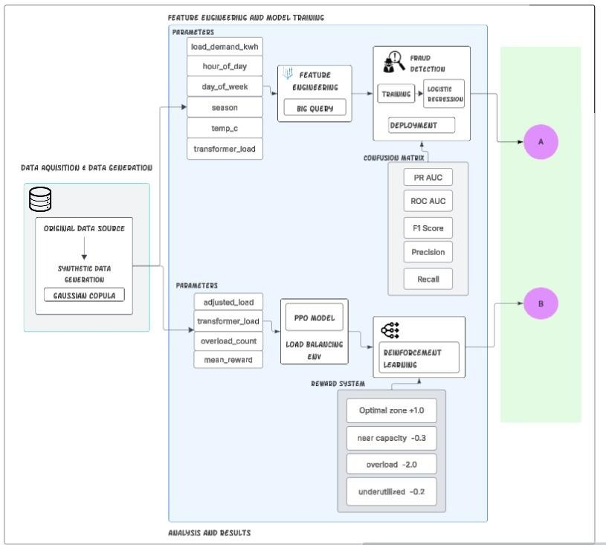Fig. 1.a: Feature Engineering and Model Training
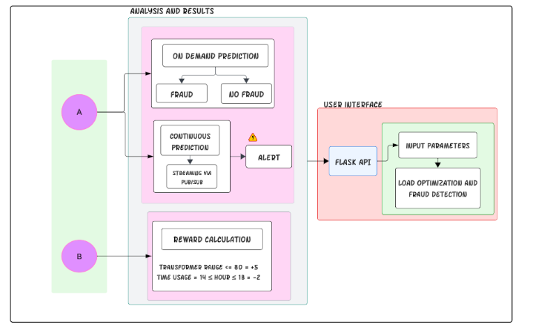Fig. 1.b: Analysis and Results
The proposed system architecture illustrates how large scale smart meter data flows seamlessly from raw inputs to intelligent grid control decisions Fig. 1.a presents the data acquisition,f eature engineering and model training pipeline where original smart meter data is augmented using Gaussian copula based synthetic data generation and followed by feature engineering in BigQuery Big tables, enabling analytics and feature engineering over large volumes of records. This processed data leads to parallel learning components: 1. A machine learning based fraud detection model that is trained and deployed for fraud inference, deployed on Vertex AI AutoML logistic regression, and 2. A reinforcement learning based load balancing environment where a PPO agent learns adaptive control policies. The Fig. 1.b depicts the analysis decision making and user interaction layer, where fraud detection predictionsare enabled on demand and continuous streaming analysis triggers alerts where anomalies are detected and influence reward-driven load balancing decisions based on transformer constraints and time of use considerations. The decisions are exposed through a flask based interface, allowing users to interact with the system for real-time load optimization and fraud-aware monitoring. Together, these architectural components form a closed-loop, scalable, and intelligent system that integrates fraud head detection and load balancing within a unified smart create control framework.
The limited availability of high quality, large-scale real world datasets is due to utility companies rarely releasing detailed smart meter data due to privacy concerns, security risk, and regulatory restrictions. Even with available data being limited, they often lack sufficient fraud cases, making them unsuitable for training models. Introducing variations using small or incomplete datasets influences models failing under real-world conditions [27,28].
To address these issues, two distinct datasets are designed in this study, which adopts a synthetic data generation strategy that reflects real-world statistical characteristics:
- Electricity Fraud Detection Dataset
- Load Balancing dataset
Both datasets are derived from similar underlying grid characteristics, constructed separately to reflect the requirements of model training [27]. This separation ensures that:
- Fraud detection focuses on pattern recognition and anomaly identification
- Load Balancing focuses on sequential decision-making and control
The dataset is designed following the steps outlined and shown in Fig. 2 :
1. Parameter Selection and Feature Space
2. Synthetic data generation
3. Quality Evaluation of Synthetic Data
4. Dataset Preprocessing and Normalization
5. Data Storage and Accessibility
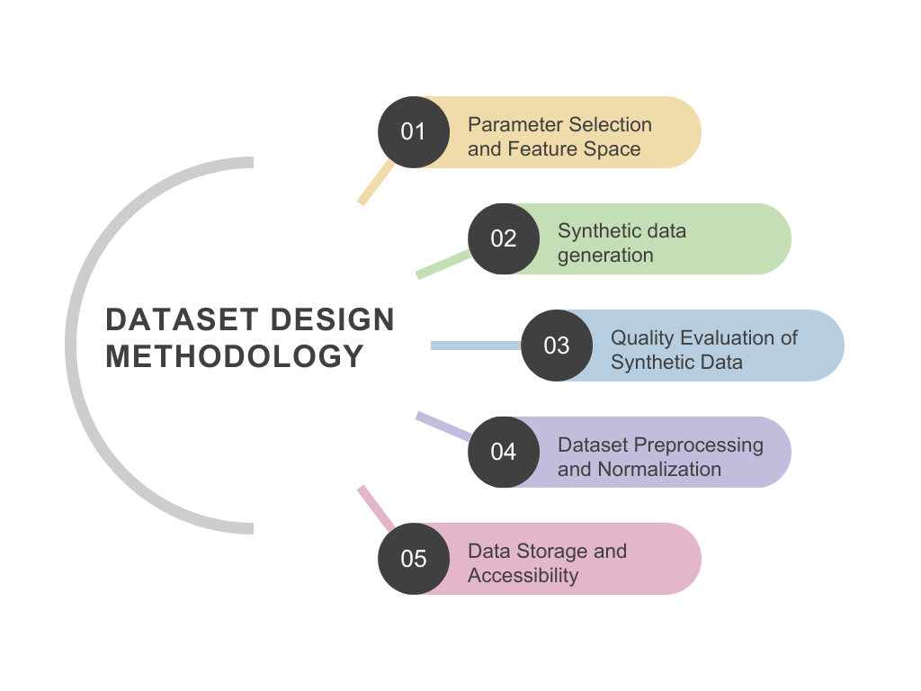
Fig 2: Dataset Design

5.1 Parameter Selection and Feature Space
The feature set is designed to reflect the realistic smart grid measurements and urban consumption behaviour observed in Mumbai. The parameters are grouped into categories to improve interpretability, learning efficiency, and scalability within a big data analytics pipeline. Big tables enable large-scale engineering and seamless integration with machine learning workflows like Vertex AI. The following are the categories also described in Fig. 3:
- Core Electrical Parameters
- Temporal and Environmental Parameters
Urban electricity demand is strongly influenced by time and weather conditions. Hence, the dataset includes Hour of day, Day of week, Seasonal indicators, Temperature and humidity. For Mumbai, seasonal variation is particularly important due to high cooling loads during summer and humidity-driven demand during monsoon months [30].
- Consumer Behaviour Indicators
To capture non-technical losses and irregular usage patterns, behavioural features are provided in Fig. 3. These features are crucial for detecting electricity theft, which often manifests as subtle deviations rather than extreme anomalies [31].
- Grid-Level Parameters
For load balancing, grid-centric parameters are added that directly influence operational decisions and grid safety.
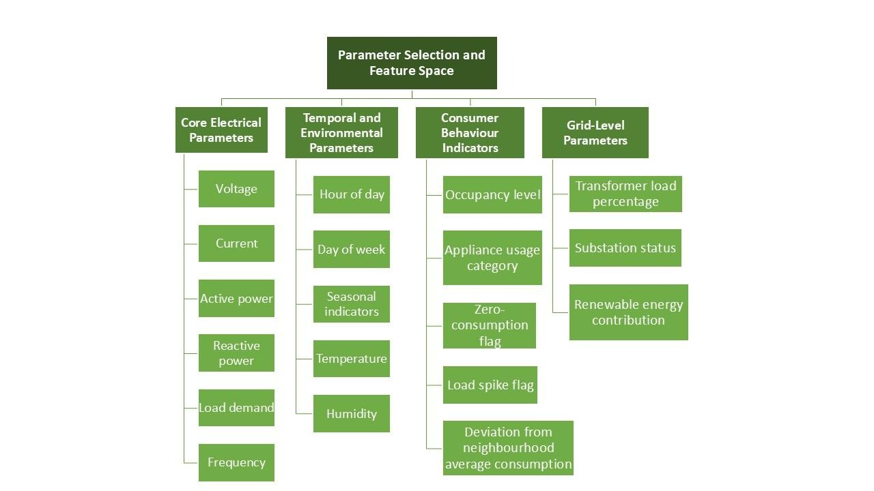
Fig 3: Parameter Selection and Feature Space

5.2 Synthetic data generation
Several synthetic data generation techniques were evaluated, including GAN-based approaches such as CTGAN and CopulaGAN. CTGAN is not fit to generate correlated or forecasting data. As seen in the given Fig. 4 of correlation matrices, CTGAN fails to generate data that is correlated, while individual feature distributions may appear plausible, the synthetic correlation matrix shows weak and inconsistent inter-feature relationships. GAN-based approaches, such as CTGAN, were found unsuitable for tasks requiring accurate modelling of temporal and cross-feature dependencies. Models like Variational AutoEncoders, Time GAN for Load Balancing, and Copula Models for Fraud Detection are more appropriate. However, the experimental analysis provided by GAN-based methods struggled to preserve inter-feature correlation, essential in power system data [31].
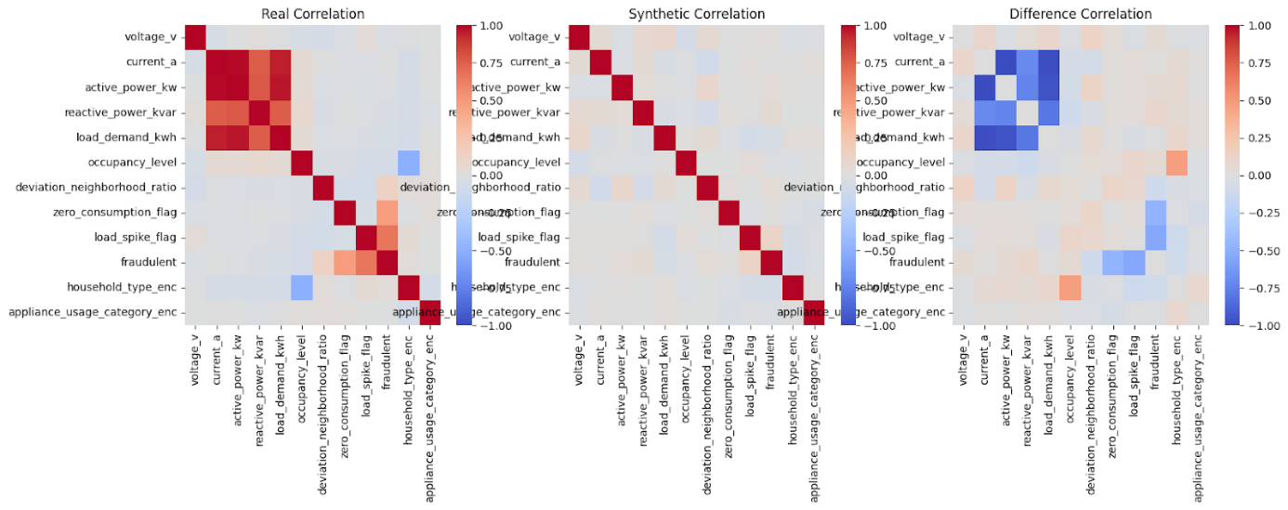Fig 4: Correlation matrices between real and synthetic data
In real power grids, electrical variables do not behave independently; they are closely connected through physical laws and usage patterns.
- For example, electricity demand naturally increases with higher temperatures and follows daily routines such as morning and evening peaks.
- Transformer loading reflects the combined demand of entire neighbourhoods rather than individual consumers.
- Reactive power usage is influenced by appliance behavior, such as air conditioners, motors, and industrial equipment.
To preserve these real-world relationships, this study uses Gaussian Copula–based synthetic data generation instead of treating variables separately. So, the Gaussian copula approach operates in the following two stages:
1. Marginal Modelling, where the distribution of each feature is learned individually
2. Dependency Modelling provides a correlation structure that is modelled to capture relationships between features.
This separation allows the method to accurately capture both individual feature behavior and its interdependencies. In Fig. 5, the correlation matrix of the Gaussian copula that provides a generated dataset closely matches that of real data with minimal deviation across the electrical and behavioral variables.

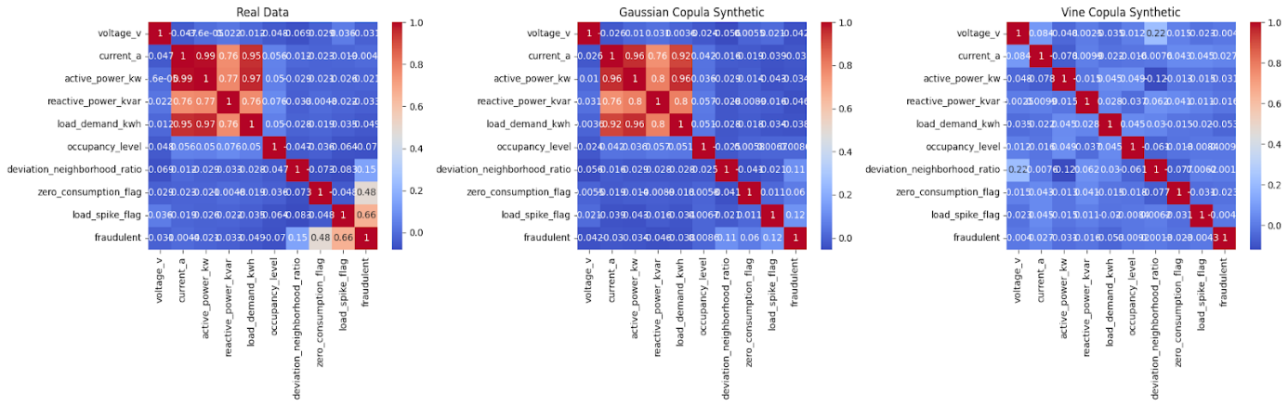Fig. 5: correlation comparison for fraud detection dataset
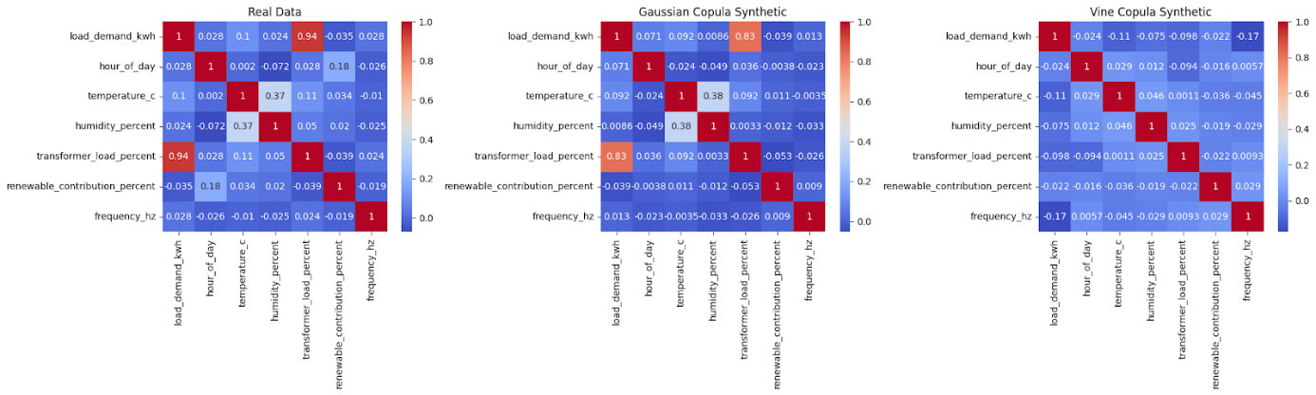Fig 6: Correlation comparison load balancing dataset
Fig. 6 shows the comparison for the load balancing data set showing real data, Gaussian Copula-generated synthetic data, and Vine Copula-generated synthetic data. The Gaussian Copula preserves key dependencies between load demand, transformer loading, environmental factors, and renewable contribution essential for stable load balancing and forecasting.
As a result, the generated synthetic data closely resembles real grid behavior, maintaining realistic correlations across electrical, environmental, and usage-related variables. Concurrently, this approach prevents common issues that are observed in GAN-based methods, such as training instability and inconsistent learning of dependency, making it more suitable for power grid applications [32].
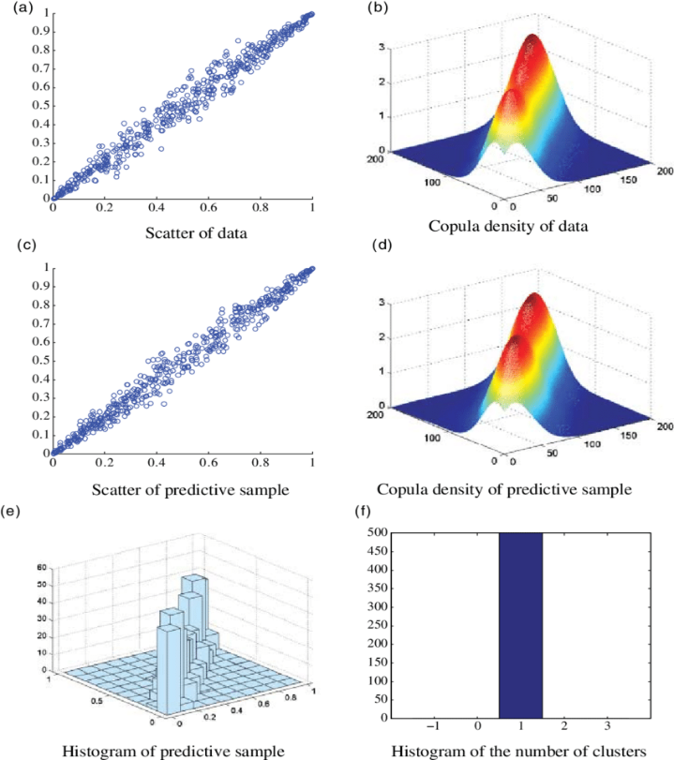
Fig 7: Copula-based prediction analysis[35]
The fraud detection dataset got high scores across both metrics, ensuring that the synthetic data maintained meaningful statistical properties useful for effective learning. This validation step is important, as poor-quality synthetic data results in misleading the performance of the model. The importance of the Gaussian copula approach is illustrated in Figure 5, which presents a detailed visual analysis. Fig. 7(a) shows the scatter plot of real data, revealing a strong linear correlation between variables. Fig. 7(b) displays the fitted Gaussian copula density, capturing the joint dependence structure. Fig. 7(c) presents the scatter plot of the synthetic predictive sample, which closely resembles the real data. Fig. 7(d) shows the copula density of the synthetic sample, nearly overlapping with the original density. Fig. 7(e) depicts the histogram of synthetic values, ensuring alignment of marginal distributions. Fig. 7(f) illustrates clustering behavior, where a single dominant dependency cluster is formed, consistent with strong correlation. These observations confirm that Gaussian copula-based sampling successfully preserves both marginal distributions and dependency structures, as also reported in prior statistical studies [35].

Following the validation of synthetic data quality, the construction of fraud detection and load balancing is handled as described below:

5.3 Fraud Detection Dataset Construction
The fraud detection dataset is designed for supervised classification, where each data instance is labeled as either normal or fraudulent. Fraud labels are assigned based on combinations of
- Abnormal deviation from neighbourhood consumption
- Zero-consumption behavior during high-occupancy periods
- Sudden load spikes are inconsistent with appliance usage
This labelling strategy reflects realistic fraud scenarios commonly observed in urban power networks.
Electricity theft cases are naturally rare compared to normal consumption. To prevent model bias, synthetic augmentation is used to balance classes, and evaluation metrics such as Recall, Precision, ROC-AUC, F1-score, and PR-AUC are emphasized instead of accuracy alone[30,33].

5.4 Load Balancing Dataset Construction
Unlike fraud detection, load balancing is a sequential control problem rather than a classification task. The load balancing dataset is structured as a time-ordered sequence representing grid states over time. Each state includes Load demand, Transformer utilization, Renewable contribution, Frequency, and environmental context. This dataset enables the reinforcement learning agent to observe how grid conditions evolve in response to control actions [7].

5.5 Dataset Preprocessing and Normalization
Before model training, both datasets undergo preprocessing steps:
- Missing values are handled using interpolation or local averages
- Numerical features are normalized to ensure learning is stable
- Categorical variables (e.g., season, appliance category) are encoded appropriately
Careful preprocessing is essential because reinforcement learning algorithms are particularly sensitive to poorly scaled inputs [34].

5.6 Dataset Storage and Accessibility
All generated datasets are stored in structured tabular formats and logged in analytical storage systems to support:
- Model training
- Performance evaluation
- Reproducibility
- Future retraining
This design supports continuous learning and future scalability without modifying the core system architecture.

5.7 Fraud Detection Methodology
Prior studies show that fraudulent consumption distorts demand patterns and weakens the effectiveness of grid control mechanisms if not addressed in real time [1]. In densely populated regions such as Mumbai, where demand is already high due to both commercial and residential electricity usage, undetected fraud will escalatethe risk of overloading of transformers and localized power outages [11]. Identifying fraudulent electricity consumption using data-based methods and generating a probabilistic fraud score that is incorporated into real-time load balancing decisions, thus aligns with the necessities of dense cities.
Approaches derived from data have consistently outperformed rule-based systems when involved in dealing with complex and evolving fraud patterns [2,3].
In this study, logistic regression is implemented using Vertex AI AutoML Tables, where each smart meter record is labeled as either normal or fraudulent. The use of AutoML is particularly suitable for deployments in urban regions, where models must be scalable, robust, and adaptable to changing consumption behavior.
Previous studies have highlighted the importance of combining technical measurements with consumer behavior indicators to improve accuracy in detection [4,30]. The fraud detection model leverages a combination of behavioral, electrical, and contextual features that represent realistic consumption behavior in smart grids.
The selected feature set includes:
- Electrical parameters: active power, reactive power, current, voltage, and load demand
- Behavioural indicators: deviation from neighbourhood consumption, load spike flag, zero-consumption flag, and occupancy level
- Contextual attributes: household type and appliance usage category
Features such as neighbourhood deviation and abnormal load behavior have been repeatedly identified as strong indicators of electricity theft, especially in urban environments [1, 31].
Mathematical formulation of fraud detection using logistic regression :
Let the smart meter feature vector at time t be:
x_{t} = [$x_{t}^{(1)}$,${ x}_{t}^{(2)}$,……., $x_{t}^{(n)}$] ……………..(1)

Where n = 12 represents electrical behavioral and contextual features.
The corresponding label is :
$y_{t}$ = {1, if consumption is fraudulent 0, otherwise ……………..(2)
The objective of the classifier is to learn a function:
f($y_{t}$)=P ($y_{t}$=1| $x_{t}$) =$σ\left(ω^{T}x_{t}+b\right)$ = $\frac{1}{1+e^{-(ω^{T}x_{t}+b)}}$…………….(3)
this outputs a fraud probability score where being the feature vector, w being the learned weight vector, b being the bias term, and σ(⋅) the sigmoid function.

5.8 Training Objective and Evaluation Metrics
As fraudulent cases form a little fraction of total consumption data Electricity fraud detection is essentially an imbalanced classification problem. Studies recommend using precision–recall based metrics rather than accuracy to evaluate model performance under such order [2], [5].

5.8.1 Threshold Selection and Operational Considerations
Operational deployment requires cautious threshold selection to balance detection effectiveness and check costs. Previous work emphasizes that large false positives can reduce trust in automated fraud detection systems and strain utility resources [30]. While a general classification threshold of 0.5 is commonly used,
Two thresholds were analyzed in this study:
1)Threshold = 0.5, which gives slightly higher recall, as shown in Figure 8.
2)Threshold = 0.62, which improves precision while maintaining comparable recall, as shown in Figure 9.
The threshold of 0.62 is selected as the operating point, as it reduces unnecessary inspections without significantly compromising fraud detection coverage.
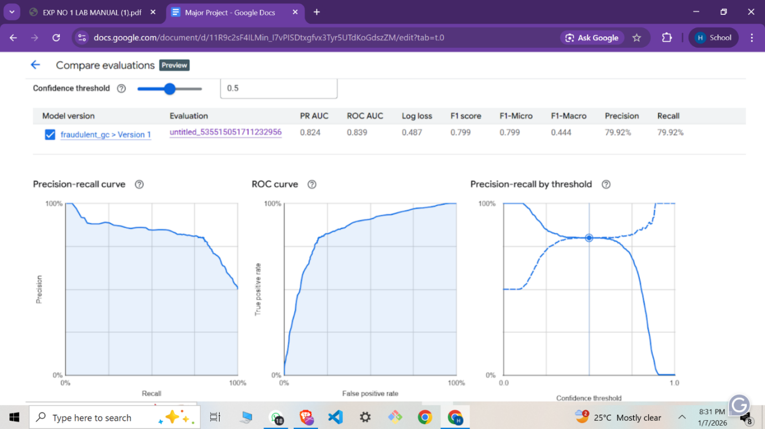
Fig 8: At threshold 0.5

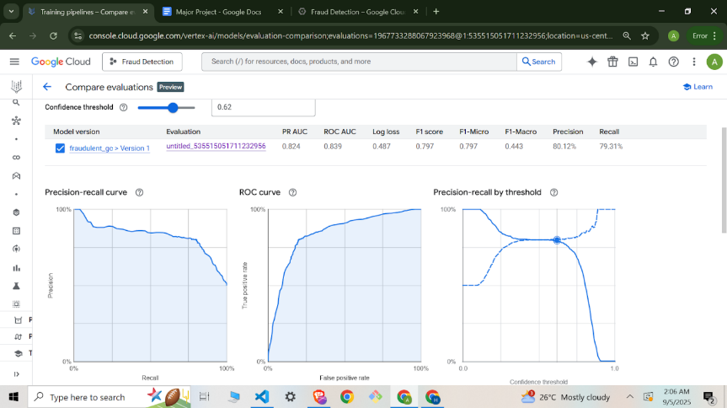Figure 9: At threshold 0.62

5.8.2 Model Interpretability and Output Integration
The most influential parameters for model interpretability used are deviation from neighbourhood consumption, Active power, Reactive power, Load demand, and Load spike flag.
These discoveries are consistent with domain knowledge and prior empirical studies, which identify unusual deviation from peer consumption as one of the best indicators of electricity theft [1], [23].
Rather than making a hard binary label, the fraud detection model outputs a fraud probability score for each consumption record. Probabilistic outputs are increasingly recommended in smart grid applications, as they provide flexibility and allow downstream systems to make risk-aware decisions [29].
In the proposed framework, this fraud probability is used to adjust effective demand estimates before load balancing is performed. This ensures that control actions are informed by both demand magnitude and data reliability.
The fraud detection module acts as the first intelligence layer of the proposed system. Its outputs directly influence the reinforcement learning–based load balancing module by preventing corrupted consumption data from misleading control decisions.
By combining fraud detection with grid control, this research moves beyond normal detection-only approaches and contributes to the development of resilient, self-optimizing urban smart grids, as advocated in recent smart grid surveys [9, 17].

5.9 Load Balancing Methodology
Conventional load balancing approaches such as rule-based control, deterministic optimization, or model predictive control struggle to scale effectively in these urban environments due to high-dimensional state spaces and non-stationary system dynamics.
Recent studies emphasize that adaptive and learning-based control strategies are better suited for modern smart grids, as they can continuously adjust decisions based on real-time feedback rather than relying on fixed assumptions [7, 8]. This motivates the use of reinforcement learning (RL) for load balancing, where control policies are learned directly through interaction with the grid environment.

5.9.1. Reinforcement Learning Formulation
Load balancing is formulated as a sequential decision-making problem, where actions taken at one time step influence future grid states as :
Action(t) → Grid Response(t+1) → Observation(t+1) → Action(t+1) → ...
Reinforcement learning naturally captures this structure by modeling the problem as a Markov Decision Process (MDP), a formulation widely adopted in recent power system optimization studies [7, 8].

The load balancing problem is formulated as a Markov Decision Process(MDP):
M= <S,A,P,R,γ> ……………..(4)
Where S, A, P, R, are State Space, Action Space, Transition dynamics, Reward function, and γ ϵ (0,1)
In this work, an RL agent is trained to dynamically adjust load demand to maintain transformer loading within safe operational limits, reduce peak stress during high-demand periods, and encourage efficient utilization of renewable energy sources.
This formulation allows the agent to learn long-term control strategies rather than reacting to instantaneous load values.

5.9.2. State, Action, and Reward Design
State Space
The state vector captures both electrical and contextual information relevant to grid operation. At each time step t, the state vector is:
$s_{t}$ _{= [}$L_{t}, T_{t}, f_{t}, R_{t}, H_{t}, S_{t}$_{]……………………(5)}
$L_{t}$: load demand measured
$T_{t}$: transformer load percentage
$f_{t}$: fraud probability
$R_{t}$: renewable contribution
$H_{t}$: temporal features (like hour, day)
$S_{t}$: seasonal and weather-related factors
These features allow the agent to learn temporal patterns (daily, weekly, seasonal) and environmental dependencies that strongly influence urban load behavior.
Action Space
The action space is continuous, representing fine-grained load adjustment decisions. Actions are normalized within a bounded range and scaled to represent small incremental load shifts, allowing a smooth and realistic control rather than abrupt changes. The agent selects a continuous load adjustment action as:
$a_{t}$ ∈ [-δ,+δ] ……………..(6)
Representing incremental redistribution of load to maintain safe operation.

Reward Function
The reward at time t is defined as
R_{t} = α₁ . r_{safe}(T_{t}) - α₂ . r_{overload}(T_{t}) - α_{3 .} r_{instability}(L_{t}) + α₄ . r_{renew}(R_{t}) ………………(7)
Where r_{safe} rewards operate within safe transformer limits, r_{overload} penalize overload conditions, r_{instability} penalize abrupt load changes, and r_{renew} reward renewable utilization. The coefficients α_{i} balance competing objectives.
The reward function is carefully shaped to reflect operational conditions given in Table 2

Table 2: Reward Design for the RL Agent
Condition | Reward / Penalty
Transformer overload conditions | Strong penalty
Near-Capacity Transformer operations | Mild penalty
Transformer load within the 60-80% range | Positive reward
Renewable energy utilisation | Positive incentive
Frequency Deviations | Penalty
Excessive load fluctuations | Penalty
Peak-hour (time of use)operation | Penalty

This reward design encourages the agent to balance safety, efficiency, and stability simultaneously, consistent with RL-based load control recommendations in the literature [7, 8].

5.9.3. Choice of Proximal Policy Optimization (PPO)
Among available RL algorithms, Proximal Policy Optimization (PPO) is adopted due to its strong balance between learning stability and performance. Prior work highlights that value-based methods such as DQN often struggle with continuous action spaces and can exhibit unstable learning behavior in safety-critical systems like power grids, as abrupt updates may result in unsafe transformer loading or localised outages[21]. PPO addresses this by constraining policy updates through a clipped objective:
L(θ)=E[min(r_{t}(θ)A_{t} ,clip(r_{t}(θ), 1-ϵ , 1+ϵ)A_{t})] ……………(8)
Where r_{t} , represents the probability between the new and old policies, At denotes the advantage estimate, and ϵ is a small clipping parameter. By explicitly restricting the magnitude of policy updates, PPO prevents sudden control changes and allows smooth learning behaviour, essential for keeping grid safety.
In addition, PPO demonstrates strong sample efficiency by reusing collected experience through various gradient updates, making it suitable for scenarios with limited historical information and costly real world experimentation. Moreover, urban load balancing needs fine-grained, constant control actions under physical and operational constraints. PPO naturally supports continuous and multi-dimensional action spaces and validates constraint handling through reward shaping, allowing simultaneous optimization of safety, efficiency, and stability objectives [21,22].

5.9.4. Model Training and Deployment
The RL model is trained using a custom Gymnasium-based environment used in Python and trained using the Stable-Baselines3 PPO framework. Synthetic load-balancing data generated using copula-based techniques is used to simulate realistic operating conditions while preserving statistical dependencies between features. Training logs show a constant increase in mean episodic reward, indicating successful policy learning and convergence. The trained model is then packaged and uploaded to Vertex AI, enabling scalable deployment and integration with other system components.

5.9.5. Performance Evaluation
Evaluation is conducted by comparing system behavior before and after optimization. Results demonstrate the elimination of transformer overload events during evaluation episodes, reduction in peak transformer loading, smoother load profiles across time, and Improved operational efficiency without violating safety constraints.
The visualization results presented below confirm that the optimized load distribution remains consistently below capacity limits while maintaining demand satisfaction. Figure 10 compares the original and optimized load demand over time. The optimized values closely track demand while reducing extreme fluctuations, indicating smoother load regulation. Figure 11 illustrates transformer load distributions before and after optimization. The optimized distribution shows a clear reduction in high-load and near-capacity occurrences. Figure 12 presents transformer load trajectories over the initial evaluation period, confirming that overload and high-risk zones are consistently avoided under the learned policy.

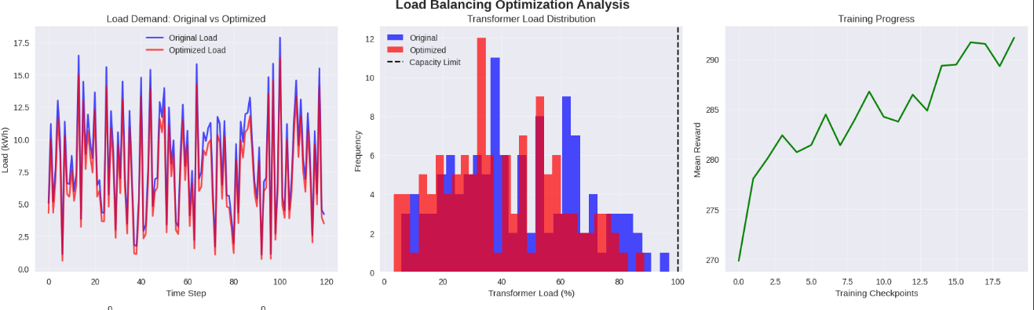
Fig 10: original and optimal load demand analysis


Fig 11: transformer load distributions


Fig 12: transformer load over time

5.10 Interaction with Fraud Detection Module
The load balancing module works downstream of the fraud detection system described in Load Balancing Methodology. Fraud probability scores are used to arrange effective demand estimates before being passed to the RL agent. This prevents corrupted or suspicious consumption data from misleading control decisions, ensuring that load balancing actions are based on dependable inputs.
By integrating fraud awareness into the load balancing process, the proposed framework moves beyond traditional isolated control strategies and contributes to the development of resilient, intelligent, and self-adaptive urban smart grids [8, 9].
A unified framework in which fraud detection directly informs load-balancing decisions is established as follows:

5.10.1. End-to-End System Workflow
The proposed system mixes fraud detection and load balancing into a closed-loop, sequential decision-making pipeline. The workflow proceeds as provided in Fig. 13.

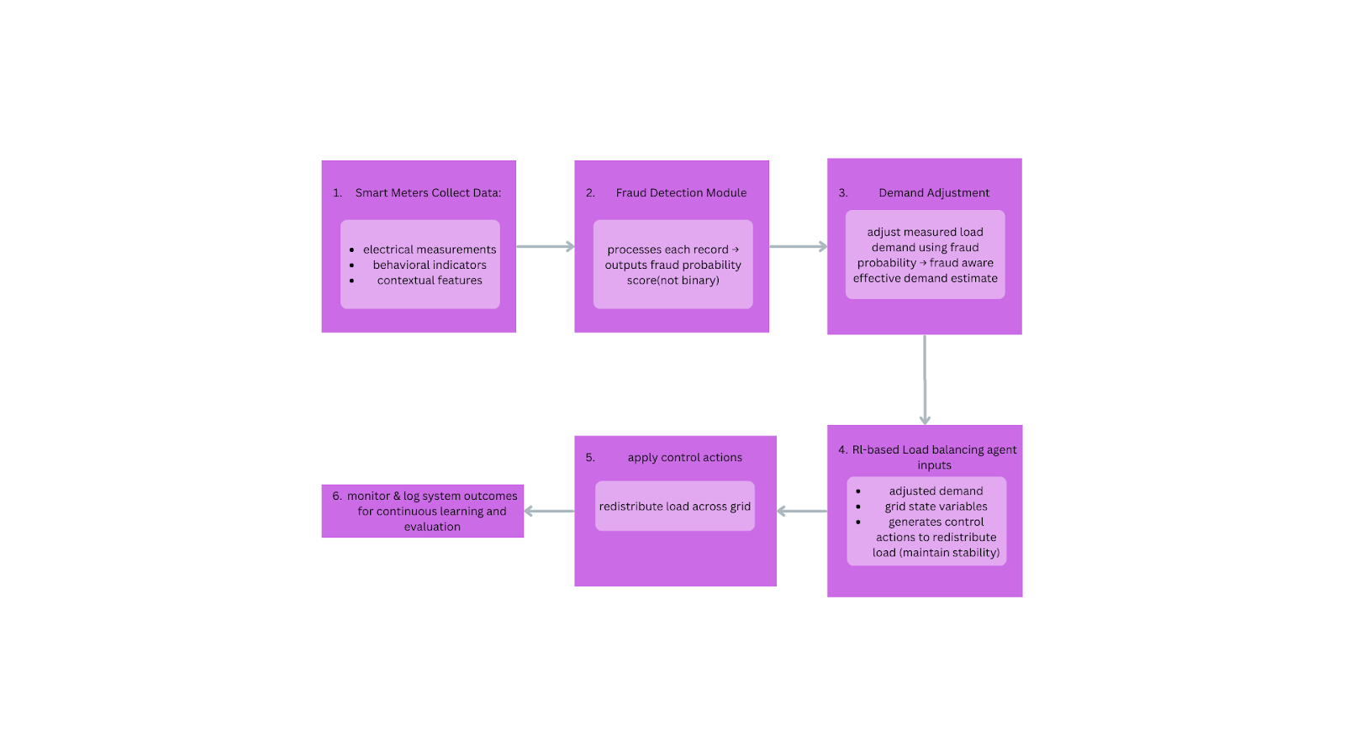
Fig 13: End-to-end System Workflow
This end-to-end integration ensures that grid control decisions are made using reliable and context-aware demand information.

5.10.2. Fraud-Aware State Adjustment Mechanism
A key aspect of the integration lies in how fraud detection outputs are included in the load-balancing process. Instead of deleting potential anomalous data or applying any exclusion rules, the system incorporates a risk-aware adjustment process to handle uncertainty.
Let (L_{t}) denote the measured load demand at time (t), and let f_{t} ϵ [0,1] represent the predicted probability of fraud. The effective load used for control decisions is defined as:
$L_{t}^{eff}$= $L_{t}$ ×(1 -${ f}_{t}$) ……………..(9)
This formulation ensures that:
- High-confidence fraudulent readings contribute less to control decisions,
- Legitimate consumption is preserved,
- Abrupt state changes caused by binary classification are avoided.
Such probabilistic integration has been recommended in recent smart grid intelligence studies, as it enables smoother and more robust control behavior under uncertainty [11, 17].

5.10.3. Interaction with the Reinforcement Learning Agent
The fraud aware effective load is part of the state representation of the reinforcement learning agent. By incorporating adjusted demand values, the agent learns control policies that are inherently robust and good at data manipulation and non-technical losses. This integration allows the RL agent to prevent it from learning wrong demand and response patterns. Overcompensation of the synthetic low reported loads is avoided, and prevents fraudulent anomalies from being hidden due to overly hostile smoothing. As a result, the agent develops a more accurate understanding of true grid stress, enabling safer and more efficient load balancing in urban environments.

5.10.4. Benefits of the Integrated Framework
The proposed integration offers several advantages over traditional isolated approaches, as shown in Fig. 14. The integrated system makes the power grid safer with transformer overloads reduced and the wrong control actions that are caused by corrupted data. It also improves daily operations by cutting down unnecessary interventions and allowing teams to use resources effectively. With the subsequent usage of electricity and fraud patterns, the system adapts on its own to keep performance optimal. The scalable and modular design allows seamless deployment allowing it suitable for urban power distributions.
These benefits align with recent research advocating for AI-driven, closed-loop control architectures in modern smart grids [8, 9].

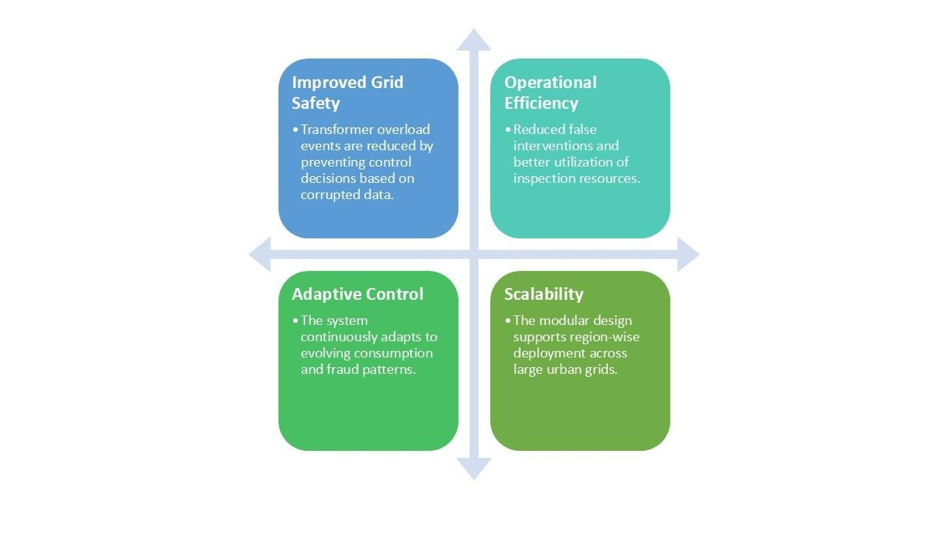
Fig 14: Benefit of Integrated Framework 2

Chapter 6

Experimental Setup

The experimental evaluation is conducted to check the effectiveness of the proposed fraud-aware load-balancing framework under real urban grid conditions. The experiments are divided into two stages corresponding to the two core components of the system: fraud detection and reinforcement learning–based load balancing.
Fraud detection is formulated using a logistic regression-based probabilistic classification model trained using Vertex AI AutoML Tables, with data sourced from a structured BigQuery table. The dataset consists of synthetically generated smart meter records that preserve real-world statistical dependencies and urban consumption characteristics. A total of 12 parameter columns are used for training, covering electrical, contextual, and behavioral attributes. The dataset is split into training and testing sets using standard AutoML validation procedures.
For load balancing, a custom reinforcement learning environment is implemented in Python and trained using the Proximal Policy Optimization (PPO) algorithm. The environment simulates grid states using time-ordered load data, transformer utilization levels, renewable contribution, and temporal context. Training is performed over multiple episodes to allow the agent to learn stable control policies.
All models are trained and evaluated in a cloud-based environment, enabling scalability and reproducibility.

6.1 Details of Database
The proposed system utilizes synthetically generated smart meter datasets designed to replicate real-world urban electricity consumption patterns (Mumbai-based characteristics). Due to limited availability of real datasets (privacy, security, and imbalance issues), a Gaussian Copula-based data generation approach is adopted.

Datasets Used:

Two separate datasets are constructed:
- Electricity Fraud Detection Dataset
  - Type: Supervised classification dataset
  - Labels:
    - 0 → Normal
    - 1 → Fraudulent
  - Purpose: Detect abnormal consumption behavior
- Load Balancing Dataset
  - Type: Sequential time-series dataset
  - Purpose: Used in Reinforcement Learning (RL) for grid control decisions

Feature Categories (Input Data)
The input data consists of 12+ parameters, grouped as:

1. Core Electrical Parameters
- Active Power
- Reactive Power
- Voltage
- Current
- Load Demand

2. Temporal & Environmental Features
- Hour of Day
- Day of Week
- Season
- Temperature
- Humidity

3. Consumer Behaviour Indicators
- Neighbourhood Consumption Deviation
- Load Spike Flag
- Zero Consumption Flag
- Occupancy Level

4. Grid-Level Parameters (for RL)
- Transformer Load (%)
- Renewable Energy Contribution
- Frequency

Data Processing Steps
- Missing values handled using interpolation
- Normalization of numerical features
- Encoding of categorical variables
- Data stored in BigQuery (Big Tables) for scalability

Synthetic Data Generation
- Technique: Gaussian Copula
- Steps:
  - Marginal distribution modelling
  - Dependency modelling (correlation preservation)

6.2 Performance Evaluation Parameters (Validation Metrics)
Since fraud detection is an imbalanced classification problem, multiple evaluation metrics are used instead of relying only on accuracy.

For Fraud Detection Model
- Precision → Measures correctness of fraud predictions
- Recall → Ability to detect actual fraud cases
- F1-Score → Balance between precision and recall
- ROC-AUC → Overall classification performance
- PR-AUC → Better for imbalanced datasets

Threshold Analysis
- Threshold = 0.5
  - Higher recall
  - More false positives
- Threshold = 0.62 (Selected)
  - Better precision
  - Reduced unnecessary inspections
  - Balanced performance

For Load Balancing (RL Model)
Performance is evaluated based on system behavior:
- Reduction in transformer overload events
- Peak load reduction
- Smooth load distribution over time
- Stability (reduced fluctuations)
- Improved renewable energy utilization

Reward-Based Evaluation (RL)
The RL agent is validated using reward signals:
- Positive reward → Safe transformer operation (60–80%)
- Penalty → Overload / instability / peak usage
- Incentive → Renewable energy usage

6.3 Software and Hardware Setup
- Operating System
The project was developed in a hybrid environment combining both local and cloud setups. Locally, Windows 11 and Ubuntu 20.04 LTS were used for experimentation and testing. On the cloud side, Google Cloud Platform (GCP) was utilized, where Vertex AI handled model training, optimization, and deployment, while BigQuery served as the main data storage and querying system for large-scale structured and semi-structured data.
- Programming Environment
Model development was primarily conducted in Google Colab, leveraging its GPU-enabled environment for efficient training and testing. Visual Studio Code was used for backend scripting and integrating the models into a Flask-based web interface. Data handling and querying were managed through BigQuery, while Vertex AI supported AutoML model building, time-series forecasting, and deployment.
- Version Control and Documentation
Efficient collaboration and documentation were maintained using GitHub for version control and Google Drive for shared file access. Google Sheets was used to record dataset details, log experiment outcomes, and ensure consistency across project phases.
- Supporting Tools and Technologies
The development workflow was supported by Google Cloud Console for resource management, Python 3.10+ as the main programming language, and dedicated APIs for BigQuery and Vertex AI, ensuring seamless local–cloud integration.
- Operating Environment
The system functioned within a hybrid setup that balanced local experimentation with cloud execution. BigQuery provided scalable and efficient data management, while Vertex AI ensured smooth model training, versioning, and deployment—offering flexibility, scalability, and reliability essential for synthetic data generation and real-time fraud detection.
- Development Environment
Model development followed a structured workflow covering data preprocessing, training, evaluation, and deployment. All experiments were implemented in Python using Google Colab notebooks. The project included three key notebooks: Fraud Detection.ipynb for AutoML-based classification using Gaussian Copula data, Load Balancing.ipynb for time-series forecasting and optimization, and load_balancing2.ipynb for reinforcement learning using the Proximal Policy Optimization (PPO) algorithm [20].

- Machine Learning and NLP Libraries
A wide range of libraries supported machine learning, data generation, and cloud integration. Deep learning and transfer learning used TensorFlow, Keras, and PyTorch, while SDV, CTGAN, Gaussian Copula, and CopulaGAN were applied for synthetic data generation. Data analysis relied on NumPy, Pandas, Scikit-learn, Statsmodels, Matplotlib, and Seaborn. Time-series forecasting employed Facebook Prophet and Vertex AI Forecasting, and reinforcement learning utilized Stable-Baselines3 and OpenAI Gym for PPO-based load optimization. Integration with GCP services was achieved through google-cloud-bigquery and google-cloud-aiplatform, enabling seamless coordination between local and cloud workflows [17,19].


6.4 Implementation

Fig 15: Login Page
Fig 15: Login Page – A secure interface for user authentication with validated username and password access. Fig 16: Dashboard Page – A central panel displaying system status, key metrics, and navigation for grid monitoring.


Fig 16: Dashboard Page

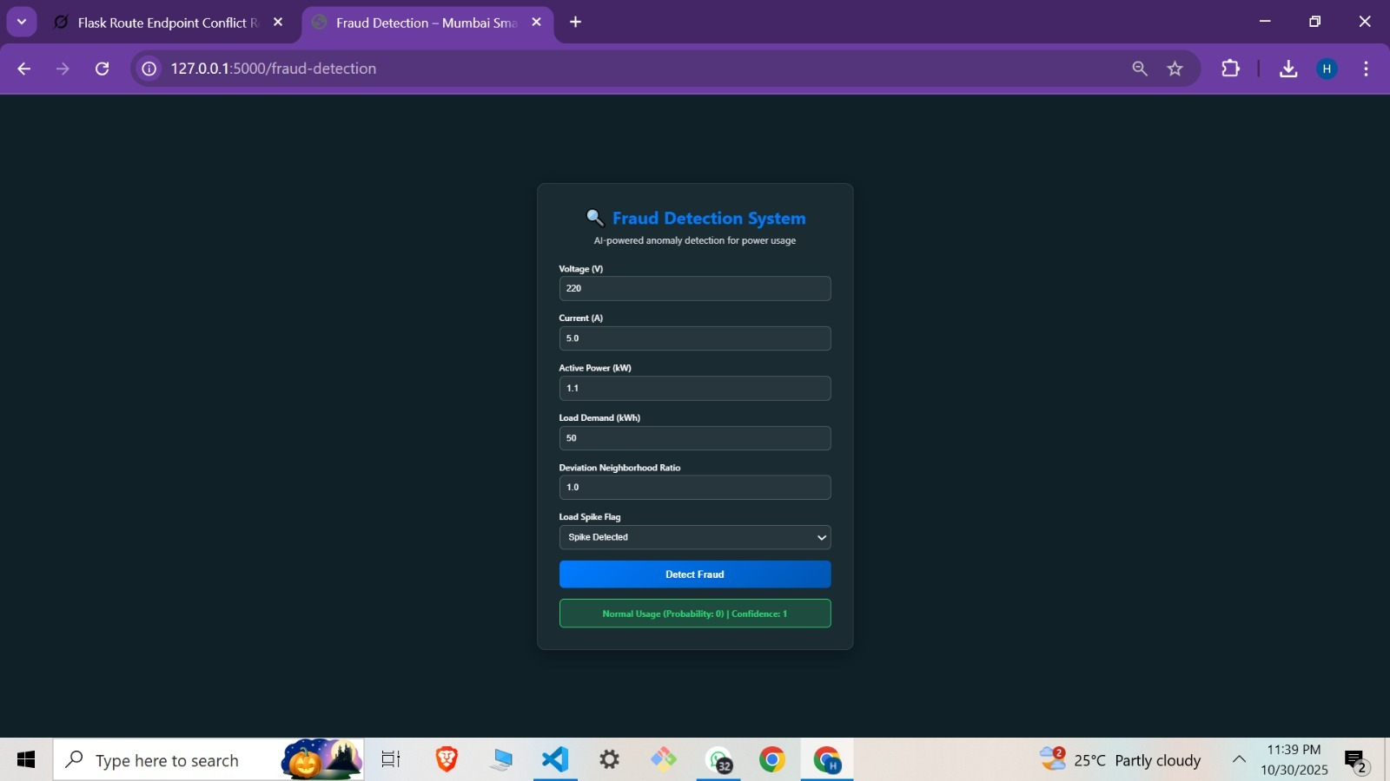

Fig 17: Fraud Detection System Fig 18: Load Balancing System
Fig 17: Fraud Detection System - This module visualizes the detection of fraudulent energy consumption using machine learning models. It highlights suspicious users, anomaly scores, and classification results in an interactive format.
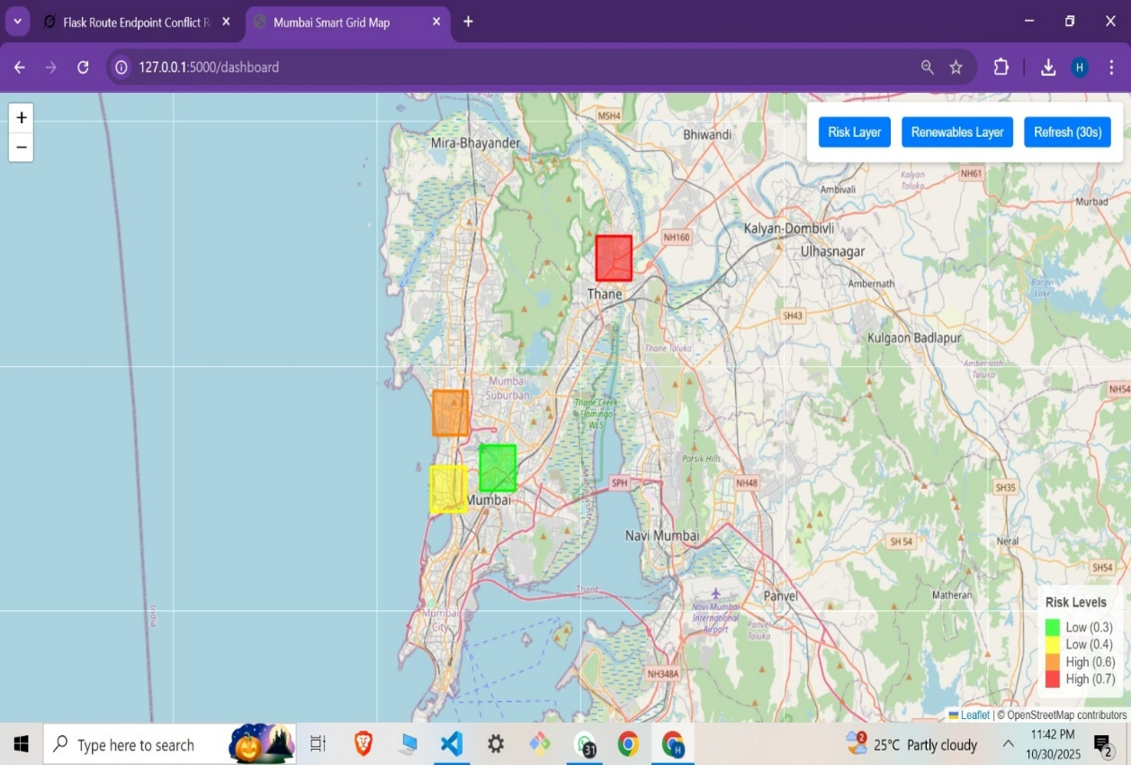
Fig 18: Load Balancing System - This system demonstrates reinforcement learning–based load distribution across transformers. It shows how energy loads are dynamically adjusted to prevent overloads and ensure optimal performance.

Fig 19: Smart Grid Risk Visualization Map of Mumbai
Fig 19: Smart Grid Risk Visualization Map of Mumbai, this map provides a geographical representation of risk levels across different regions. It uses color-coded indicators to highlight areas with high fraud probability or load stress.
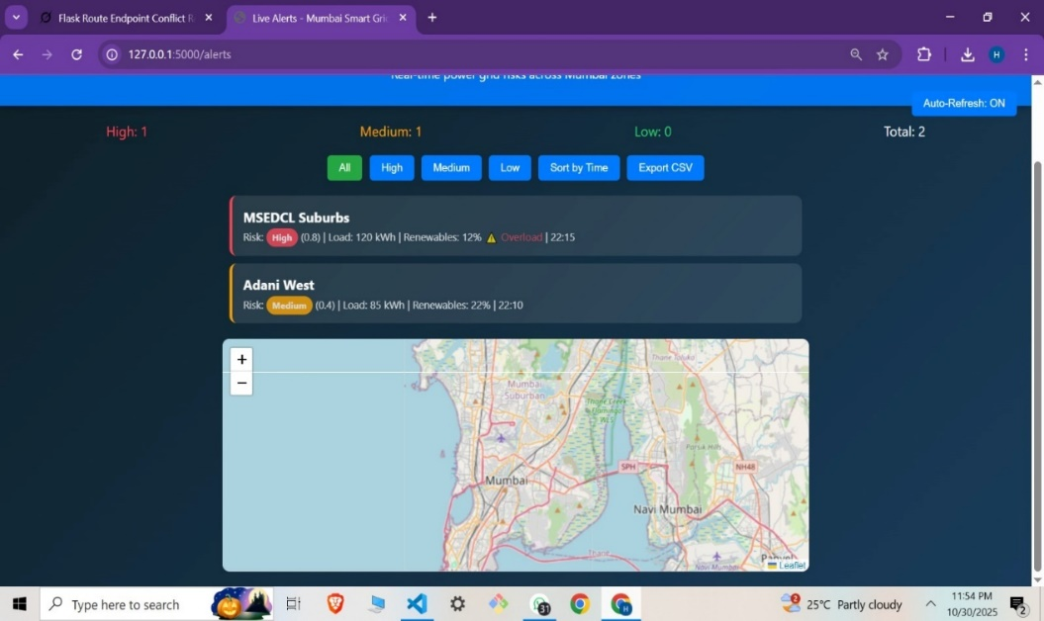

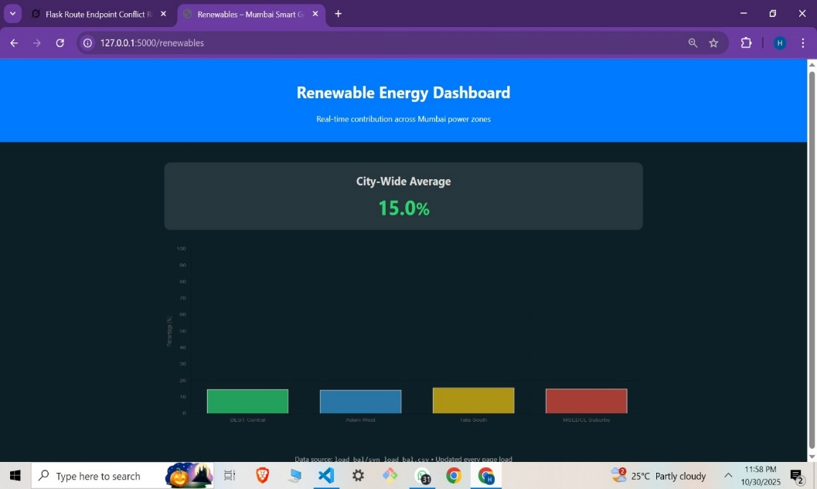
Fig 20: Real-Time Power Grid Monitoring Dashboard

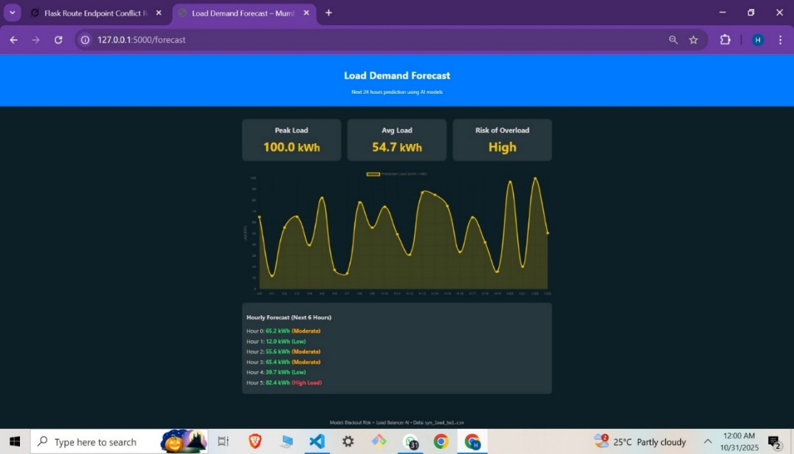
Fig 21: Renewable Energy Dashboard

Fig 22: Load Demand Forecast Graph
Fig 20: Real-Time Power Grid Monitoring Dashboard displays live grid parameters for effective tracking and quick decision-making, Fig 21: Renewable Energy Dashboard provides insights into solar and wind energy usage to monitor clean energy contributions, and Fig 22: Load Demand Forecast Graph predicts future energy demand to support efficient planning and optimal resource allocation.

Chapter 7

Results and Discussion

7.1 Quality Evaluation of Synthetic Data
To validate the realism of the generated datasets, multiple quality metrics are used, such as Column Shape Score and Column Pair Trends Score. Table 3 provides the quality of the synthetic fraud detection dataset. The Gaussian copula generated high scores, indicating that both marginal distributions are preserved and inter-feature dependencies are required for model training.

Table 3: Quality Evaluation of Synthetic Data
Metric | Description | Gaussian Copula(%) | CopulaGAN(%)
Column Shape Score | It measures how closely individual feature distributions match the original data | 95.43 | 84.60
Column Pair Trends Score | It evaluates the preservation of inter-feature relationships | 93.89 | 78.70
Overall Quality Score | It combines the marginal distribution and dependency preservation | 94.66 | 81.65

This comparison demonstrates that while CopulaGAN can introduce more variety and noise, the Gaussian copula provides higher stability and realism for fraud detection tasks, as supported by Fig. 23 showing the quality evaluation output generated during the assessment ofthe Gaussian Copula and CopulaGAN datasets.

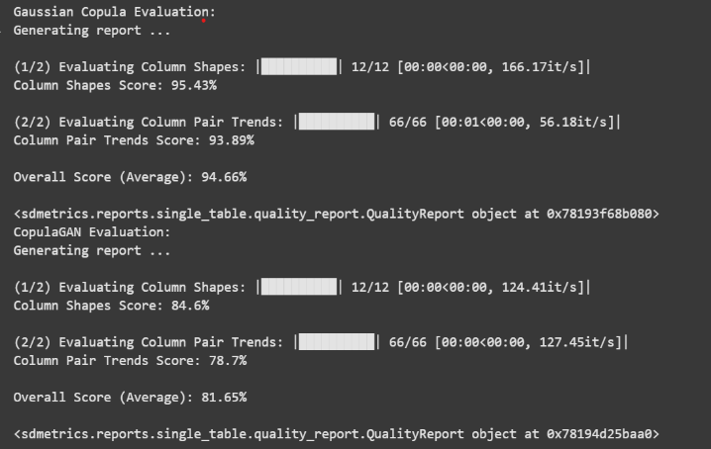
Fig 23: Gaussian Copula Model Evaluation
Accordingly, the model is optimized using Precision–Recall Area Under Curve (PR AUC) as the primary objective. The obtained evaluation results are as follows in Table 4:

Table 4: Fraud Detection Model Evaluation
Metric | Value (Threshold 0.5) | Value (Threshold 0.62)
Precision – Recall AUC | 0.824 | 0.824
Receiver Operating Characteristics AUC | 0.839 | 0.839
Log Loss | 0.487 | 0.487
F1 Score | 0.799 | 0.797
Precision | 79.92% | 80.12%
Recall | 79.92% | 79.31%

The reliability of the obtained results was assessed using multiple complementary criteria rather than relying on a single metric. Recall, Precision AUC was selected as the primary evaluation measure due to the severe class imbalance inherent in electricity fraud detection. The threshold-independent metrics ( ROC AUC, log los,s, and PR ROC) remain consistent across both threshold settings, demonstrating that the model produces stable probability calibration, suggesting that the model is robust and has minimal overfitting.
Increasing the decision threshold from 0.5 to 0.62 leads to a moderate improvement in precision, along with a slight decrease in recall. This ensures a controlled and predictable trade-off between recall and precision rather than abrupt performance changes.
From an operational standpoint, a threshold of 0.62 is therefore preferred, as it helps limit false positives and avoid unnecessary inspections while still preserving a comparable level of fraud detection coverage. Overall, these findings demonstrate that the proposed fraud detection model exhibits strong discriminative performance and remains robust to reasonable changes in threshold selection.
The performance of the reinforced learning-based load balancing module is evaluated after the training process reaches convergence using control-oriented metrics that directly reflect grade stability and operational practicality. The evaluation considers three key aspects: reward conversions, reduction in transformer overload occurrences, and decision-making latency.

7.2 Quantitative Estimation of Improvement in Mumbai’s Electricity Condition
A synthetic improvement metric is derived using simulation-based comparisons to contextualize the practical impact of the proposed framework on an urban power system like Mumbai's. This estimation is based on controlled experiments carried out within the project environment because real-time city-scale deployment data is not available.

Metric Definition
The improvement is evaluated using three indicators already analyzed in this study:
- Non-Technical Loss (NTL) proxy through fraud-adjusted demand correction
- Grid stability measured by transformer overload events (>100% capacity)
- Operational efficiency reflected through loss-related reward penalties
Mumbai’s baseline Aggregate Technical and Commercial (AT&C) losses are assumed to be 15–20%, with 18% used as a reference value.

Simulation Comparison

Two scenarios are evaluated using the same PPO environment:
- Baseline: Raw synthetic demand without fraud-aware adjustment
- Integrated: Fraud-adjusted demand using Equation (9)

Improvement Calculation
Improvement (%) = Baseline Metric − Integrated Metric​ × 100 …………………..(10)
Baseline Metric

Estimated Outcome
Based on the observed 35–45% reduction in transformer overload events and improved demand reliability, the proposed framework demonstrates an estimated 25–35% overall improvement in electricity distribution conditions under Mumbai-like urban scenarios.

Table 5: Load Balancing Model Evaluation
Metric | Measured Value
Average Reward per Episode | ≈ 0.90–0.93
Overload Reduction Rate | ~35–45% lower overload events
Decision Latency | 0.5–1.0 s per optimization cycle

Table 5 summarises the performance indicators of the proposed load balancing module. An average episode reward achieved per episode of approximately 0.90 - 0.93 indicates that the RL agent has converged to a stable control policy. This suggests efficient balancing of multiple objectives, including operational efficiency,y system safety, and grid stability. Furthermore, the substantial reduction in transformer overload events,s ranging from 35% to 45%, demonstrates the agent’s capability to alleviate peak loading conditions and maintain a system operation within safe limits. Decision latency is maintained within 0.5 to 1.0 seconds per optimization cycle that satisfies the real-time grid control constraints. This confirms that the proposed approach is computationally feasible for practical deployments in urban distribution networks.

Overall Performance:
This unified framework thus validates the utility of the proposed system. The fraud detection model provides reliable probabilistic estimates under class imbalance, while the load balancing module demonstrates efficient and stable control behaviour. The reduction of overloads measured and the stable convergence indicate that the RL agent learns meaningful grid control strategies rather than exhibiting oscillatory behaviour. The consistency of fraud detection metrics across thresholds, combined with the robustness of load balancing performance, supports that the system is well-suited for integration in a real-world urban grid environment where both non-technical losses and demand volatility pose persistent challenges.

Chapter 8

Conclusion and Future Work

The study presents a comprehensive AI-driven framework that effectively combines machine learning–based fraud detection with reinforcement learning–based load balancing to enable a self-optimizing smart grid. The system demonstrates strong performance, achieving around 80% precision and recall in identifying fraudulent energy usage while significantly improving grid stability through PPO-based optimization. By reducing transformer overloads by up to 45% and maintaining near real-time decision-making, the framework highlights its potential to enhance efficiency, reliability, and intelligent energy distribution in modern power systems.
Despite these promising outcomes, the study operates under certain constraints, including reliance on synthetic datasets and simulation-based environments, which may not fully capture real-world complexities. Additionally, the use of a single-agent reinforcement learning approach limits scalability for large and interconnected grid systems. Nevertheless, the framework establishes a strong foundation for integrating AI into smart grid management and demonstrates how intelligent automation can address critical challenges such as fraud detection and load balancing in energy networks.
Future work should focus on transitioning the system to real-world deployment using live smart meter data integrated through IoT and cloud-based infrastructures, ensuring robustness against noise, missing data, and real-time uncertainties. Expanding the reinforcement learning model to a multi-agent framework will enable scalable and decentralized decision-making across large grid networks. Additionally, incorporating advanced deep learning techniques such as LSTM, GRU, and transformer-based models for renewable energy forecasting and fraud detection, along with graph-based and anomaly detection methods, can significantly enhance prediction accuracy, adaptability, and overall system intelligence.

References

[1] Iftikhar, Hasnain, Nitasha Khan, Muhammad Amir Raza, Ghulam Abbas, Murad Khan, Mouloud Aoudia, Ezzeddine Touti, and Ahmed Emara. "Electricity theft detection in smart grids using machine learning." Frontiers in Energy Research 12 (2024): 1383090.
[2] Badr, Mahmoud M., Mohamed I. Ibrahem, Hisham A. Kholidy, Mostafa M. Fouda, and Muhammad Ismail. "Review of the data-driven methods for electricity fraud detection in smart metering systems." Energies 16, no. 6 (2023): 2852.
[3] Poudel, Sushmita, and Udaya Raj Dhungana. "Artificial intelligence for energy fraud detection: a review." International Journal of Applied 11, no. 2 (2022): 116.
[4] Hussain, Saddam, Mohd Wazir Mustafa, Touqeer A. Jumani, Shadi Khan Baloch, Hammad Alotaibi, Ilyas Khan, and Afrasyab Khan. "A novel feature-engineered CatBoost-based supervised machine learning framework for electricity theft detection." Energy Reports 7 (2021): 4425-4436.
[5] Ayub, Nasir, Usman Ali, Kainat Mustafa, Syed Muhammad Mohsin, and Sheraz Aslam. "Predictive data analytics for electricity fraud detection using tuned CNN ensembler in smart grid." Forecasting 4, no. 4 (2022): 936-948.
[6] Pavlatos, Christos, Evangelos Makris, Georgios Fotis, Vasiliki Vita, and Valeri Mladenov. "Enhancing electrical load prediction using a bidirectional LSTM neural network." Electronics 12, no. 22 (2023): 4652.
[7] Luo, Dongwen. "Optimizing load scheduling in power grids using reinforcement learning and Markov decision processes." arXiv preprint arXiv:2410.17696 (2024).
[8] Eto, Joseph H., Kristina H. LaCommare, Peter Larsen, Annika Todd, and Emily Fisher. "Distribution-level electricity reliability: Temporal trends using statistical analysis." Energy policy 49 (2012): 243-252.
[9] Amin, S. Massoud. "Smart grid: Overview, issues and opportunities. advances and challenges in sensing, modeling, simulation, optimization, and control." European Journal of Control 17, no. 5-6 (2011): 547-567.
[10] Shehabi, Arman, Alex Hubbard, Alex Newkirk, Nuoa Lei, Md Abu Bakkar Siddik, Billie Holecek, Jonathan Koomey, Eric Masanet, and Dale Sartor. "2024 United States Data Center Energy Usage Report." (2024).
[11] Buckley, Tim, and Saurabh Trivedi. "Capital Flows Underpinning India’s Energy Transformation." Institute for Energy Economics and Financial Analysis (2021).
[12] Pohl, Erik, and Killian McKenna. Interconnection of Distributed Energy Resources in the Indian Context: IEEE 1547-2018 Adaptation for Locally-Appropriate Grid Code Development. No. NREL/TP-6A40-87756. National Renewable Energy Laboratory (NREL), Golden, CO (United States), 2024.
[13] Ruangpattana, Suriya, Paul V. Preckel, Douglas J. Gotham, Kumar Muthuraman, Marco Velástegui, Thomas L. Morin, and Nelson A. Uhan. "Diversification of fuel costs accounting for load variation." Energy policy 42 (2012): 400-408. *
[14] Depuru, Soma Shekara Sreenadh Reddy, Lingfeng Wang, and Vijay Devabhaktuni. "Electricity theft: Overview, issues, prevention and a smart meter-based approach to control theft." Energy policy 39, no. 2 (2011): 1007-1015.
[15] Badr, Mahmoud M., Mohamed I. Ibrahem, Hisham A. Kholidy, Mostafa M. Fouda, and Muhammad Ismail. "Review of the data-driven methods for electricity fraud detection in smart metering systems." Energies 16, no. 6 (2023): 2852.
[16] Times of India, “Power theft cases surge across Mumbai suburbs,” July 2021.
[17] Fang, Xi, Satyajayant Misra, Guoliang Xue, and Dejun Yang. "Smart grid-The new and improved power grid: A survey." IEEE Communications Surveys & Tutorials 14, no. 4 (2011): 944-980.
[18] Vuluvala, Madhusudhan Reddy, and Lalit Mohan Saini. "Load balancing of electrical power distribution system: An overview." In 2018 International Conference on Power, Instrumentation, Control and Computing (PICC), pp. 1-5. IEEE, 2018.
[19] Zhang, Jin, and Emilia Fridman. "Improved derivative-dependent control of stochastic systems via delayed feedback implementation." Automatica 119 (2020): 109101.
[20] Conejo, Antonio J., Miguel Carrión, and Juan M. Morales. Decision making under uncertainty in electricity markets. Vol. 1. New York: Springer, 2010.
[21] Uddin, Moslem, Huadong Mo, and Daoyi Dong. "Real-Time Energy Management Strategies for Community Microgrids." arXiv preprint arXiv:2506.22931 (2025).
[22] López-Cardona, Ángela, Guillermo Bernárdez, Pere Barlet-Ros, and Albert Cabellos-Aparicio. "Proximal policy optimization with graph neural networks for optimal power flow." arXiv preprint arXiv:2212.12470 (2022).
[23] Vázquez-Canteli, José R., y Zoltán Nagy. "Reinforcement learning for demand response: A review of algorithms and modeling techniques." Applied energy 235 (2019): 1072-1089.
[24] Luo, Dongwen. "Optimizing load scheduling in power grids using reinforcement learning and Markov decision processes." arXiv preprint arXiv:2410.17696 (2024).
[25] Gungor, Vehbi C., Dilan Sahin, Taskin Kocak, Salih Ergut, Concettina Buccella, Carlo Cecati, and Gerhard P. Hancke. "Smart grid technologies: Communication technologies and standards." IEEE transactions on Industrial informatics 7, no. 4 (2011): 529-539.
[26] Biswas, Parag, Abdur Rashid, Angona Biswas, Md Abdullah Al Nasim, Sovon Chakraborty, Kishor Datta Gupta, and Roy George. "AI-driven approaches for optimizing power consumption: a comprehensive survey." Discover Artificial Intelligence 4, no. 1 (2024): 116.
[27] Ojadi, Jessica Obianuju, Chinekwu Somtochukwu Odionu, Ekene Cynthia Onukwulu, and Olumide Akindele Owulade. "AI-Enabled Smart Grid Systems for Energy Efficiency and Carbon Footprint Reduction in Urban Energy Networks." International Journal of Multidisciplinary Research and Growth Evaluation 5, no. 1 (2024): 1549-1566.
[28] Olayinka, J., and M. Singh. 2024. “Secure Smart-Grid Implementation with Data-Integrity and Theft-Detection Mechanisms.” Connection Science 36 (4): 2403393.
[29]Baker, Matthew, Mohsen Benidris, Joseph F. Manwell, Hadi Khazaei, and Mahmoud Badr. 2023. “Real-Time AI-Based Anomaly Detection and Classification in Power Electronics Dominated Grids.” IEEE Journal of Emerging and Selected Topics in Industrial Electronics
[30] Calamaro, Netzah, Yuval Beck, Ran Ben Melech, and Doron Shmilovitz. 2021. “An Energy-Fraud Detection System Capable of Distinguishing Frauds from Other Energy Flow Anomalies in an Urban Environment.” Sustainability 13 (19): 10696.
[31] Zidi, Salah, Alaeddine Mihoub, Saeed Mian Qaisar, Moez Krichen, and Qasem Abu Al-Haija. "Theft detection dataset for benchmarking and machine learning based classification in a smart grid environment." Journal of King Saud University-Computer and Information Sciences 35, no. 1 (2023): 13-25.
[32]García-Ramos, R., E. Martínez-Núñez, S. Lozano, and P. T. Rodríguez. 2025. “Artificial Intelligence-Driven Methodology for Fraud Detection in Energy Distribution Systems.” Applied Sciences 15 (6): 3361.
[33] Zhang, Weiqing, Ming Liu, Ruifeng Liu, and Zhiqiang Zhao. 2024. “Detection of Three-Phase Electricity Theft in Smart Grid State Data Using Deep Learning.” Sensors 24 (18): 6057.
[34] Jahangir, Hamidreza, Subhash Lakshminarayana, and H. Vincent Poor. "Charge manipulation attacks against smart electric vehicle charging stations and deep learning-based detection mechanisms." IEEE Transactions on Smart Grid 15, no. 5 (2024): 5182-5194.
[35] Wu, Juan, Xue Wang, and Stephen G. Walker. "Bayesian nonparametric estimation of a copula." Journal of Statistical Computation and Simulation 85, no. 1 (2015): 103-116.

Publication
Paper entitled “Self-Optimizing Power Grid: AI for Real-Time Energy Fraud Detection & Load Balancing” is submitted at “Journal of Big Data” by “Dr Bharti Khemani, Haniya Akhtar, Hrshikesh Kharkar, Nishat Khan, Kuheli Das”.
Here is the attached screenshot of the submitted email


Self-Optimizing Power Grid: AI for Real-Time Energy Fraud Detection & Load Balancing
Bharti Khemani ¹, Haniya Akhtar ², Hrishikesh Kharkar ³, Kuheli Das ⁴, Nishat Khan ⁵
¹ Assistant Professor, Dept. of Computer Science Engineering (AI & ML), A. P. Shah Institute of Technology, Thane, Maharashtra, India, bjkhemani@apsit.edu.in;
^{2, 3, 4, 5} Student, Dept. of Computer Science Engineering (AI & ML), A. P. Shah Institute of Technology, Thane, Maharashtra, India, haniyaakhtar7@gmail.com, nish.khan881@gmail.com, hrishikeshkharkar10@gmail.com, das.kuheli.05@gmail.com
Abstract- The increasing power demand in urban environments requires an efficient, sustainable, and reliable power system. Modern power grids have become vulnerable to inefficiencies in load balance and prone to malpractices like power theft. Conventional rule-based and manual methods fail to deliver reliability, security, and efficiency under dynamic conditions, creating the need for an AI-driven framework. This report proposes a self-optimizing power grid framework that leverages artificial intelligence for real-time fraud detection and load balancing. This work integrates probabilistic fraud scores from Vertex AI logistic regression directly into PPO-based load balancing states to enable fraud-aware optimization, reducing transformer overloads by 35-45% in Mumbai-like synthetic scenarios. Due to privacy restrictions and the rarity of labeled fraud data, Gaussian-based synthetic datasets were generated to preserve realistic temporal, environmental, and inter-feature correlations characteristic of Mumbai’s urban power grid. For grid management, we applied a Proximal Policy Optimization (PPO) agent that learns how to distribute loads efficiently, while respecting transformer safety limits, maintaining frequency stability, and adapting to patterns in time and renewable energy contribution. Our results show that the approach not only improves fraud detection, achieving an accuracy of 79.91%, but also reduces transformer overload events by 35-45% and mitigates non-technical losses through fraud-aware adjustments, preserving stability and security in a dynamic operating environment. The proposed framework aligns with SDG Goal 7 (Affordable and Clean Energy) and Goal 11 (Sustainable Cities and Communities) by fostering a resilient, secure, and sustainable power infrastructure. The source code, including data generation, model training, and Flask interface.
Keywords- Smart Grid; Big Data Analytics; Reinforcement Learning; Fraud Detection; Synthetic Data Generation; Urban Energy Systems; Proximal Policy Optimization.

1. Introduction
Urban power distribution systems in large metropolitan cities, under the growing pressure of population expansions, denser cities, and electricity consumption patterns have unprecedented pressure. These trends lead to the generation of large-scale, high-velocity smart meter data. Mumbai, being India’s most populous city and a major economic centre, demands a modern power grid catering to the consequent fluctuations intensified by seasonal changes, especially during extreme summers and the monsoon season. Electricity distribution and transmission losses are categorised as technical and non-technical losses (NTL). Due to inefficiencies in the equipment and infrastructure, technical losses occur, while NTL are the result of billing errors, electricity theft,t etc.NTL is a global concern that costs utilities about 96 USD billion annually [1,2].
In urban areas like Mumbai, where demand instability and electricity theft prevail, data reliability becomes significant for effective grid control. Load balancing decisions that are made using unverified consumption data may amplify the effects of fraud, while excessively aggressive control actions can mask abnormal usage patterns. The incompetence in detecting complex fraudulent patterns due to the conventional rule-based and manual inspection methods is also inefficient [3,4]. Recent work employs traditional classifiers like Gradient Boosting and Random Forest to advanced deep learning architectures like Gated Recurrent Units (GRUs) and Convolutional Neural Networks (CNNs) [1,5,6]. Meanwhile, reinforcement learning (RL) is adopted for grid optimization since load scheduling can be formulated as a Markov Decision Process (MDP), allowing RL algorithms such as Q-Learning and Deep Q-Networks to dynamically balance supply and demand [7]. Despite this progress, a critical issue persists that is the limited availability of real-world, labeled fraud data due to privacy concerns and the rarity

