Install
Clone the repository at: https://github.com/thehappycamden/personal_website.git

Run node.js server.js
Enjoy

Outline
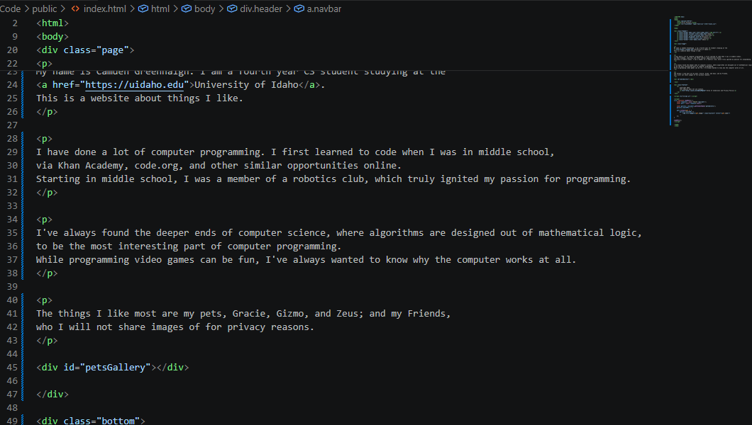
Index.html

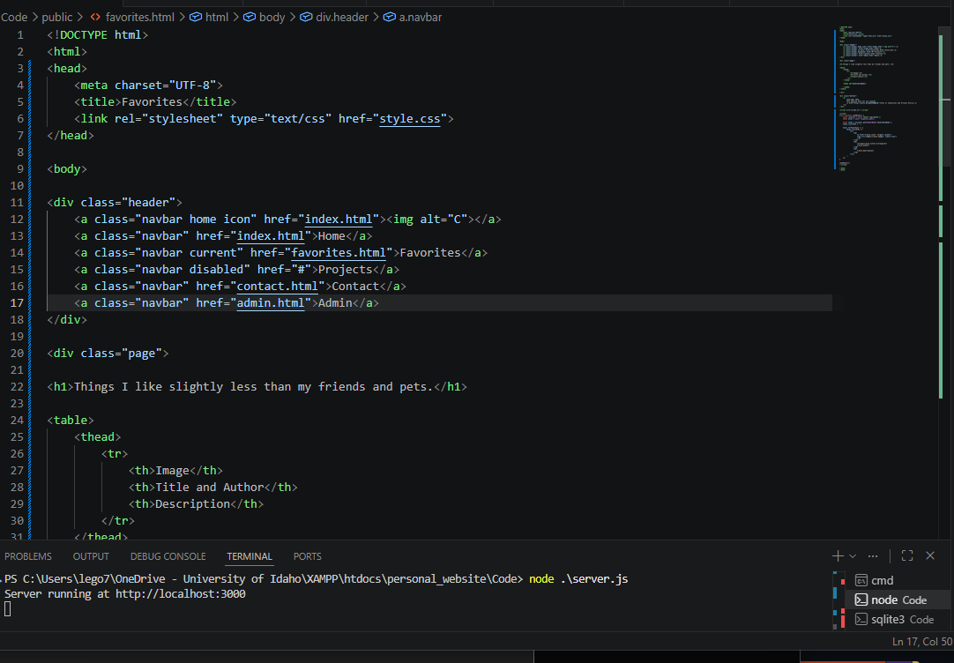
Favorites.html

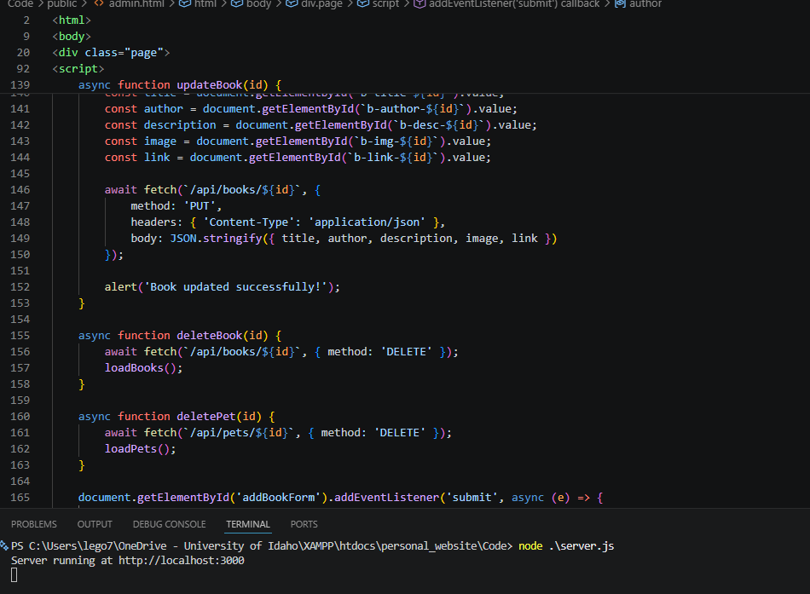
Admin.html

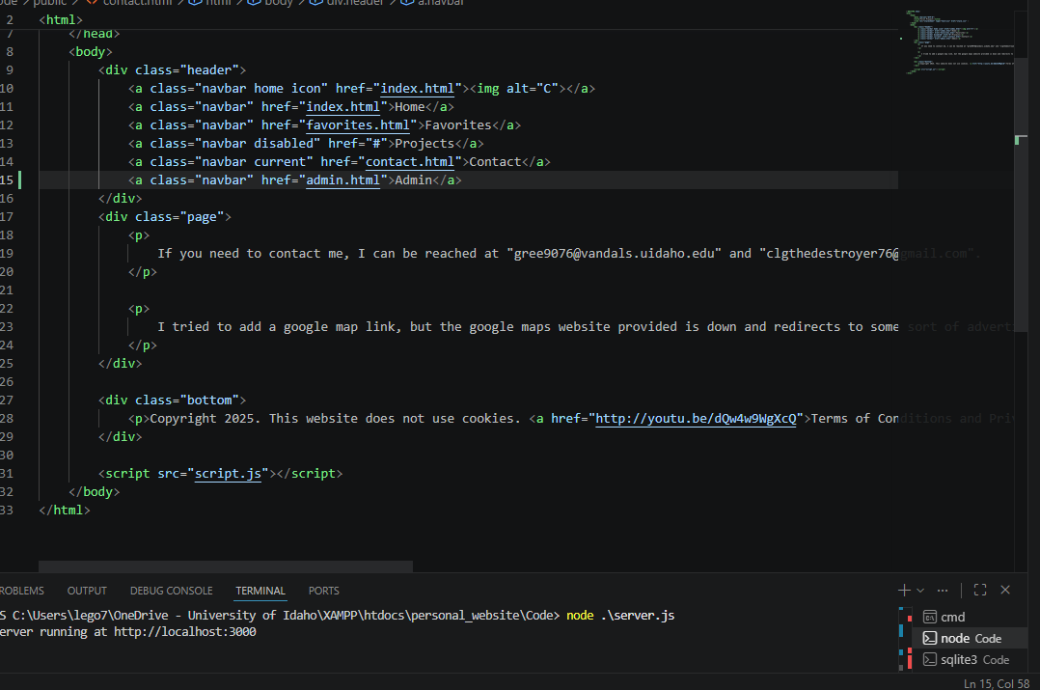
Contact.html

Database schema
The database stores entries for my pets and for my favorite books. The website loads these and displays them.
CREATE TABLE books (
id INTEGER PRIMARY KEY AUTOINCREMENT,
title TEXT,
author TEXT,
description TEXT,
image TEXT,
link TEXT
);
CREATE TABLE pets (
id INTEGER PRIMARY KEY AUTOINCREMENT,
name TEXT,
image TEXT
);

