**CSCE 606, Spring 19**

**Team** – RWBY

**ITERATION 3**

**Product Owner** – Jiacheng Liu

**Scrum master** – Harish Krishnamoorthy

**Team member**– Rohan Singh Wilkho, Ritika kamtam, Rui Kou, Kamalakshitha Aligeri

**Client** – Academic Success Centre, Texas A&M University

**Customer Meeting Details** –

Conference Room, 10th Floor, Rudder Tower, Texas A&M University

9th April, 2019

2:30 PM – 3:00 PM

The client wanted a better home page with a banner. Client also wanted to change the login part to NetID. We can mention that login should be by TAMU NetID on the homepage. Currently, the dashboard only displays a single course. Since the students would have many courses to schedule for, all the courses should be shown on the dashboard.

The application also has a time zone issue. The time zone has to be in Central Time rather than UTC. The instructions while the user is on the enter study plan page seem very vague. So, these instructions should be corrected to be made clearer. The whole point of this application is to encourage students to create and stick to their study schedules, so a reward system could be introduced on the application to encourage the students.

**USER STORIES:**

1. Feature: Add Academic Success banner on homepage

As a Student

So that I can get to know this is an ASC application

I want a banner of ASC on the homepage

Status: Completed

1. Feature: Improve instructions on study plan page

As a student

So that I can easily use the application

I want instructions on the study plan page to be precise

Status: Completed

1. Feature: Getting Central Time

As a student

So that I can work on my time zone

I want all the schedules to be in Central Time

Status: Completed

1. Feature: Dashboard to display many courses

As a student

So that I can see all courses I am enrolled into

I want the dashboard to accommodate all my schedules

Status: Completed

1. Feature: Login with TAMU email

As a student

So that I can use my NetID

I want the application to work for TAMU email with description

Status: Completed

LO-FI SKETCHES:

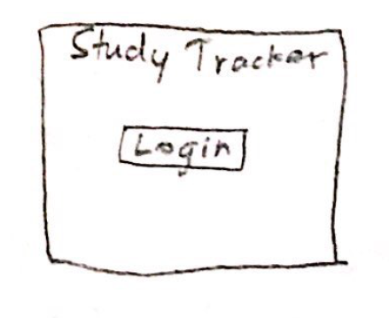 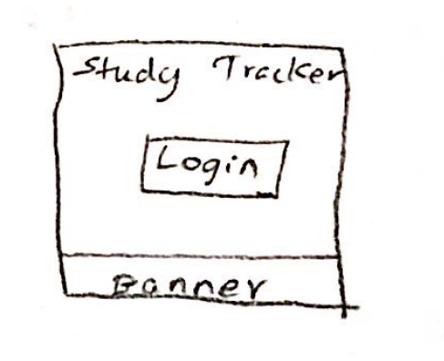

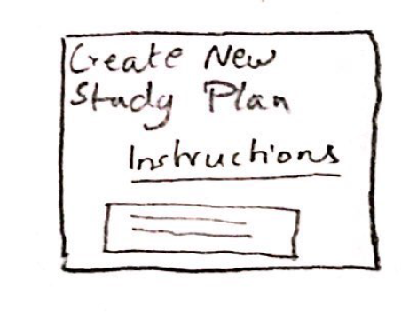 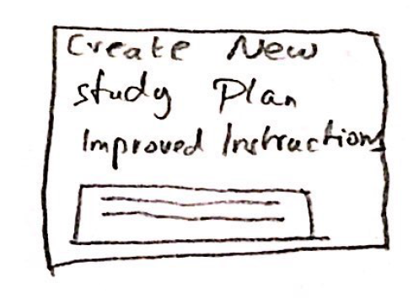

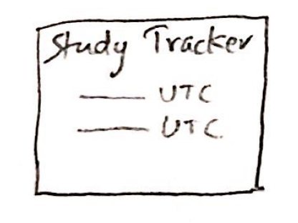 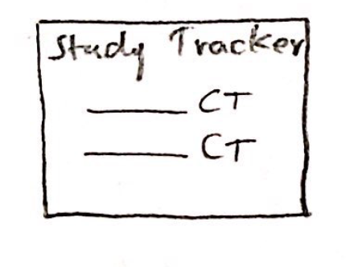

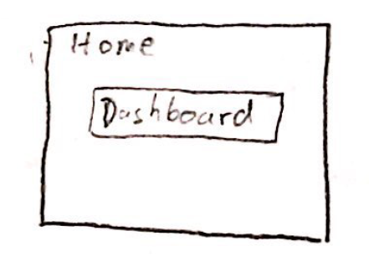 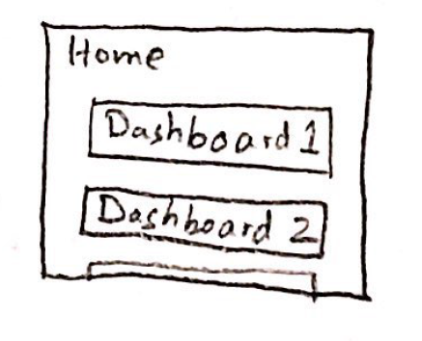

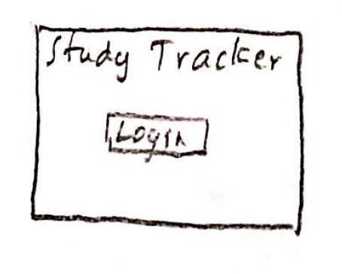 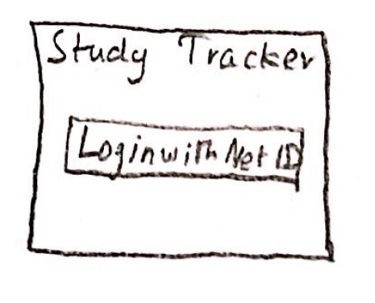

STORYBOARD:

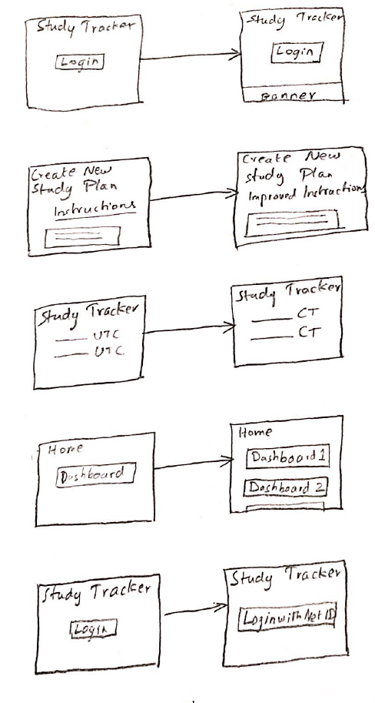

Pivotal Tracker - <https://www.pivotaltracker.com/n/projects/2318740>

GitHub - <https://github.com/theharishkm/Study-Tracker>