**CSCE 606, Spring 19**

**Team** – RWBY

**ITERATION 4**

**Product Owner** – Jiacheng Liu

**Scrum master** – Harish Krishnamoorthy

**Team member**– Rohan Singh Wilkho, Ritika kamtam, Rui Kou, Kamalakshitha Aligeri

**Client** – Academic Success Centre, Texas A&M University

**Customer Meeting Details** –

Conference Room, 10th Floor, Rudder Tower, Texas A&M University

26th April, 2019

3:00 PM – 3:30 PM

We showed all the completed features to the customers and the customers were happy. They wanted us to deploy the application and also add some animations to the homepage and to reward the students for sticking to the study plans.

**USER STORIES:**

1. Feature: Add Animation on homepage

As a Student

So that I can have an attractive ASC application

I want an animation with banner of ASC on the homepage

Status: Completed

1. Feature: Deploy animation to congratulate

As a student

So that I can be rewarded to complete the tasks

I want congratulations animations on the dashboard

Status: Completed

1. Feature: Deployment

As a student

So that I can use the application

I want the application to be deployed

Status: Completed

LO-FI SKETCHES:

Not applicable since the features involved UI tweaking. However, we are adding the screenshots of the animations.

Homepage:

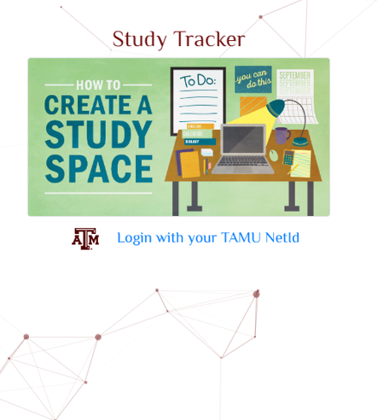

Congratulations Animation:

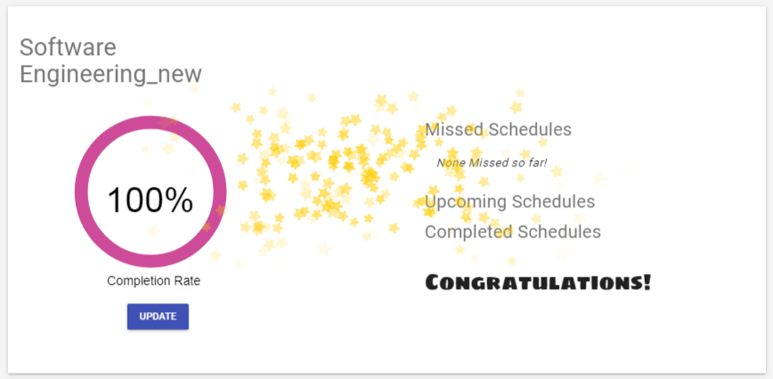

Pivotal Tracker - <https://www.pivotaltracker.com/n/projects/2318740>

GitHub - <https://github.com/theharishkm/Study-Tracker>