ASSIGNMENT 7

Tables-

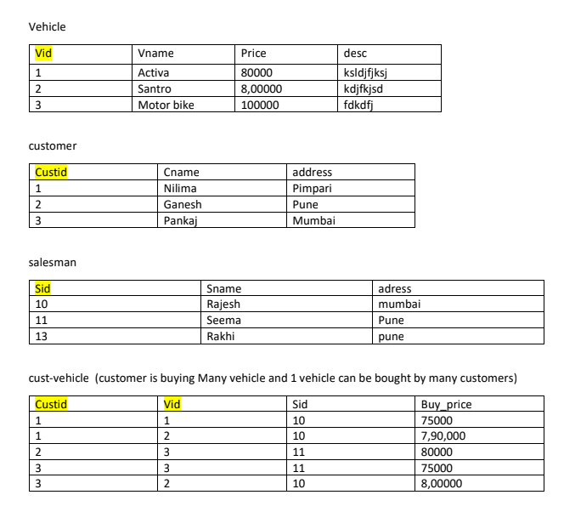

1. create all given tables

-- vehicle table
create table vehicle (
vid int primary key,
vname char(30),
price int,
description varchar(50)
);

-- customer table
create table customer (
custid int primary key,
cname char(50),
address varchar(100)
);

-- salesman table
create table salesman (
sid int primary key,
sname char(50),
address varchar(100)
);

-- cust_vehicle table
create table cust_vehicle (
custid int,
vid int,
sid int,
buy_price int,
primary key (custid, vid, sid),
foreign key (custid) references customer(custid),
foreign key (vid) references vehicle(vid),
foreign key (sid) references salesman(sid)
);

-- Data Insertion

-- 1. Vehicle Table Data
INSERT INTO Vehicle (Vid, Vname, Price, description) VALUES
(1, 'Activa', 80000.00, 'ksldjfjksj'),
(2, 'Santro', 800000.00, 'kdjfjkdsf'),
(3, 'Motor bike', 100000.00, 'fdkdfj');

-- 2. Customer Table Data
INSERT INTO Customer (Custid, Cname, address) VALUES
(1, 'Nilima', 'Pimpari'),
(2, 'Ganesh', 'Pune'),
(3, 'Pankaj', 'Mumbai');

-- 3. Salesman Table Data
INSERT INTO Salesman (Sid, Sname, address) VALUES
(10, 'Rajesh', 'mumbai'),
(11, 'Seema', 'pune'),
(13, 'Rakhi', 'pune');

-- 4. Cust_Vehicle Table Data
INSERT INTO Cust_Vehicle (Custid, Vid, Sid, buy_price) VALUES
(1, 1, 10, 75000.00),
(1, 2, 10, 790000.00),
(2, 3, 11, 80000.00),
(3, 3, 11, 75000.00),
(3, 2, 10, 800000.00);

2. create index on vehicle table based on price

create index idx_vehicle_price
on vehicle(price);

3. find all customer name,vehicle name, salesman name, discount earn by all customer

select
c.cname as customer_name,
v.vname as vehicle_name,
s.sname as salesman_name,
(v.price - cv.buy_price) as discount
from customer c
join
cust_vehicle cv on c.custid = cv.custid
join
vehicle v on v.vid = cv.vid
join
salesman s ON cv.sid = s.sid;

4. find all customer name,vehicle name,salesman name for all salesman who stays in pune

select
c.cname as customer_name,
v.vname as vehicle_name,
s.sname as salesman_name
from
customer c
join
cust_vehicle cv on c.custid = cv.custid
join
vehicle v on v.vid = cv.vid
join
salesman s on cv.sid = s.sid
where
s.address = 'pune';

5. find how many customers bought motor bike

select
count(distinct c.custid) as number_of_customers
from
customer c
join
cust_vehicle cv on c.custid = cv.custid
join
vehicle v on v.vid = cv.vid
where
v.vname = 'motor bike';

6. create a view find_discount which displays output
-------to create view

create view find_discount
as
select cname,vname,price,buying_price,price-buying_price “discount”
from customer c inner join cust_vehicle cv on c.custid=cv.cid inner join vehicle v on
v.vid=cv.vid

--------to display discount
select * from find_discount;
7. find all customer name, vehicle name, salesman name, discount earn by all customer

select
c.cname as customer_name,
v.vname as vehicle_name,
s.sname as salesman_name,
(v.price - cv.buy_price) as discount
from
customer c
join
cust_vehicle cv on c.custid = cv.custid
join
vehicle v on v.vid = cv.vid
join
salesman s on cv.sid = s.sid;

8. create view my_hr to display empno,ename,job,comm for all employees who earn
commission

create view my_hr as
select empno, ename, job, comm
from emp
where comm is not null and comm > 0;

9. create view mgr30 to display all employees from department 30

create view mgr30 as
select *
from emp
where deptno = 30;

10. insert 3 employees in view mgr30 check whether insertion is possible

insert into mgr30 (empno, ename, job, sal)
values (9001, 'amit', 'clerk', 1500),
(9002, 'sumit', 'salesman', 2000),
(9003, 'rohit', 'analyst', 3500);

11. insert 3 records in dept and display all records from dept

-- inserting new departments
insert into dept (deptno, dname, loc)
values (50, 'it', 'pune'),
(60, 'hr', 'delhi'),
(70, 'finance', 'mumbai');

-- displaying all records
select * from dept;

12. use rollback command check what happens

start transaction;

-- make some changes
update emp set sal = sal + 500 where deptno = 10;
delete from dept where deptno = 60;

-- check the changes
select * from emp where deptno = 10;

-- undo the changes
rollback;

-- check the changes after rollback
select * from emp where deptno = 10;

13. do the following
insert row in emp with empno 100
insert row in emp with empno 101
insert row in emp with empno 102
add savepoint A
insert row in emp with empno 103
insert row in emp with empno 104
insert row in emp with empno 105
add savepoint B
delete emp with empno 100
delete emp with emp no 104
rollback upto svaepoint B
check what all records will appear in employee table
rollback upto A
check what all records will appear in employee table
commit all changes
check what all records will appear in employee table
check whether you can roll back the contents.
--------------------------------------------------------------------------
start transaction;

insert into emp (empno) values (100), (101), (102);
savepoint a;
insert into emp (empno) values (103), (104), (105);
savepoint b;

delete from emp where empno = 100;
delete from emp where empno = 104;

rollback to savepoint b;
select * from emp;

rollback to savepoint a;
select * from emp;
commit;
select * from emp;
rollback;
(cannot rollback after the changes have been made permanent)

14. create a procedure getMin(deptno,minsal) to find minimum salary of given table.

delimiter $$

create procedure getmin(in p_deptno int, out p_minsal decimal(10, 2))
begin
select min(sal)
into p_minsal
from emp
where deptno = p_deptno;
end$$

delimiter ;

