ASSIGNMENT-

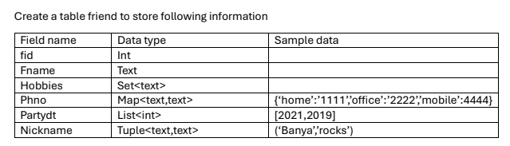

Fid is partition key
Fname is cluster key

Creating Keyspace and Table
CREATE KEYSPACE mykeyspace
WITH replication = {'class': 'SimpleStrategy', 'replication_factor': 1};
USE mykeyspace;
CREATE TABLE friend (
fid INT,
Fname TEXT,
Hobbies SET<TEXT>,
Phno MAP<TEXT, TEXT>,
Partydt LIST<INT>,
Nickname TUPLE<TEXT, TEXT>,
PRIMARY KEY (fid, Fname));

Inserting Data-
INSERT INTO friend (fid, Fname, Hobbies, Phno, Partydt, Nickname)
VALUES (1, 'Amit', {'reading', 'music'}, {'home':'1111', 'mobile':'1112'}, [2019, 2021], ('Amu', 'rockstar'));

INSERT INTO friend (fid, Fname, Hobbies, Phno, Partydt, Nickname)
VALUES (2, 'Priya', {'dancing'}, {'home':'2221'}, [2019, 2020], ('Pri', 'artist'));

INSERT INTO friend (fid, Fname, Hobbies, Phno, Partydt, Nickname)
VALUES (3, 'Rohit', {'cricket'}, {'home':'3331', 'office':'3332'}, [2021], ('Ro', 'hitman'));

INSERT INTO friend (fid, Fname, Hobbies, Phno, Partydt, Nickname)
VALUES (4, 'Sameer', {'gaming'}, {'home':'4441'}, [2021], ('Sam', 'explorer'));

INSERT INTO friend (fid, Fname, Hobbies, Phno, Partydt, Nickname)
VALUES (5, 'Raj', {'singing'}, {'mobile':'5551'}, [2022], ('Raja', 'zzz'));

1. Add year 2022,2023 in party date for all friends with fid 3 or 4

UPDATE friend SET Partydt = Partydt + [2022, 2023] WHERE fid = 3 AND Fname = 'Rohit';
UPDATE friend SET Partydt = Partydt + [2022, 2023] WHERE fid = 4 AND Fname = 'Sameer';

2. Replace home phone number of Rohit with 4444

UPDATE friend SET Phno['home'] = '4444' WHERE fid = 3 AND Fname = 'Rohit';

3. Add office phone number in Sameer’s phno
UPDATE friend SET Phno['office'] = '6666' WHERE fid = 4 AND Fname = 'Sameer';

4. Remove ‘home’ phno for friend with id 1

DELETE Phno['home'] FROM friend WHERE fid = 1 AND Fname = 'Amit';

5. Remove year 2023 from partydt for fid1

UPDATE friend SET Partydt = Partydt - [2023] WHERE fid = 1 AND Fname = 'Amit';

6. Replace year 2019 from partydt with 2020 for fid 2

UPDATE friend SET Partydt[0] = 2020 WHERE fid = 2 AND Fname = 'Priya';

7. Overwrite nicknames with (‘xxx’,’yyyy’) for fid 1

UPDATE friend SET Nickname = ('xxx', 'yyyy') WHERE fid = 1 AND Fname = 'Amit';

8. Add ‘zzz’ nickname with fid 2

UPDATE friend SET Nickname = ('Pri', 'zzz') WHERE fid = 2 AND Fname = 'Priya';

9. Remove ‘zzz’ nickname for friend with fname “Raj”

DELETE Nickname FROM friend WHERE fid = 5 AND Fname = 'Raj';

10. Remove all nicknames for fid 3

DELETE Nickname FROM friend WHERE fid = 3 AND Fname = 'Rohit';

