ASSIGNMENT-2

1. Design Vehicle Hierarchy with following specifications:
- The vehicle class has registration no, make, model and price
- Implement calculateInsurance() method as abstract method in the class

- Create TwoWheeler and FourWheeler as subclasses of Vehicle class
and implement calculateInsurance () method

For two wheeler the insurance amount is 5% of the price
For four wheeler the insurance amount is 10% of the price
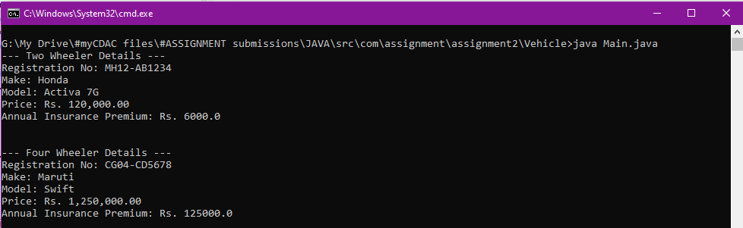

2. Design Account Hierarchy with following specifications:

- The account class has account no, name and balance
- Implement withdraw and deposit methods in the class

- Create Savings and Current as subclasses of Account class

For Savings account min balance of 10000 should be maintained while withdrawal
For current account maximum of 50000 rs can be withdrawn at a time

While deposit in saving max limit is 1 lakh and for current it is 5 lakh

